Supporting Documents For Parish council meeting 08/01/2024
Speed indicator quotes
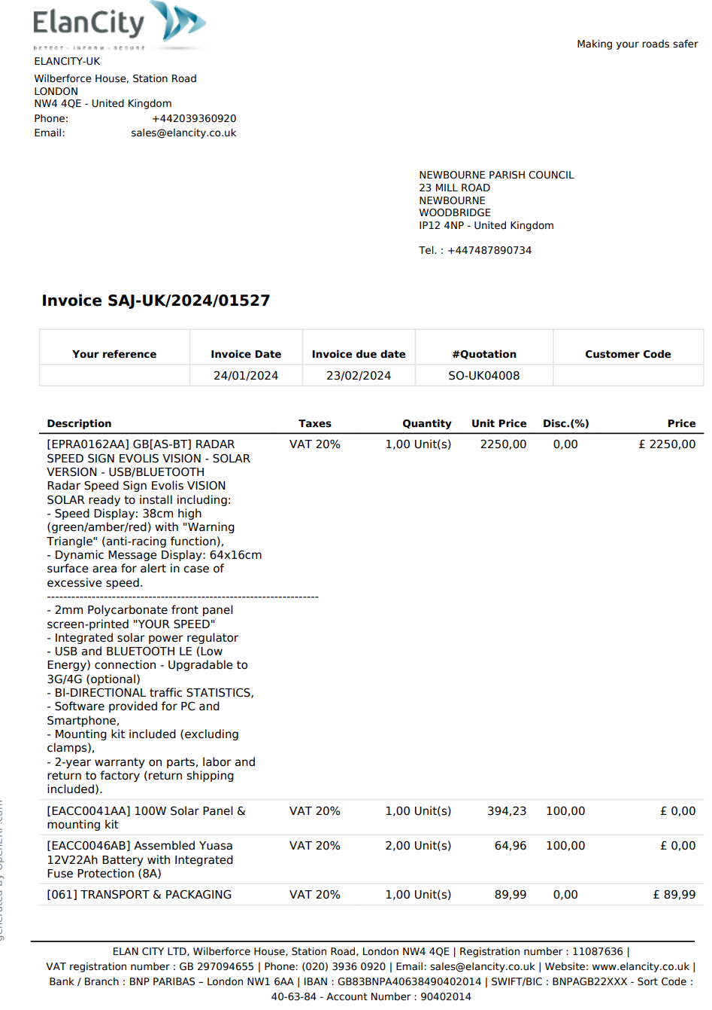
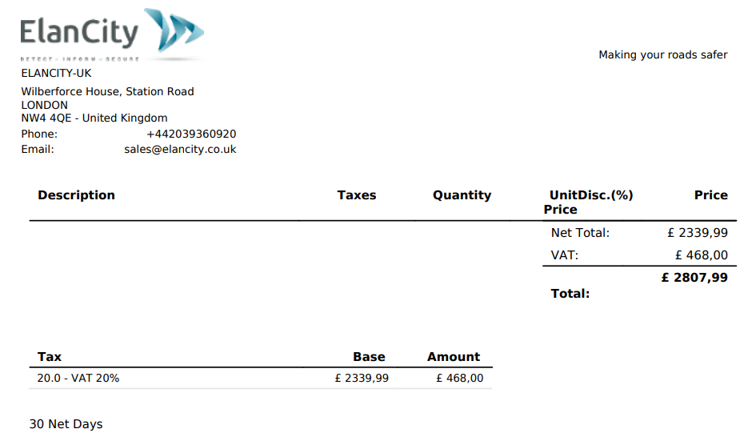

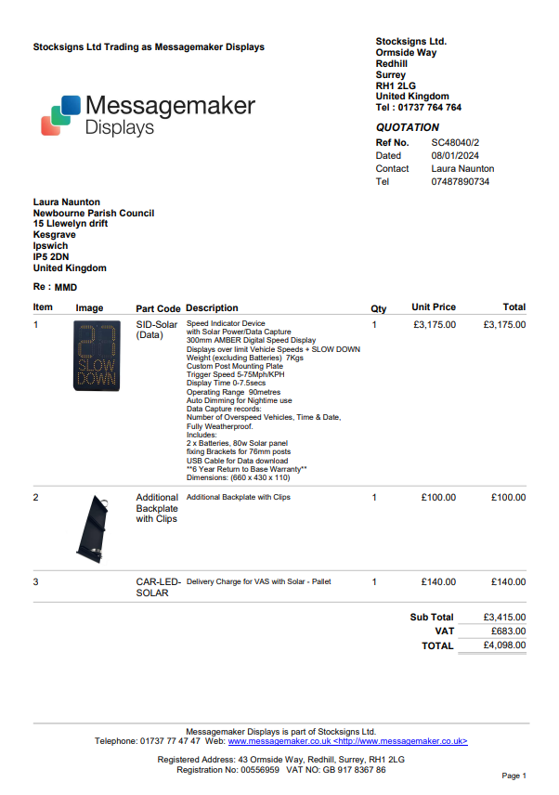

Email from Lee Reeves regarding the Foxhall roundabout issues.
Thanks for the heads up on this.

As you are probably aware there are plans by SCC to upgrade the roundabouts and other parts of the A12 between the Seven Hills roundabout and Woodbridge.

I will try to find the plans to see whether it is the intention to make changes at the Foxhall roundabout which may have a bearing on the Newbourne Road and Brightwell access points. I know exactly what the problems are at the junction as have had similar problems before when coming off from Waldringfield onto the roundabout.

Will come back to you in more detail when I know more.

In the meantime, best wishes for Christmas and the New Year to you and yours.

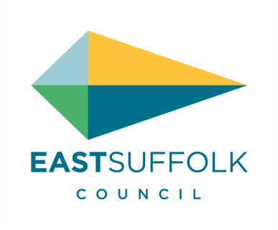   | Lee Reeves | Councillor for Orwell & Villages Ward  East Suffolk Council  07823 372501  www.eastsuffolk.gov.uk  www.eastsuffolkmeansbusiness.co.uk  Our ambition is to deliver the best possible quality of life for everyone who lives in, works in and visits East Suffolk.  We are East Suffolk

DECEMBER 2023 PARISH REPORT
ORWELL AND VILLAGES WARD

December report from ESC Councillors
PITSTOP OUTREACH PROJECT
In a new initiative, partly funded by the Felixstowe Peninsula Community Partnership, the Pitstop Outreach pop-up project is due to launch in the New Year. Building on the experience of the Pushchair Pitstop based in Felixstowe the plan is to provide a visiting food bank, clothing / toy bank, and advice service to residents across the peninsula.
The first visit should take place in Kirton towards the end of January or early February with the intention to make regular visits to all our villages as well as Old Felixstowe, which suffer from a lack of public transport.
Once the full rolling programme has been finalised it would be very helpful for parishes to publish full details in their parish magazines to ensure that those in need within our villages are aware of the help available.
TRIPLE LOCK FOR PLANNING TO BE INTRODUCED
At the December meeting of the Audit & Governance Committee it was agreed that the long awaited “triple lock” for planning referrals should come into effect for an initial trial period of six months. This means that if a parish council should object to a planning application and that objection has the support of a ward councillor and a member of the Planning Committee then the application will be heard by the Planning Committee rather than being delegated to an officer.
The Audit & Governance Committee did request that the policy be reviewed after six months in order to evaluate the effect upon the Planning Committee workload and application decision times. It is anticipated that full council will approve the implementation at the end of January.
WARM WELCOMES
East Suffolk Council’s Warm Welcomes (formerly Warm Rooms) scheme has now relaunched, with more than 20 village halls, churches and community hubs providing a warm space and an opportunity to connect with other members of the local community.
Last year, Warm Rooms operated over the winter months to provide warm, friendly spaces across East Suffolk. This winter, the rooms have been rebranded as Warm Welcomes following feedback received by those using the service, and the host venues.
Part-funded by the UK Government’s UK Shared Prosperity Fund, Warm Welcomes provide a safe and welcoming space where members of the community, including people who may be struggling with the cost of heating their homes, can come to meet with others and access information about additional support available in the community.

OUR DIRECTION
Our Direction 2028 is East Suffolk’s new strategic plan and presents the council’s key ambitions and priorities for the next four years. Our aim is to promote a bright, green, open, free, and fair future for all East Suffolk, and our priorities are:
Environmental Impact
Sustainable Housing
Tackling Inequalities
Thriving Economy
This reflects the political ambitions of the Green, Liberal Democrat and Independent administration and sets the path we are embarking on together, collaboratively, for the four years until 2028. The council wants to work with and empower communities and individuals to conserve what we love about our district, improve services where we need to and adapt to our changing environment - ensuring the district is in the best place possible in 2028.
In delivering this plan, we recognise the importance of the solid foundations that are critically important to any successful local authority. We will continue to provide excellent quality services for our residents and will always listen - engaging with you whenever possible.
Our Direction 2028 sets out the themes and priorities for East Suffolk Council across the next four years. However, it is also important that we are then seen to deliver against these priorities, ensuring real, tangible outcomes for all our communities.
Therefore, we will develop an action plan to measure exactly what we are doing and what we have achieved. It will be clear and transparent, reflecting our determination to make a genuine difference.
If parish councillors need to contact either of us, please feel free to do so.
Cllr Mike Ninnmey: Home tel no 01394 677210 Mobile: 07823 372503
E-mail: mike.ninnmey@eastsuffolk.gov.uk
Cllr Lee Reeves: Home tel no 01394 284506 Mobile 07823 372501
E-mail: lee.reeves@eastsuffolk.gov.uk

Invoices
