Monday 4th September
Minutes of Parish Council Meeting

Public Time
- Brought to the parish council’s attention that there are trees hanging over the road on Ipswich Road. Clerk will email wildlife Trust and East Suffolk council.
- Brought to the parish council’s attention that the Bus shelter needs some attention looking a bit overgrown. Clerk will arrange working party to do some work on it.
- Issue raised regarding the Bus that passes through Newbourne has been brought to the parish council’s attention that you can get a bus from Newbourne, but you can’t get one back. Clerk will look at the timetable and update.

Meeting opened at 7.40pm

- Apologies received from Cllr Lusher, ESC Reeves and ESC Ninnmey.
- Report received from ESC Reeves and ESC Ninnmey
AUGUST 2023 PARISH REPORT
ORWELL & VILLAGES WARD

We had a very interesting briefing from senior ESC officers regarding the future plans for the Seven Hills Roundabout in response to the large number of planning applications which will have implications for traffic volumes on the roundabout and on both the A14 and A12. It seems very likely that at least one further lane may be introduced together with traffic lights at some points.
We also had a Team meeting with the developers of the Reeve Lodge proposed development and toured various sites in Trimley St Mary and Trimley St Martin with the Leader and Chief Executive of ESC, parish council reps and ESPA.
Cllr Reeves attended a planning refusal appeal hearing by the Government inspector in relation to a site in Levington together with representatives of the local parish council.
We also attended several committee meetings relating to our individual responsibilities and dealt with several requests for assistance by residents.
If parish councillors need to contact either of us, please feel free to do so.
Cllr Mike Ninnmey: Home tel no 01394 677210 Mobile: 07823 372503
E-mail: mike.ninnmey@eastsuffolk.gov.uk
Cllr Lee Reeves: Home tel no 01394 284506 Mobile 07823 372501
E-mail: lee.reeves@eastsuffolk.gov.uk

Meetings with Forestry Commission and Anglian Water
The GLI Group recently met with both the Forestry Commission and Anglian Water to explore ways of protecting the outstanding natural environment of East Suffolk. East Suffolk Council and GLI Group Leader Cllr Caroline Topping is pleased that they were able to discuss important issues with both organisations. She said: "We are determined to develop and maintain a constructive dialogue with key environmental stakeholders and these two recent meetings really got the ball rolling.
"The presentation from the Forestry Commission was incredibly engaging and I am keen that we really do spread the word about the importance of tree planting and the range of grants that are available to do so.”
Meanwhile the meeting with Anglian Water was also very useful although I was disappointed by representatives' suggestion that sewage discharge into rivers was a low priority issue for the public. It was also interesting to that they are not statutory consultees with regards to planning applications which is a concern when it comes to the issue of ensuring appropriate supply to new developments.
These meetings mark our commitment to deliver on our campaign promises and prioritise residents, communities, and the environment in everything that we do. The GLI Councillors are enthusiastic about improving quality of life across the district, and this is just the beginning - so watch this space!"
New policing model: PCC and Chief answer your questions

The way local policing is delivered in Suffolk is changing and a new county policing model goes live in December 2023.

In advance of the changes, the Police and Crime Commissioner Tim Passmore and Chief Constable Rachel Kearton are hosting a series of meetings to talk through the plans with local communities and answer any questions they may have.

Meetings will be held across the county through September and October with an on-line meeting in November.
These are:
WEST AREA: Thursday September 21 2023 at Bury Town Football Club, Cotton Lane, Bury St Edmunds IP33 1XP
SOUTH AREA: Wednesday October 4 2023 at Police Headquarters, Portal Avenue, Martlesham IP5 3QS
EAST AREA: Tuesday October 10 2023 at Wherry Hotel, Bridge Road, Oulton Broad, Lowestoft NR32 3LN
MID SUFFOLK: Tuesday October 17 2023 at the new Stowmarket Police Station, IP14 2QU
All meetings start at 6.30pm and there is no need to book, just turn up on the evening.

There is also an on-line meeting on Tuesday November 7 2023 at 6pm via Microsoft Teams. Please email spcc@suffolk.police.uk to register and an invite will be sent through via email in advance of the meeting.

Time to think about how we heat our homes
Warm Homes Suffolk is accepting applications to fund improvements to residents’ homes, making properties warmer and more efficient for the colder months. Warm Homes Suffolk has new funding available for eligible households, to put towards energy efficient measures such as insulation, solar panels or heat pumps.
The scheme is administered by Suffolk County Council, and delivered by East Suffolk Council, on behalf of all councils in Suffolk. It has been funding home energy efficiency improvements for more than a year but has recently received further funding from the Department for Energy, Security and Net Zero to continue the work.
An average of £18,000 in funding per property is available for homeowners meeting the criteria. Landlords and tenants are also entitled to apply, with qualifying rental properties getting up to two-thirds of costs, as an average grant of up to £12,000.
To find out more about how Warm Homes Suffolk, visit Warm Homes Suffolk or call the team on 03456 037 686.

- Declarations of disclosable pecuniary interest – None
- Minutes of Parish Meeting 04/09/2023 Cllr Pollard & Cllr Wicks agree that the minutes are correct.
- Planning – No planning to be discussed, added so the parish council can see the amendments on the two planning applications.
- DC/23/3196/AME – Oak View Farm, Ipswich Road. Non-Material amendment of DC/23/0990/FUL – Erection of a detached dwelling, existing dwelling to be demolished, previous application withdrawn DC/22/4967/FUL. 1. Changes to finishes to provide rendered facades and slate roof. 2. Insertion of bifold doors to rear elevation (in lieu of window) 3. Changes to boiler cupboard to side elevation, and to side elevation, and to remove reference to approved plan A02/02C and supersede with plan 2077.23.OA

- DC/23/3098/VOC 7 Ipswich Road – Alternations part demolition plus, front & first floor extensions and new cart lodge. Dormers have been fitted to the front instead of rooflights. Store is to the left-hand side not right (drawing 2280.10 to replace drawing 2280.03)

- Green Infrastructure update – Terence Gaussen and Cllr Lusher attended the Inter parish Green Infrastructure meeting at the end of August. Terence updated us in Cllr Lusher’s absence. The meeting was successful and very informative with lots of information. Terence and Kwini are still getting all the information together from the meeting and will keep the parish council updated, clerk will add to the agenda each month. The Green infrastructure group will continue to meet and work together, and it is a work in progress. The parish council want to thank Terence for attending and keeping us updated.
- Quiz 21st October – Planning for the quiz is all done, just 5 tables left for the Quiz so if anyone wants one let the clerk know and Pat would like some prizes for the raffle.
- New Councillors – Thank you to Chairman Garfath-Cox for designing the leaflet, Colin Pollard for printing them and Cllr Lusher for delivering them around the village. In response to the leaflets being delivered we have had a fantastic response and Bryan Wheeler from Jackson Road and Terence Gaussen from the The Street have both shown a keen interest in joining the Parish Council.
- Bryan Wheeler has lived in the village a few years and is keen to get more involved in the village. He works mainly in Braintree but works from home dealing with residential sales and lettings.
- Terence Gaussen was previously a councillor where he previously lived in West Yorkshire. He loves Newbourne and the LSA history. Has experience with footpaths, planning, trees and issues that the Parish councils may face. Terence is also involved with the green infrastructure.
The Parish Councillors are all in agreement that they would like to welcome both Bryan and Terence in joining the parish council and that both of them would make a great addition to the other councillors.
- Insurance – Insurance quote in from Hiscox for £2068.00 for 2023/2024. Insurance quote up from last year but has gone up each year so 2021-2022 was £1513.68, 2022-2023 was £1853.51 each year seems to increase about £300.00. It was agreed to renew so companies won’t quote due to the village hall being a wooden building.
- Finance
Cheque 100488 SALC Membership £156.45 2023 -2024
Cheque 100489 Clerk wages June - August £493.90
Cheque 100490 HMRC £123.60
Cheque 100491 hiscox insurance £2068.00
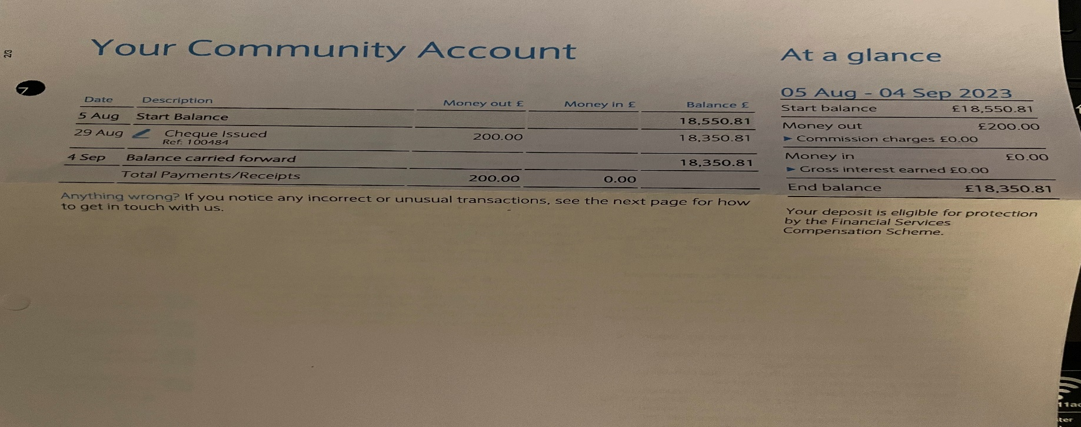
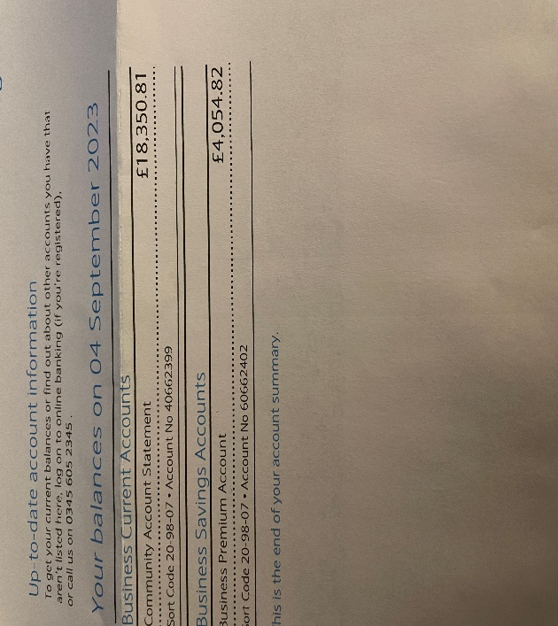

Bank Reconciliation August 2023

Cash in hand 01/08/2023 £22,594.79
Community £18,550.81
Saving £4043.98
ADD

£22,594.79
SUBTRACT
Payments
Amount Cheq no Payee
£200.00 100484 Newbourne Church Roof 29/08/2023

Cash in hand 01/8/2023 £22,394.79
B
Cash £0.00
Petty Cash £0.00
Community account £18,350.81
Saving £4043.98

- Clerks Correspondence

Speed Camera – The speed camera has an issue where it won’t keep its charge. Michael Hadley has suggested that we connect the speed camera to the mains off the village hall or invest in a solar panel to charge it. Every time it runs out of battery Michael must come and reset the camera with a laptop. If we connect to the mains, it means we can not move it to Ipswich Road. The Parish council have discussed, and we have agreed to send the speed camera back and get our money back and buy a different speed camera.

Email received from Mike Whybray regarding the OASI Container
From: Mike Whybray, Orwell Astronomical Society Ipswich

Dear Councillors,

In 2019 you supported our application to site a shipping container on the North edge of the village hall field to store our telescopes etc., to facilitate our twice monthly meetings at the village hall. We agreed a License with you and make an annual payment, on top of the hall hire charges. We also contributed to the cost of surfacing the car part. We have greatly enjoyed our meetings at the hall and hope the arrangement has been mutually beneficial.

The planning people however chose to limit their Permission to 5 years, so now we have to re-apply on the same basis as before. We have done our best to keep the Container in good order, not to disturb neighbours, and after a couple of failed attempts have finally managed to get some hedgerow plants (Hazel and Hawthorn) growing at both ends to help screen and merge the ends into the existing hedge line, as specified in our application.

Our intention is to apply for an extension to the planning permission on the same basis as before. We hope to be granted longer than 5 years this time, but to address any concerns about the container becoming a rusting ruin can I remind you of the conditions in our License (attached for information) which read:

7) This License shall endure for a minimum of 5 years from the date of the last signature. After that, either party may terminate this agreement by giving 1 year prior written notice to the other.
8) If termination of the agreement is notified the container must be removed from the Licensor's land within 1 year, at the Licensee's cost, unless other arrangements are agreed by both parties.

So if at some future date you are not happy to have the container on your land the License gives you the power to have it removed within one year.

Our original intention was to arrange a metered connection to the hall electricity supply as detailed in the License, but various delays and lack of funds at the time meant that never happened. Should we be granted planning permission for the future we will probably wish to proceed with the electrical connection scheme.

I hope the above all makes sense and is agreeable to the Parish Council. I am happy to attend a meeting to explain and discuss the above if you would like that. Due to the long lead time on getting planning approved I will be putting in the application for OASI soon and I hope you will see fit to support it. If you have any concerns or would like any changes made to our plan or the License please let me know as soon as you can so that I can address them.

Kind regards

Mike Whybray
for Orwell Astronomical Society Ipswich.

The parish council discussed and are happy for the container to remain and support the future planning to keep the container at the village hall.

Meeting closed at 20:27

