September 2025 Supporting Documents
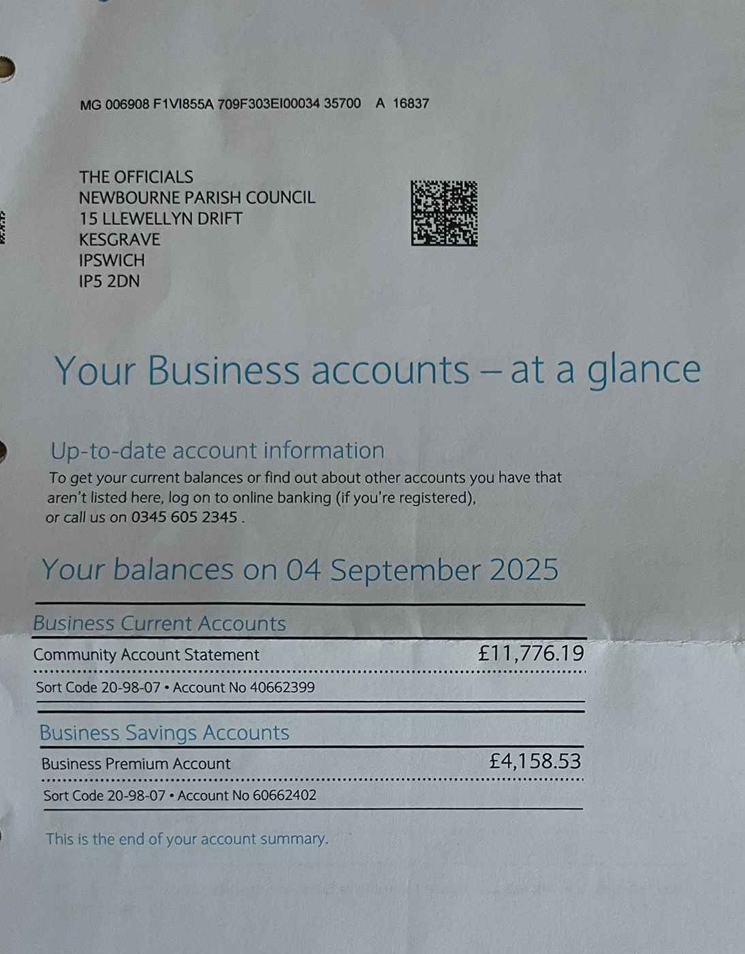
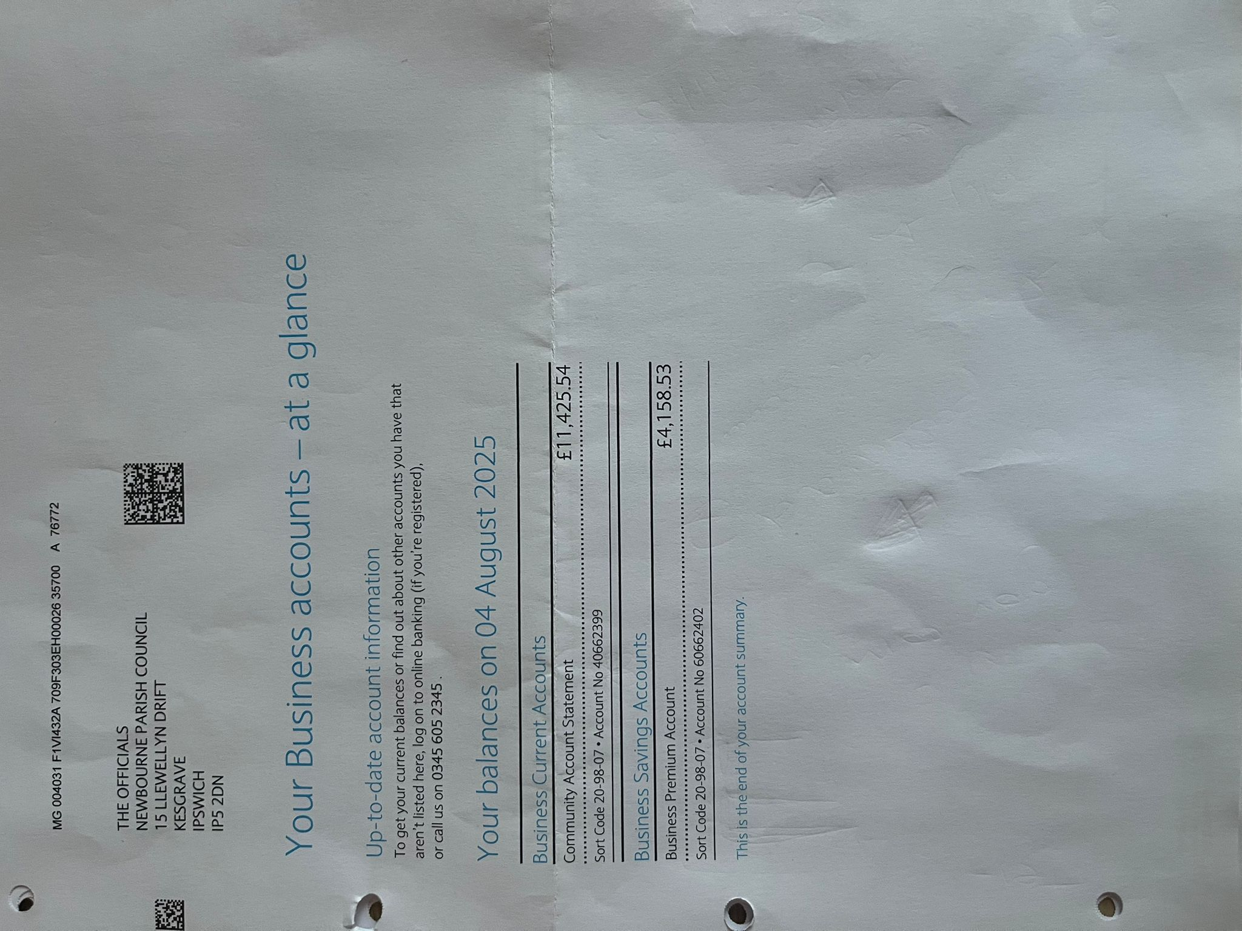
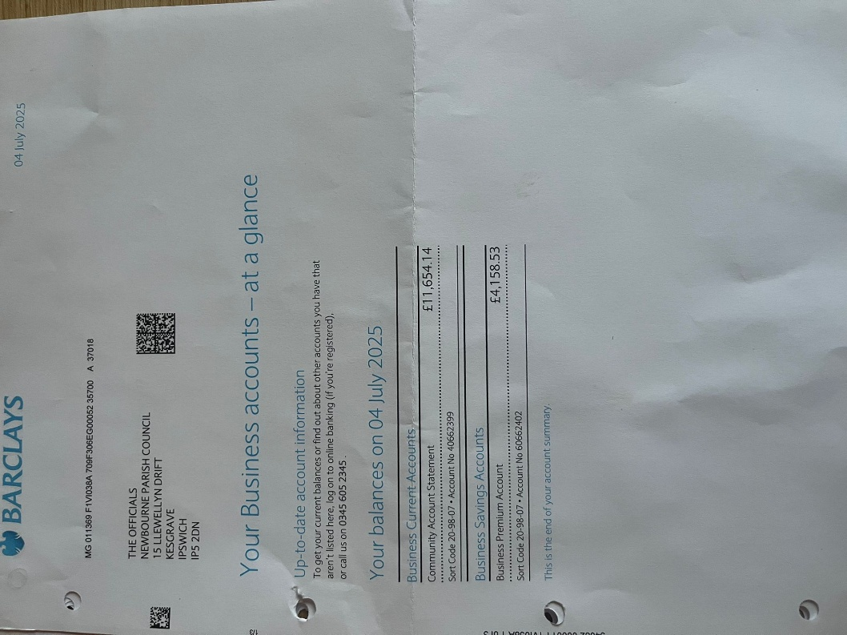
Bank Statements

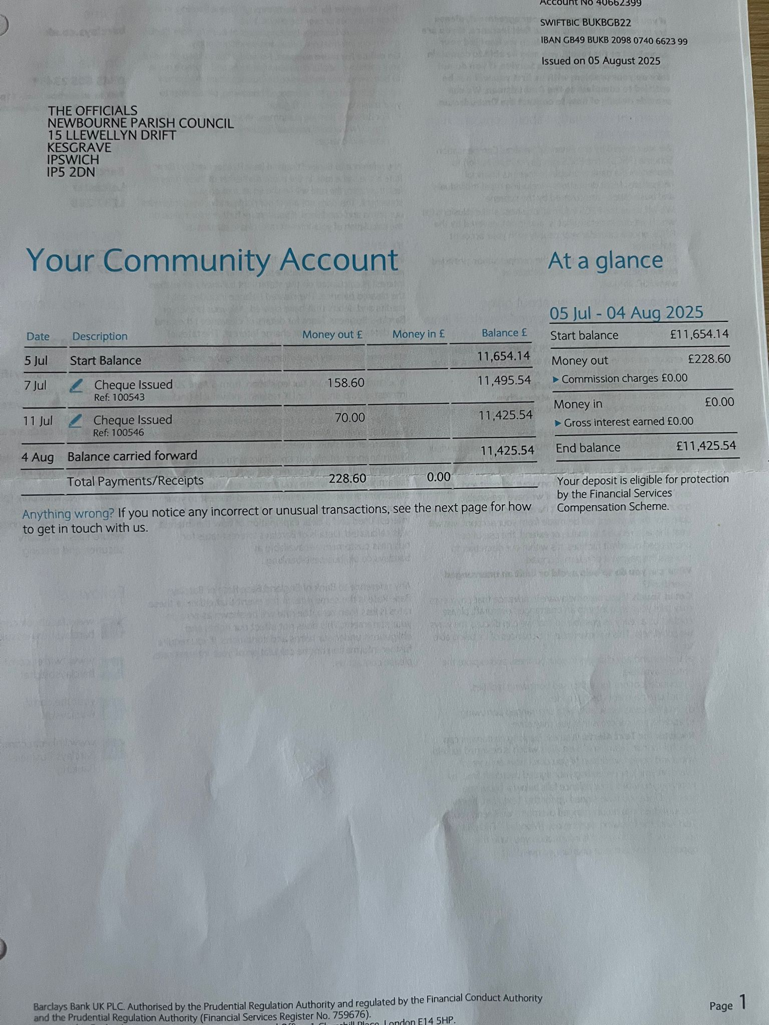

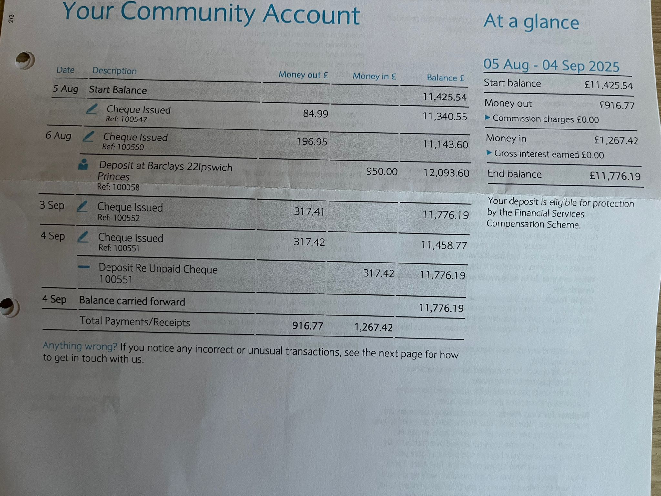

Invoices
100553 – Suffolk Association of Local Councils – £22.80 – Payroll Invoice

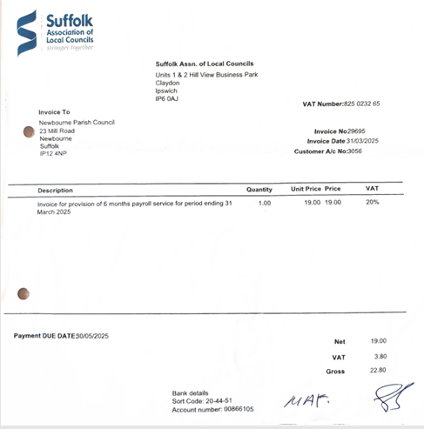
100554 - Suffolk Association of Local Councils - £167.67 – Membership
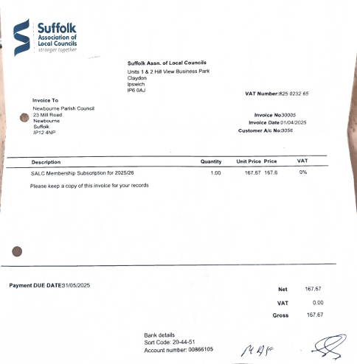
100551 – Laura Naunton - £317.42 – Clerk Wages
100552 – Julia Cooper - £317.41 – Clerk Wages

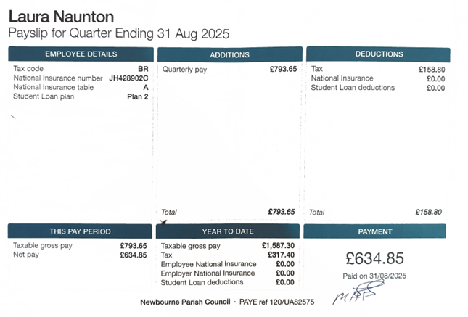

PARISH REPORT AUGUST 2025
ORWELL & VILLAGES
Local Government reorganisation
At the full council meeting held on 16th July East Suffolk Council passed a motion “to further
develop the case which presents a preferred option for a three unitary model. This will
enable decision-making to remain close to communities and offer genuine value for money.”
“to consult further with KPMG to present the detail which establishes that a three unitary
model provides high quality, sustainable public services whilst delivering efficiencies.”
“to prioritise the needs of our residents throughout the process of Local Government
Reorganisation by engaging with them throughout”
The council had rejected a proposed amendment which would have maintained the option of
two unitary authorities (West Suffolk and East Suffolk including Ipswich). There was no
supporting initial report from KPMG, no proposed boundaries had been provided to
councillors,and the motion was largely based upon a survey of 1,500 residents across
Suffolk (representing around 0.002% of Suffolk residents) which found that residents wanted
decisions to be taken close to their location and by people who know the area.
A few days later a proposed map for the three unitaries was provided showing Felixstowe,
Martlesham, Kesgrave and surrounding villages joining a much larger Ipswich which takes in
about half of the Babergh District council area as far as Hadleigh and spreads to the north of
Ipswich. The proposed area would have around 255,000 residents which may still be
considered too small for the Government.
Work is now taking place between the five district councils to put forward a detailed case
including the required amendments to ward boundaries which must be presented to the
Government by 26th September. A final decision will be made by the Minister in January.
New Trimley St Mary playground
We were both delighted to attend the official opening of the new playground in Faulkeners
Way on 5th August. Planned by the parish council for several years and part funded from the
East Suffolk Council district CIL fund for play equipment, this state-of-the art facility cost
more than £85,000. There was a great turn out from local families with entertainment
arranged and even free food and drink from local businesses. Hopefully this facility will
provide a safe play space for future generations.
Please remember that funding may also be available for your parish for play equipment or
improvements to community buildings from the District CIL funds. If you have any schemes
for consideration, please feel free to contact us.
Trimley St Mary Water Tower update
The owners of the Water Tower have advised ESC that they have appointed a specialist
company who are now drawing up a plan of action to carry out remedial works to prevent
further deterioration of the concrete cladding.
Corporate Fraud Service
More than £2.8million of public funding was protected because of work by East Suffolk
Council’s Corporate Fraud Service in2024/25.
The team uncovered more than 103 cases of irregularity between the beginning of April 2024
and the end of March 2025.
An annual Corporate Fraudreport, presented to the Council’s Audit and Governance
Committee last month, showed that officers helped to detect £2,844,032 of irregularity during
the last financial year.
Intervention included the cancellation of nine Right to Buy applications following due
diligence activities, providing £1,724,500 of prevented losses by retaining these properties
within council housing stock and continuing to yield monthly rental income and be available
for social housing needs.
Meanwhile, tenancy fraud investigations resulted in the recovery of 10 social housing
properties, saving an estimated £930,000 and enabling genuinely eligible families to become
tenants. The Corporate Fraud Service Team is professionally resourced and skilled in
investigating any potentially fraudulent activity relating to the organisation, its partnerships,
and direct contractors.
Missed bin collections
There has been a recent spate of missed waste bin collections in Newbourne, Trimley St
Martin and Waldringfield. Most of these have been caused by roadworks which have left
insufficient room for bin lorries to get by whilst others have been due to mechanical
breakdown.
Any failure to collect bins should be reported to operations@eastsuffolk.gov.uk . Efforts are
normally made to collect bins as quickly as possible once a failure is reported (especially
when multiple properties are affected) so the advice is to leave out your waste bins pending
collection.
Local Police contacts
Following the appointment of Inspector Colin Clack as the South East Community Policing
Team leader, he has now provided a list of the local community teams covering our area.
The addresses for each officer will be their first name.surname followed by
@suffolk.police.uk
Nacton: Sgt Mario Daines & Sgt Rocky Hussain
PCs Matthew Flack & Dave Goodwin
Trimleys & Villages: Sgt Nick Kitchen
PC Arlene Ell
Felixstowe: Sgt Nick Kitchen
PCs Mark Hurrell , Nicola Burnham-Slipper and Chris Payne
Inspector Clack advises that if you encounter difficulty contacting individual officers, please
contact him directly colin.clack@suffolk.police.uk

Ease the Squeeze on Cost of Living
Are you, or someone you know, worried about the increasing cost of living? We understand
the pressures faced by many people today and we are working closely with key partners to
ensure support is available to help ease the squeeze for households in East Suffolk.
To make it as easy as possible for you to access the services and support available, locally
and nationally, we have gathered information about them in one place:
www.eastsuffolk.gov.uk/community/squeeze/
For the most up to date information regarding East Suffolk Council, please visit:
www.eastsuffolk.gov.uk
If parish councillors need to contact either of us, please feel free to do so.
Cllr Mike Ninnmey: Home tel no 01394 677210 Mobile: 07823 372503
E-mail: mike.ninnmey@eastsuffolk.gov.uk
Cllr Lee Reeves: Home tel no 01394 284506 (preferred) Mobile 07823 372501
E-mail: lee.reeves@eastsuffolk.gov.uk

