October 2025 Supporting Documents
Invoices
100557 – Play Safety - £110.40 – Playground Inspection
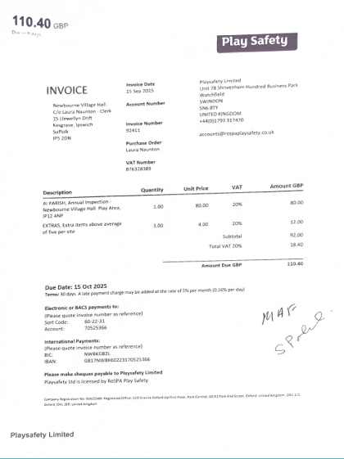

100558 – Newbourne Village Hall - £64.69 – BT Broadband

