Newbourne Parish Council Meeting 06/11/2023

Public Time
Tony gave details of Mike Irwin who oversees Brightwell lakes forum – Clerk will contact him to join the forum.
Tony has raised concerns over planning DC/21/1745/OUT that the planning for the detached dwelling a large plan covering much of the land. Also, DC/23/3790/OUT two houses on the 29 Mill Road site close to The Firs Site.
Minutes of the Parish Council Meeting held on Monday 6th November 2023
Meeting opened by: Chairman Garfath- Cox
In attendance: Cllrs Scott, Frost, Wicks, Pollard, Gaussen & Wheeler
ESC Councillors
Members of the public : 2
Minutes: Clerk
Meeting opened: 19:42

- To RECEIVE apologies for absence Cllr Lusher, ESC Cllr Ninnmey & Reeves.
- To RECEIVE reports County and District Councillors and Suffolk Police.

OCTOBER 2023 PARISH REPORT ORWELL & VILLAGES WARD

The recent heavy rain and flooding caused by Storm Babet has thrown the spotlight on both preparedness of local communities for emergency incidents and the very real threat which climate change represents, be that through flooding, wildfires, or water shortages. The two worst affected areas in Suffolk – Framlingham and Debenham- both had updated emergency plans in place through their parish councils and very quickly could co-ordinate with both Suffolk County Council and their respective District Councils to provide rest centres for residents affected by the flooding and to those visitors who were unable to leave the flooded areas. Emergency housing has been provided to those whose homes are uninhabitable and ESC aided with furniture removal and street clearance within hours of the flood.
If parishes do not currently have emergency plans in place or feel that current plans may need to be updated, then help is available from ESC and the County Resilience team.
All ESC councillors have now been invited to training in setting up rest centres and who to contact to receive supplies such as food and bedding etc. Government funding is available for those directly affected by flooding from Storm Babet (including for future flood-proofing of property and businesses) but it is very important that the council is made aware of any property flooding within parishes outside Framlingham to qualify for that funding. It would also be helpful whilst the flooding remains fresh in your minds if any areas of concern within your own parish could be recorded and advised to us, and they will be passed on centrally so we know potential future flooding sites where road diversions / closures may need to be highlighted. On a related subject we would share the following temporary stop notice against developers. East Suffolk Council has served a Temporary Stop Notice in relation to land at Mow Hill, Witnesham. Notice has been served today, Friday 27 October, in response to work commencing on site to construct dwellings without required surface water management and associated drainage systems. The works are therefore in breach of a condition of planning permission (DC/22/0998/FUL). As Local Planning Authority, East Suffolk Council requires that new developments address surface water flooding through the inclusion of appropriate measures within the site to manage surface water to ensure surface water flood risk is not increased elsewhere. We expect developers to undertake works in accordance with approved plans and the conditions included on planning permissions. Where developers fail to comply with approved plans and conditions, the Local Planning Authority can take formal enforcement action through the serving of notices. While recent flooding around the area of the Mow Hill and Tuddenham Lane junction, during an extraordinary weather event, cannot be attributed solely to the failure of Denbury Homes to complete the required surface water management works, the lack of installation of the surface water management measures may have been a contributing factor. If parish councillors need to contact either of us, please feel free to do so.
Cllr Mike Ninnmey: Home tel no 01394 677210 Mobile: 07823 372503 E-mail: mike.ninnmey@eastsuffolk.gov.uk
Cllr Lee Reeves: Home tel no 01394 284506 Mobile 07823 372501 E-mail: lee.reeves@eastsuffolk.gov.uk

Levelling -Up and Re-generation Act Unexpectedly the Levelling-Up and Re-generation Act became law on 26th October 2023. The 500 page plus document fundamentally changes some elements of planning law. Whilst the full implications are being assessed by Councillors and officers the new rules do give some additional scope for a review of the current local plans. The act aims to:
• Streamline the local plan-making process and reduce duplication by ensuring authorities have a single local plan.
• Ensure the preparation, examination and adoption process is more “front-loaded” and evidence requirements reduced. The government expects plans adopted within 30 months.
• Result in amendments to the National Policy Planning Framework which remove the current requirement for a rolling five-year supply of housing land, where the local plan is up to date.
• Councils will be able to consider slow build-out rates when approving planning.
• A new infrastructure levy will be introduced to replace the current Community Infrastructure Levy and much of the section 106 system. However, the levy, which will be charged on the value of a property when it is sold, will not now be introduced fully for a decade.
• Planning authorities will be given stronger powers to deal with those breaching planning rules and processes.
This is very clearly an important issue which will have significance for all levels of local government planning. We will push for a briefing document to be provided as soon as possible although some of the proposals will not come into effect for several years. Polling station review To ensure they remain suitable for voters, polling stations and polling districts in East Suffolk are currently being reviewed and residents are invited to comment before 30 November. The ‘Polling Districts and Polling Places’ review aims to ensure that the current polling districts, polling places and polling stations in East Suffolk are suitable and convenient for electors, and to assess feedback from voters or other interested parties. Brownfield land grant to help pave way for waterfront regeneration A Government grant worth more than £4.2million has been awarded to East Suffolk Council (ESC) to help transform brownfield land in Lowestoft into much needed future housing. The £4,203,800 grant is part of the second phase of a £180m Brownfield Land Release Fund (BLRF) designed to unlock sites across the country to make way for more than 6,000 new homes. The funding will help cover the cost of land remediation at the former Sanyo and Survitec manufacturing sites located on the south side of Lake Lothing, Lowestoft, in an area known as Kirkley Waterfront. The land was acquired by predecessor to ESC, Waveney District Council, in 2018, having stood vacant since 2009, and forms part of the Kirkley Waterfront and Sustainable Urban Neighbourhood scheme, which focuses on regenerating the area to provide housing and jobs for local people. The work will enable preparation for future development of plans which include the construction of 350 new homes at the former Sanyo and Survitec manufacturing sites. GLI Cllr David Beavan, East Suffolk's Cabinet Member for Housing said: “This is good news. Lowestoft’s industrial past can be transformed into much needed housing which is as affordable and as sustainable as we can make it. “Record homelessness needs more housing, which is better on brownfield than greenfield sites. We just need funding for the tidal barrier now to allow this project to go full steam ahead.” Time to think about how we heat our homes Warm Homes Suffolk is accepting applications to fund improvements to residents’ homes, making properties warmer and more efficient for the colder months. Warm Homes Suffolk has new funding available for eligible households, to put towards energy efficient measures such as insulation, solar panels or heat pumps. The scheme is administered by Suffolk County Council, and delivered by East Suffolk Council, on behalf of all councils in Suffolk. It has been funding home energy efficiency improvements for more than a year but has recently received further funding from the Department for Energy, Security and Net Zero to continue the work. An average of £18,000 in funding per property is available for homeowners meeting the criteria. Landlords and tenants are also entitled to apply, with qualifying rental properties getting up to two-thirds of costs, as an average grant of up to £12,000. To find out more about how Warm Homes Suffolk, visit Warm Homes Suffolk or call the team on 03456 037 686.

Suffolk Police and Crime Data

Waldringfield: 1 x Violence and sexual offences 1 x Anti-social behaviour
Newbourne: 2 x shoplifting
Hemley 1 x Anti-social behaviour
Bucklesham 1 x Anti-social behaviour
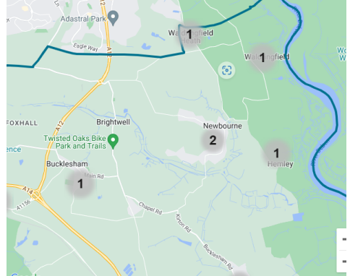

- To RECEIVE any Declarations of Disclosable pecuniary interest – None
- To APPROVE the minutes of the Parish Council meeting held on 4th October 2023
Minutes of October was not approved, and amendments were made to the minutes by the clerk. The clerk will amend these and then minutes they will l be approved along with the minutes of the November meeting in the December meeting.
- To CONSIDER Planning Applications for COMMENTS:

DC/21/1745/OUT – The Firs – Jackson Road -Erection of a detached dwelling – Access, Appearance, Layout, and scale.
- Highway issues with Jackson Road, the road is a private road in bad condition with more properties adding to the problems. If planning is permitted, they should have to repair Jackson Road where the property is.
- Further planning also to be discussed on land next to the Firs would mean 3 properties in a small cluster.
- The plans are large and would cover a large amount of the piece of land.
- The plans show a separate room, bathroom etc separate from the house which could possibly be used for holiday let in the future which would mean more traffic etc.
- The councillors voted and all voted against the planning due to size of the property.

DC/23/3790/OUT – Land adjacent to 29 Mill Road, Outline application for erection of two detached dwellings
- Shared access with 29 Mill Road.
- Proximity to the Firs
- Over development in a small area
- Close to the boundary to 29 Mill Road and Jackson Road.
- The councillors voted and all voted against the planning.

DC/23/0337/ARM Land east of 23a Mill Road – Outline application, erection of detached dwelling access layout alteration.
Not discussed as an alteration to planning

Some of the councillors have shown interest in a local plan. The clerk will get some information on this and will look to discuss in next month meeting.

Update on Previous planning applications.

DC/23/1629/FUL – The Steadings caravan park, Ipswich Road – Use of land for stationing 3 holiday lodges and change of use of existing building from reception to shop and café. Permitted

DC/23/1831/FUL – 22 Mill Road Construction of extensions and alternations
Permitted

DC/23/2033/DRC – Land to the east of 23a Mill Road, Newbourne – Discharge of conditions Nos 4 & 7 of DC/23/0337/ARM – Approval of reversed matters of DC/21/0347/OUT outline application (some matters reserved) Erection of detached dwelling condition 4 – Landscape plan provided and condition 7 - revised site plan indicating EV charging point and Brochure provided with further detailing.
Permitted

DC/23/2338/FUL – Construction of detached dwelling and garage (resubmission)
Land adjacent 23 Mill Road
Refused

DC/23/2378/AME – Non-Material amendment of DC/22/5012/FUL – 7 Ipswich Road Alternations part demolition plus front, rear and first floor extensions and new cart lodge to garden – change in window colour.
Permitted

DC/22/5012/FUL – Variations of condition 2 of planning permission DC/22/5012/FUL Alternations part demolition plus front, rear, and first floor extension and new cart lodge to garden. Dormers have been fitted to the front elevation of the cart lodge instead of rooflights. Store is to the left-hand side not the right. (Drawing 2280.10 to replace drawing 2280.03)
Permitted

DC/20/3449/FUL – Non-Material amendment – 23 Mill Road – Proposed holiday lets minor alternations of length to allow for additional plant/ store to be added.
Permitted

- An UPDATE regarding the Green Infrastructure – Nothing to report this month.
- An UPDATE regarding the Quiz on the 21st October– The quiz was a success and £570 was raised towards the play area, feedback was positive. We will look to hold another quiz in February.
- An UPDATE regarding the play area. Vandalism has been caused to the play area some wooden planks near the slide have been damaged we have contacted Adam Sterry to get rid of the damaged planks and make safe.
The clerk will investigate further funding for the play area.
- To DISCUSS the recent break ins in the village. Nourish Café and Katies Garden have recently been broken into. Just a reminder to be vigilant and report anything suspicious to the police.
- To RECEIVE and APPROVE the Financial Reports
No cheques to sign this month.

Bank Reconciliation October 2023

Cash in hand 01/10/2023 £21,364.53
Current £17,309.71
Saving £4054.82
ADD
£570.00 Quiz Money raised.
£1034.00 Cheque received from Newbourne Village Hall for half of the insurance.
£1800.00 Money received from East Suffolk council CIL payment.
SUBTRACT
Payments
Amount Cheque no Payee
09/10/2023 £2068.00 100491 Hiscox insurance
24/10/2023 £54.98 100493 Printer Ink
30/10/2023 £98.40 100492 Play area inspection
Cash in hand 31/10/2023 £23,547.15
B
Cash £0.00
Petty Cash £0.00
Community account £19,492.33
Saving £4054.82



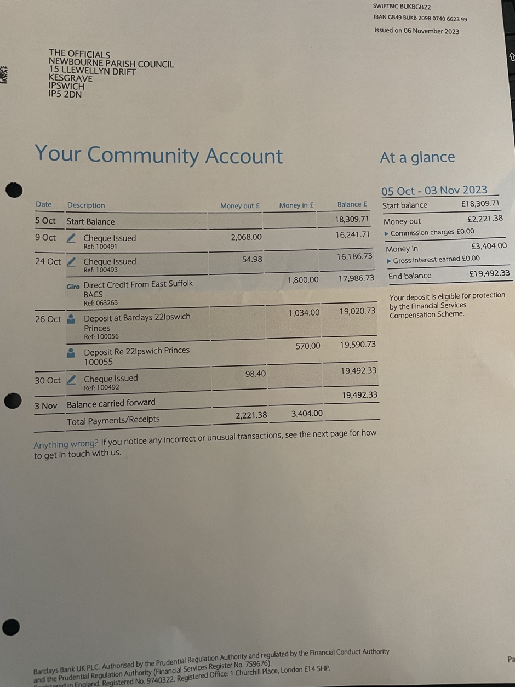

Update on Play area fundraising

£1000.00 Donated from Steadings Caravan park
£500.00 Donated from T H Moss & Son
£570.00 Raised from Quiz October 2023
£506.00 Raised from Village Day
£2415.00 CIL money received.
£698.00 CIL money received.
£710.00 Raised from Quiz February 2023
£1800.00 CIL Money received.

- Clerks Correspondence

Speed camera – Returned as faulty money should be returned next couple of weeks.

Over hanging trees – Trees at the bottom part of Woodbridge Road are overhanging very low across the road – The clerk has reported this to East Suffolk council 00427719

Narnia – Ipswich Road - Clerk spoke to planning officer and they advised planning should be submitted shortly if not then another visit will be carried out by the enforcement team.

Big Thank you to ESC Cllr Reeves who helped in the removal of the 15 fridges dumped in Newbourne. These have been successfully moved.

Cllr Gaussen has been a tree warden when he was a councillor where he previously lived and would be happy to be a Tree warden for Newbourne parish council.

Will send out planning guidelines what we should consider with planning applications.

Start considering 2024 events.
- Litter Pick
- Quiz
- Family day

Next meeting 4th December 2023

Metting closed by Chairman at 20:47

