November 2025 Supporting Documents
Invoices
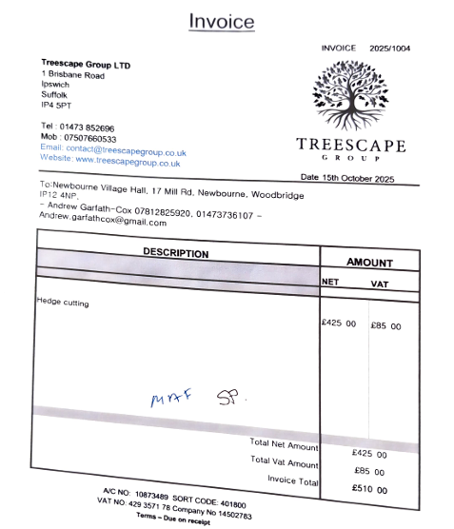
100559 – Treescape Group Ltd - £510

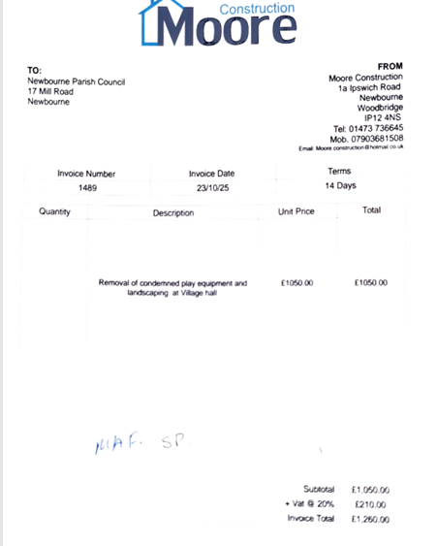
100560 – Moore Construction - £1,260

100561 – Clerk Receipts - £20.80
