Newbourne Parish Council Minutes 5th June 2023
Public Time – Nothing discussed in Public Time
Meeting opened by vice chairman Sue Pollard
- Apologies -Cllr Hadley and Cllr Gammons work commitments.
- Reports – No reports but Robert Ninnmey and Lee Reeves introduced themselves as the new East Suffolk Councillors. The are excited to get started and will try and attend as many meetings as possible.
- Declarations of disclosable pecuniary interest – None
- Minutes of Parish Council meeting 02/05/2023 – Approved by Cllr Pollard and Cllr Frost.
- Clerks Correspondence - The clerk has shared Gary Grainger email resigning from the Parish council as Chair and councillor.
Laura Naunton
Newbourne Parish Council
It is with a heavy heart that I need to resign from the parish council with immediate effect. Both as chair and councillor. I have enjoyed every minute of it, and it has been a pleasure to work with the other councillors. Unfortunately work commitments are making it incredibly difficult to attend meetings and I cannot give it my all, so I need to move aside and let someone with ore time take the reins.
Good Luck and all the best for the future.
Gary Grainger
13/05/2023
- Election of New chairman – Cllr Frost and Cllr Scott have nominated Cllr Garfath-Cox to be chairman and Cllr Garfath-Cox has agreed. The Parish council voted, and everyone voted that Cllr Garfath-Cox would be the chairman. Cllr Garfath-Cox will attend a Councillor/ Chairman course.

Cllr Pollard stood down from acting as vice chairman and Chairman Cllr Garfath- Cox stepped up and continued the meeting.

- Planning
DC/23/1831/FUL 22 Mill Road Construction of extensions and Alternations – All agreed no issues with the planning.
DC/23/0337/ARM Land to 23a Mill Road. Discharge of conditions Nos 4 &7 of DC/23/0337/ARM. Erection of detached dwelling, condition 4 landscape plan provided and condition 7 revised site plan indicating EV charging point and brochure – All agreed no issues with changes.
- Update from coronation –
REPORT TO PARISH COUNCIL ON NEWBOURNE CORONATION CELEBRATION 8th MAY 2023
The event took place from 1.00pm to 5.00pm at the Village Hall and green on 8th May. The weather was good. Probably not as many attended as the previous year but still good attendance. Say 200 people. Attendees were locals to Newbourne and neighbouring villages, family and friends and holiday makers from the campsites.
The previous years Jubilee event did not raise money (conscious decision by the Parish Council) and came in at a net loss of £732.29. This year’s event set out to raise funds and returned £402 as follows:
Cash taken | ££:PP
Sale of raffle tickets | 550.00
Bar sales | 883.00
Throw the wellie | 32.00
Donation | 30.00
Total funds generated | 1495.00
Costs
Band | 280.00
Bar license | 21.00
Sweets | 60.00
Bar | 732.00
Total costs | 1093.00
Funds raised | 402.00

A few observations:
Once again, the raffle did well. The bar held its own and covered its costs. Remaining bar stock has been sold and sales included above.
Sweets for the children is expensive and we don’t make any sort of return on this.
The pizza van only took cash and his prices seemed high. Not sure he had a good day!
As a result, cash returned to the Parish Council for Laura the Parish Clerk to bank:

Cash returned to the Parish Council | ££:PP
Funds raised from the day | 402.00
Bar fund from previous year | 104.00
 | 506.00

The true cost of the event if we had to pay for all of the volunteer time, goodwill and donations would have been around £25,000.
The event consisted of:
- Bits N Pieces live band
- Kids competitions (including the make a sceptre)
- A vintage tractor and car
- Tug of war competition
- Raffle with prizes donated by local businesses and PC friends.
- A picnic
- Pop up bar
- Wood fired Pizza’s
- Luxury Ice cream Van
- Bracelets making
- Planting a tree (thank you Andrew)
A big thank you to the Parish Councillors and helpers on the day and in the run up to the event. It is a massive undertaking to organise and source all the suppliers needed to make it a success.
Feedback from people who attended the event was good and they are looking forward to future events!
A massive Thank you to Tim Moss from T H Moss and Sons LTD for their very kind donation of £500.00 towards the new play area.
9.Future events Quiz night and possibly a New year’s eve party to be discussed at future meetings
10.Finance
- Bank statements
- Cheques for June 2023
- Cheques 2022 -2023
- Bank reconciliation 2022-2023
- Audit documents

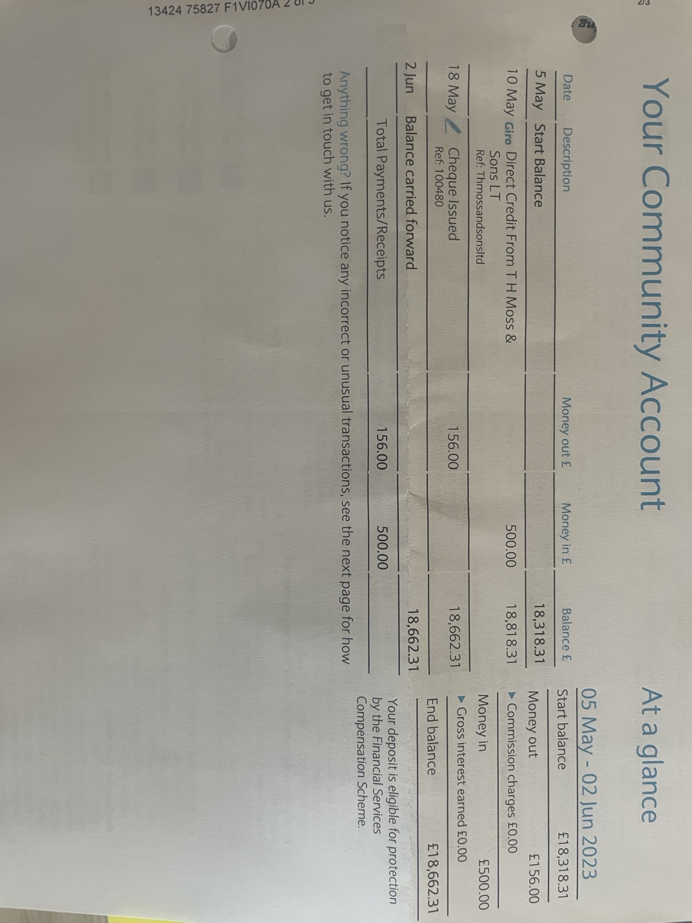

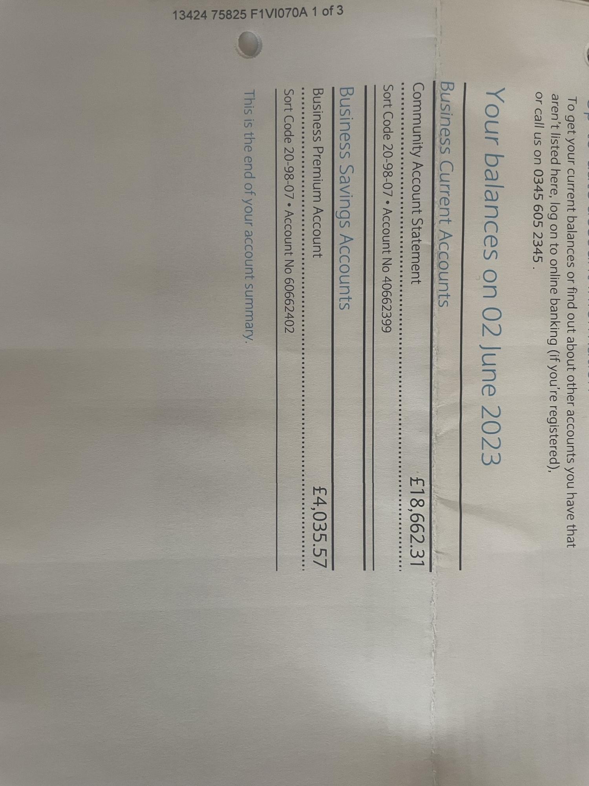

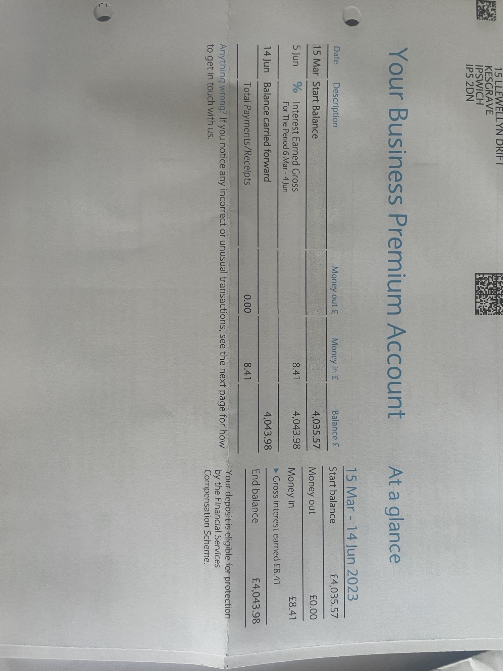

Cheques
100482 - £123.40 HMRC
100483 - £494.10 L NAUNTON – Clerks wages ending May

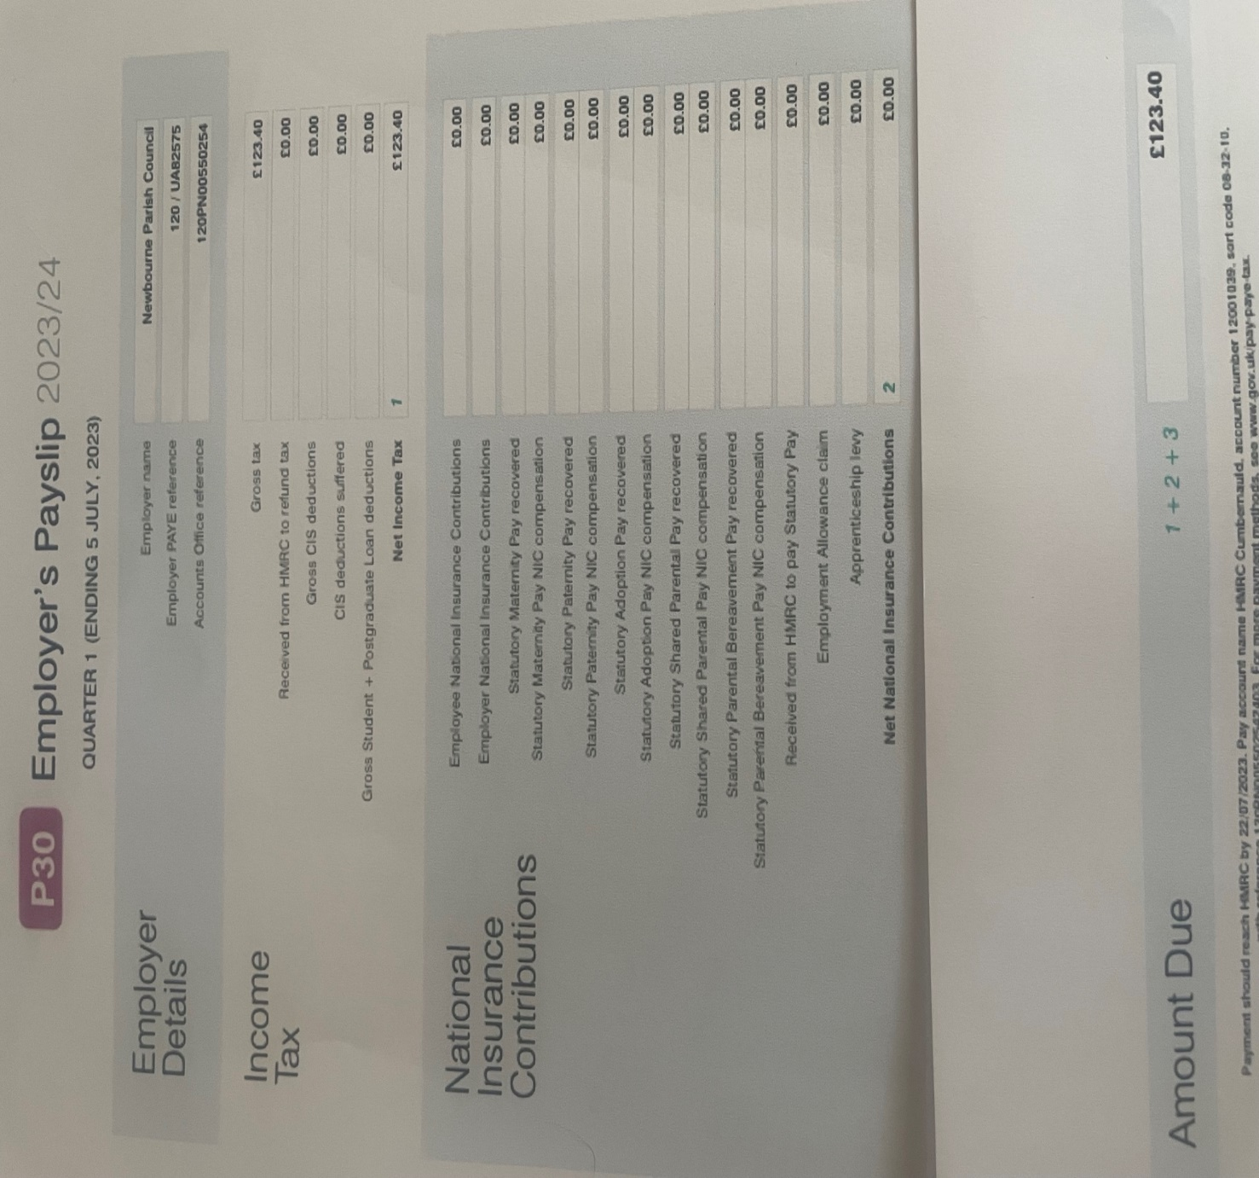

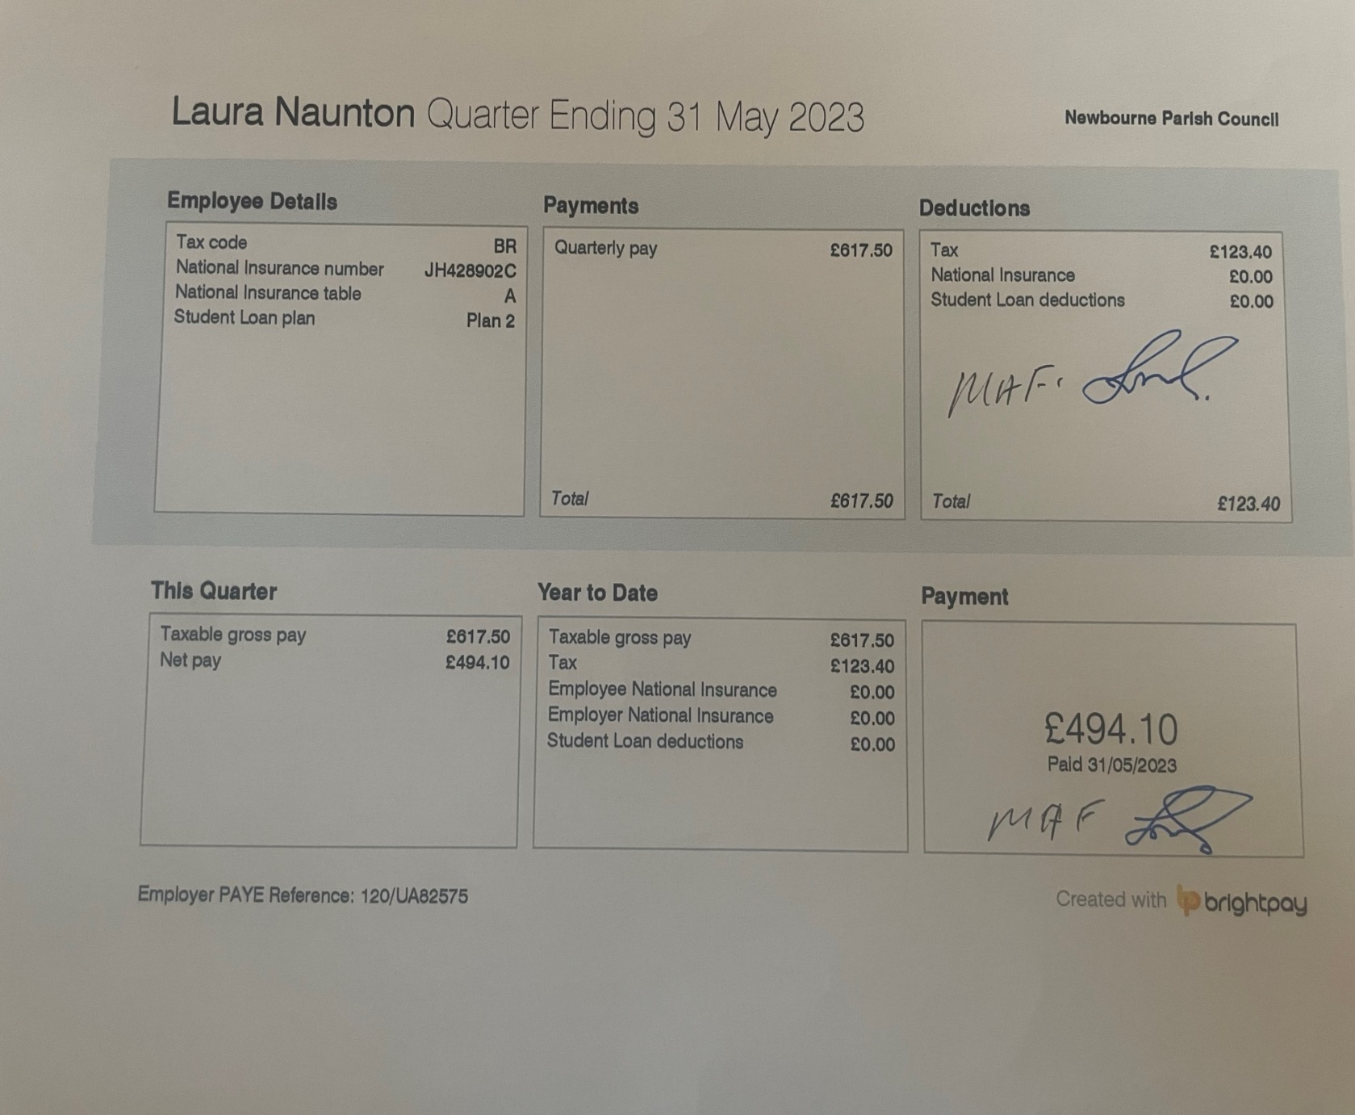
Audit 2022 -2023
- Balance Brought Forward
Community £13,621.14
Saving £4026.78
= £17,647.92
- Precept
£6000.00

- Receipts
0.30p interest on saving account
£1.24p interest on saving account
£698.05 CIL
£2.25 Interest on saving account.
£926.75 village hall money
£710.00 Money in from Quiz
£5.00 interest on saving account.
= £2343.59

- Staff Costs
£113.40 HMRC
£123.40 HMRC
£123.60 HMRC
£123.40 HMRC
£123.60 HMRC
£494.10 wage
£493.90 wage
£494.10 wage
£493.90 wage
= £2583.40

- Loans
£0.00

- All payments

DATE ISSUED CHQ No PAYEE AMOUNT CASHED
100450 SALC PAYROLL £22.80 26/04/2022
04/04/2022 100451 CAS WEBSITE £60.00 29/04/2022
04/04/2022 100452 L CULF DEFIB BOX £567.00 07/04/2022
04/04/2022 100453 SALC MEMEBERSHIP £144.94 21/06/2022
09/04/2022 100454 OIL FOR PLAYAREA £52.50 11/05/2022
09/04/2022 100455 DE FIB BATTERIES £40.00 12/05/2022
09/05/2022 100456 DECORATIONS £486.41 17/05/2022
06/06/2022 100457 EAST COAST £245.00 14/06/2022
06/06/2022 100458 OIL FOR PLAYAREA £52.50 08/06/2022
06/06/2022 100459 HMRC £123.40 19/07/2022
06/06/2022 100460 WAGES £494.10 07/06/2022
06/06/2022 100461 PLAYAREA £120.00 15/06/2022
06/06/2022 100462 DISHWASHER £1884.00 14/06/2022
04/07/2022 100463 ZIP WIRE £1302.00 15/07/2022
03/10/2022 100464 PLAYAREA £92.40 11/10/2022
03/10/2022 100465 INSURANCE £1853.51 13/10/2022
03/10/2022 100466 HMRC £123.60 11/10/2022
03/10/2022 100467 WAGES £493.90 10/10/2022
03/10/2022 100468 SALC £22.80 19/10/2022
07/11/2022 100469 DEFIB £975.00 22/11/2022
05/12/2022 100470 HMRC £123.40 01/02/2023
05/12/2022 100471 WAGES £494.10 07/12/2022
05/12/2022 100472 SPEED CAM £1800.00 17/01/2023
06/02/2023 100473 CAS £60.00 24/02/2023
06/03/2023 100474 HMRC £123.60 23/03/2023
06/03/2023 100475 WAGES £493.90 08/03/2023
06/03/2023 100476 TRACKER/INK £71.19 08/03/2023
06/03/2023 100477 GRASS £180.00 21/03/2023
= £10,032.40

Bank Reconciliation April 2022

Cash in hand 01/04/2022 £17,647.92
Community £13,621,14
Saving £4026.78
ADD
Receipts
£6000.00 Precept £6000.00

Total £23,647.92

SUBTRACT
Payments
Amount Cheq no Payee Cashed
£60.00 100451 CAS Website 29/04/2022
£567.00 100452 L Culf Defib Box 07/04/2022
£113.40 100448 HMRC 13/04/2022
£22.80 100450 SALC Inv 26/04/2022
= £763.20

Cash in hand 01/05/2022 £22,884.72

B
Cash £0.00
Petty Cash £0.00
Community account £18,857.94
Saving £4026.78
£22,884.72

Bank Reconciliation May 2022

Cash in hand 01/04/2022 £22,884.72
Community £18,857.94
Saving £4026.78
ADD
Receipts
£0.00
Total £22,884.72

SUBTRACT
Payments
Amount Cheq no Payee Cashed
£52.50 100454 Playground oil 11/05/2022
£40.00 100455 defib batteries 12/5/2022
£486.41 100456 jubilee decorations 17/05/2022
= £578.91
Cash in hand 01/05/2022 £22,305.81

B
Cash £0.00
Petty Cash £0.00
Community account £18,279.03
Saving £4026.78
£22,305.81

Bank Reconciliation June 2022

Cash in hand 01/06/2022 £22,305.81
Community £18,279.03
Saving £4026.78
ADD
Receipts
£0.30 interest on saving account
Total £22,306.11

SUBTRACT
Payments
Amount Cheq no Payee Cashed
£494.10 100460 Wages 07/06/2022
£52.50 100458 playground oil 08/06/2022
£1884.00 100462 Dishwasher 14/06/2022
£245.00 100457 Jubilee event 15/06/2022
£120.00 100461 Playarea 15/06/2022
£144.94 100453 SALC membership 21/06/2022
= £2940.54
Cash in hand 01/06/2022 £19,365.57

B
Cash £0.00
Petty Cash £0.00
Community account £15,338.49
Saving £4027.08
£19,365.57

Bank Reconciliation July 2022

Cash in hand 01/07/2022 £19,365.57
Community £15,338.49
Saving £4027.08
ADD

Total £19,365.57

SUBTRACT
Payments
Amount Cheq no Payee Cashed
£1302.00 100463 zipwire 15/07/2022
£123.40 100459 HMRC 19/07/2022
= £1425.40
Cash in hand 01/07/2022 £17,940.17

B
Cash £0.00
Petty Cash £0.00
Community account £13,913.09
Saving £4027.08
£17,940.17

Bank Reconciliation August 2022

Cash in hand 01/08/2022 £17,940.17
Community £13,913.09
Saving £4027.08
ADD

Total £17,490.17

SUBTRACT
Payments
Amount Cheq no Payee Cashed

Cash in hand 01/08/2022 £17,940.17

B
Cash £0.00
Petty Cash £0.00
Community account £13,913.09
Saving £4027.08
£17,940.17

Bank Reconciliation September 2022

Cash in hand 01/09/2022 £17,940.17
Community £13,913.09
Saving £4027.08
ADD
£1.24 interest on savings account

Total £17,941.41

SUBTRACT
Payments
Amount Cheq no Payee Cashed

Cash in hand 01/09/2022 £17,941.41

B
Cash £0.00
Petty Cash £0.00
Community account £13,913.09
Saving £4028.32
£17,941.41

Bank Reconciliation October 2022

Cash in hand 01/10/2022 £17,941.41
Community £13,913.09
Saving £4028.32
ADD
£698.05 CIL payment in from ESC
Total £18,639.46

SUBTRACT
Payments
Amount Cheq no Payee Cashed
£493.90 100467 WAGES 10/10/2022
£92.40 100464 PLAYGROUND 11/10/2022
£123.60 100466 HMRC 11/10/2022
£1853.51 100465 INSURANCE 13/10/2022
£22.80 100468 SALC 19/10/2022
= £2586.21

Cash in hand 01/10/2022 £16,053.25

B
Cash £0.00
Petty Cash £0.00
Community account £12,024.93
Saving £4028.32
£16,053.25

Bank Reconciliation November 2022

Cash in hand 01/11/2022 £16,053.25
Community £12,024.93
Saving £4028.32
ADD
Total £16,053.25

SUBTRACT
Payments
Amount Cheq no Payee Cashed
£975.00 100469 defib 22/11/2022

Cash in hand 01/11/2022 £15,078.25

B
Cash £0.00
Petty Cash £0.00
Community account £11,049.93
Saving £4028.32
£15,078.25

Bank Reconciliation December 2022

Cash in hand 01/12/2022 £15,078.25
Community £11,049.93
Saving £4028.32
ADD
Total £15,078.25

SUBTRACT
Payments
Amount Cheq no Payee Cashed
£494.10 100471 Wages 07/12/2022

Cash in hand 01/12/2022 £14,584.15

B
Cash £0.00
Petty Cash £0.00
Community account £10,555.83
Saving £4028.32
£14,584.15

Bank Reconciliation January 2023

Cash in hand 01/01/2023 £14,584.15
Community £10,555.83
Saving £4028.32
ADD
£2.25 interest on saving account.
Total £14,586.40

SUBTRACT
Payments
Amount Cheq no Payee Cashed
£1800.00 100472 speed camera 17/01/2023

Cash in hand 01/02/2023 £12,786.40

B
Cash £0.00
Petty Cash £0.00
Community account £8755.83
Saving £4030.57
£12,786.40

Bank Reconciliation February 2023

Cash in hand 01/02/2023 £12,786.40
Community £8755.83
Saving £4030.57
ADD
£926.75 Money in from Village Hall
£710.00 Money in from Quiz

Total £14,423.15

SUBTRACT
Payments
Amount Cheq no Payee Cashed
£123.40 1000470 HMRC 01/02/2023
£60.00 100473 CAS Website 24/02/2023

Cash in hand 01/03/2023 £14,239.75

B
Cash £0.00
Petty Cash £0.00
Community account £10,209.18
Saving £4030.57
£14,239.75

Bank Reconciliation March 2023

Cash in hand 01/03/2023 £14,239.75
Community £10,209.18
Saving £4030.57
ADD
£5.00 INTEREST ON SAVING ACCOUNT 06/03/2023
Total £14,244.75

SUBTRACT
Payments
Amount Cheq no Payee Cashed
£71.19 100476 Tracker+ink 08/03/2023
£493.90 100475 wages 08/03/2023
£180.00 100477 Grass cutting 21/03/2023
£123.60 100474 HMRC 23/03/2023
= £868.69

Cash in hand 01/04/2023 £13,376.06

B
Cash £0.00
Petty Cash £0.00
Community account £9340.49
Saving £4035.57
£13,376.06
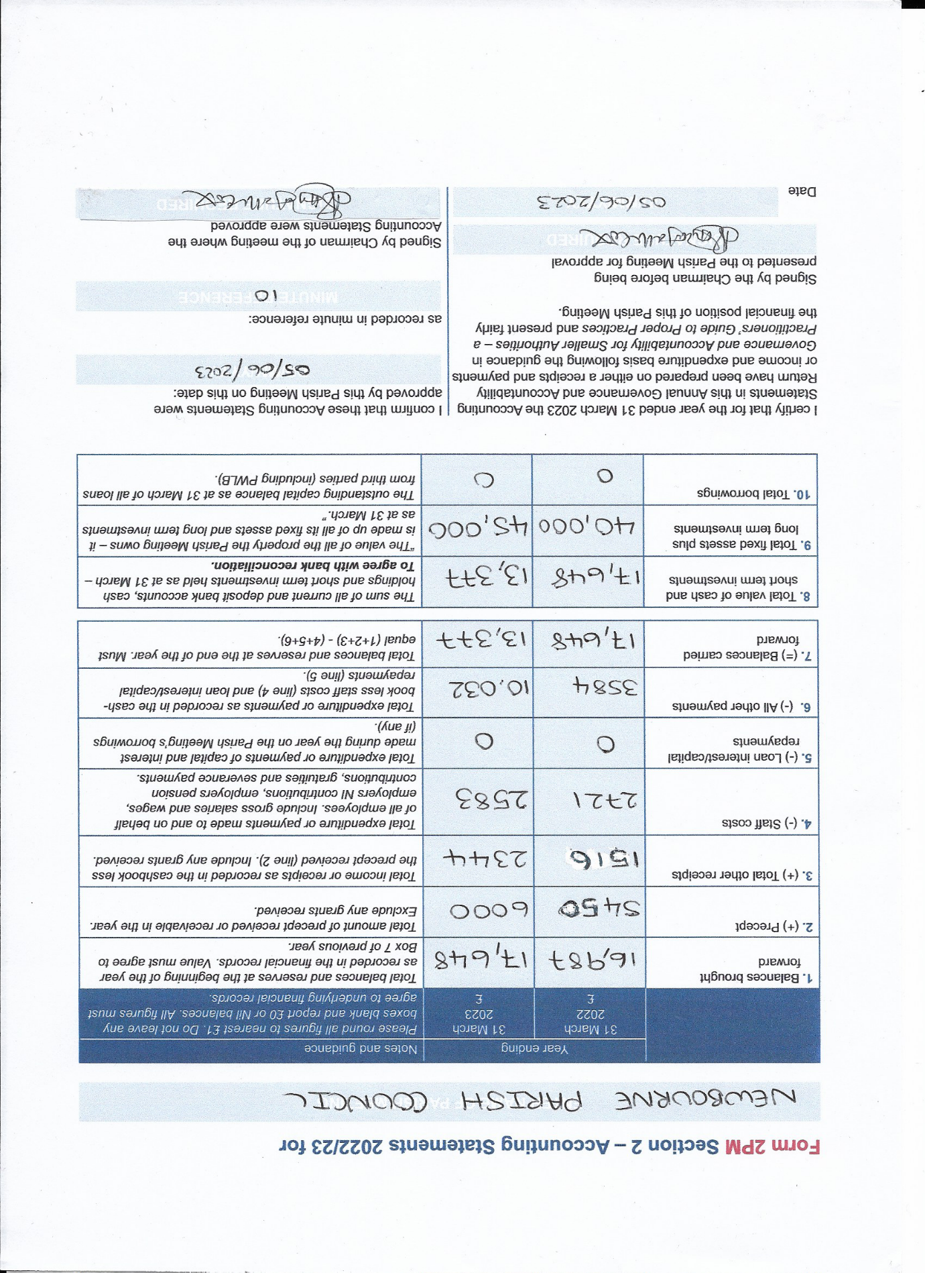

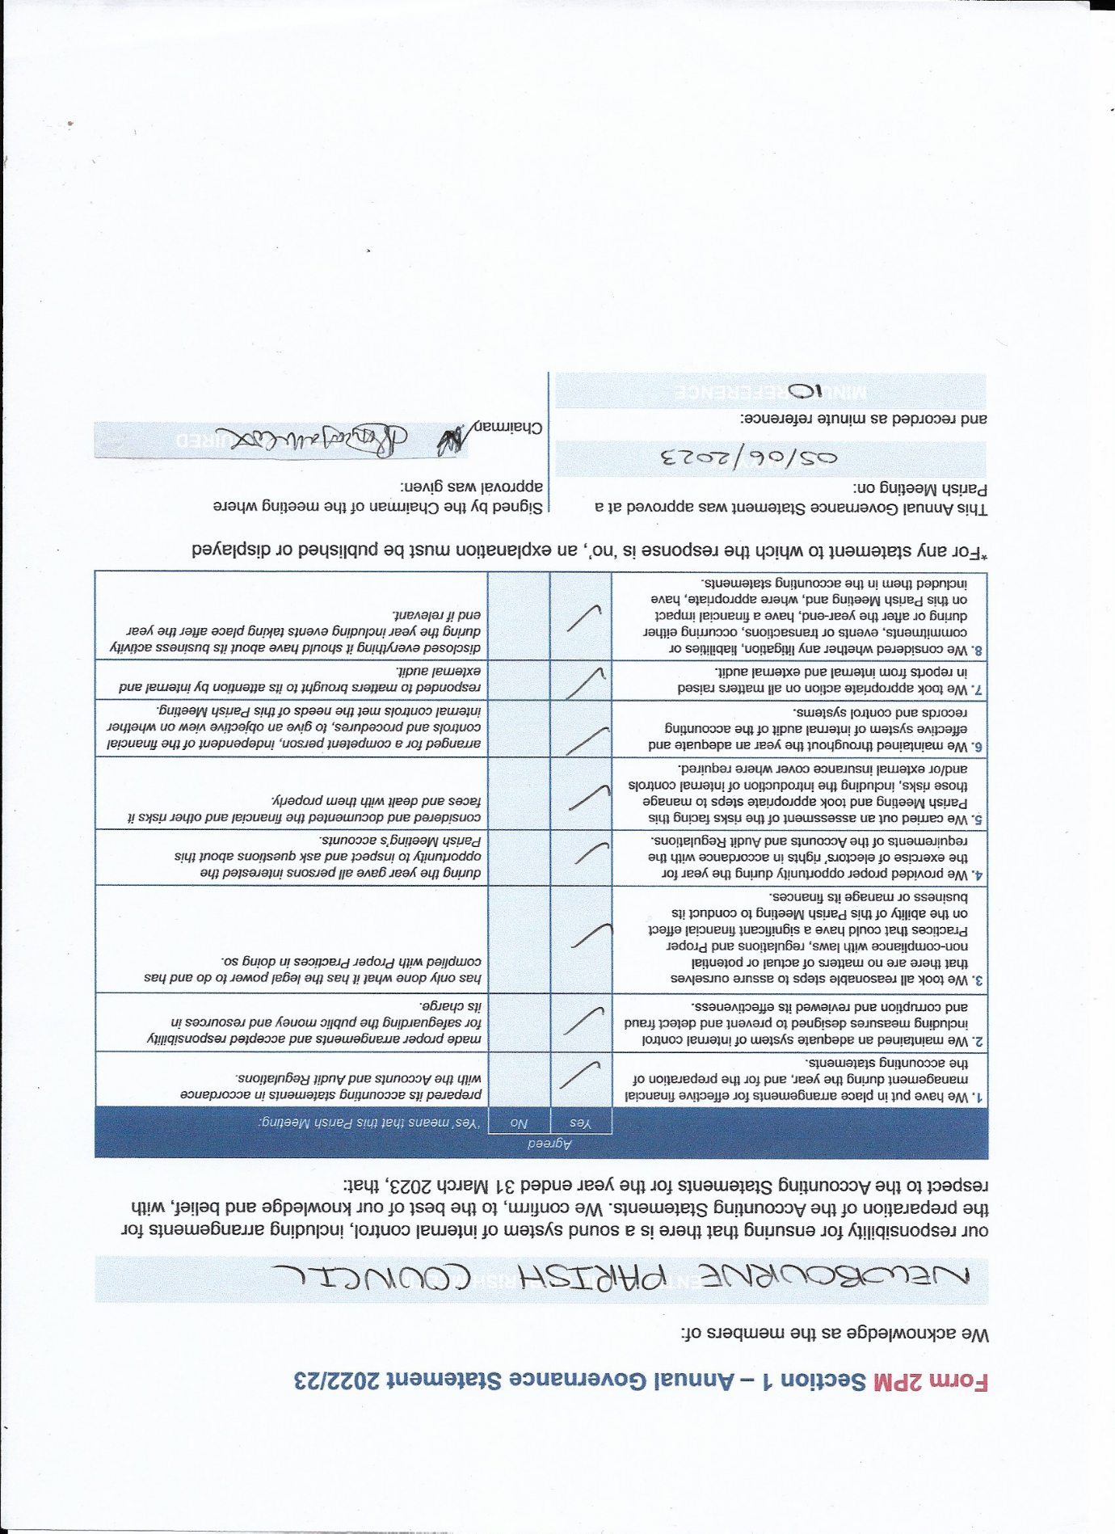

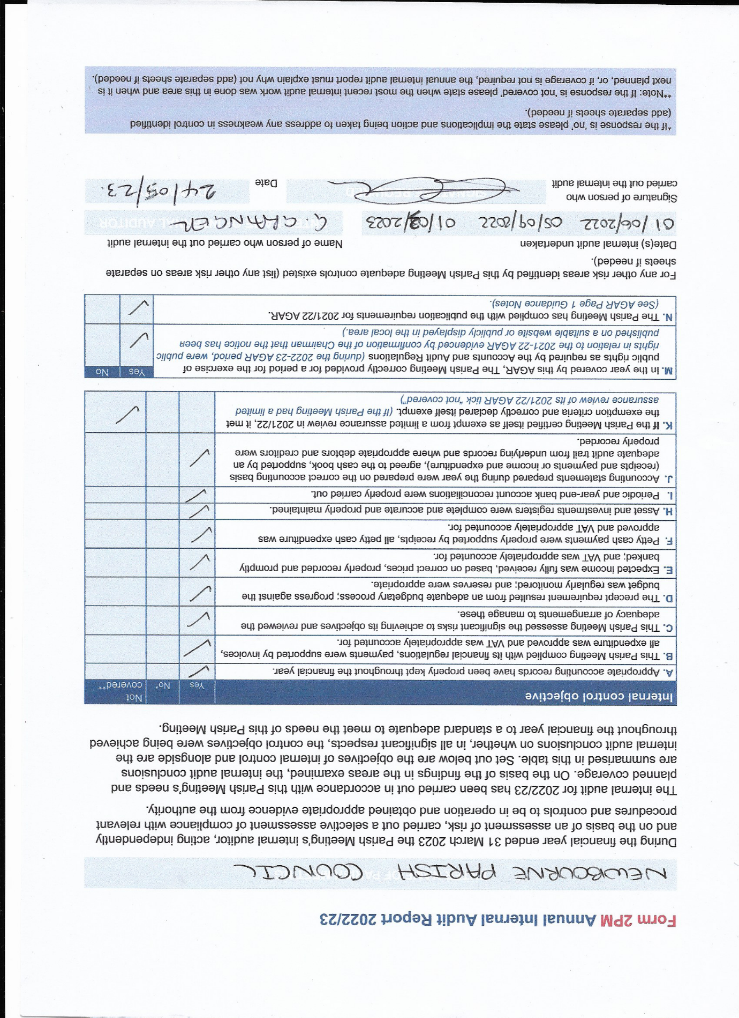

Next meeting 03/07/2023

