Newbourne Parish Council Minutes
03/07/2023
Public Time
We were lucky enough to have Betsy Reid and Jane Hall join us to talk and answer questions about the Green Infrastructure.
Adaptive Action Planning for Climate Change and Green Infrastructure.

A cluster of parishes west of the tidal Deben in the AONB and adjacent areas, with their linked habitat and shared concerns, is holding a one-day community planning workshop at 9am - 4.30pm on Wednesday 30th August 2023. The aim is to engage with key stakeholders to develop ideas for coordinated and targeted action to improve climate adaptation and green infrastructure for the parishes involved, Brightwell (with Foxhall and Purdis Farm), Hemley, Kesgrave, Martlesham, Newbourne, Rushmere St Andrew, Woodbridge, Melton and Waldringfield.

The workshop has been organized by the community group Greener Waldringfield and will be delivered by the Woodbridge Climate Action Centre. It is supported by the East Suffolk Council Greenprint Forum and participating parishes have also contributed to the funding. Key stakeholders are being approached to ensure well-informed input and robust and deliverable outcomes. Those invited include farmers, individual and representative conservationists as well as parish, district and county councilors and officials.

We are fortunate to have a very experienced facilitator in Peter Hobson, Professor of Biodiversity, Conservation and Sustainability at Writtle University. A major focus will be on natural connectivity and climate adaptation across the area. This will be at landscape scale, spanning protected land eg existing SSSIs, urban areas, public commons and greens and the farming hinterland – and spreading into private spaces.

The hope is that this will lead to a nature recovery strategy for the parish councils covering this and neighboring areas that will dovetail with the higher county level plans for biodiversity net gain as that also emerges.

▪ Wednesday 30th August, 2023 from 8.45 for 9.00 a.m. until 4.30 p.m.
▪ Waldringfield Village Hall – parking on site
▪ Lunch provided by Nourish café Newbourne (£5.00 cash per head, payable on the day or in advance)

We are fortunate enough that Terence Gaussen who lives in the village is already involved in The Green Infrastructure and Cllr Kwini Lusher is happy to be involved also. Together they will attend the meeting on the 30th August to represent Newbourne and we look forward to hearing all about the meeting in the September parish meeting.

We have been asked for a voluntary Contribution to help the funding for Green Infrastructure which will be discussed in the meeting.

If you would like more information or to be involved please contact Betsy on info@greenerwaldringfield.org
betsyr@talk21.com

It is exciting that Newbourne can be involved along with other parishes to help make a difference.

Jo from Steadings came to talk about his planning application DC/23/1629/FUL. They have recently purchased steading and they are making some improvements. Their planning application is for 3 stationary holiday lodges and change of use of existing building from reception to café and shop to be used by the site users. Jo came to keep everyone up to date with their plans and to advise them they are reducing the amount of touring caravans so would be less traffic on the roads and they are looking for more stationary caravans. If anyone wants to go and look what Steading are doing, they just need to pop in and Jo will show you around.

Meeting opened 20:00

- Apologies – None
- Reports
June 2023 Parish Report East Suffolk Council -Orwell & Villages
Update Mike Ninnmey and Lee Reeves- District councillors for Orwell & Villages Following a very steep learning curve and many training sessions for our respective responsibilities most new councillor training has now been completed. For your information
Mike Ninnmey has been appointed to the East Suffolk Council Cabinet with responsibility for Community Health. He is also a member of the Planning Committee (South) and the Felixstowe Peninsula Community Partnership. Member of Sparsity (Rural Communities).
Lee Reeves is a member of the Licensing Committee, substitute member on Audit and Governance Committee and Scrutiny Committee, member of Southwold Harbour Management Board and member of Felixstowe Peninsula Community Partnership. Appointed as Armed Forces Champion for East Suffolk Council and to Merchant Navy Welfare Board. We both intend to attend as many meetings of our parish councils as we can given that there can be several that clash at the beginning of each month. In the meantime, if parish councillors need to contact either of us, please feel free to do so.
Cllr Mike Ninnmey: Home tel no 01394 677210 Mobile: 07823 372503 E-mail: mike.ninnmey@eastsuffolk.gov.uk
Cllr Lee Reeves: Home tel no 01394 284506 Mobile 07823 372501 E-mail: lee.reeves@eastsuffolk.gov.uk
Helping families access affordable school uniform Community groups, organisations and town and parish councils are invited to apply for funding to help provide school uniform to East Suffolk families in need. The East Suffolk Uniform Bank grant scheme provides funding for community groups to open a new uniform bank or expand an existing uniform bank. Once operational, donations of new or pre-loved good-quality uniform, sportswear and school equipment can be made to the banks, which will then be made available to families who may be struggling to afford uniform. Cllr Katie Graham, East Suffolk’s cabinet member for Communities, Leisure and Tourism said: “School uniforms are a necessity but can be expensive, and many families, particularly in rural areas, struggle to purchase affordable school uniforms and school equipment. Uniform banks step in to provide good quality uniform to those in need and are also a valuable resource for those looking to do their bit to address the global problem of textile over-production and waste. Currently, an estimated 1.4 million items of school uniforms are discarded every year.” Applications are welcome from community and voluntary groups, organisations and town and parish councils. Dependent on capacity and need, successful applicants may be encouraged to also offer interview clothing and prom wear to assist families with older children. Grants are available for up to £3,000 and applications close on 28 July. For further details, please contact gemma.fraser@eastsuffolk.gov.uk East Suffolk Council understands the pressures faced by many people today and is working closely with partners and stakeholders to ensure support is available to help ease the squeeze for households in East Suffolk: www.eastsuffolk.gov.uk/squeeze Daffodil Planting Campaign Blooms Success Tens of thousands of daffodil bulbs are set to sprout across East Suffolk next spring after being distributed to communities as part of an annual planting programme. East Suffolk Council received 120 applications from voluntary and community groups to join the scheme and receive a free bunch of around 500 bulbs to plant this winter. An East Suffolk Blooms selection panel met to decide where the available 82 sets of narcissus bulbs would eventually find a home. GLI Cllr Rachel Smith-Lyte, East Suffolk Council’s cabinet member for Environment, said: “We had such a promisingly high number of applications from all over the district – with some groups and organisations so keen that they requested up to five sets. In the end, we chose 82 groups to each receive a set and help boost biodiversity while spreading colour through their communities. “I can’t wait to see these vibrant pollinators flowering across East Suffolk next spring and would encourage groups and individuals to continue to plant in their areas, even if they didn’t get the opportunity for free bulbs this year.” East Suffolk Council Environmental Commitment The council’s ambition to become a carbon neutral council, in terms of our assets and operations, and to reach carbon neutrality by 2030, also includes trialling alternatives to glyphosate sprays. No sprays or pesticides are used in council-owned cemeteries and closed churchyards, unless as a final resort to remove invasive species, and glyphosate spraying on East Suffolk Council land has reduced by 45%. East Suffolk Council’s annual ‘Pardon the weeds, we’re feeding the bees’ campaign has, since 2020, allowed grass and wildflowers to grow in more than 100 spaces in order to help wildlife thrive.
Young people in Kelsale and Yoxford offered free transport to First Light Young people living in the Kelsale and Yoxford ward were invited to take advantage of free bus travel to the First Light Festival. Supported by GLI Cllr Julia Ewart, East Suffolk Council’s ward member for Kelsale and Yoxford and working with Halesworth Area Community Transport, two minibuses were available to transport young people between 13 and 17 years old to the free festival in Lowestoft. Cllr Ewart said: “Working with our Communities Team, we’ve arranged this free transport to ensure that young people in rural communities have an opportunity to experience the magic of the First Light Festival. It will ensure youngsters can safely travel to and from the event and enjoy the rich creative experience on offer. I’m thrilled that we have been able to arrange this and thank all those who have made it possible.”
#ShakeItOut The #ShakeItOut campaign has been launched by the Suffolk Waste Partnership to encourage households in Suffolk to help improve recycling rates across the county by making sure black bin bags and other plastic sacks are not thrown in with recyclable materials. The Partnership, made up of the county, district and borough councils in Suffolk, says more than a quarter (26%) of the materials in Suffolk’s recycling bins in 2022/23 were not able to be processed as they were spoiled. Items that contributed to spoiled recycling collections included:
• Materials that were not clean and dry, or contained food and drink residue
• Rubbish sacks or plastic bags containing recycling
• Non-recyclable items, such as nappies and food waste Plastic bags and rubbish sacks are a particular problem – recycling handlers can’t see what’s inside them and they are often full of rubbish or other non-recyclable items.
For more information, visit: www.suffolkrecycling.org.uk/shake-it-out UK Shared Prosperity Fund East Suffolk Council has been allocated £2.75m to invest across two and a half years (2022/23 - 24/25) in initiatives that will address inequality and contribute to levelling up. This is in addition to the £3.75m Multiply element of the UKSPF, which Suffolk County Council can apply for to support adult numeracy across the county. The funding can only be unlocked upon submission of an Investment Plan which is signed off by both the council and the government. To develop the East Suffolk Investment Plan, the council gathered stakeholder input through a public survey to invite local stakeholders to give their views on what are the most pressing local challenges that need to be addressed, and the projects and initiatives that could best address them. This input was combined with data about the local area and existing funding, the Government criteria and wider strategic priorities to inform the development of the East Suffolk investment plan. East Suffolk Council received official approval from the Department for Levelling Up, Housing and Communities for our UKSPF Investment Plan on 5 December 2022. East Suffolk Council have launched a series of grant schemes as part of our eight key programmes, including: Events, Art and Culture Grant; East Suffolk Pantries Grant and the Move to Net Zero Grant. There are multiple rounds of applications for these grants; for example, the East Suffolk Events, Arts and Culture Grant scheme which is designed to increase footfall and visitor numbers to our high streets and diversify town centre uses. East Suffolk Council are particularly keen to see activities that build on or further develop the East Suffolk Town Celebrations concept and building and enhancing on existing events or activities but focusing on the town centre. This could be through photography, poetry and storytelling, gaming, theatre and education. The fund is available to community and voluntary groups, placed based associations, charities, social enterprises, community interest company’s, town and parish councils and businesses associated with the culture and arts sector who are located within the geographical area of East Suffolk. Following a successful first round, the second round of funding applications is now open. Grants of between £5,000 - £10,000 per application are available and applications close on 28th July. For more information, visit: www.eastsuffolk.gov.uk/business/uk-shared-prosperity-fund For the most up to date information regarding East Suffolk Council, please visit: www.eastsuffolk.gov.uk
- Declarations of disclosable pecuniary interest – None
- Minutes of Parish meeting 05/06/2023 approved by Cllr Pollard & Cllr Garfath-Cox
- Planning
DC/23/1629/FUL Use of land for stationing 3 holiday lodges and change of use of existing building from reception to shop and cafe Land At The Steadings Caravan Park Ipswich Road Newbourne Woodbridge Suffolk IP12 4NS

The planning application was discussed it was agreed less caravans in and out of the village would be good. All councillors agreed with the planning application.
DC/23/2338/FUL Construction of detached dwelling and garage (resubmission) Land Adjacent 23 Mill Road Newbourne Suffolk IP12 4NP

The planning was discussed, and the comments discussed was it’s an infill property, which will cause more traffic in the village and the issues of inconsistences of planning in the village was considered. A Vote was taken 2 Cllr’s against, and 4 Cllr’s supported the planning.

- Play area.
Fundraising continues for the play area.
Play area inspection will take place August or September.

- Future Events – Discussed and agreed we will be looking to hold another quiz on the 21st October 2023. Clerk will check with Keith Borroughs quiz master that he was available that date and then we can start to arrange.
- New councillors – As we have lost a few councillors and now have 3 spaces. It was discussed that we would produce a leaflet and leaflet drop around the village to try and get some interest in recruiting some new councillors.
- Finance

It was discussed and agreed to contribute £50.00 towards The Green infrastructure Group

New cheque issued for Newbourne Church roof as the previous one was incorrect payee.
100484 Newbourne PCC £200.00

Bank statements



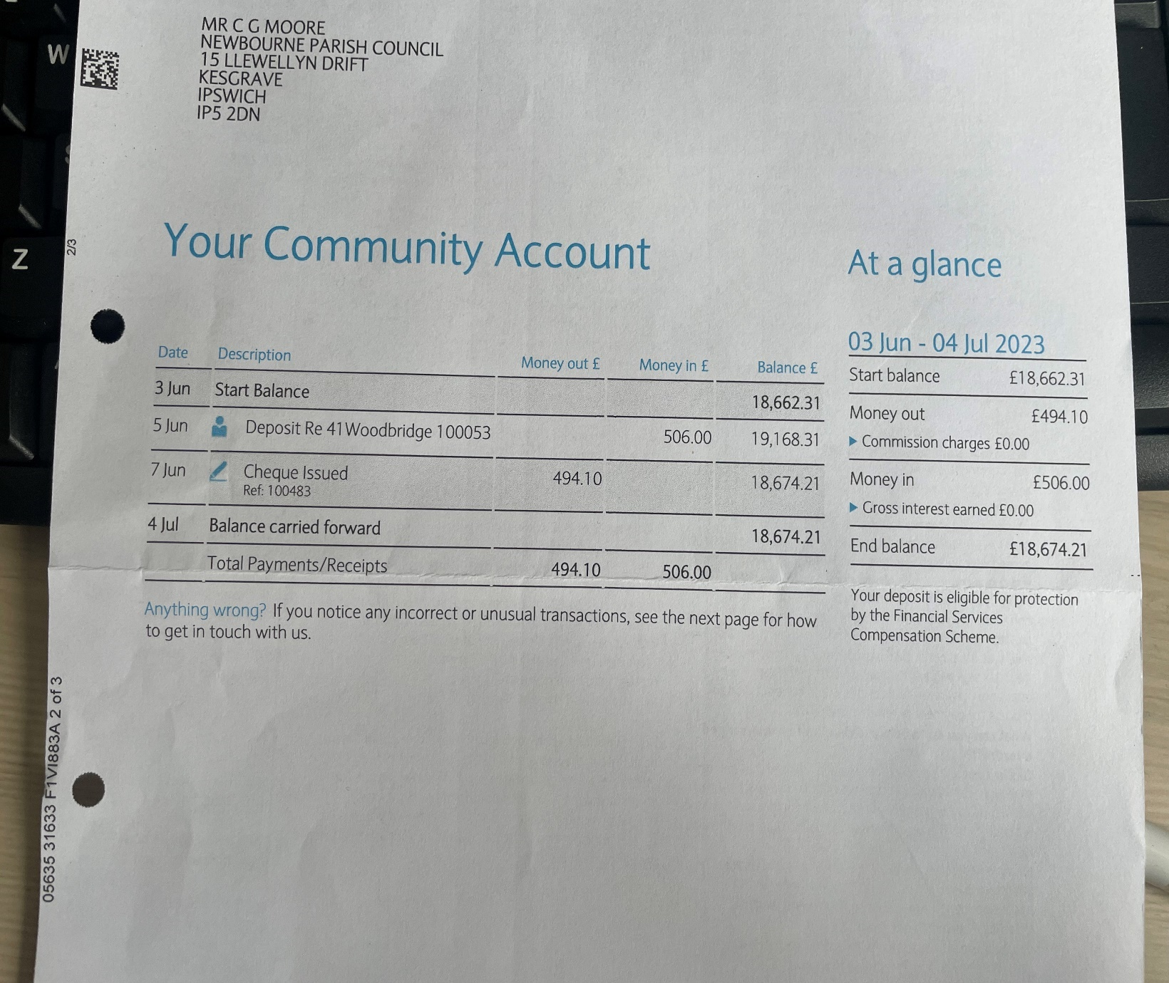

Meeting Closed 20:40
Next Meeting 07/08/2023

