Minutes of Newbourne Parish Council held on 06/02/2023.

Public Time
- Parking on the verge (The Street) next to the bus shelter opposite The Fox Inn. Number of vehicles spotted parking on the verge again this is happening even if space in the car parks. Was agreed previously that two large plant pots would be purchased and placed on the verge to stop the parked issue as this would only get worse in the summer when the pub is busy. Also, the bus shelter needs some TLC will put this on agenda for next month.
- Village hall committee raised that due to the Kings coronation in May with bookings and bank holidays the date may have to be changed otherwise would be more middle of the month than the start.

- To RECEIVE apologies for absence Cllr Lusher, Cllr Gammons, Cllr Hadley, ESC Mulcahy and ESC Kerry & ESC Richardson
- To RECEIVE Information and reports
Information from ESC Michael Richardson and report from ESC Mulcahy

The Coronation of King Charles III will take place at Westminster Abbey on Saturday 6th May 2023:

https://emea01.safelinks.protection.outlook.com/?url=https%3A%2F%2Fwww.royal.uk%2Fcoronation-his-majesty-king&data=05%7C01%7C%7C16acd5a8279a49edd95b08db0b928059%7C84df9e7fe9f640afb435aaaaaaaaaaaa%7C1%7C0%7C638116496062968228%7CUnknown%7CTWFpbGZsb3d8eyJWIjoiMC4wLjAwMDAiLCJQIjoiV2luMzIiLCJBTiI6Ik1haWwiLCJXVCI6Mn0%3D%7C3000%7C%7C%7C&sdata=8pdYeXk%2Bsh1Ywn0eSO9nTxEjIWjVu2H5L2QpS0u3W%2Bg%3D&reserved=0
The Coronation Ceremony will take place at Westminster Abbey, London, and will be conducted by the Archbishop of Canterbury.
The Ceremony will see His Majesty King Charles III crowned alongside The Queen Consort.
The Coronation of The King and The Queen Consort will be marked with events across the country and a concert at Windsor Castle. Their Majesties want to encourage people to spend the Coronation Weekend celebrating with friends, families, and their communities.
This year’s ‘Big Lunch’ has moved to the May Bank holiday to be a special Coronation Big Lunch on Sunday 7th May. The Coronation Big Lunch will bring neighbours and communities together to share friendship, food, and fun. Communities are being encouraged to join millions across the UK with a Coronation Big Lunch celebration.
A Big Lunch pack is available from
https://emea01.safelinks.protection.outlook.com/?url=https%3A%2F%2Fwww.edenprojectcommunities.com%2Fthe-&data=05%7C01%7C%7C16acd5a8279a49edd95b08db0b928059%7C84df9e7fe9f640afb435aaaaaaaaaaaa%7C1%7C0%7C638116496062968228%7CUnknown%7CTWFpbGZsb3d8eyJWIjoiMC4wLjAwMDAiLCJQIjoiV2luMzIiLCJBTiI6Ik1haWwiLCJXVCI6Mn0%3D%7C3000%7C%7C%7C&sdata=1RDKkB%2BzOXFjlfQwPUO%2FxFngfR%2FQft%2F0WS7cJfcz9oE%3D&reserved=0 coronation-big-lunch-form

Report from ESC Patti Mulcahy January 2023 report for the Martlesham Division

Temporary changes with next phase of £7.8m redevelopment of Foxhall Recycling Centre
Users of Foxhall Recycling Centre near Ipswich are being advised of major works that will temporarily mean fewer parking spaces and reduced access as part of a £7.8 million redevelopment programme.
Starting on January 26 this phase of work is scheduled to last until the summer and will raise the site level to allow for the removal of steps when using containers for recycling, making it easier for users and improving access from Foxhall Road.
The redeveloped Foxhall Recycling Centre will provide increased capacity for vehicles on site, reduced queuing, improved access from Foxhall Road, and greater capacity to meet future growth.
It is the largest part of the construction work taking place and will temporarily limit the amount of space available for public use.
During this time, cars and car-derived vans, plus those with small trailers, can continue to use the site as usual through the online booking system.
However, vans, vans with trailers, cars with large trailers and trade waste must use an alternative site.
The nearest are in Carr Road, Felixstowe, or Portman's Walk, off Sir Alf Ramsey Way, in Ipswich.
There will also be no collection bins for textiles, glass, or paper recycling at Foxhall during this time.
Alternative banks for glass and textiles can be found all over the county by using the Suffolk recycling bank locator, while paper can be disposed of thorough household recycling bins.
The redevelopment of Foxhall began last October and, once complete, will provide increased capacity for vehicles on site, reduced queuing, improved access from Foxhall Road, and greater capacity to meet future growth.
This phase also sees the recycling centre’s charity Re-use Shop temporarily re-locate to The Ancient House in Ipswich.
The shop on site closes from January 23 and will open at the Ancient House on January 30. It is anticipated to move back to site in the spring.
The move will allow it to continue to sell items such as sports equipment, kitchen supplies, books, and toys collected at the 11 recycling centres across Suffolk and which would otherwise have been disposed of as waste.
Proceeds from sales go to The Benjamin Foundation, which has been supporting young people in Suffolk and Norfolk for more than 25 years.

Council’s net zero plans making progress

The council has been keen to lead from the front with its ambition to reduce its own emissions and energy costs, while inspiring and supporting others to do the same.
It is one of only a few local authorities in the country to publish a ‘Carbon Budget’. This looks in detail at its environmental impact, to identify actions and costs needed to reduce emissions.
Calculating the council’s carbon emissions is a complex process. Papers released last month, ahead of a Council Scrutiny Committee meeting on 9 January, explain the work that the council has been doing in the last year, as it works towards net zero by 2030.
The council is reducing the emissions that it is directly responsible for, following a £12.8m ‘spend to save’ investment to decarbonise its buildings, making them more energy efficient and cheaper to run.
Changes it is making include moving its small vehicle fleet to fully electric by 2025, it has upgraded street lighting across the county, changed to a renewable electricity tariff, and is increasing the number of solar panels across its estate.
But one of the elements that will determine the council’s progress to net zero, is the ambition shown by the businesses in its supply chain. Although these are not carbon emissions directly produced by the council, its suppliers and contractors still affect the council’s target.
The Carbon Budget was presented at a Scrutiny Committee meeting on 9 January, and will then be discussed at the Full Council meeting on 9 February 2023.
More information on support available to businesses and residents can be found at www.greensuffolk.org
Suffolk’s tress and hedgerows to receive boost.
The authority will develop its work to manage and inspect trees and hedgerows on its estate, and on highways. It will have more resource to manage mature and declining trees.
In partnership with The Woodland Trust, the council has planted around 50,000 trees and hedges this planting season, which is in addition to the 200,000 planted in the last couple of years.
The investment helps work towards the council’s ambitions of being a Net Zero organisation by 2030, and supporting the recovery of Suffolk’s nature that is so vital to this.
Plans to boost funding for Citizens Advice to support people during Cost-of-Living challenges.
Suffolk County Council plans to increase its funding to Local Citizens Advice in Suffolk by £45,000, to support Suffolk Residents during the current Cost of Living challenges.
The Council has set out in its 2023/24 budget proposals, that it plans to increase the amount of funding it provides to the Citizens Advice Bureau from £120,000 in the 2022/23 financial year, to £165,000 for the 2023/24 financial year. Suffolk County Council’s budget proposals will be voted on in February.
The additional funding reflects the increased demand the service is seeing in light of the current cost of living pressures.
Local Citizen Advice officers across Suffolk are supporting Suffolk residents who need support in applying to the Local Welfare Assistance Scheme. The scheme was relaunched in October 2022 with an online application form. Suffolk residents can visit www.suffolk.gov.uk/LWAS to find out whether they may be eligible for financial support through Suffolk’s Local Welfare Assistance Scheme.
Citizens Advice provides free, confidential, independent and impartial advice on a wide range of topics. Find your local office at www.citizensadvice.org.uk
- Declarations of Disclosable Pecuniary Interest – None
- To APPROVE minutes of previous meeting 09/01/2022 Minutes approved by Cllr Pollard and Cllr Garfath-Cox
- To DISCUSS planning applications

- DC/23/0183/OUT The Firs Jackson Road Outline Application Construction of two dwellings.
Planning application discussed and all objects. Reasons increased traffic in village. The state of Jackson Road can not cope with more traffic in current condition. The site is too small for two dwellings.
- DC/22/5012/FUL 7 Ipswich Road, Alternation part demolition plus front, rear & first floor extension and new cart lodge to garden.
Planning application discussed 4 Cllrs object and 2 Cllrs chose not to vote. Reasons raised regarding planning the property would look out of place and would be close to the road.
- DC/22/4967/FUL Oak View Farm, Ipswich Road. Erection of a detached dwelling (existing dwelling to be demolished)
Planning discussed 4 Cllrs object and 2 Cllrs chose not to vote. Reasons discussed was that this property has only been built for a few years and already wanting to change the property. The planning before was from a PN3 application.

Update on previous planning enforcement issues
Case Number: ENF/23/0014/USE
Location:
9 Ipswich Road
Newbourne
Woodbridge
Suffolk
IP12 4NS

Possible Breach of Control: Residential caravan

I have now concluded my investigation into the above breach.

The site was visited on 31st January 2023 and the caravans inspected.

It was seen a tourer and separate static caravan were placed on the land surrounded by a number of household and residential items. It was confirmed with the owner of the main property and the resident of the caravan that the static caravan is being used for residential purposes.

It has been determined the change of use would require planning permission which has not been submitted and therefore are unauthorised.

For this reason, the owner has been given a period to cease the residential use of the land and remove the tourer and static caravans and all other items from the land.

I apologise for any inconvenience and distress this investigation may have caused you.

Regards

Case Number: ENF/22/0326/DEV
Location:
Narnia 16 Ipswich Road
Newbourne
Woodbridge
Suffolk
IP12 4NS

The period given to comply is due to expire shortly. If an application is not received for the works a further site visit will be completed to confirm the state of the land and any further development. If compliance had not been achieved the need for further enforcement action will be reviewed.

All works can be investigated under the existing enforcement case ENF/22/0326/DEV. However, removal or cutting of any trees or vegetation would not require permission from the Council. The site is not in a conservation area and the trees and not protected by a tree protection order.
Case Number: ENF/23/0015/COND

Location: Newbourne Park
Watermill Road
Newbourne
Woodbridge
Suffolk
IP12 4NW

Possible Breach of Control: Lodges alleged to be occupied during closed season.
Once a decision has been made on the action required you will be updated with the outcome.

Due to the ongoing strains in the Planning Department, please note that enforcement cases are likely to take longer to visit and resolve than the Council’s Enforcement Policy states.

Regards

No further update.
- To DISCUSS Roadside Verge Management.

The e-mail regarding the roadside verge management has been resent so the Cllrs can read and look at the possible sites were wild flowers and some verges could be left uncut the images of possible sites was included in previous minutes so everyone can see and other areas can be suggested.

The roadside verge management and pardon the weeds we are feeding the bees and has been discussed.
- Road Safety – Flowers, long grass and weeds on the verges that are overgrown pose a danger to motorists if their view is obscured.
- No Pavements or streetlights – As there are no pavements or streetlights in Newbourne walkers would need to use the verges to step off the road to avoid traffic if some of these were left to grow it would reduce areas this could happen on.
- Looks untidy – Overgrown verges look untidy.
- Litter – If verges are left to grow more possibility of litter and dog fouling.
- Complaints - It would cause complaints from villagers.
- Village Hall – Infront of the village hall is fire exit area and the field is booked out for the caravan club which use the whole field.
- Village surrounded by fields and wildlife- As Newbourne is rural surrounded by fields, the springs and wooded areas and wildlife do we need wildflowers and overgrown verges?
The Cllr’s voted on the above and the majority voted against the roadside management. The Parish council would like to thank Terrance for his time looking into this project.
- To DISCUSS Play area
The sub committee has not met since the last meeting to discuss the play area further. To procced getting any funding we need a detailed plan, a full breakdown of costings. Clerk will include play area on next agenda.
- To DISCUSS Church Roof Repairs
The parish Council have received the below letter from the Church Warden asking if the parish council could contribute towards the repair of the church roof. The church roof repairs are going to cost around £76,000 and Newbourne PCC have saved around 10k so far. It has been discussed if the parish council can contribute some money towards the roof. The following points has been raised and will ask for more information and it will be put on the agenda foe March’s meeting where the Cllrs will discuss further.

- 76k for repairs seems very high, why are the repairs costs so high and what happens if repairs start, and more damage is found.
- What builders have been chosen, have they been quoted by any local companies.
- The Parish council would be happy to help with fundraising events.
- The parish council would need a breakdown of what the quote is for as the money is council money.

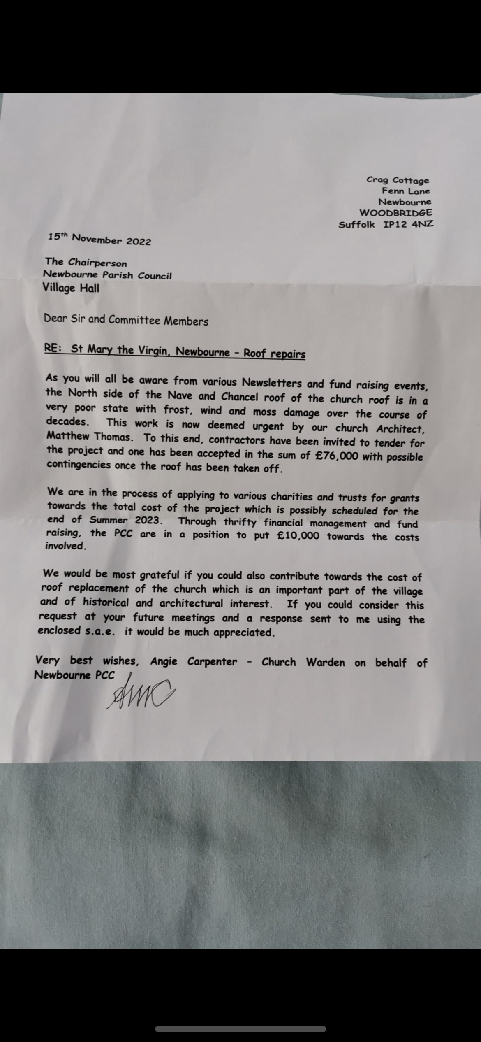

- To DISCUSS and AGREE Planters on Verge

Parking on the verge (The Street) next to the bus shelter opposite The Fox Inn. Number of vehicles spotted parking on the verge again. Was agreed previously that two large plant pots would be purchased and placed on the verge to stop the parking issue. Pat Frost has been quoted £150.00 for the two planters. This has been agreed by the Parish council. Also was discussed and agreed that the bus shelter may need attention as has been several years since the ivy has been cleared and painted.

- To DISCUSS Quiz and Village Day
QUIZ
Big Thank you to all that supported the quiz. Also, to all that helped on the evening and helped organise. We raised £708.00 to go towards the play area.
The evening was very successful everyone said they had a lovely evening, it was nice to see the village hall full. We are hoping to do another couple of quiz’s this year.

Thank you to Keith Borroughs quiz Master and The Stables coffee shop, Newbourne Fox, Nourish Café, Harbourside Kitchen who donated vouchers.

Village Day
Sub Committee needs to meet and discuss arrangements if anyone from the village wants to help organise, they just need to get in touch all hep welcome.

- To DISCUSS Finance

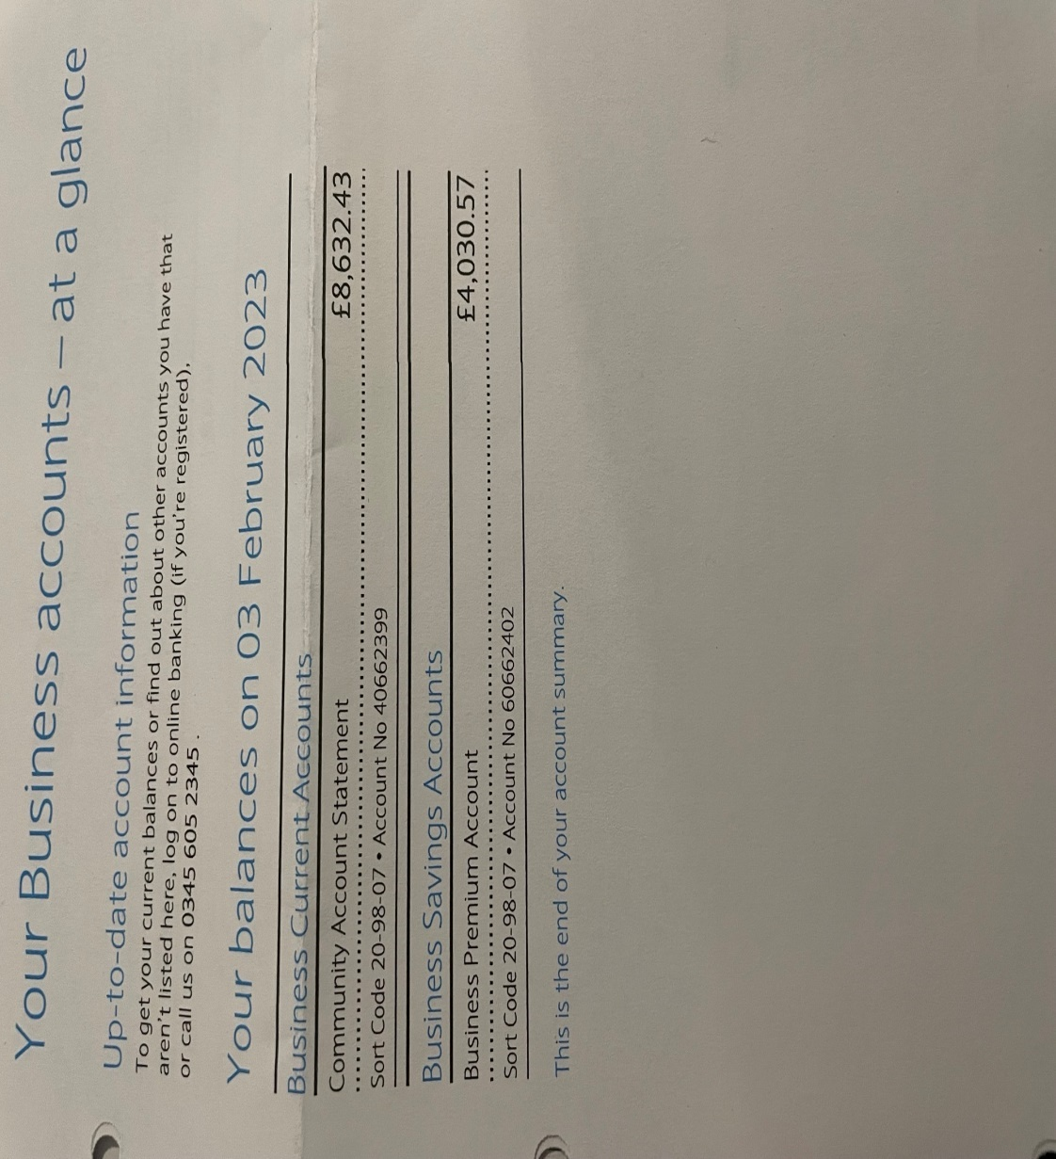

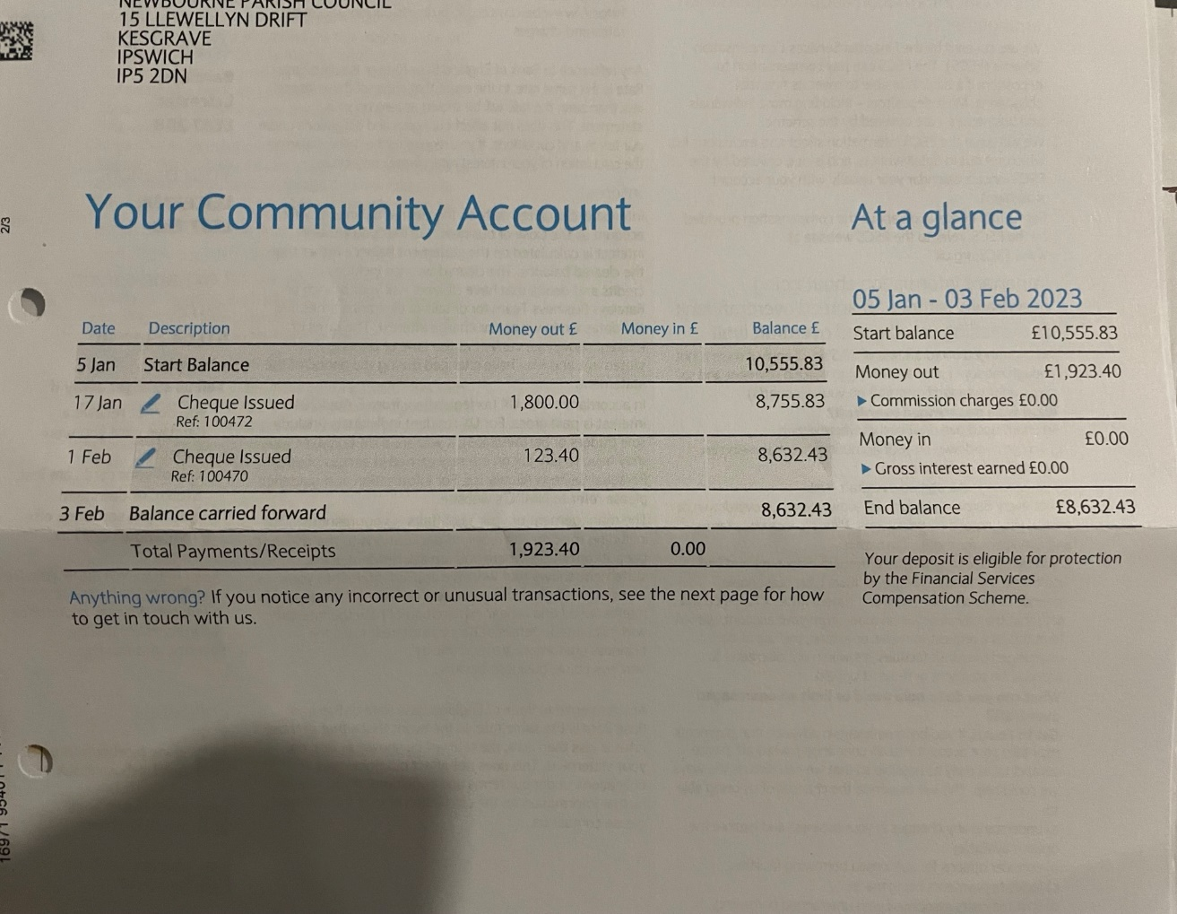

Cheques to be signed.
06/02/2023 cheque 100473 Community action Suffolk £60.00

Cash to be banked £708.00 from quiz.

Cheques that have been cashed £1800.00 speed camera and £123.40 HMRC.

- Clerks Correspondence
WIFI for village hall options will be investigated on best price.
Items to be added to next meeting’s agenda.
- Church Roof
- Bus Shelter
- Play Area
- Coronation village day

Signed ……………………………….
………………………………..

