May 2025 Supporting Documents
Lee Reeves email
Hi Laura,
Must give our apologies as again have three meetings on same night.
In terms of a report there is little to add to our previous one. Building Control have confirmed that they have written to the owners of the Trimley Water Tower and are awaiting their confirmation that repairs will be made to prevent any more concrete falling from the structure. If they do not commence remedial action, then the council would need to take court action against them.
A reminder that trees, hedges and bushes are available to parish councils free from the Woodland Trust. I believe the limit is currently 420 trees per parish. Further details can be found on https://woodlandtrust.org.uk/plant-trees/schools-and-communities/ The application time frame runs through to August 2025 subject to availability.

Email to Highways regarding the road damage on The Street.
My name is Laura, and I am the Clerk for Newbourne Parish council. First, thank you for coming out to repair all the potholes that I reported on the highway tool mainly down Ipswich Road and Woodbridge Road. We have a few issues with the roads in Newbourne which needs someone from the highways department to come and review.
The Street - IP12 4NY . I reported the damage on the highway reporting tool in March with images and the tool advised the repairs to the road would be done in 8 weeks. The start of May your workman came out and have done some repairs which are shown on the below images we thought this was a temporary repair and maybe the workman would be back to finish the job, but this is not the case the road is still in an awful state with holes this is really dangerous to cyclists, walkers and cars.
The problem as previous advised is that there are natural springs that flow freely over the road. I have attached the google map images which were taken in 2023 which shows there is an ongoing issue. The holes in the road have been filled up before and the natural springs then come up elsewhere. The water from the springs run over the road constantly throughout the year. In the winter it freezes, and the road is like an ice rink. The constant running water is causing damage to the road and the residents are worried that it will cause a sink hole as the amount of water has increased over the years. A sinkhole happened not that long ago on Mill Road from Hemley to Waldringfield. It advised that sink holes generally are caused by collapse of the surface layer due to loss of support from below, often triggered by water, which erodes and dissolve underlying rock, leading to voids and eventual collapse. The soil in Newbourne is loose and sandy and with the volume of water that is on the roads it is a worry.
This issue on the road has been raised previously and people from highways have come out to investigate the issue a few years ago but no action was taken apart from filling in the holes, but the springs just come through the road elsewhere. We have been advised that to solve the issues correct drainage would need to be put under the road for the water to drain away correctly, redirecting the natural springs away from the road surface.
The springs in the road are outside The Fox Inn, further up the Street towards Hemley also.

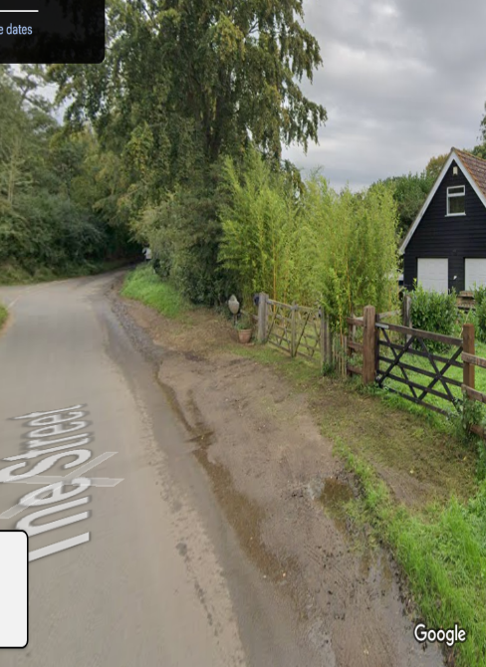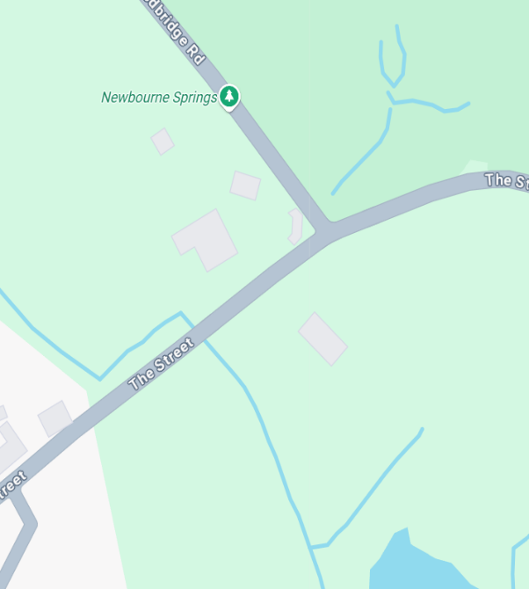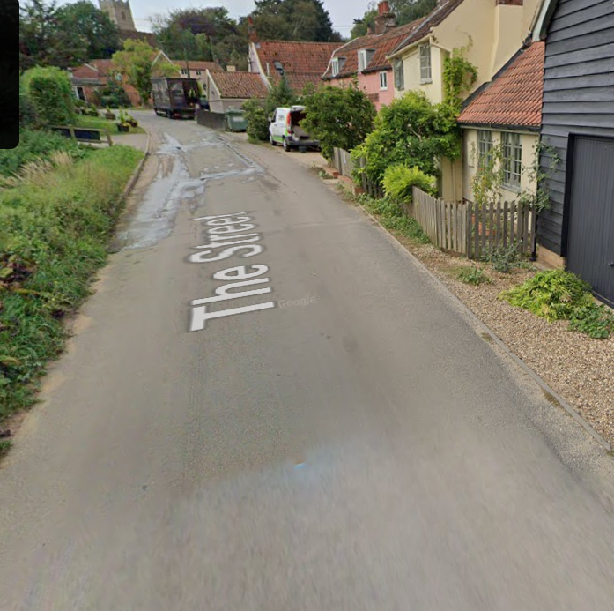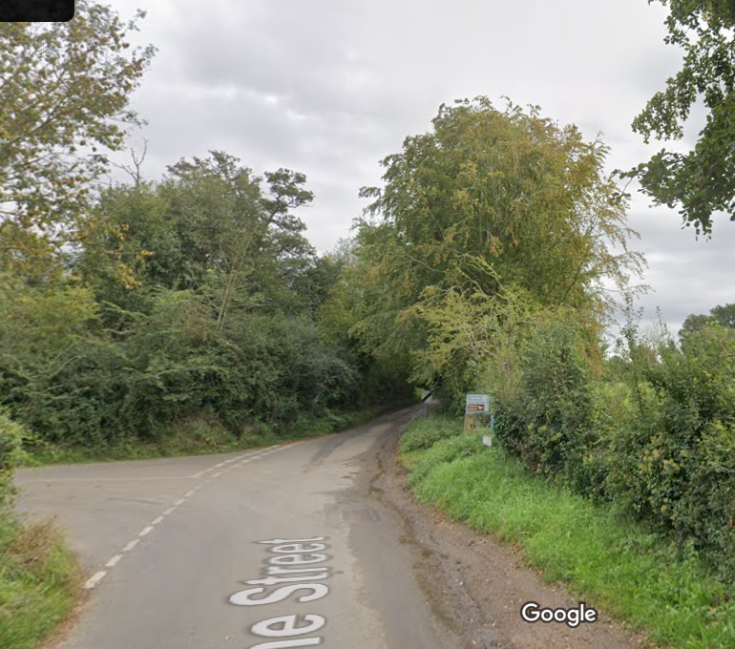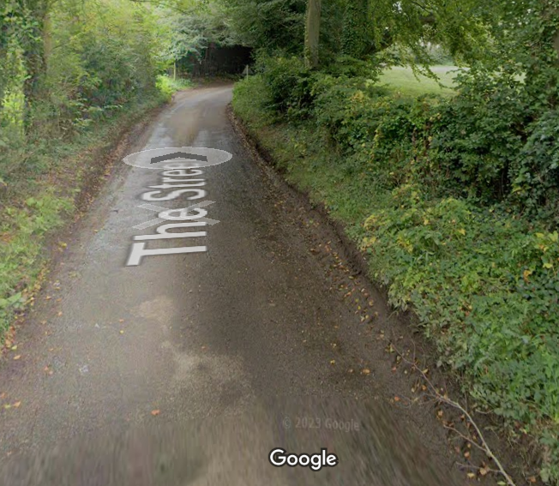

Below are the images of highways doing the repairs and the state of the road once finished as you can see the standing water on the road where they have done the repairs.

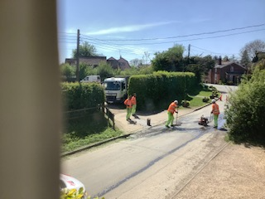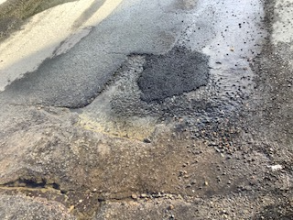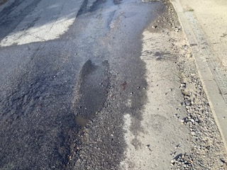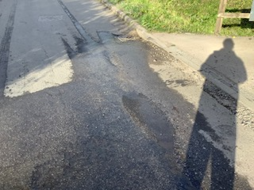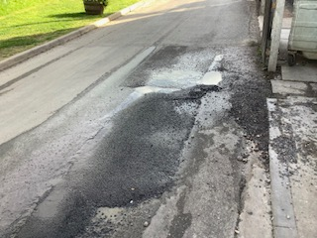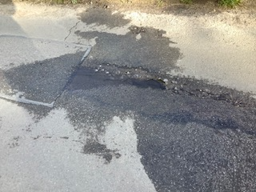#

Can we be advised if the highways department are coming back to repair the road? and if someone can come and look at the springs in the road and can we have feedback on the next steps.

Thanks
Laura Naunton
Clerk Newbourne Parish Council

