Parish Council Meeting
Tuesday 2nd May 2023

Public Time

Brian Humpries attended the meeting as he has purchased Steadings on Ipswich Road.
Brain spoke about their plans for Steadings, they are looking to improve the site, their will be some future planning put in. Brain advised that if anyone wants to have a look at Steadings or ask any questions regarding future plans, they are more than welcome to go look round and speak to his son who is going to be running it.

- To NOTE Apologies. Cllr Grainger and Cllr Gammons send their apologies
- To DISCUSS Elections. The Following now make up Newbourne Parish Council

Chairman Gary Grainer
Vice Chairman Sue Pollard
Cllr Michael Frost
Cllr Lionel Scott
Cllr Jim Wicks
Cllr Kwini Lusher
Cllr Charlotte Gammons
Cllr Andrew Garfath-Cox
Cllr Michael Hadley
- Any declarations of disclosable Pecuniary interest – None advised.
- To APPROVE Minutes of Parish council meeting 03/04/2023
- To DISCUSS Planning applications – No Planning
- To DISUCSS Coronation Celebrations – The subcommittee have the event in hand and in the next meeting will discuss how the event went. Fingers crossed for good weather.
- To DISCUSS play area fund raising. Coronation celebrations will hopefully raise some money and when the new councillors are elected, we will ask for some money from their budget. Also, the clerk will investigate other funds or grants that may be available.
- To Discuss Finance
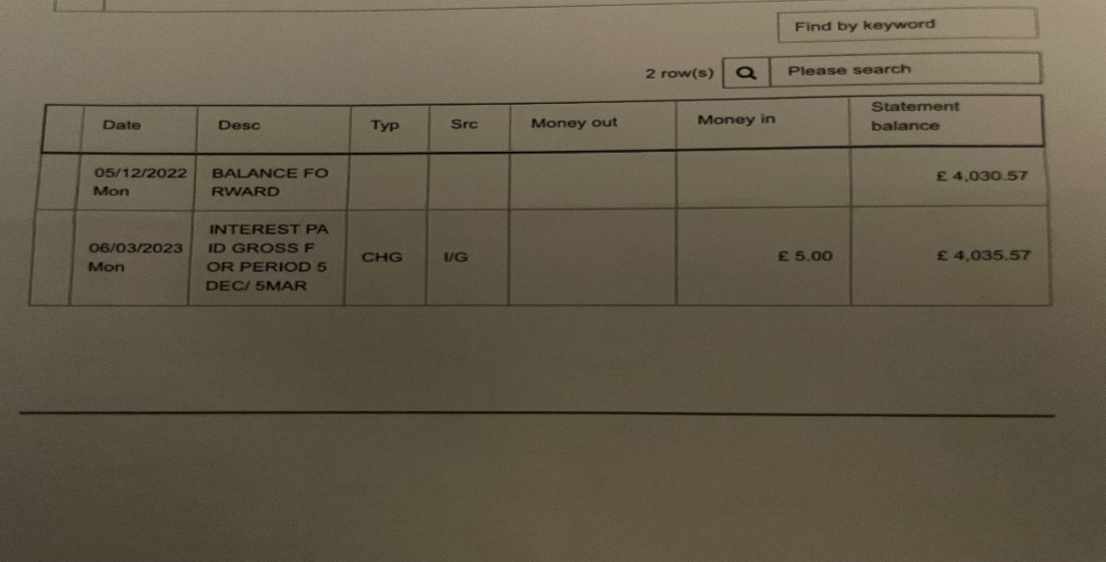
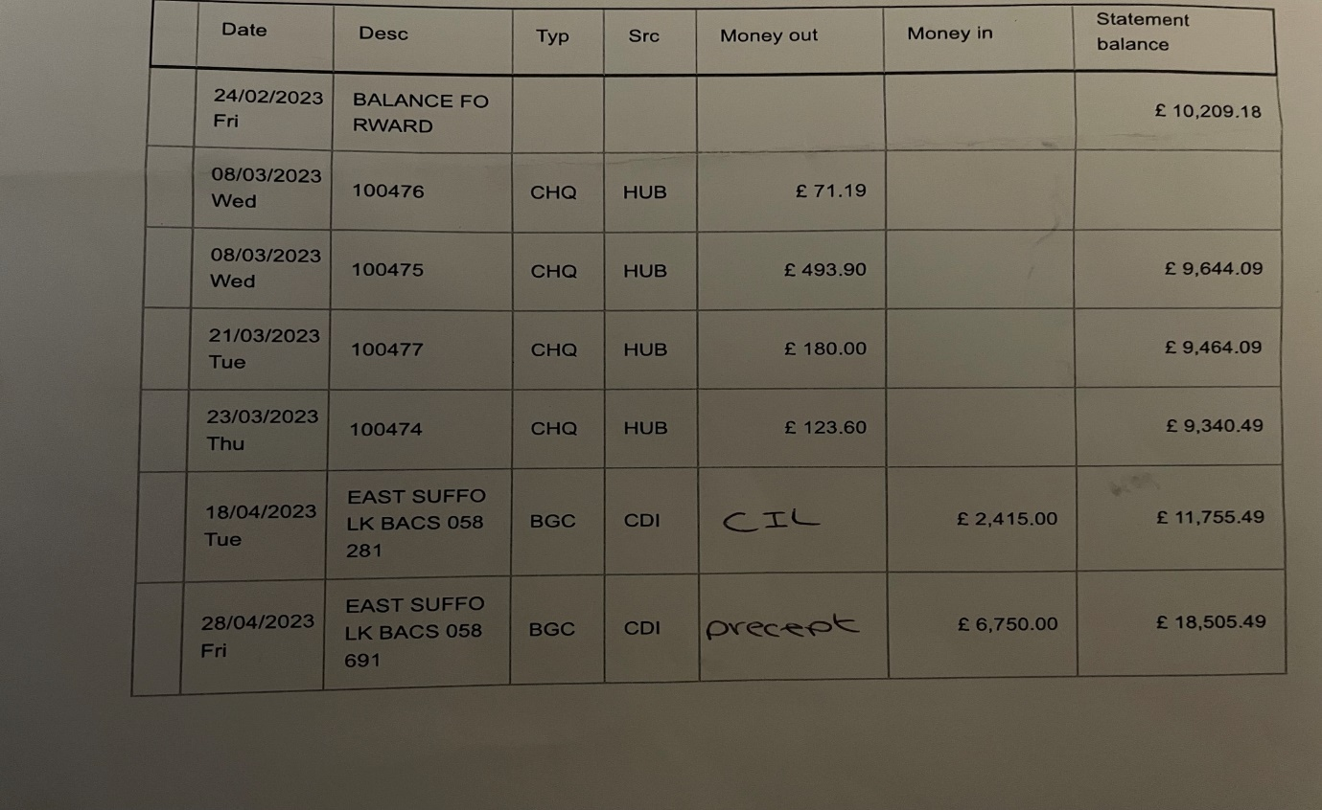

Cheque Signed by Cllr Scott and Frost 100481 L Naunton Printer Ink 02/05/2023 £53.98

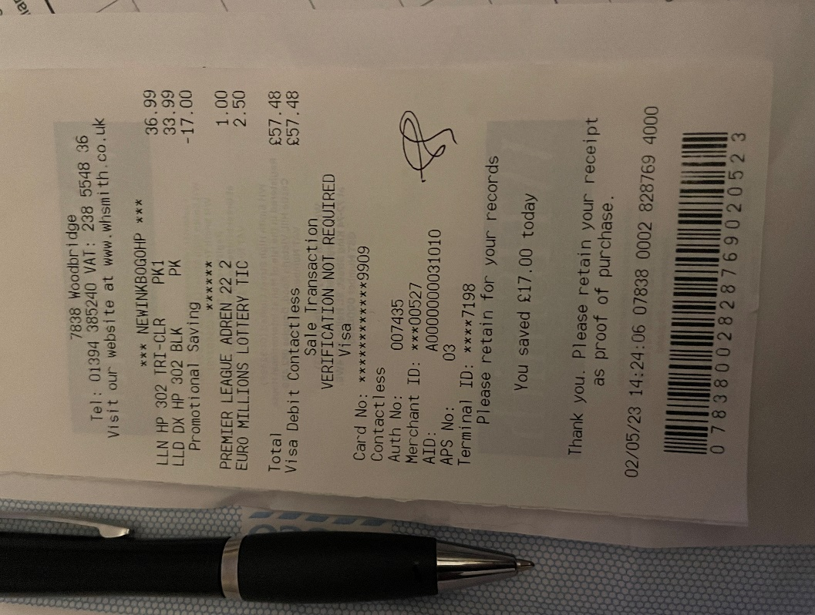
- Clerks Correspondence – None

Next meeting 05/06/2023

