Covid Lock Down
May 2021 / June 2021
Cheques

Cheques have been signed by Sue Pollard and Lionel Scott at their home addresses

Cheques signed
27/05/2021 £453.60 Wages cheque number 100427
27/05/2021 £113.20 HMRC Cheque number 100428
27/05/2021 £113.40 HMRC Cheque number 100429
27/05/2021 £60.00 SCL grass cutting cheque number 100430
27/05/2021 £240.00 SCL grass cutting cheque number 100431
27/05/2021 £453.60 Wages cheque number 100432
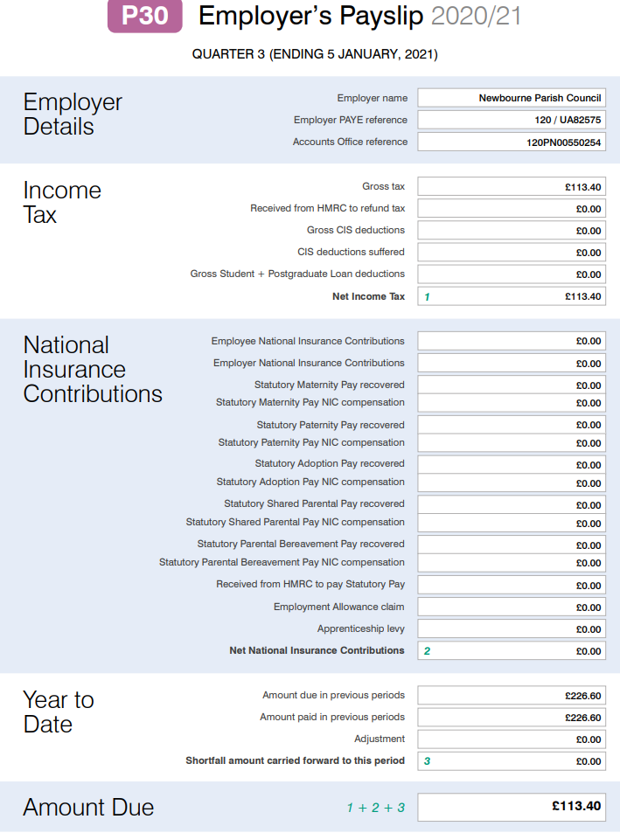
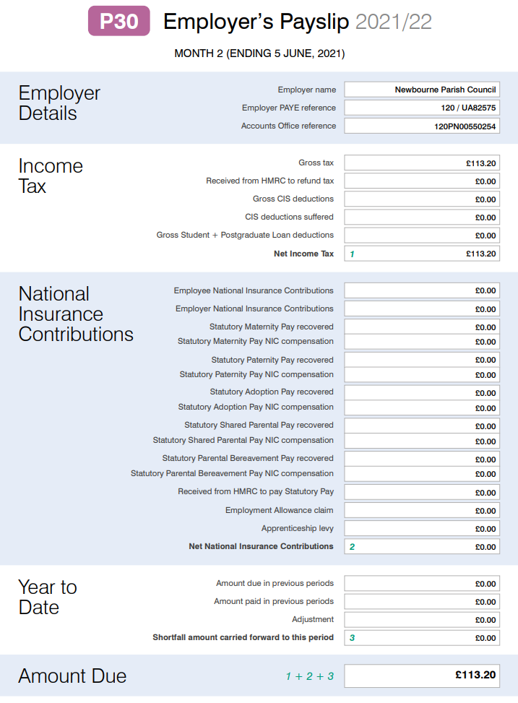
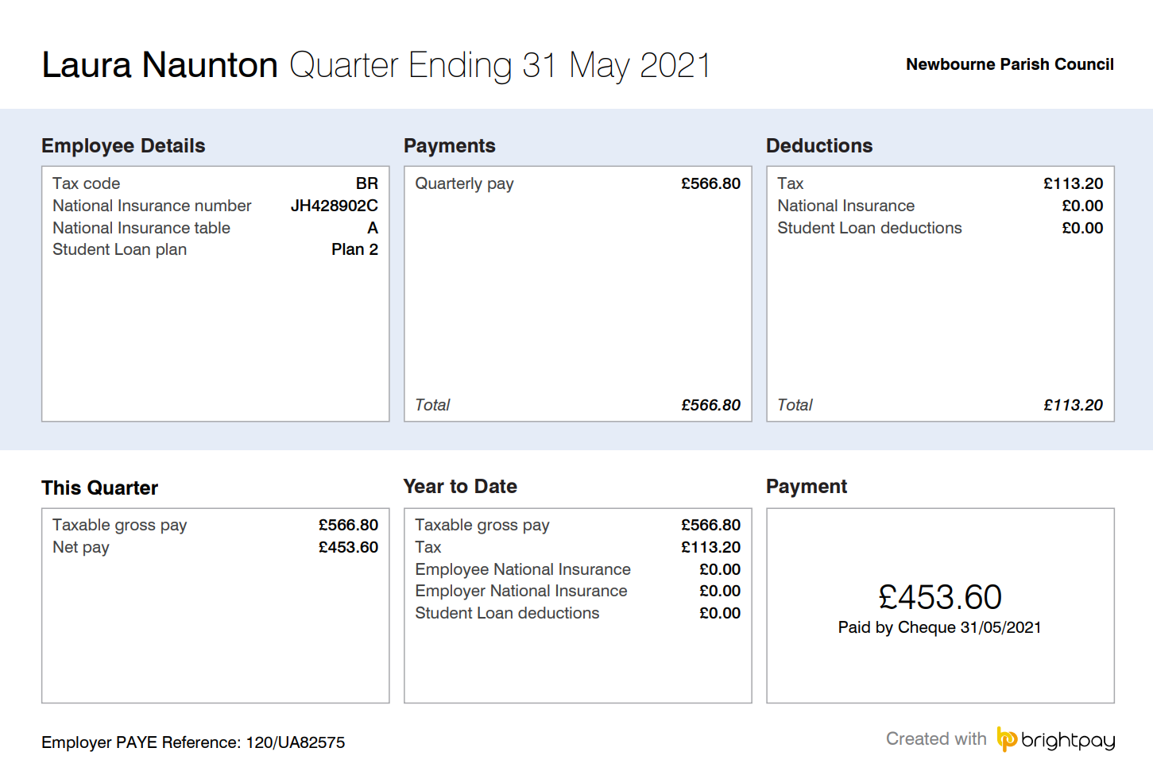
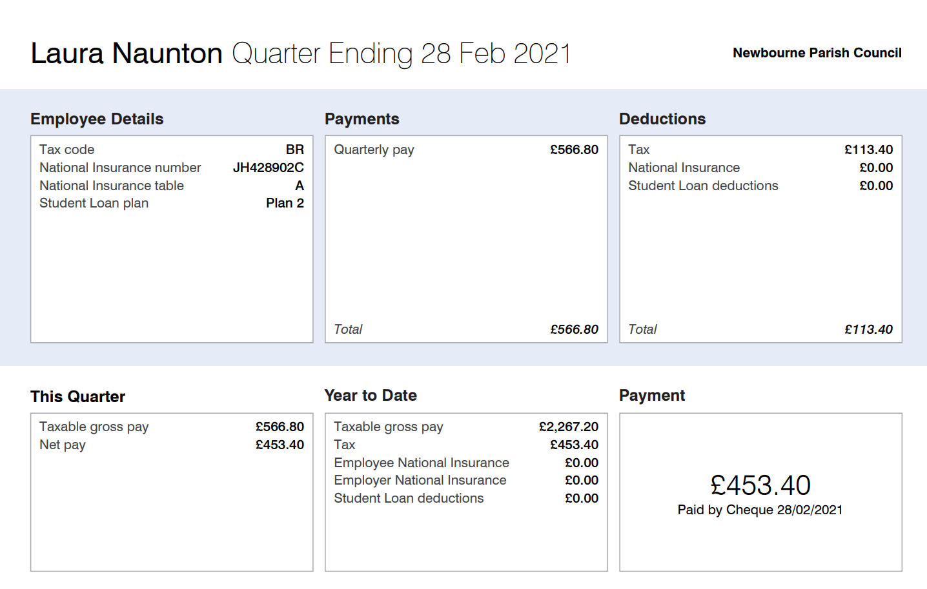
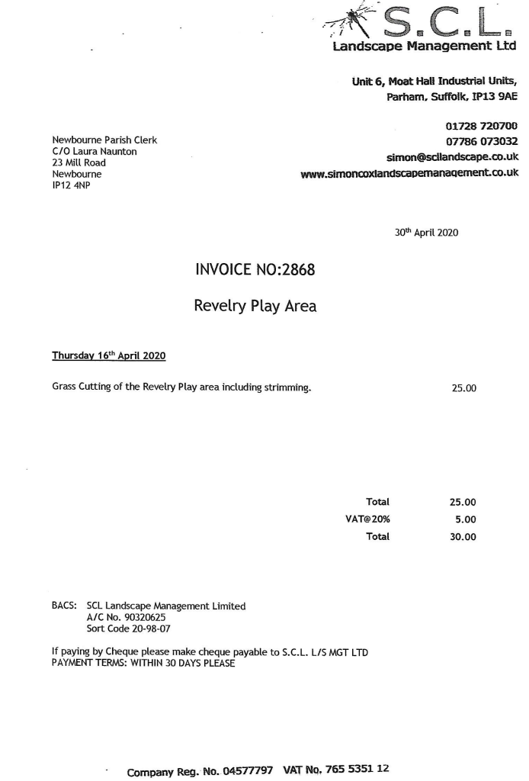
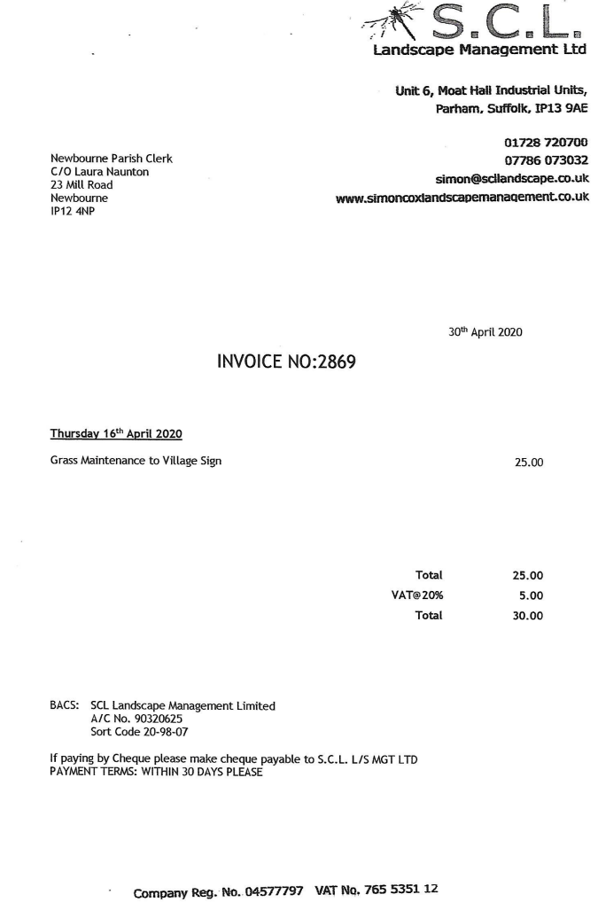
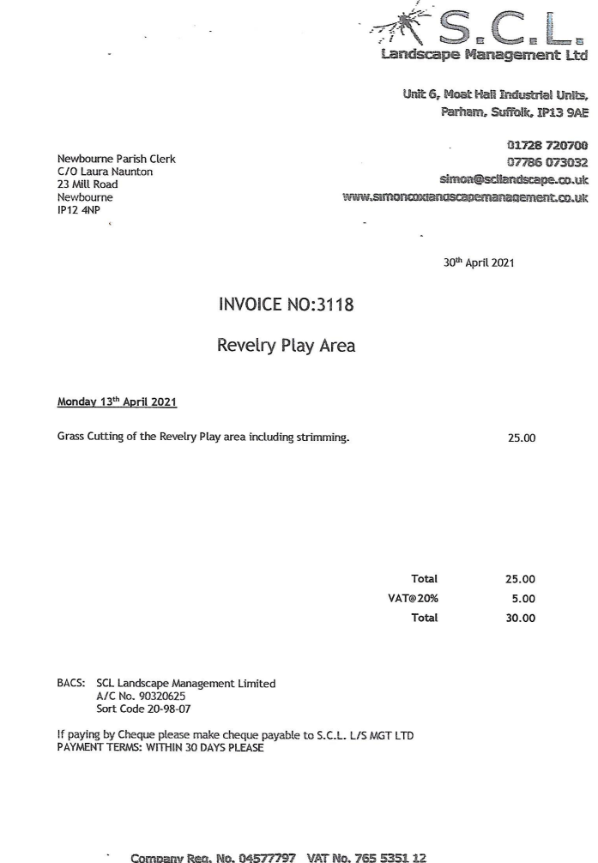
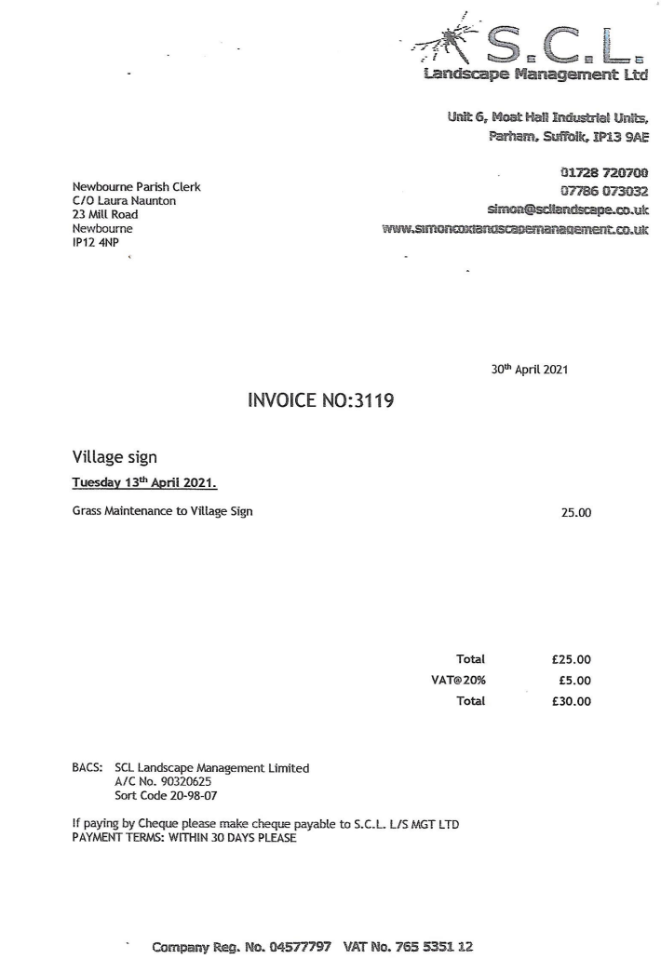

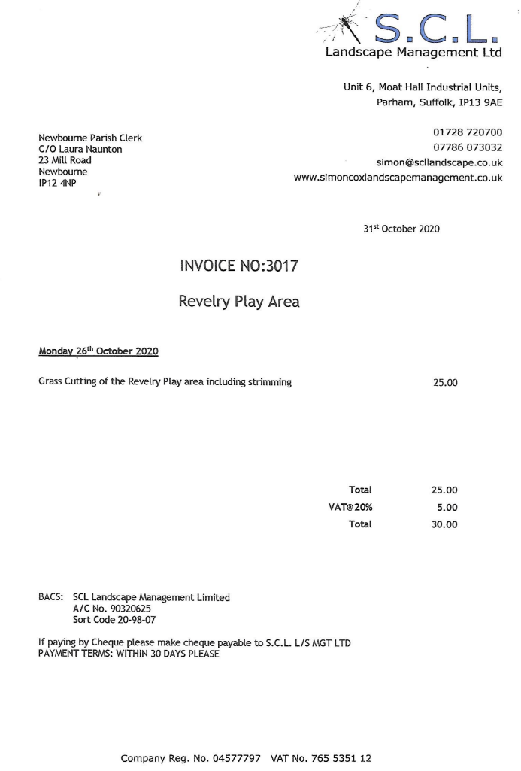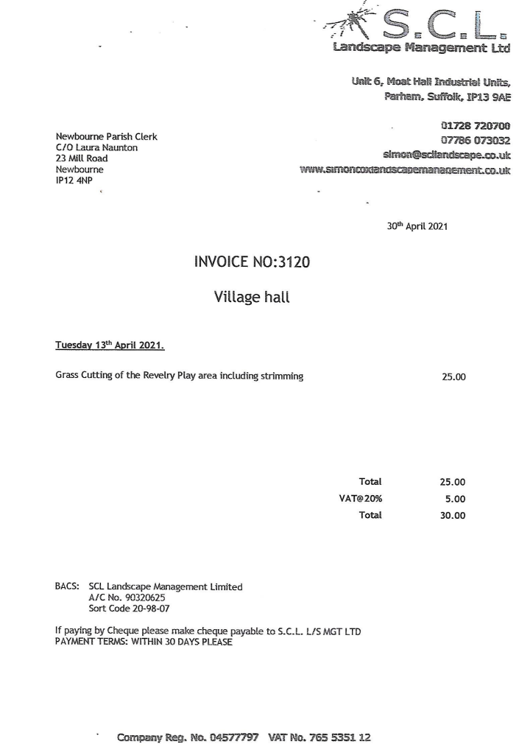
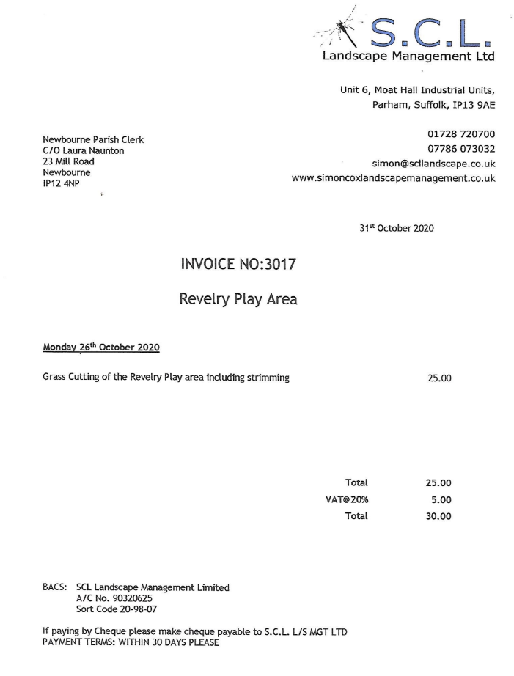
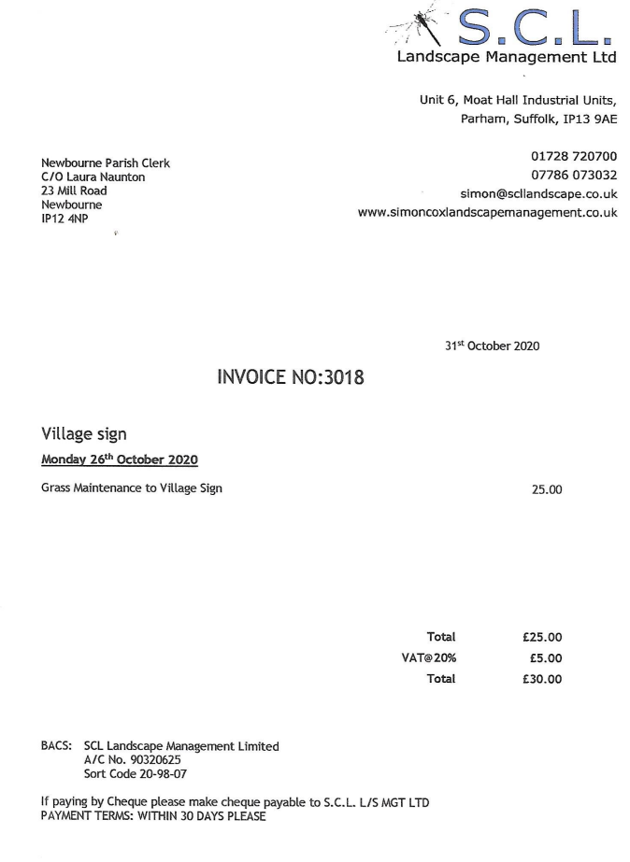
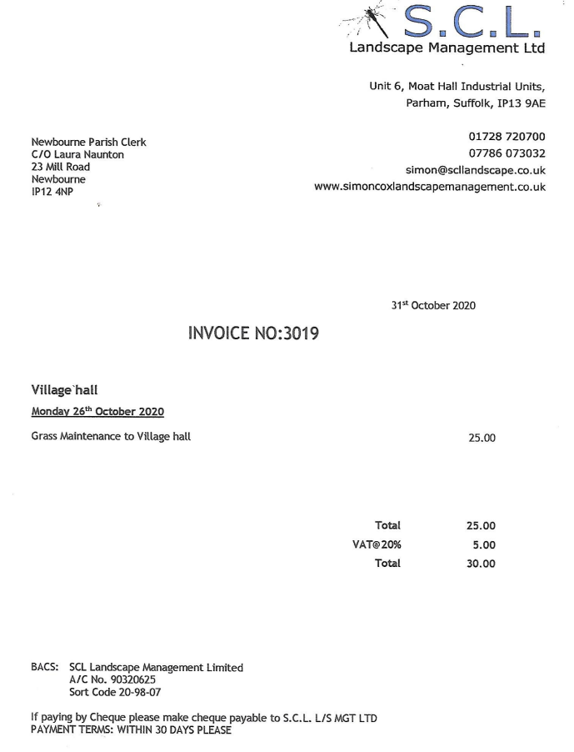
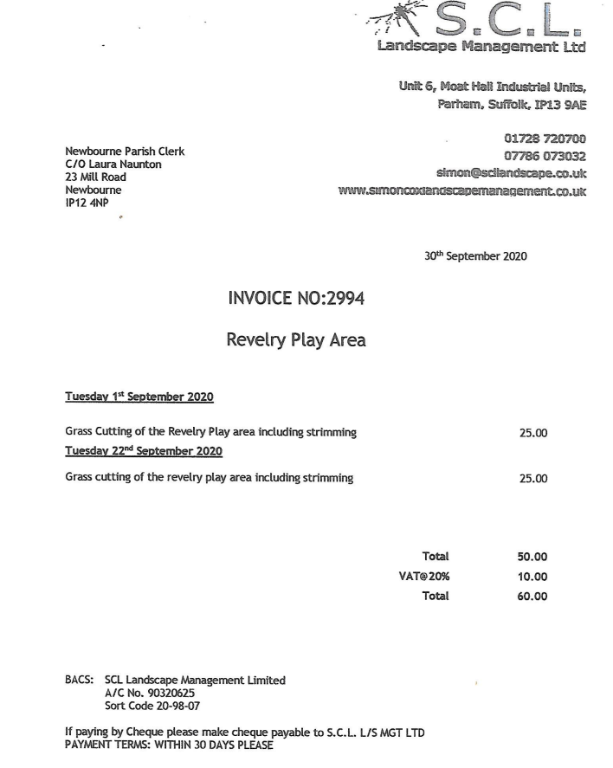
Bank Reconciliation October 2020 – June 2021

Cash in hand October 2020 £18,497.98
Community £14,471.60
Saving £4026.38
ADD
Receipts £6107.38
£5467.00 Precept
£640.38 Money from village hall
Total £24,605.36
SUBTRACT
Payments
Cheque 100415 £113.40 HMRC
Cheque 100412 £300.00 SCL GRASS CUTTING
Cheque 100416 £60.00 SCL GRASS CUTTING
Cheque 100417 £94.80 ROSPA PLAY INSPECTION
Cheque 100421 £113.47 HMRC
Cheque 100425 £453.40 WAGES AUG – NOV
Cheque 100419 £22.80 SALC PAYROLL
Cheque 100420 £60.00 COMMUNITY ACTION SUFFOLK WEBSITE
Cheque 100418 £120.00 SCL GRASS CUTTING
Cheque 100424 £113.40 HMRC
Cheque 100426 £60.00 SCL GRASS CUTTING
Cheque 100432 £453.60 WAGES NOV – FEB
Cheque 100427 £453.60 WAGES FEB – MAY
A Cash in hand 07/06/2021 £22,186.89
B
Cash £0.00
Petty Cash £0.00
Community account £18,160.51
Saving £4026.38
£22,186.89

