Monday 4th March 2024 Minutes
Public Time – Sue Pollard spoke about the Asian Hornets and handed out some leaflets about them. The Asian Hornet kills bees and wasps, and the leaflet gives pictures and more information. You can go to www.bee-craft.com to get full information.


Sue Spindler came to discuss the planning application for storage of containers at Foxburrow Farm, Waldringfield Road. Sue raised issues that the planning is not in Newbourne but would be able to be seen and heard from Newbourne. It was also raised that planning for shipping containers had already been agreed off Brightwell Street. The Clerk will investigate previous planning applications and raise with planning department.
Tony Finch raised the issue regarding the concrete blocks on verges, some new blocks have been placed on Ipswich Road outside number 14. Tony raised they are very close to the side of the road. There have been previous issues with concrete bollards outside Newbourne Hall and Little Beeches on Mill Road. The clerk will report the issue and advise highways then they can advise if they are in a dangerous position. Clerk raised issue 00464125 with concrete bollards at all three locations.
Pat Frost raised concerns regarding Family Day in July that we may not have enough helpers to make the event a success. As it takes a lot to organise and make it happen on the day.
Pat Frost also raised that the boiler in the Village Hall needs replacing, and they have requested some money from East Suffolk councils CIL money. The village hall would like some money from the Parish Council as the new boiler will cost around £6200.00.

Meeting opened by chairman at 20:00

- To RECEIVE Apologies received from Cllr Scott and Cllr Lusher and ESC Reeves and Ninnmey.
- To RECEVE any Reports from ESC will be added in Supporting Documents.
- To RECEIVE any declarations of disclosable pecuniary interest – None received.
- To REVIEW Minutes of parish meeting 05/02/2024 these have been read and approved by Cllr Wicks and Cllr Garfath- Cox
- To RECEIVE and DISCUSS Planning applications.

DC/24/0284/OUT Land adjacent last transmissions, Ipswich Road. Outline application erection of detached dwelling. Planning was discussed and it was suggested that the oak tree should stay and be protected as a large old tree. It was voted on and 1 Cllr objected but the others all supported the planning application.

- To RECEIVE update on Neighbourhood Plan.

As discussed in previous meetings. It was suggested that Newbourne have a Neighbourhood plan some of the Cllrs were for and some were against the idea. It was decided that we would get more information regarding the NP and then discuss it further. The Clerk spoke to Bucklesham Parish council who have decided not to go ahead with the NP and their clerk sent over the findings and the information that was given to the councillors following their decision not to go ahead. The clerk included this information in supporting documents for February. The clerk then arranged a meeting with the clerk of Ufford Parish council who are currently submitting a NP.

Andrew Garfath-Cox and Bryan Wheeler met up with Judi Hallett Clerk of Ufford Parish Council at the end of February to discuss the Neighbourhood Plan. Judi explained that Ufford are currently in the process of producing their Neighbourhood Plan and what is needed to be done to establish a neighbourhood plan.
- Create a steering group this should be half parish councillors and half villagers.
- Set up an open day to find out what is good to keep and what needs to be changed.
- Hire a consultant with expertise and the parish council as the legal entity to make an application for grants towards the cost.
- A number of stages follow.
  - What needs controlling?
  - What needs specifically protecting?
  - What are housing needs – affordable housing, family housing etc?
  - A biodiversity surveys.
  - An ecological survey.
  - Any non-heritage assets that should be protected. Buildings/ monuments.
  - Maintaining vistas of particular significance

Next Major step is creating a Draft Plan
- Include all policies, which must be evidence- led and include feedback from those who commented on it.
- When consultation is completed, it is given to the parish councillors for approval. Sent to an independent inspector for checking. A referendum on the plan is held and it will be adopted if 50% and more of the those eligible to vote agree.
- Submission of document. It will become a statutory document if it is in line with the local plan.
- The neighbourhood plan then needs to be repeated every 5 years.

Ufford is a village that has about six times the number of households in comparison to Newbourne and their plan required.
- Extra funding for the parish clerk – approximately 3 hours a week.
- Responsible for grants and payments to consultants. Funds not used need to be repaid and new grant applied for.
- Time taken to produce the Neighbourhood plan about 6000-man hours.
- Extra costs outside the grant about £3000.00 which cannot be paid from the community infrastructure levy.

This was all fed back in the parish council meeting and a decision was made at this time that Newbourne would not be going ahead with a neighbourhood plan. The main reasons were.

- The cost – We are a small village; a NP costs a lot to put in place and then would have to do every 5 years. Not all costs are covered by grants.
- Would we struggle to get enough people in the village involved and to dedicate a lot of their time to making a NP successful.
- It takes a lot of time to implement a plan 2-3 years to get it set up.

So, it was decided that Newbourne wouldn’t continue to discuss the NP but this can always be revisited in the future if circumstances and costs change.

- To RECEIVE any information / feedback regarding the green infrastructure and Biodiversity.
The Green infrastructure group are working on meetings together to build a joint plan with working forums and working with landowners. It is a work in progress.

- To have an UPDATE on play area. The clerk will submit paperwork to see if we can get a grant, if not then we will continue to apply for grants but we do have enough for the swing set so we will go ahead with the swings and continue to raise money.
- To have UPDATE on Quiz night 23/03/2024. The clerk confirms that we have 14 tables confirmed for the quiz, quiz master is ready. If anyone has any raffle prizes can these be given to Pat Frost.
Village Day 13/07/2024 – The parish council have decided to cancel village day due to the lack of volunteers for the event. A lot of time and effort goes into organising these events. If do not have enough people that are willing to volunteer, then these events will not be able to take place.
- To RECEIVE up to date bank statements, and financial information.

Bank Reconciliation February 2024

Cash in hand 01/02/2024 £23,940.77
Community £19,871.83
Saving £4068.94
ADD
No payments £24,720.77
SUBTRACT
Payments
Amount Cheq no Payee
£780.00 100498 AJS Grass cutting and maintenance.
Cash in hand 31/01/2024 £23,940.77
B
Cash £0.00
Petty Cash £0.00
Community account £19,871.83
Saving £4068.94

March Cheques
04/03/2024 HMRC £123.60 CHQ 100503
04/03/2024 L NAUNTON WAGES CHQ 100504
04/03/2024 NOBLE NATURE CHQ 10050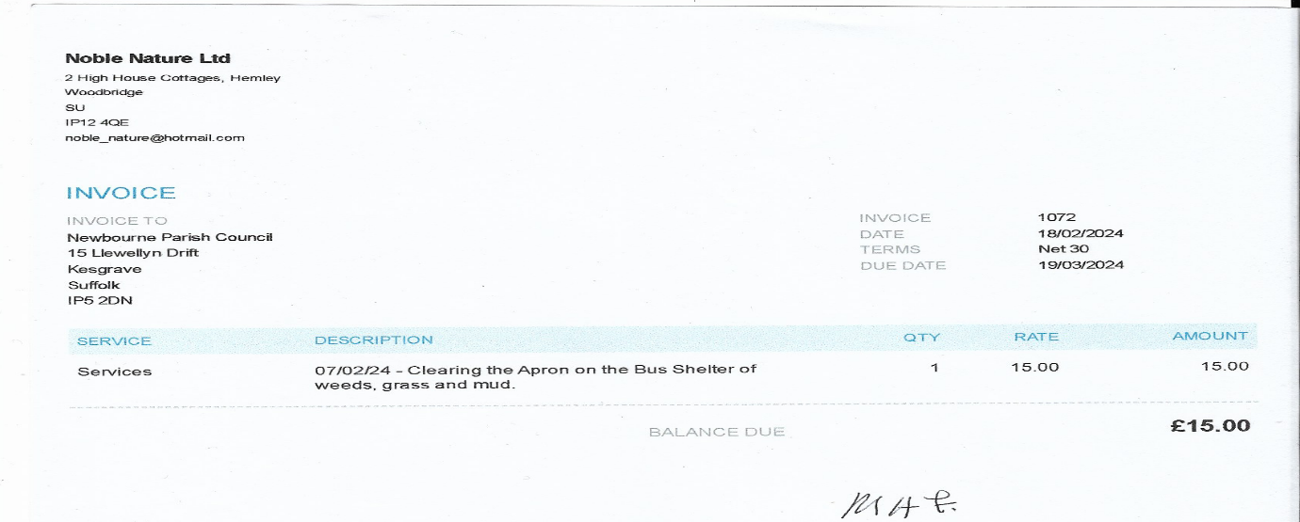
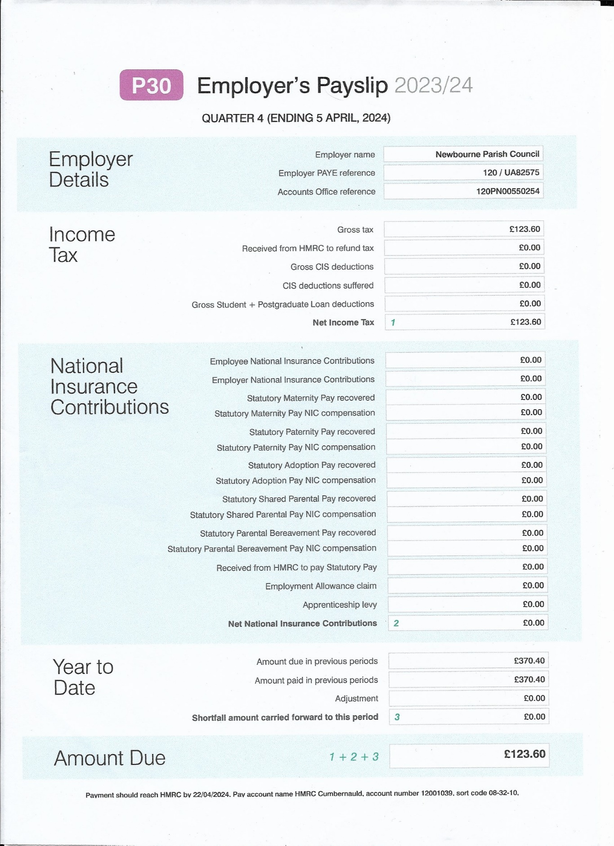
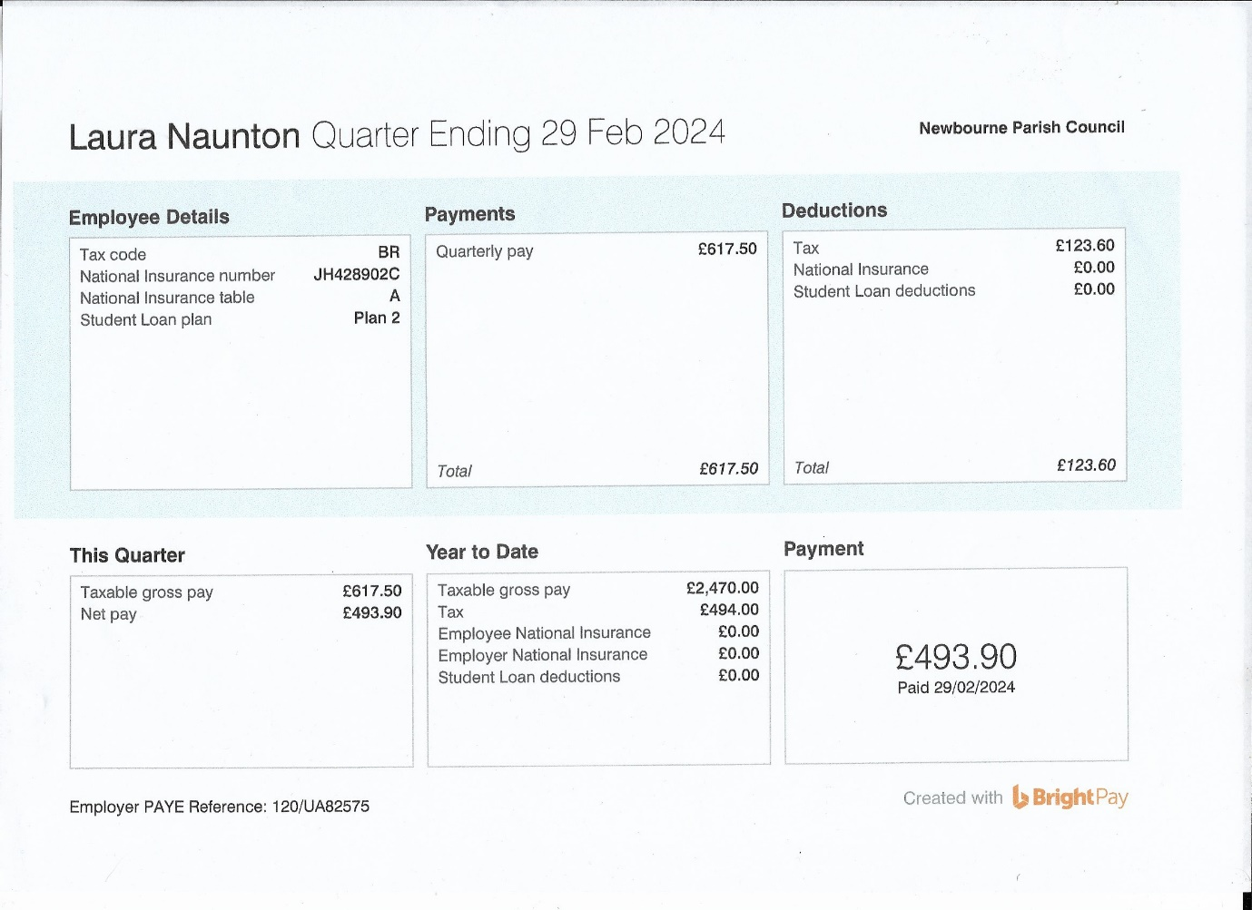

5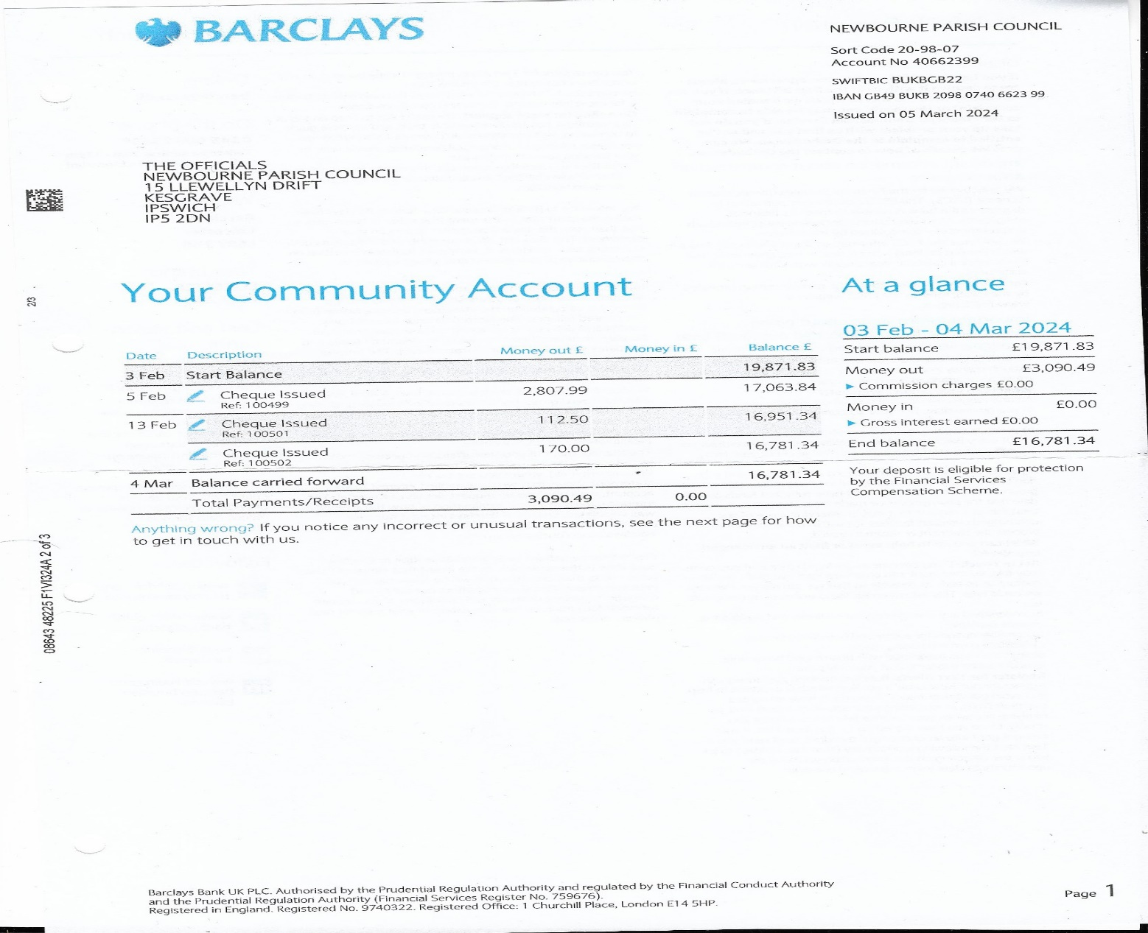
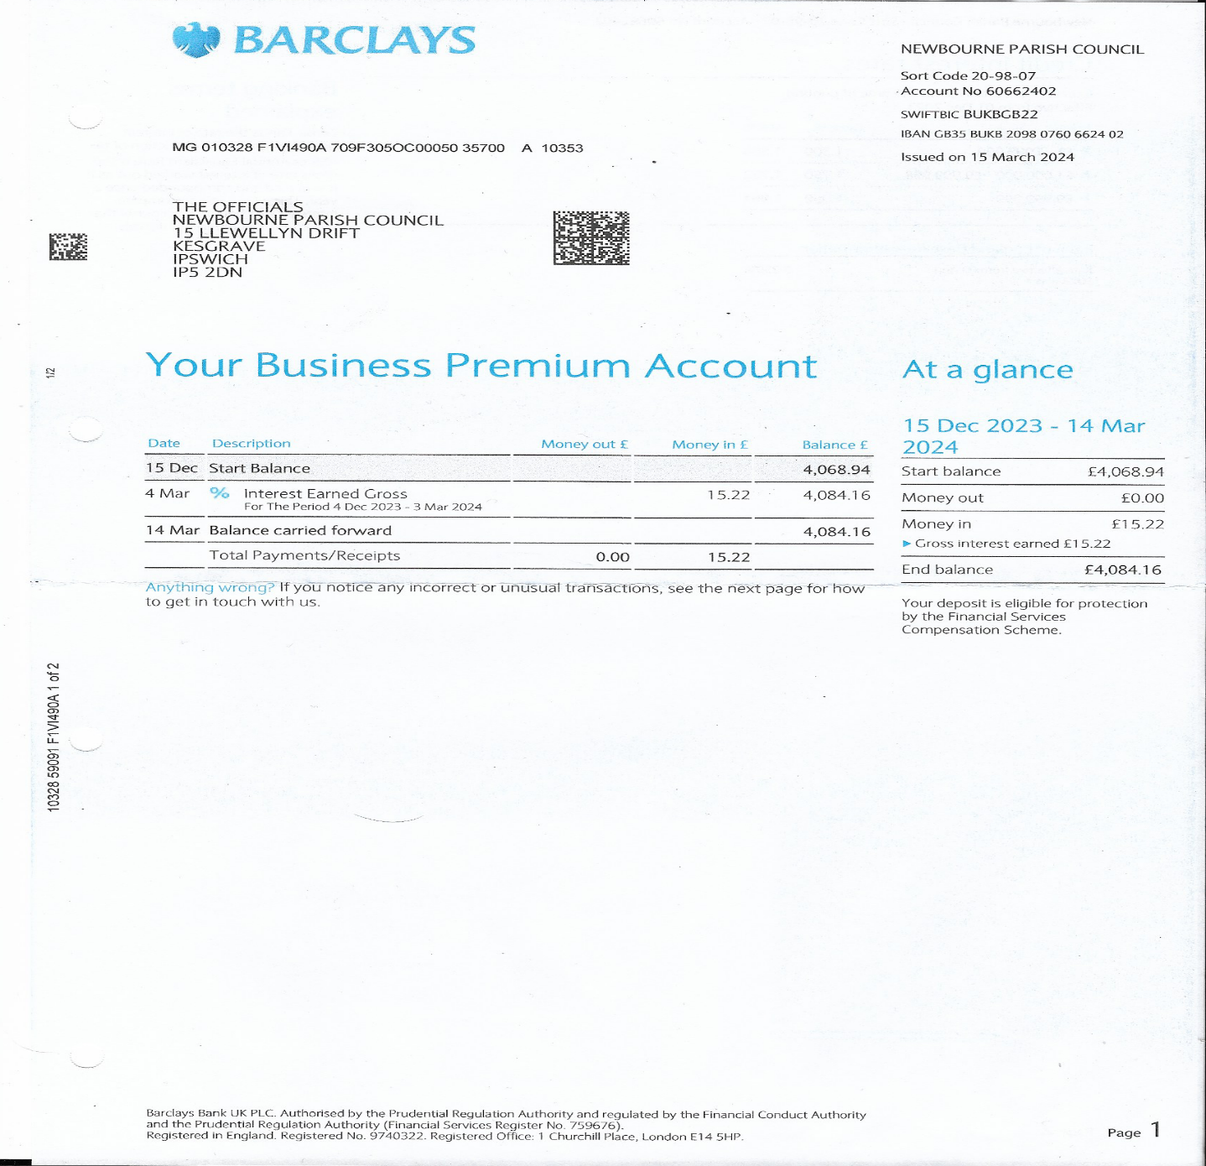
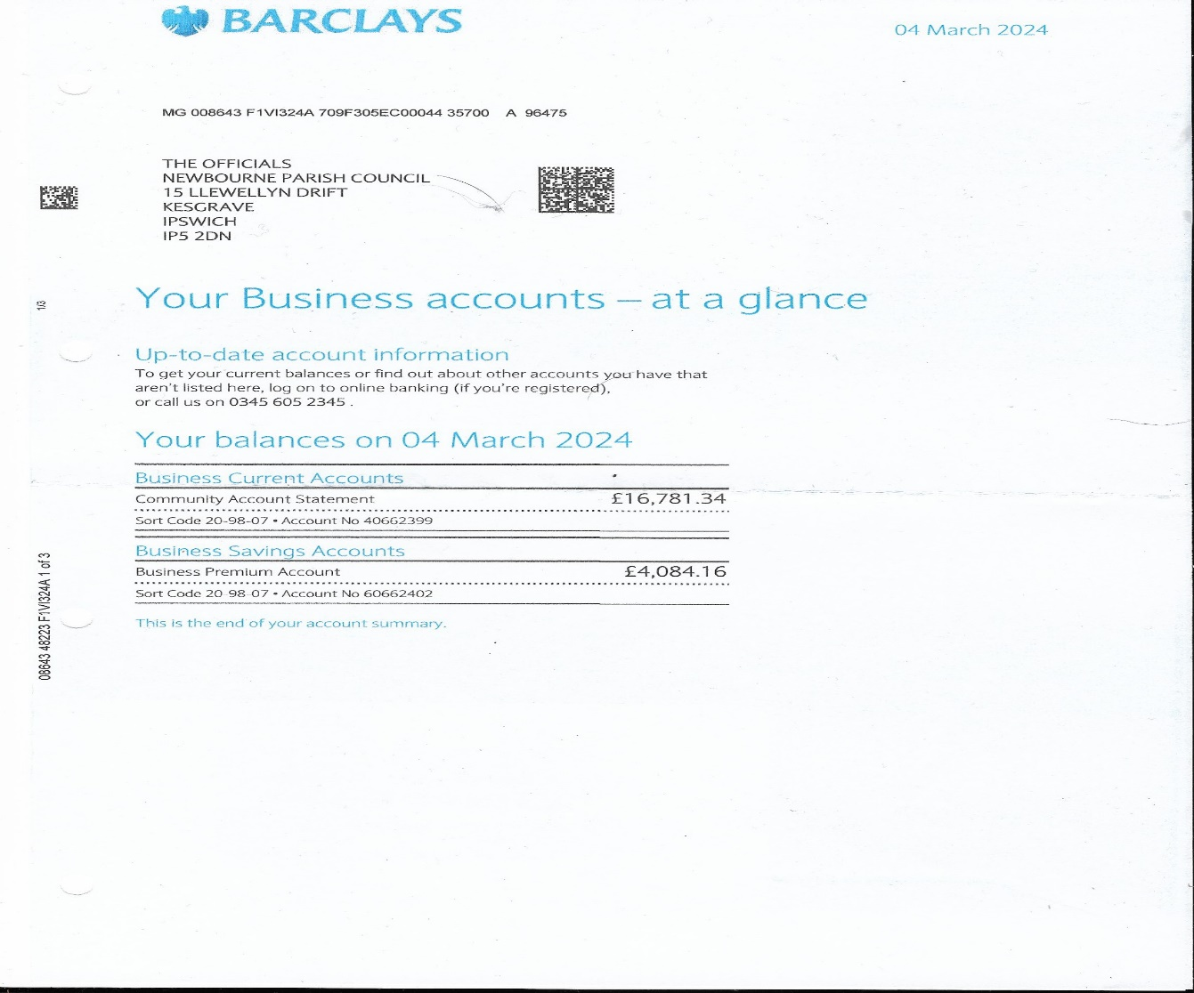

Meeting Closed at 20:50

