Minutes Meeting 6th March 2023
Public Time
John Sommerville and Peter Smythe came to discuss the below planning application.
Planning Application No. DC/23/0022/FUL
I wish to make the following observations & representations regarding the above planning application.
Firstly, I do not understand why my property was not on the list of ‘Neighbour Consultations’ as I already have an existing case with Enforcement (ENF/20/0377/COND) about the to-date unauthorised use of the building in question and also considering the fact my garden is only some 50 metres from it [see attached photo taken over my garden fence]. As well my office premises (for my livelihood work, which requires peace & quiet) is less than 100 metres away. Thus, my right to the ‘enjoyment and unencumbered use’ of my home & property, as well as my business activity, are both compromised by the existing breach of planning regulations by the applicant and would be even more so were this application for change of use to be granted.
Secondly, added to the list of Consultees should be Historic England as my Listed Building home is of the high classification Grade II*, which requires them to be informed and involved. Almost all previous planning applications on this site have been referred to Historic England for comment as any development or change of use on this site affects the setting of my important Listed Building.
The present application DC/23/0022/FUL is for a building which is a thin wooden construction within a formerly open fronted 1950’s tractor shed. As the space itself is already of insufficient size for the activities therein that have been in breach of permitted use for at least 3 years, the doors are permanently wide open so raw materials & processed wood can be brought in & out. Consent for change of use would sanction the continuation of this activity which is in direct contravention of conditions 3 & 4 of Planning Consent C.93/0176 which apply to the entire site.
Previous to this application, Mr Maddison - having been advised in 2021 by Dominic Starkey that he must cease his activities or apply for change of use - claimed he was only using the space for storage. Now, in this current application he admits that the use for which he is requesting permission, is already ongoing. Can therefore any current statements or assurances now being given, be believed or trusted.
This application seeks to use these premises from as early as 7a.m. in the morning - Monday to Saturday and this would immediately be contrary to the permitted hours for the whole site, set in condition 2 of consent C.93/0176. Subsequent applications by others to vary these set hours (C00/1260 & C01/1828) and for change of use (0641 in 2010) have always been refused as the original conditions 2,3 & 4 of consent C.93/0176 were set for reasons of ‘amenity’ - as this whole site & area is in the centre of a rural village surrounded on all sides by residential houses.
The Environmental Protection-Planning Consultation Response, suggests they are quite unaware of the existing hours of activity for this whole site, set in 1993 and which have never been granted any variation, for reasons of residential amenity. That precedent has been set and should not be changed.

East Suffolk Council Planning Dept should also know very well - as they were involved (particularly Cate Buck) in serving an Enforcement Notice in June 2017- that we local residents were subjected over a seven year period to the most appalling consequences of breaches of Planning Consent C.93/0176 by a company called SuperSips (now departed but who whilst still here sub-let the building to this current applicant for which he is now seeking permission for change of use) In serving that Enforcement Notice and winning when SuperSips appealed, the Council cited as part of their case for enforcement, Policies DM23, SP15 and it is my considered opinion this current application for change of use not only contravenes those very same policies but also probably DM12 & AP48.
I therefore object most vehemently to consent for change of use being granted to Mr Maddison of Felixstowe Fencing, principally on the grounds of noise nuisance, as the machinery already being used in this totally unsound proof outbuilding, as well as outside processes & activities, will make the lives of us local residents once again intolerable when they are already meant to be being protected by the conditions of consent C.93/0176
Yours faithfully,
John Somerville
Clerk will investigate application as it is with the enforcement team already.

- Apologies – Clerk – Training
- Reports –
Leader’s monthly bulletin – March 2023
Welcome to the March edition of my monthly bulletin, aimed at keeping Councillors up to date on the main news stories from East Suffolk and, where possible, giving you a heads up on issues which are emerging.
With pre-election period publicity restrictions in place from March 16, this will be the last Leader’s Bulletin before the election on Thursday 4 May, and indeed my final bulletin as Leader of East Suffolk Council.
It has been a great privilege to bring you this monthly collection of news from across the district – and I would like to thank every one of you for helping to fill it so completely with stories of your contributions and hard work in delivering for your communities over this administration period.
Regards,
Steve
Steve Gallant
Leader of East Suffolk Council

East Suffolk Council budget approved
East Suffolk Council reaffirmed its commitment to investment in local communities by approving a budget of over £30million to fund essential services in 2023/24.  The spending plan, to help improve the lives of residents over the coming financial year, was agreed by councillors at February’s full council meeting. | 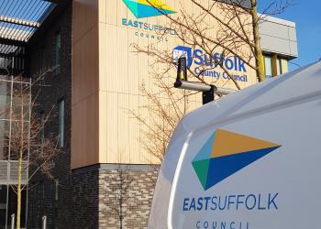
Additionally, in the five years up to and including 2026/27, a forecast £410m will go towards major projects as part of the overall General Fund Capital Programme, and an additional £83m on housing development and new build schemes, and maintenance of existing housing stock.
More than £287m has been raised from external grants and contributions towards the cost of our General Fund capital project programme. This includes a £24.9m Towns Fund grant to regenerate Lowestoft, driving economic growth and acting as a catalyst for future investment, and rising to a potential £35.9m with the addition of matched funding, while UK Shared Prosperity and Rural England Prosperity Fund grants will support local business, people and skills throughout the district.
A General Fund Revenue Budget of £30.1m for 2023/24 includes £16.37million in council tax, which makes up just over 50% of the money we receive. However, the portion of council tax East Suffolk receives (around 10% of the total bill) will only increase by 2.81%, or £4.95 for the entire year on the annual bill of a Band D property.
Suffolk councils secure £2.2m to improve tenants’ quality of life
 | Suffolk’s district and borough councils have secured £2.2m of Government funding to improve the standard of private rented homes.  The successful joint bid, led by East Suffolk Council, with Babergh, Ipswich, Mid Suffolk and West Suffolk councils, will see funding awarded over two years by the Department of Housing, Levelling Up and Communities, from a share of its £14m Private Rented Sector (PRS) Pathfinder Programme.
The funding will be used to create and support additional roles, offering advice and support to tenants and landlords, and taking enforcement action against those who continue to let poor quality housing.
It will also enable the councils to continue working collaboratively, pooling resources to improve the standards of privately rented homes as part of the Suffolk PRS - Empower, Encourage, Enforce project.
Focusing on engagement, the project will give landlords, tenants and communities a better understanding of their rights and responsibilities. Eligible landlords and tenants will also be signposted to available grants to assist with the cost of improving properties.
International cycling event’s £600,000 boost to local economy
An international cycling event hosted in East Suffolk was worth an estimated £600,000 to the local economy, according to study of visitor numbers and related expenditure.  Approximately 6,000 spectators attended the UCI Masters Cyclo-Cross World Championships between Friday 2 and Sunday 4 December. | 
The free event was supported by East Suffolk Council and staged at Trinity Park for the second successive year, featuring more than 600 competitors from 20 different nations, riding laps of a 3km circuit of trails and obstacles.
An evaluation report, commissioned by East Suffolk Council and Suffolk Growth Partnership, has since estimated the total net impact of the event on the local economy to be worth £601,850, based on the expenditure of participants, spectators, event organisers, contractors and staff.
As well as Olympians, national champions and some of the best Cyclo-Cross age category riders in the world, the event featured a support programme of open races for local riders of all ages, as well as a Special Olympics Cyclo-Cross event.
Ahead of the main event, schools in the Ipswich and South Suffolk School Games partnership also came together for a morning of cycling activity organised in partnership between East Suffolk Council, Active Suffolk, British Cycling and event organisers, Elmy Cycles.
Design team appointed for Seafront Vision project
A major Lowestoft regeneration project which will see the delivery of the first phase of the London Road, Lowestoft High Street Heritage Action Zone and Seafront Masterplan has taken a step forward with the appointment of its design team.  HemingwayDesign, Untitled Practice and Gelling Studio have been appointed as the design team for the first phase of East Suffolk Council’s Seafront Vision delivery project. | 
The Seafront Vison project is one of five transformational regeneration projects which are detailed within the Town Investment Plan, which received £24.9m from the Government’s Towns Fund last year.
The project will see the regeneration of the Royal Plain, Royal Green and South Quay Wharf areas, building on the success of the recently repurposed East Point Pavilion.
Improvements will include new public realm, improved biodiversity and green spaces across the areas, improved leisure provision and replacement of the popular fountains in Royal Plain.
Along with the other Towns Fund projects, the Seafront Vision project is expected to be completed by March 2026.
Applications now open for Community Pantries grants
Community groups, organisations, and town and parish councils are invited to apply for a new grant scheme which will help provide affordable food to East Suffolk residents in need.
Supported by the UK Shared Prosperity Fund (UKSPF), the East Suffolk Pantries Grant Scheme is a three-year programme which aims to fund the initial set up of community pantries across the district, helping people in need to access affordable food in their local community.
The pantries will provide a welcoming space, similar to a shop, where people can pay a subscription of less than £5 per week and receive food worth at least £15 in return. Pantries can also provide additional support, signposting to other local services and help to reduce social isolation.
Grants of up to £4,500 are available and applications close on 15 March.
Pantry providers will become part of the East Suffolk Food Network, bringing together organisations providing both affordable food, and food in times of crisis. The network will be used to share best practice, gain support, and manage access to surplus food to ensure fairness in distribution.
Applications are welcome – here – from community and voluntary groups, organisations and town and parish councils.
New defibrillator available for Kesgrave community
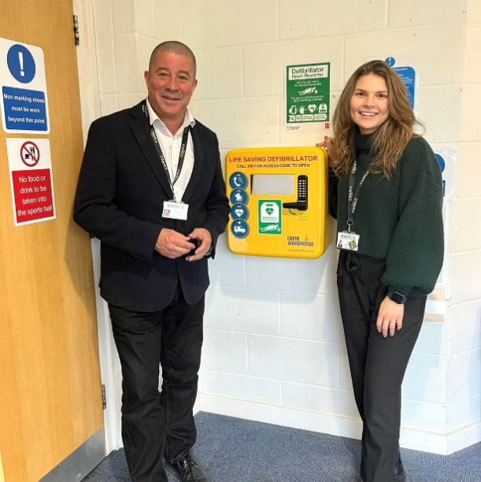 | A community centre has installed a second life-saving defibrillator, thanks to funding from an East Suffolk councillor.  Stuart Lawson, councillor for Kesgrave ward, donated £2,000 from his Enabling Communities Budget to the Kesgrave War Memorial Community Centre to support the installation of a new defibrillator.  The defibrillator, which can be used to give an electric shock to the heart of someone in cardiac arrest, is located inside Kesgrave Sports Centre, and supports an existing device located on the outside of the Community Centre, off Twelve Acre Approach.
East Suffolk Council’s Enabling Communities Budgets support activities delivered by community, voluntary and social enterprise organisations. Distributed equally among the council’s 55 members, each ward councillor has a £7,500 Enabling Community Budget to spend on community projects or to develop new projects which tackle community needs in their area.
Previous projects which have benefitted from Enabling Community Budget funding include play areas, village hall refurbishments and equipment, community events and projects supporting people with disabilities.
Local youngsters inspire new-look castle themed play area
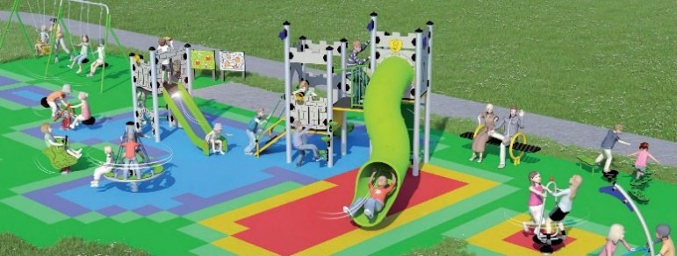 | Work is underway on the refurbishment of a popular play area in Carlton Colville.  The Matlock Dale play area is undergoing work as part of a joint improvement programme between East Suffolk Council and Carlton Colville Town Council.
Last summer, local youngsters were consulted on the type of play equipment they would like to see installed at the site.
The funding will be used to create and support additional roles, offering advice and support to tenants and landlords, and taking enforcement action against those who continue to let poor quality housing.
It will also enable the councils to continue working collaboratively, pooling resources to improve the standards of privately rented homes as part of the Suffolk PRS - Empower, Encourage, Enforce project.
Focusing on engagement, the project will give landlords, tenants and communities a better understanding of their rights and responsibilities. Eligible landlords and tenants will also be signposted to available grants to assist with the cost of improving properties.
Imported food products surrendered following vehicle spot check
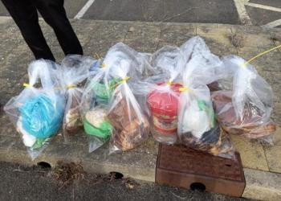
Food inspectors from East Suffolk Council helped intercept a quantity of suspected illegally imported meat following a vehicle stop in Lowestoft.
The meat was discovered, along with a quantity of eggs, in the back of a white van travelling from Romania into Great Britain, via the Port of Dover.
The discovery was made during a multi-agency spot check of vehicles, in Lowestoft, on Friday 3 February.
East Suffolk Council’s Food and Safety team investigated the contents of the vehicle following a request for assistance from Suffolk County Council Trading Standards colleagues.
The van was found to contain mainly pork, eggs and other food, which the occupants of the vehicle claimed was for personal consumption. It was also found to contain weighing scales and a refrigerator.
Although East Suffolk’s officers were prepared to use powers to seize the meat, the occupants of the vehicle agreed to voluntarily surrender all of the products that were taken to an incineration plant for safe destruction.
Since September, strict controls restricting the movement of pork and pork products into Great Britain to help safeguard Britain’s pigs from the threat of African swine fever.
It is also against the law to bring pork or pork products weighing over two kilograms into Great Britain unless they are produced to the EU's commercial standards.
Pitch perfect…with help of Enabling Communities Budget funding
A group of East Suffolk councillors have provided grant funding to help protect the playing surface at a local football club.  The four Lowestoft councillors each contributed Enabling Communities Budget funding towards the maintenance of grounds equipment belonging to Kirkley and Pakefield FC. | 
The long-established, grassroots club provides a venue for more than 550 players on some 25 youth teams and six adult teams, supported by volunteer coaches, managers and maintenance crews.
Kirkley and Pakefield Football Club is set over a 10-acre site, which accommodates five youth pitches, two adult pitches and two artificial turf pitch (ATP) areas. The maintenance of these is the sole responsibility of dedicated volunteers, with a weekly cycle involving mowing and aerating the turf, marking of the pitches and brushing of the ATPs to ensure they are in tip-top condition for longer.
Surveys and consultations
As always, we want to encourage participation in surveys and consultations, as feedback from people in East Suffolk is invaluable and helps us ensure we’re making the right decisions for our communities.

- Draft Coastal Adaptation Supplementary Planning Document
Consultation on document providing guidance on planning policy approaches along the coast from Holkham to Landguard Point. Comments on the Draft Coastal Adaptation Supplementary Planning Document must be submitted by 5pm on Wednesday 8 March 2023.
Draft Coastal Adaptation Supplementary Planning Document

- Proposed Changes to Conservation Areas in Southwold
Proposals to extend the existing Southwold Conservation Area, including to become amalgamated with the northern part of the Southwold Harbour and Walberswick Quay Conservation Area. Feedback should be provided by 5pm on Wednesday 15 March.
Proposed Changes to Conservation Areas in Southwold

- Rural Development Supplementary Planning Document
Initial consultation on document providing guidance on rural developments such as barn conversions, rural worker dwellings, farm diversification, annexes, economic development, equestrian developments and more. Feedback should be provided by 5pm on Wednesday 15 March.
Proposed Changes to Conservation Areas in Southwold

- Custom and Self-Build Housing Supplementary Planning Document
Initial consultation on document defining custom and self-build housing. Feedback should be provided by 5pm on Wednesday 15 March.
Proposed Changes to Conservation Areas in Southwold

- Extended consultation on Leiston Town Centre Masterplan Framework Document
Further consultation period, to be launched in January, on a masterplan and supporting framework for the centre of Leiston.
Leiston Town Centre Masterplan

Staying up to date on the latest East Suffolk news
The Communications Team shares all media coverage on SharePoint, so you can easily stay up to date on all media stories relevant to East Suffolk Council, whether on local, regional or national news outlets, tv, radio, print or online.
Access these at any time at https://eastsuffolkgovuk.sharepoint.com/sites/Communications/Lists/Media%20coverage/AllItems.aspx
If you have any questions or need any help with this service, you can email the team on communications@eastsuffolk.gov.uk
Don’t forget to share your own news!
We do a lot of great work in East Suffolk and we want everyone to know! I would therefore like to encourage all Councillors to share their own good news stories with the Communications Team so they can help showcase some of this work, whether this is from projects funded through your Enabling Communities Budget or supporting an initiative which will benefit our local communities.
You can email the team on communications@eastsuffolk.gov.uk
Social media
We keep our communities up to date in a variety of ways and social media has an important role to play. Please follow us and share our posts with your audiences!
Facebook: www.facebook.com/eastsuffolkcouncil
Twitter: https://twitter.com/EastSuffolk
Diary dates
- 6th March at 10.30am – Strategic Planning Committee (Conference Room, Riverside)
- 7th March at 11am – Anglia Revenues and Benefits Partnership Joint Committee (Level 5 Meeting Room, Breckland House)
- 7th March at 6.30pm – Cabinet (Deben Conference Room, East Suffolk House)
- 9th March at 4pm – Southwold Harbour Management Committee (Stella Peskett Millennium Hall)
- 9th March at 6.30pm – Framlingham, Wickham Market and villages Community Partnership (Venue TBC)
- 13th March at 6.30pm – Audit and Governance Committee (Deben Conference Room, East Suffolk House)
- 14th March at 2pm – Planning Committee North (Conference Room, Riverside)
- 15th March at 2pm – Community Partnership Board (Riverside Centre, Stratford St Andrew)
- 15th March at 6.30pm – Full Council (Conference Room, Riverside)
- 28th March at 2pm – Planning Committee South (Deben Conference Room, East Suffolk House)

Climate action blueprint bolsters environmental ambition
East Suffolk Council has reinforced its commitment to protecting the environment by setting out the guiding principles of its response to the climate emergency.
A comprehensive Climate Action Framework has been published to chart our response to date, while helping to guide further meaningful progress towards a more sustainable future.
The document aims to further uphold these commitments by gauging efforts to reduce our own carbon footprint, outlining wider partnership programmes, and looking forward to the next period of action.
Caring for our environment was made a key principle of the East Suffolk Council Strategic Plan when it was approved in 2020 with an agreement to launch an ambitious programme of more than 110 projects related to climate change and the environment, overseen by group of officers and monitored by a cross-party task group of elected members.
The Strategic Plan’s commitment to 'put the environment at the heart of everything we do' had been reinforced by the declaration of a climate emergency in 2019 and a commitment to reach net zero by 2030.
Since then, work to deliver the programme has included decarbonising our HGV fleet and updating policies to incorporate national guidance on responding to climate change through procedures such as sustainable construction and transport.
Investments such as energy efficiency upgrades across our buildings and assets have contributed to a reduction in emissions of more than 358%, while an ongoing major project to decarbonise our leisure centres will further reduce our footprint and ensure these important facilities remain accessible.
Cllr James Mallinder, East Suffolk Council cabinet member for the environment, said: “We are committed to doing everything we can to respond to the climate emergency and enabling everyone in East Suffolk to also play their part. Every one of us has the power to make small actions add up to big change.
“Not only are we committed to reaching net zero CO2e emissions by 2030, but we are also working with other councils and partners to help Suffolk, as a county, reach the same target.
“Our Climate Action Framework demonstrates the many consequent benefits of that work, from improving air quality, to boosting wellbeing, lowering energy costs and creating jobs.”
Beyond decarbonising our energy production and transport, the Climate Action Framework encompasses numerous other key factors in addressing climate change – from reducing our use of resources to restoring our natural eco-systems.
The framework will be a working document, updated every quarter, with new sections added as information emerges, and other actions removed when completed in line with the East Suffolk Council core environment programme.
The core environment programme’s priorities include reducing our footprint to deliver net zero, delivering low carbon energy projects and low energy homes, boosting biodiversity and restoring natural habitats, supporting low carbon transport and reducing use of resources.
ENDS.
The Suffolk Climate Emergency Plan sets out a commitment by Suffolk’s public sector leaders to pursue net zero strategies that respond to local, national and international evidence.

   | Tom Potter | Press and Publicity Officer  East Suffolk Council  07916 785542  Chat with me on Microsoft Teams  He/him  www.eastsuffolk.gov.uk  www.eastsuffolkmeansbusiness.co.uk  Our ambition is to deliver the best possible quality of life for everyone who lives in, works in and visits East Suffolk.  We are East Suffolk

8 March 2023 – for immediate release

Love East Suffolk this spring
East Suffolk residents are encouraged to get involved in community litter picking this spring.

East Suffolk Council’s popular ‘Love East Suffolk’ scheme invites local groups to organise a litter pick in their community for the benefit of residents and the environment, and supports the national Great British Spring Clean campaign organised by Keep Britain Tidy.

Litter picking equipment, including hi-vis vests, litter pickers and bags are available for participating groups to collect from Ufford or Lowestoft, and arrangements can be made for collected litter to be removed by East Suffolk Norse.

Cllr James Mallinder, East Suffolk’s cabinet member for the Environment said: “It is always encouraging to see communities getting involved in litter picking, which makes a huge difference to wildlife and the appearance of an area, and we know that other residents really appreciate the efforts of those who voluntarily pick up litter, helping to keep East Suffolk a beautiful place in which to live, work and visit.

“It is a shame that litter picks are needed at all but unfortunately some people think it is acceptable to dump their rubbish wherever they like. It would be far better if everyone took responsibility for their own rubbish and disposed of it correctly, using litter bins or taking it home, instead of expecting other people to pick it up on their behalf.”

Participating groups are invited to contribute photos of their litter pick which can be shared on the Council’s website and social media channels in recognition of their hard work. Photos can be sent to communications@eastsuffolk.gov.uk

To register your litter pick, please visit https://eastsuffolk.co/love
ENDS.

Karla Supple | Senior Communications & Marketing Officer
East Suffolk Council
07500 223084
Chat with me on Microsoft Teams
Pronouns she/her
www.eastsuffolk.gov.uk
www.eastsuffolkmeansbusiness.co.uk

Our ambition is to deliver the best possible quality of life for everyone who lives in, works in and visits East Suffolk.
We are East Suffolk

4.To APPROVE Minutes of Parish council meeting 06/03/2023 – Not written in minutes will add to agenda for April meeting.
5. To COMMENT on Planning DC/21/0347/OUT Land east of 23a Mill Road Approval of reserved matters outline application erection of detached dwelling. – Neither support or object
6.To DISCUSS Bus Shelter needs some attention would be nice to be same colour as The Fox Inn. do same colour as Fox. AJS services to repair the roof. No helpers Volunteered to help.
7.To DISCUSS play area the sub committee will meet to discuss the play area before the next meeting and will ask AJS Services to look at steps to slide.
8.To DISCUSS Church Roof if the parish council will look to donate some money towards the roof repair costs. It was agreed the Parish council will donate £200.00 towards the roof repairs the cheque will be issued in next meeting as the clerk is absent.
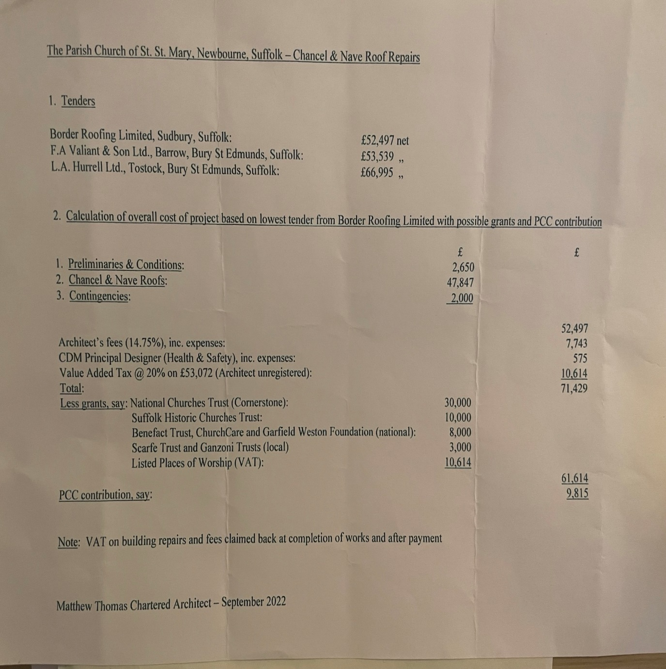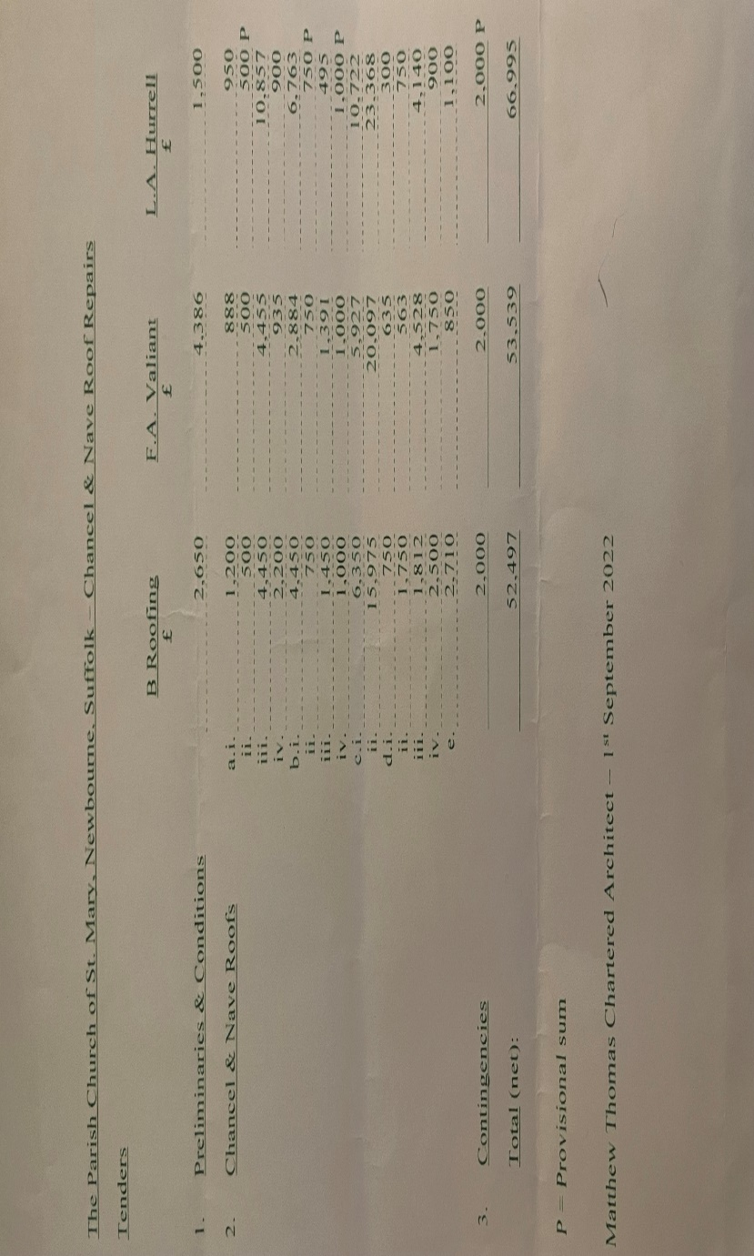

9. To DISCUSS Coronation Village Day the subcommittee will meet before next meeting and update everyone in April Meeting.
10. To DISCUSS green infrastructure agreed to keep on the agenda. Can add things like how we recycle, are carbon aware etc to our advertising etc. Clerk to send out more information regarding this.
11.Finance
CHEQUE NUMBER 100474 HMRC £123.60
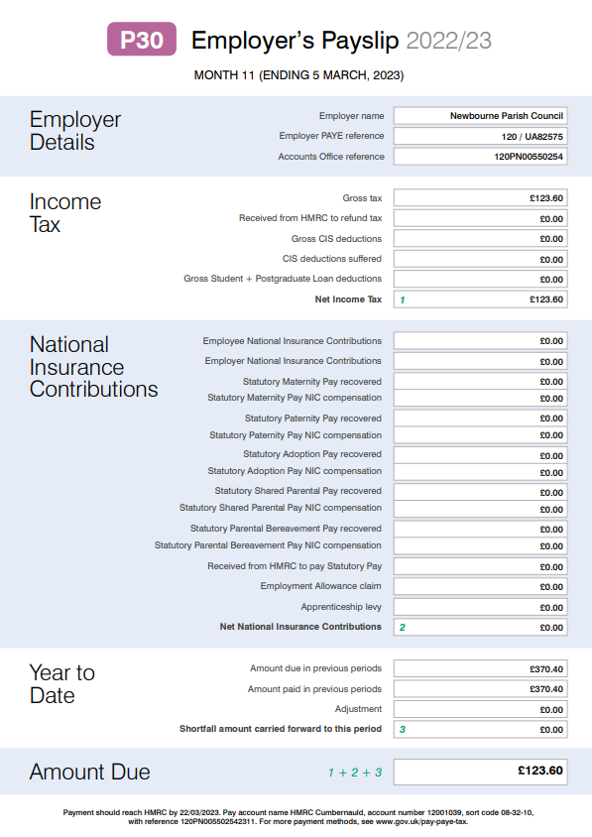

CHEQUE NUMBER 100475 WAGES £493.90

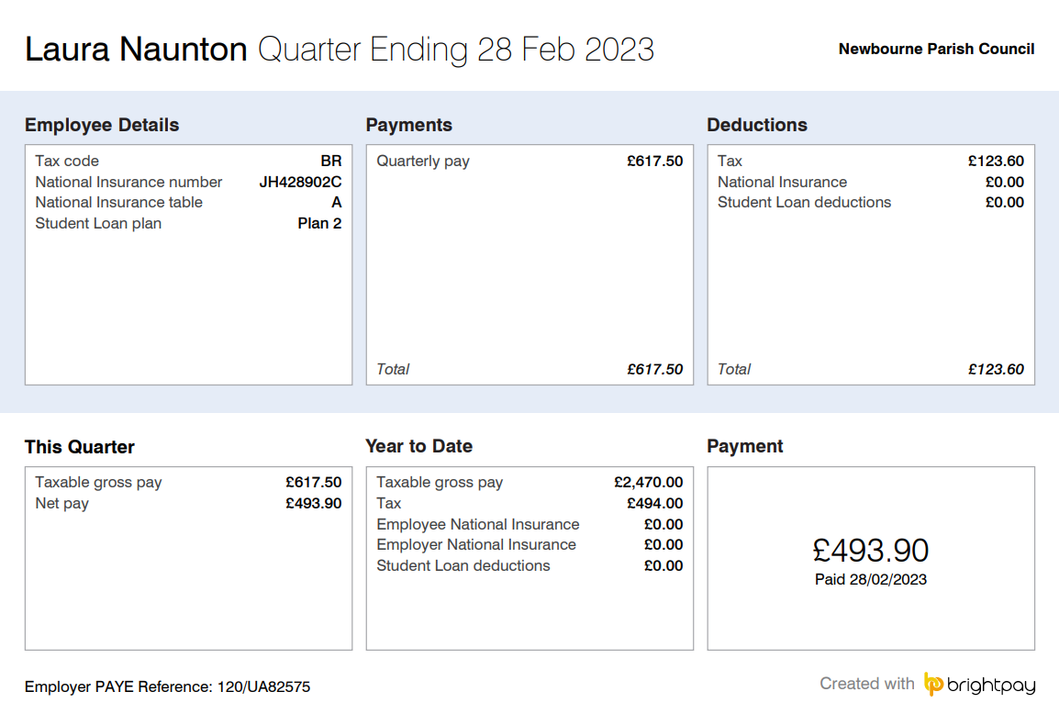

Cheque number 100476 £71.19 to L Naunton – Ink and Apple tag to track the defibrillator.
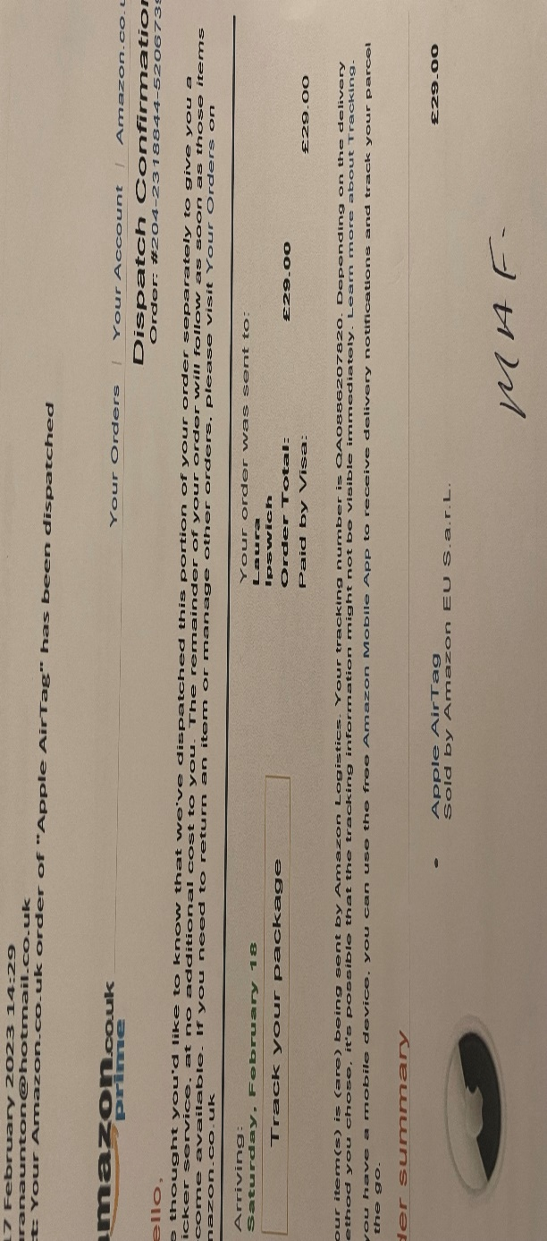
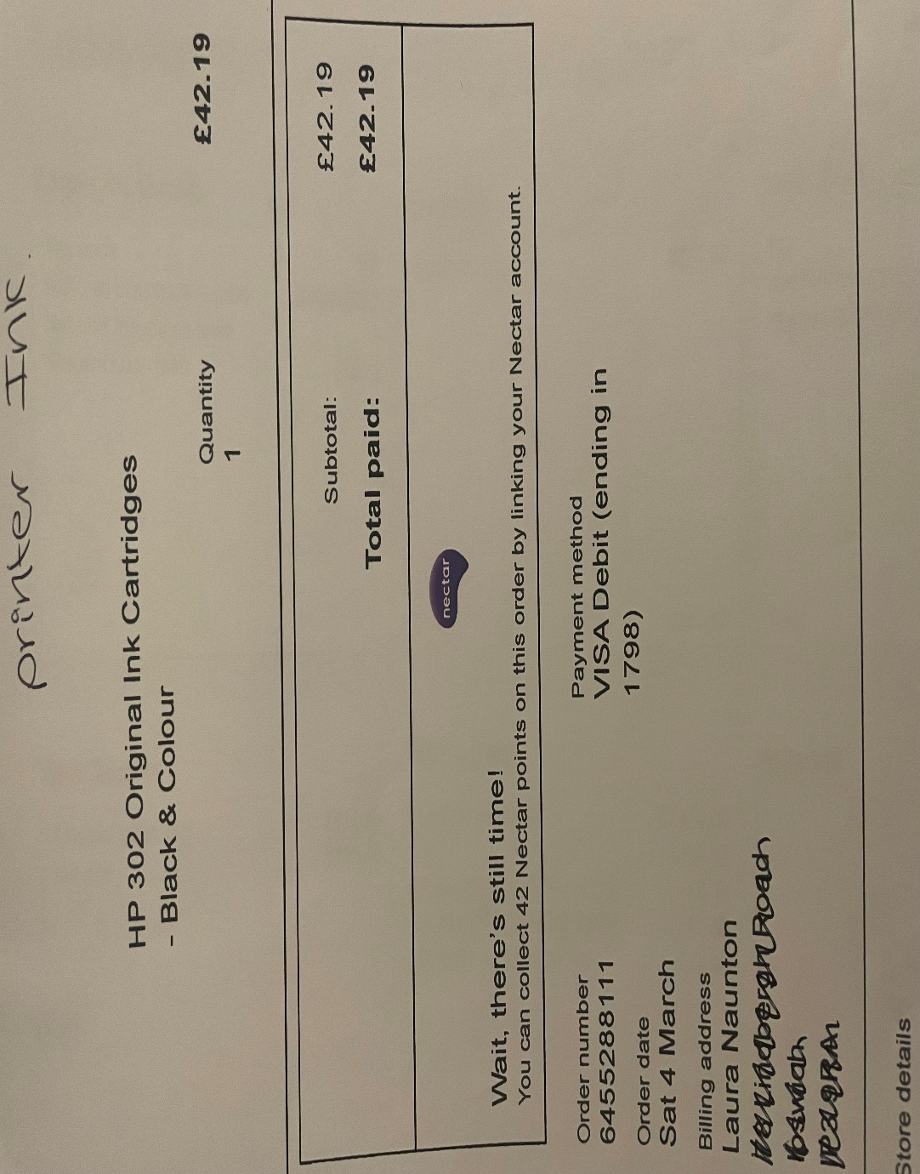

Cheque Number 100477 AJS Services – Grass Cutting £180.00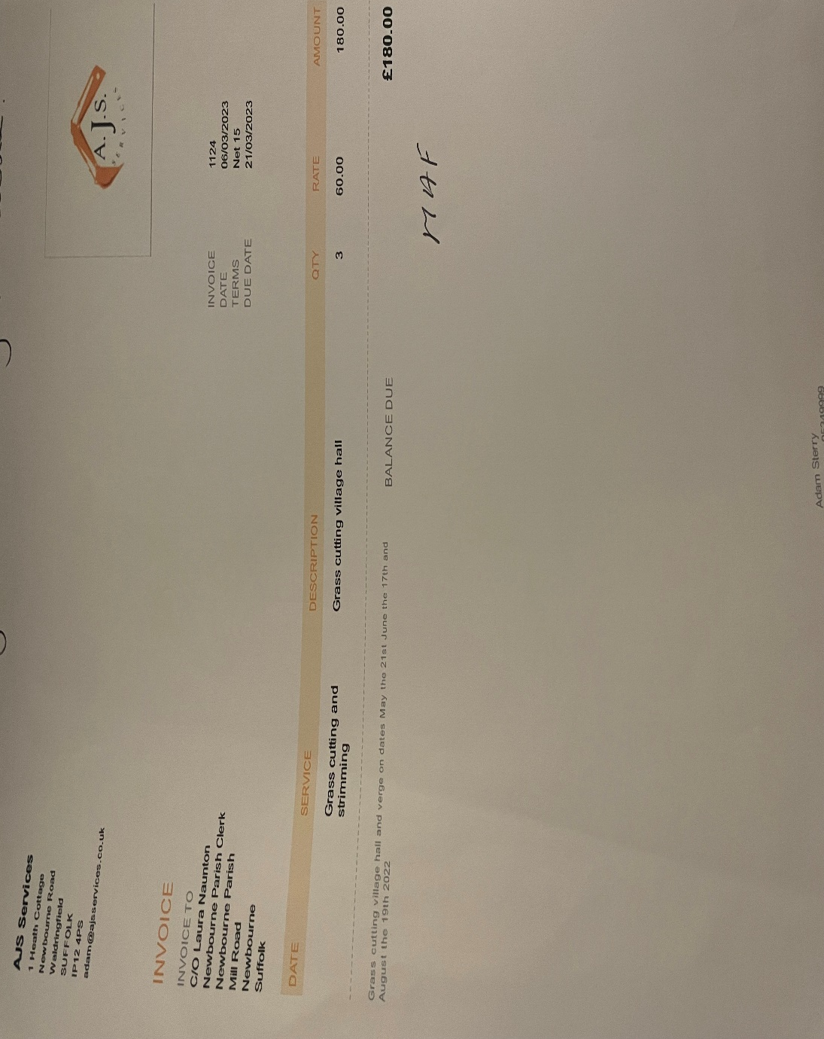

Bank Statement
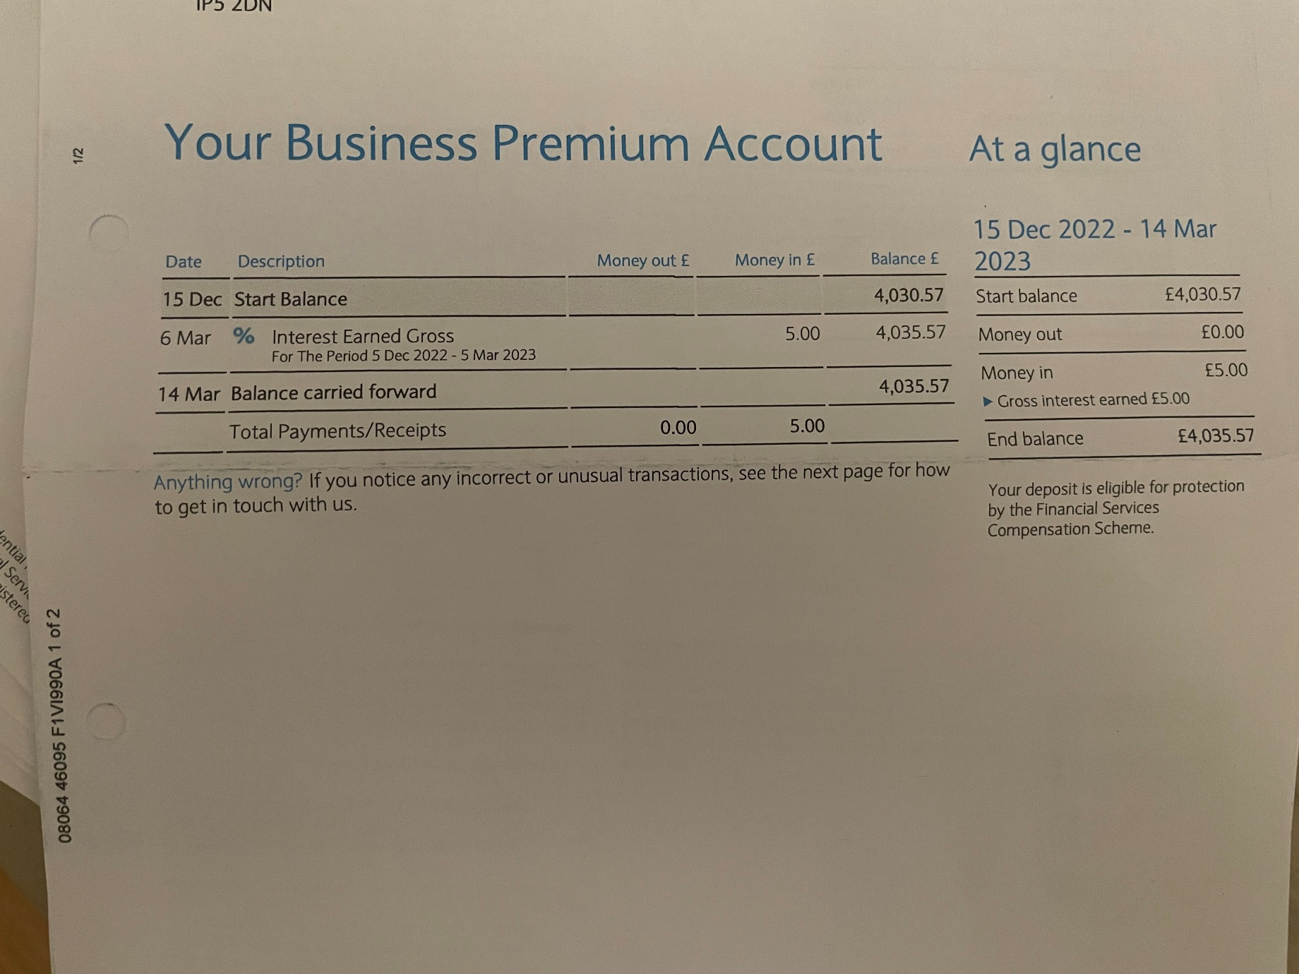

Date of next meeting 03/04/2023

