BARCLAYS NEWBOURNE PARISH COUNCIL
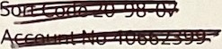
SWIFTBIC BUKBCB22
IBAN GB49 BUKB 2098 0740 6623 99
Issued on 06 June 2022
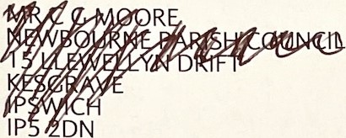
Your Community Account | At a glance
05 May - 01 lun 2022

Start balance
5 May Start Balance 18,857.94 Money out E578.91
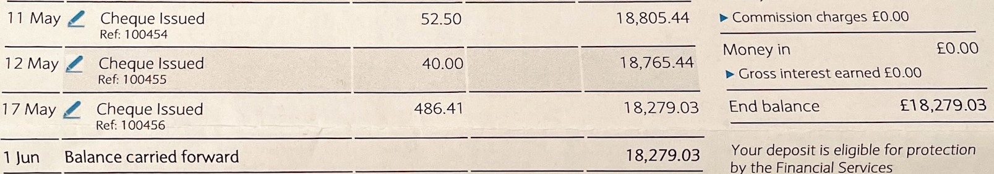Total Payments/Receipts 578.91 0.00
Compensation
Scheme.

Anything wrong? If you notice any incorrect or unusual transactions, see the next page for how to get in touch with us.
