Minutes of Newbourne Parish Council held on 09/01/2023.

Public Time
- It has been raised that residents at Newbourne Park on Watermill Road are not leaving the properties between 5th January and 5th February therefore breaking planning regulations.
- Pardon the weeds we are feeding the bees. Concerns over the verges getting overgrown and looking messy. No areas agreed yet. Terence has spoken about this and sent a very detailed email with pictures of possible sites I will resend this and attach it to the minutes and agenda email so everyone can read it before next meeting. It was discussed the possible areas while some do not agree with using the verges as they are used for people to step off the road but there are other areas in the village near the village hall etc that could be used.
- Parking on the verge opposite The Fox. Vehicles are still parking on the verge opposite The Fox even though they can use the pub carpark. Pat Frost will look into cost of Planters to put on the verge to stop the problem. This will be put as an agenda item for next meeting.
- ESC Michael Richardson has agreed to put some money towards new play area and would look to put money towards Pardon the weeds we are feeding the bees.
- It was raised that comments on planning DC/22/0573/OUT by a councillor was submitted to planning with incorrect comments regarding parish council comments. Clerk will address the issue and update.
Meeting opened 19:45pm
- To RECEIVE apologies for absence Cllr Grainger, ESC Mulcahy and ESC Kerry
- Report received from ESC Michael Richardson.
Leader’s monthly bulletin – January 2023
Welcome to the January edition of my monthly bulletin – and the first of 2023 – aimed at keeping Councillors up to date on the main news stories from East Suffolk and, where possible, giving you a heads up on emerging issues.

I would like to wish everyone a very happy new year. Despite obvious challenges, I am proud of what the Council has been able to achieve over the last 12 months, and I look forward to what more can be accomplished in the year to come.

Regards,
Steve

Steve Gallant
Leader of East Suffolk Council

Approval granted for £2.75m from Government’s UK Shared Prosperity Fund
East Suffolk Council has been allocated £2.75m from the UK Shared Prosperity Fund (UKSPF) to invest across two and a half years in initiatives that will address inequality and contribute to levelling up.
The funding will be used to support high streets, local businesses, workforce and community skills development, as well as supporting those struggling with the cost of living crisis.
In April 2022, the Government launched the UKSPF to support its Levelling Up agenda by building ‘pride in place’ and increasing life chances across the UK, focusing on communities, and supporting local business, people and skills.
The East Suffolk Investment Plan contains a number of key programmes, based on new and existing schemes, to be delivered either locally or collaboratively with other local authorities. More details can be found here.
Additionally, the Council has been allocated £1.129m under the Rural England Prosperity Fund (REPF), part of the UKSPF, which aims to support small business and community infrastructure in rural areas.
World Championship off-road cycling event returns to Trinity Park
An action-packed championship cycling event returned to East Suffolk in December.  More than 600 riders, representing 20 different nations, descended on Trinity Park for the UCI Masters Cyclo-Cross World Championships, racing along a purpose-built circuit featuring obstacles, bends, muddy slopes and bridges. | 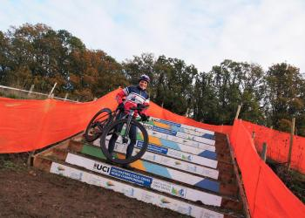
Supported by East Suffolk Council and staged at the same venue for the first time last year, the event sees riders aged 35 or over, who no longer compete in an Elite Professional Team, pitted against each other across five age groups containing many former pros, Olympians, national champions and some of the best Cyclo-Cross age category riders the world has to offer, including European Champion (50-54), Cordula Neudörffer (pictured).

The weekend of competition also featured open races for riders of all ages, as well as a Special Olympics Cyclo-Cross event.

Schools in the Ipswich and South Suffolk School Games partnership also came together for a morning of cycling activity organised in partnership between Active Suffolk, British Cycling, East Suffolk Council and Elmy Cycles, and involving the Suffolk RoadSafe partnership, Suffolk Constabulary, schools outreach organisation Kinetic Science, art organisation Rock Paper Scissors, British Cycling and Loose Cannon's Conditioning.

Digital Springboard launched to provide digital boost for businesses
 | A new online service has been introduced to provide a digital boost for businesses in East Suffolk.  Launched on behalf of East Suffolk Council by not-for-profit company MENTA, the Digital Springboard offers access to support, resources, workshops and grants for businesses hoping to create or improve online presence.
The project is the latest component of a wider Digital Towns programme already being rolled out across East Suffolk with the installation of free-to use public Wi-Fi linked to footfall counter technology and accompanying analytics.

The ambitious programme has been funded by the New Anglia LEP’s Innovative Projects Fund, the Getting Building Fund, and East Suffolk Council internal funding, and aims to strengthen the local economy and improve connectivity within the district's market towns.

Alongside masterclasses on various digital themes, the launch of a ‘Digital MOT’ profiling tool will provide analysis and insights for businesses on their current digital capabilities, while businesses that progress through the programme will also be able to apply for a small Digital Grant to support their business growth journey.

The Digital Springboard website is simple, quick, and fun way to access the full programme including free resources, one-to-one support and events, to help people grow their digital skills and business reach. The Digital Springboard can be found by following this link.

Suffolk councils’ successful bid for housing fund pot
Suffolk's local authorities are delighted to have been awarded funding by the Local Government Association to commission a vital, county-wide housing strategy review.

The £20,000 pot will kickstart a programme which aims to increase the number of genuinely affordable properties available to meet those in housing need.

The Housing Advisers Programme grant is designed to support councils seeking to innovate and will fund the provision of bespoke expert support to councils.

Suffolk’s successful bid was led by East Suffolk Council, which will work with Suffolk County Council, Ipswich Borough Council, Babergh District Council, Mid Suffolk District Council and West Suffolk Council – identifying opportunities to bridge the gap between supply and demand.

Working together as the Suffolk Housing Board, the councils have identified 900 properties available for rent, 5,000 properties marketed for sale, 1,000 long term empty homes and 6,000 second homes. And yet, despite this, there are currently a significant number of households living in unsatisfactory, unsuitable accommodation, experiencing, or at risk of homelessness.

The Suffolk Housing Board has agreed to establish a project which will agree proposals that remove barriers to accommodating people, as well as gaps in policies where accommodation solutions could be encouraged. The councils will use this opportunity to join up their approaches, exploring ideas such as resource pooling, funding empty home renovations, early engagement, legal advice and community engagement.
Free augmented reality walking trail app launched during Christmas holidays
 | A new augmented reality app was launched in the lead up to Christmas, offering a free activity for children and their families to enjoy in Lowestoft and Felixstowe.  Launched by East Suffolk Council in partnership with AR Trails, and free to download on Apple and Android devices, the ESCape Trails app challenges users to solve clues, collect characters and earn badges as they go.
The inaugural trails move through East Suffolk Free Wi-Fi zones in Lowestoft and Felixstowe, so participants need not use their own data to take part. The Lowestoft Christmas Adventure (2.4 miles) and the Felixstowe Christmas Adventure (two miles) were lined with virtual presents for youngsters to find, collect and interact with along the way.

East Suffolk Council has also worked with Go Jauntly to develop outdoor adventures across all 12 of the district's principal towns and villages as part of the Digital Towns programme, which has seen the installation of free public Wi-Fi, digital footfall counters and town marketing platforms, alongside business support, in nine East Suffolk towns to date, including Felixstowe, Lowestoft, Southwold and Woodbridge.

More time for public to have say on masterplan for Leiston town centre
Consultation on a masterplan and supporting framework for the centre of Leiston has been extended in response to the encouraging level of feedback so far received.
The Leiston Town Centre Masterplan Framework Document had been due for publication at the end of December 2022. However, due to the volume of feedback received to date, a further public consultation period will be launched in January to allow as many people as possible to contribute.
The design team, having worked closely alongside East Suffolk Council’s Economic Regeneration team, wants to ensure that there is sufficient time for ongoing consultation work and consideration of draft proposals.
The updated timeframe for delivery of the project will include further public online consultation to consider the draft masterplan and supporting framework, starting in early January, with publication of the final Masterplan Framework Document set for the end of March.
The development of the work is being led by East Suffolk Council, working in partnership with Leiston Town Council, Leiston Community Land Trust, Leiston Together and Suffolk County Council.
The masterplan and supporting framework will include improvements to public spaces and better connectivity between key locations, as well as enhanced cycling and walking routes, while also being used to identify redevelopment opportunities over the next 10 to 15 years and to help attract investment.
LDA Design, commissioned by East Suffolk Council to deliver the masterplan, brings extensive knowledge and experience to the project, and recently completed a Traffic Management Strategy for Leiston, which will also inform the work.
New and improved beach access ramp unveiled at Felixstowe seafront
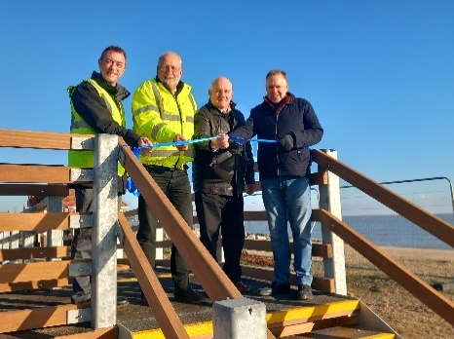 | Local residents and visitors to Felixstowe can enjoy improved access to the seafront following completion of a new ramp.  Work began in autumn to install a replacement ramp at the South Seafront, linking the pavement along Sea Road and Orford Road to the beachfront, over the sea defence wall.
Located within Flood Zone 2, to the northern extent of Martello Park, the ramp will also provide a safe escape route in the event of the sea wall gates being closed in bad weather.
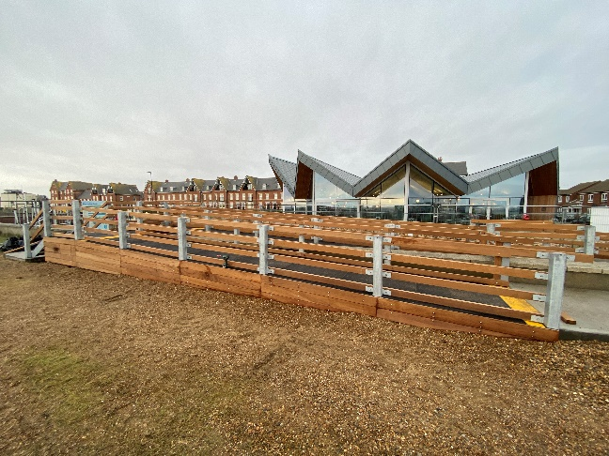
Wider by about one-and-a-half metres and longer by about five-and-a-half metres, the ramp also features the addition of steps from the beach on the southern elevation and a landing area within the mid-section along the Martello Park side, as well as slip resistant material and railings.
Designed by Framlingham based architect, Hollins, the main structure was built off-site in Great Blakenham by Elliston Steady & Hawes (Building) Ltd, before installation began on-site in September – overseen by local authority commercial partner, East Suffolk Norse.
The development forms part of wider ongoing investment in the South Seafront area, where the Martello Park has already delivered new homes, a play area and new car parking facilities, while East Suffolk Council has also invested in the development of a contemporary café, the refurbishment of two public shelters, and the long-term maintenance of an historic Martello Tower.
Meanwhile, work continues on a new Seashore Village and activity park further north along Sea Road.
Further along the East Suffolk coast, at Lowestoft’s South Beach, a new boardwalk was completed earlier this year to provide year-round access for people with disabilities, particularly wheelchair users, as well as people with pushchairs.
Surveys and consultations
As always, we want to encourage participation in surveys and consultations, as feedback from people in East Suffolk is invaluable and helps us ensure we’re making the right decisions for our communities.

- Extended consultation on Leiston Town Centre Masterplan Framework Document
Further consultation period, to be launched in January, on a masterplan and supporting framework for the centre of Leiston.
Leiston Town Centre Masterplan

- Renewal of Public Space Protection Orders
Public consultation on the proposed renewal of 13 Public Space Protection Orders (PSPOs) due to expire next year. Consultation closes at 5pm on 8 January 2023.
Public Space Protection Order consultation

- Lowestoft Flood Risk Management Tidal Barrier
A public consultation will run to Thursday 12 January 2023. Information
includes how construction is being planned, the impact on navigation and environmental studies.
Lowestoft Flood Risk Management Tidal Barrier Engagement

Staying up to date on the latest East Suffolk news
The Communications Team shares all media coverage on SharePoint, so you can easily stay up to date on all media stories relevant to East Suffolk Council, whether on local, regional or national news outlets, tv, radio, print or online.

Access these at any time at https://eastsuffolkgovuk.sharepoint.com/sites/Communications/Lists/Media%20coverage/AllItems.aspx
If you have any questions or need any help with this service, you can email the team on communications@eastsuffolk.gov.uk

Don’t forget to share your own news!
We do a lot of great work in East Suffolk and we want everyone to know! I would therefore like to encourage all Councillors to share their own good news stories with the Communications Team so they can help showcase some of this work, whether this is from projects funded through your Enabling Communities Budget or supporting an initiative which will benefit our local communities.

You can email the team on communications@eastsuffolk.gov.uk
Social media
We keep our communities up to date in a variety of ways and social media has an important role to play. Please follow us and share our posts with your audiences!
Facebook: www.facebook.com/eastsuffolkcouncil
Twitter: https://twitter.com/EastSuffolk

Diary dates
- 9th January at 10.30am – Licensing Sub-Committee (Deben Conference Room, East Suffolk House)
- 9th January at 2pm – Kesgrave, Rushmere St Andrew, Martlesham, Carlford and Fynn Valley Community Partnership (Tower Hall, Rushmere St Andrew)
- 10th January at 2pm – Planning Committee North (Conference Room, Riverside)
- 12th January at 4pm – Southwold Harbour Management Committee (Stella Peskett Millenium Hall)
- 12th January at 6pm – Framlingham, Wickham Market and villages Community Partnership (Remote meeting via Zoom)
- 16th January at 6.30pm – Licensing Committee (Deben Conference Room, East Suffolk House)
- 17th January at 2pm – Licensing Sub-Committee (Deben Conference Room, East Suffolk House)
- 19th January at 6.30pm – Scrutiny Committee (Conference Room, Riverside)
- 23rd January at 6.30pm – Audit and Governance Committee (Deben Conference Room, East Suffolk House)
- 24th January at 2pm – Planning Committee South (Deben Conference Room, East Suffolk House)
- 25th January at 6.30pm – Full Council (Conference Room, Riverside)
- 26th January at 6.30pm – Scrutiny Committee (Conference Room, Riverside)
- 30th January at 10.30am – Felixstowe Peninsula Community Partnership (The Hadwen Room, Felixstowe Library)
- 30th January at 2.30pm – Licensing Sub-Committee (Conference Room, Riverside)

- To RECEIVE declarations of pecuniary interest – None received
- To APPROVE the minutes of the Parish Council meeting held on the 09/01/2023.
Motion to approve from Cllr Scott & Cllr Frost
- To DISCUSS Pardon the weeds we are feedings the bees. Terence has spoken about this, and some councillors seem to be in favour of this while others are not keen. It was agreed that people would read the email look at possible sites, and we can vote next meeting. I have included the areas below which could be possible places in the village to use

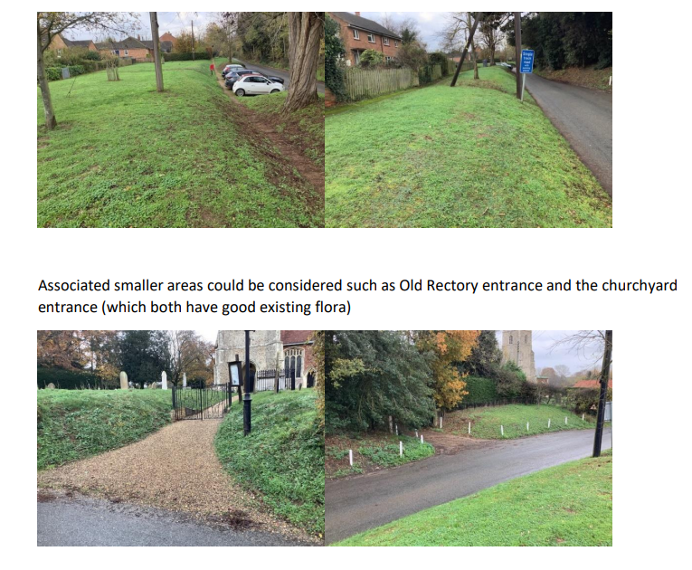
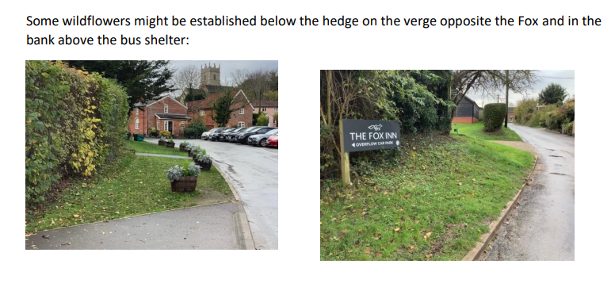
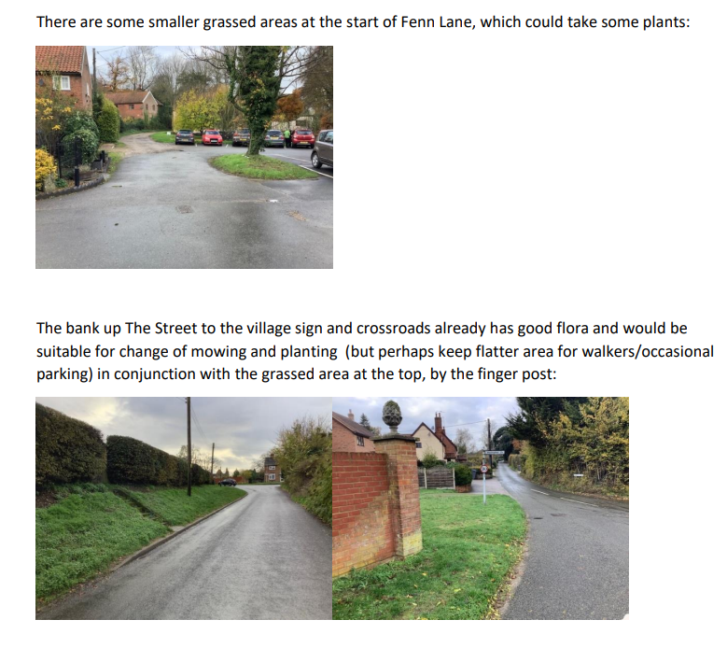
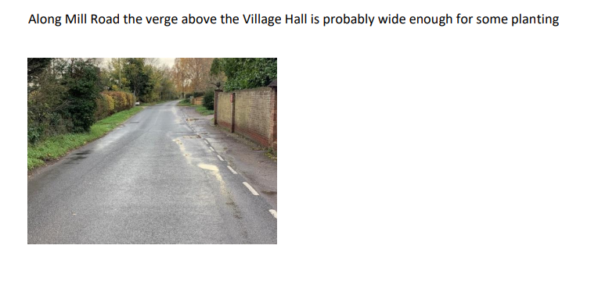
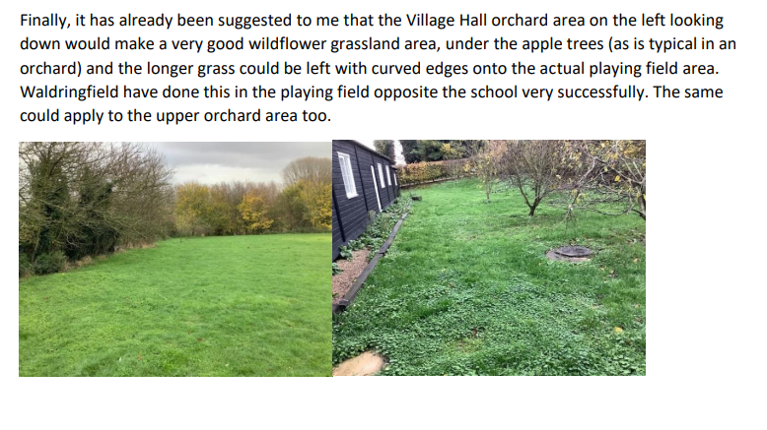
- To DISCUSS play area. No update in this meeting Andrew will arrange sub meeting to discuss play area and village day will add to agenda for February.
- To DISCUSS and agree Precept. Precept has been discussed in the previous meeting in December

Newbourne Parish council Precept currently is £6000.00

If we increased to £6500 for a band D property, there would be a % change of 6.40 a change of £3.47
If we increased to £7000 for a band D property, there would be a % change of 14.59 a change of £7.91
It was agreed that the precept that we required for 2023/ 2024 would be £6750.00
This means for a band D property, there would be a % increase of 10.19 and this would mean an increase of about £5.69.
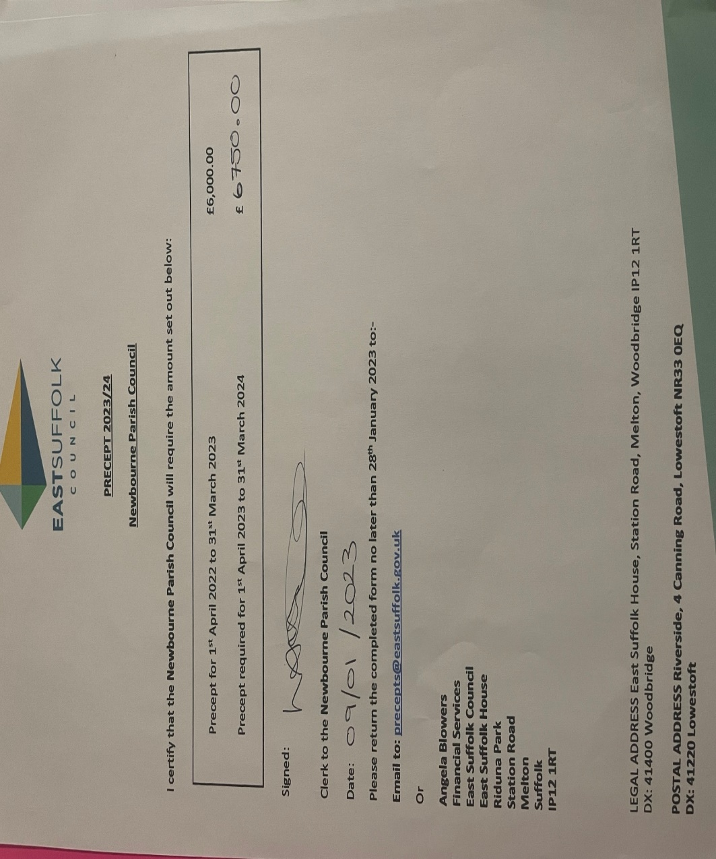

- Next events
Quiz – 04/02/2023 Advertised on noticeboard and local to Newbourne on Facebook.
Raffle prizes and quiz prizes have been organised. Quiz all in hand.
Village Day - 08/05/2023 Band is booked, and subcommittee will discuss and discuss in next meeting.
- Finance
No cheques to sign.

Current Account

DATE PAYMENT BALANCE
05/11/2022 £12,024.93
22/11/2022 Defibrillator £975.00 £11,049.93
07/12/2022 Clerk wages £494.10 £10,555.83
04/01/2023 £10,555.83

Cheques not cashed yet.
Protect and Detect speed camera £1800.00 chq number 100472
HMRC £123.40 Chq number 100470

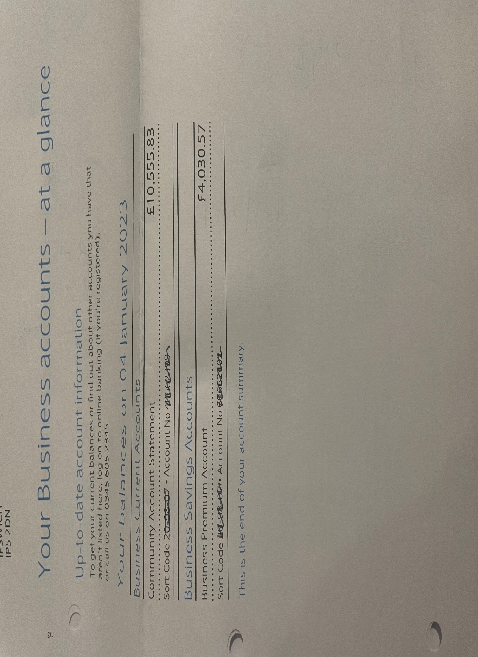

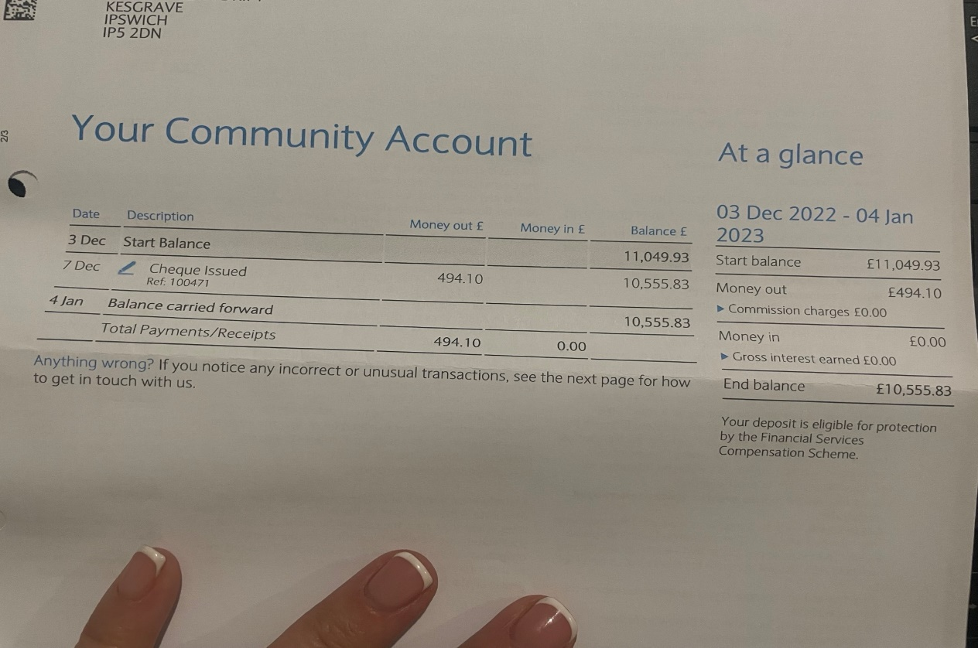

- Clerks Correspondence

I have been made aware of work being carried out at 16 Ipswich Road (Narnia) trees have been cleared, machinery is being stored there and there are containers there. No Planning permission has been received. I have made enquires and received the following.

Case Number: ENF/22/0326/DEV

Location:
16 Ipswich Road
Newbourne
Woodbridge
Suffolk
IP12 4NS

Possible Breach of Control: Removal of trees and laying of hardstanding

I have now concluded my investigation into the above breach. From the evidence I have gathered it has been determined that there is breach of control.

The land was visited on 5th September 2022 and the land use and development inspected. A hardstanding driveway with storage compound area was viewed.

The Town and Country Planning (General Permitted Development) (England) order 2015 states development is not permitted if;
(a) the height of any gate, fence, wall or means of enclosure erected or constructed adjacent to a highway used by vehicular traffic would, after the carrying out of the development, exceed—
(i) for a school, 2 metres above ground level, provided that any part of the gate, fence,
wall or means of enclosure which is more than 1 metre above ground level does not create an obstruction to the view of persons using the highway as to be likely to cause danger to such persons;
(ii) in any other case, 1 metre above ground level;
(b) the height of any other gate, fence, wall or means of enclosure erected or constructed
would exceed 2 metres above ground level; (Schedule 2, Part 2, Class A, A1).
Therefore, the fence is permitted development and would not required expressed permission from the Council.

However, it has been determined that the change of use would require planning permission which hasn’t been submitted and is therefore unauthorised. Additionally, the hardstanding and containers do not fall within any class of permitted development within the Town and Country Planning (General Permitted Development) (England) order 2015.

For this reason, the owner has been given a period of time to remove the containers, machinery and hardstanding and cease the use.

I apologise for any inconvenience and distress this investigation may have caused you.

Regards

   | Dominic Starkey | Assistant Enforcement Officer  East Suffolk Council  07796672759  www.eastsuffolk.gov.uk www.eastsuffolk.meansbusiness.co.uk  East Suffolk Council will continue to review and prioritise the delivery of its services during this unprecedented time.  The COVID-19 outbreak will severely impact what we are able to do, however we will continue to support and protect our communities, delivering the critical services you need.

January Update is that the given period to remove the containers, machinery and hardstanding and cease the use is due to be reviewed once I have an update I will update.

Also I have been advised that at 9 Ipswich road there is a caravan on the property with people living in there. They have been living in the caravan since covid but now the neighbours would like them moved on due to the amount of litter around the property which has been blown over Ipswich Road. It was discussed there are other caravans on properties in Newbourne but no complaints have been made regarding them. So the clerk will raise number 9 Ipswich Road with East Suffolk Council and if we have complaints regarding any other properties we can raise them in the future. Clerk will update when she has a response.

Update on previous planning applications

DC/22/0311/FUL Tumbledown Farm 14 Ipswich Road, Newbourne.
Variation of condition NO2 Demolish conservatories, extend, and raise eaves height with internal alternations. To reduce footprint of extension and retain roof height of existing house. Validated 12th October 2022
Permitted

DC/22/3881/OUT Grange Nurseries, Jackson Road Newbourne
Proposed dwelling.
Validated 03/10/2022
Refused

DC/22/2839/ROC Land opposite The Giants House, The Street Newbourne
Removal of condition No.4 and variation of condition No.5 of DC/18/0218/FUL Change of use to form overspill car park associated to the fox inn- timing restrictions.
Validated 26/07/2022
Permitted

