February 2024 Supporting Documents
Parish report from ESC Cllrs Mike Ninnmey & Lee Reeves
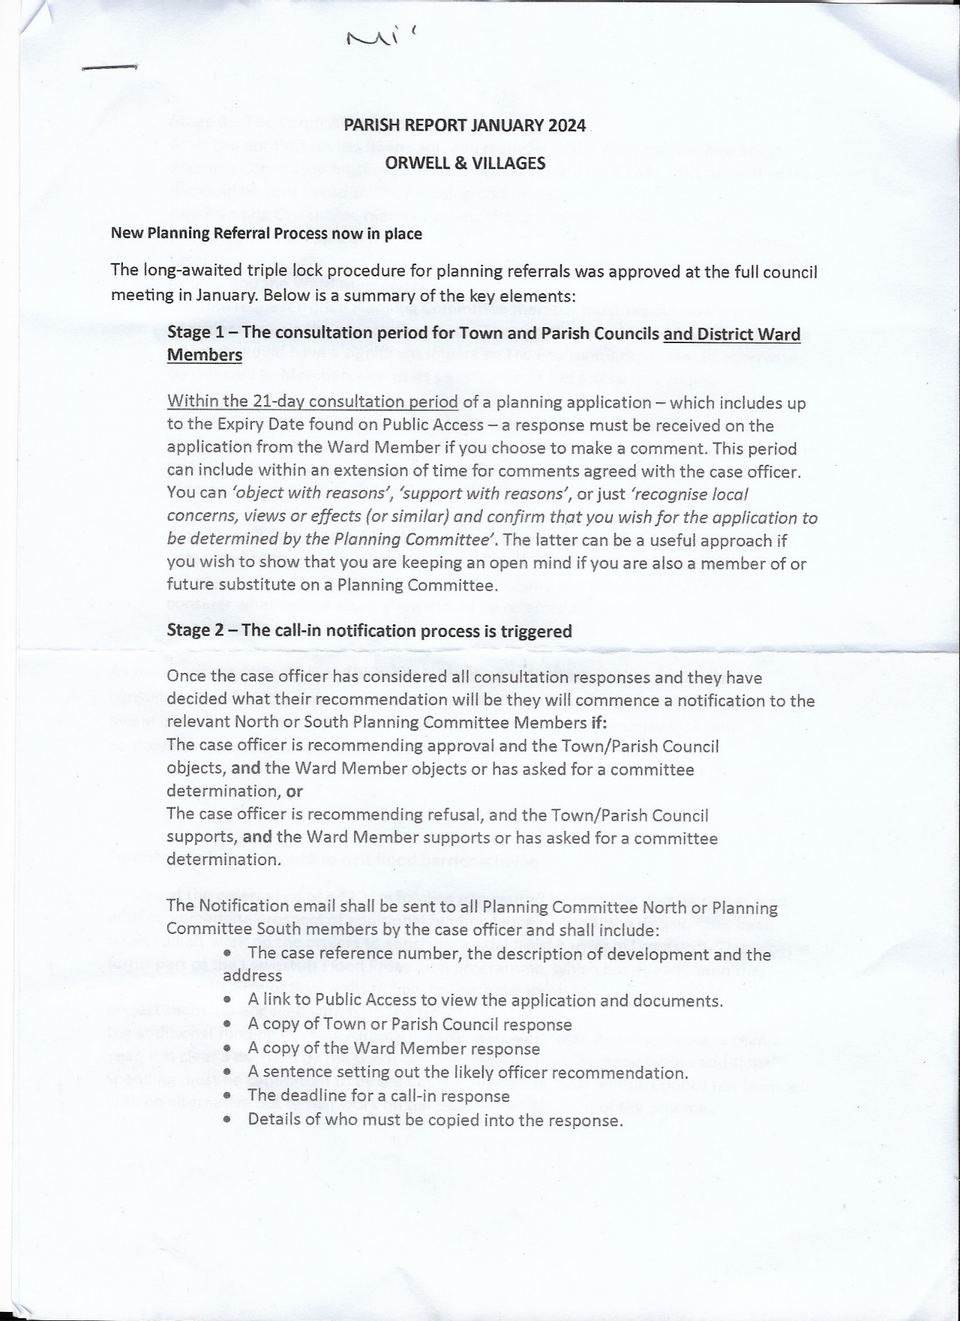
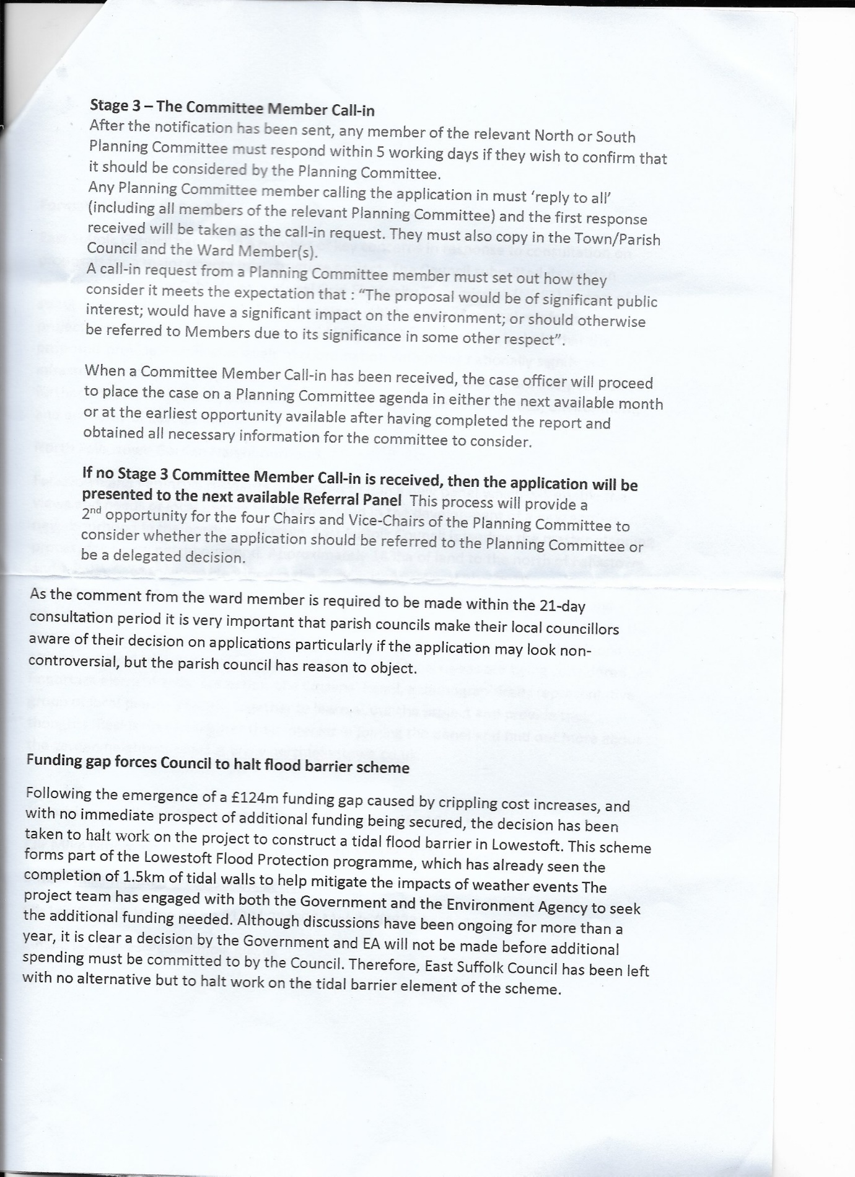
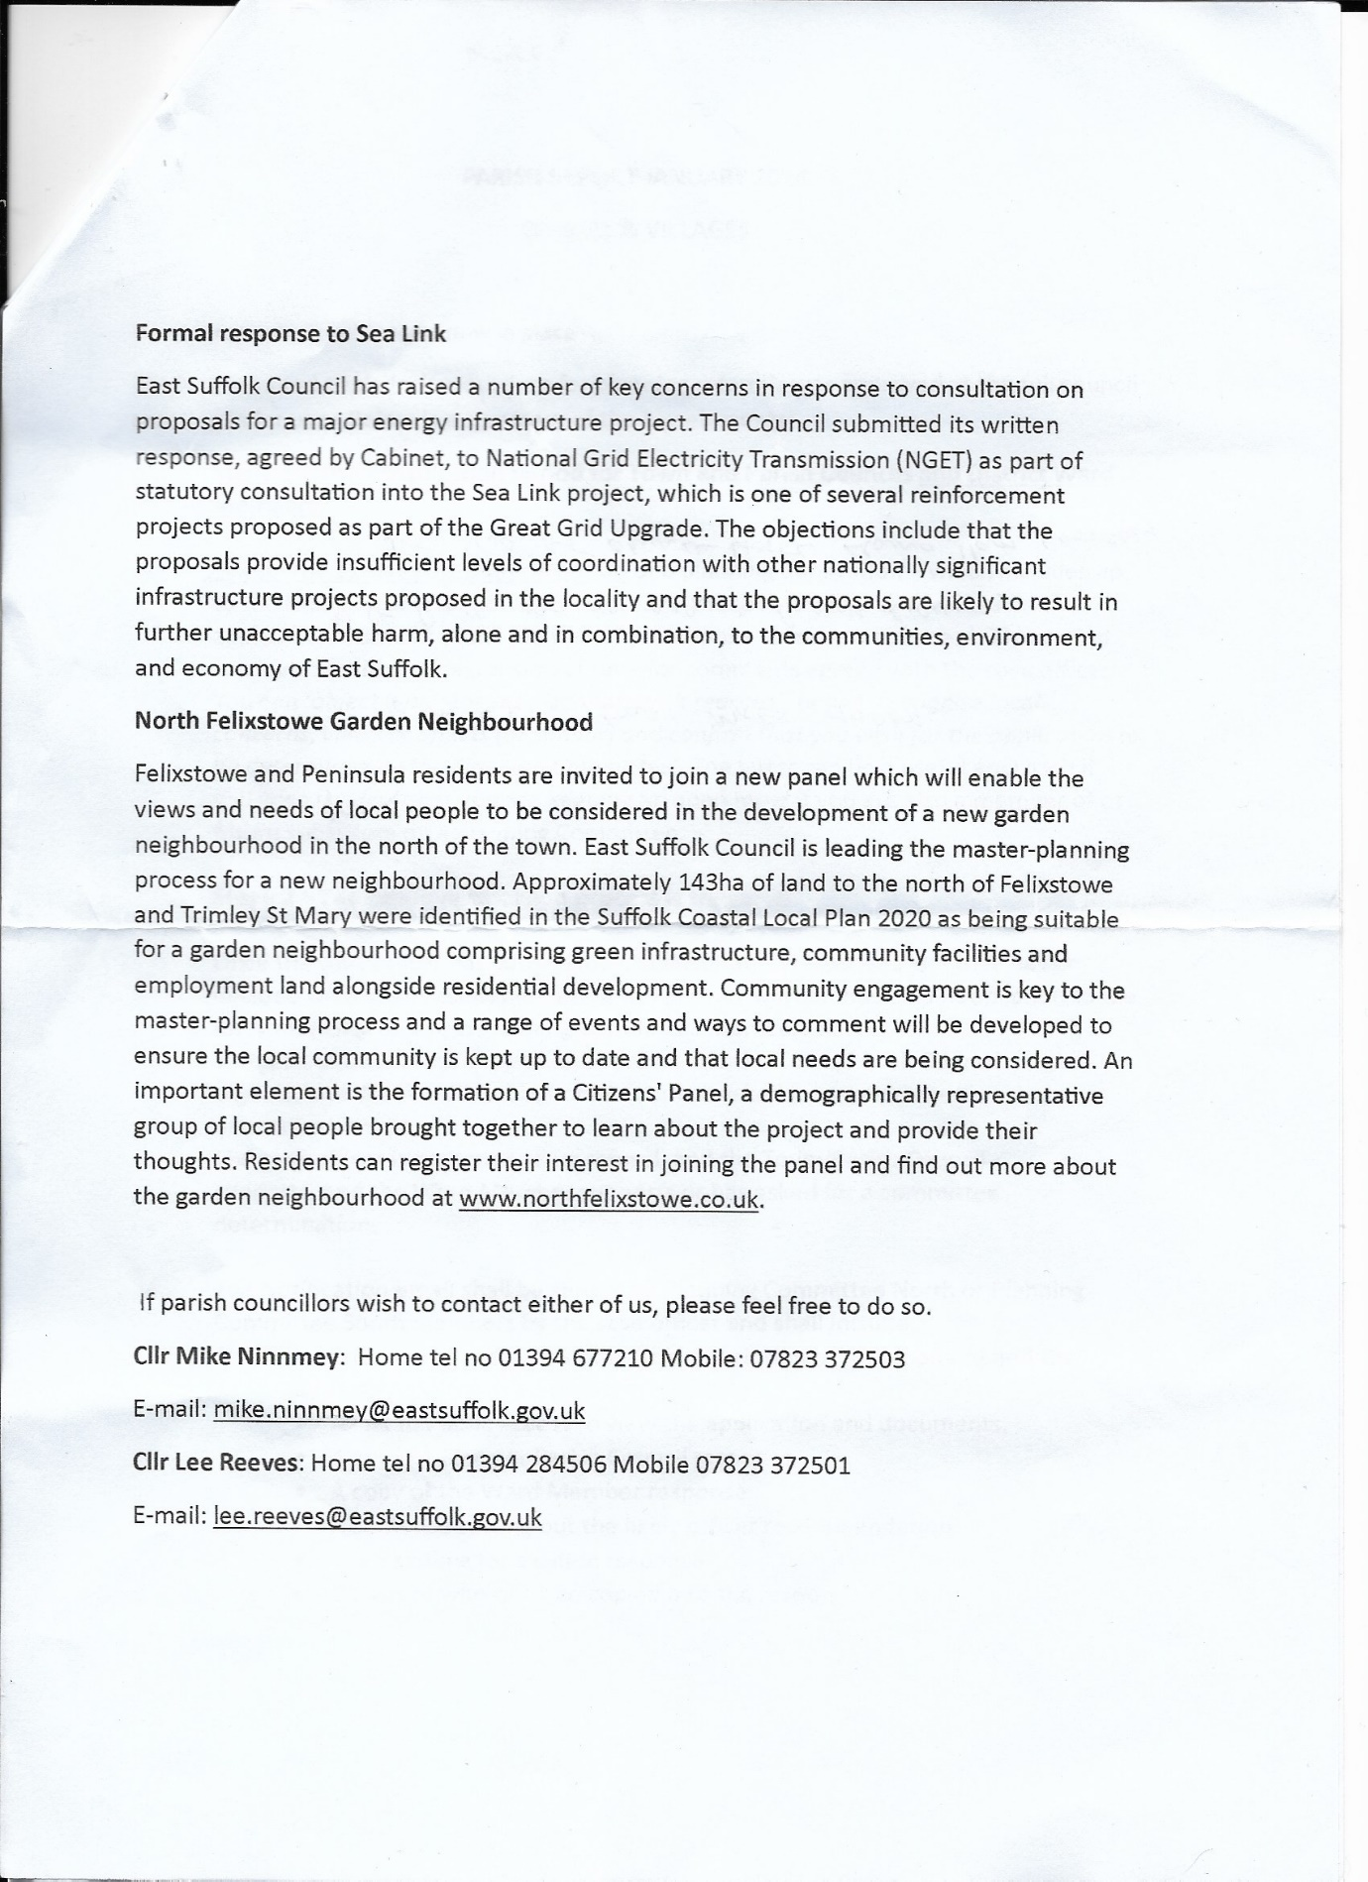
Bucklesham Parish Council information regarding Neighbourhood Plan information by Ruth Johnson 05/01/2024
