February 2026 Supporting Documents
Invoices
100570 – Printer Ink - £23.95

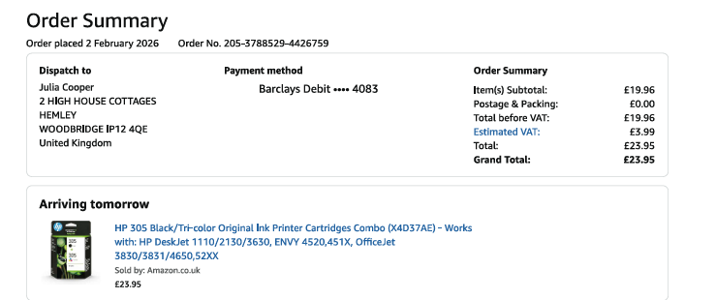

Proposed Quote from Treescape Group Ltd
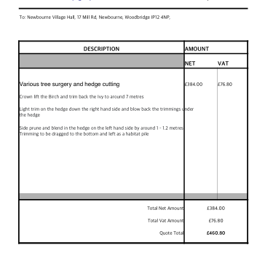

Parish Report

PARISH REPORT JANUARY 2026
ORWELL & VILLAGES

Suffolk County Council elections cancelled- again
The government has recently confirmed that elections for Suffolk County Council, which were due to take place in May, have been cancelled. This follows the announcement that the Mayoral election for Suffolk and Norfolk, which was also due in May, will not take place until 2028.
This means that current Suffolk County councillors will remain in office until May 2028 when the new unitary authorities come into effect, extending their term from four to seven years without an electoral mandate. There should be elections to the Shadow Authority in May 2027 although we are still awaiting confirmation of how many unitary councils there will be in Suffolk.

Better Recycling
All residents should have recently received a leaflet from East Suffolk Council explaining the new waste collection services which will be introduced in June 2026.
The first new food waste bins and kitchen caddies will begin to be delivered in the next few weeks in the south of the district and a month later in the north. Food waste will be collected every week. The additional bin for clean paper, newspapers, magazines and cardboard should be delivered by April in all areas.
Just a reminder that your recycling bin will be able to accept glass bottles and jars as well as Tetra-pak cartons. Thin film covers (such as ready meals) will be accepted from 2027.
Prior to commencement of the changes a calendar will be delivered to each home identifying collection days and an app should also be available to download which will advise any changes due to bad weather etc.

Accidents on A14 – subsequent damages to verges
As all will be aware there were two serious accidents on the A14 in mid- January. The first was sadly a fatal accident westbound close to the Levington exit. The second a few days later was a multi-vehicle accident eastbound- luckily without serious injuries.
The first accident caused severe delays and container lorries being diverted down unsuitable country lanes leading to HGVs meeting head-on on essentially single-track village roads. This led to damages to verges in several villages including Bucklesham, Kirton, Levington and Trimley St Martin. The single-track road with passing places only between Levington and the Trimleys was particularly badly affected and the verge ploughed into a sea of mud.
In future there must be better co-ordination of diversions to avoid two-way HGV traffic on unsuitable village roads and a faster response by Highways in dealing with damages to verges which spread mud on to the road surface.

Trimley Water Tower to be demolished
Building Control at ESC have very recently received confirmation from the owners of the Trimley Water Tower that they are terminating the contracts of the telecommunication companies using the tower and will then arrange for demolition.
The timescale for the demolition will be agreed with Building Control as will the method of demolition considering the proximity of residents.

Ease the Squeeze on Cost of Living

Are you, or someone you know, worried about the increasing cost of living? We understand the pressures faced by many people today and we are working closely with key partners to ensure support is available to help ease the squeeze for households in East Suffolk.
To make it as easy as possible for you to access the services and support available, locally and nationally, we have gathered information about them in one place:
www.eastsuffolk.gov.uk/community/squeeze/
For the most up to date information regarding East Suffolk Council, please visit: www.eastsuffolk.gov.uk
View the Well Minds East Suffolk booklet: tinyurl.com/9xhka624

As always if parish councillors need to contact either of us, please feel free to do so.
Cllr Mike Ninnmey: Home tel no 01394 277610 Mobile: 07823 372503
E-mail: mike.ninnmey@eastsuffolk.gov.uk
Cllr Lee Reeves: Home tel no 01394 284506 (preferred) Mobile 07823 372501
E-mail: lee.reeves@eastsuffolk.gov.uk

