February 2025 supporting Documents

PARISH REPORT JANUARY 2025
ORWELL & VILLAGES
Jet-ski vote narrowly passes
The Licensing Committee recently voted by 5 votes to 4 not to licence commercial personal watercraft within the East Suffolk area. There had been a record 377 representations made in response to the consultation, the vast majority requesting the council not to allow a commercial operator to hire jet-skis on the River Deben.
The vote means that there will be a presumption of refusal for commercial hire of personal watercraft throughout the district, although by law the council is required to allow a hearing by a sub-committee for commercial operators to argue exceptional circumstances.
This ruling does not affect the use of privately owned personal watercraft which is outside the scope of the licensing authority and fall under the auspices of the Maritime and Coastguard Agency.
Local Government Reorganisation
Despite several deadlines having passed we have still not received clarification from the Government as to whether the County elections are to be cancelled in May nor whether a joint Mayor for both Norfolk and Suffolk will be imposed.
The District Councils Network of all current District councils is not opposed to the creation of unitary authorities. However, 79% of the current District councils believe that the lower limit of 500,000 residents for new unitary authorities is far too high and will damage the local connection that councillors currently have with their parishes and residents. What is needed is real devolution of powers to the lowest level of elected representation possible. Instead, it appears that a centralisation of power to a single directly elected mayor across two counties will be imposed. No information is being given as to the future role of town and parish councils and how they will interact with unitary authorities and the overall Mayor.
If parish councillors need to contact either of us, please feel free to do so.
Cllr Mike Ninnmey: Home tel no 01394 677210 Mobile: 07823 372503 E-mail: mike.ninnmey@eastsuffolk.gov.uk
Cllr Lee Reeves: Home tel no 01394 284506 (preferred) Mobile 07823 372501 E-mail: lee.reeves@eastsuffolk.gov.uk

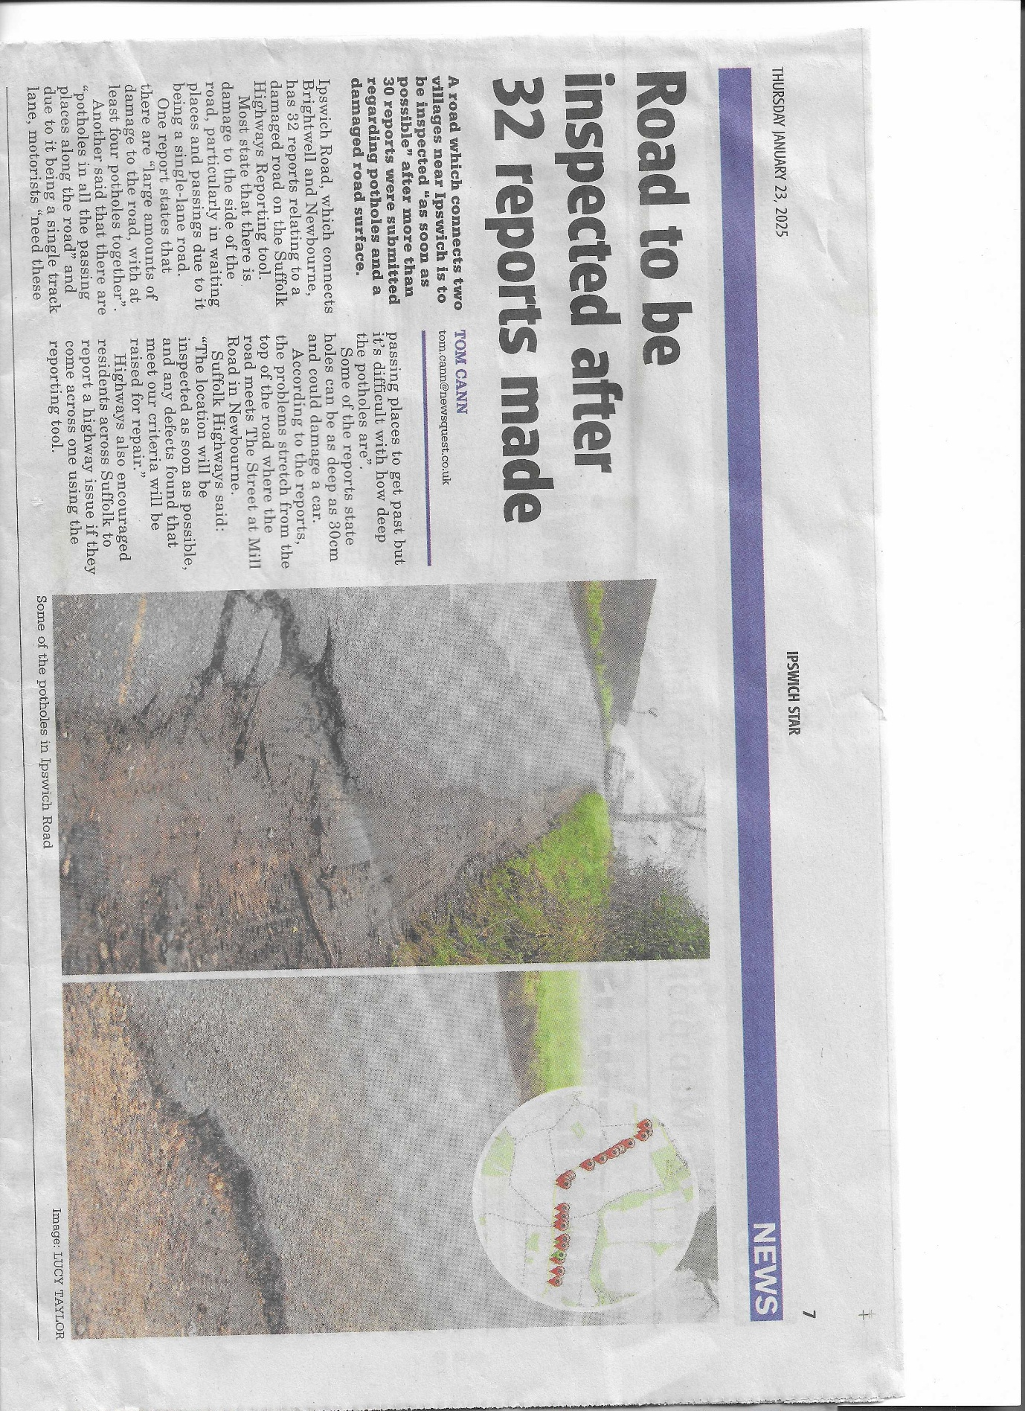
POTHOLES IPSWICH ROAD

503364 - INSPECTION PROGRAMME
500751 - INSPECTION PROGRAMME
503363 - INSPECTION PROGRAMME
503366 - INSPECTION PROGRAMME
503367 - 8 WEEKS REPAIR
503369 - INSPECTION PROGRAMME
503368 - 20 WORKING DAYS
503370 - INSPECTION PROGRAMME
503372 - INSPECTION PROGRAMME
503373 - INSPECTION PROGRAMME
503374 - 20 WORKING DAYS
503376 - NOT Maintained by Suffolk County council
503377 - INSPECTION PROGRAMME
503378 - 20 WORKING DAYS
503379 - INSPECTION PROGRAMME
503380 - INSPECTION PROGRAMME
503381 - INSPECTION PROGRAMME
503382 - INSPECTION PROGRAMME
503383 - INSPECTION PROGRAMME
503384 - INSPECTION PROGRAMME
503385 - INSPECTION PROGRAMME
503386 - NOT maintained by Suffolk County council
503387 - NO COMMENT YET
503388 - NO COMMENT YET
503390 - NO COMMENT YET
503391 - NO COMMENT YET
503392 - NO COMMENT YET
503393 - NO COMMENT YET
503394 - NO COMMENT YET
503395 - NO COMMENT YET
503399 - NO COMMENT YET
503402 - NO COMMENT YET

