Newbourne Parish Council
Minutes of the Parish Council Meeting held on Monday 3rd October 2022
In attendance: Councillors, Frost, Gammons, Wicks, Lusher, Hadley, Garfath-Cox and ESC Richardson
Members of the public:
Meeting opened 19:35
Parish Issues – An opportunity for parishioners to bring matters to the attention of the Parish Council and for parishioners to seek guidance from the Council
- To RECEIVE apologies for absence: Cllr Pollard, Scott, Grainger, and ESC Kerry
- To RECEIVE reports from SCC Cllr Patti Mulcahy, ESC Cllrs Richard Kerry and Mick Richardson.
September 2022 report for the Martlesham Division
Ipswich Register Officer moves to Endeavour House
The Ipswich Register Office will be moving to new state of the art facilities at Endeavour House, from October.
To complete the move, the Ipswich Register office at St Peter House will close on Friday 30 September and will re-open fully at Endeavour House, Russell Road, on Tuesday 4 October.
From Tuesday 4 October, registrations of births and deaths, together with Notices of Marriage/Civil partnerships and Early Bird ceremonies will take place at Endeavour House which will also offer a walk-in reception service and more modern facilities. It will also be fully accessible, in its new ground floor location, giving improved access for all customers, as well as there being more parking options available.
Telephone and email services will remain open between 1 and 3 October for any urgent enquiries.
Windows now open to apply for primary and secondary school places
Parents and carers can now apply for primary and secondary school places for September 2023.
The deadline for applications to secure a place at a Suffolk secondary school is Monday 31 October 2022.
The deadline for applying for a primary school place, including infant and junior schools, is Sunday 15 January 2023.
All applications received by the relevant closing date are processed at the same time using the schools’ oversubscription criteria to prioritise applications when necessary. Late applications are processed after all of those received on time.
Last year, Suffolk County Council received just under 15,400 applications from parents and carers indicating at which school they would prefer their child to be educated from September 2022.
Just over 95% of applicants received offers for their first preference school and almost 99% of applicants received an offer for one of their top three preferred schools.
Before making a school application, parents and carers need to consider how they will get their child to and from school. School Travel eligibility is based on a child attending the nearest suitable school that would have had a place available. This might not be the catchment area school. To find out more about SCC’s school travel policy please visit www.suffolkonboard.com/schooltravel.
Parents and carers should apply online at www.suffolk.gov.uk/admissions as they will receive confirmation that we have received their application. If for any reason parents and carers are unable to apply online they should apply on a paper application (CAF1). Suffolk County Council is unable to acknowledge receipt of paper applications and therefore suggest that proof of posting is obtained.
If families are planning to move house or think their circumstances may change before next September, it is still important to make an application on time. Advice and guidance about this process is available at www.suffolk.gov.uk/admissions.
Families who apply online will be able to log on to the Online Service on the National Offer Day, which is Wednesday 1 March 2023 for secondary school places and Monday 17 April 2023 for primary school places, to see their offer of a school place, and they will receive an email to confirm this offer on the same day. Offer letters will be sent by second class post to applicants who made a paper application.
Information to help parents and carers make their application is available at www.suffolk.gov.uk/admissions.
Alzheimer’s Awareness Month – now is the time to learn more about dementia and what support is available
World Alzheimer’s Day was held on 21 September, as part of World Alzheimer’s Month.
This year the theme is around the power of knowledge, encouraging people to do what they can to learn more about dementia and understand the changes in memory and behaviour, so people feel equipped and able to identify when and where they may can go for help and support.
Alzheimer’s disease is the most common cause of dementia, Alzheimer’s is a progressive disease. This means that gradually, over time, more parts of the brain are damaged. As this happens, more symptoms develop, and they also get worse.
According the Alzheimer Society, more than 520,000 people in the UK have dementia caused by Alzheimer’s disease and this figure is set to rise.
Sadly, the impact of the Coronavirus pandemic, combined with the stigma of dementia and the common misconception around memory loss being just part of getting old, means that dementia diagnosis rates are currently at a five-year low across the UK, which sadly means that tens of thousands of people across the country are currently living with undiagnosed dementia.
This means they don’t have access to the vital care and support that a diagnosis can bring and could risk ending up in crisis before making plans with their family and friends.
Typical early symptoms of Alzheimer’s may include memory problems like regularly forgetting recent events, people's names, or familiar faces. Becoming increasingly repetitive, asking the same question multiple times.
Regularly misplacing items or putting them in odd or unusual places. Confusion about the date or losing track of the time of day. People with the onset of dementia might also develop problems communicating or finding the right words.
If you recognise some of these symptoms, either in yourself or in a close friend or family member, book a visit with a GP as soon as possible. Whilst getting a diagnosis can be daunting all the evidence suggests it’s better to know.
Earlier this year, as part of Dementia Action Week, Alzheimer’s Society created and launched a new online symptoms checklist that can be printed off and taken with you to a GP appointment, to help talk about changes that might be due to dementia.
Unlocking early support is vital, as it opens a range of both practical and emotional support. This support can include people gaining access to the latest information and research, so they can know more about the disease and how it develops, access counselling and emotional wellbeing support, and potentially benefit from drug and non-drug treatments available to help manage the disease as it develops.
It also allows them the opportunity to explain to family and friends the changes happening in their life. You can find out more information about their symptom checklist, along with a wealth of information and a range of help sheets about everything from what support exists for individuals diagnosed with Alzheimer’s, support for carers of people with dementia, and the various treatment options which can be considered for people who are diagnosed with Alzheimer’s on the Alzheimer’s Society website.
Don’t dismiss the little symptoms you or your family may have noticed, it’s not necessarily part of getting old – it might be part of getting ill.
Within Suffolk, anyone who needs help, advice and support for themselves or others pre or post a diagnosis of dementia, can contact the Alzheimer’s Society via their Dementia Connect (Telephone 0333 150 3456 or email suffolk@alzheimers.org.uk).
The Hold’s autumn exhibition, Picture Books For All, showcases work of influential printers, W.S. Cowell
The Hold’s autumn exhibition, Picture Books For All, opens on Friday 21 October, and explores the history of Ipswich-based printers W.S. Cowell Ltd.
A prospect of Ipswich in the county of Suffolk' by W.S.Cowell.
A visually rich selection of books, prints, original artwork and journals will chart the local, national and international importance of W.S. Cowell.
The free Suffolk Archives exhibition on Ipswich Waterfront will also look at where Cowell sits in the history of modernism in Britain and examines their significant contribution to literature and society through design.
Founded in 1818, W.S. Cowell were general printers that re-invented themselves as progressive art printers during the late 1930s and 1940s. They became colour-plate lithographic printers and were pioneers of an acetate-sheet based process, called plasticowell, which allowed for an immediate and direct transfer from artist to press.
They went on to become instrumental in the launch of Puffin Picture Books at the start of the Second World War, and worked with leading illustrators and artists including Kathleen Hale, Eric Ravilious, Edward Ardizzone, Pablo Picasso and Henri Matisse; as well as with national art schools including the Royal College of Art.
The final section of the exhibition is dedicated to exploring Cowell's legacy and their impact on today’s thriving illustrated book market.
Picture Books For All features rare books and artwork from specialist collections, and hidden gems from the W.S. Cowell archive including:
- Eric Ravilious original drawings and prints from the Royal Museums Greenwich collections
- Edward Ardizonne original illustrations from the Tim and Lucy book series
- First editions of many favourite titles such as Orlando the Marmalade Cat, Barbar the Elephant and the Puffin Picture Book series.
Exhibition opening times are 9:30am-4:30pm Monday to Friday, with late opening on Thursdays. And 10:00am - 4:00pm Saturday and Sunday.
Events are ticketed, and can be booked by visiting the Suffolk Archives website.
Patti Mulcahy – Suffolk County Councillor for the Martlesham Division E-mail: patti.mulcahy@suffolk.gov.uk
Ward Cllrs monthly bulletin – September 2022
Dear All.
Welcome to the September report hope all is well in your patch, please do not hesitate to contact us with any matters that you believe we can be of assistance with.
Mick & Richard
michael.richardson@eastsuffolk.gov.uk
Telephone No:
01502 523521
Work Telephone No:
07810 816018

Email:
richard.kerry@eastsuffolk.gov.uk
Mobile Telephone No:
07903 301075

Helping East Suffolk ease the squeeze on cost of living
 | As the UK continues to face a cost-of-living crisis, households are seeing huge increases in their outgoings.  As we head into the colder months, East Suffolk Council has a responsibility to help residents find the support they need.
That is why we have launched Ease the Squeeze – a comprehensive scheme which helps connect those needing help to those helping.
We are working closely with key partners on a number of local schemes, while also directing people to other available support and services.
All the information, including practical support, funding and advice, has been gathered on our website, at www.eastsuffolk.gov.uk/squeeze. This page is continuously being updated as more schemes, services and support becomes available, so please share this with others.
We will also be running a social media campaign to raise awareness of the website.
Customer Services, Communities and Housing are working closely together to provide a wide range of support and advice.

Nicole Rickard, Head of Communities, will host live online information sessions about Ease the Squeeze, on Teams, from 11.30am-12.30pm on Tuesday 6 September and from 4pm-5pm Wednesday 14 September. Email Joanna.jonas@eastsuffolk.gov.uk to book a spot.

£24.9million regeneration programme given final go-ahead for Lowestoft
A £24.9m programme to transform Lowestoft has received final Government approval, enabling work to progress on five major regeneration projects.  In 2019, Lowestoft was one of 100 towns invited by the Department for Levelling Up to develop a bid for up to £25m of the £3.6bn Towns Fund. | 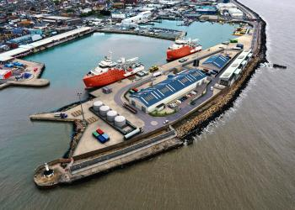
The Lowestoft Town Investment Plan, developed alongside the Lowestoft Place Board, setting out the ambitions, opportunities and challenges of the next 10 years, was submitted to the Government in 2020 as the basis of a £24.9m application, focusing on five projects:

The Station Quarter: Full restoration of the former Post Office and front of Lowestoft railway station building.
The Cultural Quarter: Improvements to the Marina Theatre, redevelopment of the East Suffolk Council’s current Customer Services Centre to provide a new cultural facility, and redevelopment of the former Battery Green multi-storey car park to provide a new leisure offer.
The Historic Quarter: Redevelopment and refurbishment of the Town Hall, along with enhancing the historic ‘Scores’.
The Seafront Vision: Redevelopment of Royal Plain, including the Royal Plain fountains, Royal Green and associated public realm to complement the recently refurbished East Point Pavilion.
The Port Gateway project: Supporting development of the Lowestoft Eastern Energy Facility (LEEF) to secure Lowestoft’s future as an Operations and Maintenance hub for the offshore renewables sector.

Full funding was provisionally secured in March 2021 before detailed businesses cases were submitted for each of the five projects in March 2022.

Businesses and visitors will be able to view proposed designs and learn more about each project in the coming months, with all five projects having now received final approval and due for completion by March 2026.

Free Wi-Fi programme expands to another two East Suffolk towns
 | Free-to-use public Wi-Fi has now been launched in Southwold and Woodbridge following recent launches in Felixstowe and Lowestoft and as part of a range of exciting digital projects.  To support local towns and businesses, East Suffolk Council is delivering a range of digital projects which aim to strengthen the local economy and improve connectivity within the district’s market towns.

One of these projects is the East Suffolk Digital Towns programme, which will digitally transform market towns through the installation of free public Wi-Fi, digital footfall counters and town marketing platforms alongside a business support programme. It was initially piloted in Framlingham in 2019.

Supported by funding from the Getting Building Fund and New Anglia Local Enterprise Partnership’s Innovative Projects fund, this new technology will be combined with bespoke business support, helping local businesses and the towns in which they are based, to grow.

New technology will enable the Council to understand the number of visitors to the towns, the busiest periods, the average time people spend in the town centre and much more. This will enable the council’s Economic Development team to provide tailored support for local businesses and provide data-based evidence to support other ongoing projects.

We are also working in partnership with an interactive walking app provider, Go Jauntly, to develop outdoor adventures across all of East Suffolk’s principal 12 towns and villages.

Following these latest launches, East Suffolk Free Wi-Fi is provisionally scheduled to be available in Beccles, Bungay, Halesworth, Aldeburgh, Leiston and Saxmundham by October.

Holiday accommodation owner fined for environmental breaches
A business owner has been ordered to pay £5,160 in fines and court costs for failing to properly dispose of rubbish at premises near Halesworth.  Richard Boddy admitted two counts of failing to comply with requirements imposed under section 47 of the Environmental Protection Act, between 7 June and 28 September 2021.  The holiday accommodation owner failed to provide suitably sized bins for the waste produced at Holly Tree Farm Barns, in Cratfield, allowing rubbish to collect around the bin compound. | 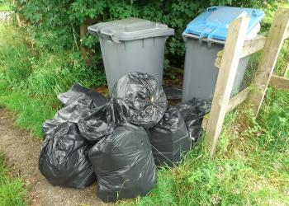
Mr Boddy was issued a section 47 notice by East Suffolk Council in October 2020 following a number of complaints concerning overflowing bins and excessive waste – in some cases attracting wild animals – at the Cratfield holiday let site.

The notice directed that all waste products be placed in receptacles of a suitable size and type; that no waste be left on the ground around the bin compound or on the public highway, and that a trade contract for regular removal of waste be arranged.

However, during subsequent site visits, conducted in June and July 2021, a waste management officer discovered loose litter and black refuse bags full of rubbish on the ground around overflowing bins.

Appointment aims to further embed good design into future developments
 | A new role has been created within the Planning team to ensure high-quality design is at the forefront of new developments in East Suffolk.  East Suffolk Council is believed to be one of the first local authorities in the country to appoint a Design Champion.  Urban designer and landscape architect, Chris King is experienced at promoting design quality in place-making.

The Design Champion role heads up the newly created Specialist Services team, which comprises highly skilled landscape, heritage, design, and ecology experts.

The creation of the Design Champion role also aligns closely with the national planning agenda, with recent and anticipated future changes to national planning policy placing an increased emphasis on achieving high quality design in new development.

Festival-style market to take place in Halesworth in September
The 'Heart of Halesworth' market on Saturday 3 September (10am – 2pm) promises to be a family-orientated, celebratory event.
Stretching along The Thoroughfare to the Market Place, the event will include live music and dance, street performers and a town trail, as well as family activities, celebrating Halesworth’s truly independent high street.  Heart of Halesworth follows the successful markets in Saxmundham, Beccles, Leiston and Lowestoft earlier this year as part of the Market Place project run by First Light Festival Community Interest Company, funded through East Suffolk Council and the Suffolk Growth Partnership. | 
First Light also delivered a consultancy package of support to another four East Suffolk towns on best practice for event development. Bungay, Felixstowe, Framlingham and Lowestoft all received a masterclass on place-making with director and co-founder, Wayne Hemingway.

Books and beach days – community benefitting from Eastern Edge
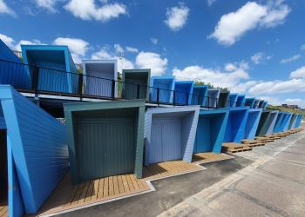 | Local residents and visitors have been enjoying the striking new Eastern Edge beach huts on Lowestoft’s South Beach – and community groups are also getting involved.  Organisations are able to hire one of the huts for a community event or special get-together, with some huts able to be linked together, by arrangement, for groups needing a larger accessible space.
Disability Advice North East Suffolk recently held a beach day at one of the accessible Eastern Edge huts – another of which was sponsored by Southwold-based Adnams and made available to local residents through the company’s Community Heroes project, which acknowledged individuals and organisations that made a difference in their communities during the pandemic.

As part of the Adnams sponsorship, Suffolk Libraries held a week of free events in a pop-up beach library, including a children’s book giveaway, colouring and storytelling.

Community celebrates opening of redesigned and modernised play area
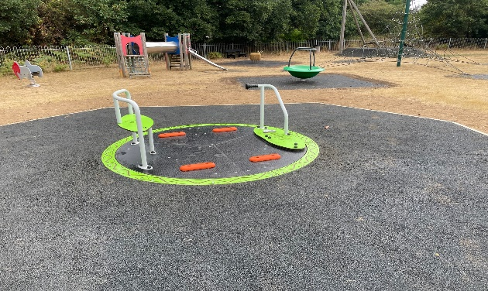 | An updated and improved play area has reopened to the local community that helped shape its new design.  Among many new features, the play area in Purdis Farm now includes seating and sculpture based on clay models handcrafted by local youngsters.
Funded through East Suffolk Council’s Outdoor Playing Space Fund, the redevelopment of the Murrills Park play area has been a community effort from as early as its inception.

In the summer of 2020, East Suffolk Council consulted residents of Purdis Farm for their views on how to spend available funds for 'sports and active play' from the Outdoor Playing Space Fund for Parishes. The responses helped to create a tender – awarded to successful bidder, Groundwork East, ahead of a series of community events earlier this year to give residents an opportunity to see the new designs and offer feedback.

Youngsters cast clay models which provided inspiration for the hare and bunny seating and the moon-gazing hare sculpture that now serve as way markers around the park – indicating an existing walking route and information boards about the area.

The park also now boasts a new accessible roundabout, part funded by county councillor Patti Mulcahy, along with a new circular group swing, a wobble sheep, and five new pieces of outdoor gym equipment.

Surveys and consultations
As always, we want to encourage participation in surveys and consultations, as feedback from people in East Suffolk is invaluable and helps us ensure we’re making the right decisions for our communities.

- Saxmundham Neighbourhood Plan
Representations are invited ahead of Saxmundham’s Neighbourhood Plan being submitted for independent examination. Representations must be received by 5pm on Friday 2 September.

- Shadingfield, Sotterley, Willingham and Ellough Neighbourhood Plan
Representations are invited ahead of Saxmundham’s Neighbourhood Plan being submitted for independent examination. Representations must be received 5pm on Wednesday 7 September.

- Lowestoft Railway Station refreshments building public consultation
Proposals for the redevelopment of a derelict part of the station building, detailed within the Lowestoft Town Investment Plan. Open until Friday 9 September.

- Patti Mulcahy Suffolk County Councillor for Martlesham Division discussed the local work she has been doing regarding the flooding in the area. It was discussed the flooding on The Street outside the Newbourne Fox and the flooding that occurs on Ipswich Road as you come into the village.
- To RECEIVE declarations of pecuniary interest – None received

- To APPROVE the minutes of the Parish Council meeting held on 01/08/2022 and 05/09/2022 Motion to approve both sets of minutes

- To CONSIDER Planning Applications for COMMENTS:
No Planning applications received.

- MATTERS for REPORT Insurance policy for year.
After discussing the insurance in the previous meeting 05/09/2022. Unfortunately, we only received one Insurance quote for the year with Hiscox Insurance Company. Policy AJG Community Schemes for £1853.51. I did speak to Gallagher and they advise there will hopefully be a few more companies quoting next year.

8. To CONSIDER Play Area ideas.
Cllr Garfath-Cox has been to visit the new play area in Martlesham and has some ideas. A sub-Committee will meet in October before the next meeting so they can report back in the November Meeting. We need a plan and costs by the end of the year so we can secure some funding for the project. It was discussed that a tree would be planted or we would do something to celebrate the life of Her Majesty Queen Elizabeth II.

9. To DISCUSS speed camera.
Cllr Hadley has advised we can buy a speed camera from his work for £1500 + vat but they do not record data. It was discussed that we could purchase two speed cameras and use both posts all the time for the price of one camera the presence of the cameras would hopefully make people slow down. The SID that records data is around £3500. It was discussed that it would be best if we had the data recorded if needed in the future clerk will approach other villages who have SID’s and ask what they have used data for and then it can be discussed if we think it is worthwhile purchasing the SID that records data in the next meeting

10. To DISCUSS next event. Cllr Garfath-Cox has kindly volunteered to organise meeting at his house the same time as the play area sub-committee to try and organise a Christmas event. An event that would be suitable for children as well. Also future events can be discussed.

11. To DISCUSS and ACTION Finance
Cheques to be signed
- Suffolk Association of local council’s payroll invoice £22.80 Cheque 100468
- Clerks Wages May 2022 – August 2022 £493.90 Cheque 100467
- HMRC May – August 2022 £123.60 Cheque 100466
- Insurance Policy 2022 -October 2023 Gallagher £1853.51 Cheque 100465

- Play area inspection £92.40 invoice 66428 Cheque 100464
Audit Documents for signing and documents attached
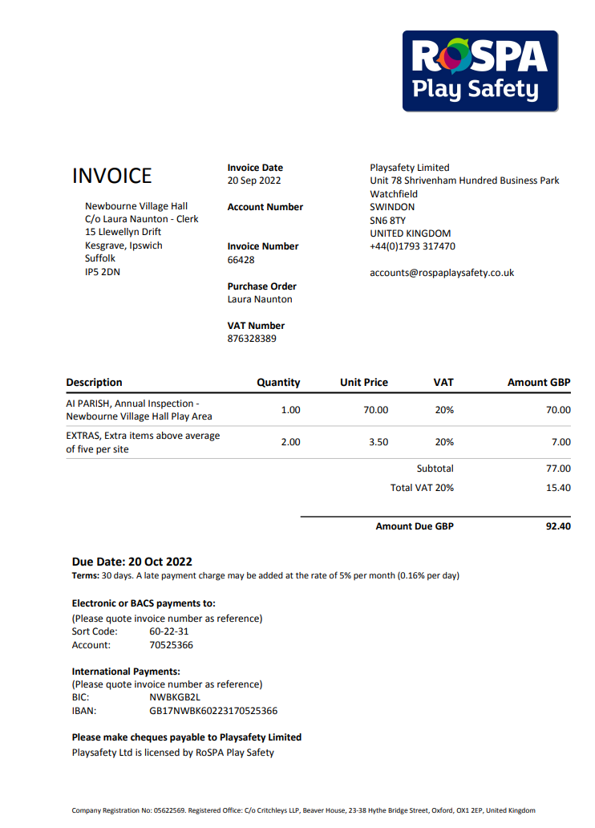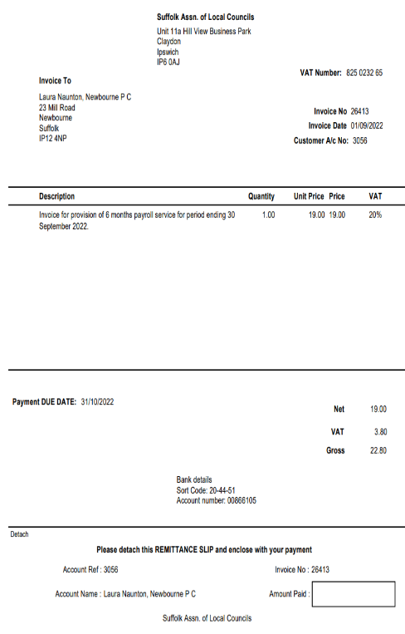

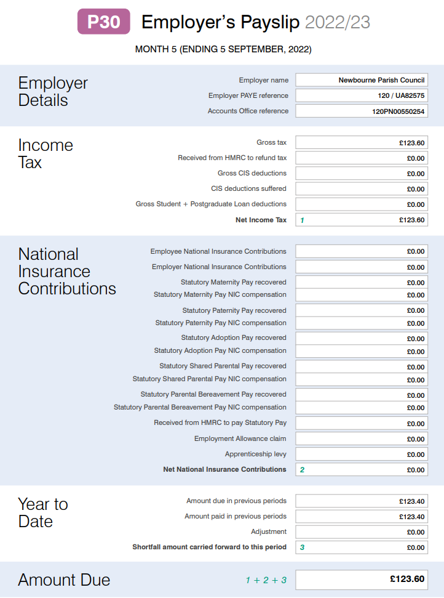
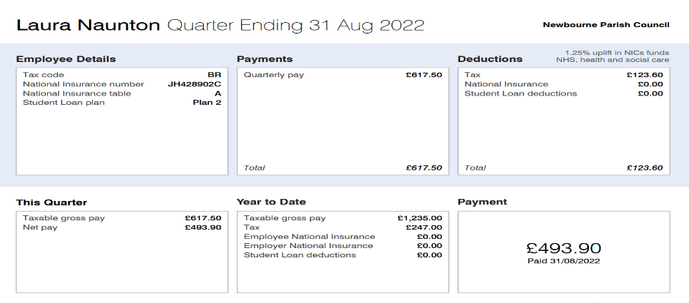

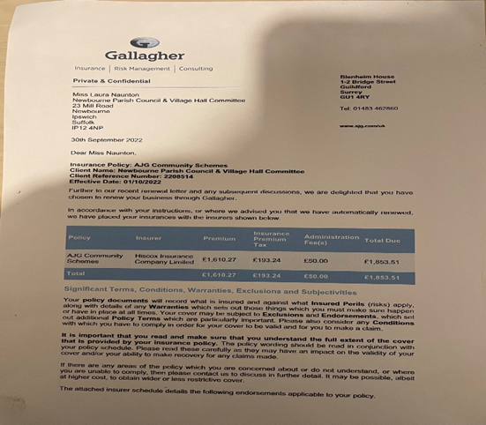

Finance 2020 – 2021
DATE AMOUNT PAYMENT DESCRIPTION BALANCE
04/04/2020 £8881.52 Opening Balance
28/04/2020 £1813.95 Money in from East Suffolk Council £10,695.47
29/04/2020 £2625.00 Money in Precept from East Suffolk Council £13,320.47
31/07/2020 £1100.00 Money in Grant Money £14,420.47
04/08/2020 £453.60 Clerks Wages £13,966.87
04/08/2020 £110.60 HMRC £13,966.87
03/09/2020 £113.20 HMRC £13,856.27 18/09/2020 £453.60 Clerks wages May 2020 -August 2020 £13,289.67
21/09/2020 £140.71 SALC Membership £13,148.96
21/09/2020 £21.60 SALC PAYROLL £13,127.36
30/09/2020 £2625.00 Precept £15,752.36
01/10/2020 £1280.76 Insurance £14,471.60
03/10/2020 £113.40 HMRC May 2020 -August 2020 £14,358.20
07/10/2020 £300.00 SCL Grass Cutting £14,058.20
13/10/2020 £60.00 SCL Grass Cutting £13,998.20
09/12/2020 £94.80 Playground inspection ROSPA £13,903.40
15/12/2020 £113.47 HMRC Outstanding payment from previous year 100421 £13,313.73
15/12/2020 £453.40 Clerks Wages August 2020 – November 2020 100425 £13,336.53
21/12/2020 £22.80 SALC PAYROLL SERVICE £13,313.73
21/12/2020 £60.00 Community action Suffolk website £13,253.73
30/12/2020 £120.00 SCL Grass Cutting 100426 £13,133.73
01/02/2020 £113.40 HMRC August 2020 -November 2020 100424 £13,020.33
23/02/2020 £60.00 SCL Grass Cutting £12,960.33
2021 / 2022
30/04/2021 £12,960.33 Opening Balance new year
30/04/2021 £5467.00 Money in Precept from East Suffolk Council
30/04/2021 £453.60 Clerk wages November 2020 – February 2021 100427
28/05/2021 £453.60 Clerks Wages Feb 2021 – May 2021 100432
07/06/2021 £640.38 Money in Cheque from Newbourne village hall
08/06/2021 £113.40 HMRC Nov 2020 – Feb 2021 100428
08/06/2021 £113.40 HMRC February 2021 – May 2021 100429
11/06/2021 £240.00 Groundwork/SCL Landscape Management 100431
11/06/2021 £60.00 Grass cutting/SCL Landscape Management 100430
08/09/2021 £453.40 Clerks Wages May 21 – August 21 100439
08/09/2021 £22.80 Suffolk Association local council’s Finance 100437
24/09/2021 £120.00 Grass Cutting/ SCL Landscape Management 100436
24/09/2021 £144.41 Suffolk Association local council’s Membership 100433
07/10/2021 £120.00 AJS Services / play area & grass 100440
07/10/2021 £203.50 AJS Services / Notice board 100435
20/10/2021 £242.00 Notice Board 100444
20/10/2021 £94.80 Playground Inspection ROSPA 100442
04/11/2021 £1513.68 Insurance Came & Company 100441
09/11/2021 £800.37 C Cracknell Village Sign Refurb 100445
04/12/2021 £453.40 Clerks Wages Aug 2021 – Nov 2022 100447
05/01/2022 £858.59 Money in Cheque in from Village Hall
07/02/2022 £113.40 HMRC August 2021 – November 2022 100438
07/02/2022 £113.40 HMRC November 2021 – February 2022 100448
18/02/2022 £22.80 Suffolk Association Local Council’s Finance 100443
08/03/2022 £453.40 Clerks Wages Nov 2021 – Feb 2022 100449

Closing balance on account £12,960.33
Location | Date Purchased | Purchase Cost | Current Value | Insurance Value
Mill Road, Newbourne | 1985 | £2000.00 | £2000.00 Nominal | £350,000
Village Hall Grounds | 2010 | £44,000 | £44,000 | £40,000
O/S Fox Public House | Pre 1980 | Not Known | £1 Nominal | Covered in outside furniture policy
Village Hall Grounds | 2012 | £800.00 | £800.00 | Covered in outside furniture policy
Centre Village | 2006 | £3094 | £3094 | Covered in outside furniture policy
Mill Road  Jackson Road  Ipswich road/ Woodbridge Road | 2013 | £406 | £406 | Covered in outside furniture policy
Village hall grounds adjacent to the play space | 2014 | £240.00 | £240.00 | Covered in outside furniture policy
Village Hall Grounds | 2014 | £183 | £183 | Covered in outside furniture policy

Audit 2021 -2022

- Balance brought forward 2021 £16,986.71
£12,960.33 Current Account
£0.00 Community Account
£4026.38 Saving Account

- Precept

£5467.00 £5467.00

- Receipts
£640.38 village hall payment
£858.59 Village hall payment
No grant
No CIL
0.40p Interest on saving account £1499.37

£23,953.08
- Staff
£453.60 28/05/2021
£453.60 01/06/2021
£453.40 08/09/2021
£453.40 04/12/2021
£453.40 08/03/2021
£113.20 08/06/2020
£113.40 08/06/2020
£113.40 07/02/2022
£113.40 07/02/2022 £2720.80

- Loan
£0.00 £0.00

- All payments
£240.00 Grass 11/06/2021
£60.00 Grass 11/06/2021
£22.80 SALC 08/09/2021
£120.00 GRASS 24/09/2021
£144.41 SALC 24/09/2021
£120.00 GRASS 07/10/2021
£203.50 NOTICE BOARD 07/10/2021
£242.00 NOTICE BOARD 20/10/2021
£94.80 ROSPA PLAY AREA 20/10/2021
£1513.68 INSURANCE 04/11/2021
£800.37 VILLAGE SIGN REFURB 09/11/2021
£22.80 SALC 18/02/2022 £3584.36

£17,647.92
Closing Balance

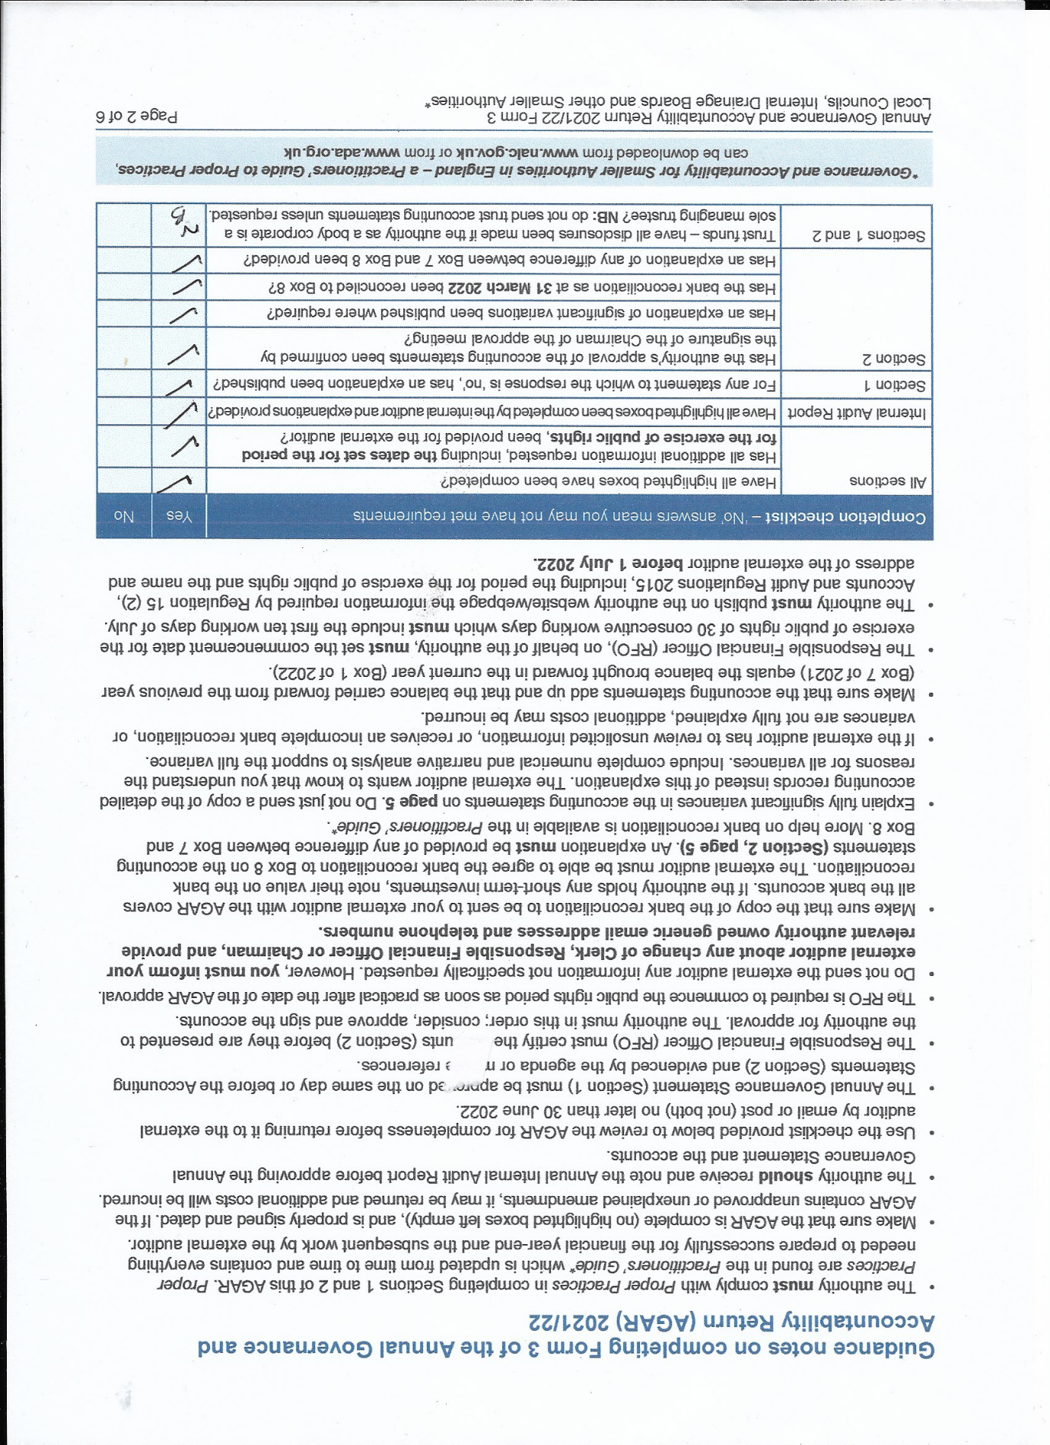

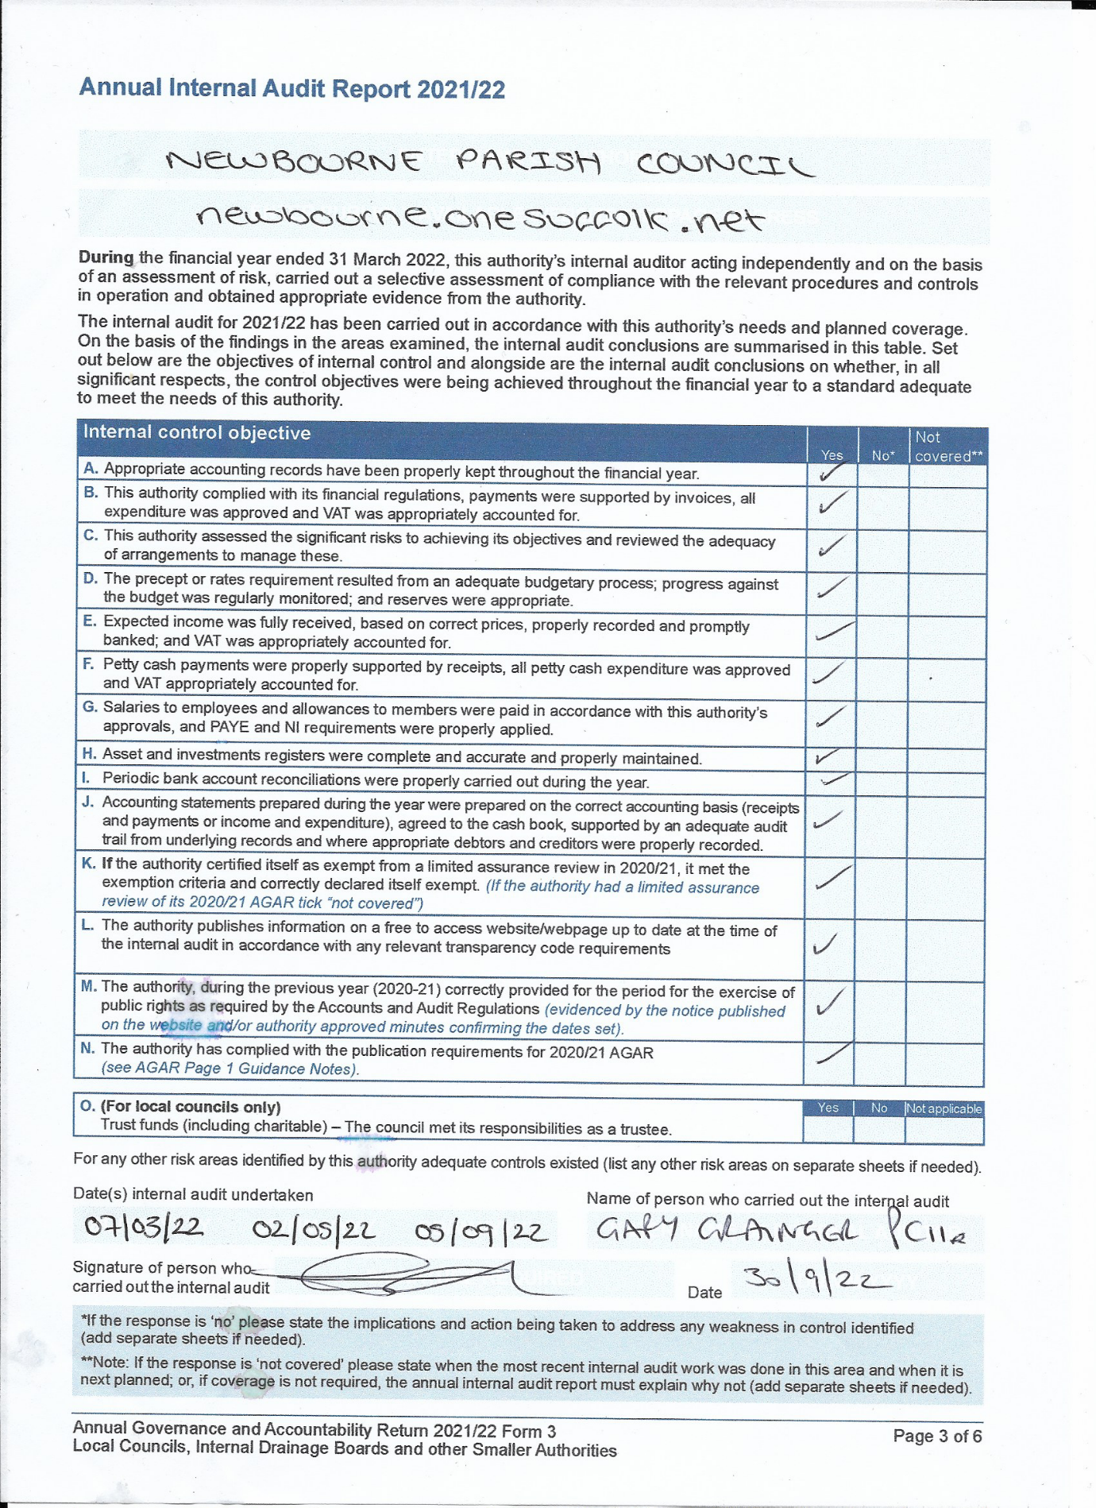
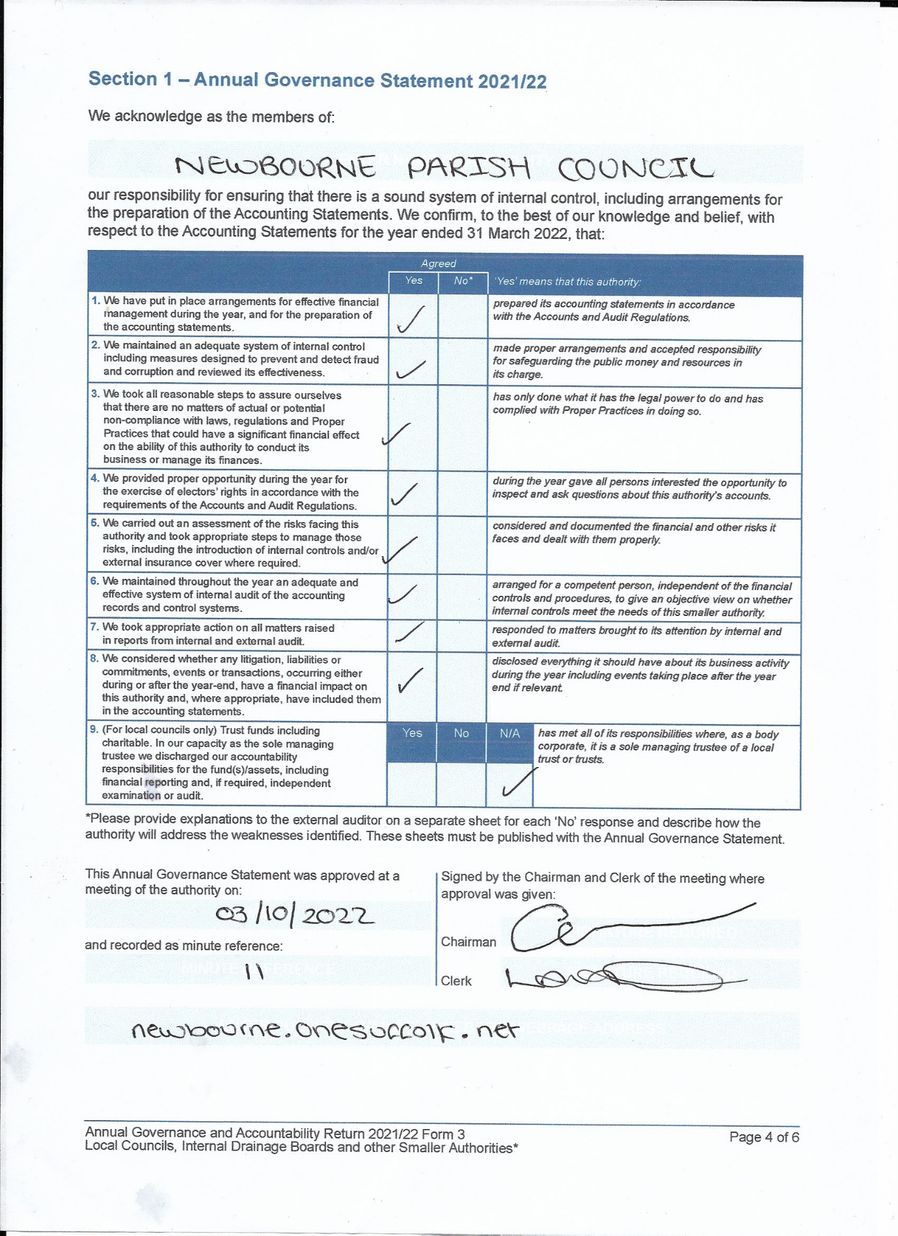

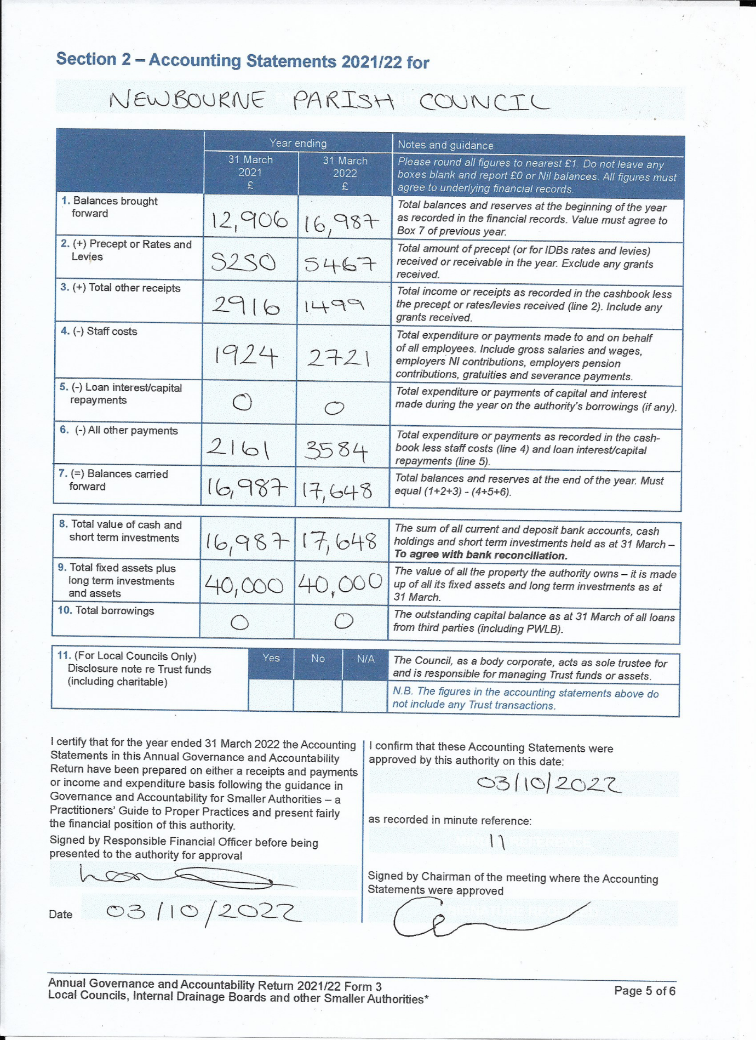
Action points for next meeting 07/11/2022

- Speed Device
- Play Area
- Fund raiser event

11. To DISCUSS any clerk’s correspondence – None

Meeting closed at 20:10

Signed ……………………………………..

……………………………………..

