Newbourne Parish Council
Contact Information
Clerk: Laura Naunton
E-mail: lauranaunton@hotmail.co.uk
Tel: 07487890734

Newbourne Parish Council Minutes 05/02/2024
Public Time
Tony raised the following.
- Make sure we are on the Brightwell lakes forum.
- On the January minutes 2024 the precept shows as 10% but should show as 14.7%, clerk advised it would be amended.
- Raised that 1/3 of the precept was spent on the speed indicator device. Tony was advised that CIL money was used towards the speed camera as it is money that needs to be put back into the community.
- Tony expressed his views that Newbourne Parish council shouldn’t get a neighbourhood plan as Newbourne are already included in the local plan 11.9 regarding the LSA holdings.
- Tony raised the issues with the recent planning on Mill Road / Jackson Road that the planning officers have agreed with the planning saying the site was ok, ESC planning officers have advised that Newbourne parish council comments were not considered as over 21 days from the date of planning.
- Tony advised that planning DC/24/0284/OUT which came on the site today 05/02/2024 will need a time extension if discussed in next meeting as it is over 21 days. Clerk will ask for time extension.

Pat raised the following.
- If we want to book ice cream van, pizza van for family day on the 13th July we probably need to book it soon before they book up.
- New prices for village hall to be put on internet.
- Sub committee for village day
- New boiler needed for the village hall; Pat is obtaining a quote.
- Need prizes for quiz on 23rd March.

Meeting opened at 20:00 by Chairman.
- To RECEIVE apologies. Cllr Pollard sends apologies as feeling under the weather. Apologies also from ESC Reeves.
- To RECEIVE report from ESC Cllr Mike Ninnmey and ESC Cllr Lee Reeves. Please see report on February supporting documents.
- To RECEIVE any Declarations of disclosable pecuniary interest – None received
- To APPROVE Minutes of Parish council meeting 08/01/2024.
Number 7 Precept needs to be amended before approved the precept agreed at 10% needs to be changed to 14.7%. Clerk will change this and then the minutes can be approved next meeting.
- To DISCUSS Planning applications and Neighbourhood Plan
Neighbourhood Plan
The clerk has contacted Bucklesham Parish Council and Ufford Parish Council to discuss Neighbourhood Plans. Bucklesham have decided against a neighbourhood plan and Ufford are in the process of getting a plan. I have attached Bucklesham’s report regarding neighbourhood plan, discussing the pros and cons and their reasons why they have voted against it in the supporting documents. Ufford’s Clerk has kindly offered to speak to us regarding their experience and why they have opted for a plan We will arrange a meeting with the clerk from Ufford and it can be discussed in the next meeting.
The neighbourhood plan has to be supported by the village and really should be led by the people in the parish with the parish council to support it.

DC/24/0072/FUL – Church Cottage, Ipswich Road

- Proposed rear single storey extension (existing conservatory to be removed) All Cllrs are happy with the planning to be permitted.
DC/23/4890/FUL – 7 Ipswich Road
- Cart lodge conversion to annexe. Discussed that this should probably be change of is as the cart lodge is already being lived in by owners while their property is being built. All Cllrs are happy with the planning to be permitted.

Extension to be requested for planning DC/24/0284/OUT Outline application Erection of detached dwelling. Land adjacent Last Transmissions Ipswich Road.

Previous Planning Applications decisions
DC/23/4037/FUL – Continued use of land for the sitting of shipping container at Newbourne village hall – Permitted.
DC/21/1745/OUT – Erection of a detached dwelling, access, appearance, layout and scale at The Firs, Jackson Road. – Withdrawn
DC/23/4741/FUL – Construction of a two-storey residential dwelling, garage/store, creation of a new highways access and associated landscaping at The Old Rectory, Ipswich Road. – Permitted.

- To RECEIVE an update on Green Infrastructure / Biodiversity
This is just to update you on my (rather limited) progress re Biodiversity and Green Infrastructure items.
- Laura has most helpfully drafted a poster and also a template to start writing a document, but I have managed to start work on these yet.
- There is a meeting of the Green Infrastructure joint working group (Hemley, Newbourne, Waldringfield, Martlesham PC’s) at Martlesham council offices on Wed Feb 14th. It is specifically about Biodiversity Action Plans and also ‘Nature Recovery Strategy’ and Ruth Chittock, Senior Landscape Officer at ESCC will be there.
- St Mary’s church has arranged a visit by Cathy Smith (Conservation Advisor, Suffolk Wildlife Trust), to advise in planning for environmentally optimal management of the churchyard and she has put me in touch with a colleague, Alex Jessop, whose role is specifically to work with parish councils and other bodies to develop biodiversity action plans – she will be able to provide more information and a draft template for this kind of plan. SWT are also organising a course this autumn for PC’s and Neighbourhood Steering Groups, which could be very helpful – details tbc.
- I have had a look at what our neighbours have done and have attached Landscape and Wildlife and Biodiversity Policy docs from Waldringfield, which perhaps provide helpful examples.

Apologies for not having progressed more, but this is at least a start on the process, and I will take it further next month, keeping the PC informed.
Terence
- To DISCUSS Play area plans.
We now have enough money to purchase a swing set which includes installation, safety flooring which is about 9.5k. We need to think about the bigger play area also and think about what items are most important to seek funding for. Cllr Ninnmey suggests that we speak to the lady at East Suffolk Council who deals with the leisure and play areas. Clerk will reach out to discuss with her and feedback next meeting.

- To DISCUSS future events
- QUIZ 23rd March 2024 – The event has been advertised and 9 tables have already been booked, 5 tables left. Pat is on the look out for some Raffle prizes anyone know of any raffle prizes please pass them to Pat.
- Family DAY 13TH July – Sub committee to be arranged to start arrangements for family day, Pat is hoping for band from Waldringfield will play for a less fee than previous band. Need to make sure we have enough volunteers to help on the day.

- To REVIEW Finance and sign cheques

- Noble Nature Ltd invoice 1067 – Bus Shelter revamp £112.50 cheque number 100501
- AJS Services invoice 1162 – Dealt with rotten wood in play area and put up the new speed sign £170.00 cheque number 100502
- 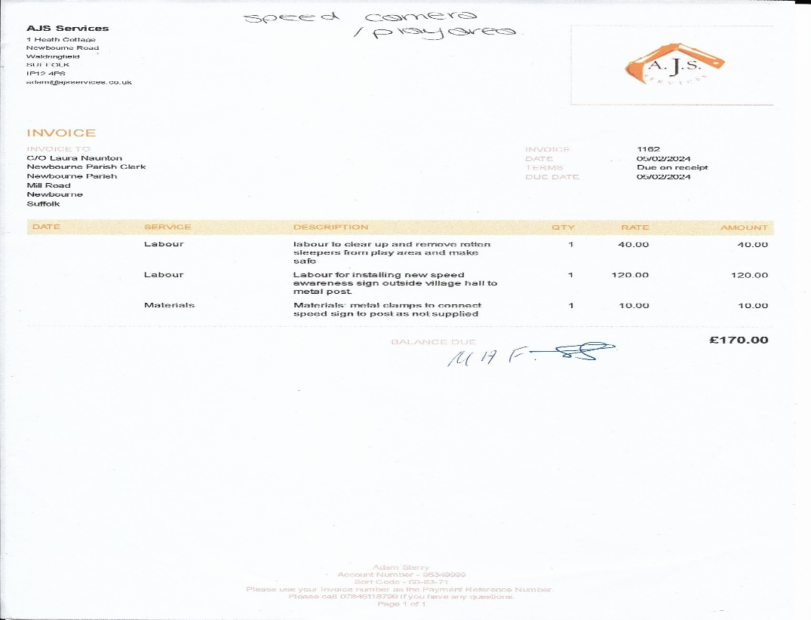
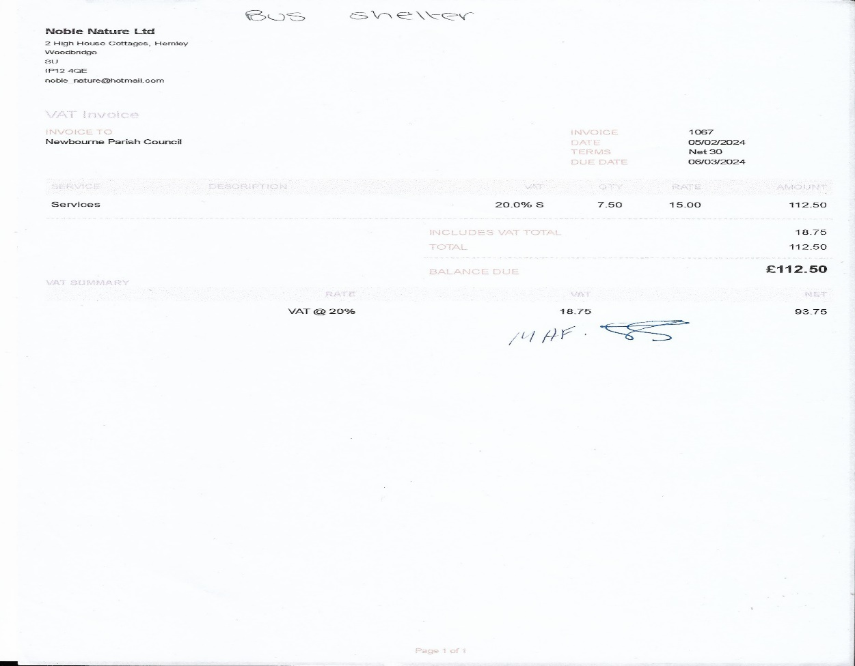

Bank Reconciliation December 2023

Cash in hand 01/12/2023 £25,547.15
Community £21,292.33
Saving £4068.94

ADD
£14.12 interest on saving account. £25,547.15

SUBTRACT
Payments
Amount Cheq no Payee
£494.10 100495 Clerks wages
£123.60 100494 HMRC
£22.80 100496 SALC Payroll
Cash in hand 31/12/2023 £24,720.77
B
Cash £0.00
Petty Cash £0.00
Community account £20,651.83
Saving £4068.94

Bank Reconciliation January 2024

Cash in hand 01/01/2024 £24,720.77
Community £20,651.83
Saving £4068.94
ADD £24,720.77
SUBTRACT
Payments
Amount Cheq no Payee
£52.09 100497 Newbourne Village Hall – ½ Internet
£780.00 100498 AJS Grass cutting and maintenance.
£2807.99 100499 Elan city – Speed indicator device
Cash in hand 31/01/2024 £21,080.69
B
Cash £0.00
Petty Cash £0.00
Community account £17,011.75
Saving £4068.94

10.To RECEIVE any Clerks Correspondence
- Speed indicator sign is up and running outside the village hall, it will be moved so it faces the other way down Mill Road and then will be moved to Ipswich Road and be rotated.
- The bus shelter opposite the Fox Pub has been repaired and had a clean, the ivy has been removed and the frontage has been cleared.
- Next meeting is 4th March 2024

Meeting ended at 20:57

