December 2025 Supporting Documents
Invoices
100562 – Community Action Suffolk - £66

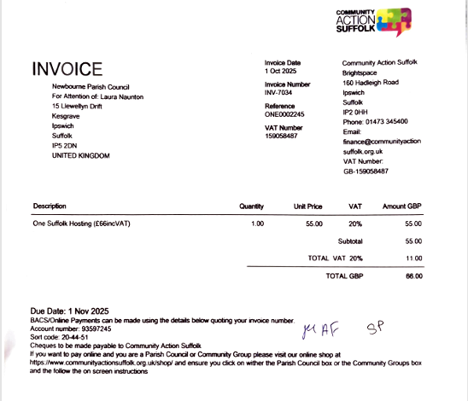

100563 – Clerk Wages - £635.05

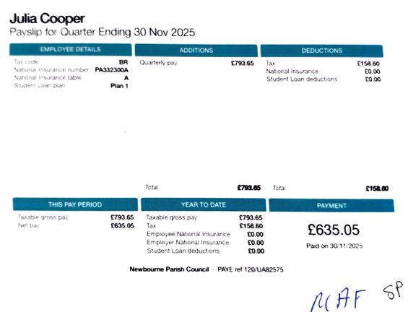
100564 – Gift for previous Clerk - £150
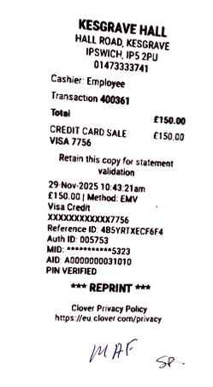

100565 – Re-imbursement for Invoice paid from personal bank account - £72

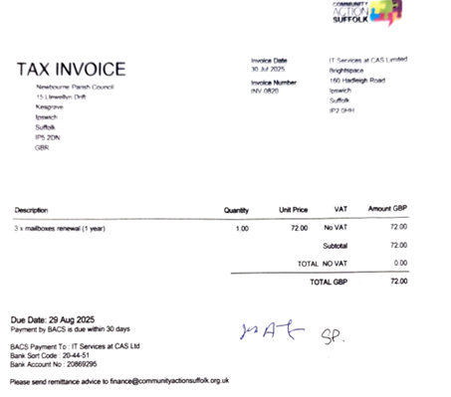

100566 – Replacing cheque 100551 - £317.42
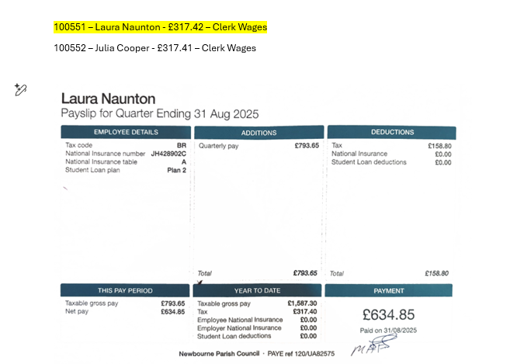

Bank Statements
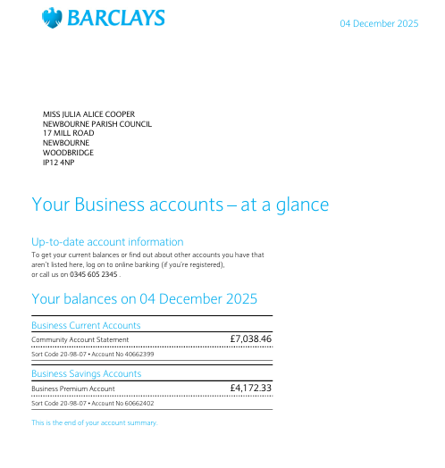
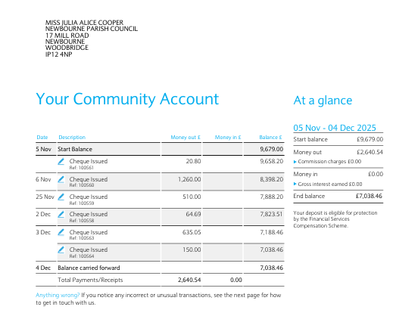

Newbourne Local Plan
Newbourne: Former Land Settlement Association Holdings
11.47 Newbourne is defined as a Small Village in the Settlement Hierarchy. The part of Newbourne which comprises the Former Land Settlement Association Holdings is a unique area within the plan area. The Land Settlement Association was set up in 1934 as an experimental scheme to provide unemployed workers from depressed industrial areas with employment on the land. The scheme and its legacy can still be seen in the number of large regular shaped plots, some of which still contain commercial scale greenhouses.
11.48 Due to its unique nature, Newbourne does not have a defined Settlement Boundary in the same way as other settlements in the plan area. It is considered that backland development, particularly for residential use, has the potential to harm the character of the village. Whilst it is preferable to maintain the plots and their associated horticultural and agricultural buildings in those uses, it is recognised that a number are not being used for their original purpose or have become derelict. There may be instances therefore where low key employment uses would be appropriate on the site of former horticultural and agricultural buildings, where this does not result in the functional or physical separation of the dwelling and the wider plot.
11.49 To retain the character, it is also important to continue to control changes which may occur through new dwellings or the replacement or enlargement of dwellings and consideration will be given to the impact on the character of the Former Land Settlement Association Holdings area of Newbourne in this respect.
Policy SCLP11.9: Newbourne - Former Land Settlement Association Holdings
The Council will encourage the retention of suitable buildings in horticultural or agricultural use of those parts of the former Land Settlement Association Holdings shown on the Policies Map, not currently used or required in connection with the residential curtilages, taking account of any physical features which currently mark garden limits.
New employment uses on backland plots will be supported where:
a. It is demonstrated that the land and/or buildings are surplus to agricultural and horticultural requirements;
b. Any new or replacement buildings are of a scale and nature appropriate to the character of the Former Land Settlement Association Holdings area;
c. They do not result in physical separation of individual plots; and
d. They are of a suitable design and construction for the proposed use.
The erection of new or replacement dwellings, or extensions to existing dwellings or ancillary residential development will be supported where:
e. Their scale and design would not harm the character of the former Land Settlement Association Holdings area; and
f. In the case of new dwellings, it would represent infill development within the existing frontage and not result in backland development.

Parish Report November 2025
PARISH REPORT NOVEMBER 2025
ORWELL & VILLAGES

Government consultation of Local Government reorganisation now open
The Government has launched its statutory consultation on the future of local government in Norfolk and Suffolk.
As you will be aware, there are two proposals being considered for Suffolk:
- Three Councils for Suffolk: proposed by district and borough councils. This would replace the current six councils with three unitary councils, each responsible for all local services.
- One Suffolk: proposed by Suffolk County Council, creating a single unitary authority.
The district and borough councils will continue to make the case, strongly, for the ‘three councils’ proposal, with a media release issued shortly (presented below) and additional activities which seek to explain why the councils believe this is the best option for the county’s communities - while also encouraging participation in the consultation process.
The consultation is open now, and your views matter. Take this opportunity to have your say by visiting Local government reorganisation in Norfolk and Suffolk - GOV.UK.
The consultation period will close on 11 January 2026.
The Secretary of State is expected to make his decision on new structures in March 2026, with new councils in place from April 2028.
We would urge all parishes to review the two proposals and respond. As you will be aware both of us had sought to keep the two-unitary option on the table which we believe would better address the original guidelines set out by the Government and maintain the link between unitary councillors and their local parishes which may be in danger of being lost if the One Suffolk proposal is accepted. Individual residents are also able to respond to the consultation.

Government set to block local councils refusing planning applications over 150 homes
The Government is about to introduce legislation which will prevent local councils from refusing planning permission for any development over 150 houses. If planning committees are minded to refuse permission, they will be obliged to refer the matter to the government who will appoint planning inspectors to review the plans and then recommend the application to the Minister for approval.
This is another example of powers being removed from elected local councillors and transferred to central government. As the Local Government Association has confirmed, 90% of planning applications are already approved by councils. In East Suffolk we already have several thousand homes already approved where building has yet to commence.

Advice on waste disposal at Christmas
The festive season brings lots of celebrations, which can create a lot of waste. Here’s some tips to make sure you get recycling right!
- Cardboard, food packaging, aluminium cans and plastic bottles can all go in your blue bin at home – just make sure you enjoy their contents and remove any non-recyclable elements before placing them in the bin.
- Christmas cards without glitter or foil effects can also be recycled at home, most wrapping paper too – just try the scrunch test before throwing it away and make sure you remove any non-recyclable tape, bows or ribbons before.
- Glass should be taken to your nearest bottle bank or recycling centre.
Got a real Christmas tree?
If you're purchasing a real Christmas tree this year, make sure you have a plan for disposal. It can go in your garden waste bin but must be cut into pieces smaller than 6cm to fit. Alternatively, you can take it to your nearest recycling centre to dispose of, or even try composting it at home.
Local charities also offer a collection services for a fee, why not get rid of your tree easily, whilst also giving back this festive season?
St Elizabeth Hospice and East Anglia’s Children’s Hospice collect trees from many areas in East Suffolk, including Kesgrave, Felixstowe, Nacton, Woodbridge, Aldeburgh, Leiston, Saxmundham and Southwold. Check if you’re eligible for collection.
Choose any amount to donate, trees will be collected on either Thursday 8 January or Friday 9 January 2026, just leave your tree at the front of your house by 9am on the designated collection dates and their volunteers will be along to pick it up.
Bank Holiday bin collections
Over Christmas and New Years, there will be some changes to our usual bin collection schedule, and we apologise for any inconvenience during this period. Here’s the updated version:
Usual collection date | New collection date | Change
Monday 22 Dec | Saturday 20 Dec | 2 days EARLY
Tuesday 23 Dec | Monday 22 Dec | 1 day EARLY
Wednesday 24 Dec | Tuesday 23 Dec | 1 day EARLY
Thursday 25 Dec | Wednesday 24 Dec | 1 day EARLY
Friday 26 Dec | Saturday 27 Dec | 1 day late
Monday 29 Dec | Monday 29 Dec | NO CHANGE
Tuesday 30 Dec | Tuesday 30 Dec | NO CHANGE
Wednesday 31 Dec | Wednesday 31 Dec | NO CHANGE
Thursday 1 Jan | Friday 2 Jan | 1 day late
Friday 2 Jan | Saturday 3 Jan | 1 day late

Remember to leave your bin out by 6am on collection day. Use our bin collection dates finder to double check.

ECB Funding
Each District councillor is allocated £ 7,500 Enabling Communities Budget (ECB) to assist funding for projects within their ward or of wider benefit. As we approach the end of another year, we would like to share the projects we have assisted so far this year. Since we were elected, we have endeavoured to fund improvements to the infrastructure in our parishes or signposted to other sources of funding, such as District CIL funding where eligible.
ECB Funding has been approved for next year 2026-2027 but it is uncertain whether it will continue in 2027-2028 – the final year of East Suffolk Council. If there are projects you have in mind for the remainder of this financial year or after next April then please let us know.

£ 3,000 for Trimley St Mary picnic benches
£ 3,000 for Bucklesham Village Hall solar panels
£ 800 for Emmaus Wellbeing Hub
£ 750 for Mind, Body and Sea- water based wellbeing
£ 350 for Stennets Community Café work with Level 2
£ 282 for bike racks at Trimley St Martin Memorial Hall
£ 220 for Felixstowe & District Sports council – first aid training
£ 100 for Grove Surgery medical wrist bands

As always if you need to contact us on any issue please feel free
Cllr Mike Ninnmey: Home tel no 01394 677210 Mobile: 07823 372503
E-mail: mike.ninnmey@eastsuffolk.gov.uk
Cllr Lee Reeves: Home tel no 01394 284506 (preferred) Mobile 07823 372501
E-mail: lee.reeves@eastsuffolk.gov.uk

We would like to take this opportunity to thank all parish clerks and councillors for the work that you do for your communities and the welcome that we have had. We endeavour to get to as many parish council meetings as we can but each month there are diary clashes especially in the first week of the month.
Best wishes for a merry Christmas and a peaceful New Year.

Cllrs Lee Reeves and Mike Ninnmey

