Minutes of the Parish Council Meeting held on Monday 5Th December 2022
Public Time
Tony has raised a few points
3 Minute Public time
Tony has suggested that in future meeting he thinks it would be beneficial if we had a 3-minute public time at the start of each agenda points.
- This would be instead of the public talking in public time at the start of the meeting.
- Each member of public would get a maximum of three minutes to discuss the agenda point. Once their three minutes is up as normal there would be no talking in the parish meeting.
- This would avoid discussing many topics all in one go at the start of the meeting and points being forgotten.
- Everyone seems to think this is a good idea and we will trial this for a January and February and see if it is successful.
Pardon The Weeds we are feeding the Bees
- He thinks that pardon the weeds we are feeding the bees would be a safety issue in Newbourne as we do not have any footpaths and a lot of people use the grass verges to get out of the way of vehicles.
- Weeds/ nettles would look messy.
- Don’t want the verges to get too high as it stops visibility when pulling out of driveways and roads.
- It was discussed that the areas to be used for pardon the weeds we are feeding the bee’s haven’t been agreed as yet and it was discussed before regarding the verges being used to step away from traffic. It will be on the agenda for January.
Play Area
- Concerned that the parish council are looking to spend over 40k on a new play area.
- As previously discussed in meetings. The parish council have made discissions regarding the play area when things have rotted or broken. The existing play area is over 15 years old and is wooden so some of the play area has rotted. It is now at the point we need to replace some of the play area. We will be looking to get funding for the play area, and it won’t be something that will all be done in one go and fund-raising events will also be taking place. It will be discussed in future meetings.
Precept
- Concerned that the parish council are looking to increase the precept. Will be discussed in the meeting.

Family Day/ Speed Camera
- Concerned that the parish council is spending money on speed camera and a bar for family day.
- As previously discussed, we have paid for the speed camera using CIL money (Community Infrastructure Levy).
- The bar at the previous Village Day didn’t make money or loose money it was a village day to celebrate the Queens jubilee it was not a fund-raising event. It has not been decided yet if a bar will be at the next village day, but the next event is a fund-raising event to help raise money for the new play area.

Meeting open at 8pm

- To RECEIVE apologies for absence: Cllr Gammons, Cllr Hadley, SCC Cllr Patti Mulcahy and ESC Kerry and ESC Richardson
- Reports
Email from Michael Richardson
Dear Councillors
This email is to inform you that the new Housing in Clusters and Small Scale Residential Development in the Countryside Supplementary Planning Document (SPD) was adopted by Cabinet on 1st November 2022. The Housing in Clusters and Small Scale Residential Development in the Countryside SPD provides guidance to support the implementation of planning policies SCLP5.4 Housing in Clusters in the Countryside and WLP8.7 Small Scale Residential Development in the Countryside.
The SPD was subject to two rounds of consultation during its production. The Consultation Statement contains summaries of the responses received and how these have informed the preparation and finalisation of the SPD.
The Housing in Clusters and Small Scale Residential Development in the Countryside SPD, Consultation Statement, Adoption Statement and other supporting documents are available to view on the East Suffolk Council website at www.eastsuffolk.gov.uk/planning/planning-policy-and-local-plans/supplementary-planning-documents/
Physical copies of documents are also available to view at the Council’s Customer Service Centres (see the Adoption Statement for details) and in libraries across the district. The Planning Policy and Delivery Team can be contacted on 01394 444557 or by email at planningpolicy@eastsuffolk.gov.uk for any assistance in accessing the documents.
If you have any queries regarding the SPD please don’t hesitate to contact me.
Kind regards

   | Ben Wright BSc(Hons) MSc  Planner (Planning Policy and Delivery)  East Suffolk Council  01502 523082 | 07584 522998  www.eastsuffolk.gov.uk  www.eastsuffolkmeansbusiness.co.uk  Our ambition is to deliver the best possible quality of life for everyone who lives in, works in and visits East Suffolk.  We are East Suffolk

Further funding on offer to help ease cost of living pressure
A new grant funding scheme has been launched in East Suffolk for voluntary organisations and community groups to help people struggling to meet the cost of living.
The East Suffolk Cost of Living Community Grant Fund has been set up with funding via the Suffolk Collaborative Communities Board, from the Suffolk Contain Outbreak Management Fund (COMF).
Funding is available to enable community, voluntary and social enterprise organisations, or town and parish councils, to support individuals and families who are struggling due to the current cost of living crisis.
The scheme is designed to help keep people warm, well-fed, safe and connected, with a particular focus on reducing incidents of respiratory conditions this winter.
Examples of eligible projects include those that support people to access hot, healthy, nutritious meals in community settings, or that help people to stay warm at home during the colder months.
Cllr Letitia Smith, East Suffolk Council’s cabinet member for Communities, Leisure and Tourism, said: “Most of us will have been affected in some way by the rising cost of living. Sadly, there are those for whom the impact has been much more severe, with some left unable to fund essential items for themselves or their families.
“By working closely with local community groups, we are aiming to help alleviate the pressure on those currently struggling.
“I urge existing or new organisations to find out about the East Suffolk Cost of Living Community Grant Fund and apply online.”
In addition to the East Suffolk Cost of Living Community Grant Fund, the Council’s overall Ease the Squeeze programme is worth more than half a million pounds.
More than £70,000 of the programme will be invested in a network of ‘Warm Rooms’ across the district in a range of locations, including community and church halls, leisure centres and pubs.
Part-funded by the UK Government (through the UK Shared Prosperity Fund) and East Suffolk Council, with a number also funded from Community Partnership budgets, the sites will provide a warm space and tea and coffee, with free activities, ranging from books and games to film showings, also being planned and funded independently by venues.
East Suffolk Cost of Living Community Grant Fund projects should complement, but not duplicate projects funded through the Ease the Squeeze programme.
The fund will provide grants of between £500 and £5,000 for projects which support local residents struggling due to the rising cost of living.
Full guidance for applicants can be found online, along with a dedicated application page.
More information about support for local residents can also be found online via Suffolk County Council.
ENDS.

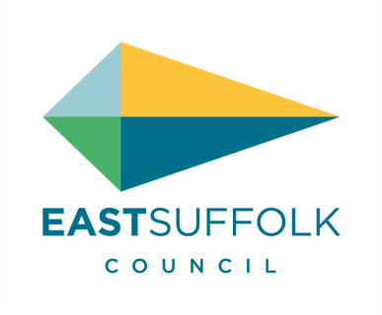   | Tom Potter | Press and Publicity Officer  East Suffolk Council  07916 785542  Chat with me on Microsoft Teams  He/him  www.eastsuffolk.gov.uk  www.eastsuffolkmeansbusiness.co.uk  Our ambition is to deliver the best possible quality of life for everyone who lives in, works in and visits East Suffolk.  We are East Suffolk

- To RECEIVE declarations of pecuniary interest – None received
- To APPROVE the minutes of the Parish Council meeting held on the 07/11/2022.
Motion to approve from Cllr Scott and Frost.
- To DISCUSS Play area. Wicksteed Play equipment has come out and have come back with a costing of £48k + vat. The costing has only been received 05/12/2022 from Wicksteed. The images were looked at in the meeting and will be discussed again in January meeting.
- Need to review what products the parish council want
- Money / Funding
- A breakdown on what costs what where we can save money a timeline on what work we can do soon, what will have to wait etc.

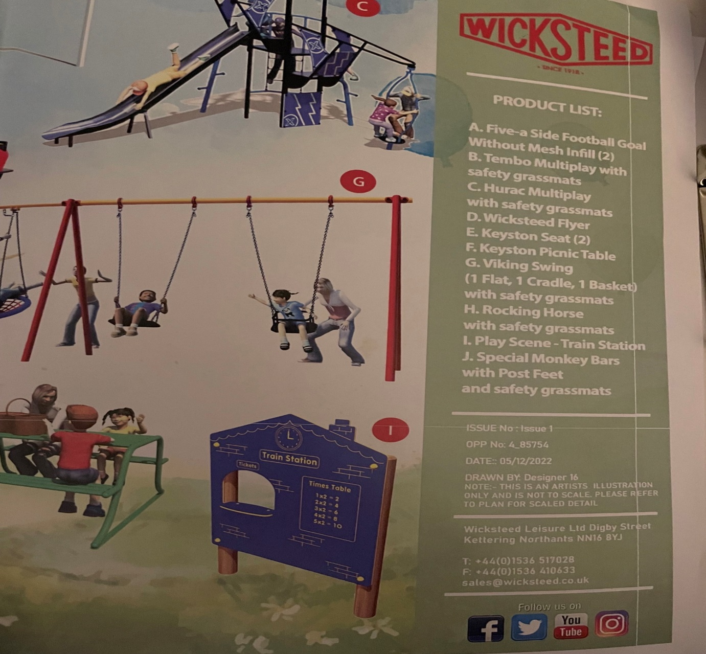

- To DISCUSS Speed Camera
Confirmed with Cllr Hadley that speed camera has message which was discussed in last meeting. Confirmed speed camera cheque to be signed.

- To DISCUSS Precept
- It been discussed that we believe Newbourne is below other villages
- Possible Referendum Clerk has checked with the East Suffolk council as it was discussed previously that a large increase may trigger a Referendum.
Reply from council “As mentioned in our conversation there is currently no council tax referendum limit for Parish Councils limiting the amount that they can raise via their precept. District Councils and County Councils are subject to council tax referendum limits, although these have been increased by the Chancellor in his autumn statement. However, Central Government has always indicated that it will keep referendum limits under review and expects Parish Councils to demonstrate restraint, and as a general principle, Town and Parish Councils should be able to explain and justify larger precept increases. There is no requirement for District Councillor approval”
- Newbourne Parish council Precept currently £6000.00

If we increased to £6500 for a band D property, there would be a % change of 6.40 a change of £3.47

If we increased to £7000 for a band D property, there would be a % change of 14.59 a change of £7.91

If we increased to £8000.00 for a band D property, there would be a % change of 30.96 a change of £16.79.

TOWN/PARISH PRECEPT REQUIREMENT 2021‐22 PARISH

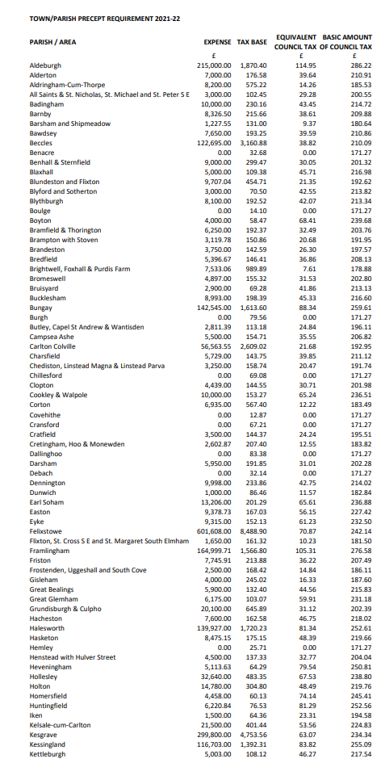
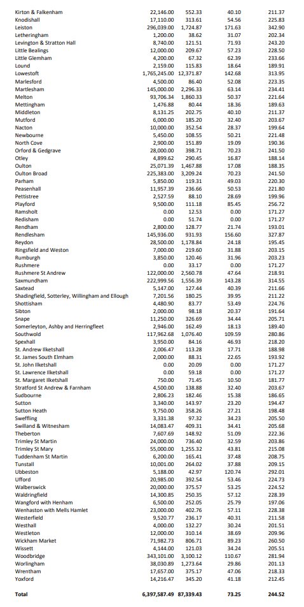
- To DISCUSS future Event Quiz
QUIZ – 4th February £5.00 a person teams of 6 people to bring own drink etc put on agenda for next meeting. Get information on local to Newbourne page ask Tracey to do a poster.

- To DISCUSS Finance

Cheques Signed

£123.40 HMRC CHQ NUMBER 100470
£494.10 L NAUNTON CHQ NUMBER 100471WAGES TILL DEC 2022
£1800.00 PROTECT & DETECT SPEED CAMERA £1800.00

