December 2020 Lock Down Covid
Cheques Signed by Sue Pollard and Lionel Scott

05/12/2020 HMRC £113.40 CHEQUE 100424
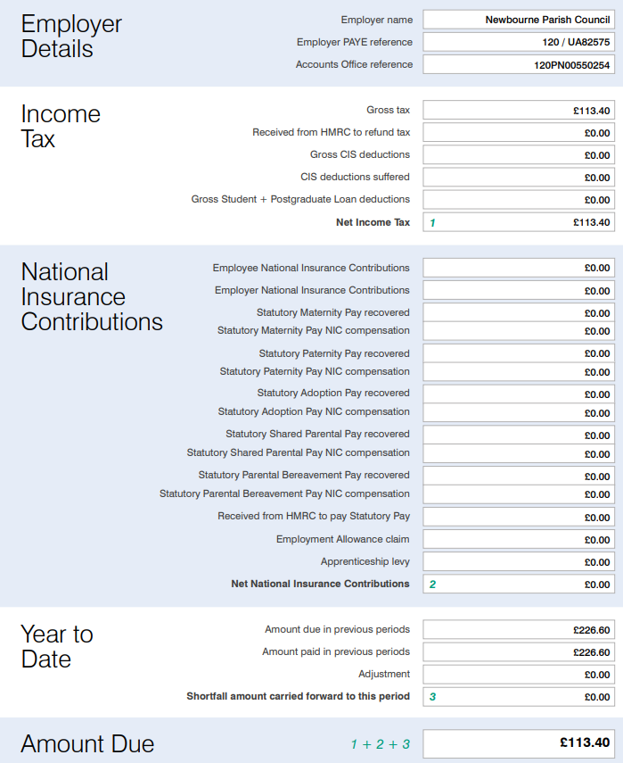
05/12/2020 WAGES £453.40 CHEQUE 100425
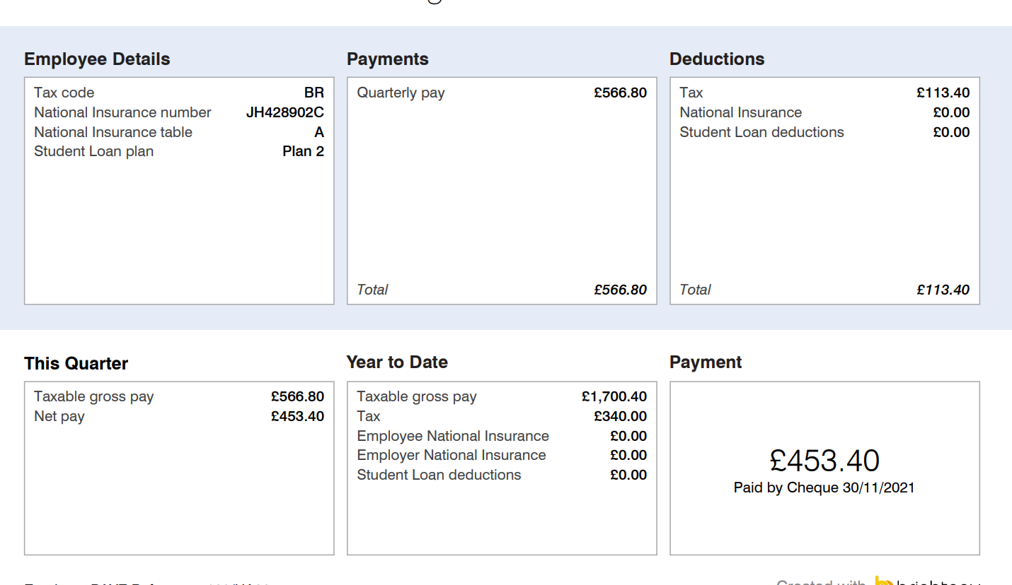
05/12/2020 SCL Grass cutting £60.00 cheque 100426
