Newbourne Parish Council Minutes 07/08/2023
Public Time
It was raised that a scout group have been using the village hall field, using the carpark and that it may cause an issue if the village hall is booked out and they need to use the carpark and field. As the scout group information wasn’t taken the clerk will send an email to local scout groups and give information regarding the hire of the hall and prices.
Meeting started at 19:38
- Apologies – ESC Mike Nimney
- Report from ESC July 2023 Parish Report Orwell & Villages ward

In July one or both of us attended six of our eight parish council meetings. Unfortunately, the other two clashed on the same night but all parishes were provided with a written report.
During the month we attended the Felixstowe & Peninsula Community Partnership and subsequent meetings setting up the School Uniform Bank. We attended a presentation by developers of the proposed business park involving Levington and Nacton and had a tour of the proposed siting for the Freeport within the Port of Felixstowe.
We also attended several committee meetings relating to our individual responsibilities.
Looking ahead to August we have requested officers to provide a briefing to councillors on all the developments affecting the Seven Hills Roundabout and what measures are being proposed to handle increased traffic.
We are also seeking a meeting with the Trimley Estate to discuss land use and with the developers of the proposed Howlett Way development.
If parish councillors need to contact either of us, please feel free to do so.
Cllr Mike Ninnmey: Home tel no 01394 677210 Mobile: 07823 372503
E-mail: mike.ninnmey@eastsuffolk.gov.uk
Cllr Lee Reeves: Home tel no 01394 284506 Mobile 07823 372501
E-mail: lee.reeves@eastsuffolk.gov.uk

Helping Families Access Affordable School Uniform
The school uniform bank for the Felixstowe Peninsula is now up and running. It is based at the Pushchair Pitstop, St Edmund’s Church Hall, Langer Road, Felixstowe IP11 2HR. They are open on Mondays, Wednesdays, and Fridays between 9am and 12pm and on alternate weekend days between 10am and 2pm.
Donations of pre-loved school uniforms, from all schools on the Peninsula will be welcome. If you know of any families in need, please put them in touch with Pushchair Pitstop and they should be able to help with both school uniforms and brand-new shirts, underwear, socks etc.
Cllr Katie Graham, East Suffolk’s cabinet member for Communities, Leisure and Tourism said: “School uniforms are a necessity but can be expensive, and many families, particularly in rural areas, struggle to purchase affordable school uniforms and school equipment. Uniform banks step in to provide good quality uniform to those in need and are also a valuable resource for those looking to do their bit to address the global problem of textile over-production and waste. Currently, an estimated 1.4 million items of school uniform are disposed of each year.
Improving Access to Private Rented Housing
A new scheme, which will help East Suffolk residents to better access private rented housing, has been launched.
Approved by East Suffolk Council’s cabinet on Tuesday 11 July, a new lettings partnership – East Suffolk Lettings – will be created, along with the introduction of a new Guaranteed Rent Scheme, to increase residents access to the private rented sector and minimise the use of temporary accommodation. East Suffolk Lettings will encourage landlords to work with the Council, by charging a lower rent, at Local Housing Allowance or within 10%. Landlords will be offered a financial incentive based on the difference in cost between what they would have been able to charge, compared to the lower rate they are charging.
Cllr David Beavan, East Suffolk’s Deputy Leader and cabinet member for Housing said: “Many more people face homelessness this year as private rents rocket, mortgages soar and landlords look to sell. After a slow building programme and right to buy sales, we sadly just do not have the houses to offer to prevent or relieve homelessness, which is our statutory duty. This imaginative letting policy, devised by our great housing team, will certainly help. Any homeless person housed is a victory but the war against the housing crisis continues unabated. We must find a way to provide more homes that people can afford to live in.”
Funded through the Homelessness Prevention Grant, received from the Department for Levelling Up, Housing and Communities, the scheme will be offered on a two-year pilot basis and if successful will become a permanent service.
Fund launched to help reinforce communities.
Community groups in East Suffolk are being invited to apply for up to £30,000 in capital grant funding for upgrades and improvements to facilities. East Suffolk Council is accepting applications from local voluntary and social enterprise groups, as well as some small to medium sized businesses, for a £15,000-30,000 share in the newly launched Rural Business and Community Hub Fund (RBCHF). | 
The fund is part of the Government’s wider Rural England Prosperity Fund (REPF) and aimed at organisations that provide, or wish to provide, a multi-purpose community hub or for-public-benefit facility offering access to a range of quality, cost-effective services. Applicants could include existing village halls, local skills providers, business and co-working spaces, health, wellbeing and mental health providers, sports and recreation providers, and arts, culture and heritage providers. Prospective RBCHF applicants can contact Community Action Suffolk for further support via info@communityactionsuffolk.org.uk. Guidance on applications can be found here East Suffolk Rural Prosperity Fund.
East Suffolk Services Limited Launches
As part of its commitment to seek the best possible value for money for residents, businesses and all local stakeholders, East Suffolk Council agreed to create a ‘Local Authority Trading Company’ (LATCo) in the Autumn of 2021, enabling it to play a more direct and influential role in how important services are delivered.
The company, now called East Suffolk Services Ltd (ESSL), operates as an ‘arms-length’ commercial business, separate to the Council and is responsible for delivering crucial council services such as waste and recycling collection, grounds maintenance and street cleansing.
Cllr Rachel Smith-Lyte, East Suffolk’s Cabinet Member for the Environment, said: “I’m really pleased this is happening and we want the new company to be a great success for our staff, customers and communities. It will maximise efficiency and seek to deliver the highest possible standard of services after, of course, a smooth transition.”
“The decision to create East Suffolk Services was taken in part to help us deliver environmental changes, such as new fuels, more efficient vehicles and different approaches to waste management. This commitment could not be more timely, and we will work together to achieve our ambitions in this area.”
Cllr Caroline Topping, Leader of East Suffolk Council said: “The Council wants to deliver improvement that benefits council taxpayers, and an incredible amount of hard work has gone into the creation of East Suffolk Services to ensure it is ready to commence trading. East Suffolk Services aims to provide a more flexible service and respond quickly to local issues.”
The Tour of Britain: Suffolk Stage
Suffolk will be hosting a full stage of the prestigious race, with Felixstowe seeing the start and finish of stage five on Thursday 7 September. Over 100 of the world’s best riders will weave through our gorgeous countryside, with Kesgrave, Framlingham, Leiston and Woodbridge all featuring. The anticipation has already begun, with a media campaign showing race-related imagery projected onto Framlingham Castle, Orwell Bridge and an Apache helicopter at Wattisham Airbase. Previously over 400,000 people watched the Tour of Britain as it visited Suffolk, generating over £8.5 million of economic benefit for the county. East Suffolk Council is an official partner of stage five.
Time to think about how we heat our homes
Warm Homes Suffolk is accepting applications to fund improvements to residents’ homes, making properties warmer and more efficient for the colder months. Warm Homes Suffolk has new funding available for eligible households, to put towards energy efficient measures such as insulation, solar panels or heat pumps.
The scheme is administered by Suffolk County Council, and delivered by East Suffolk Council, on behalf of all councils in Suffolk. It has been funding home energy efficiency improvements for more than a year but has recently received further funding from the Department for Energy, Security and Net Zero to continue the work.
An average of £18,000 in funding per property is available for homeowners meeting the criteria. Landlords and tenants are also entitled to apply, with qualifying rental properties getting up to two-thirds of costs, as an average grant of up to £12,000.
To find out more about how Warm Homes Suffolk, visit Warm Homes Suffolk or call the team on 03456 037 686.
National awards for two East Suffolk green spaces
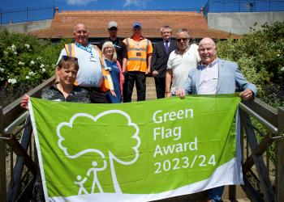 | Two green spaces in East Suffolk have been officially recognised as being among the best in the country, after receiving a Green Flag Award. Both Felixstowe Seafront Gardens and Woods Meadow Country Park in Oulton Broad have been awarded the international quality mark for parks and green spaces.
It is the eighth consecutive year that Felixstowe Seafront Gardens has received the Green Flag award and follows East Suffolk Council’s four-year restoration project, launched in 2011, to return the Grade II listed green space to its former glory as part of a town-wide regeneration programme.

New activity park opens in Felixstowe
Development of a new seaside leisure site has reached new heights with the opening of its activity park area, featuring climbing walls, sports equipment and games. The new activity park – open in time for the school holidays – forms part of a wider project to regenerate an area of land between Sea Road and the Promenade, in Felixstowe. | 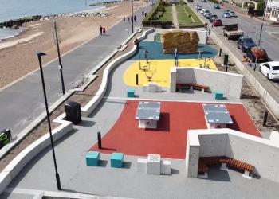
When fully complete, the Seafront Village will also feature 27 traditional-style beach huts, provided by East Suffolk Council, as well as a single-storey accessible hut, built from self-insulating panels and capable of being split into smaller rooms, or accessible beach chalets, for hire. The area will be entirely re-landscaped, with ramp access and fully accessible public conveniences with changing facilities. The development forms part of wider investment in the South Seafront area, where the Martello Park has delivered new homes, a play area and new car parking facilities, while East Suffolk Council also invested in the development of an award-winning contemporary café, the refurbishment of two public shelters and improved access linking the pavement along Sea Road and Orford Road to the beachfront.
- Declarations of disclosable pecuniary interest – None
- Minutes of Parish Council Meeting 09/07/2023 Read and agreed by Cllr Wicks and Cllr Garfath-Cox
- Planning - No planning to discuss.
Update on previous planning
- DC/23/0337/ARM Land east of 23A Mill Road – Approval of reserved matters of DC/21/0347/OUT – Outline application (some matters reserved) Erection of detached dwelling – Permitted.
- DC/23/0870/FUL 45 Jackson Road – The Proposal is to demolish the existing energy inefficient dwelling and replace it with a new re sited 2-bedroom home. – Awaiting decision
- DC/22/4967/FUL Oak View Farm – Erection of a detached (existing dwelling to be demolished) revised proposal to withdrawn application DC/22/4967/FUL – Permitted
- DC/23/1629/FUL Land at the Steadings caravan Park – Use of land for stationing 3 holiday lodges and change of use of existing building from reception to shop and café – Permitted.
- DC/23/1831/FUL 22 Mill Road Construction of extensions and alterations – Permitted.
- DC/21/0347/OUT Land East of 23A Mill Road -Discharge of condition Nos 4 & 7 of DC/23/0337/ARM Approval of reserved matters DC/21/0347/OUT Outline application (some matters reserved) Erection of detached dwelling – Condition 4 Landscape Plan provided, and condition 7 revised site plan indicating EV charging point and brochure provided with further detailing – Permitted.
- DC/23/2338/FUL 23 Mill Road – Construction of detached dwelling and garage – Refused.
- DC/23/2378/AME 7 Ipswich Road – Non-material amendment of DC/22/5012/FUL – Alterations part demolition plus front, rear and first floor extensions and new cart lodge to garden change in window colour – Permitted.
- Play Area - Inspection will take place in September.
- Quiz discussed and booked in the village hall diary for Saturday 21st October 2023, confirmed quiz master is available for this date and will be the same as the last quiz. Teams of 6, £5 per person, prize for winners and Losers and a raffle. Clerk will advertise on social media.
- New Councillors as the parish council have three seats available on the council, Chairman Garfath-Cox has produced an excellent leaflet which was shown to all Cllr’s and was agreed it would be printed and distributed around the village to try and get some new members. Colin Pollard has very kindly agreed to print the leaflets and chairman Garfath- Cox and Cllr Lusher will deliver them.

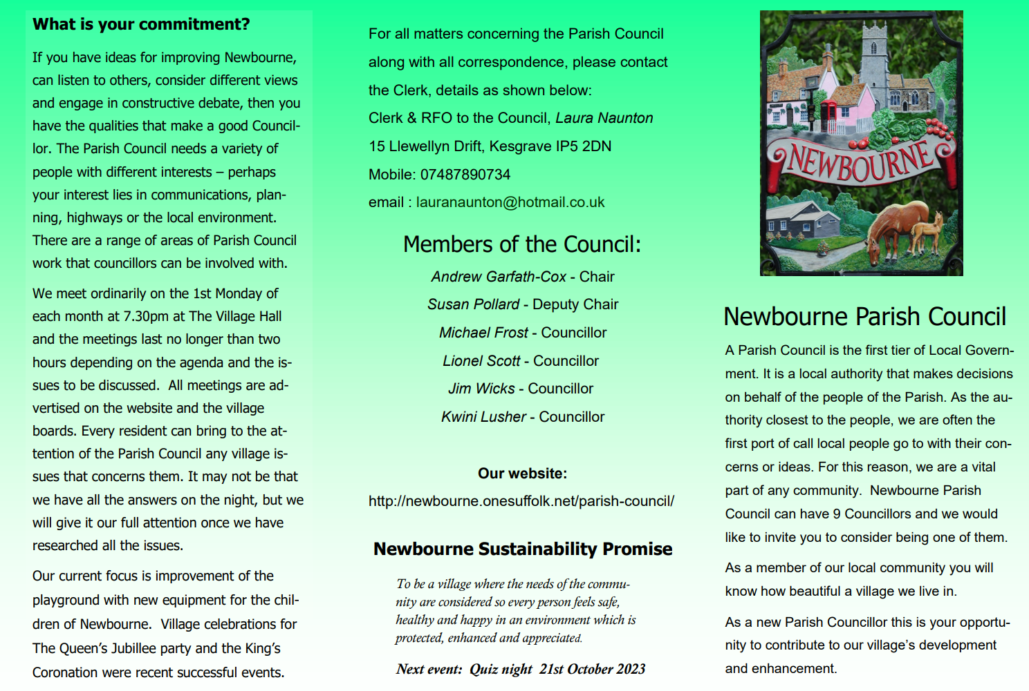
- Green Infrastructure invoice received, and cheque raised. Cllr Lusher and Terence Gaussen will be representing and attending the meeting on 31st August 2023 they will feed back to us in the September meeting.
- Finance
Cheques
100485 East Suffolk Council Uncontested election £100.98
100486 Greener Waldringfield Workshop £50.00
100487 Newbourne Village Hall £116.17 Half of internet

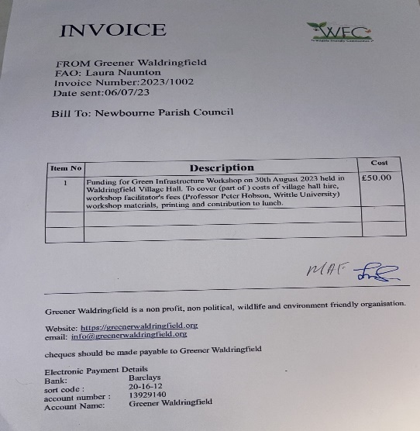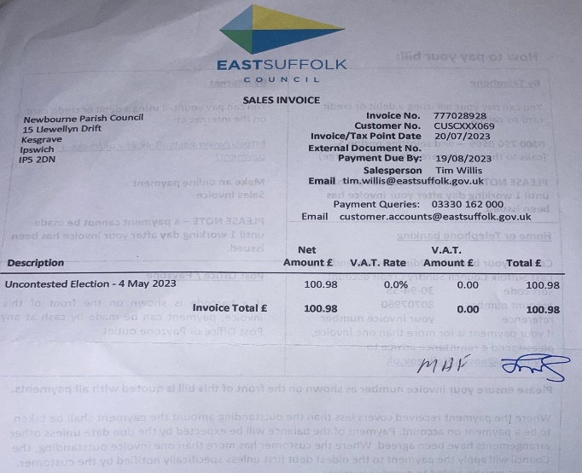

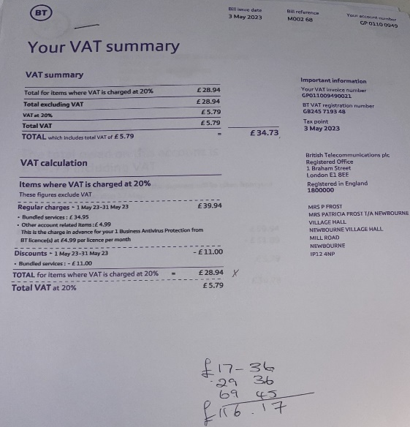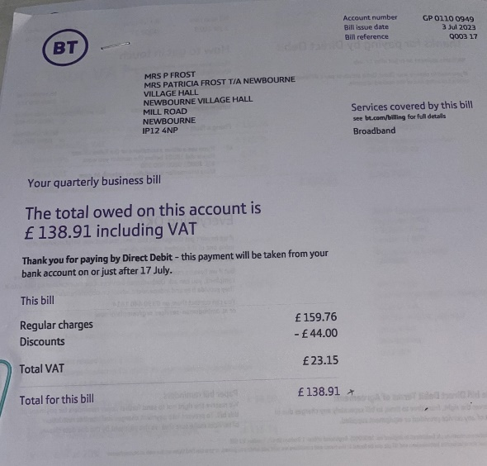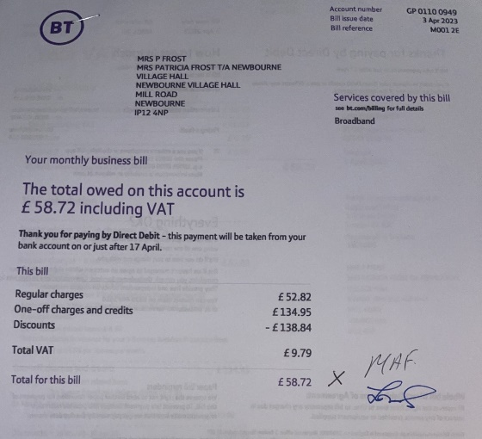

Bank Reconciliation June 2023

Cash in hand 01/06/2023 £22,697.88
Community £18,662.31
Saving £4035.57
ADD
£8.41 interest for saving account.
£506.00 Fundraising money from village day
Total £23,212.29

SUBTRACT
Payments
Amount Cheq no Payee Cashed
£494.10 100483 wages 07/6/2023

Cash in hand 01/06/2023 £22,718.19
B
Cash £0.00
Petty Cash £0.00
Community account £18,674.21
Saving £4043.98
£22,718.19
Bank Reconciliation July 2023

Cash in hand 01/06/2023 £22,718.19
Community £18,674.21
Saving £4043.98
ADD

£22,718.19

SUBTRACT
Payments
Amount Cheq no Payee Cashed
£123.40 100482 HMRC 19/07/2023

Cash in hand 01/07/2023 £22,594.79
B
Cash £0.00
Petty Cash £0.00
Community account £18,550.81
Saving £4043.98
£22,594.79

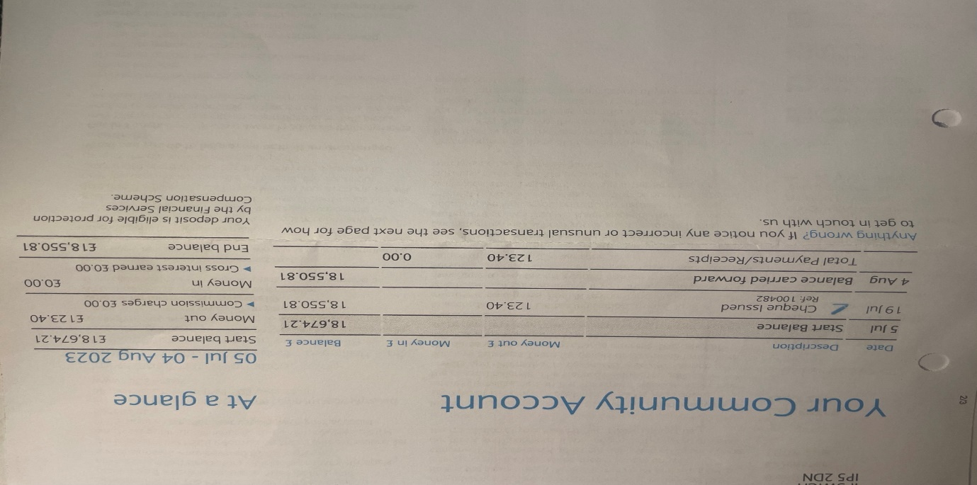


- Clerks Correspondence Speed Camera issues not working. Problem with keeping it charged will speak to Michael Hadley and find out if it needs to go back or if there is a solution to the problem.
Meeting close by chairman at 20:22

