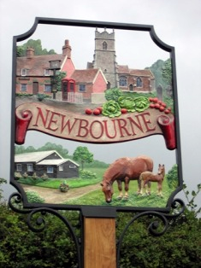

Newbourne Parish Council
Minutes 7th June 2021

Attended - Michael Frost, Jim Wicks, Lionel Scott, Charlotte Gammons, Sue Pollard

The meeting was opened at 7.30pm by chairman Charlotte Gammons

There were a few members of the public to discuss planning DC/21/2207/OUT Ugli Nursery /South of 19 Mill Road – Outline application for a 3 bedroom dwelling and DC/21/2584/OUT Greenways nursery , Ipswich Road. The public discussed their concerns with the planning on Ipswich road that the proposed 2 bungalows would be to large for the plot.
Village Hall committee have raised issued with the grass cutting at the village hall it was agreed that the clerk would discuss with SCL about the grass cutting.
Also raised Bolton Paper bin has been removed from the village hall as Bolton wanted to charge £25.00 a month for the bin to be collected.

- Apologies –Kwini Lusher
- Declarations of disclosable pecuniary interest – None
- Ward Councillors monthly bulletin – June 2021 .

Landmark development in Felixstowe enters final phase
Landmark development in Felixstowe enters final phase
Last week, I visited the site where a new iconic café is being built on Felixstowe’s South Seafront alongside Cllr Craig Rivett and Cllr Steve Wiles. This was the first time we’ve been able to visit the site since the easing of national restrictions and a lot has happened since we were last there!  We were really pleased with progress and can’t wait to see the finished result later this summer. | 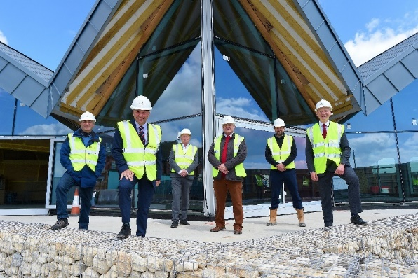
The construction is entering the final phase and once completed, it will house the new café which will no doubt play a key role in helping Felixstowe as it starts to recover from the impact of Covid-19 by not only supporting tourism, but also offering local employment opportunities – making the South Seafront an exciting place to visit, live, work and invest.

Council adopts new Air Quality Strategy
The drive for clean air and minimal pollution in East Suffolk has taken a step further after Cabinet unanimously agrees to adopt a new Air Quality Strategy.

Bringing together current policies and initiatives which have an impact on air quality, the robust strategy will now become an integrated part of our decision making, meaning that air quality will be a major consideration on a local and strategic level going forward.

It supports our vision of building environmentally sustainable communities, and enabling sustainable travel options, delivering more educational campaigns, promoting eco-friendly development and becoming carbon neutral by 2030 are just some of the objectives we seek to deliver.

Read the new Air Quality Strategy at www.eastsuffolk.gov.uk/assets/Environment/Environmental-Protection/Air-Quality/AQ-Strategy-2021.pdf
Flood project online visitor centre open
The Lowestoft Flood Risk Management Project launched a virtual visitor centre last week to provide information about the development and construction of the tidal flood walls and tidal barrier. Using gaming technology, the virtual centre provides information about the history of the project, how it has progressed and the ways in which it provides opportunities for Lowestoft. The centre will be open for the duration of the project and regularly updated with new information at https://lfrmp.virtualconsultation.co.uk/.

Approval for Council’s innovative Housing scheme
We are delighted that an exciting and innovative scheme to redevelop the Former Deben school site in Felixstowe has received planning consent.
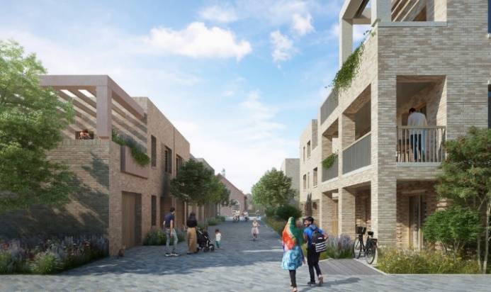 | The proposed housing development, which the council itself will deliver, will seek to set the very highest standards in green technology and underlines our commitment to innovation and designing for a more sustainable future.  Meanwhile, outline planning permission
has been secured for a leisure element with a significant proportion of the site to be set aside for indoor and outdoor sport, and new footpaths providing pedestrian links.

Appointments made for Southwold Harbour Management Committee
Following a thorough recruitment process, we have now appointed four independent members of the Southwold Harbour Management Committee – a newly formed body, responsible for running the Harbour on our behalf.

Interviews for the independent roles took place earlier in May and, with ratification by Cabinet, the chosen four will join the committee, after being assessed by a three-person Appointments Panel consisting of myself, Cllr Ian Bradbury (Southwold Town Council) and Mrs Lucy Parson, a consultant who specialises in Ports and Harbours.

They will join five Cabinet Members, who were requested to complete a Skills Audit form, setting out their suitable skills and, on that basis, were assessed to meet the criteria required. These are Cllrs Craig Rivett, James Mallinder, Maurice Cook, David Ritchie and Letitia Smith.

The Appointments Panel also unanimously agreed that the following candidates be recommended to Cabinet for their appointment as independent, co-opted members on the HMC: Mr Alistair MacFarlane, Mr David Gledhill, Mr Richard Musgrove and Mr Mike Pickles.

Bold new beach huts will put Lowestoft on the map
As part of wider work to regenerate the town, exciting and modern beach hurts are to be built at Lowestoft’s seafront after Planning Committee North approved the scheme at Jubilee Parade. | 
Designed by Norwich-based architects Chaplin Farrant, the £2.6m project will create split level beach huts, which will face partially south to ensure maximum sunshine throughout the day. The tips of the structures will face eastwards, reflecting Lowestoft’s position as the most easterly location in the country.

Historic England funding
As part of the London Road Lowestoft High Street Heritage Action Zone (HSHAZ), we have received £90,000 funding from Historic England to create and deliver community-led cultural activities over the next three years: www.eastsuffolk.gov.uk/news/high-street-heritage-action-zone-awarded-funding-for-cultural-programme/

East Suffolk chosen by Government to test use of digital tools in planning
I am delighted that East Suffolk is one of 10 local authorities to be chosen to participate in national testing of digital tools in the planning process, announced by the Housing Minister earlier this week.
The pathfinder programme will look at the digital transformation of local plans which will increase community involvement and speed up the planning process. By introducing a digital system that makes plans map-based and accessible online, local people in East Suffolk will be able to engage with planning, which will help get homes built quicker.
We will test how existing local plans translate into the new system, moving away from long text documents to an interactive map with accompanying annotation document.
The adoption of existing site allocation policies into the proposed land categorisation format will enable planners to understand the impact of proposed land designations and associated policy implications on land allocations and inform a wide range of policies across the reform programme.
Community engagement will continue to play a key role to ensure that the right levels of growth are identified to meet the needs of our local communities. In the new system digital tools will be key for making planning proposals more accessible and interactive, supporting the ambition for more effective community engagement.

Surveys and consultations
We are currently running a number of surveys and consultations and, as always we want to encourage participation as feedback from people in East Suffolk is invaluable and helps us ensure we’re making the right decisions for our communities.

- Supporting older people’s housing needs
This survey will help develop a new Older People’s Housing Strategy to support older people’s housing needs in East Suffolk so they can continue to live fulfilling lives in the right type of housing. The survey is open until 5pm on Friday 9 July at https://eu.surveymonkey.com/r/ESC_Survey_OPHS_May2021

- Vote for your favourite name for proposed beach village
We have submitted a planning application for a new beach village in Felixstowe, aimed at improving the beach hut experiencing by creating accessible facilities that enables families and groups to enjoy everything the beach and town has to offer. As part of this, we’re looking for a new name for the site and are asking local people to vote for their favourite out of 5 suggestions in a survey which closes at 5pm on Friday 30 July at https://eu.surveymonkey.com/r/BeachVillage

- Improving privately rented homes in East Suffolk
We have partnered with Generation Rent, the national campaigning body for private renters, for a pilot consultation to help us improve homes in East Suffolk. As part of this, private renters in the Harbour & Normanston ward, Beccles & Worlingham ward and Aldeburgh & Leiston ward are invited to share their experiences of renting privately in a survey which is open until Monday 21 June at https://my.eastsuffolk.gov.uk/service/Private_Renters_Survey.
This will be followed up later this year with forums and focus group discussions.

- Southwold Neighbourhood Plan
People can now have their say on the Southwold Neighbourhood Plan until 5pm on Friday 9 July at https://eastsuffolk.inconsult.uk/SouthwoldNP/consultationHome
When finalised, the Plan will act as a guide to development in the town and will be required to be used by anyone considering, or making, a planning application.

- Residential development brief for land north of Union Lane, Oulton
Residential development briefs are being prepared for a number of sites allocated in the East Suffolk Local Plans. The first residential development brief to be prepared is for WLP2.14 (Land north of Union Lane, Oulton) - the site is allocated for approximately 150 homes in the Waveney Local Plan. People can now submit their views in a public consultation, which is open until 5pm on Monday 21 June, at https://storymaps.arcgis.com/stories/24fdfdf19a9d49228f7b9860a4048b25

- Understanding the hidden impact of periods
Our Communities Team is currently carrying out a survey to get a clearer picture of how people in East Suffolk are affected by their periods. This will enable us to provide the necessary support and reduce the stigma associated with the menstrual cycle. The survey is open until Friday 18 June at https://eu.surveymonkey.com/r/3W3LFPF

Staying up to date on the latest East Suffolk news
The Communications Team now share all media coverage on SharePoint, meaning you can stay up to date on all media stories relevant to East Suffolk Council, whether on local, regional or national news outlets, tv, radio, print or online.
You can access these at any time at https://eastsuffolkgovuk.sharepoint.com/sites/Communications/Lists/Media%20coverage/AllItems.aspx

From here, you can easily share a story by clicking on the relevant story and selecting ‘Share’ or ‘Copy Link’. For PDF’s (saved from print publications), you can also select ‘Download’ to save the PDF. It also makes it easier for you to find a specific story/date/publication etc. as you can filter through all the cuttings in no time by clicking on the funnel icon in the righthand corner of the page.
If you have any questions or need any help with this service, you can email the team on communications@eastsuffolk.gov.uk
Social media
We keep our communities up to date in a variety of ways and social media has an important role to play. Please follow us and share our posts with your audiences!
Facebook: www.facebook.com/eastsuffolkcouncil
Twitter: https://twitter.com/EastSuffolk

Regards,
Mel and Richard

4. A Covid catch up to make sure all the councilors have been ok during the covid lock down, any changes in the village etc. We spoke about Mental health. Also we discussed access to Zoom incase of any future lockdowns.

Mental Health Useful numbers and contacts

Anxiety 03444775774
Samaritans 116 123

5. Planning DC/2207/OUT Ugli Nursery /South of 19 Mill Road – Outline application for construction of an three bedroom dwelling.

Planning discussed.
5 votes for
1 vote against

Against argument the roads are not wide enough to support more properties.

DC/21/2207/OUT Greenways Nursery Ipswich Road – Demolition of nursery buildings and erection of 2 chalet bungalows and associated works.
Planning discussed
5 votes against
0 votes for

Over development of site.
Plot never used for a nursery

6. New councilor – Gary Grainger would like to join the parish council as a councilor he has lived in the village for over 5 years and is an Accountant. The parish council would like to welcome Gary on to the parish council.

7. Finance
- Budget Report – Up to date bank statements

8. Allotment – Waldringfield Parish Council have asked they we ask we know of anyone in Newbourne that would be willing to rent a acre of land to be used for allotments for villagers of Waldringfield. Discussion had and no one is aware of any land that people would be willing to rent out for allotments.

9. Clerks correspondence – None
10. Next meeting Agenda points sign , grass cutting.

10. Date of next meeting – 5th July

