Newbourne Parish Council Minutes 03/04/2023

Public Time

Damon and Debbie Jones came to speak about their future plans. They have advised that steadings has now been sold to Brain Humpries and his son will be running Steadings. Damon and Debbie will be going to live in Spain for a few months and then would like to live at Oak View Farm when they return the plans have now been changed and advised that the planning office advised them to build piggery building then knock it down and build on existing site.

Richard East who has recently brought 7 Ipswich Road came to discuss his recently amended plans. Richard explained that they have scaled back the plans, Plans were shown so the public and cllr’s could see the changes.

Apologies and approval of absences Gary and Patti

- To receive Declarations of Interest – None

- Reports

March 2023 report for the Martlesham Division Cllr Patti Mulcahy
Suffolk County Councillor – Martlesham

Ipswich Re-use shop returns to Foxhall Recycling Centre

The popular Re-use shop had temporarily moved out as part of the ongoing £7.8m refurbishment of the center. A popular shop selling items diverted from Suffolk’s recycling center’s has moved back to its Ipswich home. The Re-use shop has re-opened at Foxhall Recycling Centre after temporarily relocating as part of a £7.8 million refurbishment of the complex. The new shop design at Foxhall makes it more accessible for customers and it will be the first thing the public will see when entering the site.
It will have dedicated customer parking and more outside space, along with a canopy. The shop sells furniture, sports equipment, kitchen supplies, books, toys, and bric-a-brac, collected at the 11 recycling centers across Suffolk and which would otherwise have been disposed of as waste. Its average footfall was 1,500 a month and since the shop first opened in 2016 it has sold a total of 343,721 items, equivalent to 2,429 tonnes of material. There is a sister shop at the Bury St Edmunds site. The shops are run by local charity The Benjamin Foundation, which has been supporting young people in Suffolk and Norfolk for more than 25 years.
The new shop is part of the £7.8 million refurbishment of Foxhall Recycling Centre.

Suffolk Walking Festival returns for 15th instalment

Tickets are on sale now for The Suffolk Walking Festival 2023 as it celebrates its 15th year.

This year’s festival boasts a 16-day programme and offers over 70 walks across 350 miles of Suffolk’s beautiful landscapes. With lots of weekend, evening, and family walks. The programme has accessible, short, medium, long-distance walks, and more challenging walks – so there is something for everyone. From learning about the ancient tradition of ‘Beating the Bounds’ to exploring the heart of The Brecks with its gorse-covered sandy chalk soils characterised by purple heathland, tall pines and rare wildlife, this year’s festival appeals to a wide range of individuals. There is a range of shorter urban strolls, and for those looking to stretch their legs, several spectacular riverside walks and valley yomps. Also returning this year are ever the popular Walk n’ Water River trips with a boat in Sudbury; an exclusive walk with Sweep the sheepdog on Orford Ness; a twilight safari in an ancient woodland; and the intriguing stories of ancient smugglers and shipping routes on Dunwich Heath.
The festival kicks off at Thornham Walks on Saturday 13th May with refreshments and 5 launch jaunts. It then runs every day until 28th May.
Visit www.suffolkwalkingfestival.co.uk for more details on the programme, to sign up to newsletters, and to buy tickets.

Help design a new Virtual Reality app for people living with dementia.

Suffolk County Council is looking for people to help develop a new Virtual Reality (VR) app for people living with dementia in Suffolk.
The county council is inviting people living with dementia, their family carers, as well as health and social care professionals, who live or are based in Suffolk, to join a user group to help co-create the bespoke platform.
The group will be called ‘Synergy’ and members will have input into all aspects of the look, design, and structure of the new VR app. Over the last 10 years clinical research has demonstrated that not only do people with dementia tolerate virtual reality, but they can actually derive a wide variety of benefits from it, including improvements in well-being, cognition and communication.
The app is being produced in partnership with Spark Emerging Technologies Ltd, who were awarded a contract by Suffolk County Council in December last year.
To learn more about the user group and to apply visit suffolk.gov.uk/care-and-support-for-adults/virtual-reality-project

New exhibition opens at Sutton Hoo telling the story of royal Anglo-Saxon Rendlesham

Rendlesham Revealed: The Heart of a Kingdom AD 400-800 is a new exhibition opening on Thursday 23 March 2023 at the National Trust’s Sutton Hoo, in Suffolk.

The exhibition takes visitors on a 400-year journey to reveal how the Anglo-Saxon royal settlement at Rendlesham grew and developed, and celebrates the many volunteers from the local community who uncovered the long-lost archaeological remains.

This story is brought to life with over 150 archaeological finds from the settlement, ranging from food remains to gold jewellery, many of which have never been on public display before.
Suffolk County Council’s Archaeological Service is curating the exhibition to celebrate “Rendlesham Revealed”, a community archaeology project funded by The National Lottery Heritage Fund.
Over 400 volunteers from the local community have been involved in uncovering Rendlesham’s past, including young adults from the Suffolk Family Carers and Suffolk Mind, and local school children from Rendlesham, Eyke and Wickham Market primary schools. Volunteering has had a positive impact on many of those who took part.
The exhibition opens at Sutton Hoo on 23 March 2023 and will run until 29 October 2023. Entry to the temporary exhibition will be included in the normal admission charge to Sutton Hoo, which is free for National Trust members.
Smaller displays will also be on show at Norwich Castle and the West Stow Anglo-Saxon Village and Museum in 2024.
To find out more about the Rendlesham Revealed project visit: heritage.suffolk.gov.uk/rendlesham

Michael Richardson passed on this information.

Climate action blueprint bolsters environmental ambition
East Suffolk Council has reinforced its commitment to protecting the environment by setting out the guiding principles of its response to the climate emergency.
A comprehensive Climate Action Framework has been published to chart our response to date, while helping to guide further meaningful progress towards a more sustainable future.
The document aims to further uphold these commitments by gauging efforts to reduce our own carbon footprint, outlining wider partnership programmes, and looking forward to the next period of action.
Caring for our environment was made a key principle of the East Suffolk Council Strategic Plan when it was approved in 2020 with an agreement to launch an ambitious programme of more than 110 projects related to climate change and the environment, overseen by group of officers and monitored by a cross-party task group of elected members.
The Strategic Plan’s commitment to 'put the environment at the heart of everything we do' had been reinforced by the declaration of a climate emergency in 2019 and a commitment to reach net zero by 2030.
Since then, work to deliver the programme has included decarbonising our HGV fleet and updating policies to incorporate national guidance on responding to climate change through procedures such as sustainable construction and transport.
Investments such as energy efficiency upgrades across our buildings and assets have contributed to a reduction in emissions of more than 358%, while an ongoing major project to decarbonise our leisure centres will further reduce our footprint and ensure these important facilities remain accessible.
Cllr James Mallinder, East Suffolk Council cabinet member for the environment, said: “We are committed to doing everything we can to respond to the climate emergency and enabling everyone in East Suffolk to also play their part. Every one of us has the power to make small actions add up to big change.
“Not only are we committed to reaching net zero CO2e emissions by 2030, but we are also working with other councils and partners to help Suffolk, as a county, reach the same target.
“Our Climate Action Framework demonstrates the many consequent benefits of that work, from improving air quality, to boosting wellbeing, lowering energy costs and creating jobs.”
Beyond decarbonising our energy production and transport, the Climate Action Framework encompasses numerous other key factors in addressing climate change – from reducing our use of resources to restoring our natural eco-systems.
The framework will be a working document, updated every quarter, with new sections added as information emerges, and other actions removed when completed in line with the East Suffolk Council core environment programme.
The core environment programme’s priorities include reducing our footprint to deliver net zero, delivering low carbon energy projects and low energy homes, boosting biodiversity and restoring natural habitats, supporting low carbon transport and reducing use of resources.

The Suffolk Climate Emergency Plan sets out a commitment by Suffolk’s public sector leaders to pursue net zero strategies that respond to local, national and international evidence.

Love East Suffolk this spring
East Suffolk residents are encouraged to get involved in community litter picking this spring.

East Suffolk Council’s popular ‘Love East Suffolk’ scheme invites local groups to organise a litter pick in their community for the benefit of residents and the environment, and supports the national Great British Spring Clean campaign organised by Keep Britain Tidy.

Litter picking equipment, including hi-vis vests, litter pickers and bags are available for participating groups to collect from Ufford or Lowestoft, and arrangements can be made for collected litter to be removed by East Suffolk Norse.

Cllr James Mallinder, East Suffolk’s cabinet member for the Environment said: “It is always encouraging to see communities getting involved in litter picking, which makes a huge difference to wildlife and the appearance of an area, and we know that other residents really appreciate the efforts of those who voluntarily pick up litter, helping to keep East Suffolk a beautiful place in which to live, work and visit.

“It is a shame that litter picks are needed at all but unfortunately some people think it is acceptable to dump their rubbish wherever they like. It would be far better if everyone took responsibility for their own rubbish and disposed of it correctly, using litter bins or taking it home, instead of expecting other people to pick it up on their behalf.”

Participating groups are invited to contribute photos of their litter pick which can be shared on the Council’s website and social media channels in recognition of their hard work. Photos can be sent to communications@eastsuffolk.gov.uk

To register your litter pick, please visit https://eastsuffolk.co/love

- To resolve that the minutes of the meeting of the council held on 06/03/2023 are a true and correct record. Cllr Lusher and Cllr Pollard

- To consider planning applications
To consider planning applications:
- DC/23/0990/FUL Erection of a detached dwelling (existing dwelling to be demolished) Revised proposal to withdrawn Application DC/22/4967/FUL – Oak View Farm, Ipswich Road.
Damon and Debbie Jones discussed their plans for Oak View Farm in public time at the time questions were asked about the plans. The parish council voted on the planning, and all voted for the parish council to support.
- DC/23/0870/FUL The Proposal is to demolish the existing energy inefficient dwelling and replace it with a new re-sited 2-bedroom home. 45 Jackson Road.
Planning discussed and the Cllr’s discussed and 6 Cllr’s support the planning and 1 against. The ongoing state of Jackson Road was discussed and also that LSA houses are not energy efficient.
- DC/22/5012/FUL Alternations part demolition plus front, rear and first floor extensions and new cart lodge to garden. 7 Ipswich Road.
The Cllr’s voted on the planning and all voted for the parish to support the planning. It was previously discussed as the Cllr’s thought the house would be too close to Ipswich road and the property was large the amended plans are smaller.

- To DISCUSS the play area

The Play area committee has received a quote for the swings as below.
It has been agreed that we do the play area in sections starting with the swings.
Andrew has done a great job organizing the committee hosting and speaking to Wicksteed.
The Cllr’s have discussed the quotation and they would like 3 quotes for the swings.
They would like us to raise money and secure grants so we can pay for the parts of the play area and not be happy borrowing money from the village hall committee.
Also, we need to see if any businesses in Newbourne would help with funding.

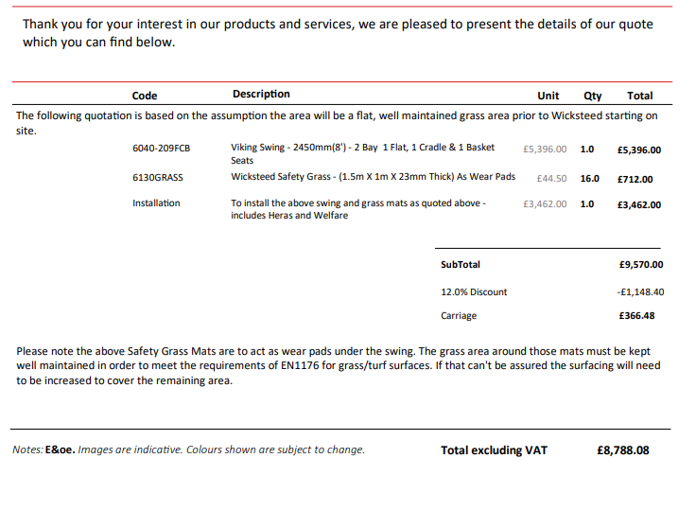

- To DISCUSS Coronation / Village Day
Coronation sub committee have met and arranged the following.

Band – booked.
Raffle – Pat to sort
Food – Pizza and ice cream booked
Bar -Gary will organize and buy the bar supplies and sweets for kids games
Kids games – Mike to sort tug of war rope
Parking – Speak to business Park
Tractors – Gary has sent a message to tractor owners.

- Finance
  - To receive Finance Report

  - To authorise payments as listed below:

Planters for outside bus shelter – Hannah Stock 100478 £133.20
Church Roof repairs Donation – Newbourne Church 100479 £200.00
Clerk training – SALC 100480 £156.00

Bank Statements

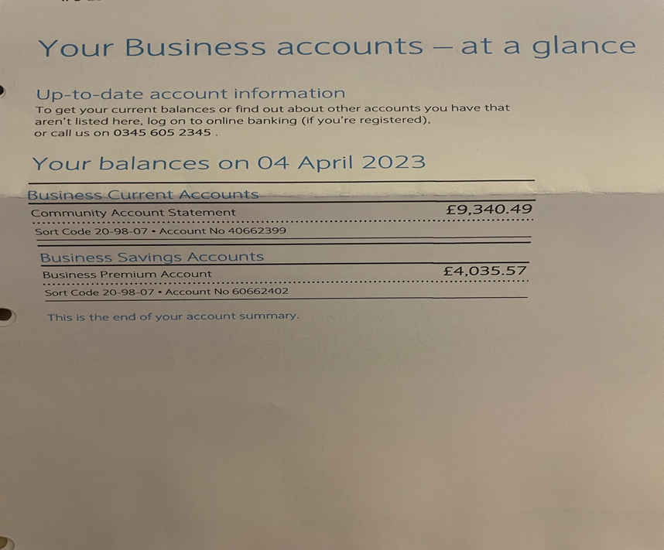

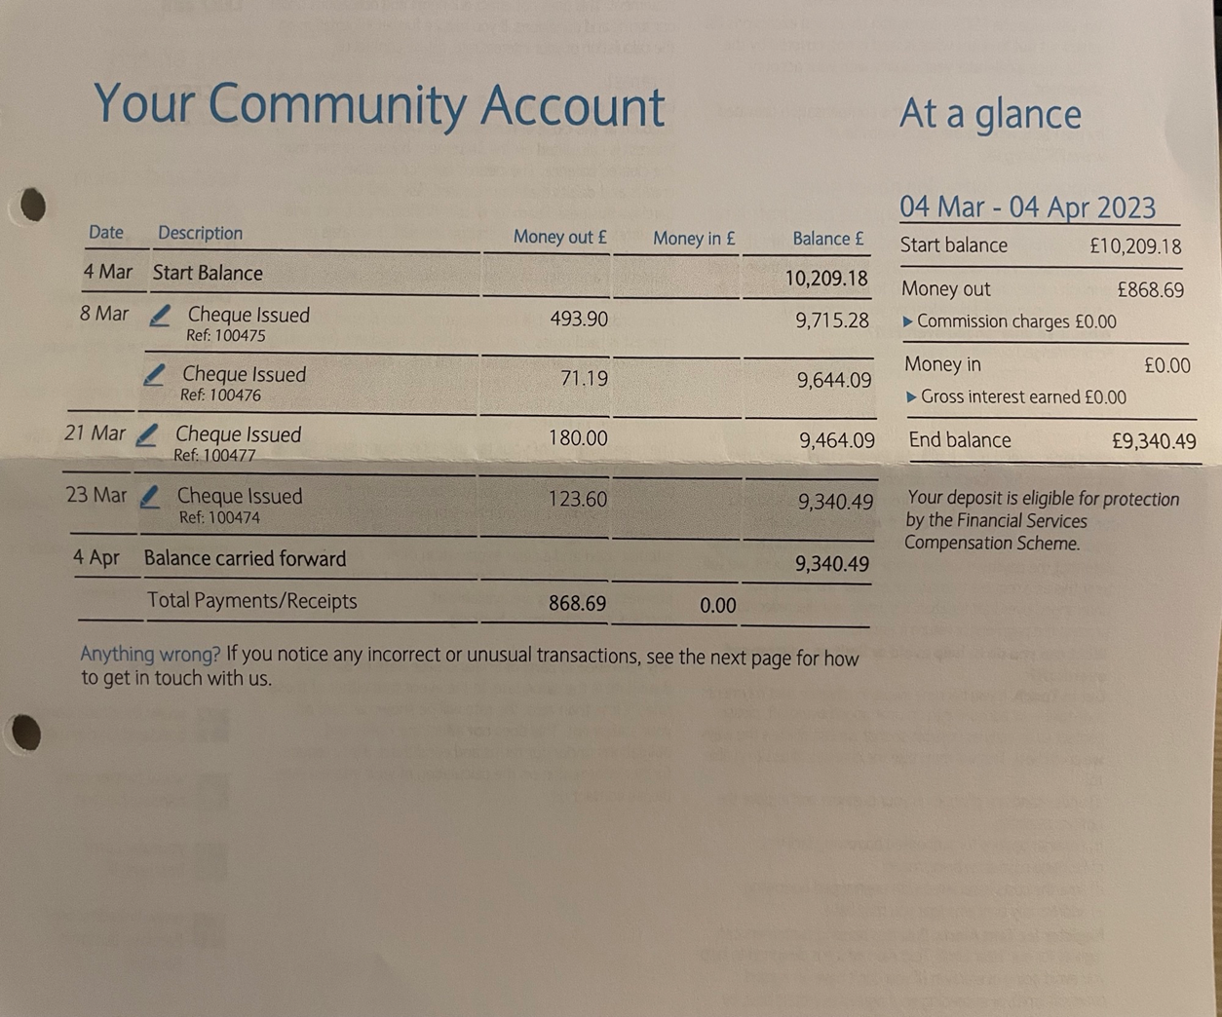

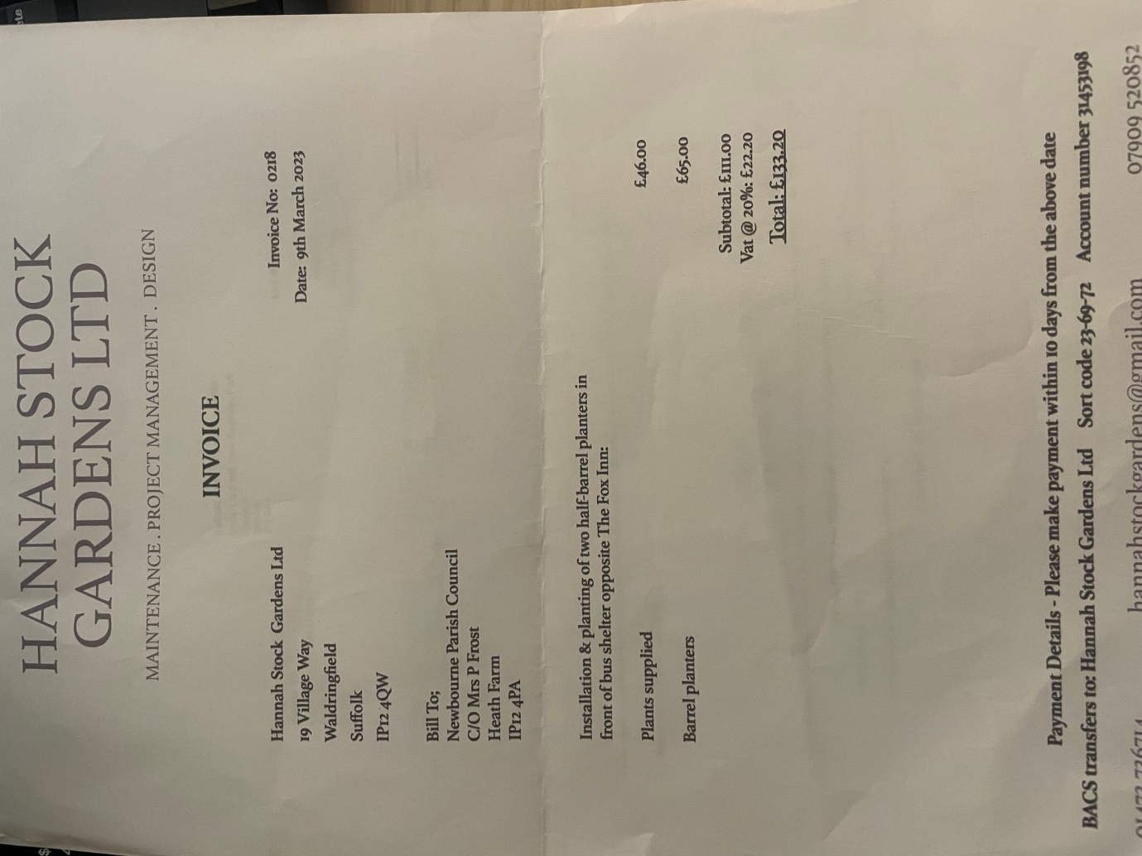

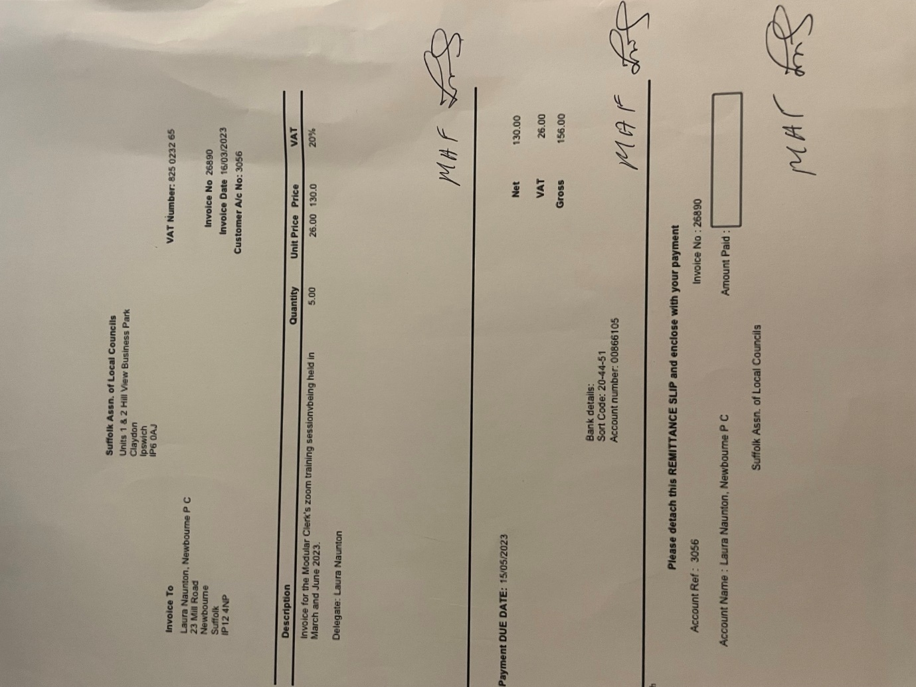

Clerks Correspondence – None Clerk will send out anything via email between meetings.

Date of next meeting
To confirm the date of the next meeting, scheduled for Tuesday 2nd May as there are two bank holidays in May otherwise the meeting would be in the middle of the month.

