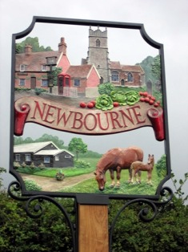

Newbourne Parish Council

Attended - Michael Frost, Jim Wicks, Tony Finch, Charlotte Gammons, Sue Pollard, Kwini Lusher and Susan Harvey

1. Apologies – Lionel Scott & Patricia O’Brien

The meeting opened at 7.30pm there was one member of the general public and

2. Patricia O’Brien – No Report

3. Cllr Susan Harvey Kirton Ward District Councillor’s Report – No report as Susan’s last report was last month but Susan is holding a Suffolk day in Kirton on the 22nd June 2019.

4. Declarations of disclosable pecuniary interest - None

5. Minutes from the last meeting proposed by Tony Finch and Seconded by Sue Pollard

6. Planning –

7. Village Hall – No complaints and no issues regarding the village hall

8. .Elections – Election papers completed to be handed in tomorrow.

9. Speed cameras – The paperwork has been sent to the highways regarding the sites for the speed cameras.

10. Finance
- Budget Report – Up to date bank statements
- Cheques – £ Waldringfield Parish council for speed camera

11. Clerks correspondence – Nothing to report

12. Date of next meeting – 04/06/2019

