Supporting Documents for the Parish Council Meeting – Monday 2nd March 2026

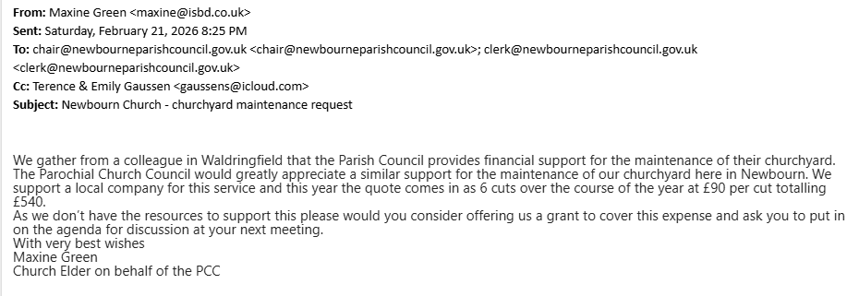
Request from Parochial Church Council:

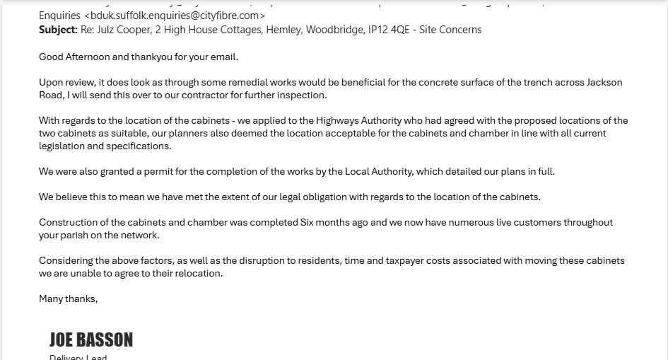
Response from CityFibre on Snagging Report:

Invoices Approved During Meeting:
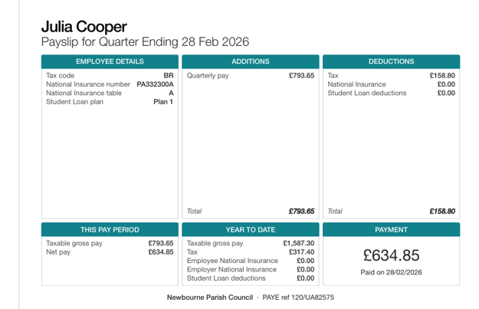
Cheque 100572 – Clerk Wages

Cheque 100573 – Treescape Group Ltd
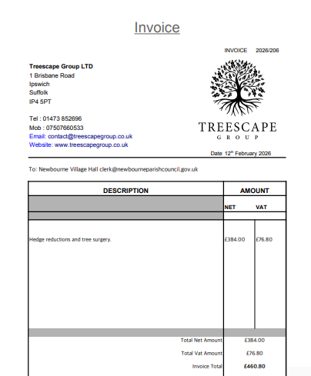

Bank Statements:
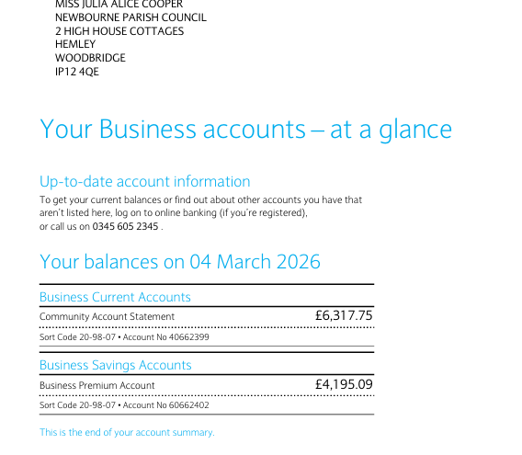

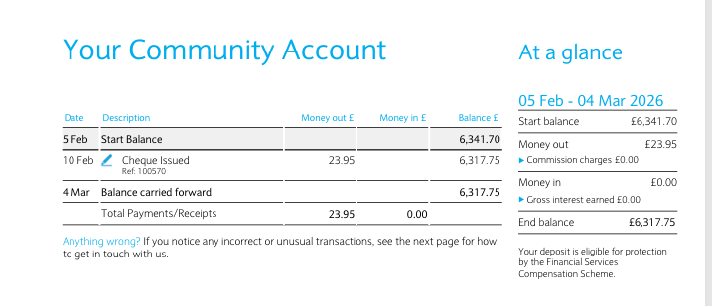

Parish Report February 2026:
PARISH REPORT FEBRUARY 2026
ORWELL & VILLAGES

Brand new fund to support smaller parishes
At the Town Councils conference on 26th February the new Thriving Places fund was introduced which will strengthen the long-term resilience and sustainability of the district’s smallest communities. The total amount available to parishes and towns outside Felixstowe and Lowestoft is £1.5 million.
Leader of East Suffolk Council, Cllr Caroline Topping said: “We recognise the challenges our rural communities face – such as declining infrastructure, reduced access to services and the impact of social isolation, and to address the historical lack of place-based investment in these smaller communities, we are prioritising this funding support to meet each communities’ specific needs. The Thriving Places Fund aims to address these challenges and empower each locality to develop projects that with have a lasting and positive impact on the lives of local people.”
Communities can apply for grants of up to £50,000 to support local projects which aim to reduce inequalities in the area, help people to adapt to changes, help to protect important local assets like buildings or spaces, improve access to services, skills, wellbeing activities and local facilities and support long-term local growth.
Capital grants of between £10,00 and £50,000 will be available for purchasing or improving physical assets, while revenue grants between £5,000 and £25,000 can be utilised to cover project-specific activities and operational costs. Up to 60% of project costs will be covered by the new grants and up to 80% for successful applications from community and not-for-profit organisations. Each year communities can apply within four funding rounds, with the final decision made by a grant panel consisting of senior East Suffolk councillors and officers.
Full details will be coming shortly with the first round of funding beginning in April. We would urge parishes who have limited or no access to Neighbourhood or District CIL funds to consider applying for funding from this source.

2026-2027 ESC Budget passed
On Wednesday 25 February, Full Council gave approval to a balanced Budget for 2026/27 supporting vital everyday services as well as the delivery of programmes to improve the quality of people’s lives.
Over £58m from the Council’s General Fund revenue budgets has been allocated to pay for services such as planning, leisure, housing and environmental services, waste collection and parking.

The General Fund also allows for projects to help improve the lives of people in East Suffolk, such as supporting the most vulnerable residents through the Community Help Hub and the ‘Ease the Squeeze’ programme as well as funding the mobile community pantry and advice hubs until 2027/28.
The increase in the portion of council tax East Suffolk Council receive (based on a Band D property) equates to just £5.67 extra per household for the entire year – meaning residents paying only an additional 11 pence per week. However, this will enable the Council to deliver a balanced Budget which protects core services in the face of significant ongoing cost pressures from pay, service demand and inflation - which year-on-year continues to outstrip any increases.
Proposed 70 place lorry park at Stratton Hall defeated
A proposal to build a 70-place lorry park on the old A45 at Stratton Hall was rejected by 7 votes to 2 at Planning Committee South on 24th February. The committee heard from officers who had recommended acceptance as well as the applicant and representations from objectors including Levington & Stratton Hall parish council. After listening to all sides, the committee found that there was no public benefit to build on the countryside which could lead to coalescence between Ipswich and Trimley St Martin, contrary to the Local Plan.
In general, it is very helpful for the planning committee to hear from parish councils or other objectors in order that we understand local feelings on applications.

County Council elections back on after Labour U-turn
The Government have now advised that the Suffolk County Council elections will go ahead on Thursday 7th May after having been postponed last year and again earlier this year. Luckily the arrangements such as booking polling places and hiring polling staff had been continued by Suffolk’s district councils. We should all know how many unitary councils for Suffolk there will be within the next two weeks.
To summarise county councillors elected in May will sit in that role until April 2028 when Suffolk County Council will cease to exist. In May 2027 there will be elections to the new Shadow Authority which will take over from both the current District and elected County councillors in April 2028.
The Mayoral election for both Suffolk and Norfolk will take place in May 2028.

Ease the Squeeze on Cost of Living
Are you, or someone you know, worried about the increasing cost of living? We understand the pressures faced by many people today and we are working closely with key partners to ensure support is available to help ease the squeeze for households in East Suffolk.
To make it as easy as possible for you to access the services and support available, locally and nationally, we have gathered information about them in one place:
www.eastsuffolk.gov.uk/community/squeeze/
For the most up to date information regarding East Suffolk Council, please visit: www.eastsuffolk.gov.uk
View the Well Minds East Suffolk booklet: tinyurl.com/9xhka624

As always if parish councillors need to contact either of us, please feel free to do so.
Cllr Mike Ninnmey: Home tel no 01394 277610 Mobile: 07823 372503
E-mail: mike.ninnmey@eastsuffolk.gov.uk
Cllr Lee Reeves: Home tel no 01394 284506 (preferred) Mobile 07823 372501
E-mail: lee.reeves@eastsuffolk.gov.uk

