March Supporting Documents 2025

Finance 2024 -2025
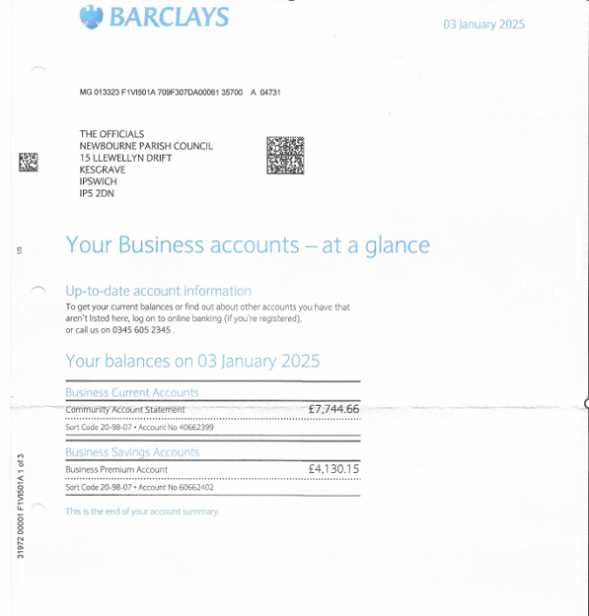
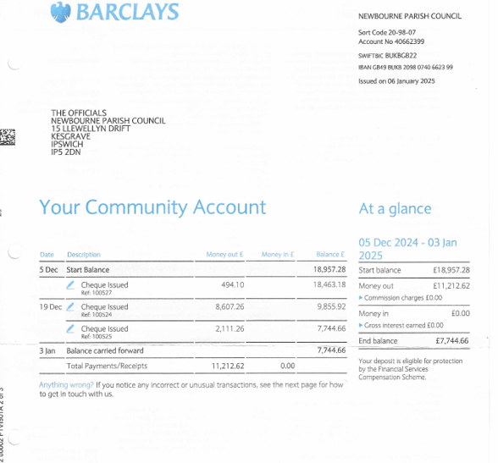
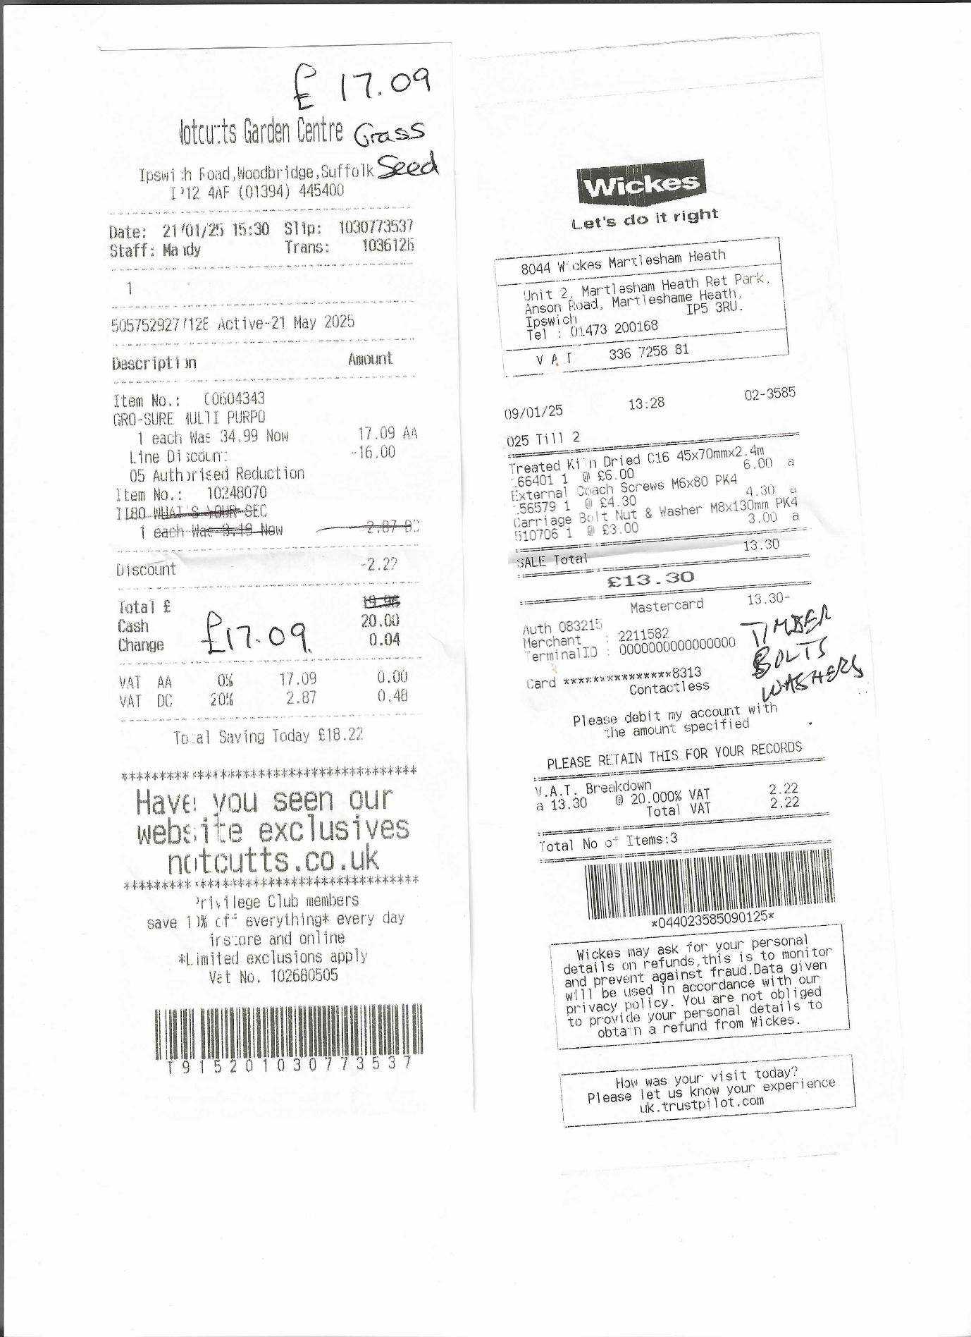

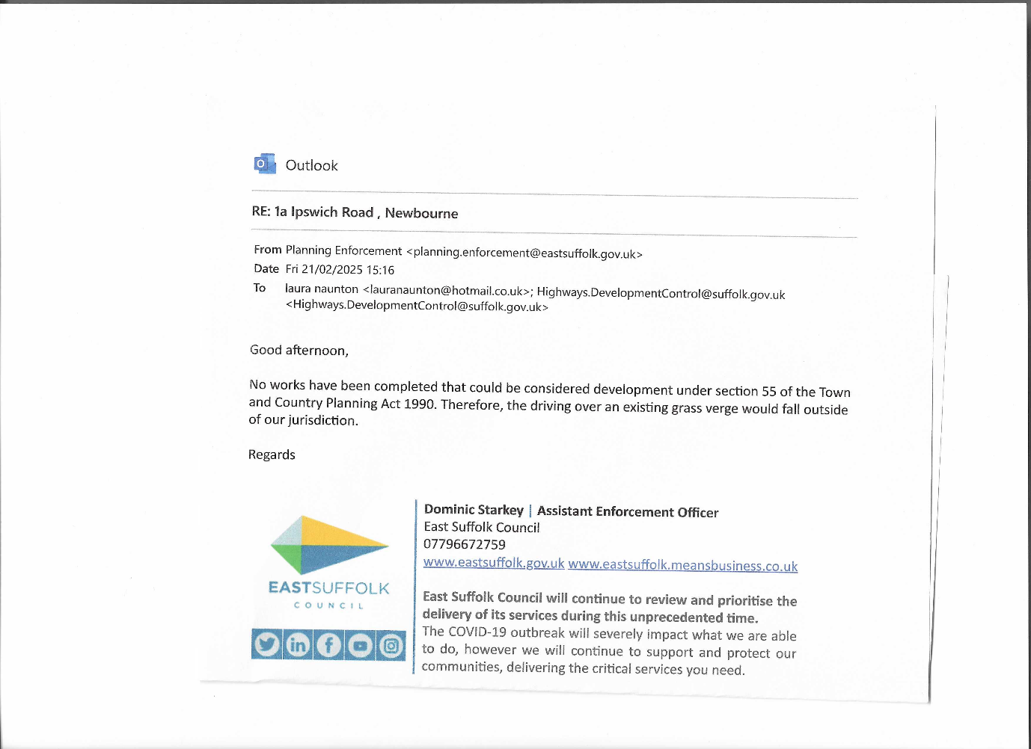

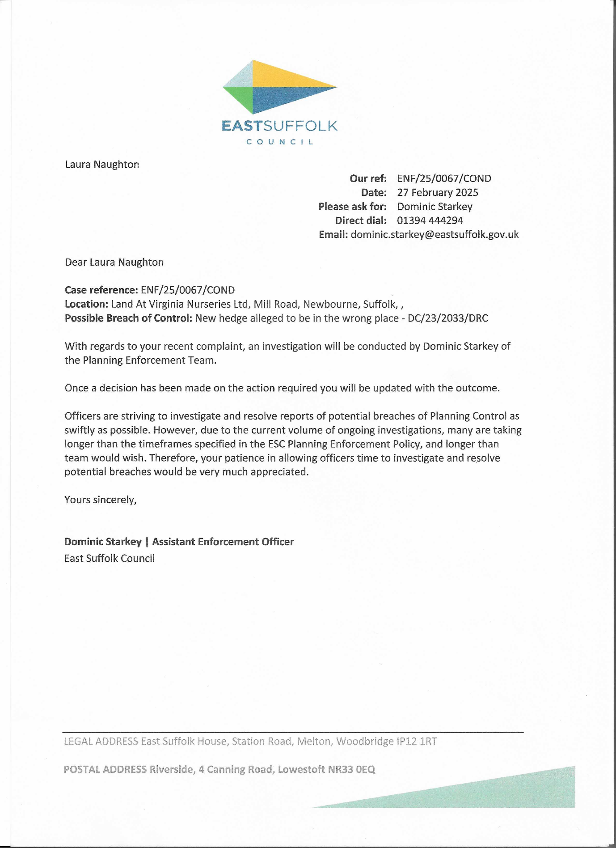

Finance

Payments up till March 2025

Finance 2024 -2025

01/04/2024 Opening Balance £16,287.44
08/04/2024 Money in £595.00 £16,882.44
11/04/2024 Chq 100503 HMRC £123.60 £16,758.84
16/04/2024 Chq 100497 WIFI VH £52.09 £16,706.75
16/04/2024 Chq 100506 WIFI VH £57.08 £16,649.67
17/04/2024 Money in East Suffolk £699.75 £17,349.42
23/04/2024 Money in Vat in £853.80 £18,203.22
30/04/2024 Precept in £7750.00 £25,953.22
05/06/2024 Chq 100510 Clerk wages £494.10 £25,459.12
17/06/2024 Chq 100509 HMRC £123.50 £25,335.72
20/06/2024 Chq 100507 SALC FINANCE £22.80 £25,312.92
20/06/2024 Chq 100508 SALC Membership 24-25 £163.30 £25,149.62
03/07/2024 Chq 100511 AJS - GRASS £420.00 £24,729.62
03/07/2024 Chq 100512 Printer+ Microsoft office £99.98 £24,629.64
23/08/2024 Chq 100513 IT /WEB £90.00 £24,539.64
17/09/2024 Chq 100516 Clerk wages £493.90 £24,045.74
02/10/2024 Chq 100517 Insurance £2124.45 £21,921.29
08/10/2024 Chq 100514 WIFI VH £57.08 £21,864.21
09/10/2024 Chq 100519 Boiler VH £7980.33 £13,883.88
14/10/2024 Chq 100515 HMRC £123.60 £13,760.28
22/10/2024 Chq 100518 playground inspection £103.20 £13,657.08
04/11/2024 Money in Village Hall £5583.00 £19,240.08
07/11/2024 Chq 100521 AJS - GRASS £160.00 £19,080.08
07/11/2024 Chq 100522 AJS - PLAYAREA £100.00 £18,980.08
25/11/2024 Chq 100523 SALC FINANCE £22.80 £18,957.28
05/12/2024 Chq 100527 Clerk Wages £494.10 £18,463.18
19/12/2024 Chq 100524 SWING/ WICKSTEED £8607.26 £9855.92
19/12/2024 Chq 100525 PLAYDALE REPAIRS £2111.26 £7744.66
10/02/2025 Money in quiz £670.00 £8291.26

Saving Account
01/04/2024 Opening balance £4084.16
02/09/2024 Interest £15.33
02/12/2024 Interest £15.39
03/06/2024 Interest £15.27 £4130.15

£8607.26 paid out for new swing for play area. Some CIL money put towards this. Also, some maintenance done on the play area.

Accounts show to G Grainger 01/03/2025

