June 2025 Supporting Documents

Email to Suffolk wildlife trust about the springs
Good Afternoon
I am Laura the clerk for Newbourne Parish council we were discussing the springs in a recent parish council meeting, and we were wondering if there is a long-term plan for the springs or what happens in the springs each season like clearing, hazel coppice etc. Does Suffolk wildlife trust ask for volunteers to help out? If so, we could advertise on our local page on Facebook as i think we might have a few people interested in helping. We wanted to know if someone from Suffolk Wildlife trust would like to come and talk about the Springs in one of our meetings. Our meeting for the rest of the year is 7th July 4th August 1st September 6th October 3rd November and 1st December we meet at Newbourne Village Hall at 7.30pm.
Thanks
Laura Naunton
Newbourne Parish Council Clerk

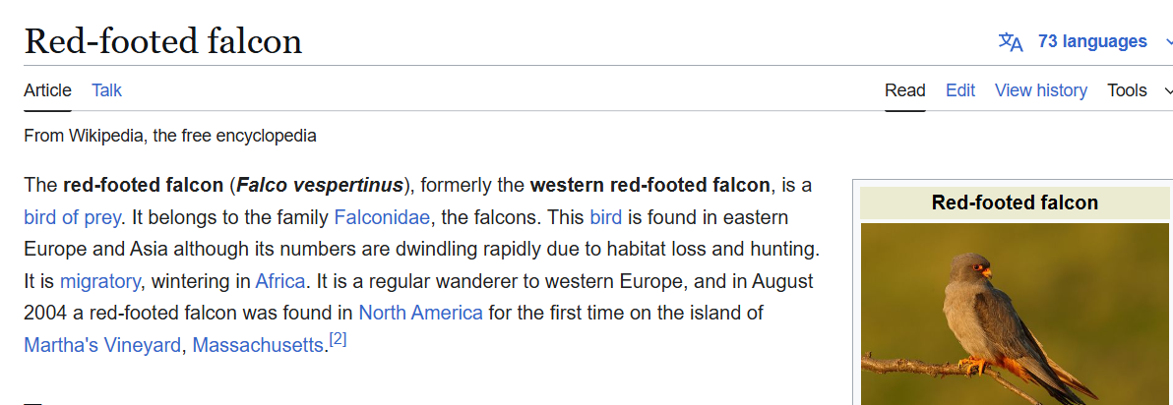

We have been made aware of a possible sighting of a red footed falcon in the springs apparently it has also been spotted in Lowestoft.

Email to Highways, sent to other local parishes and contacted Police to See if we can get stats on how many accidents on the road
Good Afternoon
I am the Clerk of Newbourne parish council, and we have had lots of reports of near miss accidents and accidents on the Newbourne Road / A12 Foxhall Roundabout. People travelling towards the roundabout from Brightwell, Newbourne and Waldringfield seem to think the approach to the roundabout is two lanes. I have tested this on Sat Nav and it doesn’t direct people over. The reports that we have had are when people area coming off the roundabout travelling towards Newbourne when rounding the corner, they come head on with vehicles on the wrong side of the road. I have contacted Suffolk police to ask what the stats are with accidents on this section of road. Could a solid white line be put from the roundabout to near the Brightwell Road so vehicles are aware to keep to their own lane? We have raised this issue before but were advised that the road layout would be sorted with the Brightwell Lakes development roads were sorted but nothing has been done so far. Can we have an update on if this part of the road is going to be sorted with the Brightwell lakes development and a time frame before anyone is seriously injured.
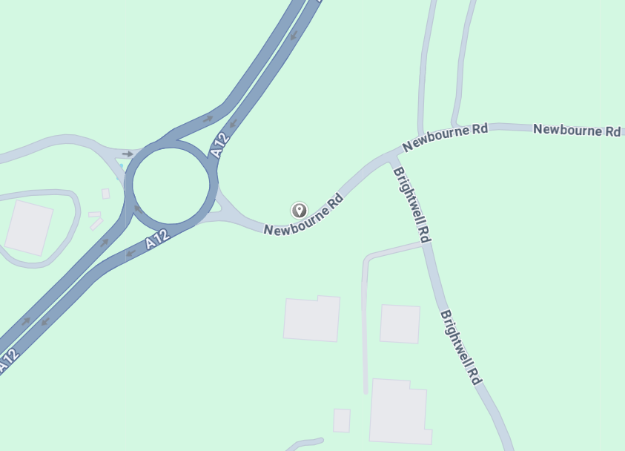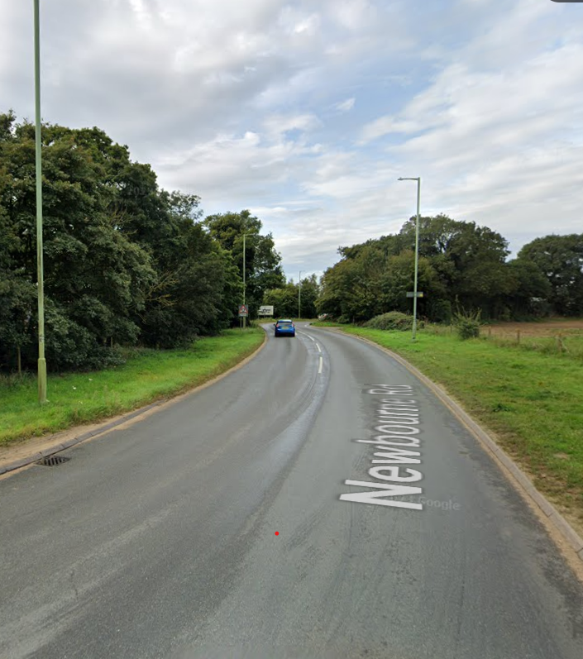
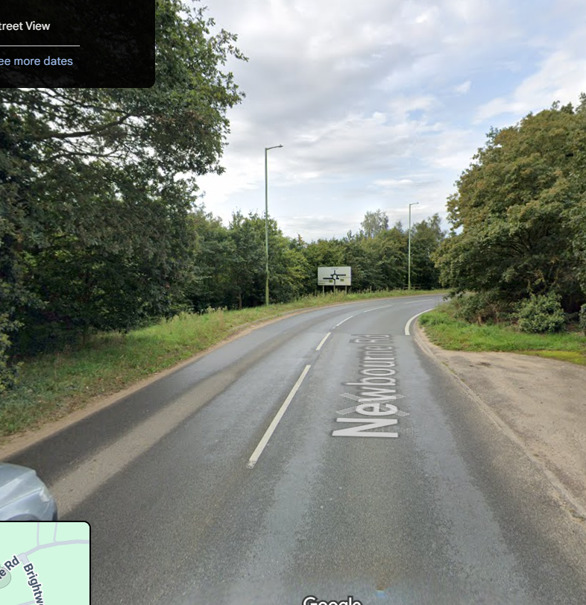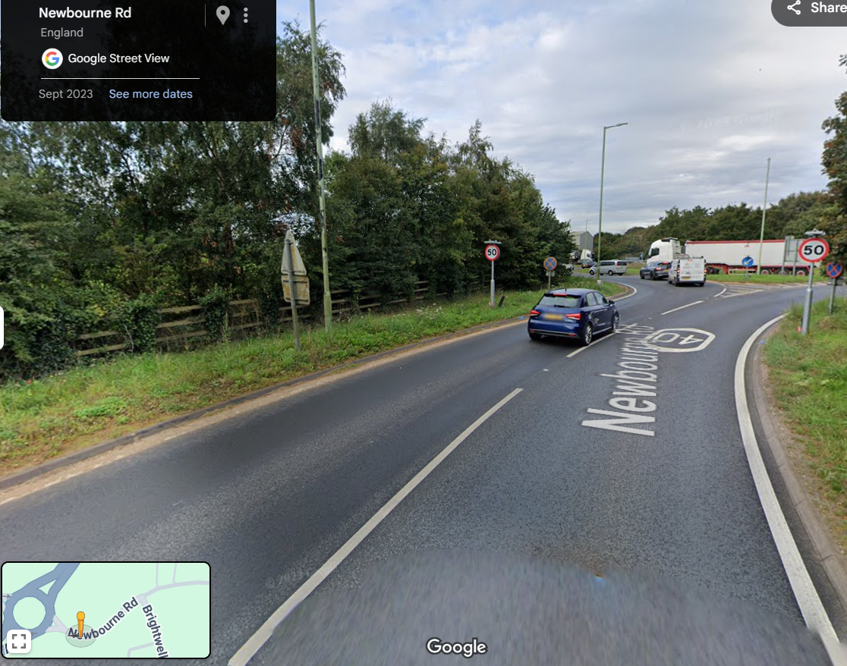

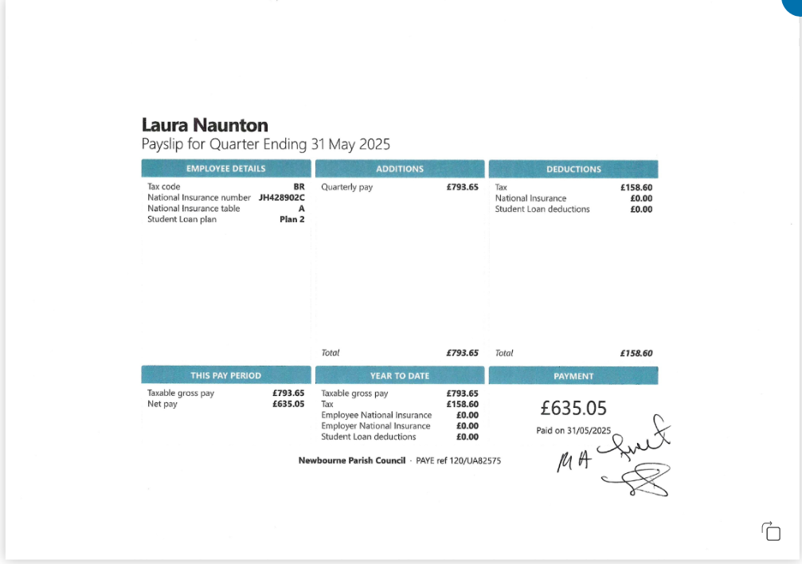
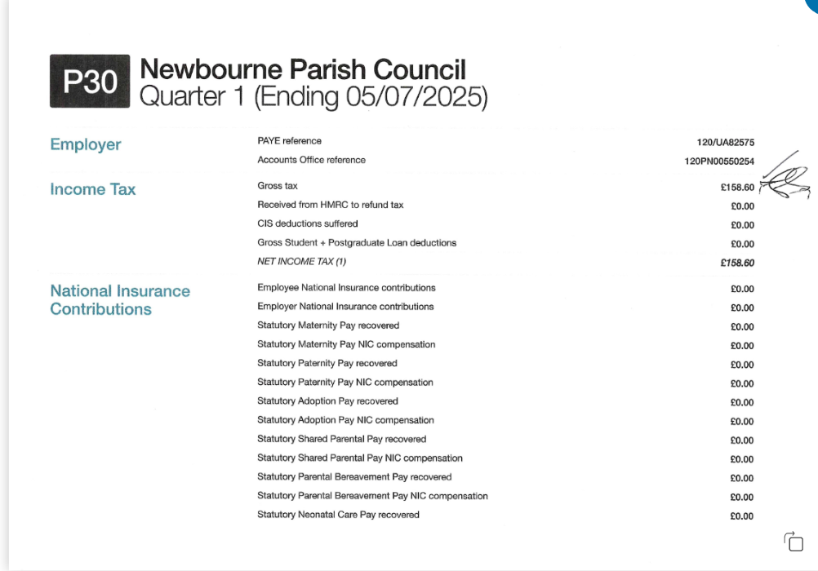
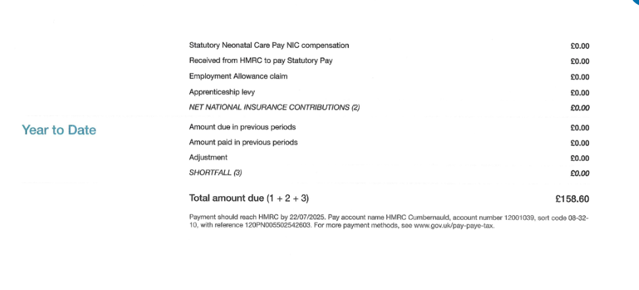

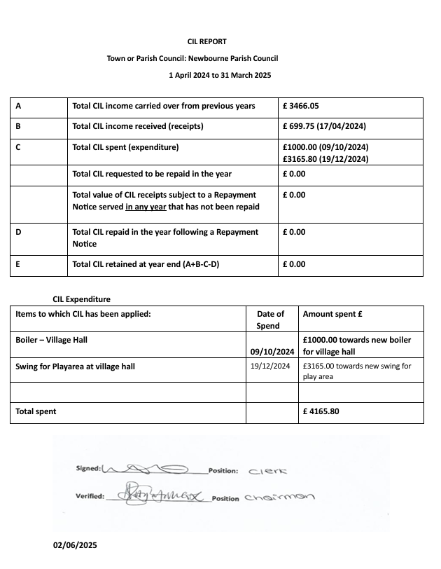
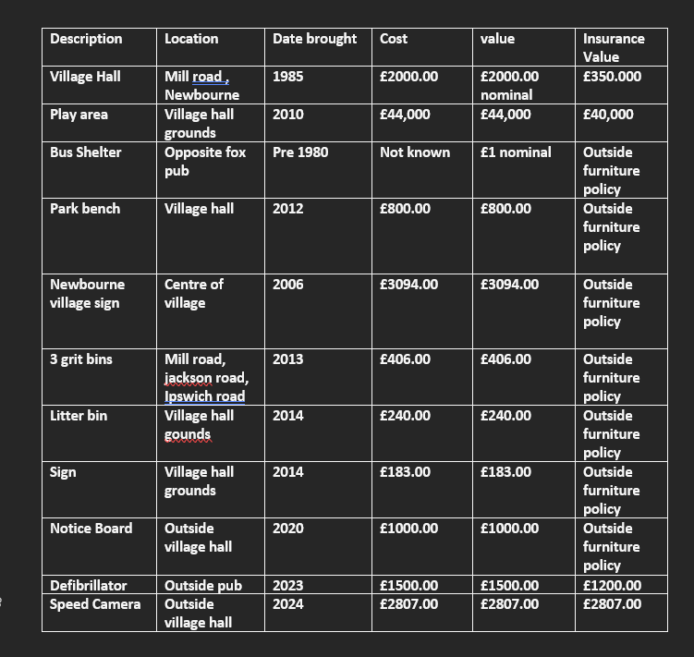
Finance 2024 -2025

01/04/2024 Opening Balance £16,287.44
08/04/2024 Money in £595.00 £16,882.44
11/04/2024 Chq 100503 HMRC £123.60 £16,758.84
16/04/2024 Chq 100497 WIFI VH £52.09 £16,706.75
16/04/2024 Chq 100506 WIFI VH £57.08 £16,649.67
17/04/2024 Money in East Suffolk £699.75 £17,349.42
23/04/2024 Money in Vat in £853.80 £18,203.22
30/04/2024 Precept in £7750.00 £25,953.22
05/06/2024 Chq 100510 Clerk wages £494.10 £25,459.12
17/06/2024 Chq 100509 HMRC £123.50 £25,335.72
20/06/2024 Chq 100507 SALC FINANCE £22.80 £25,312.92
20/06/2024 Chq 100508 SALC Membership 24-25 £163.30 £25,149.62
03/07/2024 Chq 100511 AJS - GRASS £420.00 £24,729.62
03/07/2024 Chq 100512 Printer+ Microsoft office £99.98 £24,629.64
23/08/2024 Chq 100513 IT /WEB £90.00 £24,539.64
17/09/2024 Chq 100516 Clerk wages £493.90 £24,045.74
02/10/2024 Chq 100517 Insurance £2124.45 £21,921.29
08/10/2024 Chq 100514 WIFI VH £57.08 £21,864.21
09/10/2024 Chq 100519 Boiler VH £7980.33 £13,883.88
14/10/2024 Chq 100515 HMRC £123.60 £13,760.28
22/10/2024 Chq 100518 playground inspection £103.20 £13,657.08
04/11/2024 Money in Village Hall £5583.00 £19,240.08
07/11/2024 Chq 100521 AJS - GRASS £160.00 £19,080.08
07/11/2024 Chq 100522 AJS - PLAYAREA £100.00 £18,980.08
25/11/2024 Chq 100523 SALC FINANCE £22.80 £18,957.28
05/12/2024 Chq 100527 Clerk Wages £494.10 £18,463.18
19/12/2024 Chq 100524 SWING/ WICKSTEED £8607.26 £9855.92
19/12/2024 Chq 100525 PLAYDALE REPAIRS £2111.26 £7744.66
10/02/2025 Money in quiz £670.00 £8291.26
07/03/2025 Chq 100531 Clerks wages £493.90 £7797.36
10/03/2025 Chq 100528 Railing repairs £19.30 £7778.06
15/03/2025 Chq 100529 Grass seed £17.09 £7760.97
20/03/2025 Chq 100530 HMRC £123.60 £7637.37
01/04/2025 closing balance £7637.37

Saving Account
01/04/2024 Opening balance £4084.16
02/09/2024 Interest £15.33
02/12/2024 Interest £15.39
03/06/2024 Interest £15.27
03/03/2025 Interest £14.61
01/04/2025 Closing Balance £4144.76

Money in
Precept in £7750.00
Interest £60.60
VAT refund £853.80
CIL Money £699.75
Money in from Village Hall £5583.00
Fundraising - £1265.00

Payments
Clerks Wages - £1976.00
WIFI village hall - £171.24
Insurance £2124.00
HMRC payment £494.00
Play area improvements - £10,835.61
Village Hall improvements - £7980.33
SALC payments £163.00
Website £90.00
Printer and ink £99.98
Grass / Maintenance £599.30

