July Supporting Documents 2025
Email sent to east Suffolk and highways regarding damage to The Street,
Newbourne
Good Morning
My name is Laura, and I am the Clerk for Newbourne Parish council. First, thank you
for coming out to repair all the potholes that I reported on the highway tool mainly
down Ipswich Road and Woodbridge Road. We have a few issues with the roads in
Newbourne which needs someone from the highways department to come and
review.
The Street - IP12 4NY . I reported the damage on the highway reporting tool in
March with images and the tool advised the repairs to the road would be done in 8
weeks. The start of May your workman came out and have done some repairs which
are shown on the below images we thought this was a temporary repair and maybe
the workman would be back to finish the job, but this is not the case the road is still
in an awful state with holes this is really dangerous to cyclists, walkers and cars.
The problem as previous advised is that there are natural springs that flow freely
over the road. I have attached the google map images which were taken in 2023
which shows there is an ongoing issue. The holes in the road have been filled up
before and the natural springs then come up elsewhere. The water from the springs
run over the road constantly throughout the year. In the winter it freezes, and the
road is like an ice rink. The constant running water is causing damage to the road
and the residents are worried that it will cause a sink hole as the amount of water
has definitely increased over the years. A sinkhole happened not that long ago on
Mill Road from Hemley to Waldringfield. It advised that sink holes generally are
caused by collapse of the surface layer due to loss of support from below, often
triggered by water, which erodes and dissolve underlying rock, leading to voids and
eventual collapse. The soil in Newbourne is loose and sandy and with the volume of
water that is on the roads it is a worry.
This issue on the road has been raised previously and people from highways have
come out to look into the issue a few years ago but no action was taken apart from
filling in the holes, but the springs just come through the road elsewhere. We have
been advised that to solve the issues correct drainage would need to be put under
the road for the water to drain away correctly, redirecting the natural springs away
from the road surface.
The springs in the road are outside The Fox Inn , further up the Street towards
Hemley also.
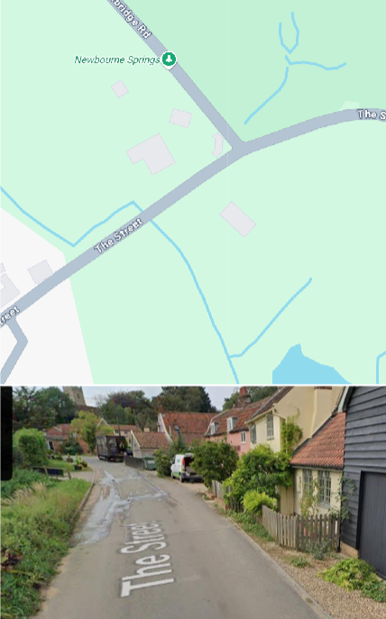
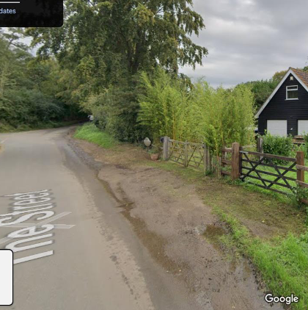
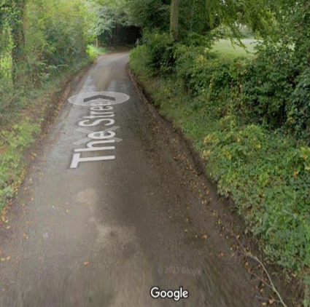
Below are the images of highways doing the repairs and the state of the road once
finished as you can see the standing water on the road where they have done the
repairs.
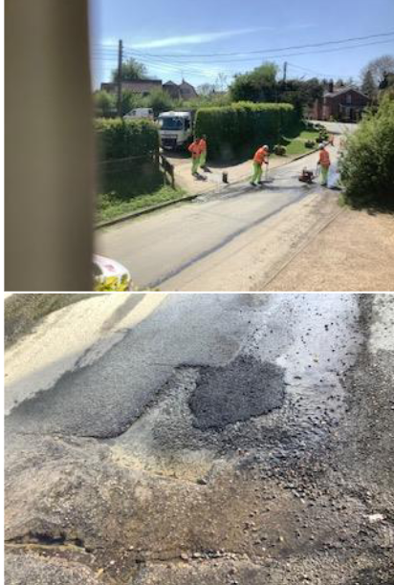
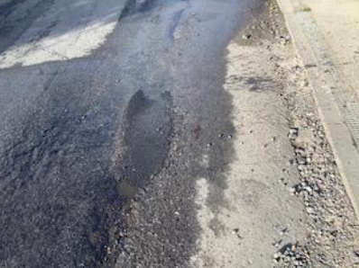
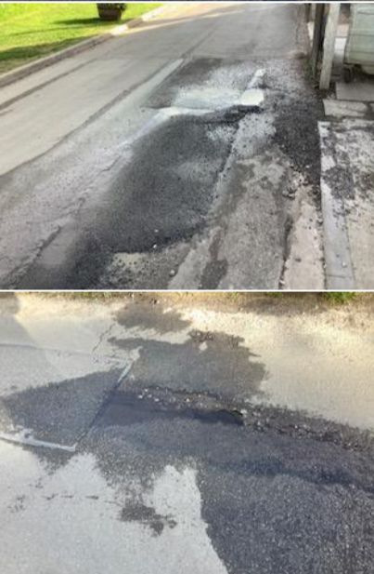
Can we be advised if the highways department are coming back to repair the road?
and if someone can come and look at the springs in the road and can we have
feedback on the next steps.
Thanks
Laura Naunton
Clerk Newbourne Parish Council

Finance –
1.Balance carried over from April 2025 £11,782
Community Account £7637.37
Saving account £4144.76
Total = £11,782.13
2. Precept £8500.00
3. Money in
4. Staff costs
5.Loan repayments £0.00
6. Payments made
09/04/2025 - £1236.00 – Hand dryer in village hall - 100538
15/04/2025 - £756.41 – Water heater for village hall - 100537
12/05/2025 - £19.80- Printer ink
12/05/2025 – Noble Nature - £97.50 Greenspace Maintenance -100541
12/05/2025 – Matt Moore - £1548.00 Hedge, Work on village hall and swing preparation.
12/06/2025 - £22.80 – SALC - 100535
12/06/2025 - £167.67 SALC Membership 100539

