Supporting Documents November 2024
PARISH REPORT SEPTEMBER 2024
ORWELL & VILLAGES

Funding secured for GP practice expansions
East Suffolk Council has allocated £1.5million to fund the expansion of three local doctors’ surgeries and ensure that residents benefit from improved health facilities in areas of housing growth.
Among 13 District CIL (DCIL) bids that were allocated a total £3.5m, following review through the CIL Spending Working Group, were proposals to expand Haven Health Surgery and Grove Medical Centre, in Felixstowe, and Cutlers Hill Surgery, in Halesworth, in order to meet the growing demand for clinical services.
Councillor Kay Yule, East Suffolk Council Cabinet member for Planning and Coastal Management, said: “We want to ensure that the right infrastructure is put in the right place at the right time. So, it is pleasing to see the reinvestment of money levied on developers building nearby homes back into the community to support the expansion of local GP practices to help meet increased demand.
“There is a well-documented need for housing across the country, but as work continues to meet that need, we must consider the resulting need to grow capacity in services like health and social care. It is important that our larger housing developers help to financially meet that need.
“These projects directly relate to two of our strategic plan objectives as a local authority; to maximise health and well-being in our communities, and to support and deliver infrastructure for the economy.”
Funding worth £611,569.15 has been allocated to Suffolk Primary Care for the expansion of primary care at Haven Health Surgery, with the remaining £22,000 secured through other funding, to include an additional five clinical rooms and help futureproof service delivery.
The project, supported by Suffolk and North East Essex Integrated Care Board (ICB), will help offer up to 60 additional appointments per 1,000 patients per week and deliver more services in community settings.
Dr Paul Driscoll, a GP partner with Suffolk Primary Care, said: “We are delighted that East Suffolk Council has approved our bid for CIL funding so that this important extension can take place. It will give us a valuable opportunity to reconfigure the building so that it works more effectively for our patients. The extra space will also mean we can host additional services.
“Importantly, it will also ensure we can continue to meet demand in the future and offer high quality, accessible services to our patients as the population of Felixstowe increases.”
Another £61,641.68 will fund the conversion of four rooms at the Grove Medical Centre into clinical accommodation, with a large upstairs office also divided to include a clinical room and telephone consultation area.

CIL Funding for local projects and from next year Play Areas
The Community Infrastructure Levy was adopted in the former Waveney District area in August 2013, and in the former Suffolk Coastal District area in July 2015.
CIL is paid on commencement of planning permissions for liable development where exemptions or relief from CIL has not been granted, allowing local authorities to raise funds from developers undertaking new building projects in their area.
Funding can be used on range of infrastructure needed because of development, including education, health and social care facilities, green spaces and leisure provision.
To date, East Suffolk Council has formally allocated over £14.3m of District CIL to a variety of local infrastructure projects.
The CIL Spending Working Group has also ringfenced £13m of District CIL to secure Health and Education projects proposed to be delivered over a five-year period.
A Local CIL Fund, based on a calculation of 3% of the District CIL received in the financial year, is held for smaller, local projects, while approximately £6.7m has been passed to parish and town councils through Neighbourhood CIL payments since the adoption of CIL in East Suffolk.
In recognition of the importance of play facilities, the CSWG has also developed a new 3% Local CIL Play Fund to operate alongside the existing Local CIL Fund from April 2025. The Local CIL Play Fund will focus on match funding play improvement projects in areas where new housing development create a need to improve existing facilities.
It was mentioned at a recent meeting that applications for District CIL funding are fairly low so if any parish has a project, they wish to bring forward, an application for CIL funding may be worthwhile.
New waste collections cycle agreed from March 2026
As set out in our report last month the revised waste collection details were agreed at the last Full Council meeting on 25th September. Food waste collections will take place weekly and new bins and kitchen caddies will be supplied to all households. A further recycling bin will be provided for all cardboard and paper. The other recycling bin will then be used for other recycling which will now include glass, tetrapaks, plastic containers etc. The residual waste will be collected on a 3-weekly basis. Garden waste collection is unaffected.
It is recognised that some households will have requirements due to lack of space for additional bins, additional collection needs and these will be reviewed on a case-by-case basis. A full publicity campaign will be carried out well in advance.
Whilst there had been calls to delay any decision until 2025 this was not possible as orders need to be made for new bins and refuse lorries.

Housing Needs
Both of us attended an all-day workshop on housing needs within East Suffolk last week.
As many will know East Suffolk Council came about from the merger of Waveney Council and Suffolk Coastal District Council in 2019. The two councils had very different approaches to housing. Waveney had around 5,000 council houses in 2019 whereas Suffolk Coastal had taken the decision to dispose of its entire housing stock for around £6- 8,000 per home, mainly to housing associations and through private sale.
We currently have around 4,400 council houses in the north of East Suffolk (many having been sold under Right to Buy).
East Suffolk Council currently has 4,872 people on the waiting list for a social rent home. On average we have only 700 lettings available each year. The average waiting time for a 3 bedroomed house in the Felixstowe area is 30 months.
In the south of the area there is a chronic shortage of temporary housing – places where people can go if they are made homeless or are sleeping rough. The council is under statutory duty to arrange housing for them.
At present we have 200 children living in temporary housing – often B&Bs or hotels with 28 families with 45 children currently housed in temporary accommodation outside East Suffolk- due to all accommodation within East Suffolk being full. Many of those needing temporary housing in the old Suffolk Coastal area are having to be moved to Lowestoft or further afield away from jobs, schools and social networks.
Whilst some projects are under way locally it is difficult to see how the crisis can be lessened without additional funding agreements for councils to fund purchases or new builds of social rent accommodation.

If parish councillors need to contact either of us, please feel free to do so.
Cllr Mike Ninnmey: Home tel no 01394 677210 Mobile: 07823 372503
E-mail: mike.ninnmey@eastsuffolk.gov.uk
Cllr Lee Reeves: Home tel no 01394 284506 (preferred) Mobile 07823 372501
E-mail: lee.reeves@eastsuffolk.gov.uk

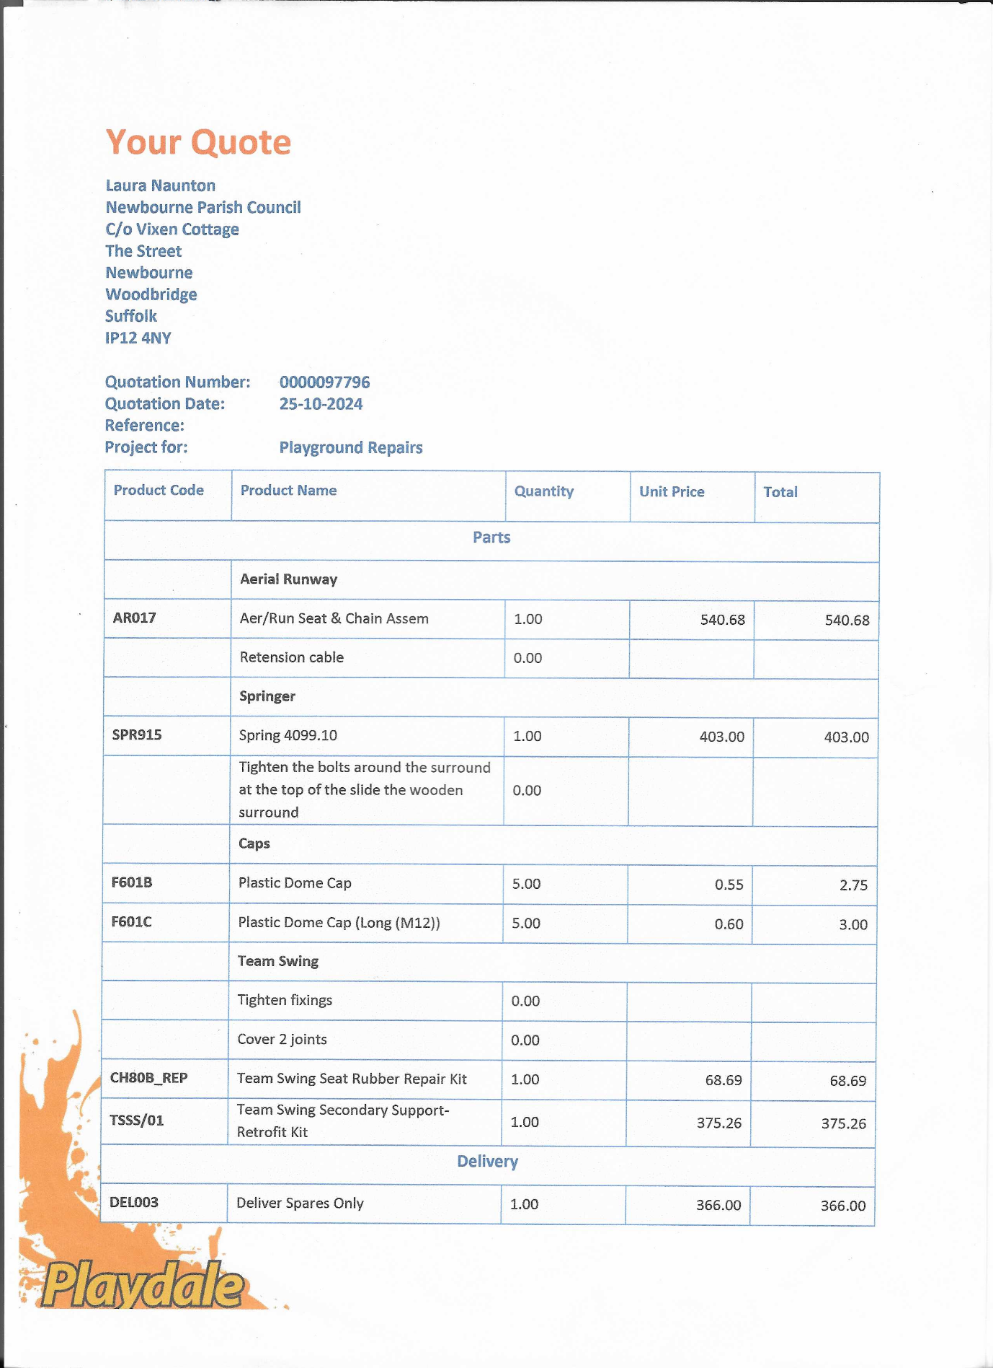
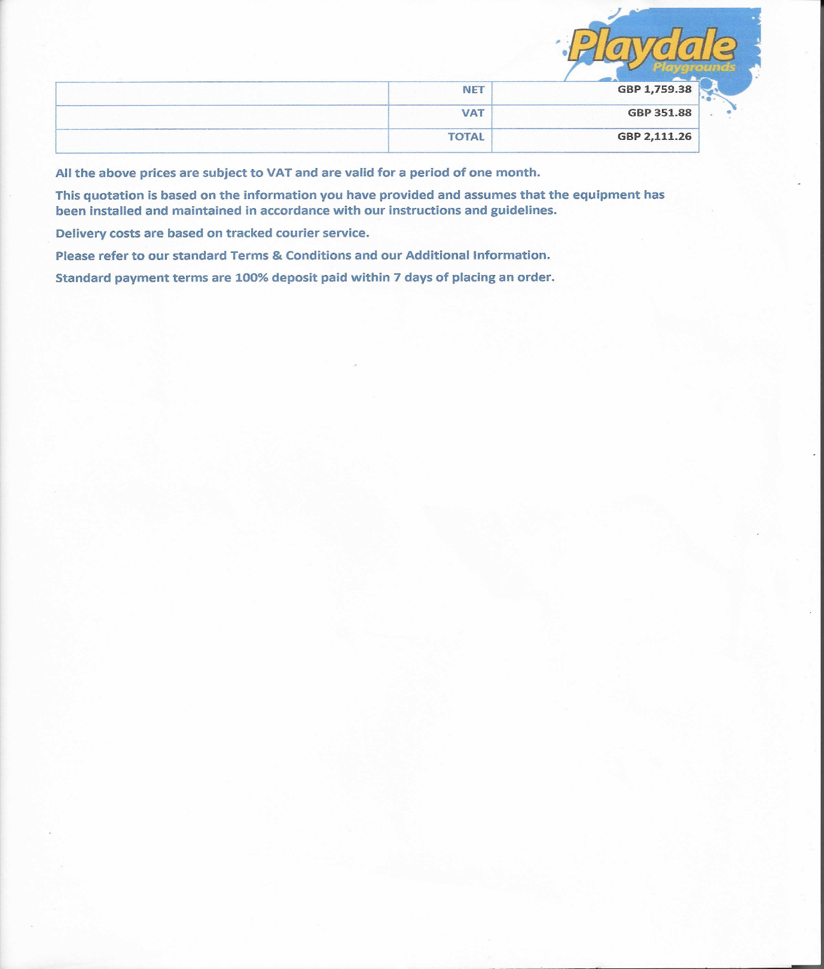
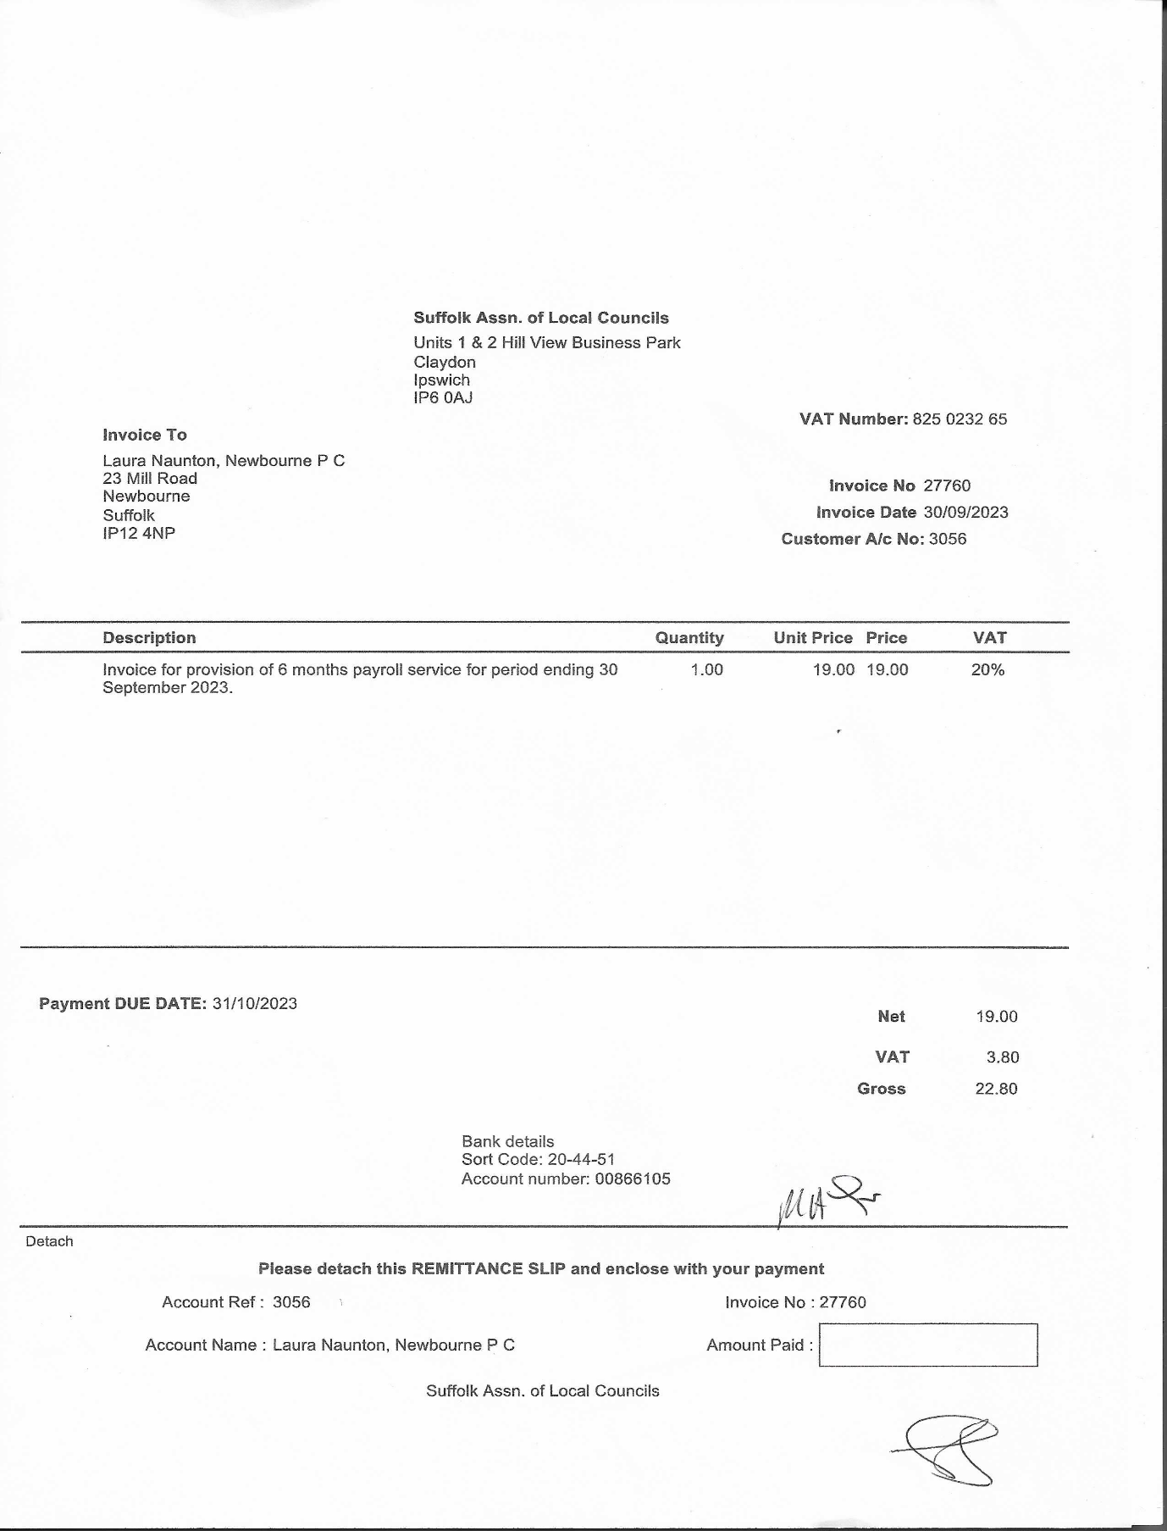

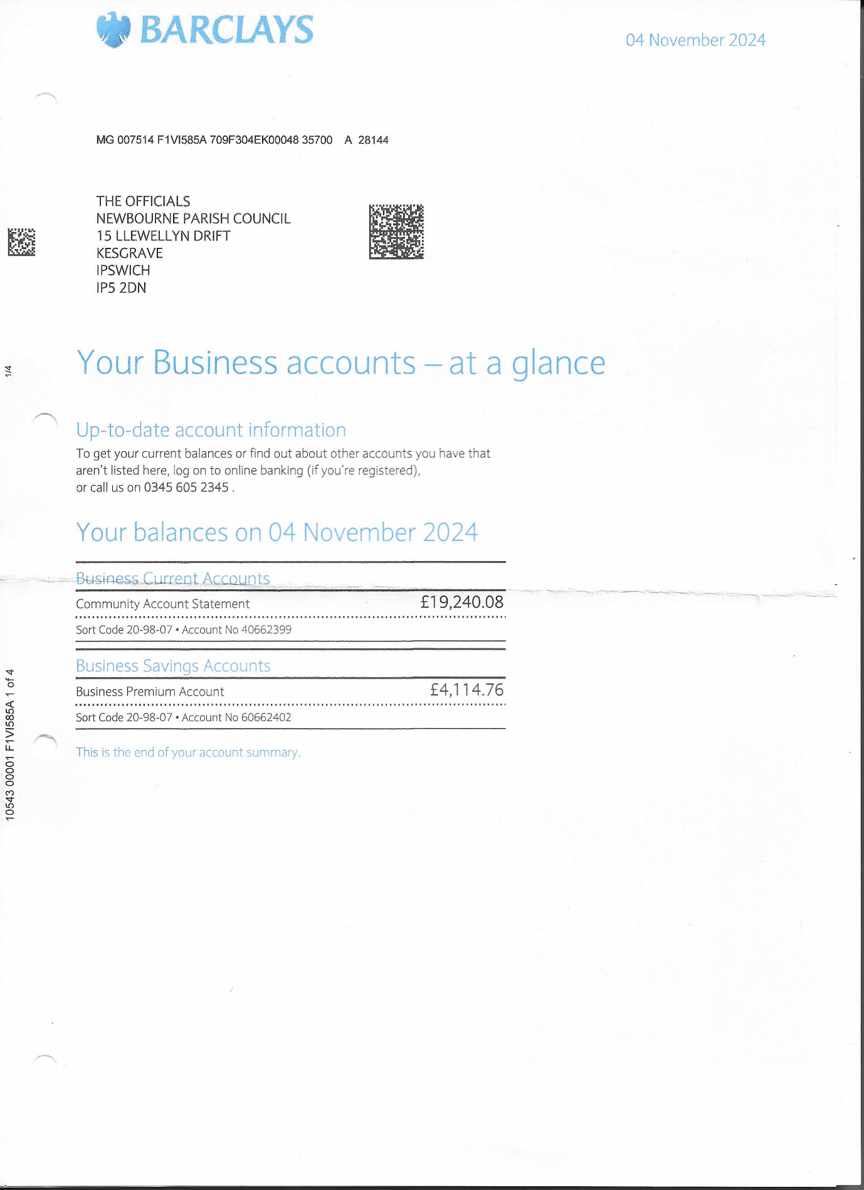
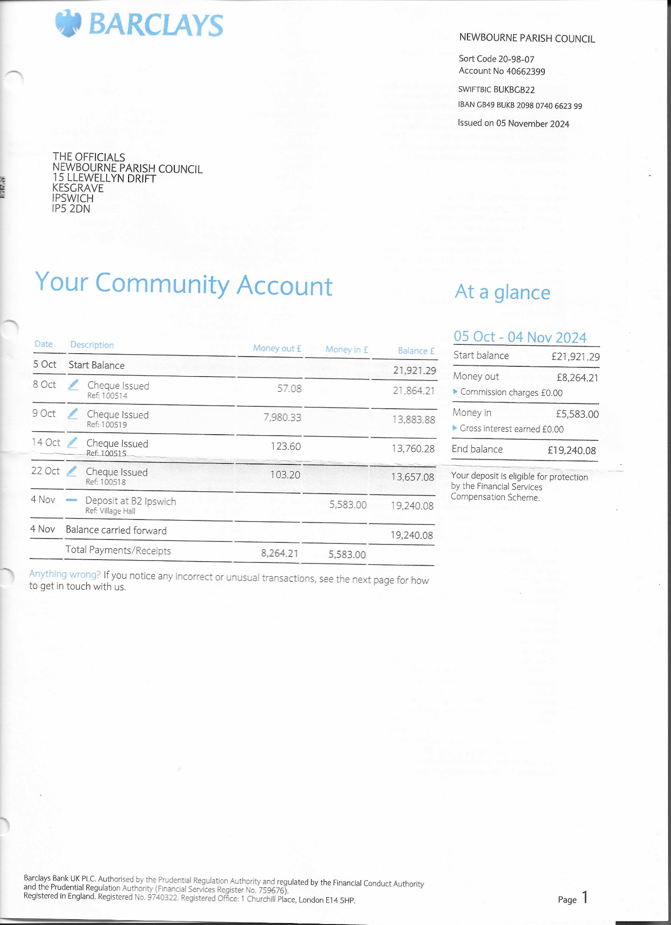

Finance

01/04/2024 Opening Balance £16,287.44
08/04/2024 Money in £595.00 £16,882.44
11/04/2024 Chq 100503 HMRC £123.60 £16,758.84
16/04/2024 Chq 100497 WIFI VH £52.09 £16,706.75
16/04/2024 Chq 100506 WIFI VH £57.08 £16,649.67
17/04/2024 Money in East Suffolk £699.75 £17,349.42
23/04/2024 Money in Vat in £853.80 £18,203.22
30/04/2024 Precept in £7750.00 £25,953.22
05/06/2024 Chq 100510 Clerk wages £494.10 £25,459.12
17/06/2024 Chq 100509 HMRC £123.50 £25,335.72
20/06/2024 Chq 100507 SALC FINANCE £22.80 £25,312.92
20/06/2024 Chq 100508 SALC Membership 24-25 £163.30 £25,149.62
03/07/2024 Chq 100511 AJS - GRASS £420.00 £24,729.62
03/07/2024 Chq 100512 Printer+ Microsoft office £99.98 £24,629.64
23/08/2024 Chq 100513 IT /WEB £90.00 £24,539.64
17/09/2024 Chq 100516 Clerk wages £493.90 £24,045.74
02/10/2024 Chq 100517 Insurance £2124.45 £21,921.29
08/10/2024 Chq 100514 WIFI VH £57.08 £21,864.21
09/10/2024 Chq 100519 Boiler VH £7980.33 £13,883.88
14/10/2024 Chq 100515 HMRC £123.60 £13,760.28
22/10/2024 Chq 100518 playground inspection £103.20 £13,657.08
04/11/2024 Money in Village Hall £5583.00 £19,240.08

After an inspection it was decided a new boiler was needed in the village hall. The old boiler is many years old and not efficient anymore. A local company was used that lives in the village as decided if any issues in the future they were close to come and sort any issues.
Agreed that some CIL money £1000.00 would go towards the new boiler and the parish council would cover some of the cost and the village hall committee would cover the rest.
Playground inspection done and areas of improvement recognised.
Checked with Gary Grainger 10/11/2024 before parish meeting

