Supporting Documents 3rd June 2024
PARISH REPORT MAY 2024 ORWELL & VILLAGES
Foxburrow Farm Container Storage Decision Although we had requested that the matter be heard by
the Planning Committee in light of the substantial public interest in this application (at least seven
parish councils objecting), this did not prove necessary as the Planning Officers recommendation to
refuse was in accord with the objections submitted by the parish councils. Therefore, it was an officer
decision by the two interim Heads of Planning to refuse which was made on 29th May. We would
caution that the applicant may appeal or submit a new application with changes. As you will be
aware the applicant has made numerous applications for different schemes in different places. Sadly,
we feel we need to remain alert and work with all the local parishes to counter any similar
subsequent applications which may harm our area.
Felixstowe North Garden Neighbourhood This project remains under consultation. There has been a
great deal of distortion of the facts on recent social media which is unfortunately being stoked up by
certain individuals for their own party-political purposes. There is absolutely no truth in the rumour
that The Grove will be chopped down to make way for housing. The Grove is a protected ancient
woodland. No decisions have yet been made as to the location of the proposed new leisure centre/
community facilities on the overall site nor the number, type, and location of housing. These aspects
are part of the continuing consultation process.
Resilience Fund A new fund has been established to provide immediate, short-term financial support
to East Suffolk communities affected by future emergency events. In February, as part of the 2024-25
Budget setting process, East Suffolk Council created a Resilience Reserve in response to the severe
disruption caused by Storm Babet last October. Now, Cabinet members have agreed how this
£500,000 pot will be managed, through a newly established Resilience and Emergency Response
Fund (RERF). The RERF is designed to ensure East Suffolk Council can be more flexible and responsive
to cover reasonable additional costs incurred by town and parish councils during an emergency
event. In the aftermath of Storm Babet, East Suffolk Council established the East Suffolk Flood
Recovery Group, that provided a physical presence in Framlingham and Wickham Market to assist
and deal with affected residents enquiries and clean up in the aftermath. Although longer-term
grants were available under central Government’s flood recovery framework, a gap was identified to
support the immediate and urgent needs of residents and communities; for example, provision of
skips through East Suffolk Services to remove damaged household items and costs (food, bedding,
clothing) for displaced people using the emergency centre set up in Framlingham's Community Hall.
GLI Cabinet member for Resources and Value for Money, Cllr Vince Langdon-Morris said: “The severe
disruption and flooding caused by Storm Babet last October has had a significant and ongoing impact
on the lives and livelihoods of many East Suffolk residents. In our district alone, 320 properties were
directly impacted by the storm. Winter storms are predicted to increase in frequency and severity as
we come to terms with the effects and impacts of ongoing climate change. “As much as we cannot sit
back and allow climate change to irreversibly worsen, we must try and support communities affected
by its ongoing impacts, including flooding from rising sea levels, prolonged rainfall and intense
storms. “This fund can bring significant relief for our residents at a time of need and empower our
district council to act quickly. But, importantly, the RERF is a short-term resource and is in no way a
replacement for central government support.” Examples of support that could be provided by the
fund include temporary accommodation costs for up to 48 hours, disposal costs for damaged
furniture, carpets or flooring, and support for voluntary groups to assist and co-ordinate recovery
activities. In addition to the RERF, a dedicated council officer will be appointed, to build upon our
existing emergency response capacity, providing a communication, co-ordinating and enabling role
for our town and parish councils, communities and residents before, during and after future
emergency events.
East Suffolk’s Amazing East Suffolk Council Leader Caroline Topping is asking local people to take
pride in where they live with the launch of a brand-new campaign: “East Suffolk’s Amazing – Let’s
Keep It That Way!” A cross-party working group of councillors is looking at different ways that we can
all work together to maintain the beauty of East Suffolk, and this includes encouraging more
residents to take active pride in their local area. This includes reducing fly-tipping, recycling properly
and even, where possible, looking after the spaces outside residents’ own property. There is already
an incredible network of volunteers who help keep our district beautiful, with regular litter-picks,
planting, and an all-round effort to keep their local area clean. East Suffolk Council is encouraging
more people to get involved and to really do their bit to keep East Suffolk Amazing.
The Council will support local communities and groups by lending out equipment for litter pick
events, including hi-viz vests, litter pickers, bags and bag hoops. With this in mind, a range of
information about how communities can get involved in schemes, as well as a range of tips and
advice, can be now found online. For more information, visit:
www.eastsuffolk.gov.uk/waste/litter/amazing/ Ease the Squeeze on Cost of Living Are you, or
someone you know, worried about the increasing cost of living? We understand the pressures faced
by many people today and we are working closely with key partners to ensure support is available to
help ease the squeeze for households in East Suffolk. To make it as easy as possible for you to access
the services and support available, locally and nationally, we have gathered information about them
in one place: www.eastsuffolk.gov.uk/community/squeeze/ If parish councillors need to contact
either of us, please feel free to do so.
Cllr Mike Ninnmey: Home tel no 01394 677210 Mobile: 07823 372503 E-mail:
mike.ninnmey@eastsuffolk.gov.uk Cllr Lee Reeves: Home tel no 01394 284506 (preferred) Mobile
07823 372501
Planning information
Regarding DC/22/1393/out - the planning Statement sets out the application :-
PLANNING APPLICATION AT GRANGE NURSERIES, JACKSON ROAD, NEWBOURNE
Please find enclosed an application for a new dwelling at the above address. This follows a
previous application (DC/21/0113/OUT) and a recent appeal decision, dated 28th March 22
reference APP/X3540/W/21/3281480), a copy of which is also submitted reference.
DC/21/0113/OUT had two reasons for refusal. In essence, the site not being suitable for a
dwelling, and required mitigation due to the site falling within the recreational disturbance
zone of influence for nearby habitats sites. The appeal dealt with the first issue. The inspector
found the proposal would align with local strategy for residential development, as per the
local development plan, setting out that; 10. The proposal would therefore result in a
dwelling that clearly aligns with the locational hierarchy and strategy for residential
development as set out within the local development plan. I have not been provided with
any substantive reason to depart from the development plan and as such, the proposal
would comply with LP Policies SCLP3.2, SCLP3.3, SCLP5.3, SCLP5.4, SCLP5.5, SCLP5.6,
SCLP5.11 and SCLP11.9. These policies collectively, and amongst other matters, set the
locational strategy for residential development, suitable exceptions to this strategy, and sets
out protection for former Land Settlement Association Holdings.
Therefore, the appeal established the principle of a dwelling at the site, by finding no issue
with the proposal in that regard. The proposed dwellings align with the relevant planning
policy. The appeal decision did however uphold the objection in relation to required
mitigation in relation to the designated sites. This could not be dealt with via condition.
This application therefore seeks to resolve the second issue, by agreeing to the necessary
mitigation via financial contribution. Once the application is validated and assigned a
reference number this can be provided. Given the findings of the appeal, the submitted
information is the same as that under DC/21/0113/OUT but should now be determined in
view of the recent appeal decision, and also the mitigation measures to be provided.
The appeal decision did however uphold the objection in relation to required mitigation in
relation to the designated sites. This could not be dealt with via condition.
This application therefore seeks to resolve the second issue, by agreeing to the necessary
mitigation via financial contribution. Once the application is validated and assigned a
reference number this can be provided. Given the findings of the appeal, the submitted
information is the same as that under DC/21/0113/OUT, but should now be determined in
view of the recent appeal decision, and also the mitigation measures to be provided.
Hopefully this helps, Kind regards Adine
Government Email address information
Dear Laura
Are you considering switching your website address and email addresses to a gov.uk domain name?
The Central Digital and Data Office's vision is that by 2025, the UK Government will be a
transformed, more efficient digital government that provides better outcomes for everyone. This
includes an ambition to make town and parish councils work in a secure and effective way.
In response to this vision, back in October last year, we announced that we could now offer .gov.uk
domain names and email addresses to all Parish Councils.
Now, In the past few weeks, we've been delighted to become part of the local government domain
helper service (via our domain name partner) and therefore we can now pass on discounts
of £120 on your initial move to these services as well.
The pricing for the gov.uk domain name now stands at just £18.00 for the initial first 2 years of
having the domain name and then £138.00 for every 2 years after that.
If you are also looking for email addresses to be attached to your own domain name then we can
also supply these.
Currently we charge £30.00 per mailbox per year for a 10GB mailbox. However, if you were to
order a .gov.uk domain name then we will discount this to £24.00 per mailbox per year. Please
also note the size of this mailbox, we provide very generous 10GB business quality mailboxes
which should be ample for any needs. With smaller mailbox sizes (1GB or 2GB) you will find
yourself quickly exceeding this storage if you do a reasonable amount of emailing.
All prices shown in this email include VAT.
The process to move to a gov.uk domain name and email address is surprisingly straightforward
and usually takes around 2 weeks from start to finish. We handle the whole process for you and
barring a request for a small amount of information from yourselves there is very little that you, as
a Parish Council, needs to do. We also support you once the process is complete so should you
have any email related issues then we are on hand to help.
If you would like to discuss anything in this email or you'd like to proceed then please contact us
using the contact details below.
Matthew Morling
IT Manager
Clerk Advert
NEWBOURNE PARISH COUNCIL
Applications are invited for the following post: PARISH CLERK and RESPONSIBLE FINANCE
OFFICER. This is a permanent, part-time position.
Newbourne is located in the Orwell and Villages Ward of East Suffolk District
Council, east of Ipswich 2 miles from A12 Foxhall Road roundabout. There are 137
dwellings. The Parish Council currently consists of 8 Councillors with 1 vacancy.
Salary Rates: In accordance with National Joint Council (NJC) salary rates depending on
experience and qualifications.
Hours: The hours are flexible equating to 5 hours per week, to include attendance at
monthly evening Parish Council meetings held at The Village Hall, 17 Mill Road, Newbourne
IP12 4NP ordinarily on the first Monday of each month at 7.30pm plus any extraordinary or
urgent planning meetings that may be occasionally called.
The Successful Candidate: We are looking for a person who is looking for a role in local
government and able to help promote the parish of Newbourne. The position would suit
someone already in part-time employment or recently retired. Assistance will be provided
to the successful candidate to settle in this role.
If you are interested in joining us, we are keen to hear from you. Please email for further
details of the post to the Clerk at newbourneparishclerk@mail.com
Applications to be received by: 22 July 2024

Finance
2023 – 2024 Full Finance
2023 – 2024 Full Finance
Opening balance
£9340.49 community account
£4035.57 Saving account
Precept - £6750.00
Receipts - £9673.59
Staff costs - £2346.60
Payments - £7081.45
Closing balance - £20,371.60

Asset Register 2023-2024
Description | Location | Date brought | Cost | value | Insurance Value
Village Hall | Mill road , Newbourne | 1985 | £2000.00 | £2000.00 nominal | £350.000
Play area | Village hall grounds | 2010 | £44,000 | £44,000 | £40,000
Bus Shelter | Opposite fox pub | Pre 1980 | Not known | £1 nominal | Outside furniture policy
Park bench | Village hall | 2012 | £800.00 | £800.00 | Outside furniture policy
Newbourne village sign | Centre of village | 2006 | £3094.00 | £3094.00 | Outside furniture policy
3 grit bins | Mill road, jackson road, Ipswich road | 2013 | £406.00 | £406.00 | Outside furniture policy
Litter bin | Village hall gounds | 2014 | £240.00 | £240.00 | Outside furniture policy
Sign | Village hall grounds | 2014 | £183.00 | £183.00 | Outside furniture policy
Notice Board | Outside village hall | 2020 | £1000.00 | £1000.00 | Outside furniture policy
Defibrillator | Outside pub | 2023 | £1500.00 | £1500.00 | £1200.00
Speed Camera | Outside village hall | 2024 | £2807.00 | £2807.00 | £2807.00


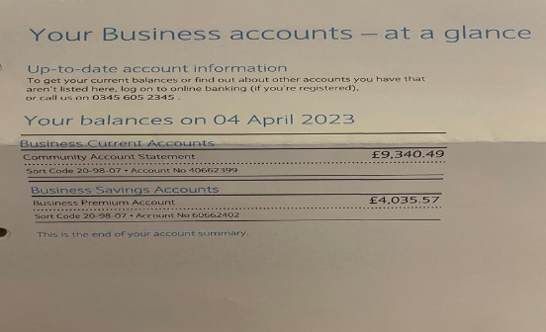
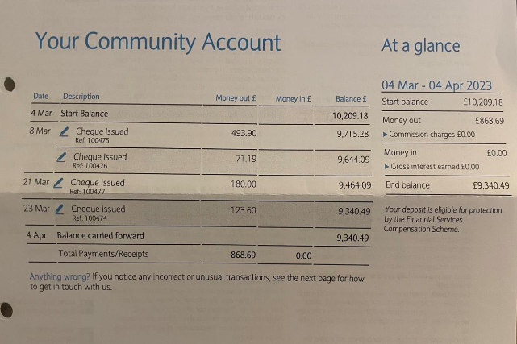
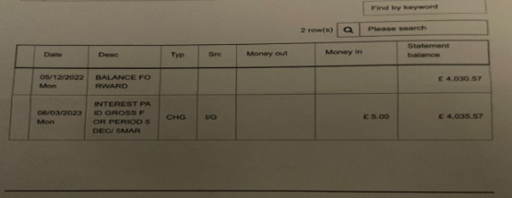
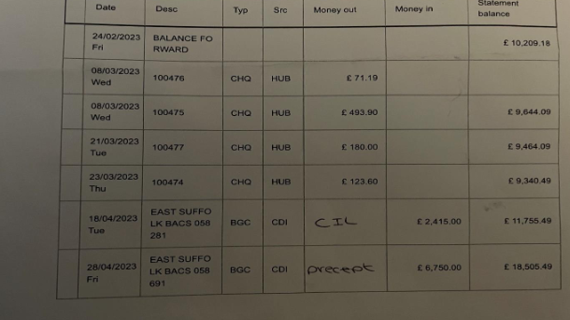
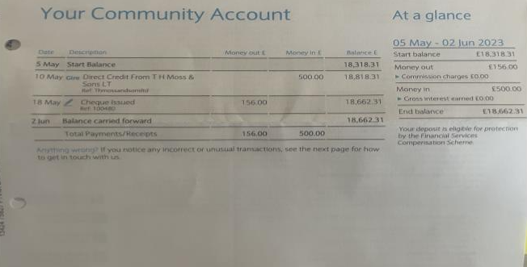
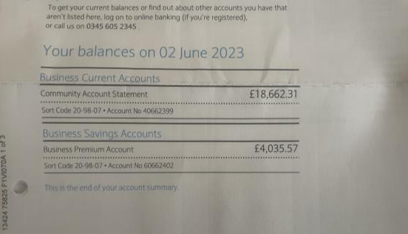
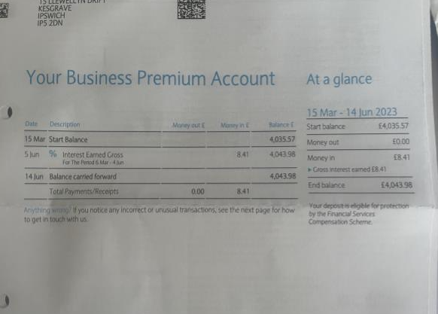
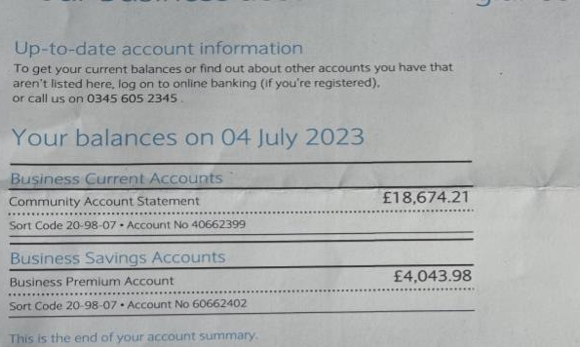
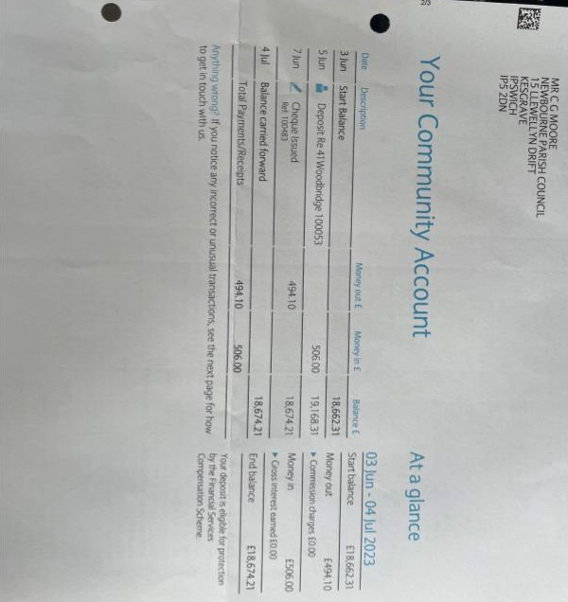
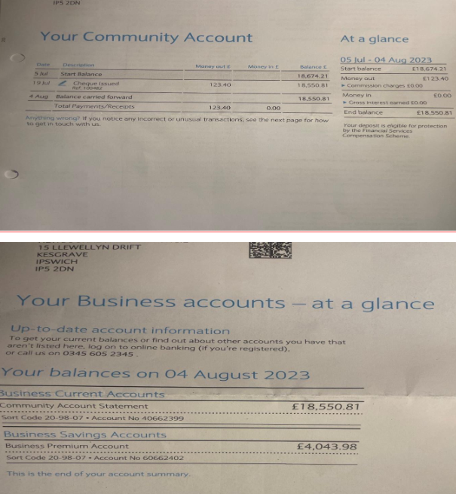

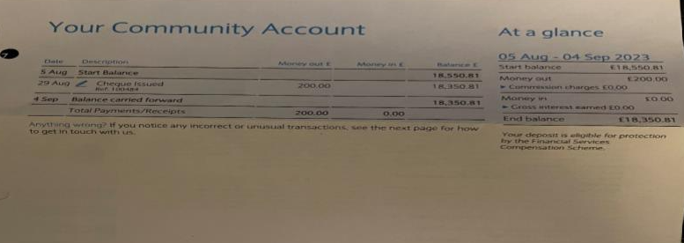
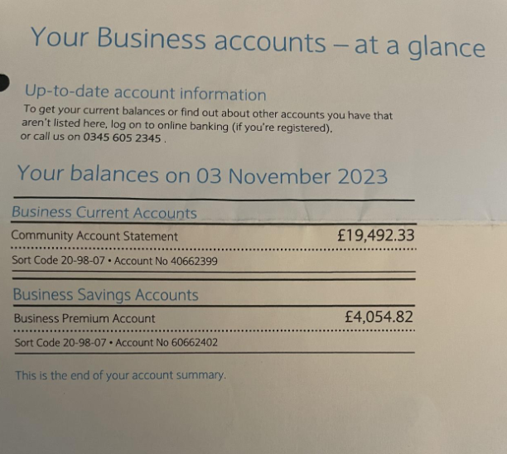
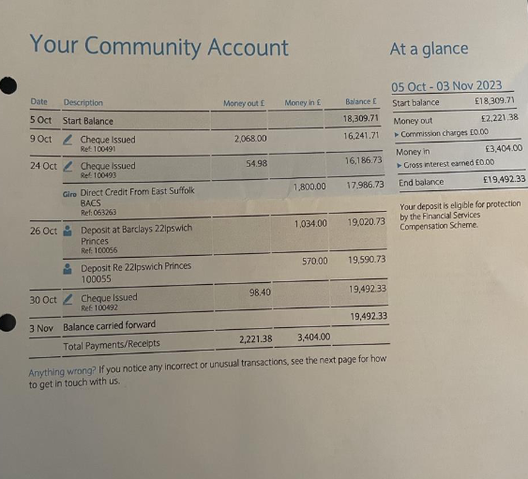
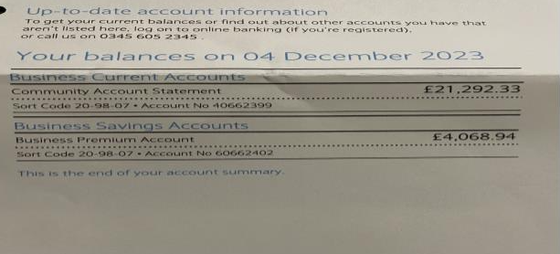

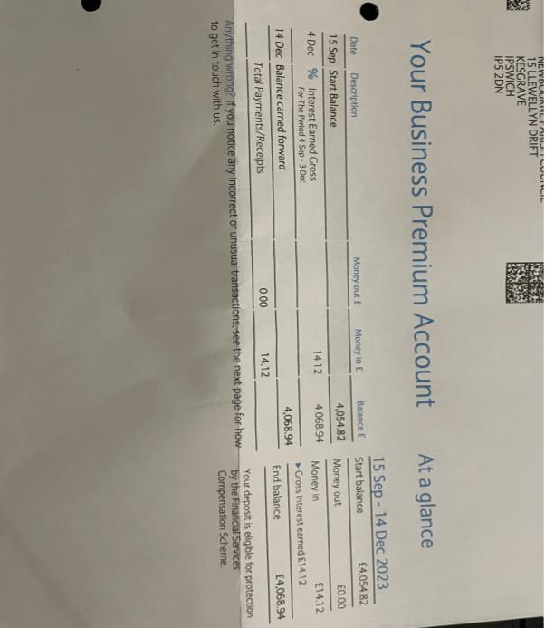
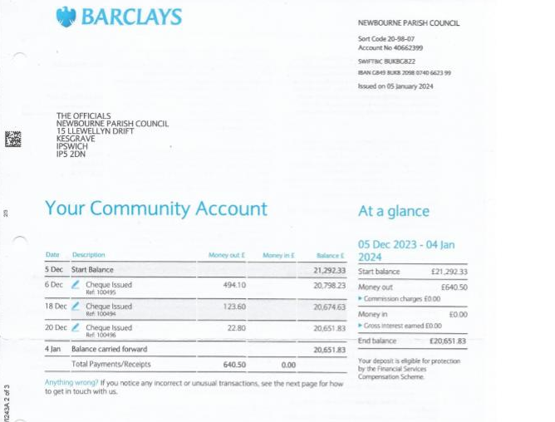

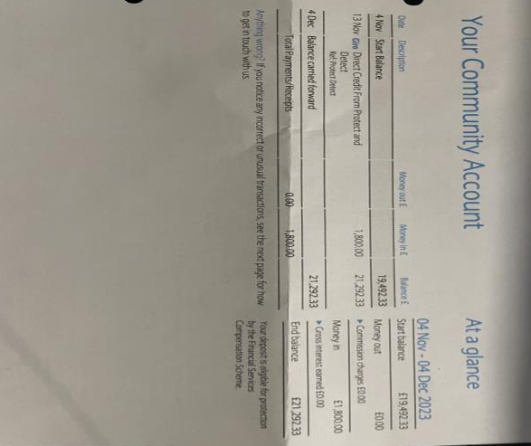
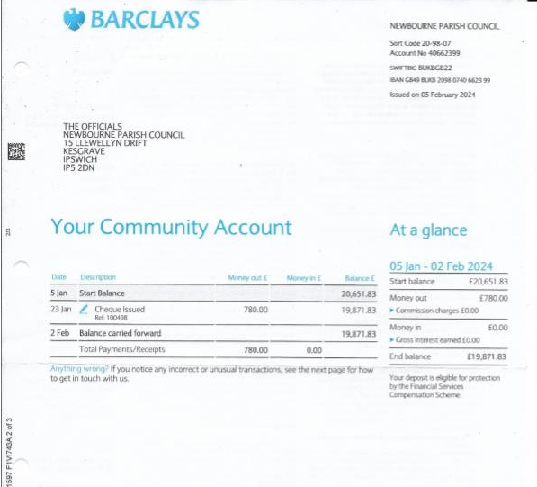


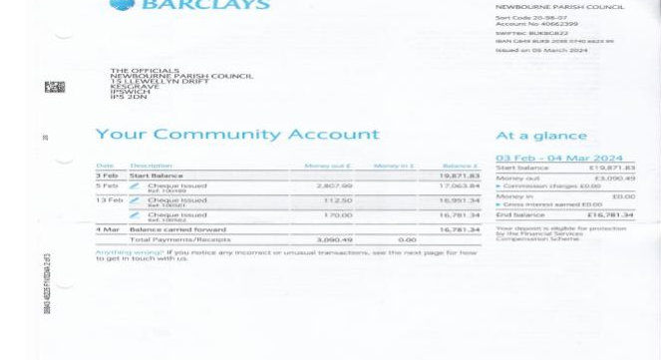
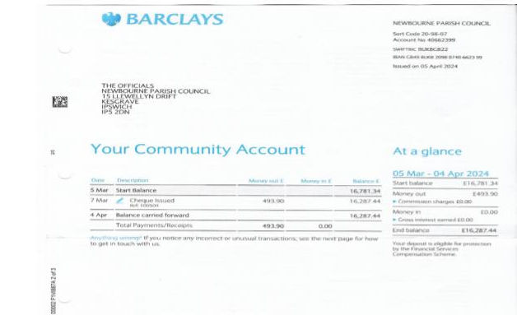
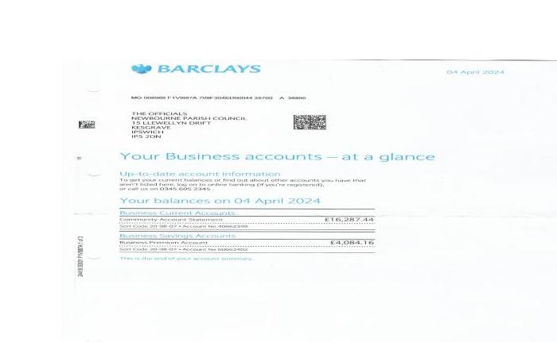

 |  | Amount | Payment Reason
02/05/2023 | 100481 | £53.98 | Clerk -Printer Ink
05/06/2023 | 100482 | £123.40 | HMRC
05/06/2023 | 100483 | £494.10 | Clerks Wages Feb - May
03/07/2023 | 100484 | £200.00 | Church Roof donation
07/08/2023 | 100485 | £100.98 | ESC Uncontested election
07/08/2023 | 100486 | £50.00 | Greener Waldringfield
07/08/2023 | 100487 | £116.17 | Internet - Village Hall 50% Contribution
04/09/2023 | 100488 | £156.45 | SALC Membership 2023 -2024
04/09/2023 | 100489 | £493.90 | clerks wages june - August
04/09/2023 | 100490 | £123.60 | HMRC
04/09/2023 | 100491 | £2,068.00 | Insurance
02/10/2023 | 100492 | £98.40 | Playsafety - playground inspection
02/10/2023 | 100493 | £54.98 | Clerk Printer ink
04/12/2023 | 100494 | £123.60 | HMRC September-November
04/12/2023 | 100495 | £494.10 | Clerks wages September - November
04/12/2023 | 100496 | £22.80 | SALC Payroll
08/01/2024 | 100497 | £52.09 | Internet - Village Hall 50% Contribution
08/01/2024 | 100498 | £780.00 | AJS Services Grass cutting 2023- Jan 2024
08/01/2024 | 100499 | £2,807.99 | Elan City - Speed indicator device
05/02/2024 | 100501 | £112.50 | Noble Nature - bus shelter repairs
05/02/2024 | 100502 | £170.00 | AJS Services Put up Speed Camera / take away rotten wood play area

2023 -2024
Money In
£6750.00 Precept
£53.59 Interest on saving account
£1076.00 Fundraising Money from village Day and quiz money
£1034.00 Money in from village hall
£1800.00 Refund on speed indicator device
Donations In
£500.00 T H Moss & Sons Ltd
£1000.00 Steadings Holiday Park
CIL Money in
£1800.00
£2415.00
Money Out
Wages - £2469.90
HMRC - £494.20
Grass Cutting £1130.00
Noble Nature £112.50
Defib tracker /printer ink £180.15
Planters £133.20
Training £156.00
Donation £200.00
Membership Greener Waldringfield £50.00
ESC Election £100.98
Internet 116.17
Salc membership £156.45
Insurance £2068.00
Playarea safety inspection £98.40
Salc payroll £22.80
Speed indicator device £2807.99
Predicted Spend 2024 – 2025
Wages £1976.00
HMRC £494.20
SALC Membership £156.45
SALC PAYROLL £91.20
Grass Maintenance £1000.00
Insurance £2300.00
Playground inspection £98.40
CAS Website £60.00
Internet £120.00

