Annual Meeting 2024
13/05/2024

7PM Meeting opened.
- Election of Chairman and Vice Chairman.
Officers elected,
Chairman Andrew Garfath-Cox -Sue Pollard nominated and Micheal Fost seconded.
Vice Chairman Sue Pollard – Micheal Frost nominated and seconded by Jim Wicks.
- Apologies Cllr Wheeler & Cllr Lusher.
- Minutes of the last annual Parish Council meeting 8th May 2023 were agreed and adopted.
- Chairmans Report
Newbourne Parish Council Chairman’s Report at Annual General Meeting 13 May 2024 Welcome to the Annual Parish Meeting!
Since the last Annual Meeting of the parish there have been several changes of personnel. Three Parish Councillors resigned through pressure of work and in the local elections for District Councillors two new members were elected. In June, Cllr. Gary Grainger stepped down from his rôle as Chairman and we thank him for leading us through the last few years which saw the orderly business of the Council meetings and the organisation of successful Village events for both the celebration of the Her Majesty the Queen’s Platinum Jubilee and the Coronations of Their Majesties King Charles and Queen Camilla. He also brought us into the technological world with the connection to wi-fi internet in this Village Hall. We thank also Cllr. Charlotte Gammons and Cllr. Michael Hadley for their service to the Council. The latter helped with the installation of CCTV for security in this Village Hall. At the local East Suffolk elections, Cllr. Michael Richardson who had been a frequent contributor to our parish meetings lost his seat and in his place Mike Ninnmey and Lee Reeves became district councillors for the Orwell and Villages Ward. They have kept us well informed with comprehensive reports and helpful advice on many issues throughout the year attending as frequently as possible, as other meetings often clash with ours. They have been instrumental in providing funds for the boiler required for the Village Hall necessary to meet new regulations. Laura Naunton, our Parish Clerk and RFO, has undertaken her duties with integrity and good humour with characteristic professionalism. We thank her for keeping our finances in good order, her pursuit of resolutions with the local authority of issues concerning planning matters that have arisen, her involvement in pursuing funds for the playground improvements through her engagement in the Quiz nights and Village Days, the recurrent checking of the defibrillator, and the installation of the speed camera. But I must report that Laura is stepping away from her role and we shall need to recruit a new Parish Clerk and RFO imminently although Laura has willingly agreed to continue in post until we have found a new person to fulfil her important job. When Gary Grainger resigned, a new Chairman was required and Cllr. Sue Pollard as Vice-Chairman invited nominations. Cllr. Michael Frost and Cllr. Lionel Scott proposed that I should become the new Chairman and the vote taken of current councillors all present was duly passed nem. con. To bring our depleted complement of parish councillors back to strength of nine in total, I prepared a leaflet which outlined the duties of a parish councillor and our aims as village committee. This was distributed with the help of Cllrs. Pollard and Lusher to all houses in the catchment area of Newbourne in the hope of attracting new Councillors which proved an opportunity for me to speak with many members of the village personally. Fortunately, this initiative bore fruit. Bryan Wheeler and Terence Gaussen offered their services and were invited to speak on what contributions they would tender. The Parish Council voted unanimously in agreement that they should take their seats on Council. We still have one vacant place should you wish to volunteer your services! We also want to encourage our village community to step forward to help with ad hoc events whenever they can. What has been achieved during this year? We have considered what benefits and advantages our village offers us and how they affect us. Three principal issues have been on our agenda: Planning, the Green Infrastructure Initiative, and the production of a Neighbourhood Plan. In relation to planning, we have been aware that planning applications had not always led to consistent decision making. To improve this situation, we drew up a list of criteria pertinent to our village ambience and development that would be guidelines for more dependable and answerable judgments to be made, which we hope will be a satisfactory resolution to this dilemma. In relation to biodiversity, an opportunity arose in the East Suffolk district to consider the biodiversity through a Green Infrastructure Initiative. Initially parishes met and then smaller clusters of closely neighbouring parishes worked together on discussion of their needs and other factors. We thank Cllr. Terence Gaussen for attending these meetings and keeping us informed as how we might proceed through greater awareness of what would/could be worthwhile to accomplish. We are a village with a lot of open spaces which we wish to maintain responsibly, and an informative poster was produced to illustrate this fact. Our District Councillors brought the government scheme of a Neighbourhood Plan to our attention. They cited that this had been taken up by a few PCs in East Suffolk. On investigation, this was a small handful, mostly localities with population sizes many times greater than Newbourne. Cllr. Bryan Wheeler and I attended an information gathering session with the parish Clerk of Ufford who helpfully and impartially outlined the pros and cons of this idea. The Council listened to and discussed the principles of this matter considering the judgement of Bucklesham Parish Council who in a carefully reasoned paper had rejected the idea. Our Councillors decided that the substantial ongoing costs and the necessity to involve members of the parish very fully in its implementation outweighed any benefit and it would also severely impact our limited finances. On these grounds implementation was rejected. Our funds are limited but we want very much to improve our playground facilities. We are now in a position where we have raised sufficient funds through the success of the Village days, the Quiz nights, and personal donations to now put in the swings. Several people have generously helped with these events: Keith Burroughs as our quiz master and setter of the questions; Colin Pollard for printing all the publicity materials; Pat Frost for organising the raffles and the donation of prizes and a generous donation from Tim Moss towards the playground. We are still pursuing grants that are available to substantially change the appearance and fun element of the play equipment which the children of Newbourne and our many visitors to the Village Hall deserve. We have also engaged in improving the appearance of our bus shelters with the flower tubs adding to an attractive ambience. We also received a letter of thanks from Angie Carpenter, churchwarden of our 1000-year-old church, for our donation to the roof fund which is in urgent need of very sizeable injections of cash for its repair. During this past year, we believe we have carried out our statutory duties on behalf of the local community. Our finances are in good order and the decision to raise the precept significantly, especially considering the very considerable increases in costs experienced during the year with high inflationary pressures, was taken to ensure that all our domestic expenses could be met. This includes a contingency for unexpected calamities. But we also have a willingness to continue to fund raise for additional amenities and projects. The increase was fully supported by all members of Council. The Agenda for every meeting has been sent out and displayed on the Notice Board and meetings have been governed appropriately; the minutes of previous meeting have been reviewed and ratified by the parish councillors present; the public time before each meeting has been well attended and each person given sufficient time to make requests, give suggestions, offer comments or corrections which have been followed up with appropriate bodies. There have been no declarations of pecuniary interest from any Councillor in the year covered by this report. I wish to thank all my fellow Councillors for the support that they have given throughout the year and for their ongoing commitment to parish governance.
Andrew Garfath-Cox Chairman Newbourne Parish Council 13 May 2024

- Report given from Sue Pollard for Newbourne Village Hall.
This Report is based upon accounts for the end of our financial year to September 2023.
The village Hall committee comprises of
Pat Frost – Booking Clerk and Caretaker
Sue Pollard – Treasurer and Chairman
Chris Cousins – Secretary
Sue Spindler – Member
Unfortunately, everything has become very expensive we have changed our electricity supplier from E-ON to Octopus energy.
INCOME - £5108.17
DONATIONS - £1420.00
= £6528.17

EXPENDITURE
Caretaker - £1040.00
Repairs - £1021.20
Insurance - £926.75
Utility - £3937.37
Sundries - £95.00
Petty Cash -£187.24
= £7207.56

Bank Statement September 2023
Business account £2414.62
Saving Account £5064.91

- PARISH REPORT APRIL 2024 ORWELL & VILLAGES
East Suffolk Blooms
A flourishing environmental scheme, encouraging people in East Suffolk to grow beautiful, pollinator-friendly wildflowers, is returning for 2024. Each year, East Suffolk Council distributes free packs of bulbs to town and parish councils, community groups and organisations to plant locally as part of the East Suffolk Blooms campaign. The planting efforts of last year’s successful applicants are already being rewarded with colourful narcissus displays. This time, in tandem with the East Suffolk’s Amazing project to promote an all-round effort to keeping the district clean and attractive, and in order to provide greater benefit to pollinators, East Suffolk Council will be offering blends of native bulbs that appeal particularly to bees and butterflies. East Suffolk Council's Public Realm Contracts Manager, Laura Hack said: “We were thrilled with the level of interest in last year’s scheme and we’re looking forward to receiving applications for East Suffolk Blooms in 2024.“We expect to have enough bags of bulbs to distribute one to each of 50 groups across the district.” Packs of bulbs will be available to collect in the autumn, around October, from two locations in the district. A ‘Bees Mix’ of bulbs flowers from February to May and includes crocuses, chionodoxas, scillas, muscaris and naturalising tulips, while the ‘Butterfly Mix’ flowers between May and July and comprises camassias, nectaroscordums, irises and alliums.
The scheme is funded by East Suffolk Council’s trading company and services operator, East Suffolk Services Ltd, and from the Enabling Communities Budget scheme.An application form will be available to complete online until 30 June, before a judging panel meets to decide the successful applicants, with additional consideration given to groups reapplying after missing out last year. Applicants will then be informed of the decision by August.
To view the application form, visit: my.eastsuffolk.gov.uk/service/east_suffolk_blooms
East Suffolk's Amazing
We invest every single penny we can in services to help maintain the beauty and cleanliness of East Suffolk but sometimes admit that it can never necessarily be enough.
A cross-party working group of councillors is already working on different ways we can work to maintain the beauty of East Suffolk, which includes encouraging more residents to take active pride in their local area.
This includes reducing fly-tipping, recycling properly and even, where possible, looking after the spaces outside your own property. We are also working closely and collaboratively with Suffolk County Council who have responsibility for weeds on roads and pavements, potholes and road signs.
There is already an incredible network of volunteers who work to help keep our district beautiful, with regular litter-picks, planting, and an all-round effort to keep their local area clean. If East Suffolk matters to you, if you want to play your part we would love you to get involved. East Suffolk’s Amazing… let’s keep it that way!
For information on community litter picks, recycling, community composting schemes and reporting issues, please visit: www.eastsuffolk.gov.uk/waste/litter/amazing/
Ease the Squeeze on cost of living.
Are you, or someone you know, worried about the increasing cost of living?
We understand the pressures faced by many people today and we are working closely with key partners to ensure support is available to help ease the squeeze for households in East Suffolk.
To make it as easy as possible for you to access the services and support available, locally and nationally, we have gathered information about them in one place: www.eastsuffolk.gov.uk/community/squeeze/
If parish councillors wish to contact either of us, please feel free to do so.
Cllr Mike Ninnmey: Home tel no 01394 677210 Mobile: 07823 372503 E-mail: mike.ninnmey@eastsuffolk.gov.uk
Cllr Lee Reeves: Home tel no 01394 284506 (preferred) Mobile 07823 372501 E-mail: lee.reeves@eastsuffolk.gov.uk

- Clerk Update 2023 -2024
Things we have achieved this year.

- New planters on the verge opposite the fox. This was to help sort out the parking on the verge issue which was causing poor visibility when driving down The Street. The new planters look nice and have solved the issue with the parking.
- The bus shelter opposite the Fox, was looking a little run down but has been cleaned up and due to be painted this year. Thank you too Terrance for clearing the frontage of the bus shelter.
- Two Successful Quiz’s in the year raising money for the play area.
- We donated money towards the Church Roof.
- Joined Greener Waldringfield and starting our Biodiversity plan.
- Purchased the speed indicator device to help with the speeding in the village.
- Received £1500 in donations for play area from TH Moss and sons and Steadings caravan Park.

What we want to do in 2024 -2025
- Organise another Quiz night.
- Arrange litter pick.
- Play area.
- Replace boiler in the village hall.

- Planning
Planning 2023 / 2024
For all planning applications please can we review them using the below considerations.
You should try to limit comments to those which are ‘Material Planning Considerations’ in the determination of planning applications. These can include:
- Access / Traffic (Parking any road safety issues)
- Amenity daylight, sunlight, privacy
- Affordable Housing
- Conservation Area / Listed Building
- Consultee Responses
- Fear of crime
- Government policy
- Cumulative impacts
- Layout, density, design/ appearance and character
- Local Economy
- Local Planning policy
- Noise, smell, or other disturbances
- Outlook
- Prematurity
- Previous similar decisions
- Site History
- Fall back permitted development position.
- Protected Trees
- Local Economic benefits
- Ecology and wildlife
The below not Material Planning Considerations, and therefore cannot be considered in the determination of applications:
- Commercial competition
- Impact upon property values
- Your Personal views of the application/ agent
- Moral objections
- Matters covered by other legislation.
- Private access rights
- Loss of view

Applications the parish council have considered 2023 / 2024
18/05/2023 – DC/23/1831/FUL -22 Mill Road Newbourne, Woodbridge, Construction of extensions and alterations – Permitted.
22/05/2023 - DC/21/0347/OUT Land to the east of 23a Mill Road, Newbourne, Woodbridge – Discharge of conditions No’s 4 & 7 of DC/23/0337/ARM Approval of reserved matters reserved. Erection of detached dwelling condition 4 landscape plan provided and condition 7. Revised site plan indicating Ev charging point and brochure provided with further detailing.
14/06/2023 – DC/23/1629/FUL - Land at the steadings Caravan Park, Ipswich Road. Use of land for stationing 3 holiday lodges and change of use of existing building from reception to shop and café. Permitted.
28/06/2023 – DC/23/2338/FUL 23 Mill Road, Newbourne Construction of detached dwelling and garage – Refused.
16/06/2023 – DC/23/2378/AME 7 IPSWICH ROAD – Non material amendment of DC/22/5012/FUL – Alterations part demolition plus front , rear and first floor extensions and new cart lodge- change window colour - Permitted
07/08/2023 – Dc/23/3098/VOC 7 Ipswich Road, Newbourne – Variation of condition 2 of planning permission DC/22/5012/FUL, Alternations part demolition plus front, rear and first floor extensions and new cart lodge to garden. Dormers have been fitted to the front elevation of the cart lodge instead of roof lights. Store is to left hand side not the right. Drawing to replace drawing 2280.03 – Permitted.
14/08/2023 DC/23/3196/AME – Oak view farm, Ipswich Road Newbourne. Non-Material amendment of DC/23/0990/FUL – Erection of a detached dwelling (existing dwelling to be demolished) revised proposal to be withdrawn application DC/22/4967/FUL. 1Changes to finishes to provide rendered facades and slate rook.2 insertion of bio fold doors to rear elevation in lieu of window and 3 changes to boiler cupboard to side elevation – Withdrawn.
21/08 2023 DC/23/3292/VOC – Oak View Farm -Variation of Condition No. 2 of DC/23/0990/FUL - Erection of a detached dwelling (existing dwelling to be demolished) - Revised proposal to withdrawn application DC/22/4967/FUL - Changes to finishes to provide rendered facades and slate roof, Insertion of bifold doors to rear elevation (in lieu of window), Changes to boiler cupboard to side elevation, and to remove reference to approved plan A02/02C and supersede with plan 2077.23.0A – Permitted
26/09/2023 DC/23/3666/AME – 23 Mill Road, Newbourne Nonmaterial amendment of Dc/20/3449/Ful – Proposed holiday lets – Minor alteration of length to allow for additional store/ plant room to be added- Permitted
09/10/2023 -DC/23/3726/VOC Land east of 23a Mill road Variation of condition No 4 DC/23/0337/ARM – Approval of reserved matters of Dc/21/0347/out outline application erection of detached dwelling access layout alterations – Refused
02/10/2023 – DC/23/3790/OUT Land adjacent 29 Mill Road – Outline application (with some matters reserved) erection of two dwellings (resubmission) – Permitted.

13/10/2023 -DC/23/3942/ARM – The Firs, Newbourne Approval of reserved Matters of DC/21/1745/OUT Erection of a detached dwelling- access, appearance and layout and scale. – Withdrawn
27/10/2023 - DC/23/4037/FUL – Newbourne village hall. Continued use of land for the siting of shipping container. Permitted
12/01/2024 – DC/23/4890/FUL – 7 Ipswich Road, Newbourne Cart lodge conversion to annexe.
11/12/2023 – DC/23/4741/FUL – The old rectory. Ipswich Road – Construction pf a two-storey residential dwelling, garage / store creation of a new highway access and associated landscaping. Permitted.
09/01/2024 – DC/24/0072/FUL – Proposed rear single storey extension (existing conservatory to be removed) Church cottage, Ipswich - Permitted
24/01/2024 – DC/24/0251/ARM – The Firs Approval of reversed matters of planning permission DC/21/1745/OUT – Erection of detached dwelling – Permitted.
07/03/2024 DC/23/4196/FUL – Retention of existing access, change of use of land for tourism to include stationing of 4 cabins and provisions of 20 pitches. Erection of welfare unit and maintenance compound. Associated hard and soft Landscaping – Awaiting Decision
26/01/2024 – DC/21/1745/OUT – The Firs, Jackson Road. Approval of reserved matters of planning permission DC/21/1745/OUT – Erection of detached dwelling -
09/01/2024 – DC/24/0072/FUL – Church Cottage, Ipswich Road Proposed rear single storey extension (existing conservatory to be removed – Permitted
12/01/2024 – DC/23/4890/FUL – 7 Ipswich Road, Cart lodge conversion to annexe – Permitted.
12/01/2024 DC/23/4741/FUL – The Old Rectory, Ipswich Road – Construction of a two storey residential dwelling garage / store creation of a new highways access and associated landscaping – Permitted
24/01/2024 DC/24/0251/ARM – The Firs, Jackson Road – Approval of reserved matters of planning permission DC/21/1745/OUT Erection of detached dwelling – Permitted.
26/01/2024 DC/24/0284/OUT – Land adjacent last transmissions, Ipswich road – Outline application erection of a detached dwelling – Refused.
05/03/2024 – DC /24/0725/ARM – 36 Jackson Road – Approval of reserved matters DC/21/5189/OUT – Erection of a detached dwelling, garage and access. Application to remove all reserved matters so we have planning approval. – Awaiting decision.
27/02/2024 – DC/24/0735/FUL – Balfour Cottage, The Street, Front extension – Permitted
27/03/2024 – DC/24/0857/FUL – Steadings caravan park , 10 Ipswich road – Use of land for stationing of 3 fishing glamping pods – Awaiting decision.
19/3/2024 – DC/24/0878/OUT – Land Adj to 16 Ipswich Road, Outline application for erection of dwelling. - Awaiting decision.
19/03/2024 - DC/24/1006/AGO Field North East of Newbourne Village
Prior Notification (Agricultural) - A balanced cut and fill earth moving exercise to create an irrigation reservoir, this will be lined with High Density Poly Ethylene (HDPE). The reservoir will be filled during winter months, this will allow a reduction in summer abstractions which are becoming unsustainable. Construction will start in September after the spring/summer nesting season. No material will leave or be brought onto the site. Why necessary for agriculture: The existing summer abstraction license is becoming less reliable due to drought in addition to this the EA are reviewing all summer abstractions in the area with a view to cut back on these "direct" abstraction licenses in 2026. Potatoes, onions and carrots require at least 200mm each year it is therefore essential to move to winter storage for irrigation water. Why designed for agriculture: It is adjacent to the existing irrigation pipeline and adjacent to electric power. – Permitted.
- Financial Report
March 2023

Cash in hand 01/03/2023 £14,239.75
Community £10,209.18
Saving £4030.57
Add
£5.00 interest on saving account 06/03/2023
Total £14,244.75
Subtract
Payments
AMOUNT CHQ No PAYEE CASHED
£71.19 100476 Tracker for defib + ink 08/03/2023
£493.90 100475 Clerks Wages 08/03/2023
£180.00 100477 Grass Cutting 21/03/2023.
£123.60 100474 HMRC payment 23/03/2023
Cash in hand 30/03/2023 £13,376.06
B
Cash £0.00
Petty Cash £0.00
Community Account £9340.49
Saving Account £4035.57

£13,376.06
April 2023

Cash in hand 01/04/2023 £13,376.06
Community £9340.49
Saving £4035.57
Add
£2415.00 Community infrastructure levy payment
£6750.00 Precept
Total £22,541.06
Subtract
Payments
AMOUNT CHQ No PAYEE CASHED

Cash in hand 30/04/2023 £22,541.06

B
Cash £0.00
Petty Cash £0.00
Community Account £18,505.49
Saving Account £4035.57

£22,541.06

May 2023
Cash in hand 01/05/2023 £22,541.06
Community £18,505.49
Saving £4035.57
Add
£500.00 Donation in from T H Moss and sons Ltd
Total £23,041.06
Subtract
Payments
AMOUNT CHQ No PAYEE CASHED
£133.20 100478 Planters for verge 04/05/2023
£53.98 100481 Printer Ink 04/05/2023
£156.00 100480 Training 18/05/2023
Cash in hand 30/05/2023 £22,697.88
B
Cash £0.00
Petty Cash £0.00
Community Account £18,662.31
Saving Account £4035.57

£22,697.88
June 2023
Cash in hand 01/06/2023 £22,697.88
Community £18,662.31
Saving £4035.57
Add
£8.41 interest on saving account
£506.00 Money raised from Fundraising from village day.

Total £23,212.29
Subtract
Payments
AMOUNT CHQ No PAYEE CASHED
£494.10 100483 Clerks Wages 07/06/2023
Cash in hand 30/06/2023 £22,718.19
B
Cash £0.00
Petty Cash £0.00
Community Account £18,674.21
Saving Account £4043.98

£22,718.19

July 2023
Cash in hand 01/07/2023 £22,718.19
Community £18,674.21
Saving £4043.98
Add
Total £22,718.19
Subtract
Payments
AMOUNT CHQ No PAYEE CASHED
£123.40 100482 HMRC 19/07/2023
Cash in hand 30/07/2023 £22,594.79
B
Cash £0.00
Petty Cash £0.00
Community Account £18,550.81
Saving Account £4043.98

£22,594.79

August 2023
Cash in hand 01/08/2023 £22,594.79
Community £18,505.81
Saving £4043.98
Add

Total £22,594.79
Subtract
Payments
AMOUNT CHQ No PAYEE CASHED
£200.00 100484 Donation Church Roof 29/08/2023
Cash in hand 31/08/2023 £22,394.79
B
Cash £0.00
Petty Cash £0.00
Community Account £18,350.81
Saving Account £4043.98

£22,394.79

September 2023
Cash in hand 01/09/2023 £22,394.79
Community £18,350.81
Saving £4043.98

Add
£10.84 Interest on saving account
Total £22,402.63
Subtract
Payments
AMOUNT CHQ No PAYEE CASHED
£493.90 100489 clerk wages 06/09/2023
£123.60 100490 HMRC 14/09/2023
£50.00 100486 Greener waldringfield 15/09/2023
£100.98 100485 ESC Election Fee 21/09/2023
£116.17 100487 ½ internet 22/09/2023
£156.45 100488 SALC Membership 25/09/2023

Cash in hand 30/09/2023 £21,364.53
B
Cash £0.00
Petty Cash £0.00
Community Account £17,309.71
Saving Account £4054.82
£21,364.53

October 2023
Cash in hand 01/10/2023 £21,364.53
Community £17,309.71
Saving £4054.82
Add
£1000.00 Donation from Steadings Holiday Park
£1800.00 CIL payment
£1034.00 Money in from Village Hall
£570.00 Fundraising money from Quiz

Total £25,768.53
Subtract
Payments
AMOUNT CHQ No PAYEE CASHED
£2068.00 100491 Hiscox insurance 09/10/2023
£54.98 100493 Printer Ink 24/10/2023
£98.40 100492 Play Safety inspection 30/10/2023

Cash in hand 30/10/2023 £23,47.15
B
Cash £0.00
Petty Cash £0.00
Community Account £19,492.33
Saving Account £4054.82

£23,547.15
November 2023
Cash in hand 01/11/2023 £23,547.15
Community £19,4922.33
Saving £4054.82
Add
£1800.00 Protect and Detect – Refund on faulty speed device
Total £25,347.15
Subtract
Payments
AMOUNT CHQ No PAYEE CASHED
Cash in hand 30/11/2023 £23,47.15
B
Cash £0.00
Petty Cash £0.00
Community Account £21,292.33
Saving Account £4054.82

£23,547.15

December 2023
Cash in hand 01/12/2023 £23,547.15
Community £21,292.33
Saving £4054.82
Add
£14.12 interest on saving account
Total £25,547.15
Subtract
Payments
AMOUNT CHQ No PAYEE CASHED
£494.10 100495 Clerks wages 06/12/2023
£123.60 100494 HMRC 18/12/2023
£22.80 100496 SALC Payroll 20/12/2023

Cash in hand 31/12/2023 £24,720.77
B
Cash £0.00
Petty Cash £0.00
Community Account £20,651.83
Saving Account £4068.94
£24,720.77

January 2024
Cash in hand 01/01/2024 £24,720.77
Community £19,871.83
Saving £4068.94
Add

Total £24,720.77
Subtract
Payments
AMOUNT CHQ No PAYEE CASHED
£780.00 100498 AJS Grass cutting 23/01/2024

Cash in hand 31/01/2024 £23,940.77
B
Cash £0.00
Petty Cash £0.00
Community Account £19,871.83
Saving Account £4068.94

February 2024
Cash in hand 01/02/2024 £23,940.77
Community £19,871.83
Saving £4068.94
Add
Total £23,940.77
Subtract
Payments
AMOUNT CHQ No PAYEE CASHED
£2807.99 100499 Elan City – Speed indicator 05/02/2024
£170.00 100502 AJS Services – play area 13/02/2024
£112.50 100501 Noble Nature – Bus shelter 13/02/2024

Cash in hand 31/02/2024 £23,940.77
B
Cash £0.00
Petty Cash £0.00
Community Account £16,781.34
Saving Account £4068.94

£20,850.28

March 2024
Cash in hand 01/03/2024 £20,850.28
Community £16,781.34
Saving £4068.94
Add
£15.22 interest on saving account.

Total £20,865.50

Subtract
Payments
AMOUNT CHQ No PAYEE CASHED
£493.90 100504 clerk wages 07/03/2024
Cash in hand 31/03/2024 £20,371.60
B
Cash £0.00
Petty Cash £0.00
Community Account £16,287.44
Saving Account £4084.16

£20,371.60
2023 -2024
Money In
£6750.00 Precept
£53.59 Interest on saving account
£1076.00 Fundraising Money from village Day and quiz money
£1034.00 Money in from village hall
£1800.00 Refund on speed indicator device

Donations In
£500.00 T H Moss & Sons Ltd
£1000.00 Steadings Holiday Park

CIL Money in
£1800.00
£2415.00

Money Out
Wages - £2469.90
HMRC - £494.20
Grass Cutting £1130.00
Noble Nature £112.50
Defib tracker /printer ink £180.15
Planters £133.20
Training £156.00
Donation £200.00
Membership Greener Waldringfield £50.00
ESC Election £100.98
Internet 116.17
Salc membership £156.45
Insurance £2068.00
Playarea safety inspection £98.40
Salc payroll £22.80
Speed indicator device £2807.99

Predicted Spend 2024 – 2025
Wages £1976.00
HMRC £494.20
SALC Membership £156.45
SALC PAYROLL £91.20
Grass Maintenance £1000.00
Insurance £2300.00
Playground inspection £98.40
CAS Website £60.00
Internet £120.00

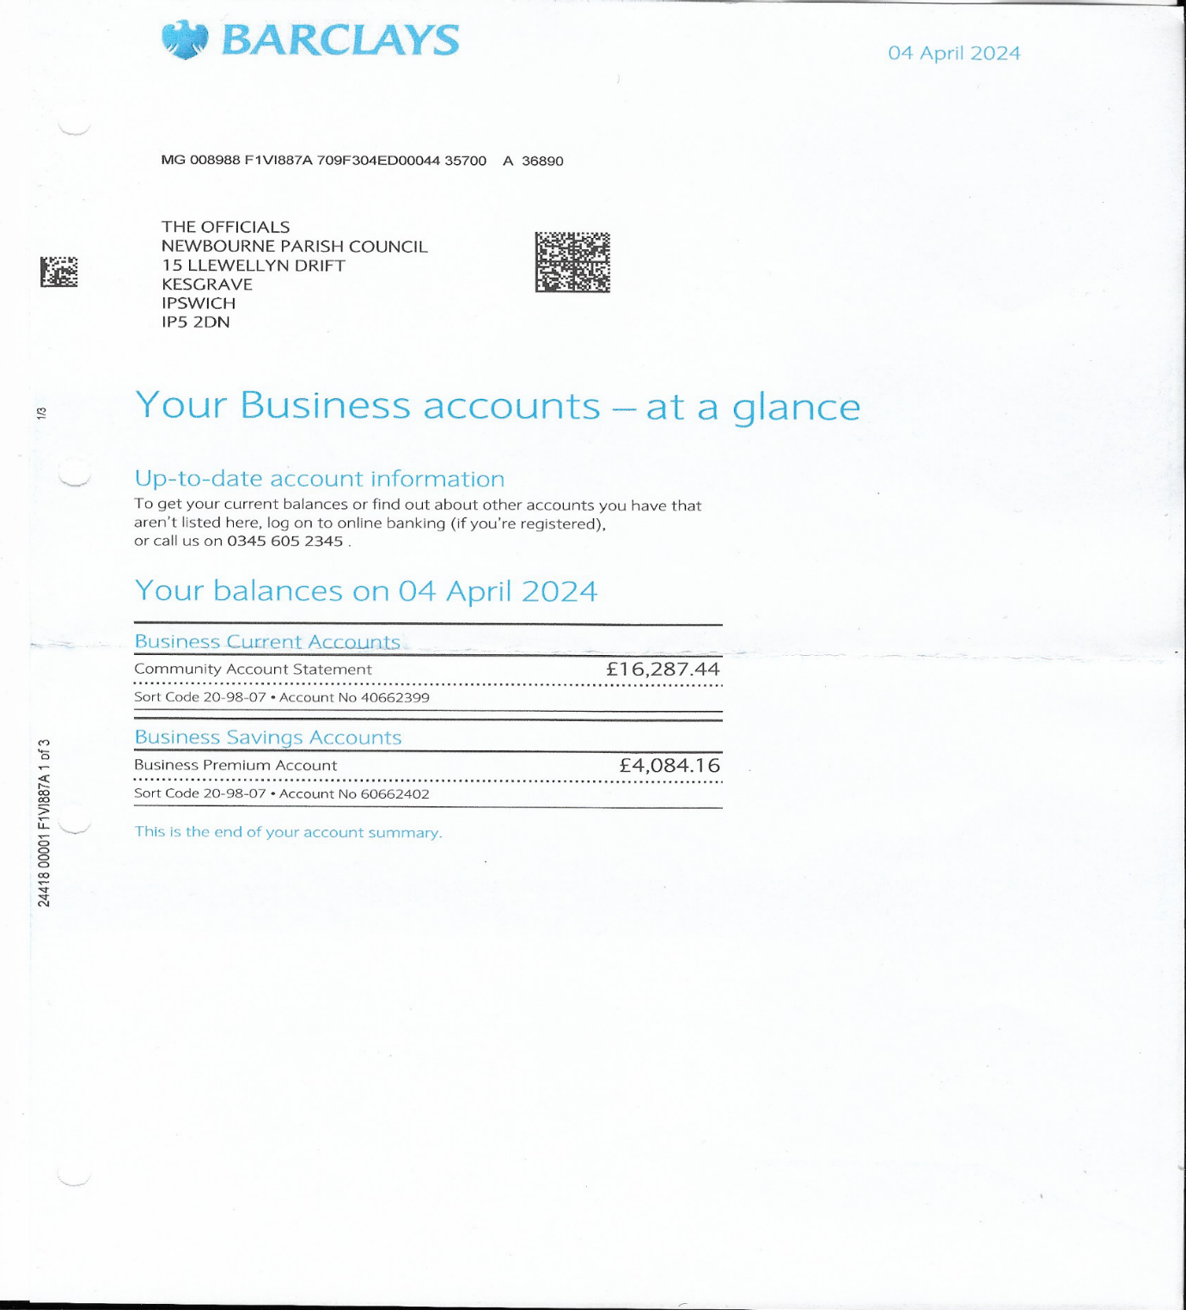

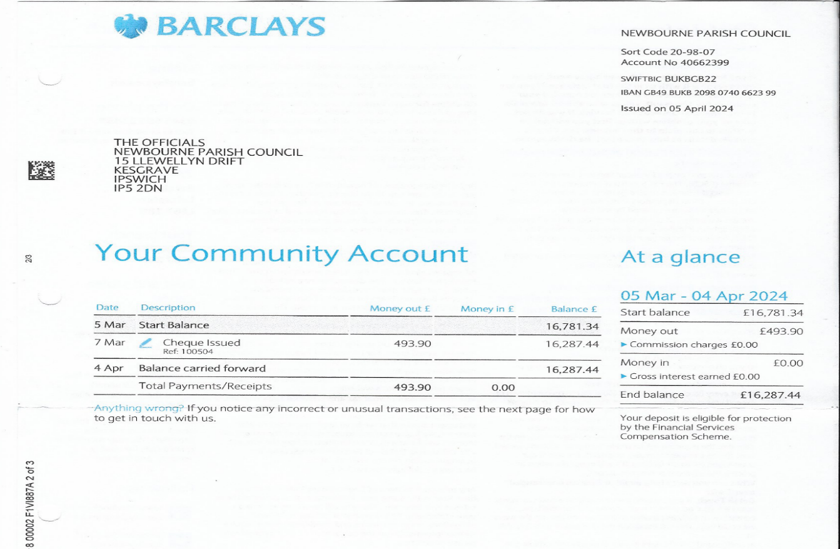

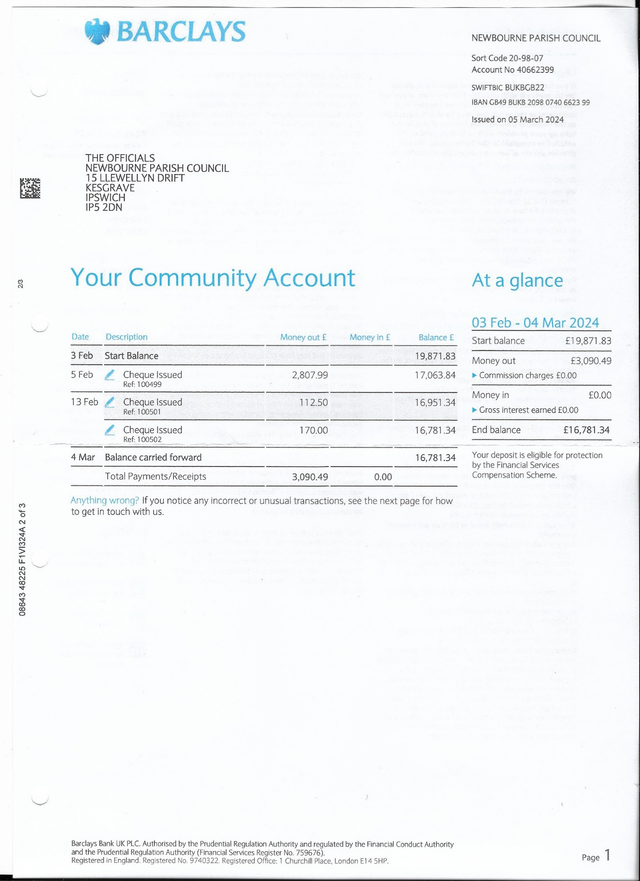
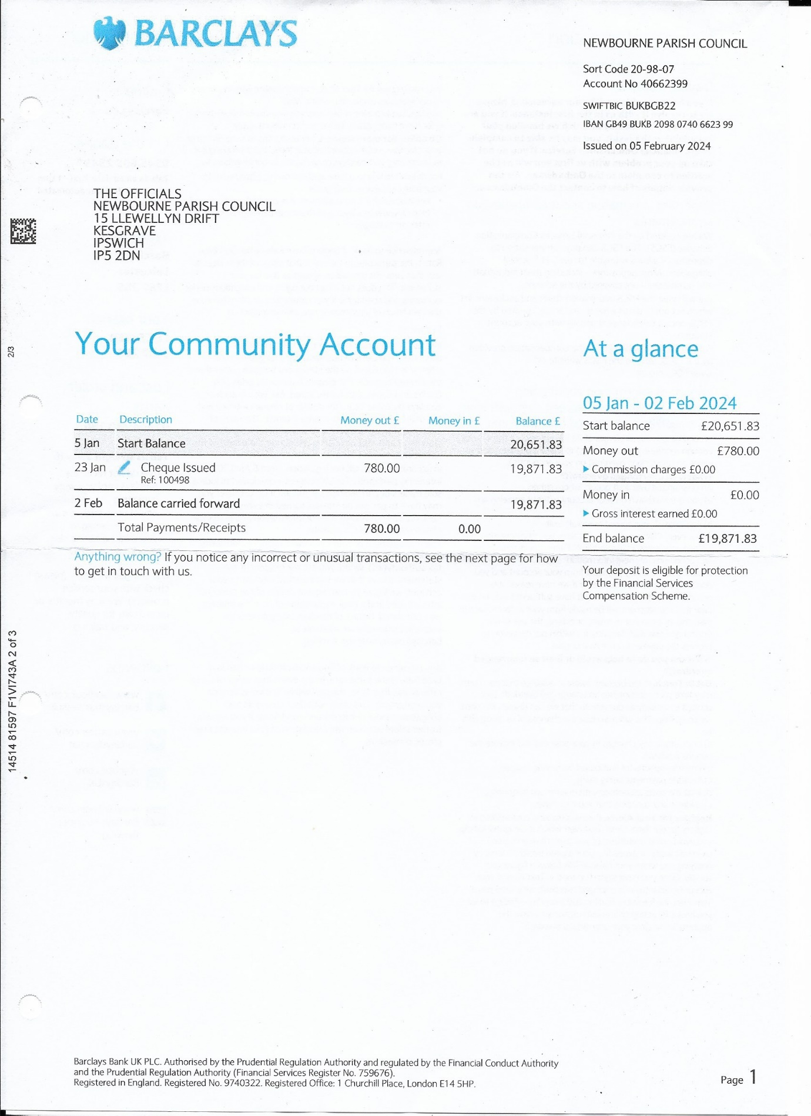
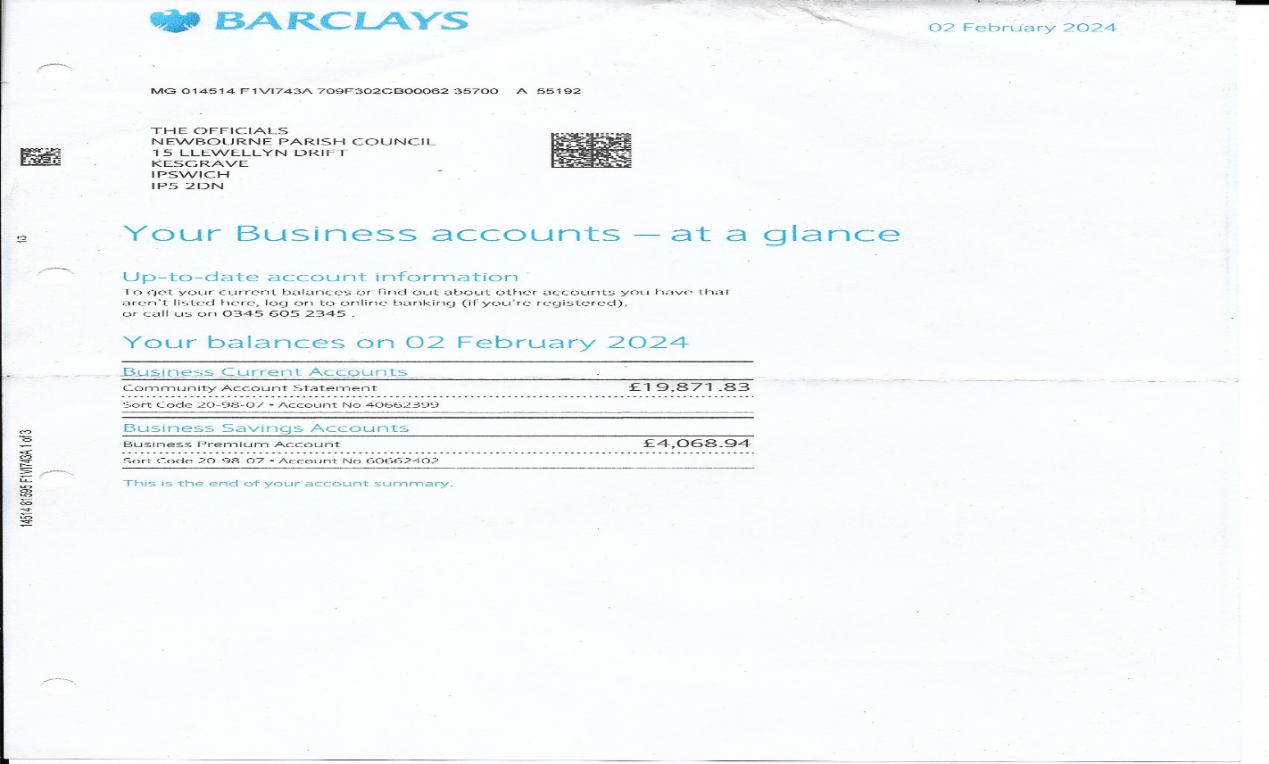

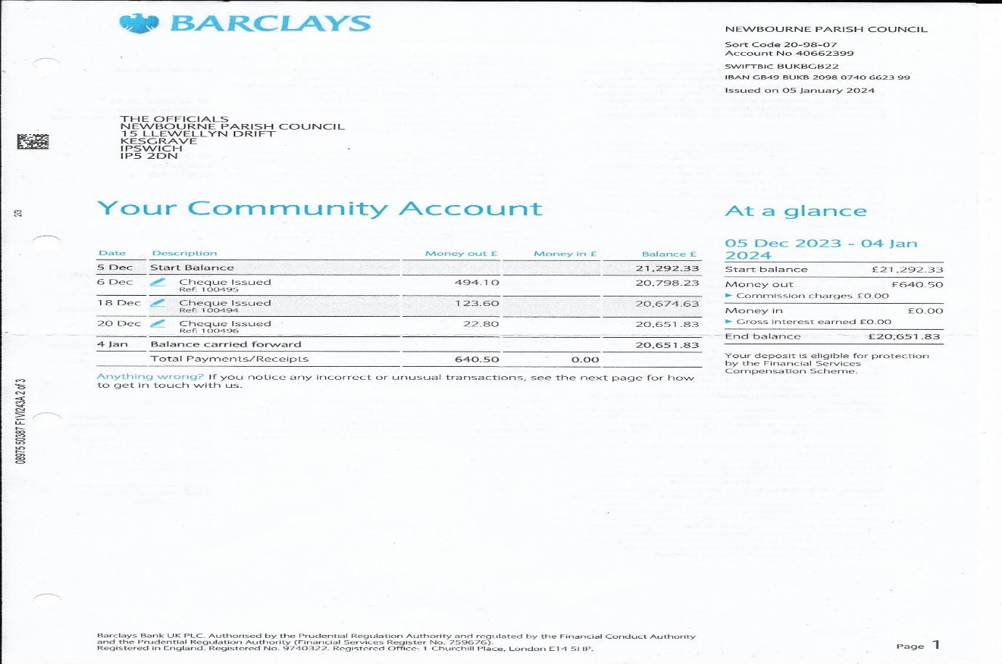
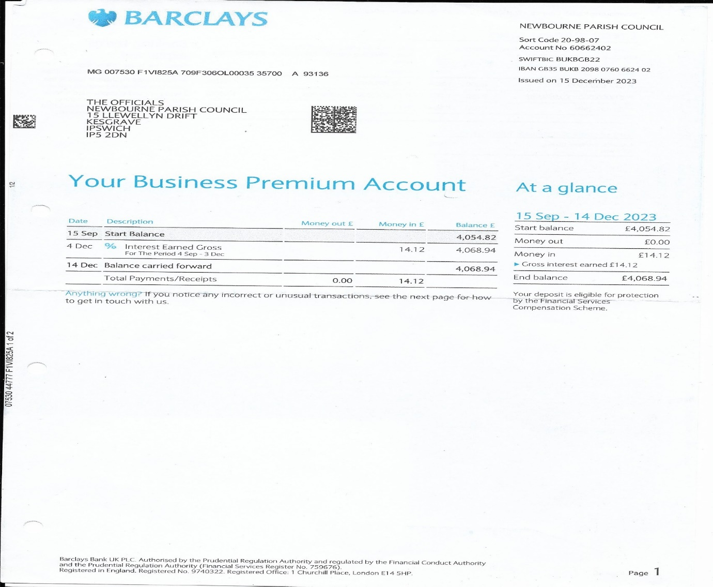
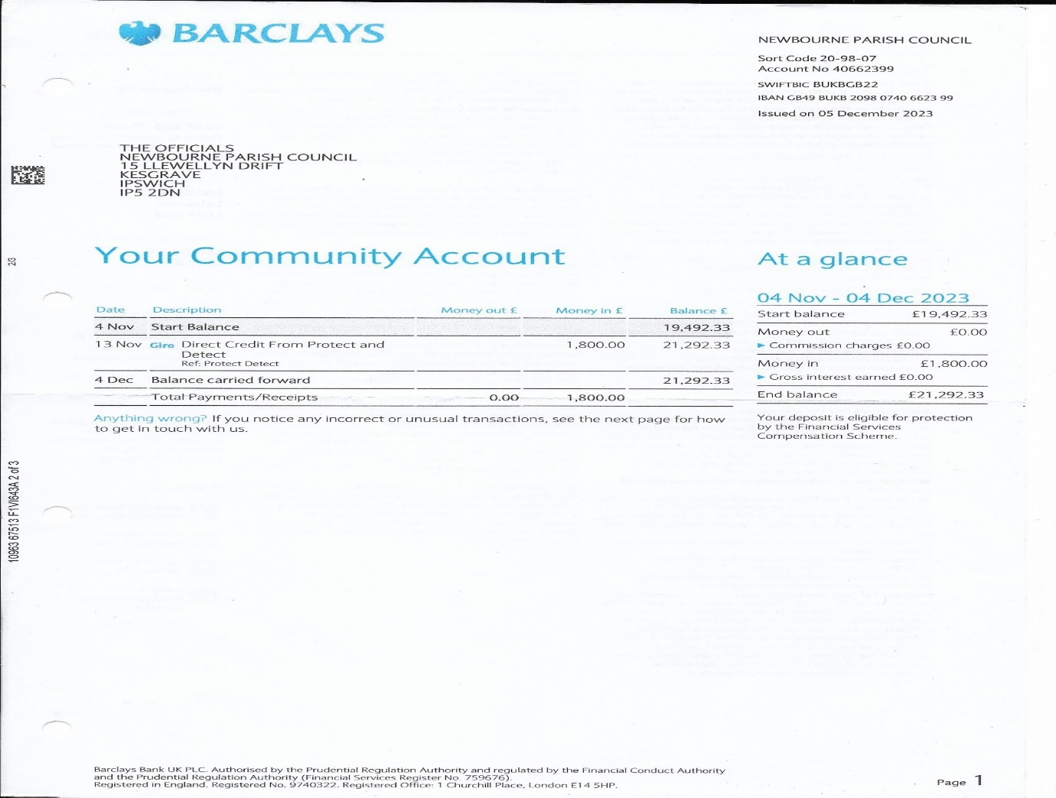
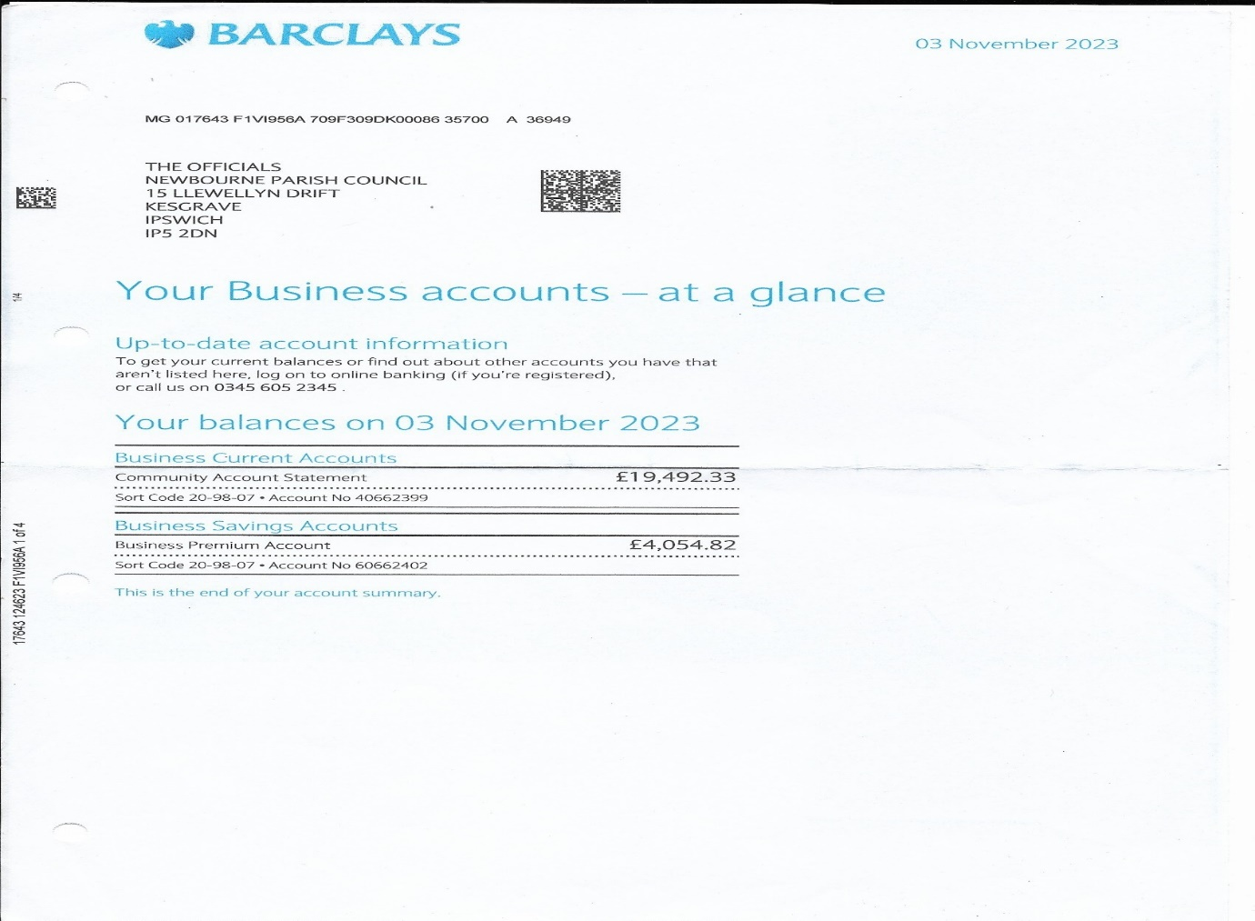

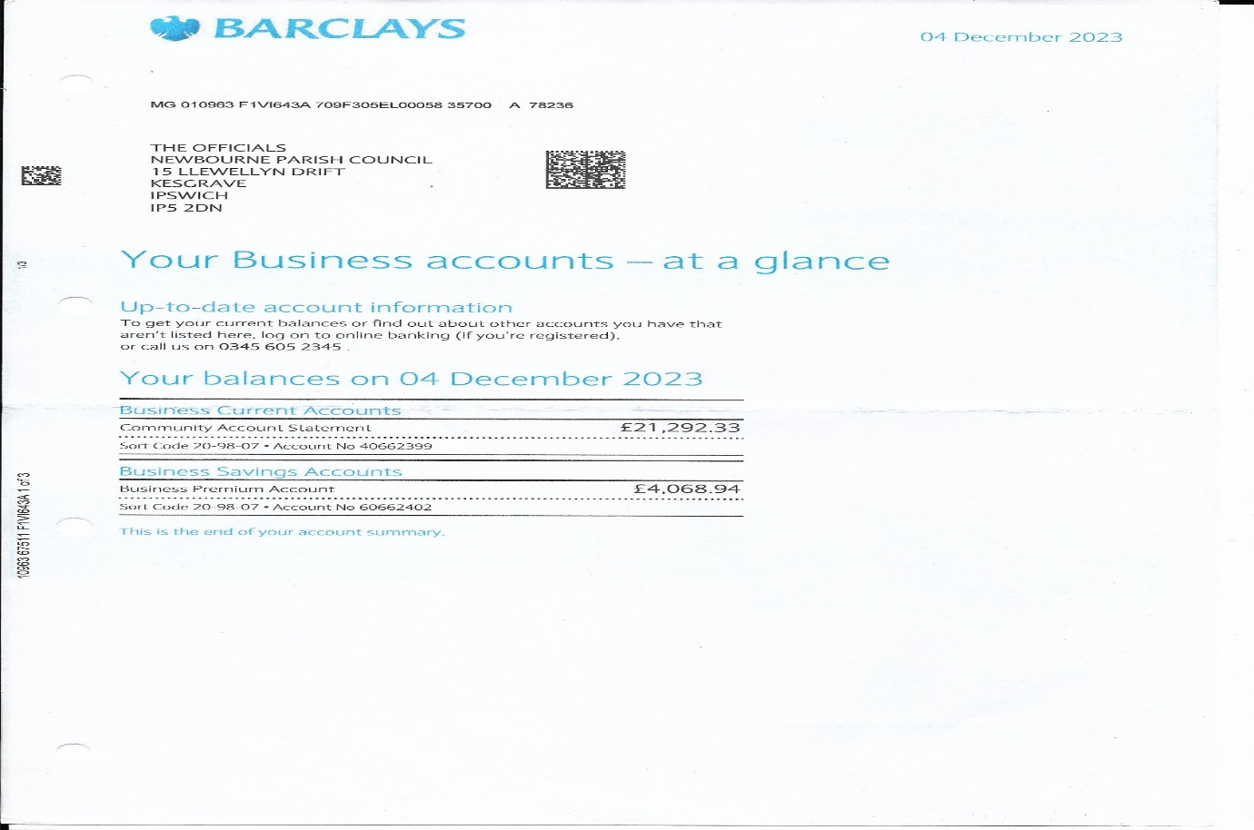
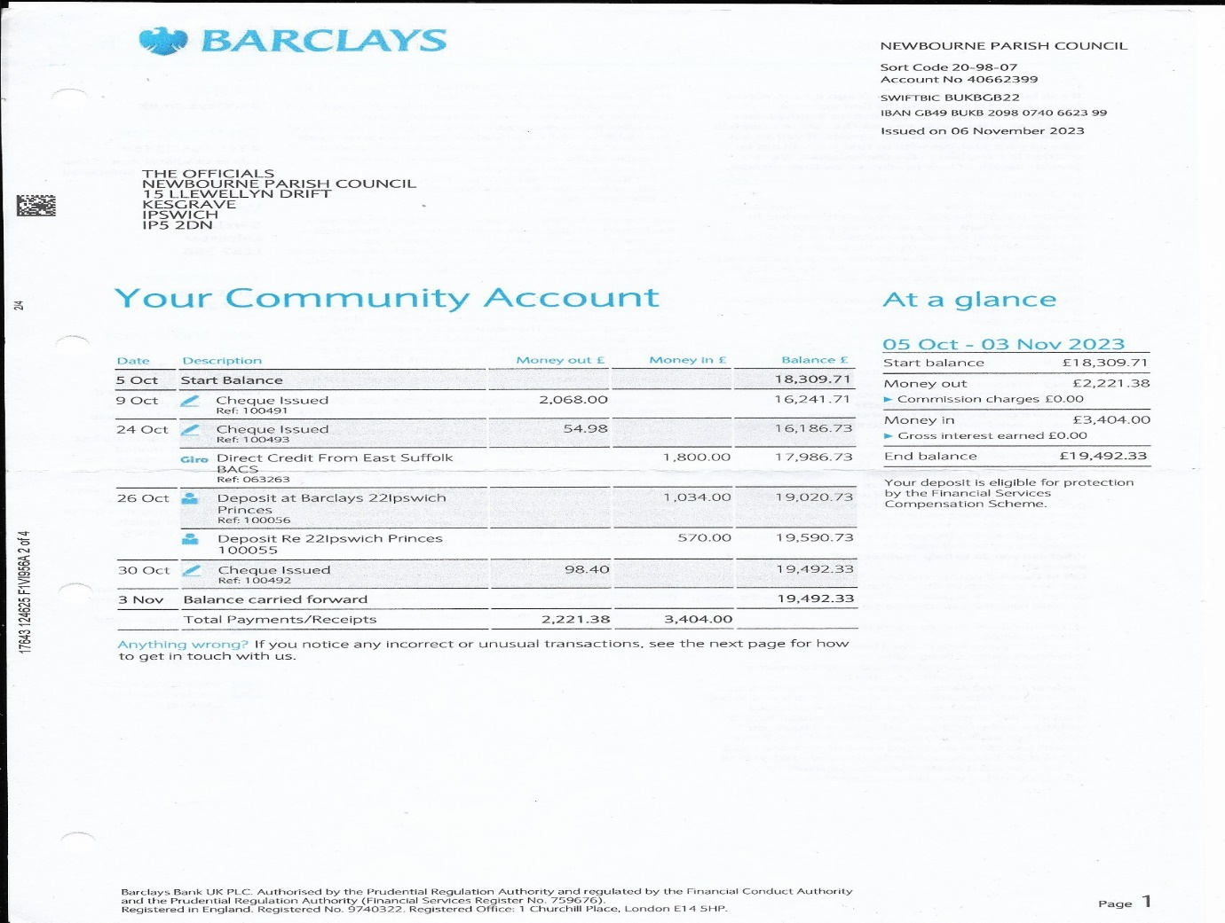
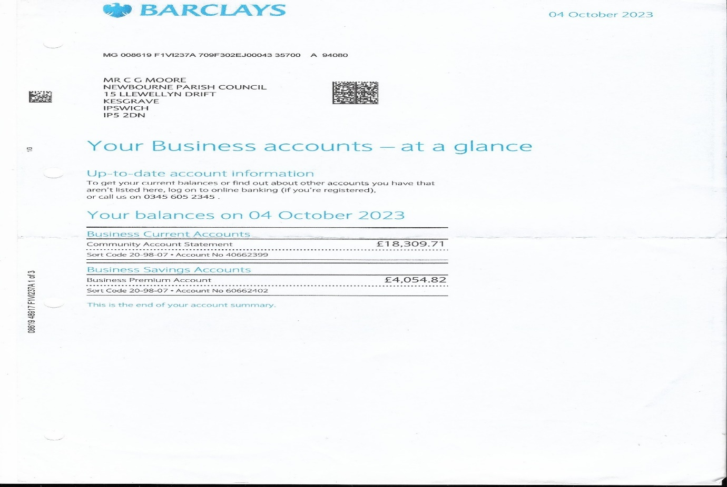

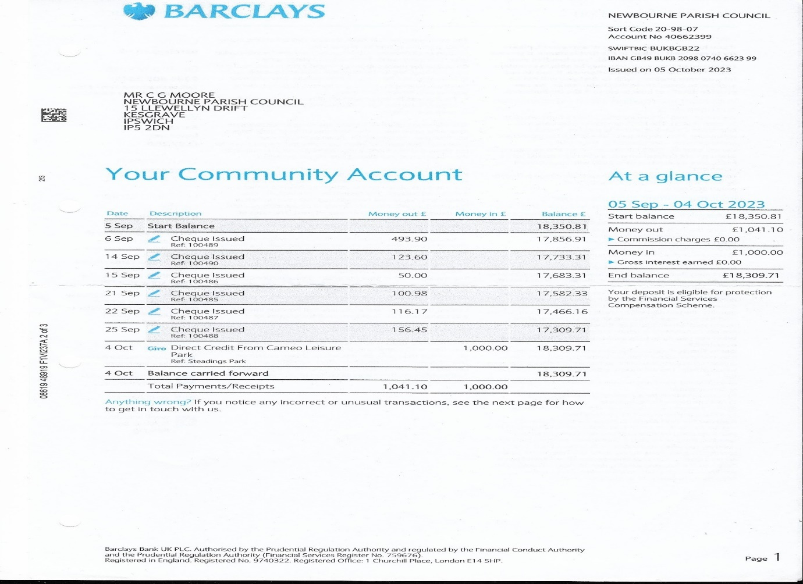
]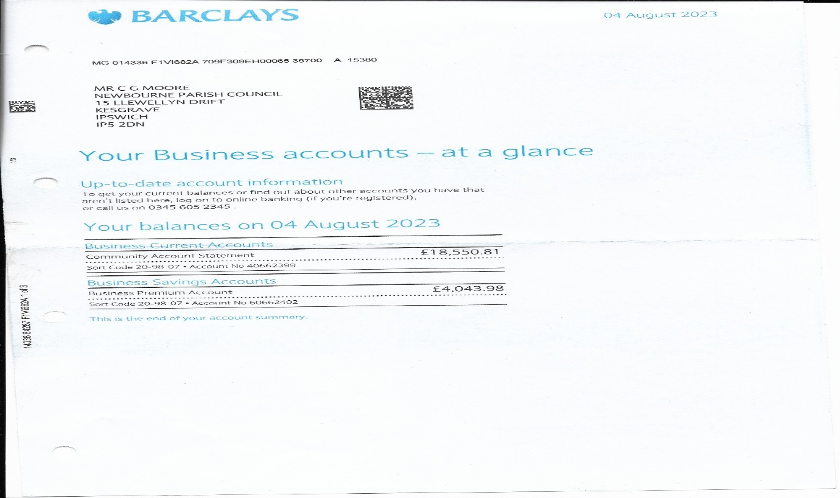
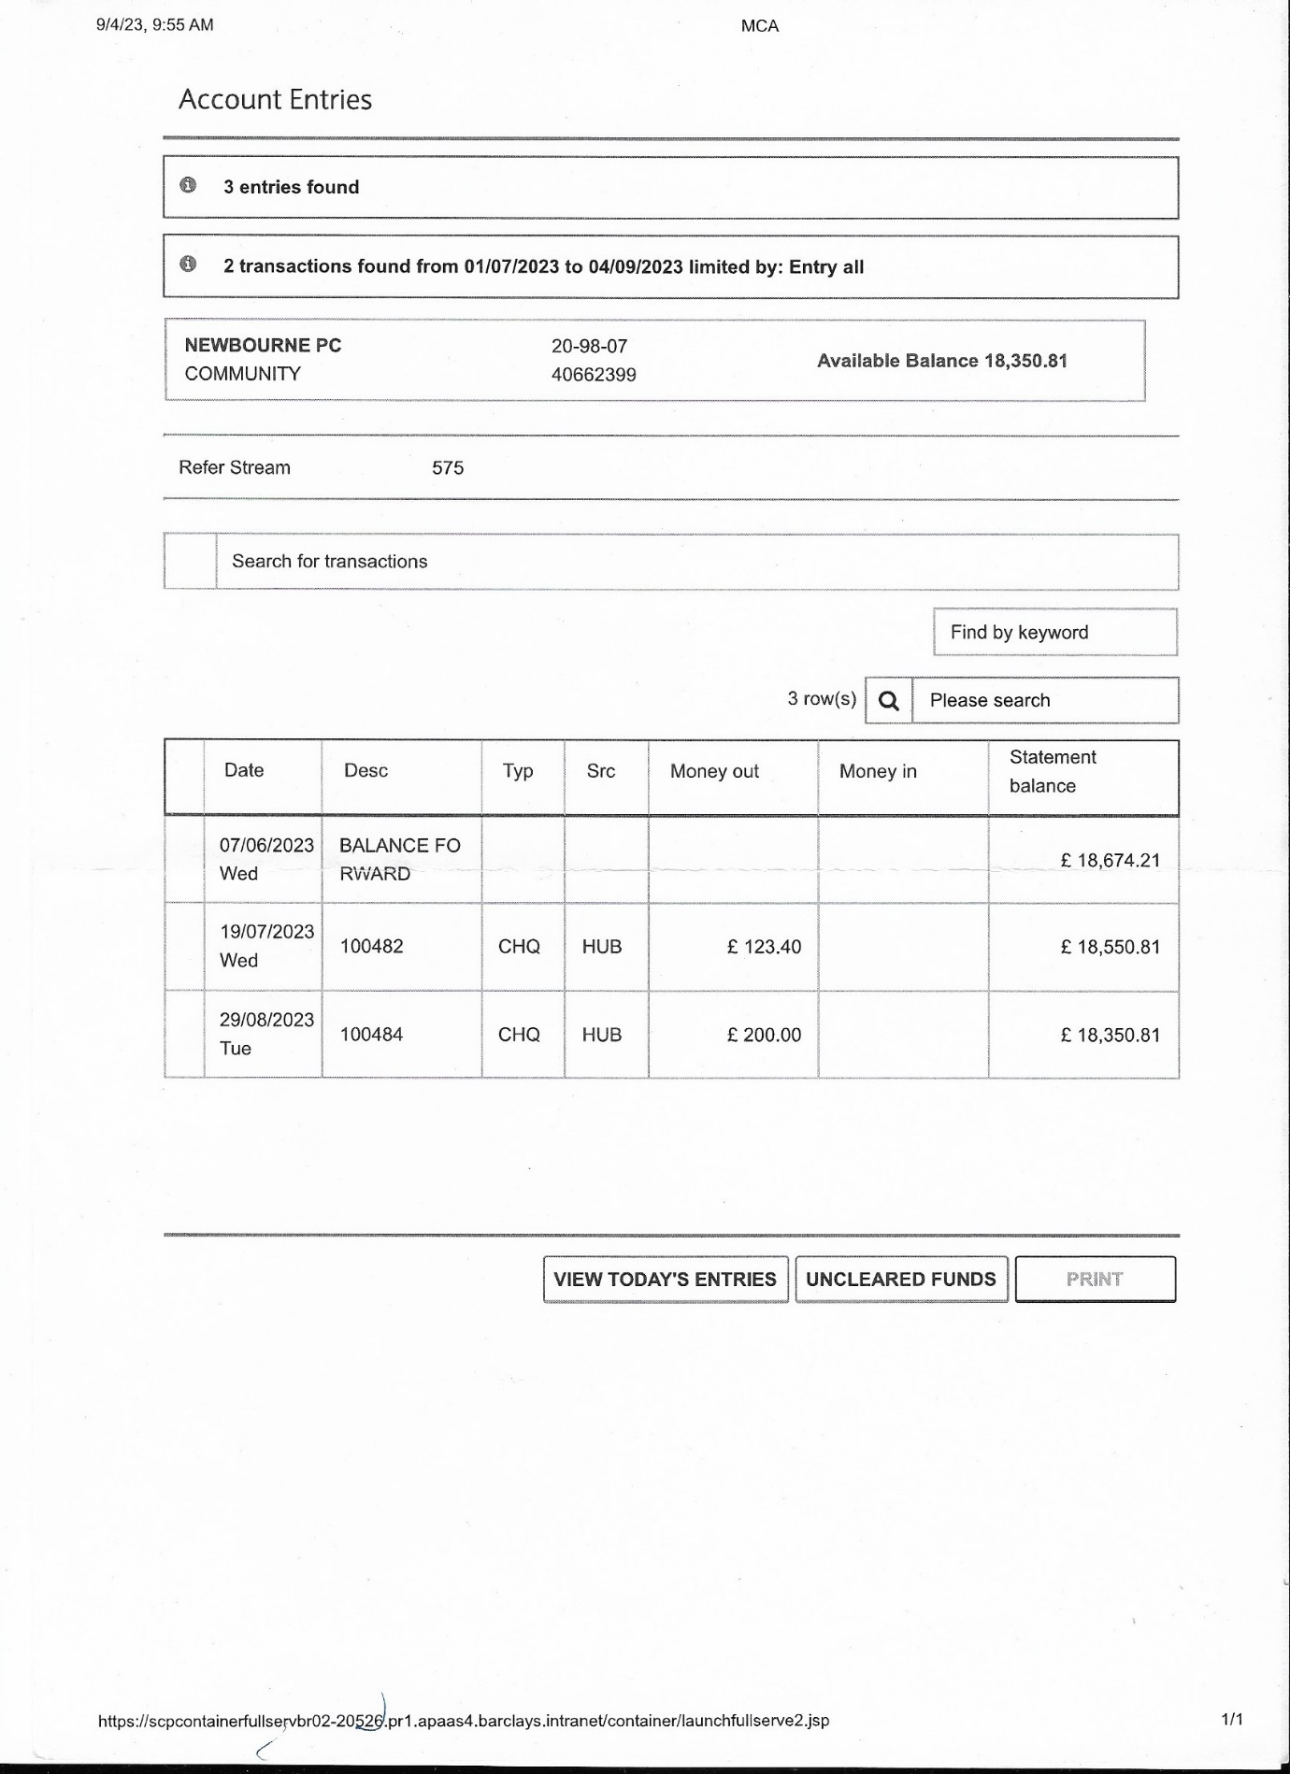
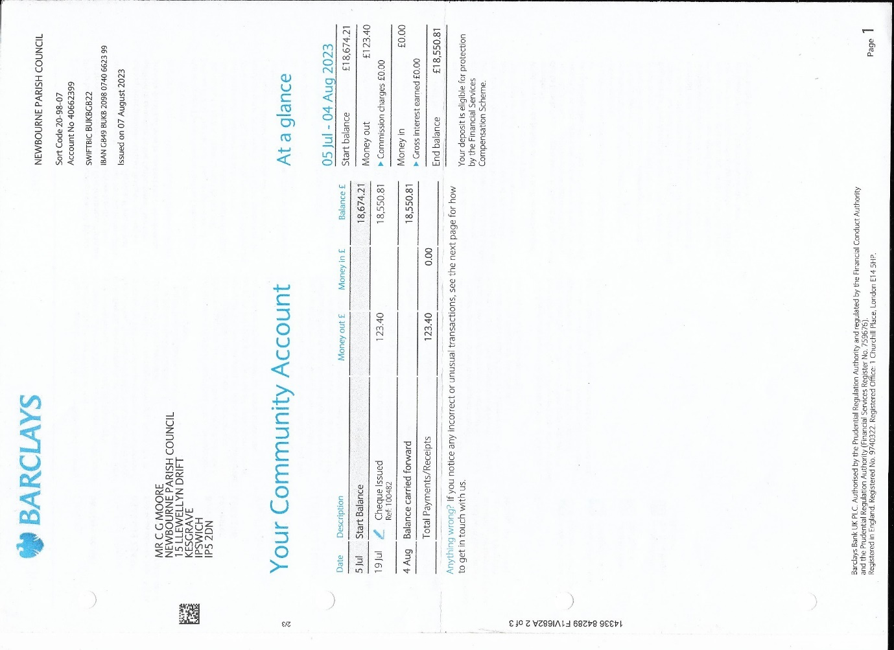
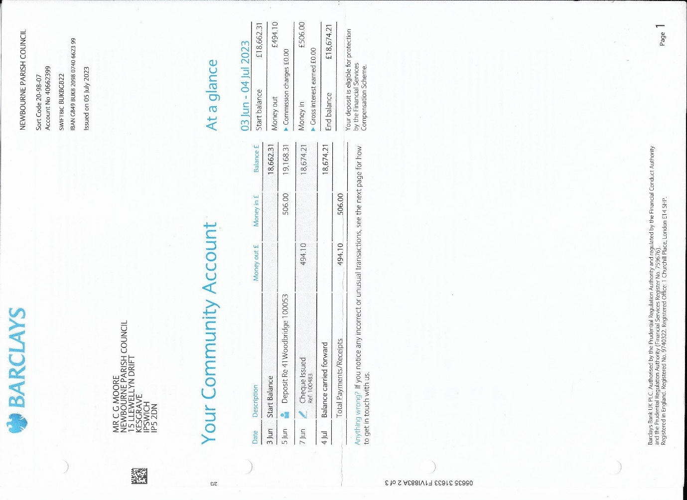
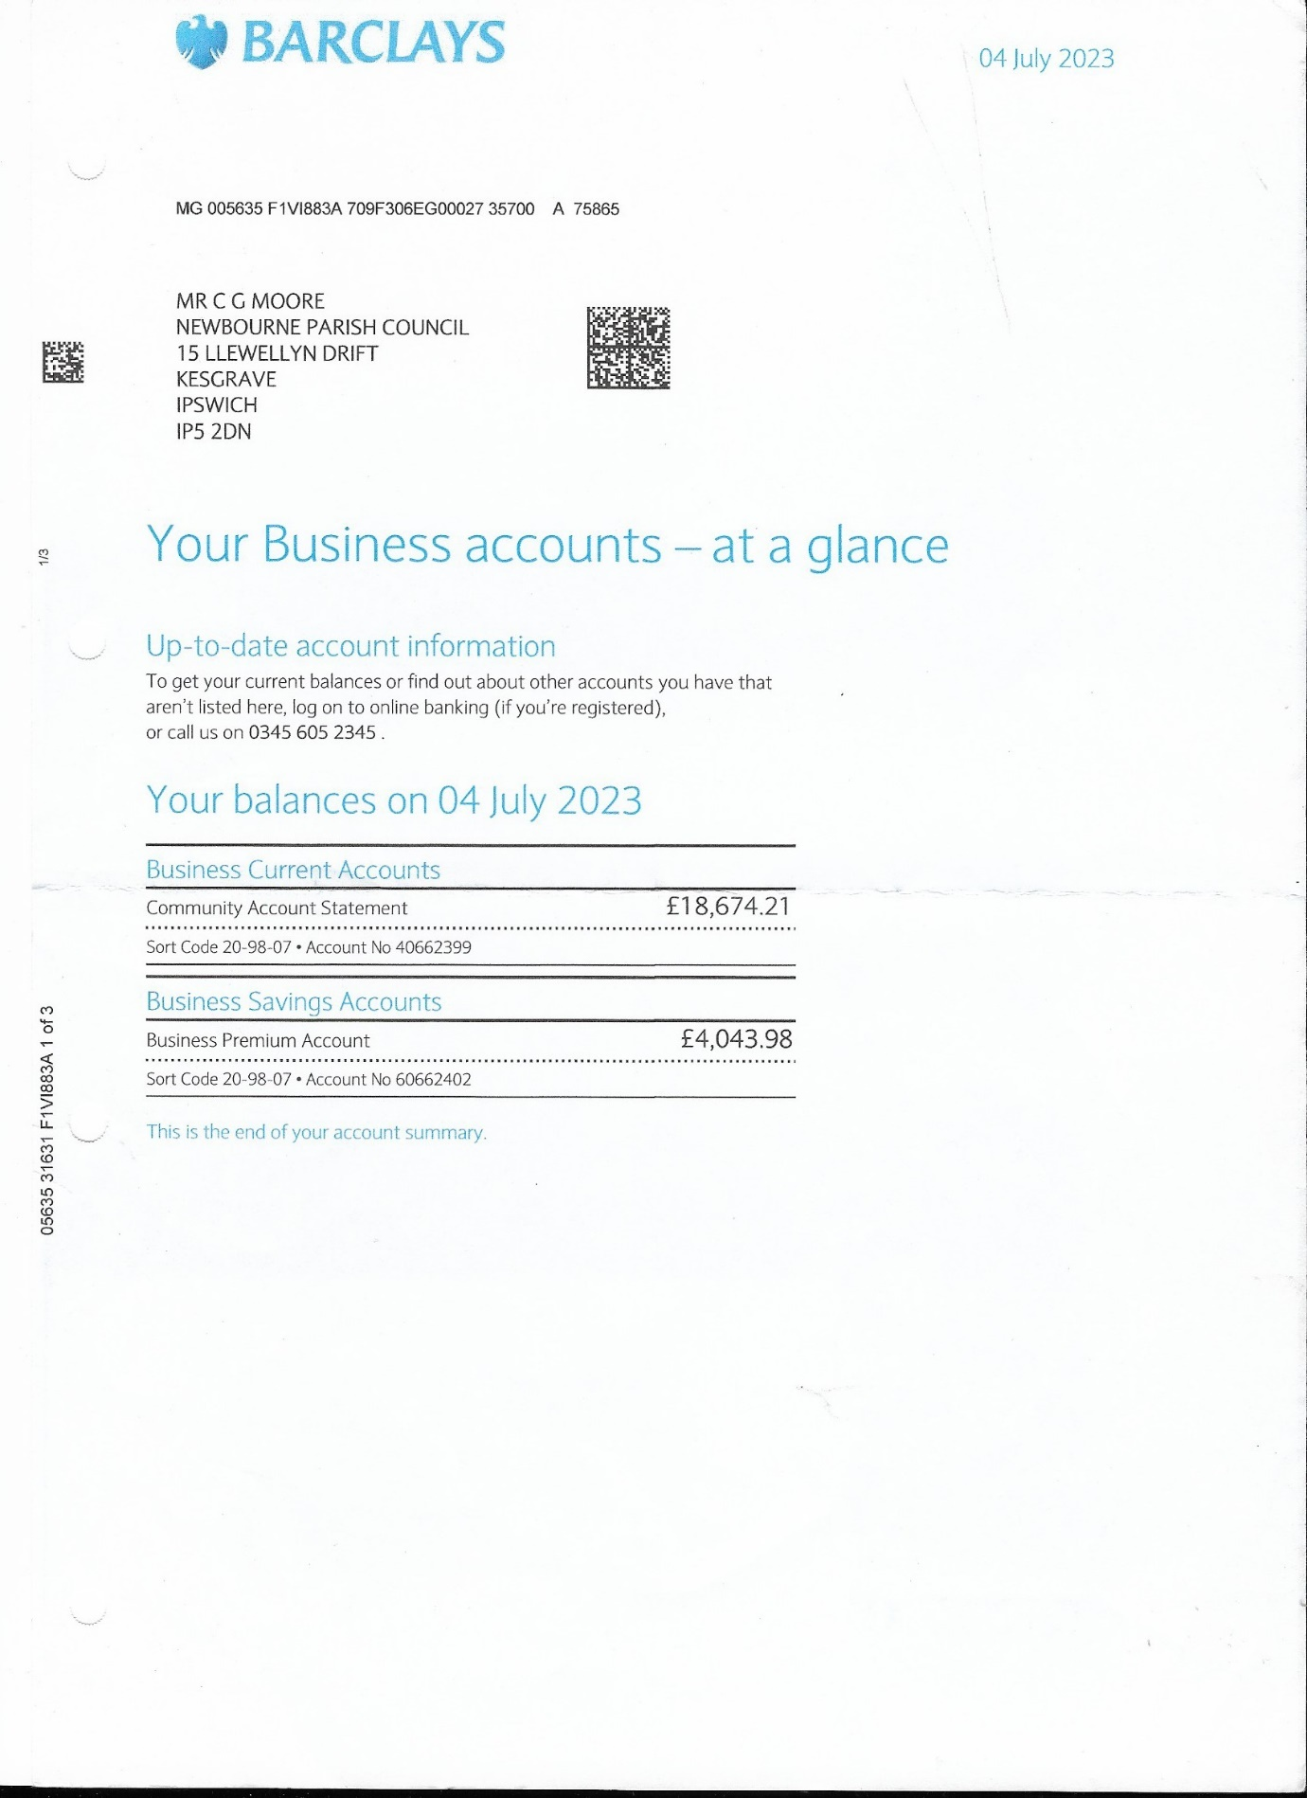
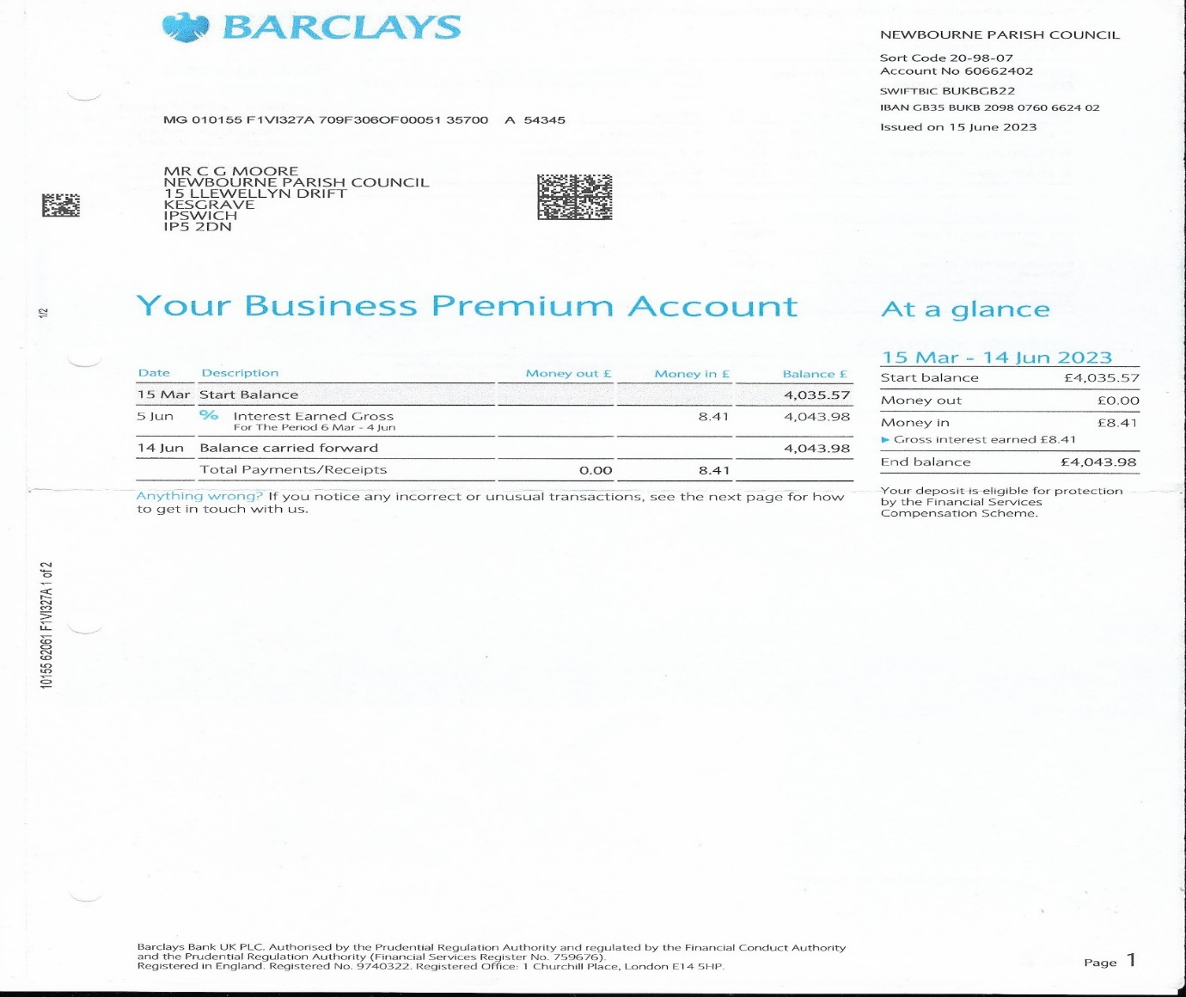
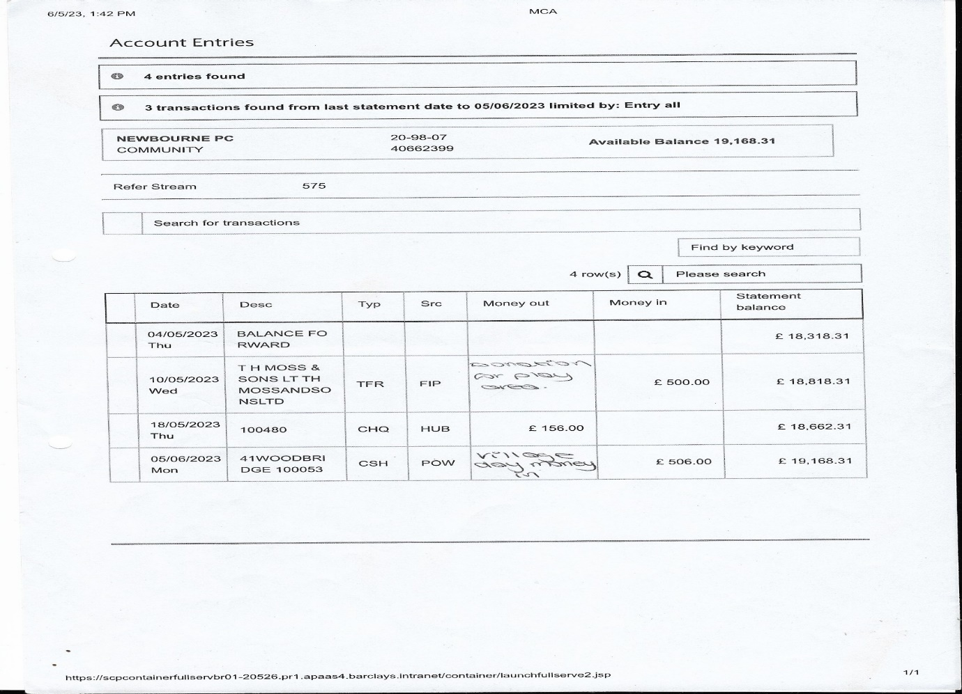
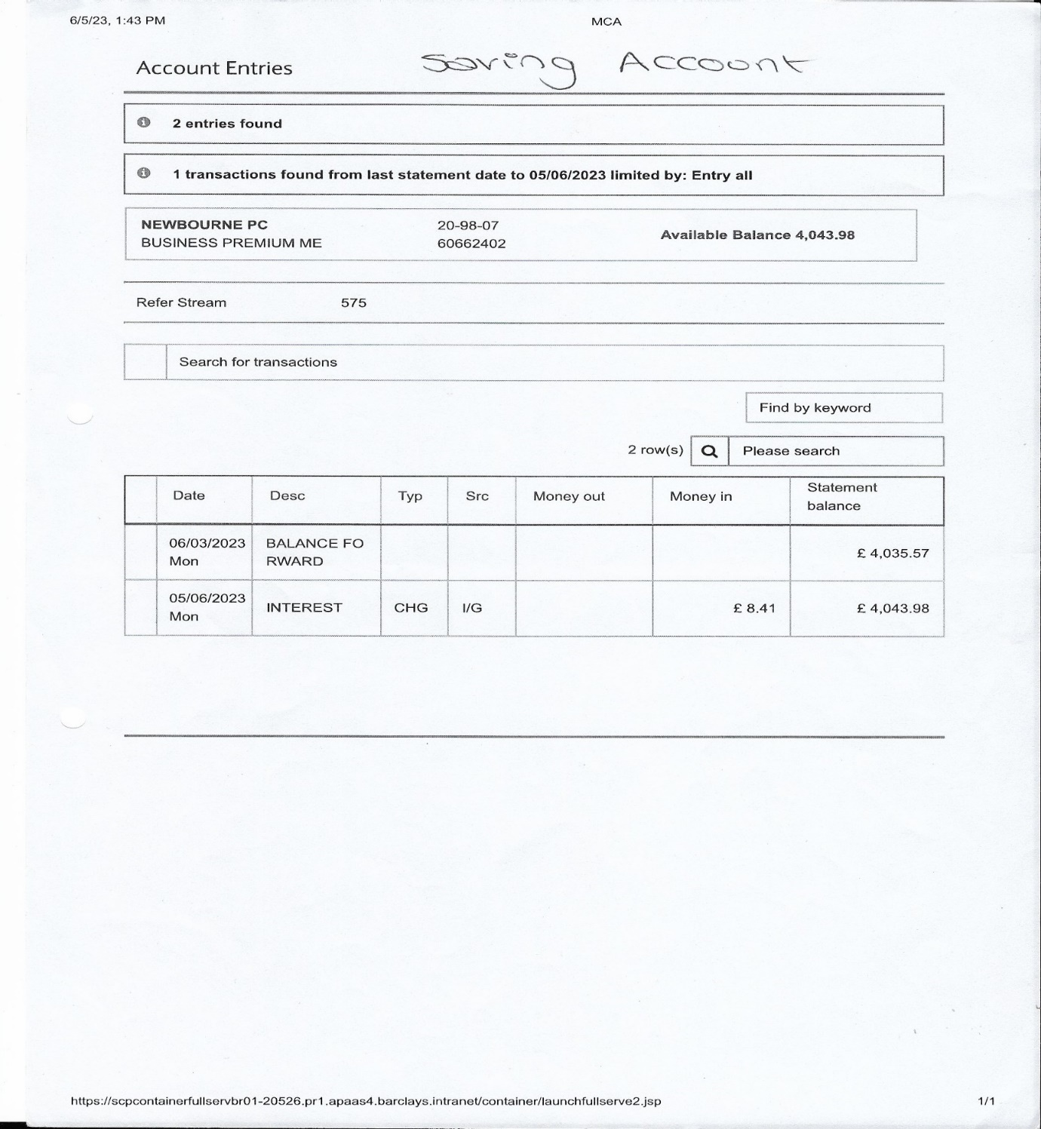
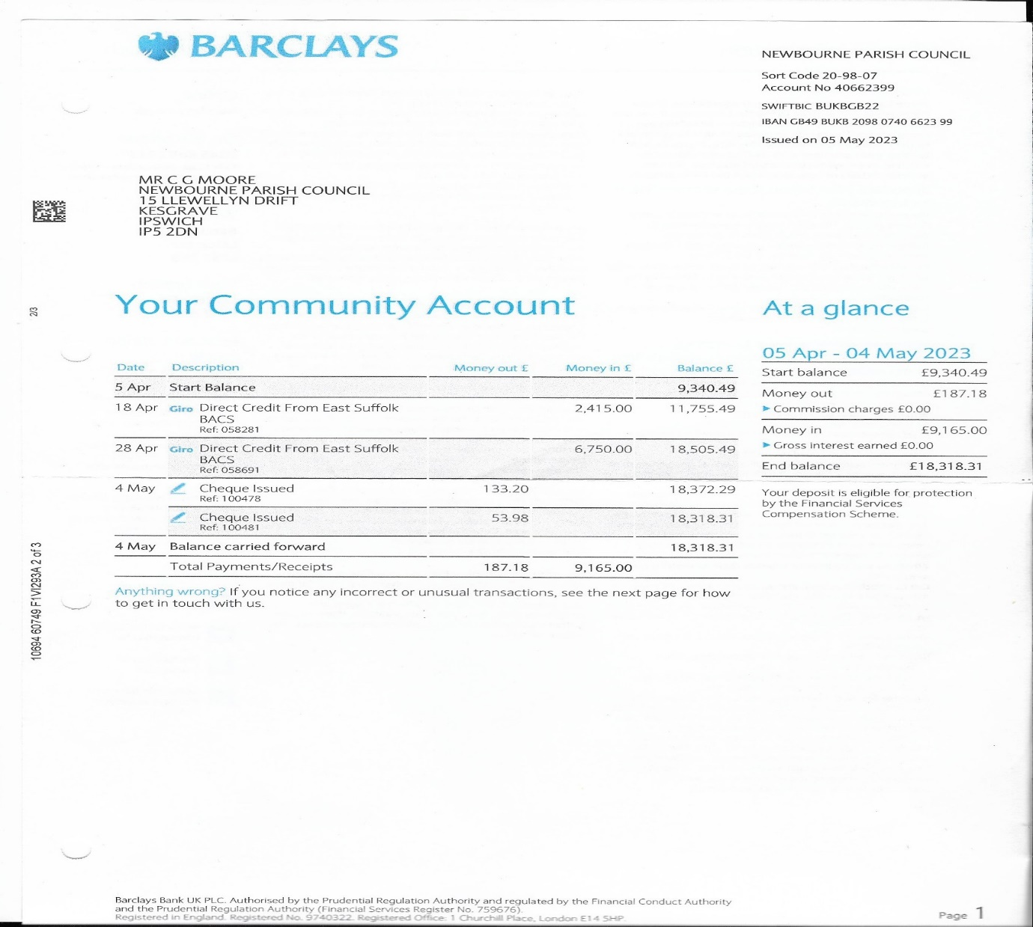
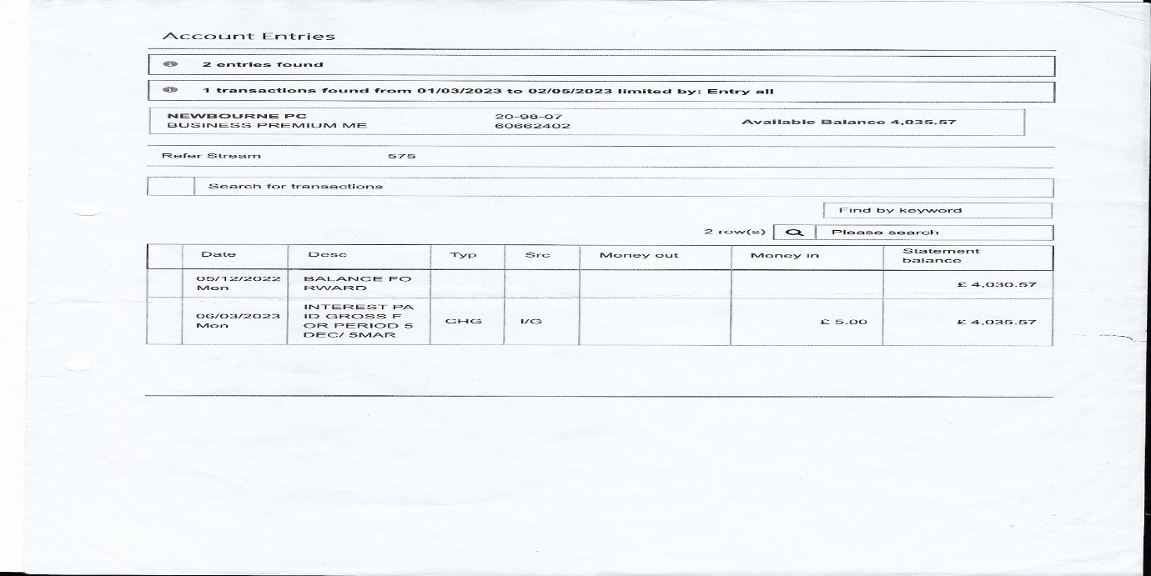
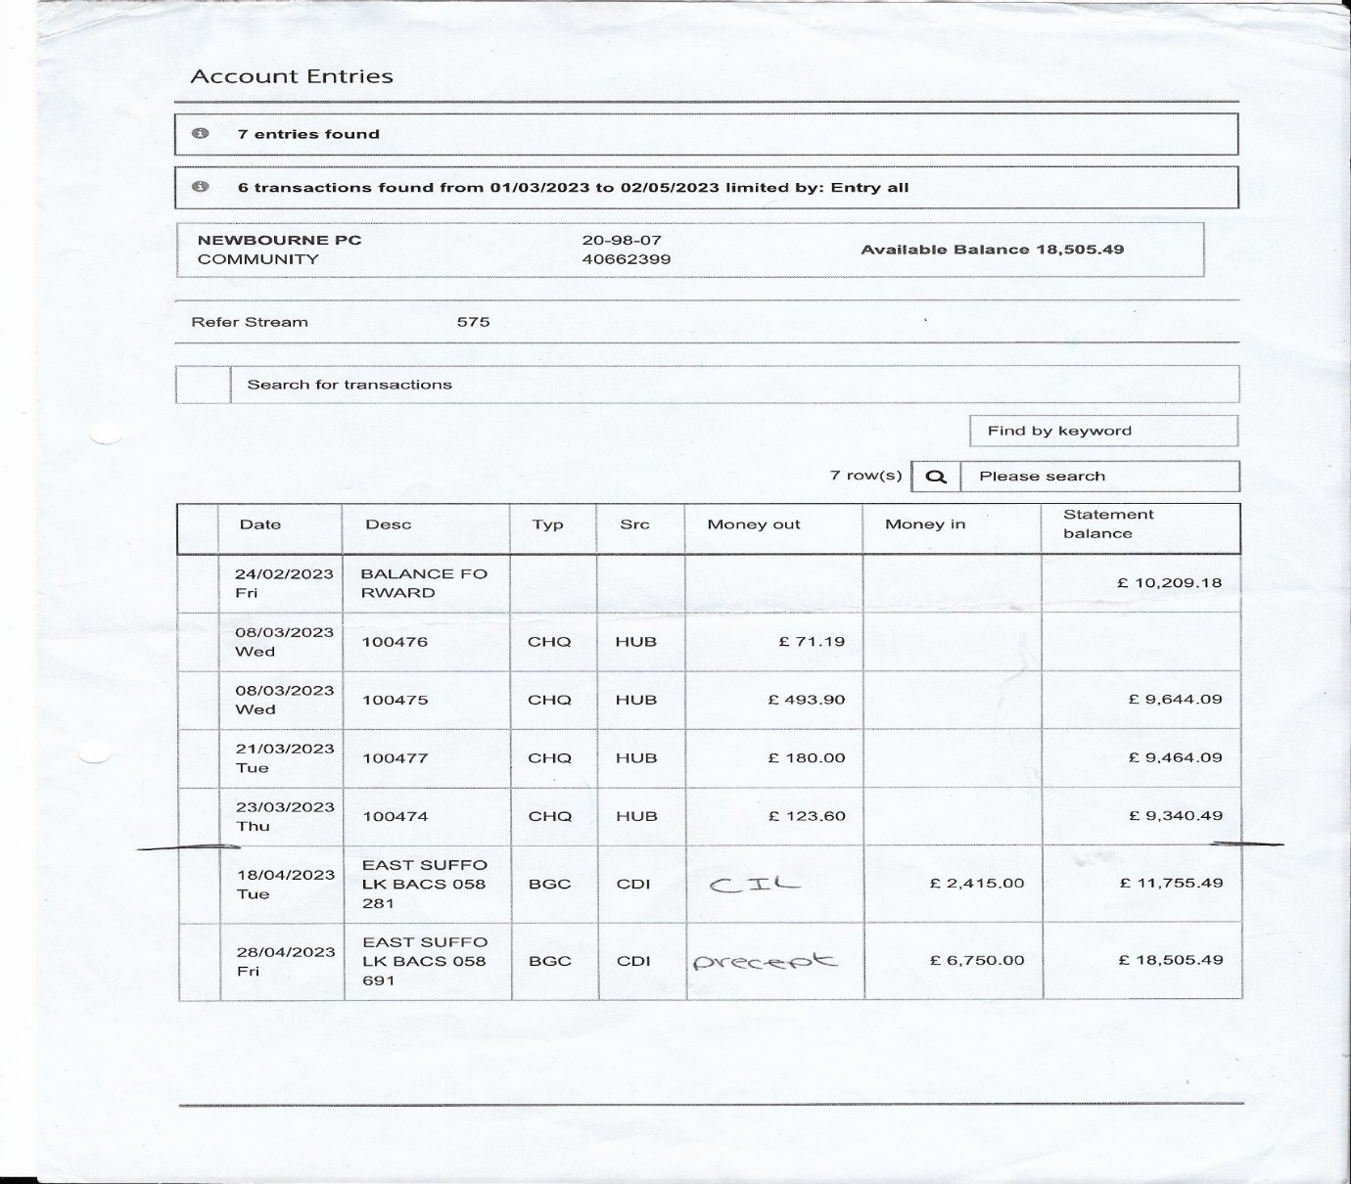

- No other business

Meeting closed at 19:24

