Newbourne Parish Council Meeting 4/12/2023

Public Time
No Comments from the public

Minutes of the Parish Council Meeting held on Monday 6th November 2023
Meeting opened by: Chairman Garfath- Cox
In attendance: Cllrs Scott, Frost, Wicks, Pollard, Lusher, Gaussen & Wheeler
ESC Councillors
Members of the public : 1
Minutes: Clerk
Meeting opened: 19:30

- To RECEIVE apologies for absence ESC Cllr Ninnmey & Reeves.
- To RECEIVE reports County and District Councillors and Suffolk Police. Reports on supporting documentation.
- To RECEIVE any Declarations of Pecuniary interest. None
- To APPROVE minutes of the October Meeting approved by Cllr Pollard and Cllr Frost, to approve minutes of November meeting approved by Cllr Wheeler and Cllr Garfath- Cox.
- To DISCUSS planning – No planning to discuss.

We discussed that the below should be considered on all future planning applications and that these are East Suffolk Council’s guidelines.
Planning
For all future planning applications please can we review them using the below considerations.
You should try to limit comments to those which are ‘Material Planning Considerations’ in the determination of planning applications. These can include:
- Access / Traffic (Parking any road safety issues)
- Amenity daylight, sunlight, privacy
- Affordable Housing
- Conservation Area / Listed Building
- Consultee Responses
- Fear of crime
- Government policy
- Cumulative impacts
- Layout, density, design/ appearance, and character
- Local Economy
- Local Planning policy
- Noise, smell, or other disturbances
- Outlook
- Prematurity
- Previous similar decisions
- Site History
- Fall back permitted development position.
- Protected Trees
- Local Economic benefits
- Ecology and wildlife
The below not Material Planning Considerations, and therefore cannot be considered in the determination of applications:
- Commercial competition
- Impact upon property values
- Your Personal views of the application/ agent
- Moral objections
- Matters covered by other legislation.
- Private access rights
- Loss of view

Some of the Cllr’s are interested in a Neighbourhood Plan for Newbourne so we discussed the following.

- Keep the legacy of the LSA houses as it is history in Newbourne.
- Residential design and environmental effects.
- Boundary issues - Keeping properties in size and not to close to boundary lines to avoid overcrowding.
- Historic environment – To avoid houses being built on back land.
- Highway issues and parking – Roads will get busier, single lane roads, traffic increase and the need to slow down the traffic. No pavements dog walkers and horseriders.
- Reason for growth
- Green input – Solar power
- Commercial properties – If we had a neighbourhood plan would it apply to commercial properties also.
- To be able to control local development.
- Can ask for support from East Suffolk council or seek advice from another village that has already implemented the neighbourhood pros and cons of having a local plan.
- Would need to set out what we want for planning, history of the village to retain, within parameters of planning.
- Is a neighbourhood plan updated every 3 years?
- Consult the whole village regarding implementing a neighbourhood plan.
- Would ESC override us in planning applications?
- Could we have an environmental plan that is linked to a neighbourhood plan?
- Biodiversity plan – Clerk will look more into this.
Clerk will look to get someone to attend meeting to provide more information regarding the Neighbourhood plan.
- An UPDATE on Green Infrastructure - Cllr Gaussen attended a meeting in October with Waldringfield, Martlesham and Hemley. It was discussed in the meeting that it was important to encourage local owners to keep the green corridors, along roads and footpaths. To help increase biodiversity, and help the village become more resilient to climate changes. To encourage local landowners to use trees that wildlife can live in and can feed off instead of using laurels and other trees and plants that don’t help wildlife.
- To RECEIVE and APPROVE the Financial Reports
Cheques to sign
HMRC £123.60 Cheque number 100494
L Naunton £494.10 cheque number 100495
Payroll SALC £22.80 Cheque number 100496

Bank Reconciliation November 2023

Cash in hand 01/11/2023 £23,547.15
Current £19,492.33
Saving £4054.82
ADD
£1800.00 Speed Camera money in from Protect and Detect
£14.12 interest on saving account.
SUBTRACT
Payments
Amount Cheque no Payee
No payments
Cash in hand 01/12/2023 £25,361.27
B
Cash £0.00
Petty Cash £0.00
Community account £21,292.33
Saving £4068.94

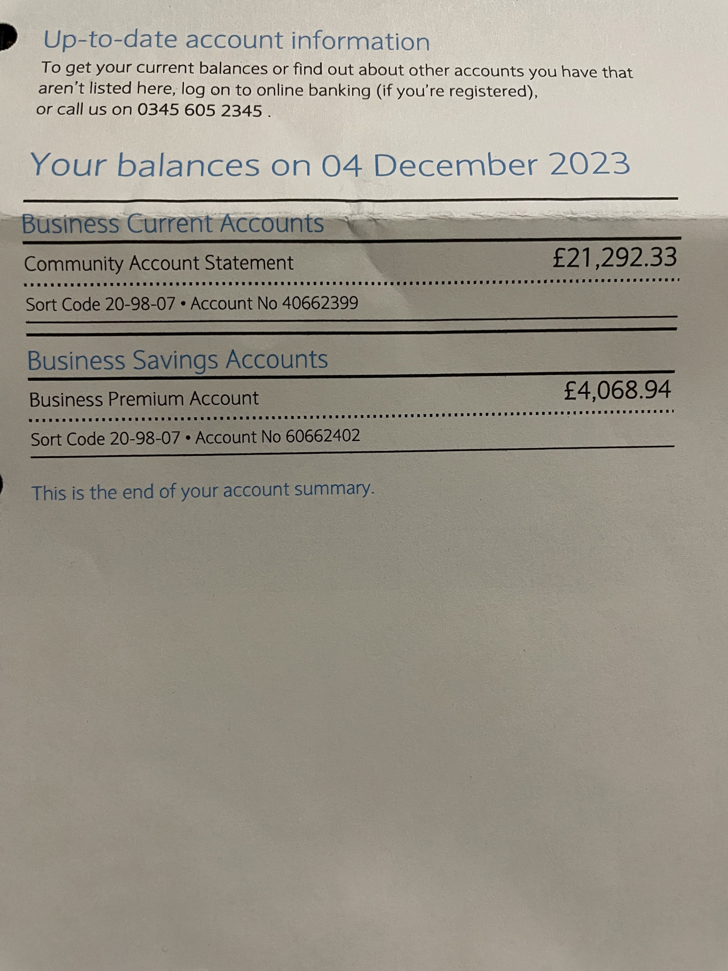

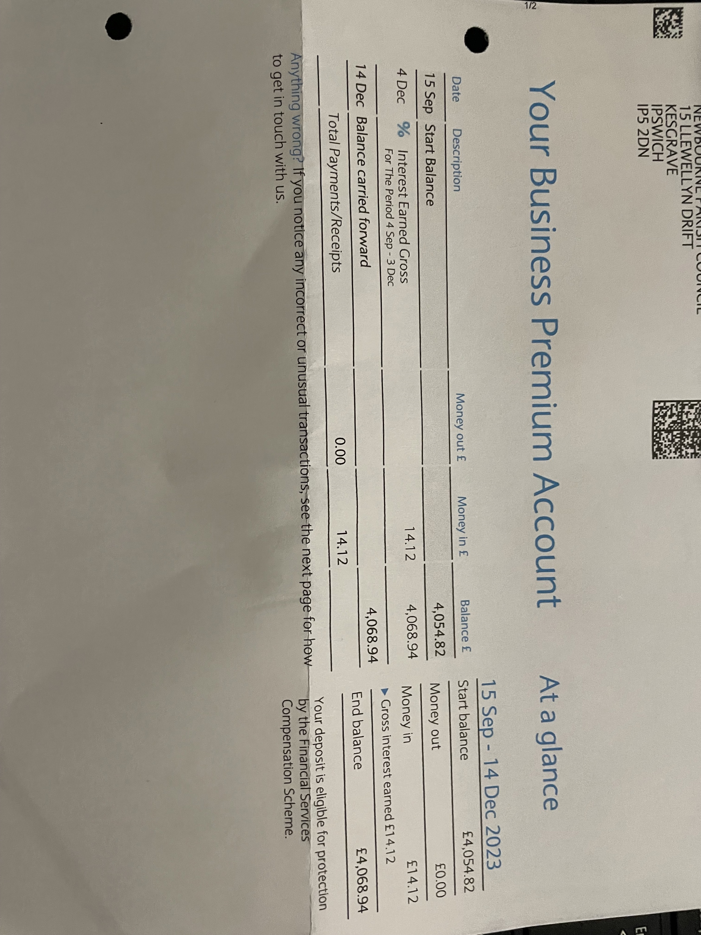

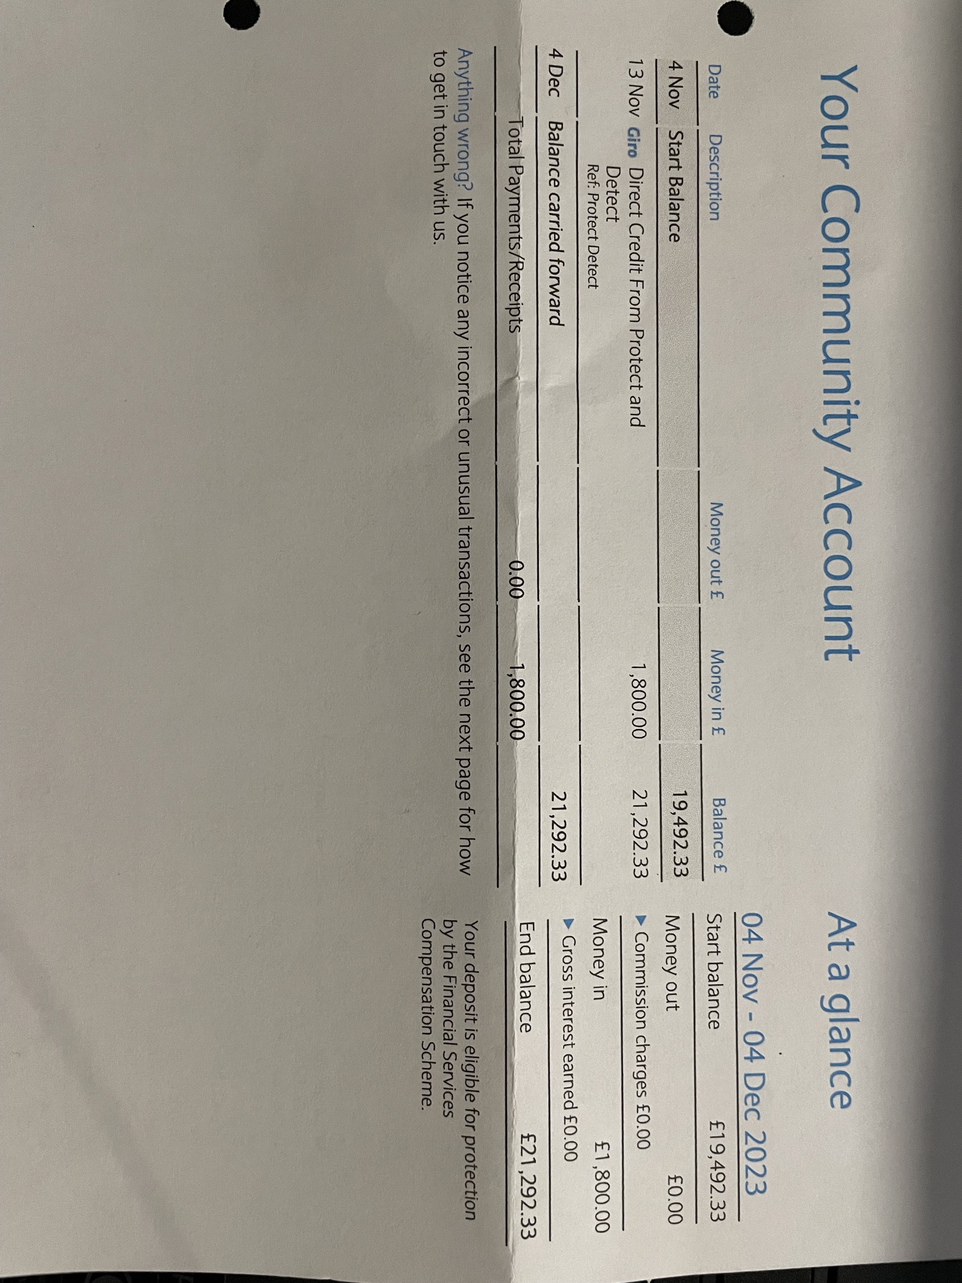

- Clerks Correspondence
Have been asked to raise the following issue regarding the road that leads up to Foxhall Roundabout included is the email sent to ESC regarding the issue.
Good evening, Mike & Lee
Hope you are both well?
I was wondering if you could help with this highway issue we have.
We have had several concerns raised over Newbourne Road that leads to Foxhall Roundabout. There have been many accidents on this stretch of road where there is a bend just as you approach or leave the roundabout. On several occasions when travelling off foxhall roundabout towards Newbourne, Brightwell and Waldringfield people have reported that they have been faced with oncoming vehicles on the wrong side of the road. Also, people reporting that they have seen people travelling towards the roundabout on the wrong side of the road. It seems that some people think it is two lanes when travelling to the roundabout.
The road markings are not very clear and there are not enough road signs to clearly state the road layout. For people that that have lived or live local to the area they more than likely know the road layout but as the area is getting increasingly busy with people visiting businesses and with the new Brightwell lakes traffic is going to increase with more people from other areas.
A post was added on our local to Newbourne site on Facebook after someone in the village had this happen to her lately and there were over 64 comments regarding near misses or accidents on this bend to the roundabout and that is just from local people.

Have reported this on the highway tool but where do I need to escalate it too if nothing is done? Any help or guidance would be very much appreciated. I have included an image of the part of the road that is the issue and comments from other people that have commented.
Happy Christmas & New Year
Laura Naunton
Newbourne Parish council clerk
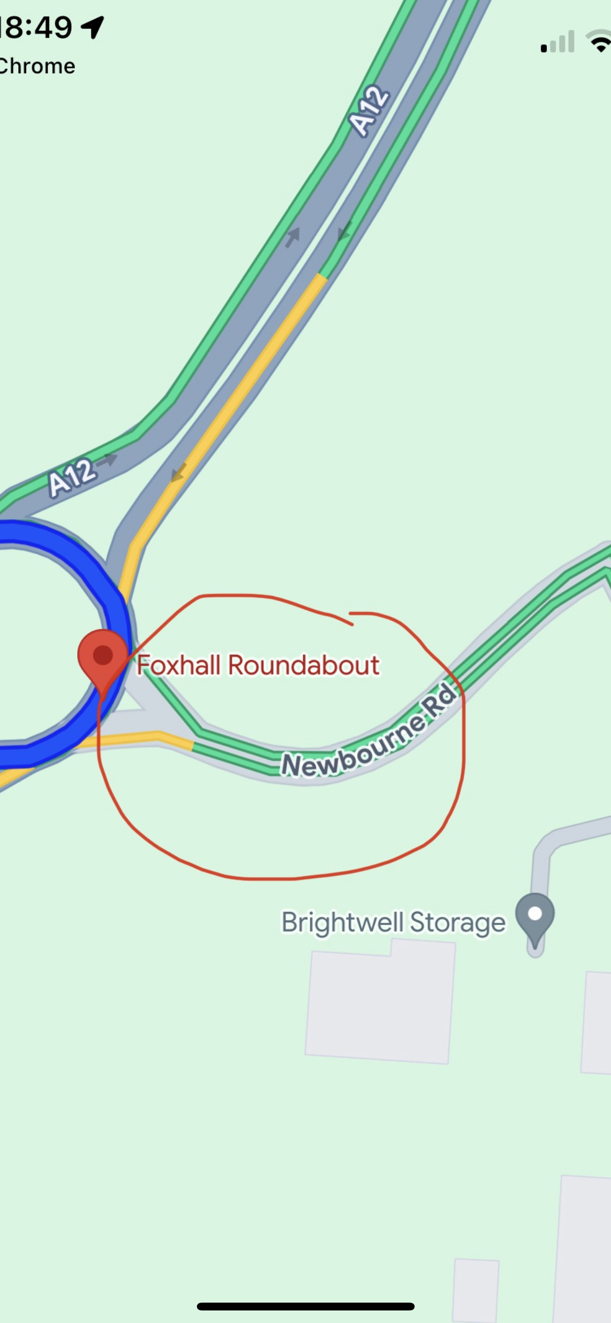
The clerk also raised the issue of litter especially on Ipswich Road heading out of the village. We could organise one next year when the weather improves so we have more volunteers to help.

A warm welcome to Rev Nick Williams who has joined Newbourne Church.

Meeting closed at 20:40

