; 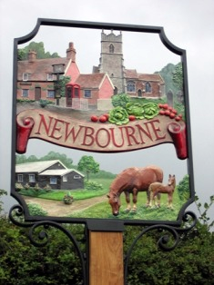
NEWBOURNE PARISH COUNCIL
Minutes Monday 7th March 2022 in the Newbourne Village Hall, 7.30pm.

Public Time
- Discussion of footpath.
- Terrance has kindly offered to clear the area in front of the bus stop on the Street.
- Planning at 18 Mill Road was discussed.
- Wild Verges
- Speed watch

Meeting started at 8pm

- Apologies – Lionel Scott, Richard Kerry, Sue Pollard, Gary Grainger
- Update from Mick Richardson Councillor
This evening, (02.02.2022) I attended Bucklesham Parish Council’s meeting – and had the pleasurable company of Pc Rachel Partridge who attended to speak to them about ASB issues (speeding / NOC cartridges / Speedwatch etc).
Rachel mentioned to me a couple of issues of interest (I leave it to you as to which bits are of interest to you).
Firstly, the Felixstowe SNT supervisor Ps Russel Mason is moving on and in his place, a new supervisor, Ps Nick Kitchen takes over the role of Fx SNT Sgt as of Monday March 7th 2022.
Nick is a highly experienced officer and a ‘good all round egg’ who has amassed numerous years’ experience not only as a police officer, but also as a supervisor.
I’m sure all of us will welcome Nick into his new role serving our communities and leading our SNT.
Rachel also mentioned the value that the SNT places upon reports of ASB (in whatever guise) to them in the most prompt medium possible (101 / email / on-line reporting etc).
As a result of my picking up ‘intelligence’ (going back to my roots!) from various parish council meetings that I have attended and passing it on to Rachel, she and her colleagues have been able to build up the bigger picture around individuals and activities that can cause levels of concern within your communities. She was able to advise me as to how they had used that information to (shall we say?) ‘interact’ with certain individuals of interest.
I think my message here is not to wait until you meet me and pass on concerns, but instead to raise those concerns directly with the SNT in a timely manner – and tell me later!
Speedwatch.
Numbers of you are either considering Community Speedwatch (for the first time) or attempting to resurrect a defunct scheme.
In the olden days when I was involved from the police side of the equation, whilst the police held the equipment in order to qualify that it was kept safe and was regularly calibrated to ensure accuracy, it was usually the case that the equipment itself was ‘funded’ (purchased) by one means or another – which may have meant that a parish council spent funds or a District / County councillor spent their budget on the equipment.
I’m aware that there is currently some mystery as to where some of that kit is now ……….
However, all that is now a thing of the past.
Suffolk Constabulary will supply all the equipment required to run a community speedwatch scheme and will also cover all the insurance related aspects.
That means then that those of you trying to locate ‘old’ equipment can effectively write it off as you no longer need to locate it to be able to use it.
Please contact Rachel to take your speedwatch plans further – Rachel.partridge@suffolk.pnn.police.uk
Lastly, a message from myself on a more personal level.
I was honoured to be elected last August as your latest District Councillor. I have put my name forward to stand again in May 2023 (hopefully, I’ll be reselected – but who knows!)
In the 6 months between last August and now, I have attended each parish council meeting at least once – and in some cases much more often.
There are different factors involved in my attendance (or not) which I’d like to address with you all.
In my election address, I undertook to work with all the PC’s in my ward and represent you all to the very best of my ability (and I hope that I have been able to demonstrate that to you) – and I very much appreciate being able to join you at your meetings where we can interact on a face to face level. That undertaking remains true.
I’m aware that some members at ESC who have the same problem of multiple meeting on the same evening choose to ‘bunny hop’ from one to another – however, I personally do not subscribe to that model, preferring to attend ‘your’ meeting only and give you my full attention.
My biggest frustration is that so many meetings clash with each other, and I’m left in a position whereby I have to decide whose meeting I attend, and who I need to send apologies to.
I’d very much prefer not to have to send any apologies at all – but I have little choice.
Whilst I make every effort to be fair to you all, there are occasions where I am specifically asked to attend (insert parish name here) in order to provide a ‘targeted input’ to a meeting, meaning that I need to offer an apology to another meeting that I might otherwise have attended which I hadn’t been able to attend previously.
It’s further complicated in that not all parish councils meet monthly.
Would it be beyond the realms of possibility for each parish council to have their regular meeting on a different day of the week?
I very much appreciate that this would require a reworking of everybody’s calendar - and I also appreciate that your meeting dates are published for the year to come – but – if we worked from May 2023 onwards, it leaves plenty of time for all the parish councils in the ward to talk to each other and create a schedule of non-conflicting dates for the meetings.
If this was possible, and came to be, then every parish council could almost guarantee the attendance of an elected representative at District / County level to be in attendance. Gone would be the inevitable apology and the frustrations that go with it.
I very much appreciate that this might appear to be a ‘big ask’ of you all – and in truth, it may not be me that turns up to your meetings (if I’m neither reselected to stand, or not elected at all), but I do believe it will allow your elected representatives to become more visible to yourselves and your communities should you consider this proposal in a positive light.
I will be very happy to discuss this further as and when we meet, but in any case, I’d welcome your feedback on the subject.
With my very best regards
Mick Richardson
- Declarations of disclosable pecuniary interest – None
- Minutes of Parish Council Meeting 07/02/2022
- Planning DC/22/0573/OUT – Land to the north of 18 Mill Road, Newbourne Outline Application – Construction of up to two dwellings and access. The councillors voted and it was 3 for the development and 1 against.
DC/22/0085/FUL Use of land for stationary holiday lodge – The Parish council does not support any further planning on this site as discussed previously.
- The Fox issues – Planning will go in for the fox to use the car park all year round and once the Fox has this in place then Mr Lomas will look to put flower planters on the verge to stop the parking issues.
- The Village Hall carpark Issues – Vehicles in the carpark details passed to police.
- Queens Platinum Jubilee- Afternoon tea Friday 3rd June 3-5pm? Further discussions on Jubilee event.
- Finance
a) Budget Report – Up to date bank statements
b) Cheques to be signed
HMRC £113.40 cheque number 100448
Clerk wages £453.40 cheque 100449
SALC £22.80 cheque number 100450
Community action Suffolk £60.00 cheque number 100451
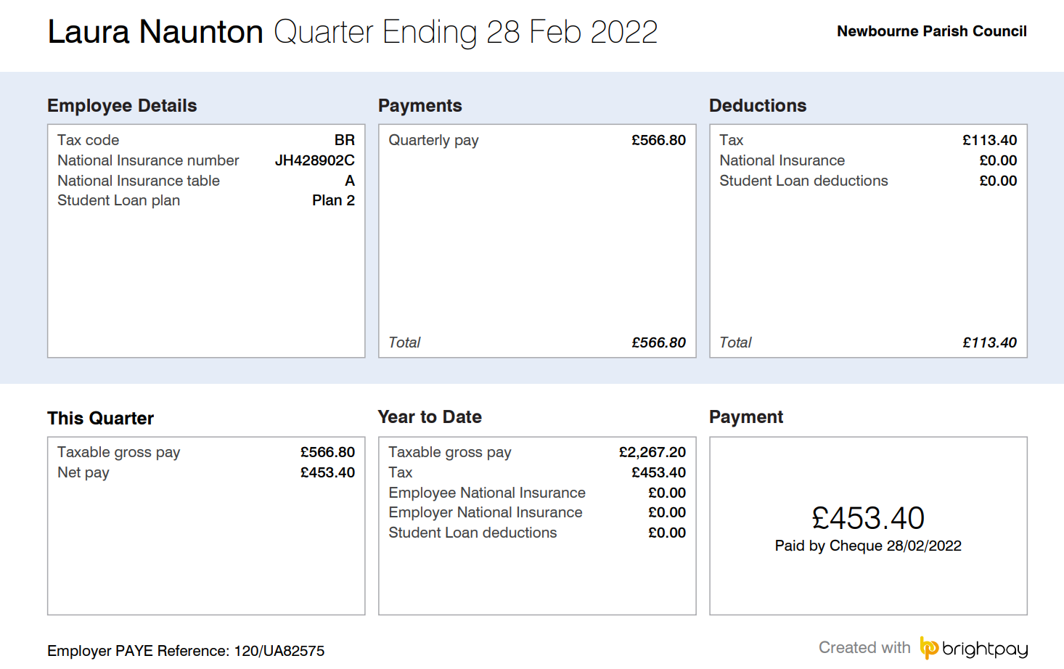
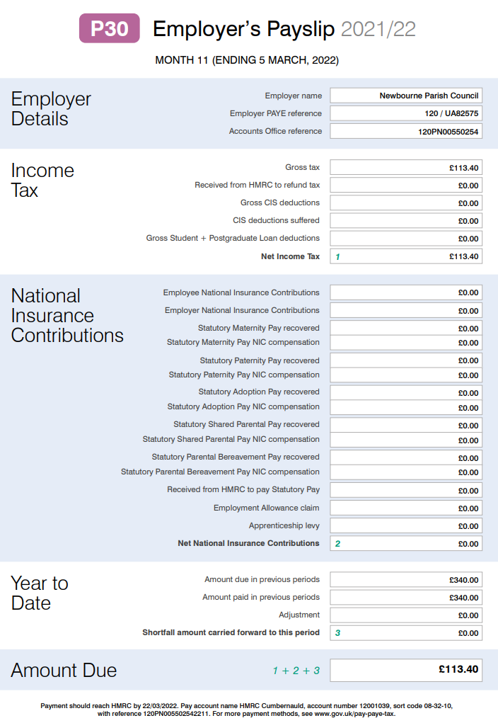

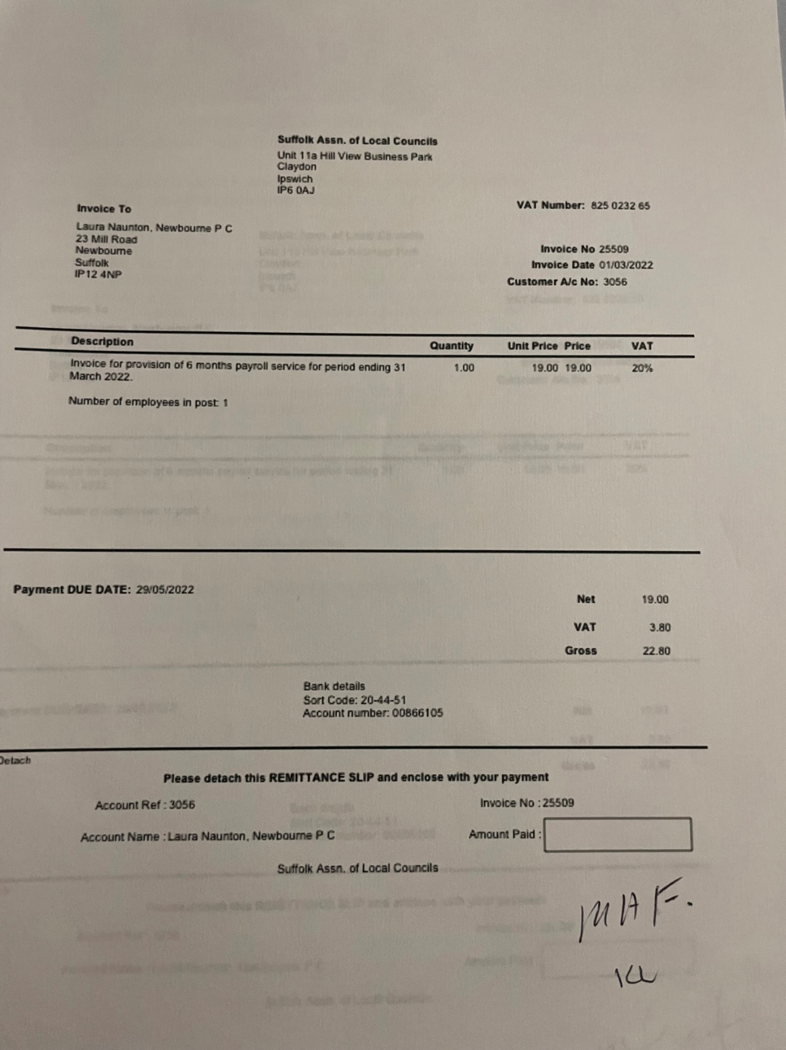

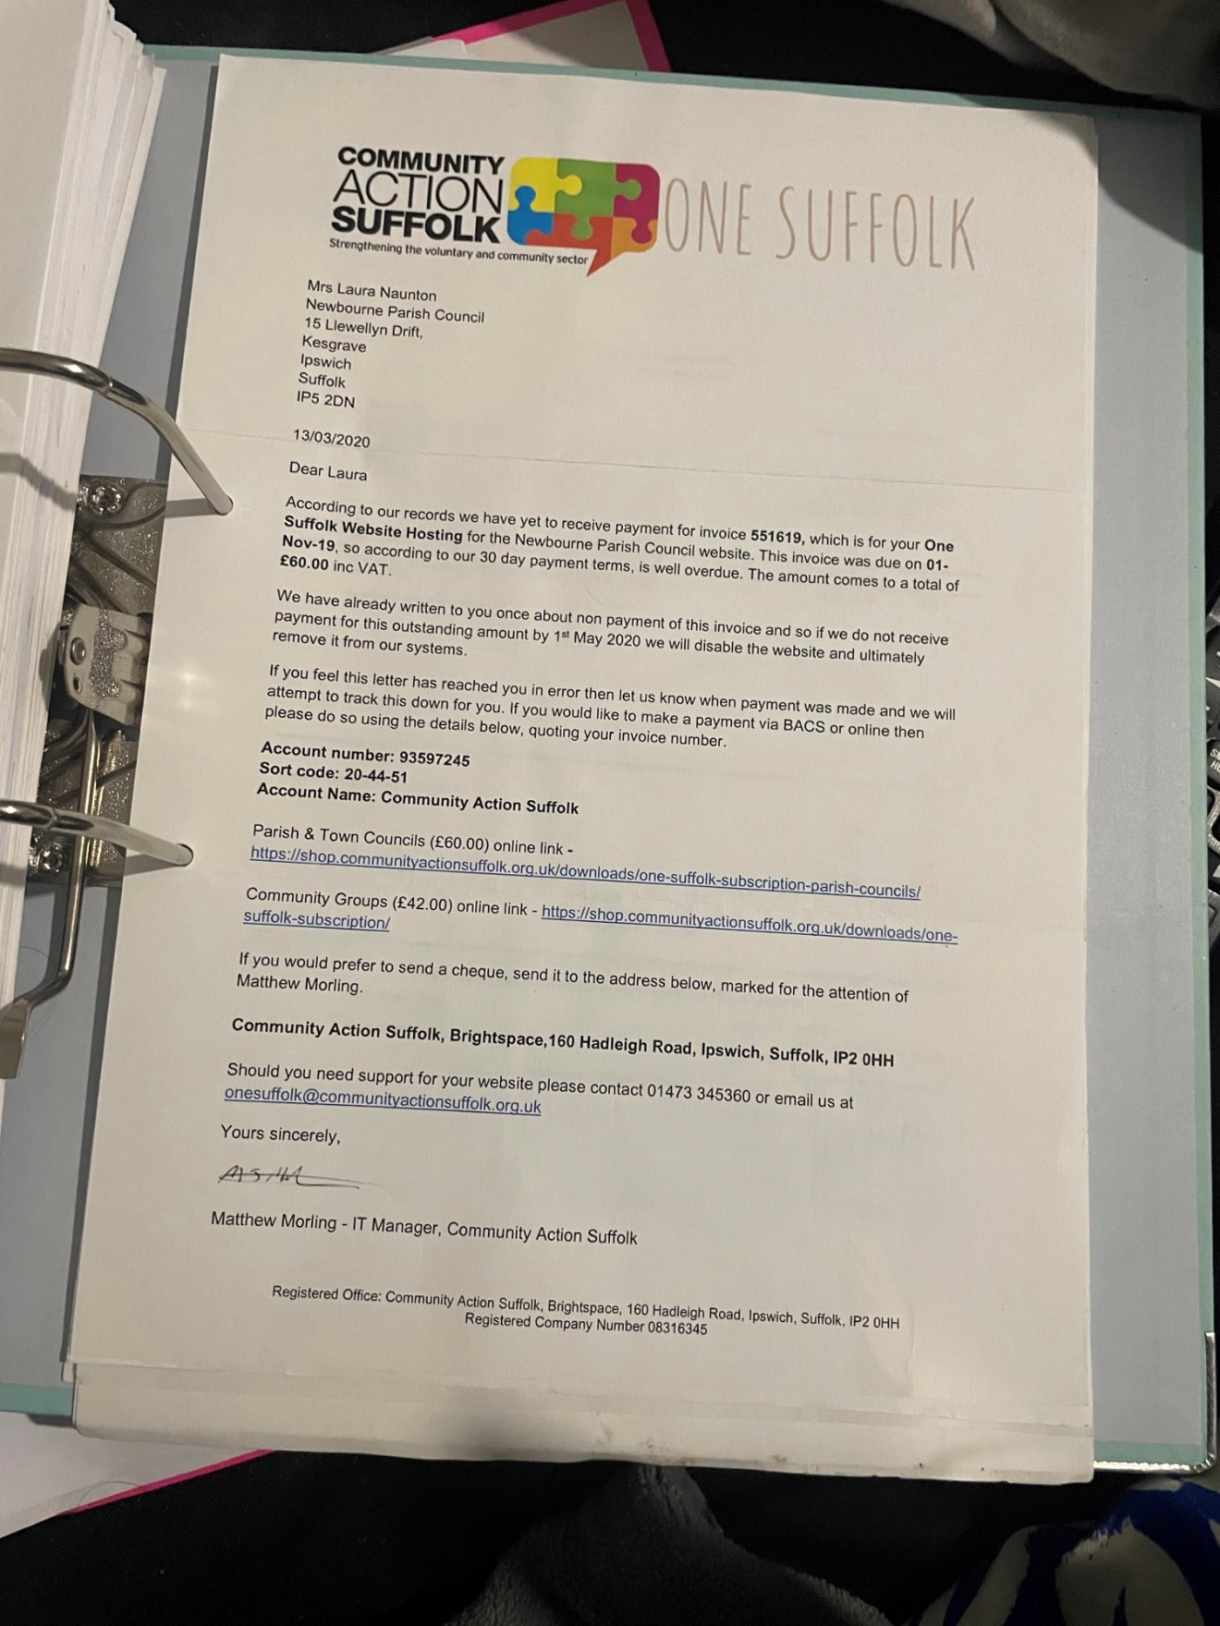

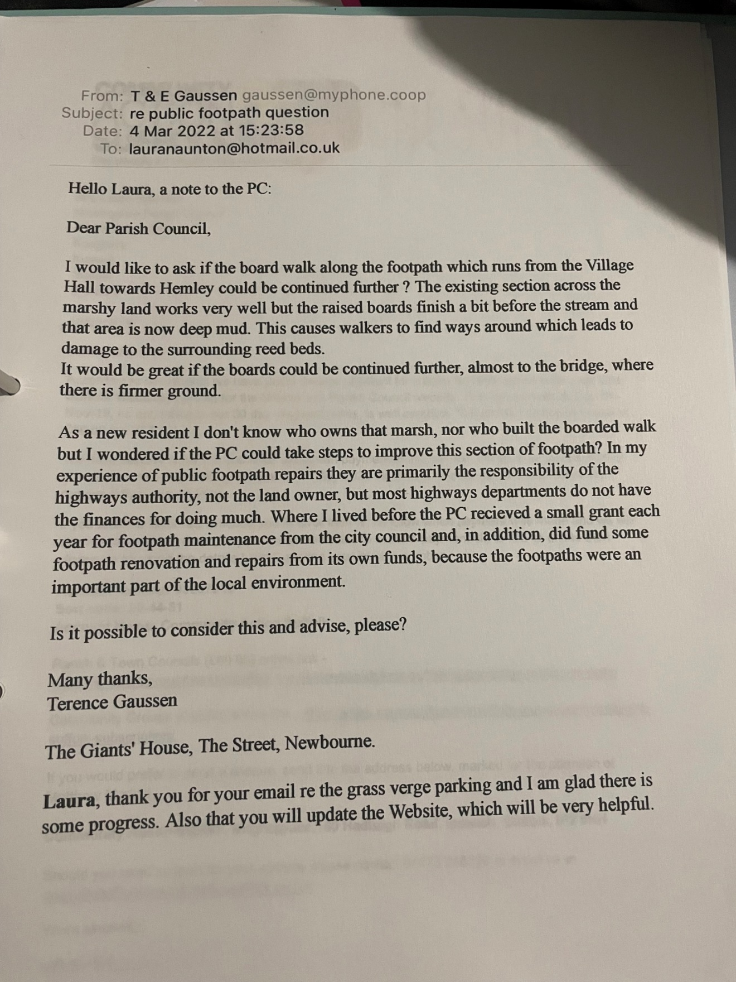

9.Clerks correspondence
Hello Laura,
Here is another note to the PC:
Dear Parish Council,
I happened to be looking online at photos of Newbourne and found the one below (not dated) of the verge by the bus shelter, showing paving in front of the shelter and two white posts which prevent vehicles crossing it. Interestingly also some kind of posts or planting further down.
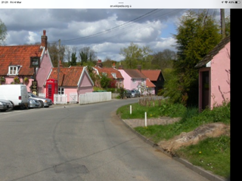
I took a spade this morning and cleared the mud from the main area, revealing the paving in good condition.
There is a covering of grass turfs just in front of the shelter, but I left it in place because it could be used to make good the muddy areas either side, once they are flattened.
However, before doing more, I thought I should ask the PC if you would like me to volunteer to do flatten the deep mud tracks and put the grass turfs on top, leaving the paving clear. I am very willing to do this but it would only be worth doing if two small posts (as in the photo) could be placed to prevent cars coming onto the verge and churning it all up again. I would supply and install the posts with your approval.
This is of course independent of provision to prevent parking on the next section of verge, currently under consideration, but if planters, or similar, are used there then they could also be placed to protect the shelter frontage and the small posts removed, so they would only be temporary.
I took the liberty of removing the ivy from inside the shelter too and hope that’s ok?
Please let me know and I can do it this week,
Terence Gaussen

