Newbourne Parish Council
Minutes of the Parish Council Meeting held on Monday 4th July 2022
In attendance: Councillors Scott, Frost, Wicks, Grainger, Lusher, Hadley and Garfath-Cox.
ESC Cllr Richardson
Members of the public:
Meeting opened 19:30
Parish Issues – An opportunity for parishioners to bring matters to the attention of the Parish Council and for parishioners to seek guidance from the Council
Public Time: The Grundisburugh and district News was given so we could look at the play area and speed camera information.
20:15
- To RECEIVE apologies for absence: Cllr Gammons and ESC Kerry.
- To RECEIVE reports from SCC Cllr Patti Mulcahy, ESC Cllrs Richard Kerry and Mick Richardson, and Suffolk Police.
Ward Councillors Report – June 2022
Mick & Richard
michael.richardson@eastsuffolk.gov.uk
Telephone No:
01502 523521
Work Telephone No:
07810 816018

Email:
richard.kerry@eastsuffolk.gov.uk
Mobile Telephone No:
07903 301075

East Suffolk Free Wi-fi launches in Lowestoft
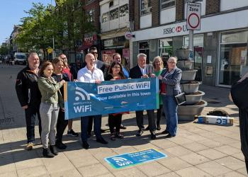 | Free-to-use public wi-fi has been launched in Lowestoft as part of a range of exciting digital projects taking place across the district.  We’re delivering a range of digital projects which aim to strengthen the local economy and improve connectivity within the district's market towns.

One of these projects is the East Suffolk Digital Towns programme, which will digitally transform market towns through the installation of free public Wi-Fi, digital footfall counters and town marketing platforms, alongside a business support programme.

Supported by funding from the Getting Building Fund and New Anglia Local Enterprise Partnership’s Innovative Projects fund, this new technology will be combined with bespoke business support, helping local businesses, and the towns in which they are based, to grow.

The free public Wi-Fi has now been launched in the main shopping areas of Lowestoft, as well as the seafront areas, with an ambition for other market towns to follow later this year.

We’re working in partnership with interactive walking app provider, Go Jauntly to develop outdoor adventures across all of East Suffolk’s principle 12 towns and villages. Three trails will be launching in Lowestoft at the same of the free-to-use Wi-Fi via the app.

East Suffolk beaches among the best
Our beautiful beaches have once again received national awards, ranking them among the best in the country.

Four of East Suffolk’s beaches have been awarded Blue Flags and Seaside Awards this year.

Both Felixstowe (Felixstowe South and Pier) and Southwold (Southwold Pier) have received combined Seaside Awards and Blue Flags, while the beaches at Lowestoft South of Claremont Pier (bathing/resort) and Kessingland (non-bathing) received Seaside Awards.

Eighty beaches met the high standard required for a Blue Flag across the country, while 128 beaches received Seaside Awards, and 57 beaches are proudly displaying both Blue Flag and Seaside Awards.

This is the third consecutive year in which Felixstowe has received the Blue Flag, while it comes as a welcome return to Southwold, which was last awarded a Blue Flag in 2018.

Another step towards environmental aims with dedicated officer role appointment
This Council has stepped up its commitment to delivering on environmental ambitions by appointing a dedicated lead officer to help shape policy in the fight against climate change.  The new Environment and Climate Change Lead Officer will be responsible for advising the Council on environmental strategies, policies and initiatives, and their contribution to national, regional and local goals.  Acting as a champion for environmental issues, the Lead Officer will also raise awareness of the impact of emerging environmental issues and the difference the Council can make. | 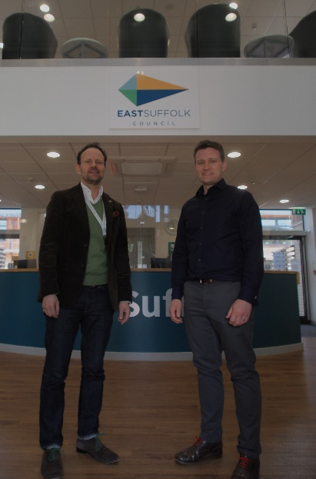

In January, ESC demonstrated its commitment to delivering against its environmental ambitions by approving the additional funding required for the new post.

The Council has now confirmed the appointment of Paul Mackie – bringing with him more than 15 years of experience in the environment sector to this important new role.

Paul spent seven years working with East Suffolk Council as part of Coastal Partnership East, raising more than £75million of investment for projects to help make our coastal communities resilient to climate change.

As well as advising colleagues and partner organisations on the Council’s Strategic Plan objectives, strategies and associated work concerning climate change mitigation and adaptation, Paul will work closely with Cabinet Member for the Environment, Councillor James Mallinder.

A tribute to former Waveney MP and Council Leader, Bob Blizzard
It is with sadness that we received news that former Waveney MP and Council Leader Bob Blizzard had passed away.

Bob was the Leader of Waveney District Council, a predecessor authority to East Suffolk, from 1991 until 1997, having been elected to the authority in 1987. He then became MP for the Waveney Constituency in 1997, serving on the Environmental Audit Select Committee for two years and as a Parliamentary Private Secretary (PPS) to various Government Ministers. He was also a Lords Commissioner whip in the Treasury from 2008 to 2010.

He remained an MP until 2010 and retired from political life following the 2015 General Election.

Colleagues paid their own tributes to Bob following the announcement on May 10, hailing him a hugely important figure in both local and national politics.

Landmark café opens doors on Felixstowe’s South Seafront
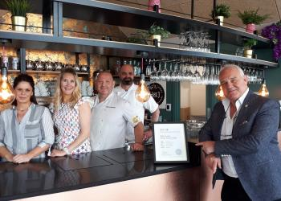 | The eagerly anticipated opening of an acclaimed new café has been met with celebration in Felixstowe, as part of the continued wider redevelopment of the town’s South Seafront area.  The strikingly designed contemporary venue opened its doors to customers at the entrance to Martello Park – after the building’s architects, Plaice Design Company, were ‘Highly Commended’ at the Riba Suffolk Design Awards 2022.
The £1.5 million landmark project was funded by ESC, with grant funding of £950,000 from the Government’s Coastal Communities Fund and a further £30,000 from the Coastal Revival Fund.

It’s the latest development in a wider project of ongoing regeneration in the South Seafront area, following the arrival of new homes, a play area and parking at Martello Park, as well as further investment in the refurbishment of the two public shelters and the long-term maintenance of its historic Martello tower centrepiece.

The café is run by Cameron and Claire Marshall, owners of The Kitchen @ Group, which was forged from the original Dedham Boathouse.

Working alongside ESC, Plaice Design and the Kitchen @ Group on delivering the project were Barnes Construction, Superstructures and Gill Associates.

Food traders announced for East Point Pavilion
An exciting mix of food traders have been announced for the soon-to-open East Point Pavilion, in Lowestoft.
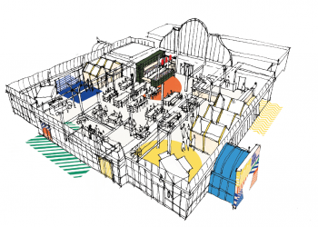 | Following six months of works on the iconic sea front building, the Pavilion will officially open its doors on Friday 17 June, the evening before the 24-hour, non-stop, multi arts First Light Festival kicks off.  The East Point Pavilion is owned by East Suffolk Council but will be run by First Light Festival Community Interest Company (CIC).

The traders include Black Dog Pizza and Sir Toby’s Beers, well known for its craft beer stall on Norwich Market and for opening the real ale-selling Stanford Arms in Lowestoft.

See the full list of traders here: www.eastsuffolk.gov.uk/news/food-traders-announced-for-east-point-pavilion/

Helping to deliver affordable homes in East Suffolk
A new planning document has been adopted to help guide the development of affordable homes being delivered across the district.

This Council has adopted a new Affordable Housing Supplementary Planning Document (SPD), which provides guidance to support the implementation of planning policies on affordable housing.

The new document includes guidance on the design of affordable housing, legal agreements and carrying out local housing needs assessments. It will be a material consideration in the determination of planning applications going forward.

View the Affordable Housing SPD, and supporting documents, including the Consultation Statement and the Adoption Notice.

Physical copies of the documents are also available at ESC’s Customer Service Centres and at all libraries in the district.

New tendering tool designed to deliver long-term benefits for Lowestoft
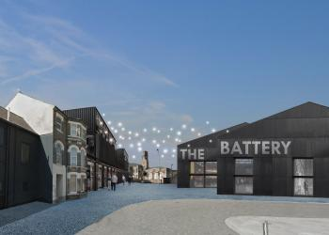 | A new online tool has been launched to allow suppliers exclusive access to major regeneration projects lined up for Lowestoft.  Our officers have developed a Dynamic Purchasing System (DPS) to give suppliers the opportunity to prequalify for contracts and bid for work within eight subdivided procurement ‘lots’.
The lots include construction work valued at less than £500,000, making it more accessible to small and medium sized enterprises (SMEs), and allowing the local authority to refine the tendering process by specific skills or services required for each individual project.

The DPS has been launched to operate hand-in-hand with the Lowestoft Town Investment Plan, which was developed by Lowestoft Place Board in partnership with East Suffolk Council and sets out proposals for £350million of regeneration projects over the next 10 years.

The plan was created as a catalyst for attracting funding from both public and private sector investment, like the £24.9m government grant awarded for Lowestoft through the Towns Fund process last March, with priority projects including the regeneration of the town’s Cultural, Historic and Station Quarters.

Unlocking potential with apprenticeships
This Council has once again opened applications for its apprenticeship scheme, offering a fantastic opportunity to gain real life work experience, new skills and qualifications while also being paid.

This year, the successful scheme, which has seen over 80% of apprentices stay beyond their apprenticeship, has eight exciting opportunities available in a number of teams, including ICT, Customer Services, HR, Food Safety, Communities and Assets.

Applications can be submitted at www.eastsuffolk.gov.uk/apprenticeships until Sunday 12 June and successful applicants start in September.

Housing improvement programme making progress
ESC is making progress with a detailed improvement programme following the authority’s decision earlier this year to report itself to the Regulator for Social Housing.

The Council’s review, which encompasses information dating back to East Suffolk’s predecessor authority Waveney District Council, is considering how we set our rental charges, to ensure we meet the requirements set out in the nationally recognised ‘Rent Standard’.

The Council previously explained that some tenants, who moved in after 2014, may have been incorrectly charged a higher rent. An independent, external audit of every rent account is now underway, and this will identify which tenants have been affected and calculate any overpayments that should be credited back to the rent account.

The review is also looking at all aspects of Health and Safety related to our properties, including Fire Risk Assessments, Asbestos Management, Water Safety, Gas and Electrical Safety as well as the management and maintenance of equipment including Lifts and Stairlifts.

Following the Council’s decision to report itself, the Regulator has considered the information provided to them by East Suffolk and has now shared its findings. As anticipated, they confirm breaches of Housing Regulations, and their findings have been published in the form of a Regulatory Notice.

The Regulator for Social Housing acknowledged that the Council acted in an appropriate manner, understands the issues fully, has taken appropriate advice and has developed a detailed plan to address all issues in a timely fashion.

Work begins to provide beach access for everyone
Work to construct a boardwalk, which will enable people with disabilities to access Lowestoft’s South Beach more easily, is now underway.

The boardwalk project has been led by the Waveney Disability Forum, who have worked closely with this Council to consider how people with disabilities, particularly wheelchair users, as well as people with pushchairs, could gain access to the beach.

Located near to public toilets, the beach access ramp and the Claremont car park, the boardwalk will be approximately 1.5m wide and 54m from the lower promenade. At the end, there will be a performance space approximately 6m by 8m, which will be available for events and classes and will be managed through an online booking system.

Beccles-based contractors Foxwood Building Services began work on Thursday 5 May, with the installation of ground anchors to secure the boardwalk into place.

The boardwalk is expected to be complete in time for the First Light Festival 2022.

Signed, sealed, delivered…restored: Insights into Post Office conservation project
 | A series of revealing workshops will provide insight into some of the specialist conservation work being carried out to restore Lowestoft’s historic former Post Office building.  Work has been underway since January to conserve and repair the fabric of the Grade II listed building in preparation for internal works to be completed next year.

Delivered through the London Road, Lowestoft Heritage Action Zone programme, the works are being funded by ESC and Historic England, as well as the government-backed Towns Fund, and use traditional conservation techniques to repair the exterior of the building.

As part of the restoration project, a series of workshops are scheduled to take place at the building from 10am and 2pm on Wednesday 8 June, offering people the chance to hear from the specialist tradespeople working on the project and observe practical demonstrations of the conservation repairs.

The talks and demonstrations are aimed at anyone with an interest in traditional building repairs, including people who live in older buildings and are interested in learning more about how to repair and maintain historic material.

Find out more by following this link: https://www.eastsuffolk.gov.uk/news/lowestoft-former-old-post-office-restoration/

Surveys and consultations
We are currently running a number of consultations and, as always, we want to encourage participation as feedback from people in East Suffolk is invaluable and helps us ensure we’re making the right decisions for our communities.

- Bungay Neighbourhood Plan
Local residents are invited to comment on the Bungay Neighbourhood Plan, ahead of it being submitted for independent examination. When finalised, the Neighbourhood Plan will be required to be used by anyone considering, or making, a planning application in the Bungay Neighbourhood Area. The consultation is open until Monday 6 June at www.eastsuffolk.gov.uk/planning/neighbourhood-planning/neighbourhood-plans-in-the-area/bungay-neighbourhood-area/

- Rushmere St Andrew Neighbourhood Plan
Local residents are invited to comment on the Rushmere St Andrew Neighbourhood Plan, ahead of it being submitted for independent examination. When finalised, the Neighbourhood Plan will be required to be used by anyone considering, or making, a planning application in the Bungay Neighbourhood Area. The consultation is open until Monday 6 June at www.eastsuffolk.gov.uk/planning/neighbourhood-planning/neighbourhood-plans-in-the-area/rushmere-st-andrew-neighbourhood-area/

- Oulton Neighbourhood Plan
Local residents are invited to comment on the Oulton Neighbourhood Plan, ahead of it being submitted for independent examination. When finalised, the Neighbourhood Plan will be required to be used by anyone considering, or making, a planning application in the Oulton Neighbourhood Area. The consultation is open until Friday 24 June at https://www.eastsuffolk.gov.uk/planning/neighbourhood-planning/neighbourhood-plans-in-the-area/oulton-neighbourhood-area/

3.To RECEIVE declarations of pecuniary interest – None received

4.To APPROVE the minutes of the Parish Council meeting held on 6th June 2022. Motion to approve minutes – all in favour

5. To CONSIDER Planning Applications for COMMENTS:
DC/22/2057/FUL Balfour Cottage – The Street- Demolition of existing single storey conservatory to the front of the dwelling and construction of new single storey front extension forming new kitchen and sitting area.

6. MATTERS for REPORT from minutes of previous meetings and to REVIEW ACTION POINTS from the minutes of the Parish Council meetings held on 06/06/2022

Speed Camera update and requested information
Speed Indicator Device
I have spoken to a few parishes regarding there SID’s and Community speed watch.
Most villages have volunteers that have signed up for the community speed watch and like to do this and you don’t have to do it just in Newbourne. Waldringfield do not want to get involved in the community speed watch.
Most villages that have SID have the data collection but advise they don’t really use the data as very time consuming going through it all, they have had times when speeding has been a major problem if road works and diversions etc, but they think the flashing signs are a good deterrent to make most people slow down.
The SID that is shared at Waldringfield is the Small Westcote flashing device which flashes the speed when a vehicle travels past this but does not have a message at the bottom like Thank you etc this one record data. The data that it records is date, time, and speed as you can imagine it generates a lot of data. The clerk of Waldringfield Jennifer advised they have used the data once from the SID in the time that they have had it regarding a speeding complaint from a villager and they are looking to put a new pole up near the school in Waldringfield as that is the place, they have received most complaints about speeding. Discussions in their meetings Jennifer advises they think the sign makes people slow down when they see the sign and when the speed flashes up make people slow down who maybe speeding and did or didn’t know they were.
A SID the same as the Waldringfield one which means we could use the same brackets etc is £2760.00 which just flashes the speed
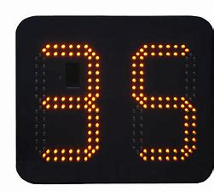
and the larger model which flashes the speed and Thank you or slow down is £2940.00 that is the larger sign and that would need the larger brackets.
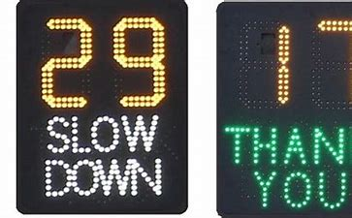
Each sign included 2 batteries and a charger and a bracket.
To have the data collection that is an additional £379.00 for a sign.
7. To DISCUSS play area. Zipwire and climbing wall completed and quote received for matting around the areas of the play area that need it. £2400.00 has been quoted from the company that completed work on the zipwire etc. Quote for play area not accepted and would like costings for new play area, fenced off and any grants we can access to help pay for the work.

8. MATTERS for REPORT After discussion in meetings 09/05/2022 and 06/06/2022 we are going to get internet in the village hall which will benefit everyone and will make it easier to monitor the CCTV.

9. To DISCUSS Fundraising events. Cllr Hadley has kindly volunteered to start a sub committee for any future events to organise meetings.

10. To Discuss Defibrillator - All agreed to service cost around £200.00. Discussion about whether we should move it to village hall / Second defibrillator.

11. To discuss FINANCE

CHEQUE £1302.00 CHEQUE NUMBER 100463
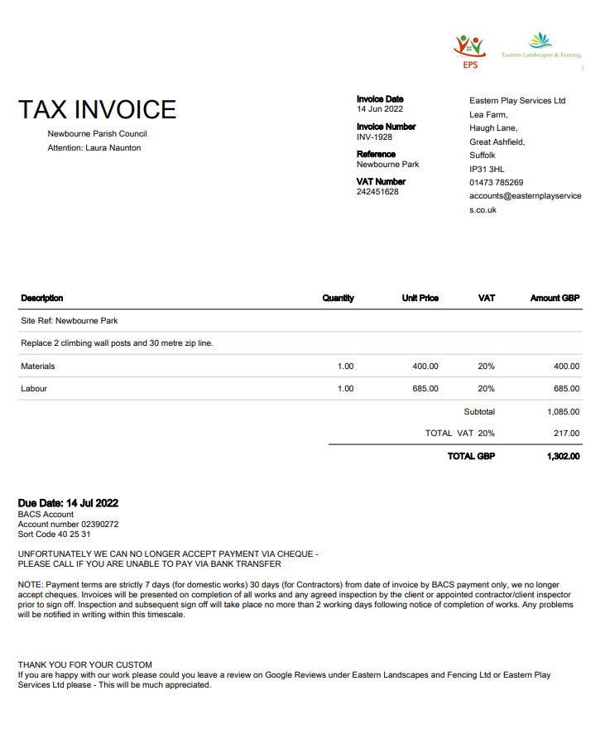
Bank Reconciliation
June 2022 – July 2022
A
Cash in hand 01 June 2022 £22,306.11
Community £18,279.03
Saving £4027.08

ADD
Receipts June 2022 - July 2022 £0.00
Total £22,306.11

SUBTRACT
Payments June – July 2022 £2940.54

£52.50 100458 Playground oil
£494.10 100460 wages Feb – May
£245.00 100457 East Coast Adventures
£1884.00 100462 Dishwasher in village hall
£120.00 100461 Eastern play area
£144.94 100453 SALC Membership
£19,365.57

Cash in hand 31/03/2020 £19,365.57
B
Cash £0.00
Petty Cash £0.00
Community account £15,338.49
Saving £4027.08

A = B £19,365.57

Action points for next meeting 01/08/2022

- Speed Device
- Play Area
- Fund raiser event

11. To DISCUSS any clerk’s correspondence

Resignation as Clerk
So, after 6 plus years I have made the sad decision that I need to pass my clerk responsibilities on to someone new to take over. Someone that has the time to keep you all in order and to keep on top of everything.
I am struggling to keep on top of everything at the moment with work and the kids I just don’t have enough time in the day. I have no date that I need to leave by and there is no rush, and I will stay until a replacement is found I just wanted to let you know of my intentions to leave so it can be discussed in the next meeting and a replacement can be found.

Meeting closed at 20:30

Signed ……………………………………..

……………………………………..

