Minutes 04/04/2021
The Village Hall needs a new dishwasher as it is broken. Pat has had a look found a few examples around £1500 -£2000 so will bring to next meeting so we can get one sorted.
- Apologies – Cllr Scott, Cllr Pollard, Cllr Gammons
- Declarations of disclosable Pecuniary interest – None
- Minutes of meeting 08/03/2022 – cllr Frost & Cllr Lusher

Ward Councillors Report – April 2022
Mick & Richard
michael.richardson@eastsuffolk.gov.uk
Telephone No:
01502 523521
Work Telephone No:
07810 816018

Email:
richard.kerry@eastsuffolk.gov.uk
Mobile Telephone No:
07903 301075

Council Tax £150 Energy Rebate
Households in Council Tax band A to D are likely to receive a £150 Council Tax rebate from the Government to help towards the cost of living now that gas and electricity prices are going up.

Eligible households already paying by direct debit should receive a one-off payment straight into their bank account from us in late April or early May and do not need to do anything.

Households not paying by direct debit will need to claim the rebate which may take longer. We will contact those household to let them know how to claim.

Empty homes and second homes will not get the rebate.

See more information at www.eastsuffolk.gov.uk/features/council-tax-150-energy-rebate/

Felixstowe Triathlon awarded national recognition
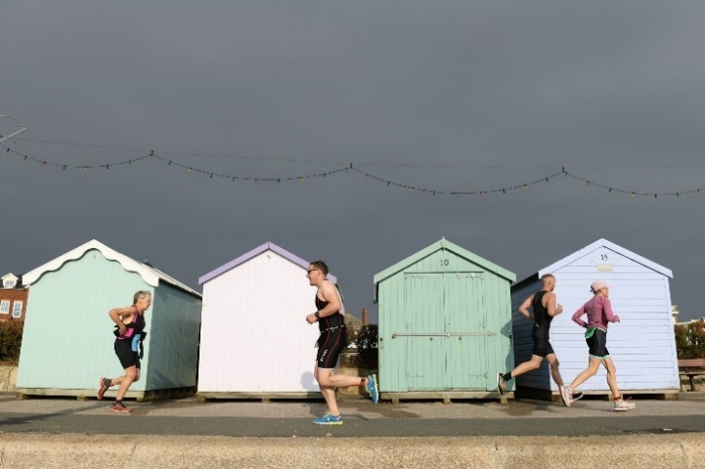 | Felixstowe Triathlon has been named Large Event of the Year at the 2022 HUUB Triathlon England Awards – after already having received the honour for the East Region.  The second annual Felixstowe Triathlon is scheduled to take part just three weeks after the Commonwealth Games close this summer – and entries are still open for the event on Sunday 28 August.
People can find more and sign up at www.felixstowetriathlon.uk/

Incredible interest shown in ‘Eastern Edge’ huts
A huge number of enquiries have been received from people interested in purchasing one of the contemporary beach huts that are being built on Lowestoft’s seafront.  The sale of a number of beach huts is being jointly managed by agents Paul Hubbard and Steel & Co. Those who have already formally expressed an interest in buying one of the Eastern Edge huts will be contacted and provide with pre-sales information over the next few weeks.  New enquiries can be made to Paul Hubbard by calling | 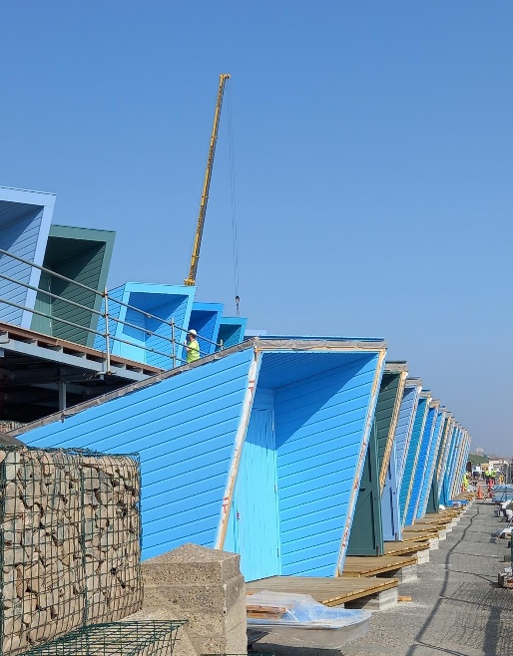
01502 531218 or emailing info@paulhubbardonline.com

East Suffolk united in support for Ukraine
The Council has united to condemn Russia’s invasion of Ukraine and pledged to support any Ukrainians seeking refuge in the district.

Local authorities Suffolk are working closely together to ensure they can deliver an effective, co-ordinated response to Government requirements to support Ukrainians seeking refuge in Suffolk.

To assist this co-ordinated approach and to ensure those living and working in East Suffolk are kept informed of the Government’s response to the crisis, a new position has now been created within our cabinet and as of Friday 1 April, Cllr Judy Cloke is the Assistant Cabinet Member for Refugee Support.

Read more at www.eastsuffolk.gov.uk/news/east-suffolk-united-in-support-for-ukraine/

Robopets bringing comfort to older residents
To help older residents, especially those living with dementia, we have recently purchased 20 companion pets which are being given to local dementia groups and care homes across East Suffolk.

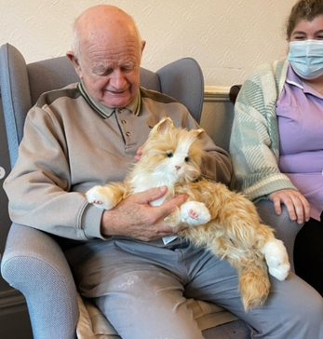 | The pets, which are robotic cats and dogs, provide the interactive companionship associated with owning a pet which can be therapeutic for many people, especially those living with dementia.  Piloted at the Memory Lane Group in Felixstowe, robopets have so far been given to Sole Bay Health Centre in Reydon, Glebe House Residential Care Home in Hollesley, the Pear Tree Fund in Halesworth and the Forget Me Not Café in Kesgrave.

Community radio receives Community Partnership grant funding
Rendlesham Community Radio, which provides opportunities for young people to gain experience as presenters or producers, has been awarded over £1,400 in funding through
the Melon, Woodbridge and Deben Peninsula Community Partnership.

The station originated as a way of connecting the community during the pandemic – broadcasting for Rendlesham Youth Group’s room in the local community centre but has since grown substantially.

As well as supporting undiscovered local talent by offering the chance to perform in the studio ‘live lounge’, the parish council-backed initiative aims to encourage young people to explore their potential in performing arts – expressing the challenges they face and telling their stories through a chosen artform.
Rendlesham Community Radio's £1,443.17 grant will be put towards further supporting its work around youth engagement, community cohesion, work-related learning and social isolation.

New lease of life for former railway signalman’s cottage
A run-down railway crossing cottage has been granted a new lease of life thanks to a deal enabled by the Council.  The former signalman’s cottage, just north of Campsea Ashe, near Wickham Market, was purchased and sold as part of our strategy to | 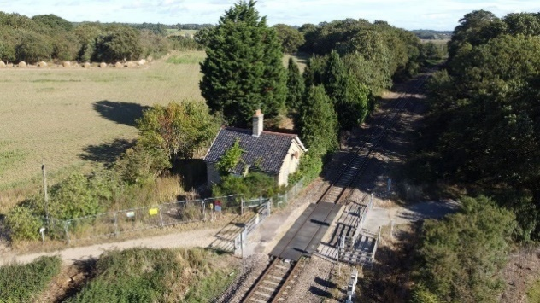
ensure availability of good quality housing for the benefit of the East Suffolk community.

Free cooking workshops
Residents in Halesworth are invited to attend free cooking workshops to learn new cooking skills, cook and eat healthy and affordable food and pick up tips on making food go further.

The sessions are open to all in the local Halesworth community, including older children who are welcome to attend with their parents.

The sessions take place between 10am – 1pm on the following dates:
• Saturday 9 April
• Saturday 23 April
• Saturday 14 May
• Saturday 21 May
• Saturday 28 May
To book a place, please call 01986 875749.

Surveys and consultations
We are currently running one survey and, as always, we want to encourage participation as feedback from people in East Suffolk is invaluable and helps us ensure we’re making the right decisions for our communities.

- Firework displays on council-owned land
As part of a review into firework displays on council-owned land, we have launched an 8-week consultation to better understand how residents feel about them and whether the rules need to be reconsidered. The consultation close on Friday 20 May: www.eastsuffolk.gov.uk/features/new-consultation-seeks-views-on-firework-displays/

- Planning DC/22/1082/FUL 23 Mill Road – Construction of detached dwelling and garage. Discussed in meeting as this planning is to replace the planning for 3 holiday lets. 1 for 1 against and 2 on the fence.
- Fox issues – No further update will chase one for next meeting so we can see if resolved to remove from agenda
- Village hall car park issues discussed and number plates etc passed to the police.
- Queens Platinum Jubilee celebration. A separate group has been set up to arrange and organise the event updates will be given in May meeting.
- Potential new councillors Michael and Andrew gave us a background into them, village life and why they would like to join the parish council and we would be lucky to have them join. We will hear from Terence in an upcoming meeting as he would like to join also.
- Finance

Cheques to be signed
SALC £144.94 cheque number 100453
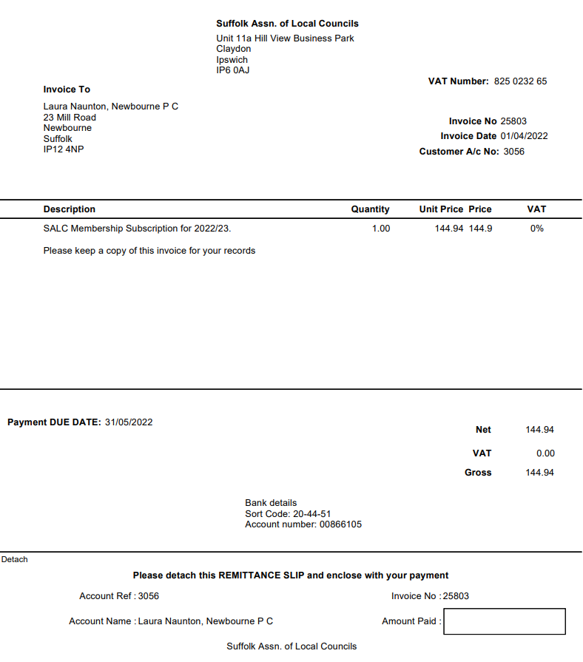
Lewis Culf £567.00 Defibrillator storage box cheque number 100452
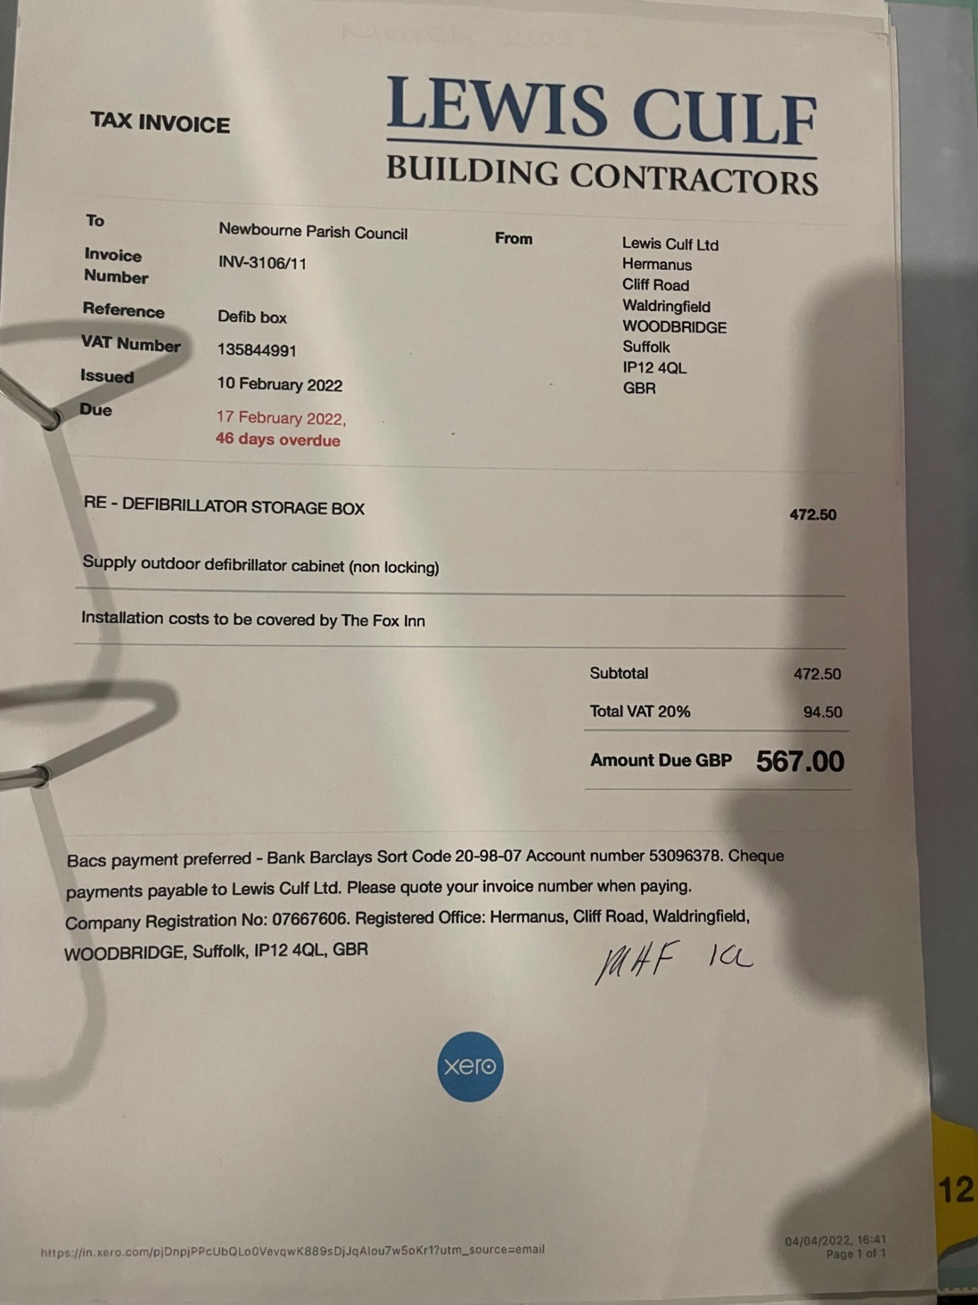

Up to date bank statement.

Bank Reconciliation March 2022– April 1st 2022
A
Cash in hand £18,101.22
Community £14,074.54
Saving £4026.78
ADD
Receipts £0.00

SUBTRACT
Payments
Cheque 100438 £453.40 wages £453.40

B £17,647.82
Cash £0.00
Petty Cash £0.00
Community account £13,621.14
Saving £4026.68
£17,647.82

Starting Balance 01/04/2021
DATE AMOUNT PAYMENT INFORMATION CHEQUE
30/04/2021 £12,960.33 Opening Balance new year
30/04/2021 £5467.00 Money in Precept from East Suffolk Council
30/04/2021 £453.60 Clerk wages November 2020 – February 2021 100427
28/05/2021 £453.60 Clerks Wages Feb 2021 – May 2021 100432 07/06/2021 £640.38 Money in Cheque from Newbourne village hall
08/06/2021 £113.40 HMRC Nov 2020 – Feb 2021 100428
08/06/2021 £113.40 HMRC February 2021 – May 2021 100429
11/06/2021 £240.00 Groundwork/SCL Landscape Management 100431
11/06/2021 £60.00 Grass cutting/SCL Landscape Management 100430
08/09/2021 £453.40 Clerks Wages May 21 – August 21 100439
08/09/2021 £22.80 Suffolk Association local council’s Finance 100437
24/09/2021 £120.00 Grass Cutting/ SCL Landscape Management 100436 24/09/2021 £144.41 Suffolk Association local council’s Membership 100433
07/10/2021 £120.00 AJS Services / play area & grass 100440
07/10/2021 £203.50 AJS Services / Notice board 100435
20/10/2021 £242.00 Notice Board 100444
20/10/2021 £94.80 Playground Inspection ROSPA 100442
04/11/2021 £1513.68 Insurance Came & Company 100441
09/11/2021 £800.37 C Cracknell Village Sign Refurb 100445
04/12/2021 £453.40 Clerks Wages Aug 2021 – Nov 2022 100447
05/01/2022 £858.59 Money in Cheque in from Village Hall
07/02/2022 £113.40 HMRC August 2021 – November 2022 100438
07/02/2022 £113.40 HMRC November 2021 – February 2022 100448
18/02/2022 £22.80 Suffolk Association Local Council’s Finance 100443
08/03/2022 £453.40 Clerks Wages Nov 2021 – Feb 2022 100449

