Newbourne Parish Council Minutes
Annual Meeting 2022

Draft Minutes of the Annual Parish Meeting held on 6th June 2022
Present: Parish Councillors Scott, Frost, Pollard, Wicks, Grainger, Gammons, Hadley and Gareth-Cox. ESC Cllr Richardson
1. To receive apologies for absence. Apologies were received from Parish Councillor Lusher and from ESC Cllrs Kerry.
3. Matters arising from the minutes of the last meeting. There were no matters arising. The 2020/2021 Annual Parish Meeting was cancelled due to the Covid-19 pandemic.
4. Chairman report
NEWBOURNE PARISH COUNCIL
CHAIRMAN’S REPORT JUNE 22

The Parish Council has operated without a full complement of Councillors for most of the year 2021/2022. We have been running on 7 rather than 9 councillors and steps have been taken to recruit new members and they have joined the Parish Council from May 2022. We welcome PCllr Michael Hanley and PCllr Andrew Garfath-Cox to the Council.
I took over as Chairman of the Parish Council in August 2021 from PCllr Charlotte Gammons who tendered her resignation from the chair but remains a Councillor. I would like to thank Charlotte for her chairmanship and also extend a thank you to the rest of the Councillors for their loyal support and ongoing commitment to parish governance.
Introducing the Parish Council:
PCllr Gary Grainger – Chairman
PCllr Charlotte Gammons – Deputy Chairman
PCllr Kwini Lusher
PCllr Sue Pollard
PCllr Jim Wicks
PCllr Lionel Scott – Bank Signatory
PCllr Michael Frost – Bank Signatory
PCllr Andrew Garfath-Cox
Pcllr Michael Hadley
Supported by Laura Naunton – Parish Clerk
I am most fortunate in having knowledgeable and supportive colleague Parish Councillors and am confident that we have a good understanding of the needs of the Parish and will work together to ensure that we meet the requirements put forward to the best of our ability.
I would also like to thank Laura Naunton who has been the Parish Clerk since 2015 for 6 years. Laura has done a great job navigating due process for the Council at Parish and Borough level and we look forward to her continued support and enthusiasm in the coming Parish year
Covid-19 did impact the Council for the period 2021 to mid-2022 when no face-to-face meetings or virtual meetings were held. For the coming year we will take steps to ensure that virtual meetings are established as a viable alternative to face-to-face meetings should the need arise.
Inevitably, even when face to face meetings were possible, some Councillors suffered with Covid and have been absent from time to time. Having said that, post lockdown, we resumed our normal meeting schedule and were able to successfully hold quorate meetings and follow due process each month despite unavoidable absences. Thank you to all Councillors for their resilience during this period and understanding and empathy with the tragic situation that we find ourselves in.
Meetings are routinely scheduled for the first Monday of each month at 7.30pm and are held at the community Village Hall. The meetings are open to the public and we generally have good attendance form the local community. Additionally, they are attended by Mike Richardson who is a Ward Councillor for East Suffolk covering the neighbouring parishes.
A standard Parish Council agenda is followed to ensure that all parish matters and reviewed and governed appropriately.
A Ward Councillors’ report is submitted and reviewed by the Parish Council at each meeting and this is authored by Ward Councillors Mike Richardson and Richard Kerry.
The previous meeting minutes are reviewed and approved at the following meeting.
There have been no declarations of pecuniary interest from any Councillor in the year covered by this report.
Parish Council finances are in good order and reviewed at each meeting. They are well managed, on behalf of the council, by the Parish Clerk. All financial matters have appropriate governance and control over the parish’s funding and budget.
Issues are raised by Parish Councillors on behalf of the local community or during the public question time section that is scheduled on the monthly agenda. There have been several issues that have affected that parish during the year which have been addressed with varying degrees of success.
There have been four issues at the centre of Newbourne Village in the area surrounding The Fox public house. These have been raised by local residents. They are:
- Public house customers parking on the village grass verges adjacent to The Fox and causing damage and a “muddy mess” to the verges.
- Volume of customers parking in the centre of the village and overflowing the pub’s car park at busy times.
- Noise generated by extractor fans used in the pub’s kitchen that impacts neighbouring residents.
- The natural spring that continues to bleed to the surface in The Street and flow across the road that could be a hazard caused by slipping on water or ice depending on the time of the year.
The Parish Council fully supports having vibrant local community business like The Fox and the visitors that it attracts to the local area. Newbourne is a fantastic area of outstanding natural beauty steeped in history and the Parish Council fully supports sharing it with the wider community and visitors. We have been working collaboratively with Steve Lomas FBII, Managing Director of Deben Inns Limited , to address items 1,2,3 above and we are making good progress. Items 1 and 2 will be resolved with new planters on the verge, to prevent parking, which will be aesthetically pleasing in the village centre and, the potential to extend the usage of The Fox’s overflow car park. Item 3 is being addressed by Mr Lomas through engaging specialist acoustic engineers to mitigate the noise issues as much as possible.
We thank Steve Lomas for his ongoing support and investing time and resources to fix these issues in support of the local community. The Parish Council will continue to monitor progress.
Item 4 is a matter between the Parish Council and Anglian Water Services Limited and a number of attempts, over the years, have been made to stop the spring from bleeding the surface. This is a natural phenomenon and will likely be an ongoing issue for the Parish Council to address with Anglian Water Services Ltd going forward.
Speeding and the volume of traffic continues to be of concern to the local community. Newbourne Parish Council is able to share a traffic calming device with it’s neighbourhood parish of Waldringfield. This is potentially not enough and we will bring back to the Parish Council meeting during the next term plans to procure dedicated speeding devices for the village. A related concern, raised by councillors, is traffic increases caused by ongoing housing development planning applications that are submitted to East Suffolk Council Planning Department. The Parish Council will continue to monitor and raise concerns as appropriate.
The extensive new development of housing at Brightwell Lakes by Taylor Wimpey will see 2,000 new homes built in a site in Martlesham, Suffolk. The public consultation for the first phase of this development is now closed. This isn’t directly in Newbourne and the Parish Council fully supports the development of much needed housing but we do have concerns about the knock on pass-through traffic impact in Newbourne. The Parish Council will monitor and raise it’s concerns on behalf of the local community as and when the need arises.
There have been concerns that the Village Hall car park is being used for illegal drug trafficking. The Parish Council fully condemns this and we have taken steps to eradicate. We will be installing CCTV monitors at the Village Hall and will continue to liaise with the local Police as and when necessary.
There play area on the field behind the Village Hall is in need of attention. Some immediate fixes are in place to enable the area to be used by children are underway. Repairing the zipwire and removing decayed wood. Longer term the Parish Council will have on its agenda a go forward plan to upscale the play area and we will be looking at what local authority support is available to enable this to happen. The play area gets a lot of visitors from local school children through to holiday campers in the community.
The Parish Council is supporting the Platinum Jubilee by arranging a family day on 3rd June 22 called the “Newbourne Jubilee Picnic Party”. Creating this event has been a real team effort between the Parish Council, The Village Hall Committee and local residents who have volunteered their valuable time and effort to make this happen. The event is hoping to attract local residents, their affiliates and holiday makers in the vicinity. There are fun activities planned on the day mixed with some tradition to represent the local rural ex-LSA community that we are. It is very much hoped that this event is a spring board for future community spirited events, There seems to be an appetite for this amongst the local community, which has had quite a number of new residents in the last couple of years, and it would be great to see Newbourne grasp this opportunity as it has a legacy of holding events to underpin community spirit and support for each other.
In summary it has been a challenging year for the Parish Council which has, no doubt, been experienced by all the other Parish Council’s during this period.
I appreciate the support from my fellow Parish Councillors and look forward to working with them in the year ahead to maintain, support and build brant community in Newbourne.
Chairman – Newbourne Parish Council
- Report from Village Hall
The Newbourne Village Hall Committee Chaiman’s Report June 2022
This report is based on the accounts for the end of our financial year October 2020 to September 2021.
The village hall committee comprise of
Susan Pollard – Treasurer and chairman
Pat Frost – Booking clerk and caretaker
Chris Cousins – Secretary
Sue Spindler
At the time of our end of year accounts we had a very good balance having been given £10k from the Government because of Covid.
Village Hall painted £3363.60
Electrics £908.10
New door £708.00
Expenditure £5313.74
Lettings £1527.00
Fund raising £10442.80
= £11,969.80
Caretaker £1040.00
Replacement £484.80
Insurance £640.38
Utilities £4188.56
= £5313.74
Business current account £9588.43
Business Saving account £5029.49
- Parish council Finances 2020 – 2022
Finance 2020 – 2021
Start Balance 2020 04/04/2020 £8881.52
£1813.95 East Suffolk Council £10,695.47 28/04/2020
£2625.00 Precept £13,320.47 29/04/2020
£1100.00 Grant Money £14,420.47 31/07/2020
£453.60 Clerks Wages £13,966.87 04/08/2020
£110.60 HMRC £13,966.87 04/08/2020
£113.20 HMRC £13,856.27 03/09/2020
£453.60 Clerks wages £13,289.67 18/09/2020
£140.71 SALC £13,148.96 21/09/2020
£21.60 SALC PAYROLL £13,127.36 21/09/2020
£2625.00 Precept £15,752.36 30/09/2020
£1280.76 Insurance £14,471.60 01/10/2020
£113.40 HMRC £14,358.20 03/10/2020
£300.00 Grass Cutting £14,058.20 07/10/2020
£60.00 Grass Cutting £13,998.20 13/10/2020
£94.80 Playground inspection £13,903.40 09/12/2020
£113.47 HMRC £13,313.73 15/12/2020
£453.40 Clerks Wages £13,336.53 15/12/2020
£22.80 SALC £13,313.73 21/12/2020
£60.00 CAS £13,253.73 21/12/2020
£120.00 Grass Cutting £13,133.73 30/12/2020
£113.40 HMRC £13,020.33 01/02/2021
£60.00 Grass Cutting £12,960.33 23/02/2021

Closing balance on account £12,960.33 25/03/2021

Starting Balance 01/04/2021 £12,960.33
£5467.00 Precept East Suffolk £18,427.33 30/04/2021
£453.60 Clerk wages £17,973.73 28/05/2021 100427
£453.60 Clerks Wages £17,520.13 01/06/2021 100432
£640.38 ½ insurance VH 2021 £18,160.51 07/06/2021
£113.40 HMRC £18,047.11 08/06/2021 100428
£113.40 HMRC £17,933.91 08/06/2021 100429
£240.00 Grass cutting £17,693.91 11/06/2021 100431
£60.00 Grass cutting £17,633.91 11/06/2021 100430
£453.40 Clerks Wages till Sep £17,180.51 08/09/2021 100439
£22.80 SALC £17,157.71 08/09/2021 100437
£120.00 Grass Cutting £17,037.71 24/09/2021 100436
£144.41 SALC £16,893.30 24/09/2021 100433
£120.00 Grass Cutting £16,773.50 07/10/2021 100440
£203.50 Notice Board £16,569.80 07/10/2021 100435
£242.00 Notice Board £16327.80 20/10/2021 100444
£94.80 Playground Inspection £16,233.00 20/10/2021 100442
£1513.68 Insurance £14,719.32 04/11/2021 100441
£800.37 Village Sign Refurb £13,918.95 09/11/2021 100445
£453.40 Wages till Nov £13,465.55 04/12/2021 100447
£858.59 Village Hall £14,324.14 05/01/2022
£113.40 HMRC £14,210.74 07/02/2022 100438
£113.40 HMRC £14,097.34 07/02/2022 100448
£22.80 SALC £14,074.54 18/02/2022 100443
£453.40 Wages till end feb £13,621.14 08/03/2022 100449
Ending balance £13,621.14 08/03/2022

Newbourne Parish Council Finance
2021 – 2022
Summary of Receipts and Payments

Receipts

Precept £5467
Insurance money from Village hall £858.59

Payments
Community Action Suffolk £60.00
SALC £212.81
Clerks Wages £1813.80
HMRC £453.60
Village Sign Refurbishment £800.37
Playground Inspection £94.80
Insurance £1513.68 (Village Hall contributes half)
Grass cutting £660.00
A financial plan will be put in place to arrange fundraising ideas for the upcoming year.
Cheques to sign
Jubilee Celebration Cheques
£245.00 East Coast Adventures (Archery ) cheque number 100457
£52.50 Tim Leeder brought and oiled play area cheque number 100458
£123.40 HMRC Cheque number 100459
£494.10 Wages feb – may 2022 cheque number 100460
£120.00 Eastern play area repairs cheque 100461
£1884.00 Catercall Dishwasher for village hall cheque number 100462
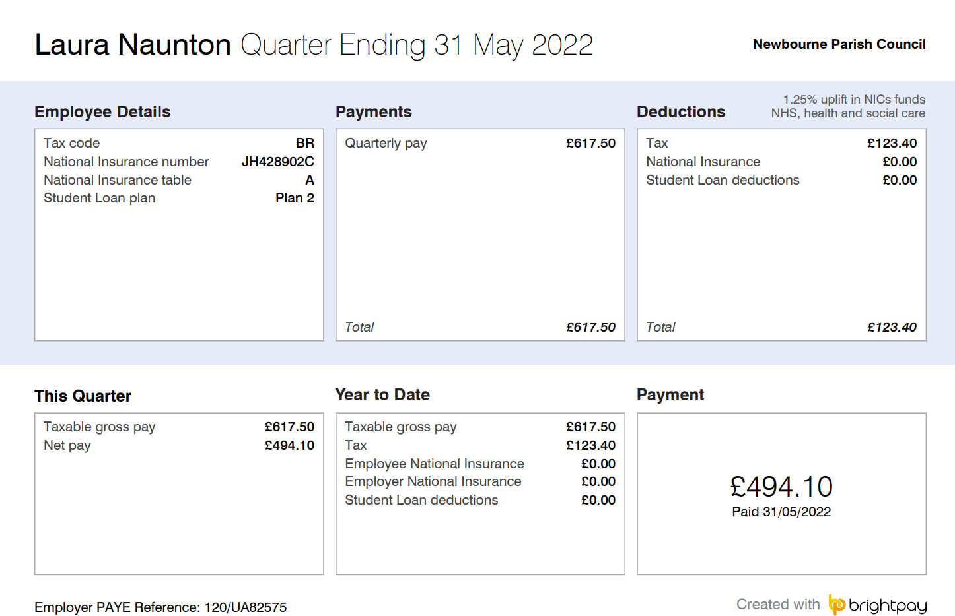
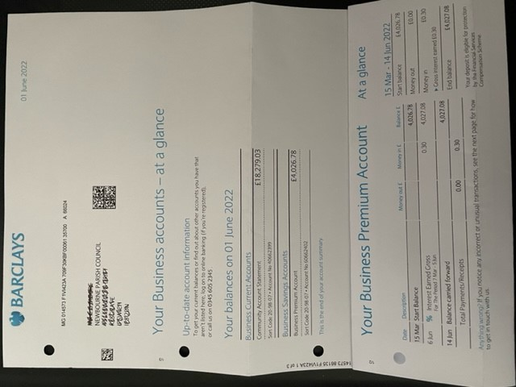
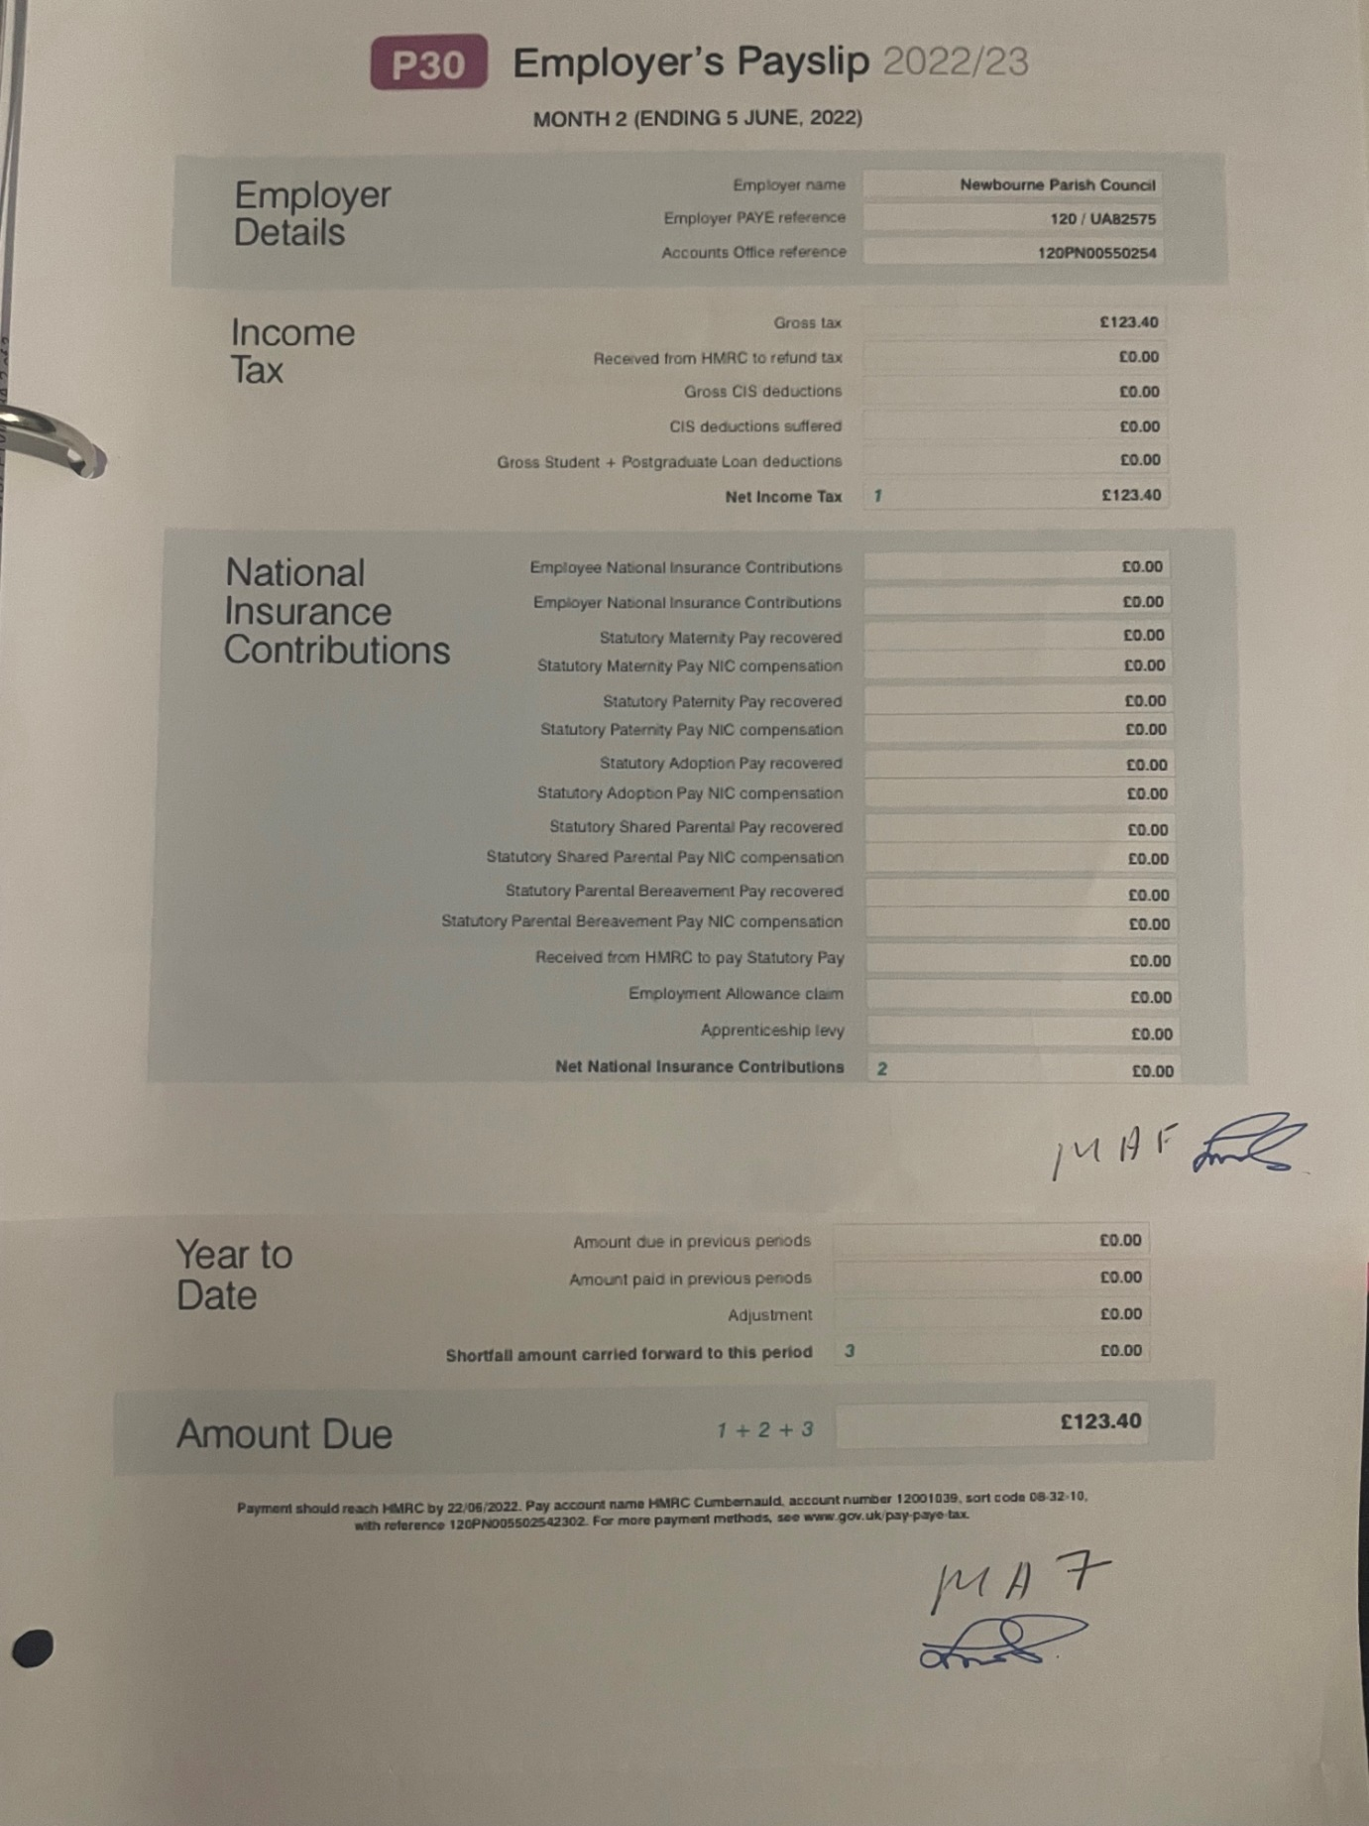
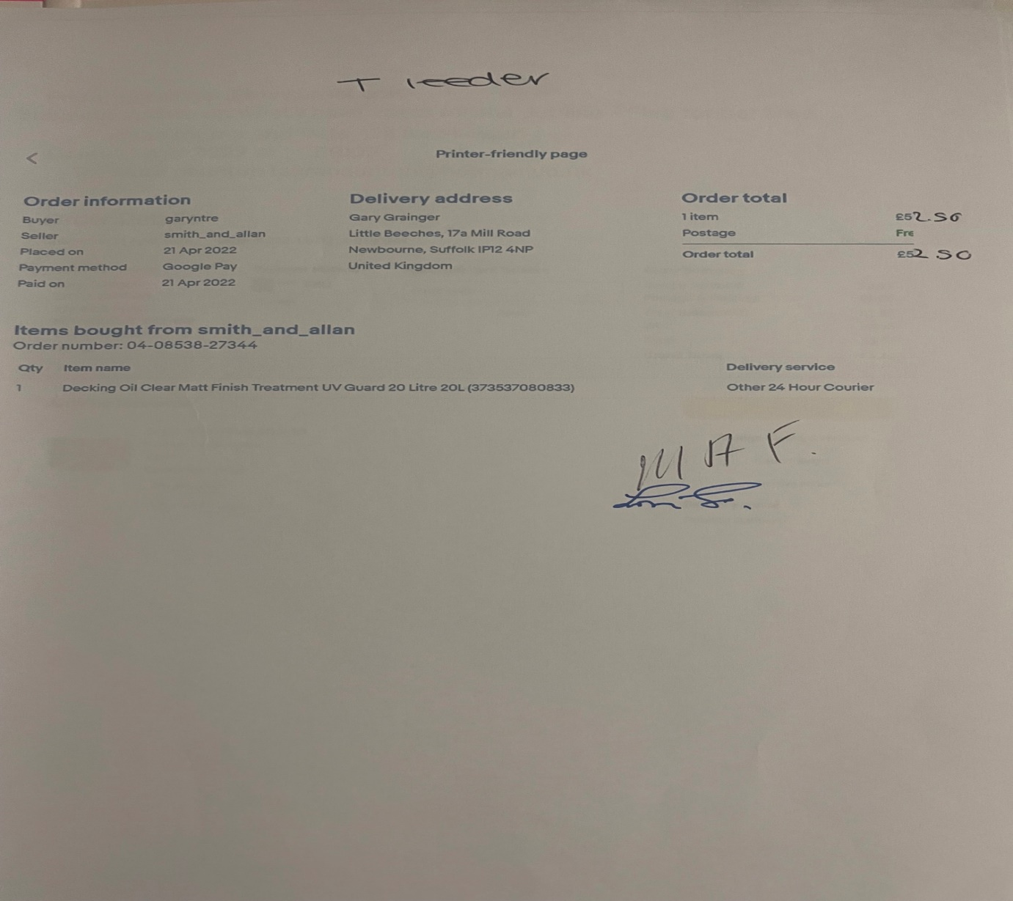
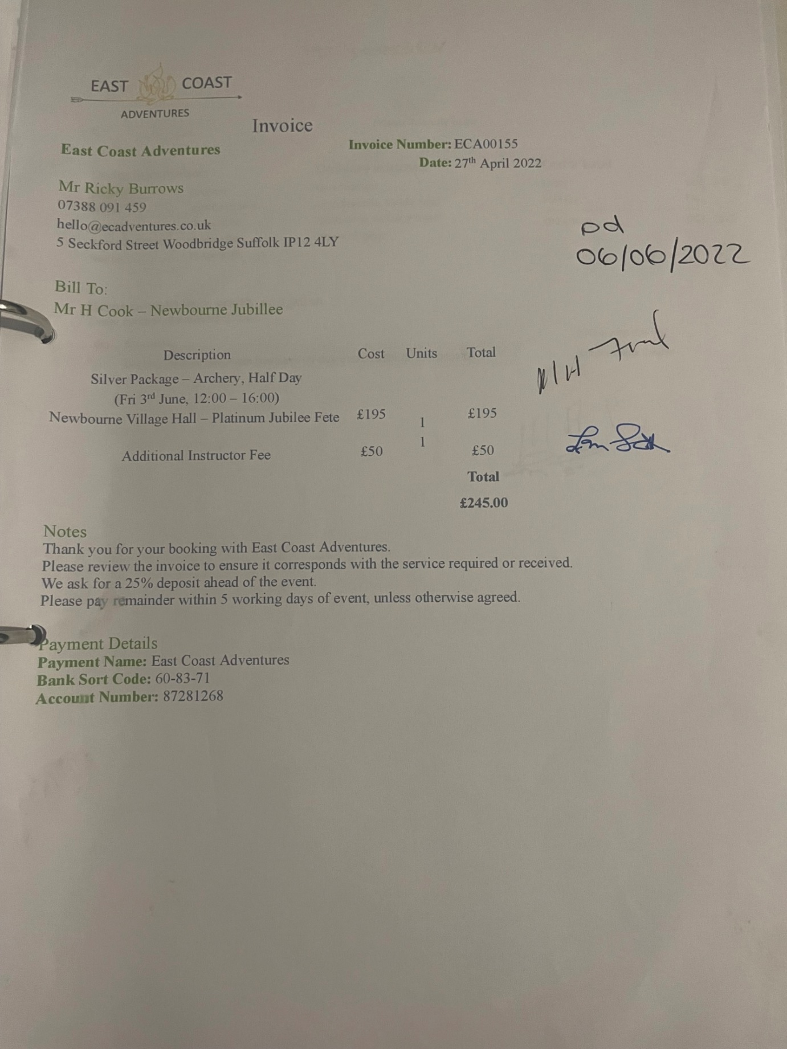
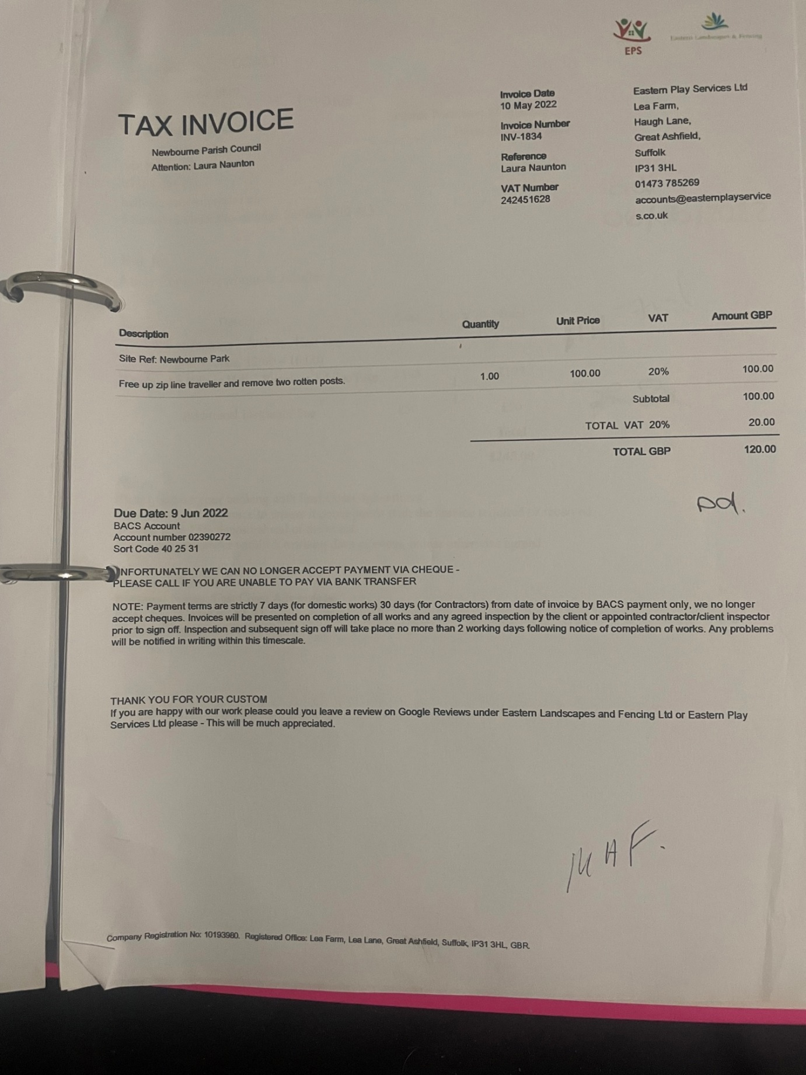

- Website – Andrew Gareth-Cox is going to get the website back up and running.
- Playground – To receive quotes for flooring and the Village Hall would like a swing added to the play area. The zipline and part of the climbing wall should be repaired in the next few weeks.

