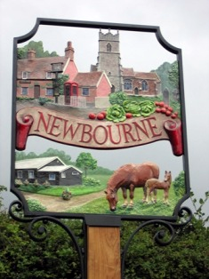

Newbourne Parish Council
Minutes 04/10/2021

The meeting was opened at 7.30pm by Charlotte Gammons

- Apologies – Richard Kerry, Patti Mulchay,
- Declarations of disclosable pecuniary interest – None
- Report From Richard and Mick
Ward Councillors monthly bulletin – October 2021
Welcome to the October edition of the monthly newsletter, aimed at keeping Councillors and Residents up to date on the main news stories from East Suffolk and, where possible, giving you a heads up on issues which are emerging.

Please note we still have some of the Councillors Enabling Funding available for help on your local projects.

Regards,
Richard & Mick

Restoring historic character of Lowestoft building
An exciting project to restore the façade of Lowestoft’s former Post Office is set to start later this year.  The project will help improve the condition and appearance of the building whilst restoring its historic character. It will include work to fix the roof, repair the windows, carry out conservation | 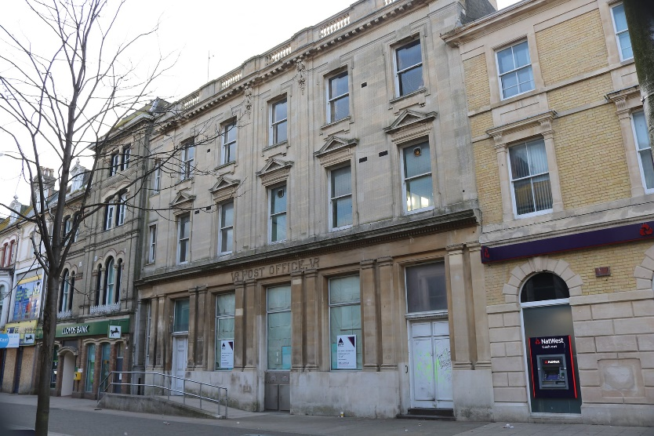
of stonework and reconfigure the ground floor windows to restore the entrance to the central bay of the building, as per the original design of the building. This will incorporate repositioning the existing ramp which would greatly improve the appearance of the building.

A planning and listed building consent application has been submitted on behalf of the Council to seek permission for the scheme and, if approved, work is intended to start in the winter. These repairs will be funded through the London Road, Lowestoft High Street Heritage Action Zone, financed by Historic England and East Suffolk Council, delivered in partnership with Lowestoft Town Council and East Suffolk Building Preservation Trust.

Improving private rented homes in East Suffolk
We're working with Generation Rent UK to better support East Suffolk residents who privately rent their homes and help ensure that homes in the district are secure, safe and energy efficient.

Earlier this year, we asked private renters living in the Harbour & Normanston ward, Beccles & Worlingham ward and Aldeburgh & Leiston wards, to share their experiences in a survey.
Findings from the survey revealed that private renters in these three wards are most concerned about:

- losing their tenancy
- being unable to move into homeownership
- rent increases
- almost 50% of those surveyed are concerned to some degree about being asked to leave their home by their landlord or letting agent this year.

As part of this work, we will be running focus group discussions later this year. Anyone who rents privately in East Suffolk can get involved in these, regardless of which ward they live in. Eligible participants will receive a £10 shopping voucher.

People can sign up now at https://my.eastsuffolk.gov.uk/service/Private_renter_session_registration

Historic shelter reopens following arson attack
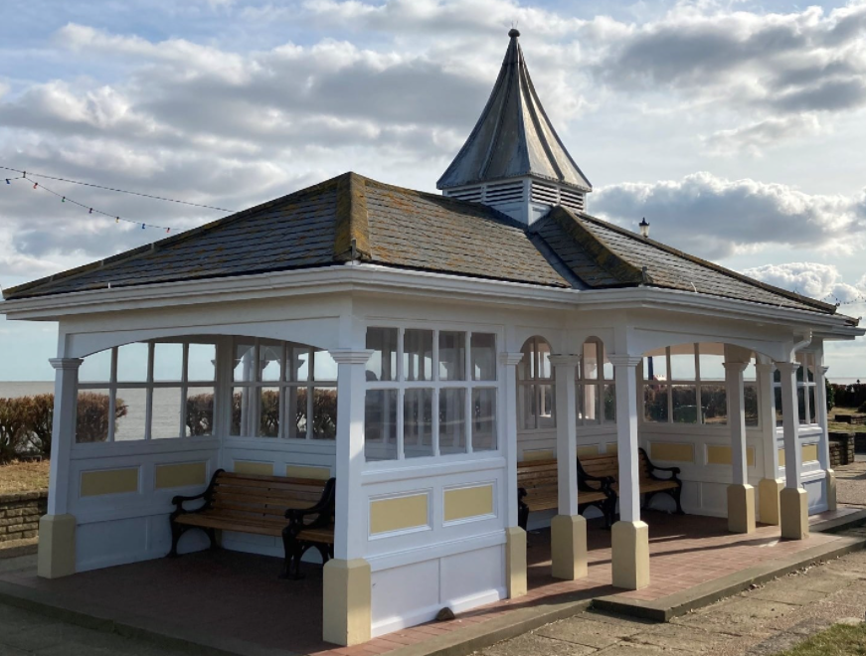 | Having been damaged during an appalling arson attack last year, the historic Manwick shelter on Felixstowe’s South Seafront has been reopened to the community.  The shelter, along with the nearby Arwela shelter, were fully refurbished in 2018 after suffering significant timber decay, vandalism and weather damage over the years, exacerbated by flooding during tidal surges. This £150,000 project was part of the
Council’s ongoing investment in the South Seafront area.

Support available to help businesses recover
Funding and support is available for businesses in East Suffolk which have been, and continue to be, severely affected by Covid-19 restrictions.

Delivered in partnership with the New Anglia Local Enterprise, the new ‘Plan for the Future’ scheme provides support to local businesses which are looking to bring forward investment projects that will have a significant impact on their business. Eligible businesses will be able to apply for grants of between £5,000 and £25,000 to help support their projects.

Businesses wishing to apply for support should first contact the New Anglia Growth Hub on 0300 333 6536 or email growthhub@newangliagrowthhub.co.uk

Expert and impartial Business Growth Advisers will work with businesses to develop an action plan and complete the application.

See more information at www.eastsuffolk.gov.uk/news/support-available-to-help-businesses-recover/

Funding boost for local communities
The Beccles, Bungay, Halesworth and villages Community Partnership has awarded a total of £10,880 through the second round of its Small Grant Scheme to community and voluntary groups, enabling them to deliver projects which addresses local priorities and benefit the wider communities.  Some of the project which have benefit from the scheme include Bungay | 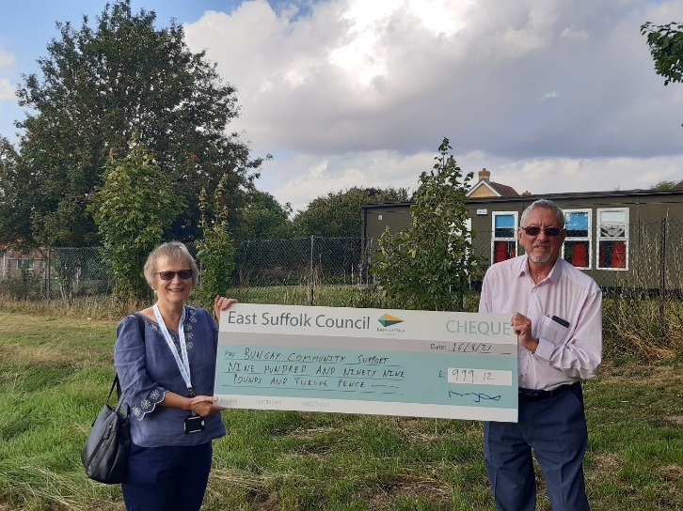
Community Support, Singing with Friends, Asperger East Anglia, Beccles Parish team and Eartwake CIC.

Key infrastructure projects to benefit from £6.3m funding
Over £6 million in contributions from new housing developments has been allocated to support the expansion of schools, leisure and health facilities in East Suffolk.

Earlier this month, cabinet agreed to award a total of £6,308,245 in Community Infrastructure Levy (CIL) funding to support seven major projects which are identified within the Local Plan as being key to planned growth within the local area.

CIL is a fee which we can charge developers when new housing is built in the district. CIL can then be put towards improvements to local infrastructure, such as play areas, schools and GP surgeries. We hold a list of key projects which are included in the Local Plan and these projects are then put forward for the latest round of CIL funding.

See more details about the projects at www.eastsuffolk.gov.uk/news/key-infrastructure-projects-to-benefit-from-6-3m-funding/

Funding agreed to support First Light 2022
To help ensure an incredible programme of activities at First Light Lowestoft in 2022, we've committed £200,000 to support next year's event.

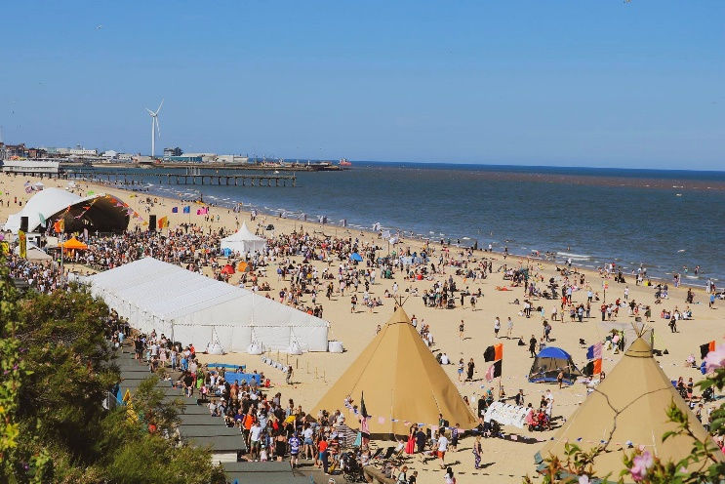 | Plans for the 2022 festival are still being developed but it is hoped that the event will be even larger than 2019, with a focus on young people.  The programme is expected to include a mix of music, international DJs on the main stage, a larger Beach Club Bar, a showcase for talented new musicians and writers, comedy, dance and a late-night silent beach cinema.

Helping young people take the next step
We’re continuing to support young people with further funding agreed by cabinet for the East Suffolk Youth Employment Service (YES), which is helping young people, aged between 16 and 24 years old, to find employment and training opportunities.

Delivered by Inspire Suffolk, young people can visit the dedicated YES. Suffolk website at www.yessuffolk.co.uk to view current job opportunities, find training programmes and other support information and advice. Referrals can also be made by community groups. Young people will be allocated an employment coach to support them into appropriate work, education or training. Wellbeing services are also available, provided by Inspire Suffolk.

Work has started on new beach huts in Lowestoft
As part of a wider programme to regenerate the town, work has now started on the construction of brand new, exciting and contemporary beach huts on Lowestoft’s seafront.

Designed by Norwich-based architects Chaplin Farrant, the £2.6 million scheme, which is expected to be completed by March 2022, will see the creation of 72 contemporary beach huts on two levels, which will face partially south to ensure maximum sunshine throughout the day. The tips of the structures will face eastwards reflecting Lowestoft’s position as the
most easterly location in the country.  A raised decking promenade will also be created to enable people to sit in front of the new huts on the upper level without restricting access to those using the promenade. Ten of the beach huts will be accessible with level access | 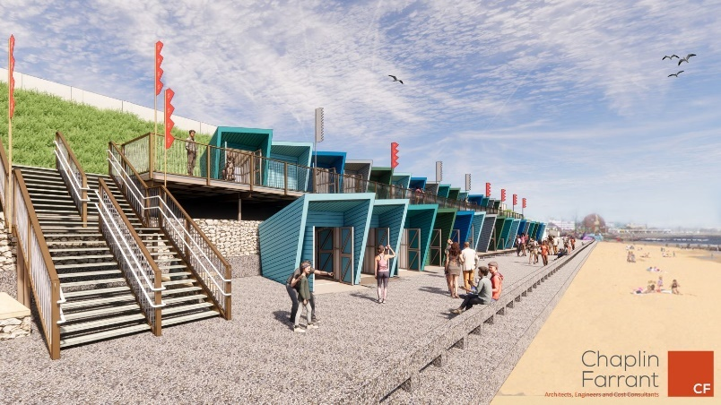
from the lower promenade.

The beach huts are being manufactured by Lowestoft company, P J Spillings, while the platform and ancillary works are being undertaken by M S Oakes – also from the town.

Surveys and consultations
We are currently running a couple of surveys and consultations and, as always we want to encourage participation as feedback from people in East Suffolk is invaluable and helps us ensure we’re making the right decisions for our communities.

- Recycling in East Suffolk
As part of a wider social media campaign, we’re currently running a recycling survey to get a better understanding of how much people in East Suffolk know about recycling and what we can do to help when it comes to knowing what items go into what bin. The survey is aimed at social media users only via our online social media accounts and closes tonight.

- Lound with Ashy, Herringfleet and Somerleyton Neighbourhood Plan
Lound with Ashby, Herringfleet and Somerleyton Parish Councils have submitted their Neighbourhood Plan to East Suffolk Council and the Broads Authority ahead of it being submitted for independent examination. Once finalised, the Neighbourhood Plan will determine future planning applications in the area.

People can have their say on the consultation until 13 October at www.eastsuffolk.gov.uk/planning/neighbourhood-planning/neighbourhood-plans-in-the-area/lound-ashby-herringfleet-and-somerleyton-neighbourhood-area/

Staying up to date on the latest East Suffolk news

- Declarations of disclosable interest. – None
- Minutes of Parish Council Meeting 06/09/2021 Jim and Lionel
- Chairman Charlotte is looking to step down as chairman due to family commitments, but Gary is willing to take over the roll everyone voted in favour for Gary to take over Sue or Charlotte agreed to stay as Vice Chairman.
- Planning DC/21/4156/FUL Tumbledown Farm 14 Ipswich Road, planning discussed parish council have no objections.
- Insurance – Only one quoted
9. Village Hall notice board – Adam has put the new notice board up.
10. Play area report in no major issues we are going to look at cost options for next meeting.
11.Finance
£22.80 SALC
£120.00 Adam Sterry
£1513.68 Insurance
£94.80 Rospa
£203.50 notice board
(1/2 insurance and notice board to be paid by village hall)
- Budget Report – Up to date bank statements

12. no clerks correspondence

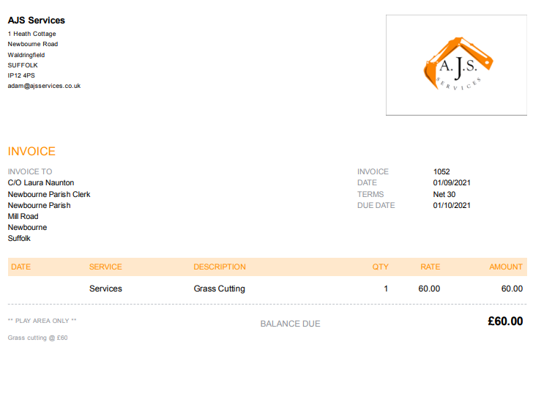

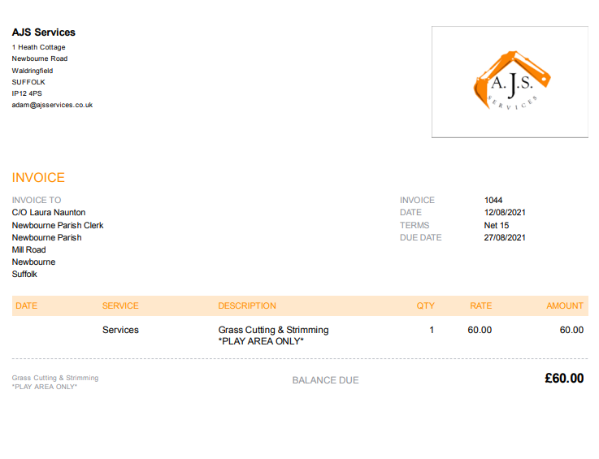

Dear Miss Naunton,
Thank you for choosing to arrange your insurance through Came & Company Local Council Insurance brokers last year. The renewal for Newbourne Parish Council & Village Hall Committee is due on 1st October 2021 and we have pleasure in presenting our proposals for the upcoming insurance renewal, in accordance with your requirements.
Important Information - Insurance Act
The renewal quotation for Newbourne Parish Council & Village Hall Committee is based upon the information previously provided to us and held by your insurers and the attached statement of fact, details of which are shown on the attached schedule.
If you wish to proceed with renewing the Council's cover, you must be sure that none of this information has changed (or, if it has, you must tell us about the changes before we arrange cover).
Additionally, under the Insurance Act 2015 you now have a new duty to provide a ‘fair presentation’ of the risk to insurers, which replaces the previous duty to disclose all material facts. This means that you must now clearly disclose every material circumstance which you, your Councillors or persons responsible for arranging your insurance, know or ought to know following a reasonable search. A material circumstance is one that may influence an insurer’s judgement over whether to take the risk and, if so, on what terms. If you are in any doubt as to whether a circumstance is material you are advised to disclose it.
Please note that failure to disclose a material circumstance may entitle the insurer(s) to impose different terms on your cover or reduce the amount of a claim payable. In some cases your cover could be invalidated, which would mean that a claim would not be paid.
To avoid the risk of under-insurance it is vitally important that your sums insured /indemnity limits are maintained at a correct level. I would, therefore, ask you to consider whether the policy coverage and sums insured / indemnity limits are sufficient to ensure that you will be adequately protected in the event of a claim.
Newbourne Parish Council & Village Hall Committee Renewal Summary
Based on the information we hold, we have assessed your demands and needs as those of a Council wishing to insure the risks shown, at the levels of cover set out in the attached schedule of insurance, with a reputable insurer and at a cost effective premium.
Please see the attached cover comparison which details a summary of the core covers automatically included with all Came & Company Local Council Insurance policies. In addition to these our insurer panel can provide enhanced levels of protection and additional covers where appropriate.
In preparing our recommendation for Newbourne Parish Council & Village Hall Committee we undertook a review with our panel of insurers and the below table summarises the quotations we were able to obtain:
Insurer | Insurer Premium | Administration Fee
Pen Underwriting Limited | £1,463.68 annual only | £50.00
Hiscox | Terms Awaited from the Insurers | £50.00
Premiums are inclusive of Insurance Premium Tax (IPT) charged by HMRC at the applicable rate
Our recommendation is that you accept the Pen Underwriting Limited quotation to meet the demands and needs of Newbourne Parish Council & Village Hall Committee.
Pen Underwriting Limited is a company within the Gallagher group and acts on behalf of a number of insurers. We always aim to treat you fairly and we manage all potential conflicts in accordance with our Terms of Business.
 | Insurer Premium | Administration Fee | Total Premium
Annual Policy with Pen Underwriting Limited | £1,463.68 | £50.00 | £1,513.68
Premiums are inclusive of Insurance Premium Tax (IPT) charged by HMRC at the applicable rate
Quote Reference | 2208514
Cover Period | 1st October 2021 to 30th September 2022
In handling this policy we will act solely as your agent, including when assisting you with any claim.
Renewal Comparison
 | Premium
2021 Annual Premium | £1,463.68 plus admin fee
2020 Annual Premium | £1,230.76 plus admin fee
We have included last year’s annual premium so that you can see how it has changed. If you have made any changes to the policy in the last 12 months, that altered the premium, this is reflected.
Index linking is currently calculated at 3% for both buildings and contents. Please contact the office should you not wish to index link these items.
The difference in annual premium will also be as a result of any rate changes applied by the recommended insurer and the index linking of any items insured against loss or damage.

Renewal Payment Options
Option | Notes
Bank Transfer – Please note our new bank details | If you’d like to pay by bank transfer, please send your payment to :
  Bank : | Lloyds
  Sort Code : | 30-80-12
  Account : | 19511668
  Account Name: | Arthur J. Gallagher
  Please quote reference: | 2208514
Cheque | Made payable to Came & Company, quoting 2208514 on the reverse
Direct Debit | Please contact our office should this option be required
Our Remuneration
We arrange the policy with the insurer on your behalf. You do not pay us a fee for doing this. We receive commission from the insurer which is a percentage of the total annual premium.
When you take out a policy with us we charge you an administration fee of £50.00. In addition, we receive commission from the insurer which is a percentage of the total annual premium.
Important Documents
We have pleasure in attaching the following documents on behalf of Pen Underwriting Limited;
Newbourne Parish Council & Village Hall Committee Schedule of Insurance
Newbourne Parish Council & Village Hall CommitteeEmployers’ Liability Certificate
Pen Underwriting Limited Policy Summary
Pen Underwriting Limited Statement of Fact
Summary of policy changes
Important Information from Pen Underwriting Limited
In response to market changes we have applied a Disease exclusion to your policy. Where you have Business interruption cover, we have also made changes to the following covers, where these covers are shown as operative on your schedule:
Denial of access (damage) cover
Denial of access (non damage) cover
Key person cover
Failure of selected public supplies cover
Failure of selected public supplies terminal ends cover
Loss of attraction (damage) cover
Murder suicide or Denial of access cover
Please read the endorsements that have been added to your policy carefully so that you can understand the changes made.
For a more detailed explanation of the changes made please see our Coronavirus hub which can be found at
https://www.axaconnect.co.uk/coronavirus-hub/
There have also been changes made to the following areas of cover:
Employment practices liability section: The standard excess is now £10,000, but reducing to £1,000 when the assistance of rradar is sought (please see endorsement on your schedule)
Council legal liability and legal expenses section (including Employee Dishonesty): The standard excess is now £5,000 and £2,500 in respect of Legal Pursuit (please see endorsement on you schedule)
Additional Documentation
Please also find attached the following documents sent on behalf of Came & Company Local Council Insurance;
Statement of Demands and Needs
Comparison Sheet
Pen Underwriting Limited Invoice – please note payment must be made no later than 1st October 2021
We strongly recommend that you familiarise yourself with these documents as they contain important information explaining the terms under which we operate; including how we handle your payment, and how and why we have selected the insurer. A specimen of the full policy wording is available on request.
Next Steps
This renewal quotation, the attached Renewal Schedule and Statement of Demands & Needs, should clearly describe the insurance requirements of Newbourne Parish Council & Village Hall Committee and how we plan to meet them. In order to renew the policy you must;
Check the attached documents and inform us if anything needs changing
Check the cover still meets the needs of Newbourne Parish Council & Village Hall Committee
Request that the policy for Newbourne Parish Council & Village Hall Committee is renewed with via renewals@cameandcompany.co.uk or via phone on 01483 462860.
Pay for your policy before 1st October 2021
Failure to provide renewal instructions before 1st October 2021 could result in your policy and cover lapsing.
On receipt of payment, a full policy wording will be issued accordingly.
We trust that you will find our quotation to be competitive and look forward to continuing to provide for your insurance needs, but should you need any assistance or wish to review our recommendation in anyway, please do contact Came & Company Local Council Insurance on 01483 462860 or via renewals@cameandcompany.co.uk.
Yours sincerely,
The Local Council Insurance Renewal Team
Came & Company Local Council Insurance
Blenheim House, 1-2 Bridge Street, Guildford, Surrey GU1 4RY
Office Tel: 01483 462860
Email: renewals@cameandcompany.co.uk

