Newbourne Parish Minutes 1st November 2021
Public Time- Tony Finch discussed his frustrations regarding the inconsistences and decisions made by East Suffolk Planners to SCLP 11.9 and Ex LSA Holdings. Tony Discussed his planning and other planning in the village which has got planning permission.
The meeting was opened by the chairman at 7:45pm.

1.Apologies Cllr Pollard, ESC Patti Mulcany and ESC Richard Kerry
2.Update from Richard & Mick District Councillors
Orwell & Villages Ward Councillors Report – November 2021
Best Regards Mick & Richard.

Planning
There seems to be some misinformation appearing locally about building on green field sites.
Changes to National Planning Policy is conducted in Parliament by way of a Green Paper that is usually a consultation document then a White Paper that goes through both houses before it gets Royal assent.
The adopted local plans will not be disregarded, and planning applications are likely on all the sites that do not currently have one. That does not necessarily mean they will be approved.
At Cabinet on 2nd November the CIL charging strategy has been voted through so it goes to the next stage, locally in Trimley, Howlett Way is classed as a major site and CIL is set at £165.00/sq. Mt and Reeve Lodge at £200.00/sq., Mt. Brightwell Lakes has no CIL charge as it has section 106 agreements in place.

East Suffolk magazine – out now and online!
The latest East Suffolk Magazine - with news and a wide range of information about Council projects, activities and services - is out now.  Produced by the Communications & Marketing team, with contributions from colleagues around the council, it is delivered to every household in the district, twice a year.  You can also read it online at https://www.eastsuffolk.gov.uk/assets/Your-Council/East-Suffolk-Magazine/011-East-Suffolk-Magazine-October-2021.pdf | 
This edition is not only packed with information, it also contains a survey which anyone who lives or works in East Suffolk is welcome and encouraged to complete. Turn to page 8 for the details or go to www.eastsuffolk.gov.uk/survey.

Culture still the focus in East Suffolk
Our joint bid with Great Yarmouth did not make the longlist for the UK City of Culture 2025 competition. Whilst this is obviously disappointing news, our ambition to shine a light on the wealth of amazing arts and cultural groups and activities in East Suffolk firmly remains.

Our bid has brought people together to talk about the potential of the area and we fully intend to keep that momentum going. The key focus for our joint bid was to offer and promote cultural activities which our communities could get involved with and we will continue to do that wherever possible.

Free event focuses on eco-friendly agriculture
A free online event is taking place next month to explore examples of eco-friendly agriculture in East Suffolk and how others can follow.

Titled ‘Farming Today, Fit for Tomorrow’, attendees can learn more about sustainable farming and how we can all help to fight climate change by thinking about how our food is grown.

Organised by the East Suffolk Greenprint Forum, the event will include guest speakers from Suffolk Farming & Wildlife Advisory Group, Oak Tree Community Farm, Maple Farm Kelsale, Peach and Pippin, Wakelyns Agroforestry and Fobbing Farm.

The event is taking place on Friday 19 November at 2pm – 4pm on Zoom and is open to everyone, however, registration is required at https://my.eastsuffolk.gov.uk/service/Greenprint_Forum_event_registration

Bringing empty properties back into use
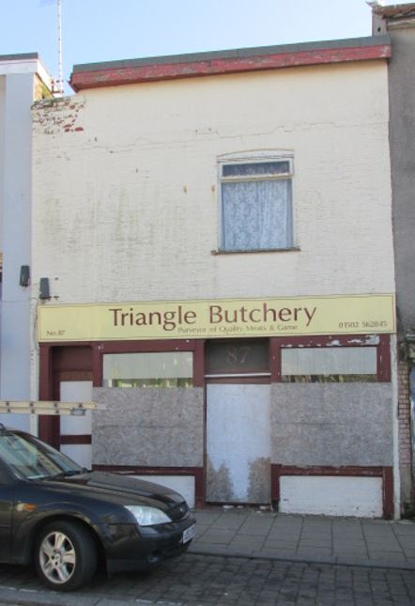 | We’re continuing work to reduce the number of long-term empty properties in East Suffolk as they are a wasted resource, often becoming a target for vandalism, arson, squatters, fly-tipping and other criminal behaviour.  As part of this, we review properties which Council Tax data reveals have stood empty for more than 6 months on an annual basis. Properties which have been empty for more than 2 years but would provide good quality housing that would benefit the community, are priorities during these reviews.  The last review, which was carried out in October 2021,
showed that the number of long-term empty properties in East Suffolk has fallen dramatically over the past 12 months, with a 23% decline in properties standing empty for more than 2 years and a 50% decline in properties standing empty for more than 6 months.

Some long-term empty properties may become part of our housing stock to provide much-needed affordable housing, whilst also address regeneration, such as 87 The High Street in Lowestoft which stood empty within the Heritage Action Zone, in a very poor condition, for more than 6 years. We purchased the property and plans are now being prepared to convert the whole building into flats which may be retained to provide homes for council tenants.

We will continue to work with, and support, owners to help them return long-term empty properties to a positive use, providing much-needed good quality housing in East Suffolk.

More information on what help is available if you own a long-term empty property and how to report a property is available at www.eastsuffolk.gov.uk/housing/empty-properties/

New beach village gets the go ahead
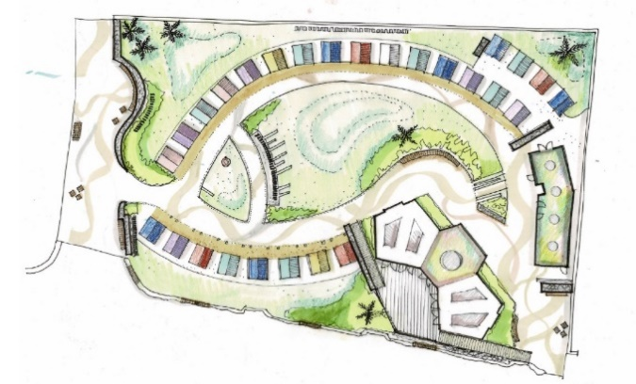 | As part of our ongoing investment in Felixstowe’s South Seafront, a new beach village has been given the go ahead to improve the beach hut experience for locals and visitors.  The beach village will include 5 accessible, purpose-built pods, 27 traditional huts and a new public convenience block with Changing
Places facilities.

The existing trim trial has been moved to Langer Park and the current volleyball site will be re-landscaped and made into an activity park. As part of this, new outdoor gym equipment will be installed, along with additional facilities, including concrete table tennis tables, a climbing wall, petanque pistes, accessible picnic benches, chess tables and outdoor space for workouts.

Furthermore, a new name for the site has now been decided after we ran a survey in which local people were asked to vote for their favourite names from a top five. Nearby 500 people took part and with over 30% of the votes, the new site will be named the Seashore Village.

Construction is expected to begin in early 2022 with completion scheduled for later in the year.

Local communities to benefit from further funding
Two Community Partnerships have announced a further round of their Small Grant Schemes, enabling community and voluntary groups to apply for much-needed funding:

The Framlingham, Wickham Market and Villages Community Partnership has opened for its second round of funding for projects that help develop opportunities for young people and reduce social isolation and/or loneliness. The scheme is open until 3 December 2021, offering grants between £250 and £1,000.

The Melton, Woodbridge and Deben Peninsula Community Partnership has opened for its third round of funding for projects that help improve opportunities for young people and community village hubs. The scheme is open until 1 January 2022, offering grants between £250 and £2,500.

Full details about eligibility criteria and how to apply can be found at www.eastsuffolk.gov.uk/community/community-partnerships/community-partnership-small-grant-schemes/

Lowestoft resident charged over nuisance noise offences
A Lowestoft man has been fined over £2,000 for continuing to play loud music, despite being given a notice to stop.
At a hearing at Suffolk Magistrates’ Court on Friday 15 October, David Learmonth from Burnham Way in Lowestoft was found guilty of breaching Section 80(1) of the Environmental Protection Act 1990 and failing to comply with an abatement notice served under Section 80(1) of the Environmental Protection Act 1990, contrary to Sections 80(4) and 80(5) of the Environmental Protection Act 1990.
Mr Learmonth attended the court but was denied attendance to the hearing due to threatening behaviour towards staff earlier in the day. Permission was granted to proceed in his absence.
The court fined Mr Learmonth a total of £2,040 for the offences, comprising £500 for two charges of breaching the abatement notice, £940 in costs and £100 for the victim surcharge.
Under the Noise Act 1996, the court also ordered the forfeiture of Mr Learmonth's sound equipment, including a bass box, CDs, a sound bar and several sets of speakers.

All abord the Bungay Shoppa
Delivered by Bungay Events and Business Association and Bact community transport, the new service will connect those isolated and without transport in Bungay’s neighbouring villages to Bungay on market days.  The Bungay SHoppa will serve stops in Wainford, Shipmeadow, Barsham, Ilketshall St. Andrew, Ilketshall St. John, | 
Ilketshall St. Lawrence, Ilketshall St. Margaret, South Elmham St. Peter, South Elmham St. Michael, All Saints, Rumburgh, Homersfield and Flixton.
The service will take place on Thursdays (market days) until February and will also run on the Sunday Street Market days that fall during this time.
The project has received funding from the Beccles, Bungay, Halesworth and villages Community Partnership as well as funding from Cllr Judy Cloke’s Enabling Communities Budget.
View the timetable at https://bungay-suffolk.co.uk/bungay-shoppa-timetable/

Sizewell C Examination: Our response
As part of a six-month Planning Inspectorate examination of the proposals for a new nuclear power plant at Sizewell, we welcome a range of important revisions to the scheme and a multi-million pound financial package for investment back into local communities.

Read our full response here: www.eastsuffolk.gov.uk/news/sizewell-c-examination-east-suffolk-council-response/

Funding boost for innovative new youth project
Earlier this week, cabinet agreed to allocate £101,650 for a two-year pilot project which aims to support young people in rural parts of East Suffolk as they face ongoing challenges
from the pandemic.

Delivered by Community Action Suffolk, the Rural Youth Support Project will initially focus on the four most rural Community Partnership areas in East Suffolk, which are within the Beccles, Bungay, Halesworth and villages Community Partnership, the Carlton Colville, Kessingland and villages Community Partnership, the Framlingham, Wickham Market and villages Community Partnership and Melton, Woodbridge and Deben Peninsula Community Partnership.

The aim of the project is to provide support tailored to each community, which will be based on engagement with its young people about their needs. This could include providing more social opportunities with a youth café or youth club, supporting a healthier lifestyle with activity sessions or making services more accessible with carpools.
Surveys and consultations
We are currently running a couple of surveys and consultations and, as always we want to encourage participation as feedback from people in East Suffolk is invaluable and helps us ensure we’re making the right decisions for our communities.

- East Suffolk survey
We’re asking people who live and work in East Suffolk to take part in a short service to help us shape East Suffolk. After such a difficult period, we would like to know what they think, what matters most to them and where we should be spending our money. The survey closes on 29 November: https://eu.surveymonkey.com/r/EastSuffolkSurvey

- The Affordable Housing Supplementary Planning Document
Consultation on draft document which will provide guidance on the implementation of our affordable housing planning policies. People are able to comment until 13 December at https://eastsuffolk.inconsult.uk/ESAFFHSGDRAFT/consultationHome

- The Sustainable Construction Supplementary Planning Document
Consultation on draft document which will provide guidance on our planning policies on sustainable construction, including guidance on a range of topics relating to the construction of environmentally sustainable buildings. People have until 13 December to comment: https://eastsuffolk.inconsult.uk/SUSCONSPDDRAFT/consultationHome

- The draft East Suffolk Cycling and Walking Strategy
Consultation on draft document which provides a district-wide shortlist of cycling and walking infrastructure opportunities. The strategy aims to encourage greater use of sustainable forms of transport, reduce contributions to climate change, support the growth of the tourism industry, and to improve the health and wellbeing of residents by ensuring more trips to work, school, leisure, day-to-day errands, or public transport hubs, such as train stations or park and ride sites, are accessible by bike or on foot. Once adopted, this strategy will replace the Waveney Cycle Strategy (2016) and will cover the whole of the district. People can have their say on the consultation until 10 January at https://storymaps.arcgis.com/stories/cbc57e4a9cc24eeea7d174fb34b1bf0e

- Proposed extension to Beccles Cemetery
People are invited to have their say on proposals to extend Beccles Cemetery. The proposed extension will allow for traditional burial and cremation plots, as well as meadow burial plots where grass will be left to grow longer in the summer. Green burials will also be available. People can view the documents at https://www.eastsuffolk.gov.uk/assets/Community/Cemeteries/Beccles-Cemetery-extension-consultation.pdf and email comments to leisure@eastsuffolk.gov.uk by 31 December 2021.
Social media
We keep our communities up to date in a variety of ways and social media has an important role to play. Please follow us and share our posts with your audiences!
Facebook: www.facebook.com/eastsuffolkcouncil
Twitter: https://twitter.com/EastSuffolk
- Declarations of Pecuniary interest – None
- Minutes approved by Gary and Charlotte
- Planning DC/21/4455/FUL Single storey extension and front porch 47 Jackson Road
4 councilors for planning / none against
- Playground – Get Adam to have a look at playground and see how many problems we have. See if we can get any funding etc. for work that needs to be done.
- The issues at the Fox Public House. Mr Lomas has contacted the neighbours involved to update them on the issues (e-mail read out in meeting ) which seems to be outstanding but will keep on agenda to get update next month. It was raised that the email did not mention the parking issues on the verge and nothing has been done to address this issue. We will wait till December to see if anything has changed.
- It was discussed in the meeting that a letter would be put together by the Clerk to send to the council regarding Tony’s issues with the inconsistences and decisions made regarding planning. This will be added to the agenda in December for the letter o be checked before it is sent/ emailed.
- Finance.
Cheques £800.37 refurb of village sign Cheque number 100445
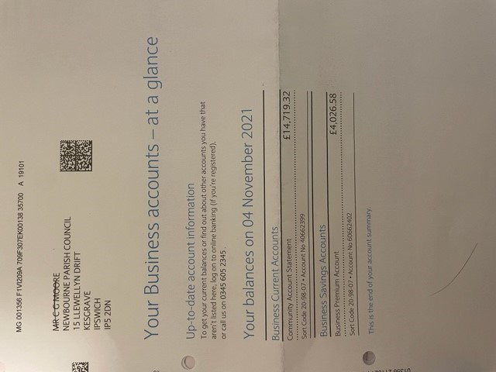

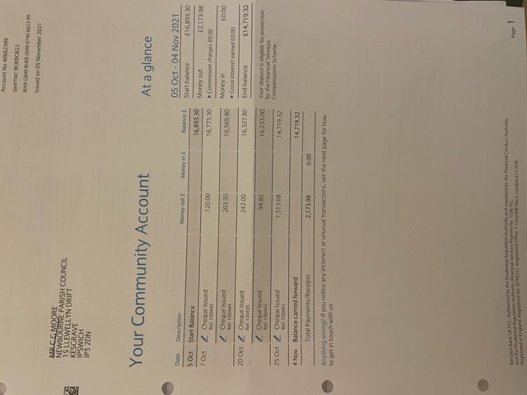

Tony Finch E-Mails regarding planning

From: Ben Woolnough
Sent: 22 October 2021 15:44
To: Rachel Smith; Tony Finch; Katherine Scott
Subject: RE: DC/21/2584/OUT

Dear Mr Finch

I entirely support Rachel’s position on this. I gathered a number of very experienced officers together to discuss the influence of the Cluster policy (SCLP5.4) and Newbourne policy (SCLP11.9) on the scheme and others sites prior to a recommendation and to establish our wider position going forward. Your proposal is not one which is supported by either of those policies and the site covers such a large gap that it cannot be seen as a form of infilling. We will be continuing with some internal work in establishing the extent of infilling in the village permitted by policy but Rachel’s position is as per the stance of East Suffolk going forward.

Kind regards

Ben

Ben Woolnough BSc MSc MRTPI
Planning Manager (Development Management)
East Suffolk Council
01394 444593 | 07833 406681
I am mostly working from home. Please use my mobile number to call me first. If I don’t answer I may be on a call so please leave a voicemail or send me a text message and I will get back to you as soon as possible.

www.eastsuffolk.gov.uk
www.eastsuffolkmeansbusiness.co.uk

East Suffolk Council will continue to review and prioritise the delivery of its services during this unprecedented time.
The COVID-19 outbreak will severely impact what we are able to do, however we will continue to support and protect our communities, delivering the critical services you need.

From: Rachel Smith <Rachel.Smith@eastsuffolk.gov.uk>
Sent: 22 October 2021 15:29
To: Tony Finch <finch1938@btinternet.com>; Ben Woolnough <Ben.Woolnough@eastsuffolk.gov.uk>; Katherine Scott <Katherine.Scott@eastsuffolk.gov.uk>
Subject: RE: DC/21/2584/OUT

Dear Mr. Finch,

Members of the Referral Panel were made aware of some recent approvals within Newbourne during the presentation.

In relation to your comments in relation to clusters, while I appreciate that some of my previous comments have referred to the ‘clusters’ policy and interpretation of whether your application site would comply, during the most recent discussion I had with colleagues, it was decided that the ‘clusters’ policy was not the most relevant in relation to consideration of proposals within the former Land Settlement Association Holdings Area. The refusal reason therefore does not refer to Policy SCLP5.4. When the application has been checked and signed off, the decision notice will detail the reason for refusal in full.

I apologise that you feel there has been some inconsistencies with decision making but our recent discussions internally have been trying to reach a clear, agreed and justified position such that any such inconsistencies don’t occur.

Kind regards,

Rachel Smith | Senior Planner
East Suffolk Council
01394 444628| 07887 452719
www.eastsuffolk.gov.uk
www.eastsuffolkmeansbusiness.co.uk

I am mostly working from home. Please use my mobile number to call me first. If I don’t answer I may be on another call so please leave a voicemail or send a text message and I will get back to you as soon as possible.

East Suffolk Council will continue to review and prioritise the delivery of its services during this unprecedented time.
The COVID-19 outbreak will severely impact what we are able to do, however we will continue to support and protect our communities, delivering the critical services you need.

From: Tony Finch <finch1938@btinternet.com>
Sent: 22 October 2021 12:09
To: Rachel Smith <Rachel.Smith@eastsuffolk.gov.uk>; Ben Woolnough <Ben.Woolnough@eastsuffolk.gov.uk>; Katherine Scott <Katherine.Scott@eastsuffolk.gov.uk>
Subject: RE: DC/21/2584/OUT

Good Morning
Yes I am disappointed with the outcome in particular that the Referral Panel were not told that previous decisions had been approved in Mill Road either without reference to “ clusters “ or with the distance to the 5th dwelling in the cluster being a further distance away.

Please reply to the following questions.

- Why was the application DC/20/4939/FUL permitted without any mention of “ clusters” with the 5th dwelling required being a further distance away?
Please refer to the Officers Report.

- Why was the application DC/21/1745/OUT permitted with the 5th dwelling for the cluster being again a further distance away?
Please refer to the Officers Report.

- Why was this application treated differently to the applications mentioned in Questions 1 and 2?

- As each site has it’s own set of specific circumstances would moving the proposed dwelling closer to Number 20 Mill road thus including Numbers 21,22,23,23A,24, and the plot associated with DC/21/0347/OUT be more acceptable to the position regarding clusters?
Please refer to DC/20/3449/FUL, in particular diagram 3879-20 Location Plan.
- It would seem that decisions with regard to new dwellings on the Ex L.S.A. Holdings are wholly dependant on which Officer is assigned to the case and their subjective opinion with regards to distances involving “clusters”?

Regards
Tony Finch

From: Rachel Smith
Sent: 21 October 2021 13:37
To: Tony Finch
Subject: RE: DC/21/2584/OUT

Dear Mr Finch,

Following on from the Referral Panel meeting yesterday where the above application was discussed, Members determined that Officers were interpreting the policies in respect of Newbourne correctly and therefore the application didn’t warrant further debate at Planning Committee. They therefore granted the Head of Planning and Coastal Management delegated powers to determine the application.

I appreciate that you may not agree with the recommendation however the appeal process is then open to you. More information on this is available on the decision notice.

Kind regards,

Rachel Smith | Senior Planner
East Suffolk Council
01394 444628| 07887 452719
www.eastsuffolk.gov.uk
www.eastsuffolkmeansbusiness.co.uk

I am mostly working from home. Please use my mobile number to call me first. If I don’t answer I may be on another call so please leave a voicemail or send a text message and I will get back to you as soon as possible.

East Suffolk Council will continue to review and prioritise the delivery of its services during this unprecedented time.
The COVID-19 outbreak will severely impact what we are able to do, however we will continue to support and protect our communities, delivering the critical services you need.

From: Rachel Smith
Sent: 18 October 2021 16:06
To: Tony Finch <finch1938@btinternet.com>
Subject: RE: DC/21/2584/OUT

Dear Mr. Finch,

In answer to your questions, please see below:

- Applications that are considered to be a departure from the Development Plan when assessed as a whole have to be advertised as such. This application is not considered to meet this criteria given Newbourne’s position in the Settlement Hierarchy as a Small Village and the options that the Local Plan sets out for some development in the countryside.
- There is no maximum distance for properties to be apart from each other in relation to the clusters policy – each case is assessed on its merits and a judgement made.
- The case will be presented by myself or Principal Planner (Katherine Scott) to the referral panel.
- All correspondence relating to applications is available for Members of the Referral Panel to view however emails would not normally be included within reports or presentations. The Members will be made of any necessary planning history and policies etc.
- This is correct
- The Local Plan is a relatively new document and therefore with some policies there can be discussion about their interpretation and aims and what they seek to achieve as part of the Local Plan as a whole. As I have said to you, I have had multiple discussions with colleagues about this application and others in Newbourne as the Local Plan has set out a unique policy position whereby there is no Settlement Boundary but it is classified as a Small Village. Officers seek to interpret these policies in the best way they can considering site specific circumstances, the overall aims of the Local Plan and any other material considerations. As Newbourne’s position in the Local Plan is in its infancy and I am not aware of any relevant appeal decisions to influence consideration further (although one has very recently been submitted), there may be some variation in the way applications are considered, having said that, each site has its own setoff specific circumstances.

I will make you aware of the outcome of the Referral Panel meeting following their decision.

Kind regards,

Rachel Smith | Senior Planner
East Suffolk Council
01394 444628| 07887 452719
www.eastsuffolk.gov.uk
www.eastsuffolkmeansbusiness.co.uk

I am mostly working from home. Please use my mobile number to call me first. If I don’t answer I may be on another call so please leave a voicemail or send a text message and I will get back to you as soon as possible.

East Suffolk Council will continue to review and prioritise the delivery of its services during this unprecedented time.
The COVID-19 outbreak will severely impact what we are able to do, however we will continue to support and protect our communities, delivering the critical services you need.

From: Tony Finch <finch1938@btinternet.com>
Sent: 11 October 2021 12:49
To: Rachel Smith <Rachel.Smith@eastsuffolk.gov.uk>
Subject: DC/21/2584/OUT

Good morning.
It would seem that we have come to an end with our extended exchanges and I now make a formal request for replies to the questions below so that I will be able to present the case either to the Planning Committee or to the Appeals Inspectorate.

- Why was this application not published, as is legally required if it is a Departure from the Local Plan, in the East Anglian Daily Times ?

- What is the maximum distance to the 5th dwelling required for it to be considered part of a “ Cluster “ ?

- Who presents the case to the Referral Panel ?

- Will my e- mails, particularly that of 26th August, which shows DC/21/1745/OUT, which was permitted after my Planning statement was written, along with other examples, be presented so that the Referral Panel have all the information ?

- Are you aware that your pre-application advice, to which you constantly refer, was made on 9th March and authorised by Liz Beighton, the same Officer who subsequently authorised DC/21/1745/OUT some 10 weeks later on 26th May ?

- This later decision must supersede your previous advice ?

I await your replies

Yours sincerely

Tony Finch
Sent from Mail for Window

Click here to report this email as spam.

Confidentiality: This email and its attachments are intended for the above named only and may be confidential. If they have come to you in error you must take no action based on them, nor must you copy or show them to anyone; please reply to this email and highlight the error.
Security Warning: Please note that this email has been created in the knowledge that Internet email is not a 100% secure communications medium. We advise that you understand and accept this lack of security when emailing us.
Viruses: Although we have taken steps to ensure that this email and attachments are free from any virus, we advise that in keeping with good computing practice the recipient should ensure they are actually virus free.

This message has been scanned for malware by Websense. www.websense.com

