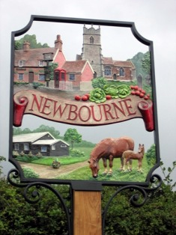

Newbourne Parish Council
Minutes 05/07/2021

Attended – Cllr Frost, Cllr Wicks, Cllr Scott, Cllr Gammons, Cllr Pollard, Cllr Grainger, ESC Patti Mulcany

The meeting was opened at 7.30pm by chairman Charlotte Gammons

- Apologies – Kwini Lusher
- Patti Mulcany an introduction to the parish council

Ward Councillor monthly bulletin – July 2021
Welcome to the July edition of the monthly newsletter, aimed at keeping Orwell & Villages Parishes up to date on the main news stories from East Suffolk and, where possible, give them a head’s up on issues which are emerging.
Regards,
Richard
Richard Kerry
Ward Councillor- Cabinet Member for Housing
Melissa Allen
Unfortunately,
Melissa as resigned her position on East Suffolk Council as Ward Member for Orwell and Villages.

Specialist accommodation created to support former rough sleepers
As part of the Council’s commitment to support people facing homelessness, a property in Lowestoft has been transformed into specialist accommodation especially for former rough sleepers.  Following a successful bid to the Ministry of Housing, Communities and Local Government, the Council received £93,312 | 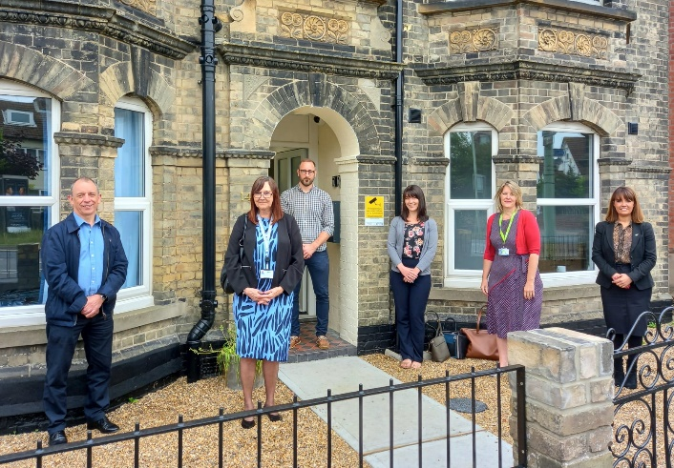
in September 2020 through the Government’s Next Steps Accommodation Programme (NSAP), to provide accommodation and support to rough sleepers during the pandemic.

An additional £389,482 was then secured from the NSAP earlier this year to provide support to rough sleepers in East Suffolk through the delivery of longer-term ‘move on’ accommodation. This enabled us to purchase a large property in St Peter’s Street and over the past few months, the Housing Maintenance Team have worked tirelessly to transform the building into a seven-bed unit of specialist, supported accommodation specifically for former rough sleepers and single homeless people.

An official opening event was held on Monday 28 June and was attended by representatives from East Suffolk Council and Orwell Housing, who will manage the accommodation and provide care and support for residents.

Free parking scheme extended to support vaccination staff
To support the Covid-19 vaccination programme, East Suffolk Council will continue to offer free parking for healthcare staff working in vaccination centres across East Suffolk until the full easing of current restrictions, currently expected to be 19 July.

The extension to the parking pass only applies to those working at vaccination sites and does not extend to wider health and social care staff. Health and social care workers who need to park in resident parking zones can register for permits, known as ‘carer vouchers’ at www.eastsuffolk.gov.uk/parking
New virtual hub for Lowestoft creatives
To enable the growing creative sector in Lowestoft to reach its full potential and attract further investment, a new Virtual Creative Hub has been launched.
 | Developed in response to feedback to the Council’s Cultural Strategy, ‘Celebrating Culture on the Edge’, the Virtual Creative Hub will provide creatives with a way to network, feel more connected and access information, training and funding opportunities. These were all key requirements raised by local creatives during a consultation last year.
Funded through Arts Council England, the Virtual Hub is open to creatives who are based in Lowestoft or deliver work in the town.
Working in partnership with Suffolk County Council, a small grant scheme, part of Creative Unlimited, funded by Suffolk Inclusive Growth Investment Fund, will be available for people who engage with the Hub. Awards of up to £1,000 are available to fund materials, exhibition equipment through to digital development, marketing and promotion.
Find out more! www.eastsuffolk.gov.uk/lowestoft-virtual-creative-hub/

New policy for commemorative benches in East Suffolk
We have introduced a new policy for ‘commemorative’ benches, the service which allows people to sponsor seating at locations in the district to remember a friend, relative or colleague who has passed.
People can sponsor a new bench with a commemorative plaque for a period of ten years in numerous locations on council land, mainly replacing existing benches that are coming to an end of practical use. The benches are located in places where everyone can sit, rest and reflect.
Members of the public who choose to commemorate someone in this way will also be encouraged to not attach any additional items to the benches. Unfortunately, these items, which can often include flowers, wreaths and balloons, can either prevent people from sitting, or make them feel uncomfortable about doing so.
Items can sometimes be left for a long period of time and can also cause environmental issues, particularly if they are not degradable.
With this in mind, we are now also kindly asking people to collect and take care of any items they may have placed on benches on council land, which they would like to keep.

New recycling campaign aims to get people recycling right
We’ll be launching a new recycling campaign across the Council’s social media channels soon to help our residents dispose of their waste correctly.  As part of this, we’re currently carrying out | 
a short recycling survey which all residents in East Suffolk are invited to participate in. It should only take a couple of minutes to complete and as a thank you, those taking part can opt in to enter a fantastic prize draw for a chance to win a goodie bag full of eco-friendly homewares, including metal straws, food covers and wax food wrappers, worth £42.

The survey is open until 5 July at https://eu.surveymonkey.com/r/RecyclinginEastSuffolk

This comes after more than 5000 tonnes (about 24%) of recycling in East Suffolk is rejected annually due to the wrong items being placed in kerbside recycling bins, including glass, black sacks, food waste, cartons and nappies.

New grant scheme puts nature first
As part of our ongoing drive to build the right environment for East Suffolk, the Greenprint Forum has launched a funding scheme for voluntary and community groups who are planning projects that help promote biodiversity.
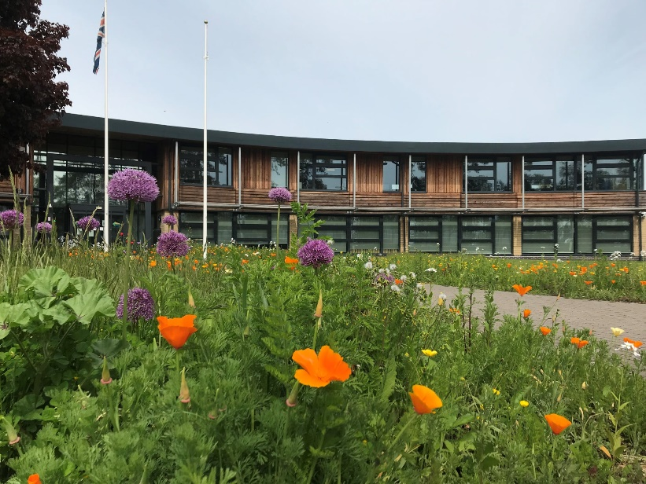 | Eligible projects could include work to restore existing habitats or create to new ones, provision of nesting/roosting places for birds, pollinators and other animals, or activities to help local people of any age learn more about and enjoy their local biodiversity.  The scheme will run over four phases during 2021/22, offering grants of up to £1,000.
The first application period is now open until 28 July 2021 and full details, including eligibility and how to apply, can be found at www.eastsuffolk.gov.uk/environment/east-suffolk-greenprint-forum/supporting-community-environmental-action/nature-first-small-grants-scheme/

Free community Health and Wellbeing drop-in events
Families and residents of all ages are invited to free Health & Wellbeing events to meet their local groups, organisations and service providers to find out more about the help and service available in their local communities.

The events will be taking place across the south of the district, with the first one in Framlingham on Monday 26 July, followed by events in Kesgrave, Felixstowe, Saxmundham and Melton.

For more information, including dates and venues, go to www.eastsuffolk.gov.uk/news/free-community-health-and-well-being-drop-in-events/

Protecting East Suffolk’s historic environment
The Council has adopted a new Historic Environment Supplementary Planning Document which will provide guidance on a range of topics, including repairs and alterations of historic buildings, to support the implementation of the adopted Local Plan policies.

View the new document, and supporting documents, at www.eastsuffolk.gov.uk/planning/planning-policy-and-local-plans/supplementary-planning-documents/

Surveys and consultations
We are currently running a number of surveys and consultations and, as always we want to encourage participation as feedback from people in East Suffolk is invaluable and helps us ensure we’re making the right decisions for our communities.

- Supporting older people’s housing needs
This survey will help develop a new Older People’s Housing Strategy to support older people’s housing needs in East Suffolk so they can continue to live fulfilling lives in the right type of housing. The survey is open until 5pm on Friday 9 July at https://eu.surveymonkey.com/r/ESC_Survey_OPHS_May2021

- Vote for your favourite name for proposed beach village
We have submitted a planning application for a new beach village in Felixstowe, aimed at improving the beach hut experiencing by creating accessible facilities that enables families and groups to enjoy everything the beach and town has to offer. As part of this, we’re looking for a new name for the site and are asking local people to vote for their favourite out of 5 suggestions in a survey which closes at 5pm on Friday 30 July at https://eu.surveymonkey.com/r/BeachVillage

- Improving recycling in East Suffolk
As part of a wider social media campaign, we’re currently running a recycling survey to get a better understanding of how much people in East Suffolk know about recycling and what we can do to help when it comes to knowing what items go into what bin. The survey is open until 5 July at https://eu.surveymonkey.com/r/RecyclinginEastSuffolk

- Southwold Neighbourhood Plan
People can now have their say on the Southwold Neighbourhood Plan until 5pm on Friday 9 July at https://eastsuffolk.inconsult.uk/SouthwoldNP/consultationHome
When finalised, the Plan will act as a guide to development in the town and will be required to be used by anyone considering, or making, a planning application.

Staying up to date on the latest East Suffolk news
The Communications Team share all media coverage on Sharepoint, so you can easily stay up to date on all media stories relevant to East Suffolk Council, whether on local, regional or national news outlets, tv, radio, print or online.

Access these at any time at https://eastsuffolkgovuk.sharepoint.com/sites/Communications/Lists/Media%20coverage/AllItems.aspx
If you have any questions or need any help with this service, you can email the team on communications@eastsuffolk.gov.uk

Don’t forget to share your own news!
We do a lot of great work in East Suffolk and we want everyone to know! I would therefore like to encourage all Councillors to share their own good news stories with the Communications Team so they can help showcase some of this work, whether this is from projects funded through your Enabling Communities Budget or supporting an initiative which will benefit our local communities.

You can email the team on communications@eastsuffolk.gov.uk
Social media
We keep our communities up to date in a variety of ways and social media has an important role to play. Please follow us and share our posts with your audiences!
Facebook: www.facebook.com/eastsuffolkcouncil
Twitter: https://twitter.com/EastSuffolk
4.Declarations of disclosure of pecuniary interest – None
5. Minutes from July meeting agreed by Lionel and Gary
6. Planning DC/21/2879/FUL Agree no objections
7. Notice board – Parish council agreed to pay half of the cost of a new notice board for the village hall and the village hall committee will pay the other half.
8. Village Sign agreed work will be done to sign and we will see if we can get some funding to help with the cost will be about £500.

9. Finance – Finance reports shown.
Cheque signed for SALC £144.41 Membership fee Cheque number 100433
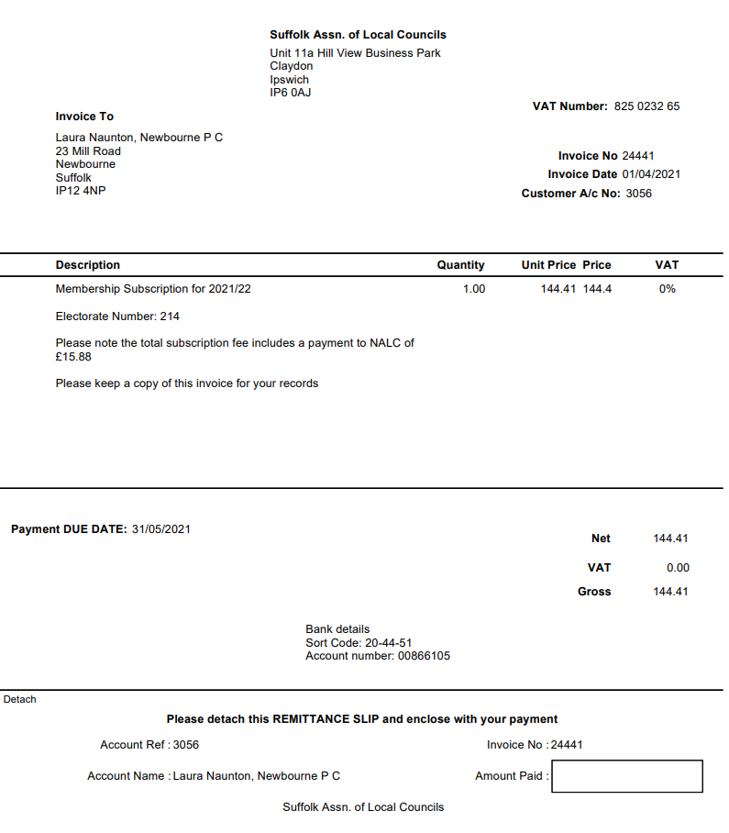

Bank Reconciliation April 2021 – June 2021
A
Cash in hand £16,986.71
Community £12,960.33
Saving £4026.38

ADD
Receipts
£5467.00 Precept
£640.38 Money in from village hall £6107.38

Total £23,094.09

SUBTRACT
Payments
£453.60 Wages 100432
£453.60 Wages 100427
£907.20
£22,186.89

Cash in hand £22,186.89
B
Cash £0.00
Petty Cash £0.00
Community account £18,160.51
Saving £4026.38

A = B £22,186.89

10.Brightwell lakes – Clerk agreed to go to web seminar regarding development.
11. Clerk’s correspondence – Footpath behind steadings will investigate

Agenda items for next meeting
Hedges in village
Highway issue with road coming into Newbourne.

Next Meeting 2nd August 2021

