Minutes of Meeting 06/12/2021
Newbourne Parish Council

Members of the public came to discuss the parking on the verge opposite The Fox Inn, Suggestions have been made if posts could be put into the verge to stop parking. It was discussed that maybe the Fox Inn should submit plans to the council to see if they can use the carpark all year round, also it was suggested that yellow lines were put in the problem area.
Also water from the Spring on The Street is still a problem this has been raised with Highways.
Meeting Opened at 19:40pm by chairman
- Apologies Cllr Pollard, Cllr Lusher, Richard Kerry, Patti Mulcany and Cllr Gammons
- Welcome Mick Richardson. Mick gave us a quick oversight to what he does and will try and attend as many meetings as possible.
Ward Cllrs monthly bulletin – December 2021
Welcome to the December edition of our monthly bulletin, aimed at keeping Councillors up to date on the main news stories from East Suffolk. If you require any assistance, please email or call.

We wish you all a Happy Christmas.
Mick & Richard
michael.richardson@eastsuffolk.gov.uk
Telephone No:
01502 523521
Work Telephone No:
07810 816018

Email:
richard.kerry@eastsuffolk.gov.uk
Mobile Telephone No:
07903 301075

Funding boost for biodiversity
The Greenprint Forum has awarded grants totalling £8,265.19 to 11 projects in East Suffolk which will help to make a difference to the people who live in our communities by enhancing and promoting nature and biodiversity.  The Forum launched its Nature | 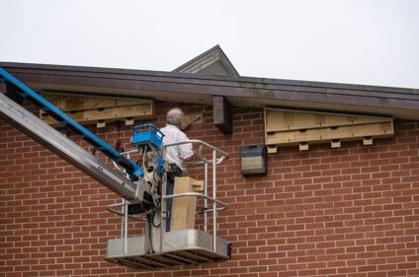
First Small Grant scheme earlier this year, thanks to funding from East Suffolk Council.

Lowestoft in Bloom has been able to create a nature garden at St Margaret’s allotments site after receiving £414.95. Children from local schools will be invited to the garden to discover wildlife, learn about where vegetables come from, and carry out other activities.

Meanwhile, another project to protect biodiversity was allocated £1,600. Jetty Lane CIO is working in partnership with Transition Woodbridge to rewild the land at the site of the future Jetty Lane Centre to ensure biodiversity is protected and provide a useful addition to the network of wildlife corridors in the town.

Read more about the projects which has received funding and details about how to apply at https://www.eastsuffolk.gov.uk/news/funding-boost-for-biodiversity-in-east-suffolk/

New Trading Company to deliver key council services
As part of our commitment to seek the best possible value for money for residents, businesses and all local stakeholders, we’re creating a Local Authority Trading Company (LATCo) to play a more direct and influence role in how important services are delivered.

The LATCo will operate as an ‘arms-length’ commercial business, separate to the Council and will be responsible for crucial services such as waste and recycling collection, grounds maintenance and street cleansing.
This means that we will exercise our right not to renew the contract we hold with Norse for the provision of operational services, and therefore this contract will come to a natural end in July 2023.
Operational staff currently employed by East Suffolk Norse, will be legally entitled to transfer to the new organisation, on the same terms and conditions, through ‘protection under law’ TUPE legislation and we will be seeking as seamless a transition as possible.

Read my full statement here: www.eastsuffolk.gov.uk/news/new-trading-company-to-deliver-key-council-services/

Planting trees for the Queen’s Jubilee
We are supporting ‘Treebilee’, a project launched by HRH Prince Charles to encourage the planting of trees during a year-long celebration of the Queen’s 70-year reign in 2022.

As part of this, we have purchased 200 oak trees which will be donated to every town and parish council in East Suffolk. Not only will this mark the very special occasion, but it will also help tackle climate change and contribute towards our vision to create environmentally sustainable communities.

Town and Parish councils are being written to with details of how to take ownership of their own special tree.
Funding enables Community Hub to serve hot lunches
Cllr Mike Deacon has donated £2,020 from his Enabling Communities Budget to St. Philips Community Hub in Felixstowe.
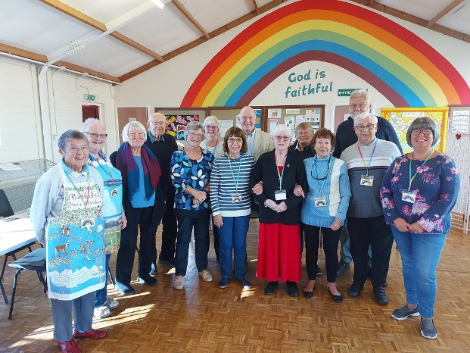 | Initially opened in May 2021 by Reverend Paul Clarke of St Marys Church Walton and St Martin in Trimley along with a group of volunteers as a response to Covid 19, the Hub provides a place where people can come for a cuppa, cake and chat to help reduce isolation and loneliness in the community.  As part of this, the Hub now offers weekly light
lunch, where people can sit down with others to enjoy a warm meal in a relaxed social environment throughout the darker winter months where many feel at their most vulnerable and lonely.
This funding has enabled the Hub to purchase the equipment required to make the lunches as well as enough food for 6 months. Furthermore, the Hub can now also host a Christmas party on 23 December to get everyone into the festive spirit, serving food, drinks and a little Christmas present to those attending.
Additionally, the funding has also enabled the Hub to replace the inefficient lighting in the hall, which now uses brighter and more energy-efficient LED lights.

Trinity Park hosting World Championship cycling event
Hundreds of riders are set to descend on Trinity Park this weekend to compete in the UCI
Masters Cyclo-Cross World Championships.

The adrenaline-fuelled event, which East Suffolk Council has sponsored, will see more than 600 world-class competitors from 20 different nations race along a purpose-built circuit of varying and often tricky terrain, including obstacles, bridges, twisting turns and muddy slopes.

Racing starts at 12.15pm today (Friday 3 December) and 9am tomorrow (Saturday 4 December), with medal ceremonies closing the event at 4pm each day. Supporting races for children and local riders conclude the weekend’s racing on Sunday.

As well as food and sportswear stalls, event-goers will be offered free onsite lateral flow Covid test kits beside the entrance to the arena.

See more details at https://worldmasterscx.co.uk/

Look out for the sticker this Christmas
We’re running a campaign across our social media channels this month to encourage residents and visitors in East Suffolk to look out for the Food Hygiene Rating sticker if they’re planning a meal out or ordering a takeaway.

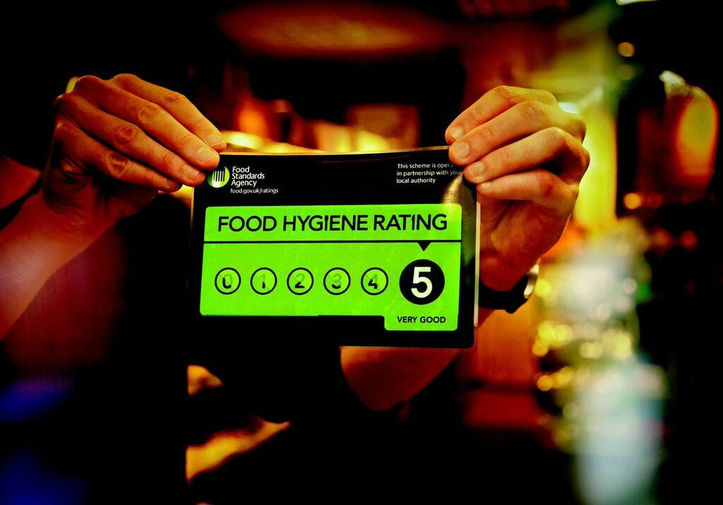 | The Food Hygiene Rating scheme gives information about the hygiene standards in restaurants, pubs, cafes, takeaways, hotels and other food businesses, making it easier for people to choose where to eat or buy their food.  Food businesses are given a hygiene rating when it is inspected by one of our Environmental Health Officers, to show how closely the business is meeting the
requirements of food hygiene law.

The Food Safety Team has awarded food hygiene ratings between 0 - 5 to over 2,200 local food businesses to ensure it is safe for residents and visitors and to help businesses improve, with 5 being very good and 0 meaning urgent improvements are necessary.

Over 98% of food businesses rated in East Suffolk have a Food Safety Rating of 3 or better, meaning there are plenty of great places to choose from when it comes to deciding where to eat or buy festive foods – just make sure to check first.

The first video for the campaign was posted yesterday: https://www.facebook.com/eastsuffolkcouncil/videos/3062768687324219

If you’re active on Facebook, Twitter or Instagram, please make sure you keep an eye out for these and share them, so we can really spread the message about this important service.

People can check food ratings online at https://ratings.food.gov.uk/

Lowestoft leads the UK with new flood defences
A 40m mitre flood gate, the second largest in the UK, will be built in the entrance to Lake Lothing as part of the Lowestoft Flood Risk Management Project. The ambitious project will see the mitre flood gate be the first of such structure in the UK to be built without diverting the navigation channel.

The gate will form the tidal barrier element of the project and be built over a number of winter seasons to maintain access to the inner harbour. The 40m mitre flood gate will keep the width of the current navigation channel for vessels entering Lake Lothing. This approach will allow Lowestoft to continue developing as a hub for offshore wind energy.

The detailed design phase of the mitre flood gate will begin next year and will provide a firm completion date for the project. Once complete, the gate, working in combination with tidal floodwalls, will provide valuable protection for people, homes and businesses for many years to come.

Reducing waste this Christmas
We are encouraging residents to look after the environment this Christmas by reducing waste and considering eco-friendly options where possible, such as ensuring wrapping paper is recyclable, only buy the food needed to avoid food waste and how to dispose of Christmas trees.

Also, there will be no changes to bin collections during the Christmas and New Year period this year, so we’re reminding people to leave their bins out for collection as normal.

As a result, no bin hangers will be left on the bins this year, however, people can view or down a copy of their 2022 bin collection calendar at https://www.eastsuffolk.gov.uk/waste/waste-collection-and-disposal/bin-collection/your-2022-bin-collection-calendar/

Please encourage residents to help those without access to the internet get a copy of their calendars.

Drink, feast and shop east this winter
Residents and visitors to East Suffolk are being urged to ‘drink, feast, shop east’ this winter with a new campaign created to boost local business.  ‘Think Local’ is funded by the Welcome Back Fund to support the safe return to high streets and help build back better from the pandemic. | 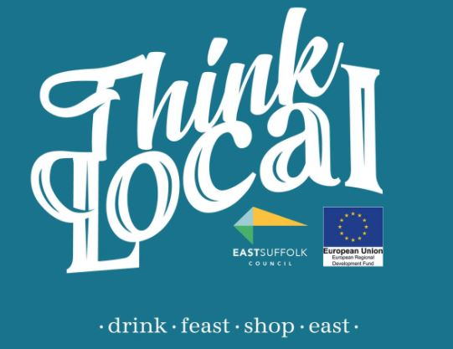

The campaign will highlight hidden gems, share unique local shops, restaurants, pubs and experiences - and deliver a few surprises along the way. It has been given a big thumbs up by shops across East Suffolk who are hoping Christmas trade will help them recover from a difficult 18 months.

Those unable to get to their nearest high street can still support local businesses by using Click It Local East Suffolk, a new virtual high street service.

Launched yesterday (Thursday 2 December), Click It Local East Suffolk has also been funded by the ERDF Welcome Back Fund and is supported by the Council.

Residents anywhere in the district can use Click It Local East Suffolk to buy from any participating local shop and have it delivered on the same or next day. From weekly food essentials, gifts and treats to last-minute basics, customers can buy everything they need from as many shops as they like, with one payment and one delivery.

Businesses interested in finding out more about signing up with Click It Local can contact georgina@clickitlocal.co.uk or sign up directly via www.clickitlocal.co.uk/store-sign-up/

First Light organisers to manage restyled pavilion
The organisers of Lowestoft’s First Light Festival have been confirmed as the operator for the East Point Pavilion, which is to be repurposed into a community and events space.

Last year, planning permission was granted for the pavilion to be redesigned internally, creating a food hall with a mix of traders within a flexible, open plan space for community and cultural activity, art, music and comedy performances.

Supported by the Council, First Light CIC will use their expertise to curate a programme of events and activities to be held within the pavilion, in addition to a unique street food offer. First Light CIC will also use the pavilion as an office base.

A contractor to undertake the refurbishment work is currently being sought, with work expected to start in January, ready for an Easter opening.

Surveys and consultations
We are currently running a couple of surveys and consultations and, as always we want to encourage participation as feedback from people in East Suffolk is invaluable and helps us ensure we’re making the right decisions for our communities.

- Draft East Suffolk CIL Charging Schedule
Residents are invited to have their say on a draft Community Infrastructure Levy Charging Schedule which sets out the amount developers pay to fund new and improved infrastructure in East Suffolk. The consultation ends at 5pm on Thursday 23 December 2021: www.eastsuffolk.gov.uk/planning/developer-contributions/community-infrastructure-levy/cil-charging-schedule/

- The Affordable Housing Supplementary Planning Document
Consultation on draft document which will provide guidance on the implementation of our affordable housing planning policies. People are able to comment until 13 December at https://eastsuffolk.inconsult.uk/ESAFFHSGDRAFT/consultationHome

- The Sustainable Construction Supplementary Planning Document
Consultation on draft document which will provide guidance on our planning policies on sustainable construction, including guidance on a range of topics relating to the construction of environmentally sustainable buildings. People have until 13 December to comment: https://eastsuffolk.inconsult.uk/SUSCONSPDDRAFT/consultationHome

- The draft East Suffolk Cycling and Walking Strategy
Consultation on draft document which provides a district-wide shortlist of cycling and walking infrastructure opportunities. The strategy aims to encourage greater use of sustainable forms of transport, reduce contributions to climate change, support the growth of the tourism industry, and to improve the health and wellbeing of residents by ensuring more trips to work, school, leisure, day-to-day errands, or public transport hubs, such as train stations or park and ride sites, are accessible by bike or on foot. Once adopted, this strategy will replace the Waveney Cycle Strategy (2016) and will cover the whole of the district. People can have their say on the consultation until 10 January at https://storymaps.arcgis.com/stories/cbc57e4a9cc24eeea7d174fb34b1bf0e

- Proposed extension to Beccles Cemetery
People are invited to have their say on proposals to extend Beccles Cemetery. The proposed extension will allow for traditional burial and cremation plots, as well as meadow burial plots where grass will be left to grow longer in the summer. Green burials will also be available. People can view the documents at https://www.eastsuffolk.gov.uk/assets/Community/Cemeteries/Beccles-Cemetery-extension-consultation.pdf and email comments to leisure@eastsuffolk.gov.uk by 31 December 2021.

3. Declarations of Pecuniary Interest – None
4.Previous Meetings Minutes 1/11/2021 All ok Agreed by Cllr Frost and Cllr Wicks
5. Planning
DC/21/5225/OUT Demolition of Nursery Building and erection 1 chalet bungalow
Discussed 1 against – others no comments
DC/21/5189/OUT Construction of detached dwelling, garage
Discussed 1 against – other no comments
6. Fox Issues – Email from Steve Lomas read out to meeting attached.
Dear All
Just a further update and responses.
I have had further discussions with the acoustic and air movement engineers following the noise survey and designs/calculations are currently being worked upon to alleviate the noise whilst maintaining a safe working environment for my team. Early stages but, this could include attenuation of the existing fan, physical barriers or potentially a larger fan to be able to work at lower speeds. I will report when I have something meaningful.
The sound engineers have also highlighted the external fridge & freezer motors as an issue and I have had further discussions with our refrigeration engineers and this is far simpler to remedy.
In regards to the issue of parking I would suggest that if cars were not on the verge they may well be left on the roads which, in my opinion, could be more troublesome. I would welcome the parish council’s views on whether the overflow car park should be able to be used all year round?
As soon as I have anything else to report I will, thanks again for your understanding.
Kind regards
Steve Lomas FBII
Managing Director
Deben Inns Limited

7. Response letter regarding planning regarding the inconsistences and decisions made by east Suffolk planners to SCLP 11.9 and Ex LSA Holdings – Letter discussed, and we will send on email.
8. Water Issue on The Street outside pub. Still ongoing but has been reported to highways to try and rectify the issue they have now made. Will make sure that issue is still logged
9. Up to date bank statement
Bank Reconciliation Oct – Nov 2021

Cash in hand 05/10/2021 £20,919.88
Community £16,893.30
Saving £4026.58
ADD
Receipts £0.00
Total £20,919.88

SUBTRACT
Payments
Cheque 100440 £120.00 Adam Sterry work complete
Cheque 100444 £203.50 Notice Board
Cheque 100435 £242.00 Notice Board
Cheque 100442 £94.80 play area inspection
Cheque 100441 £1513.68 Insurance £2173.98

Cash in hand 05/11/2021 £18,745.90

B
Cash £0.00
Petty Cash £0.00
Community account £14,719.32
Saving £4026.58
£18,745.90

and cheques issued
Cheque 100446 HMRC £113.40
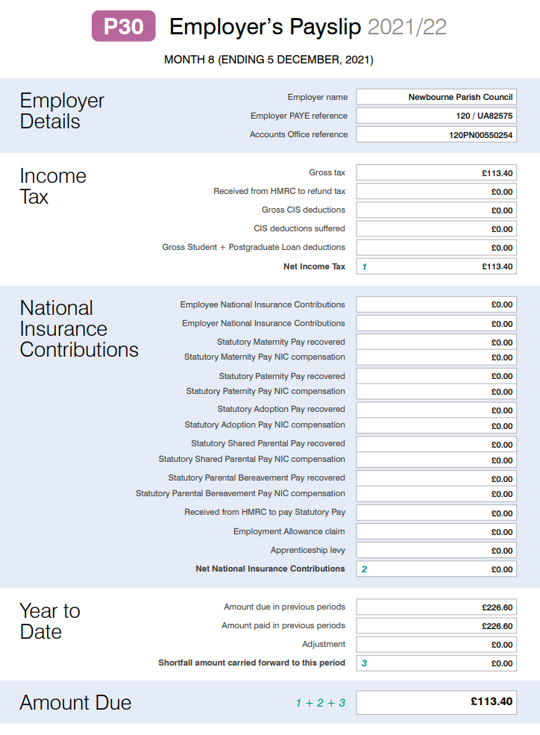
Chq 100447 Clerks Wages £453.40 (up to November 2021)
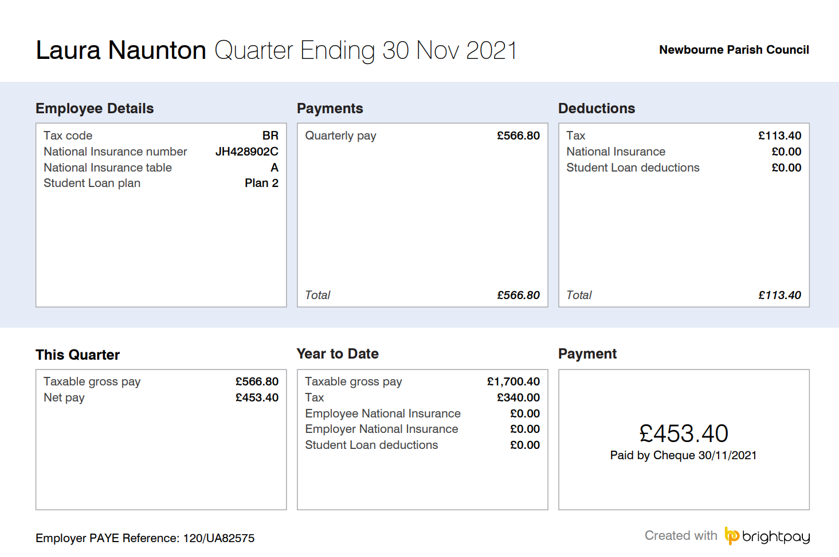
10. Clerks correspondence – Nothing

