Supporting Documents Monday 13th May 2024

Green infrastructure / Biodiverssity

Hello PC colleagues,
I just wanted to update on the Bio diversity planning and this is with apologies for late circulation.
As you may recall from last meeting the plan is to formulate a Group Biodiversity Plan for our local cluster of 5 parishes: Hemley, Newbourne, Waldringfield, Martlesham and Brightwell/Purdis Park. The purpose of joining with the other parishes is to share the load of necessary work within a geographical area which has many shared landscape, habitat and ecological features and issues.
The working group name is the Cluster Green Infrastructure Group.
The next meeting is this week, on Wednesday 15th May at 9.30 at Martlesham PC offices. I will go and will report back with next actions for Newbourne. (Sue P: might you be able to come too?)
There is also a bigger meeting of all the participants who attended the APCCNR (Adaptive Planning for Climate Change and Nature Recovery workshop, now shortened to “Green Infrastructure” for ease of reference) day at Waldringfield on 30th August last year, in Ufford on Wednesday 18th September 2024.
I should have more to bring back to you for the June PC meeting from the Martlesham meeting, but meanwhile I have attached a document from Leicestershire CC on how to set up a Plan. This is worth looking at since it lays out the process of setting up a Biodiversity Policy and then doing the necessary work to set up a Plan.
I have also attached Waldringfield PC’s statement of their Biodiversity Policy (which they have adopted and is registered in the Minutes). I would suggest that we could write a similar Policy statement and record it in our Minutes at the next meeting. We can then follow up with the development of the plan with the other parishes in the Cluster.
I have lots of other links and documents but thought you might not wish to have too many at this stage.
I would also like to suggest that we might produce a leaflet to circulate to all addresses in the Parish saying that the we have adopted a Biodiversity Policy, outlining it very briefly and using this to approach landowners/householders to start the process of increasing biodiversity even before we have finalised a plan (which may take some time!). This could incorporate the poster idea that Laura developed but would be delivered direct rather than on a poster which people might not see. We could also put fuller information on the website.
I would like to note too that Flagship Services, which own and maintain the land in front of Blackthornes, have changed the mowing management schedules to allow some areas to grow longer, but keeping the paths and some parts of the banking cut so that it looks cared for. They did this last year too (in fact I had been in touch with them to suggest it) and at least two orchids were noted in the grassy bank as well as many other wildflowers and grasses. Flagship are a good example of a landowner which now has a policy to maintain areas to increase biodiversity and they have a full time officer (Dan Salliss: Biodiversity and Land Manager) who is an ecologist who arranges the scheme. I have been in contact with him and can provide more details if the PC wishes. This is an example of how we might work with other landowners to manage areas to increase biodiversity and create attractive environments with benefits for wildflowers, insects and many other forms of life.
Lots could happen before the full Plan is developed.
See you tonight,
Terence

Finance

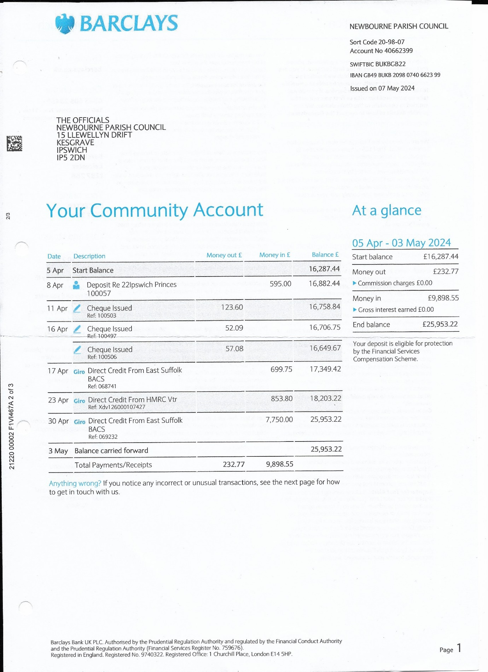
March 2024
Cash in hand 01/03/2024 £20,850.28
Community £16,781.34
Saving £4068.94
Add
£15.22 interest on saving account.

Total £20,865.50

Subtract
Payments
Amount cheque no Payee Cashed
£493.90 100504 clerk wages 07/03/2024

Cash in hand 31/03/2024 £20,371.60
B
Cash £0.00
Petty Cash £0.00
Community Account £16,287.44
Saving Account £4084.16

£20,371.60

April 2024
Cash in hand 01/04/2024 £20,371.60
Community £16,287.44
Saving £4084.16
Add
£595.00 Money in from Quiz Evening
£699.75 CIL Money in from East Suffolk council
£853.80 HMRC Tax
£7750.00 Precept in

Subtract
Payments
AMOUNT CHEQ No PAYEE CASHED
£57.08 100506 VILLAGE HALL INTERNET 16/04/2024
£123.60 100503 HMRC 16/04/2024
£52.09 100497 VILLAGE HALL INTERNET 16/04/2024

Cash in hand 30/04/2024 £30,037.38
B
Cash £0.00
Petty Cash £0.00
Community Account £25,953.22
Saving Account £4084.16

£30,037.38

