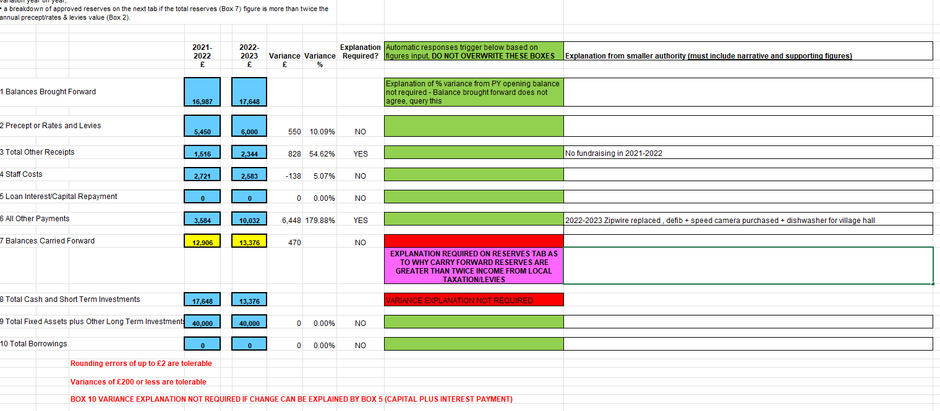
Predicted Spend 2022 -2023
 | Predicted
Clerk Wages | £1980
HMRC | £494
SALC Payroll | £91.20
SALC Membership | £145.00
Postage, Printer ink | £50.00
Insurance | £1500.00
Training | £0.00
Internet | £0.00
Defibrillator | £50.00
Grass Cutting | £800.00
Playground Maintenance | £1000
Celebration Day’s | £1000
Community items | £0.00
Playground inspection | £92.40
Speed camera | £3000.00
CAS | £60.00
Election | £0.00
Donations | £0.00
Membership | £0.00

Predicted Money In
Precept | £6000.00
CIL | £1000.00
Grants from local authorities | £0.00
Fundraising | £500
Village Hall money in | 900

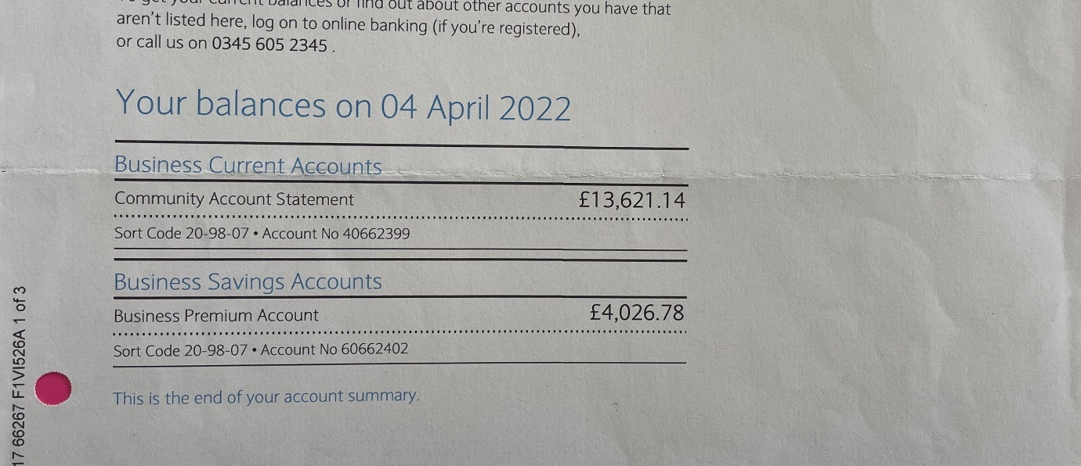

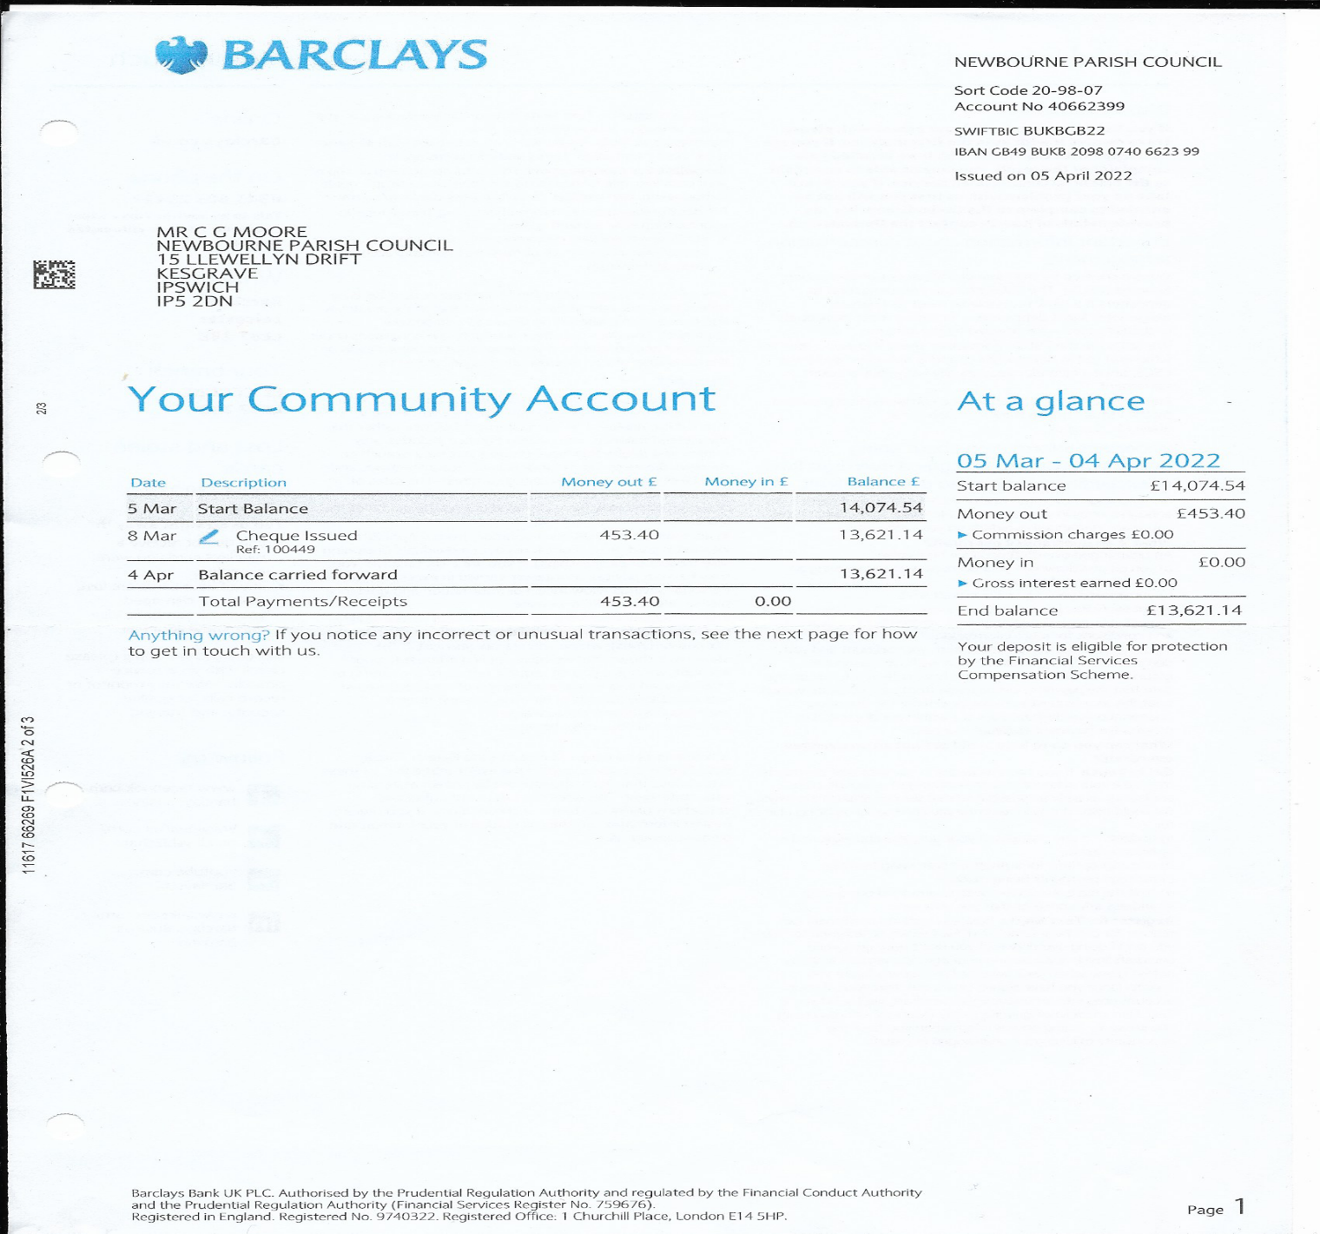
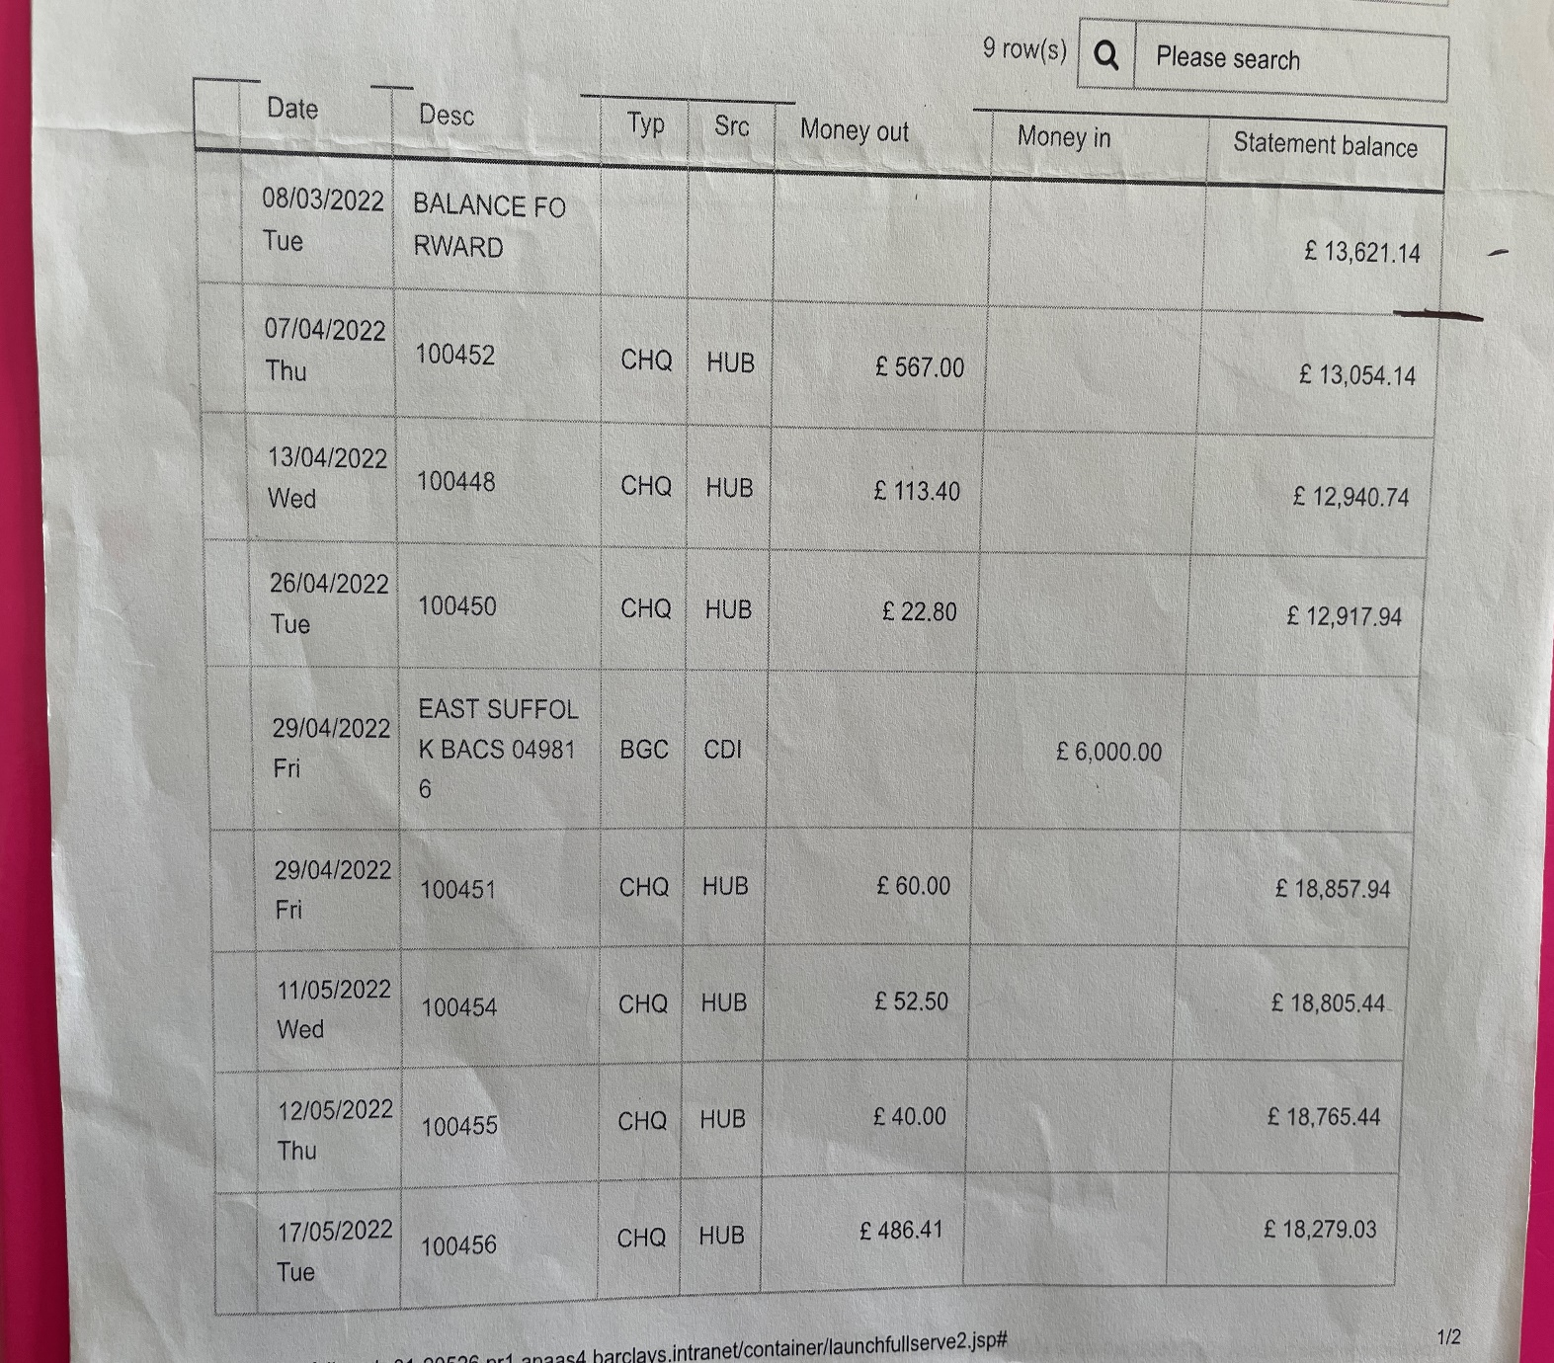
Opening balance from March 2022
Current Account £13,621.14
Saving Account £4026.78
Audit
1.Opening Balance £17,647.92
Community account £13,621.14
Saving Account £4026.78

2. Precept £6000.00
3. Receipts – Money in £2343.59
10/02/2023 Village Hall Money in £926.75
23/02/2023 Fundraising quiz money £710.00
Interest in £8.79
£21/10/2022 CIL Money £698.05

4. Staff payments
13/04/2022 – HMRC - £113.40
07/06/2022 – WAGES - £494.10
19/07/2022 – HMRC - £123.40
10/10/2022 – WAGES – £493.90
07/12/2022 – WAGES - £494.10
02/02/2023 – HMRC - £123.40
08/03/2023 – WAGES- £493.90
23/03/2023 – HMRC - £123.60 £2459.80

5. Loan repayments £0.00

6.Payments £10,032.05
£60.00 100451 Community Action Suffolk
£567.00 100452 Defibrillator box for phone box.
£144.94 100453 SALC Membership
£52.50 100454 Playground oil
£40.00 100455 Defibrillator batteries
£486.41 100456 Tracey Holt Jubilee decorations
£245.00 100457 East coast adventures jubilee celebrations
£52.50 100458 oil for play area
£120.00 100461 Eastern Play area
£1884.00 100462 Dishwasher for village hall
£1302.00 100463 Eastern Play area zipwire repair
£92.40 100464 Play safety,Play area inspection
£1853.51 100465 Insurance
£22.80 100468 SALC Payroll
£975.00 100469 DEFIB AED DONATE
£1800.00 100472 Protect and Detect
£60.00 100473 £60.00 Community Action Suffolk
£71.19 100476 Tracker for Defibrillator £29.00 and printer ink £42.19 = £71.19 Printer ink
£180.00 100477 Adam Sterry – Grass Cutting

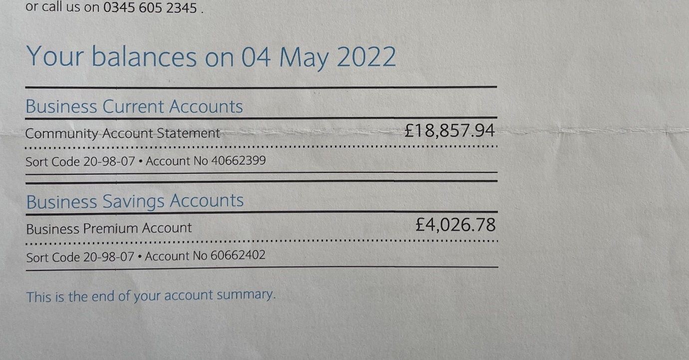

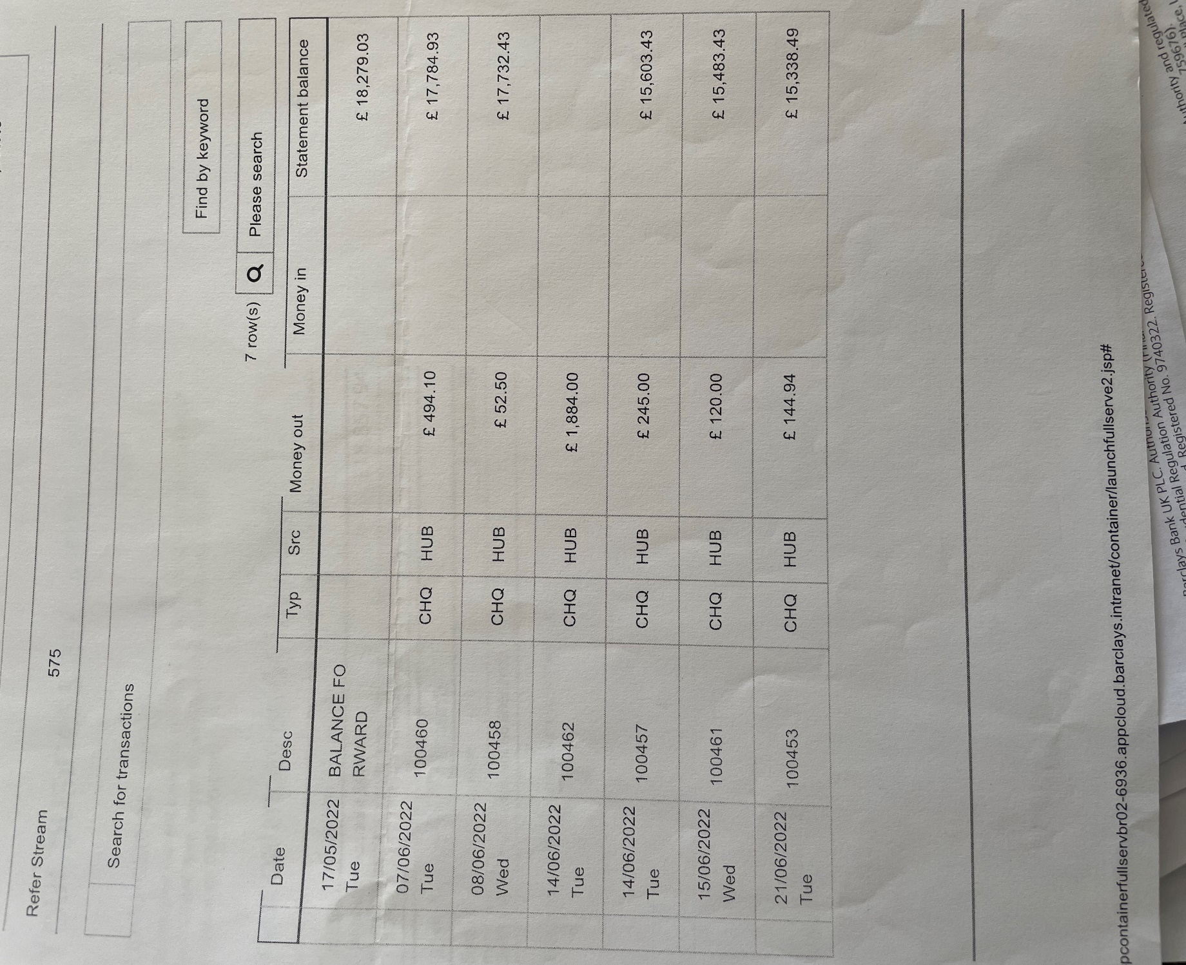

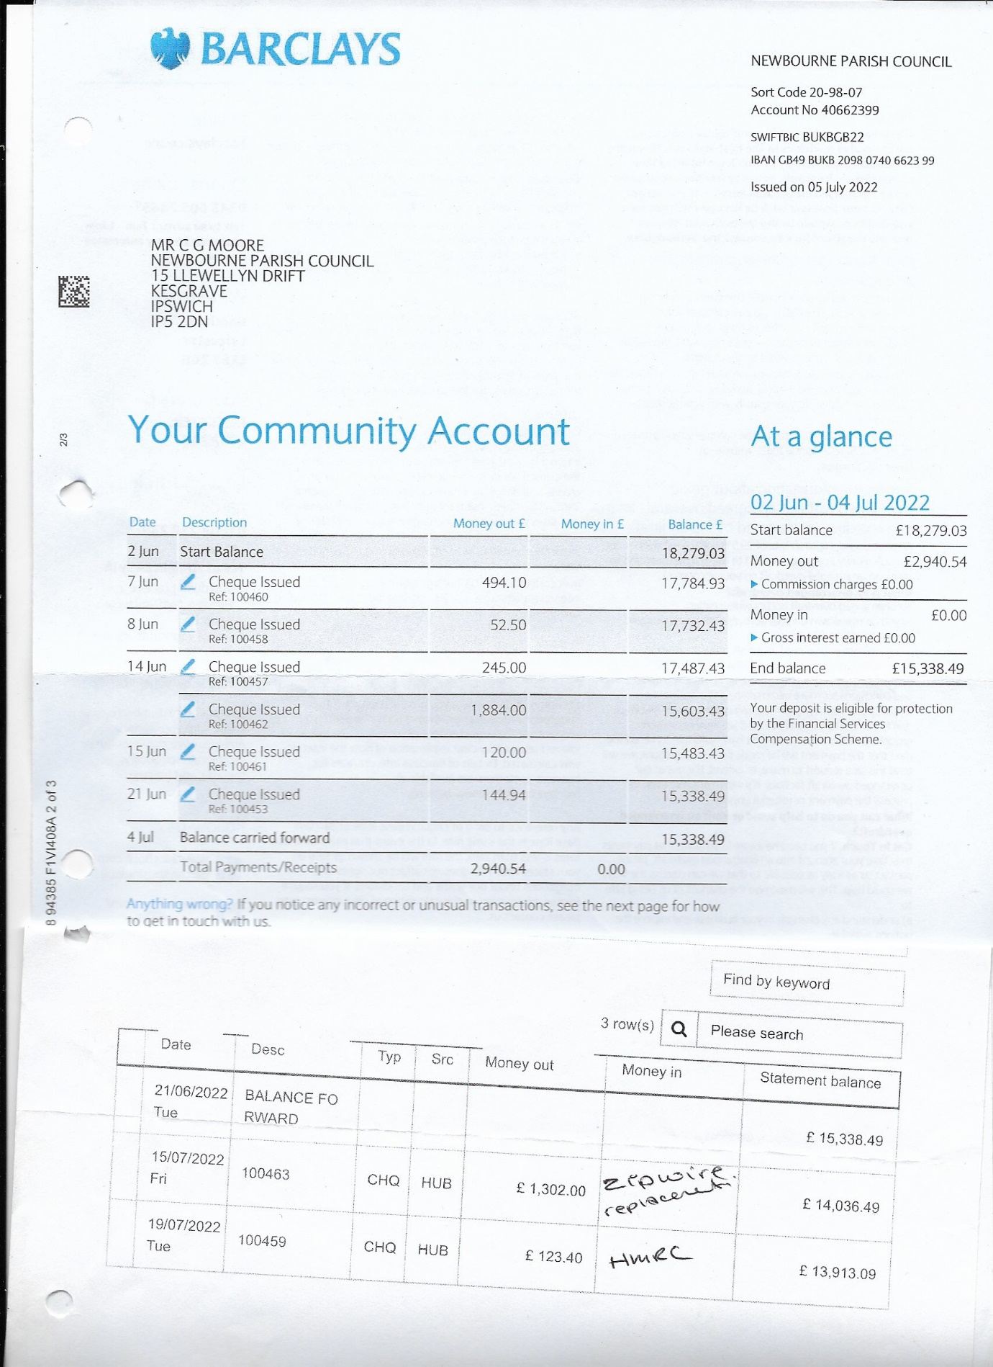

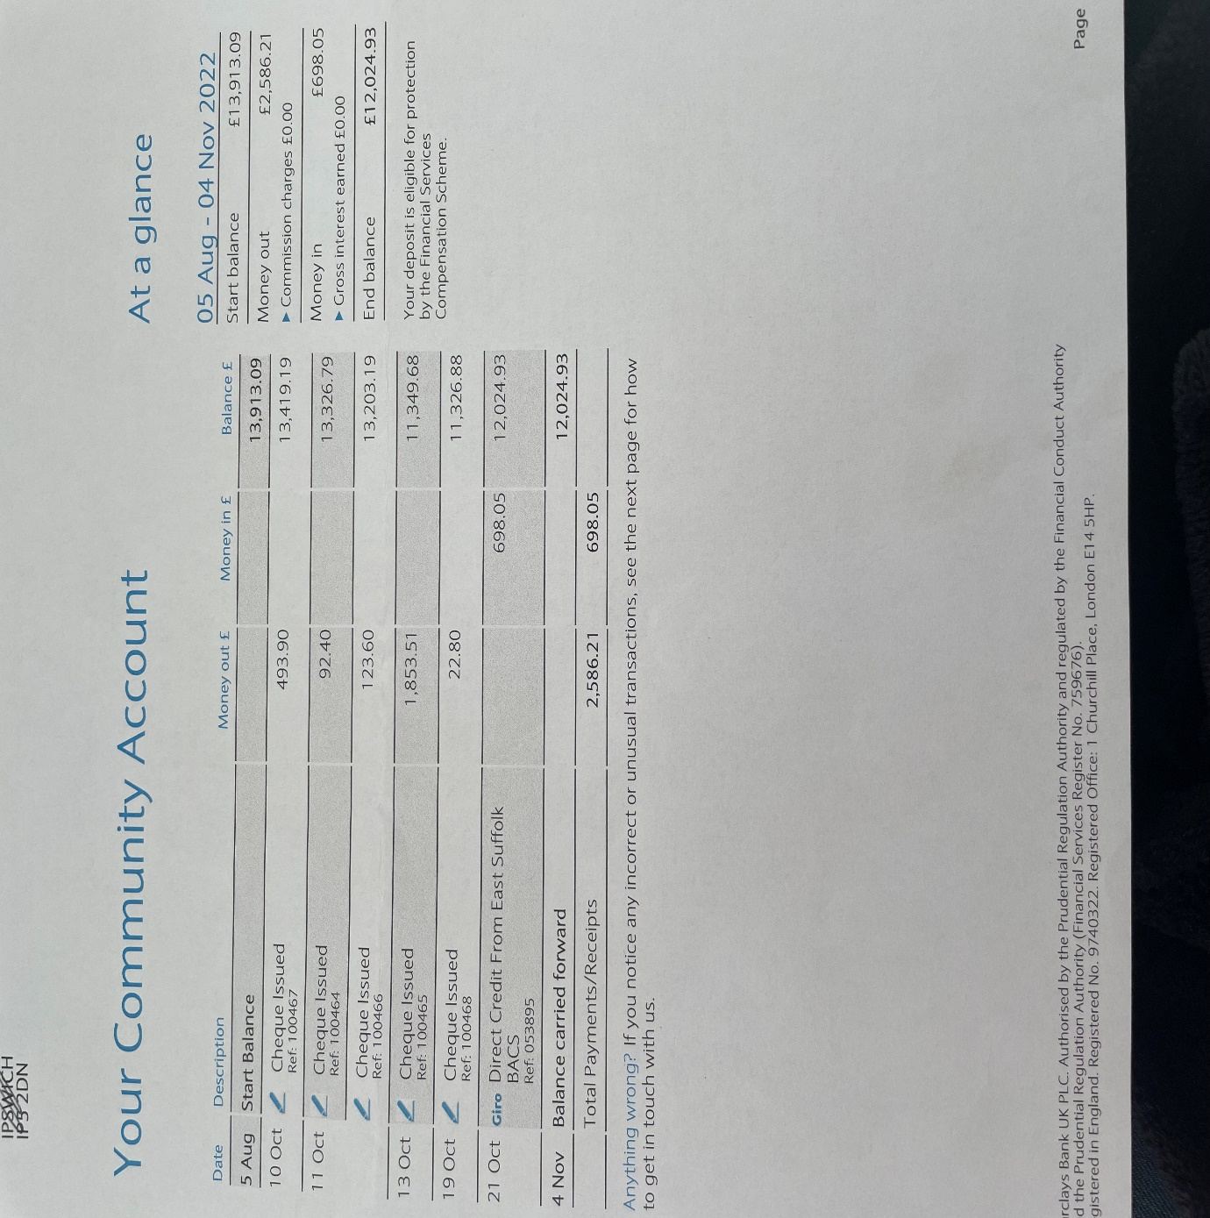

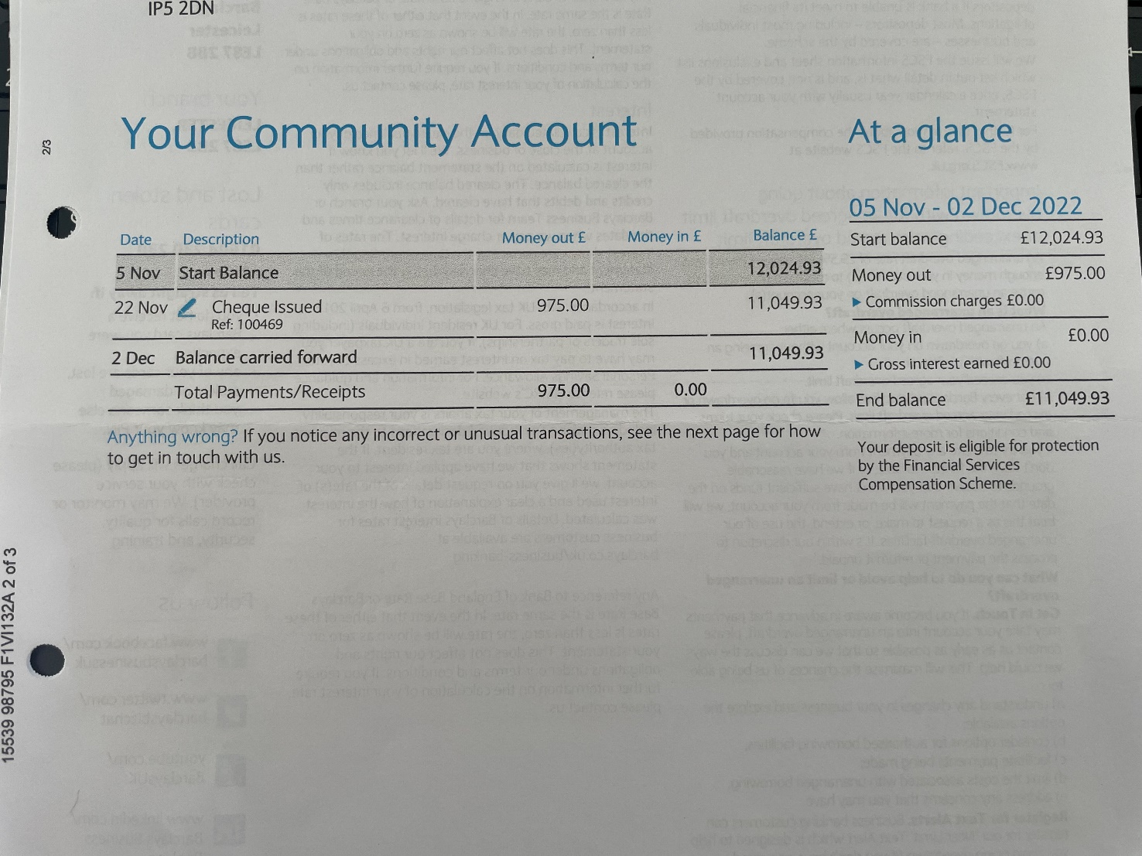

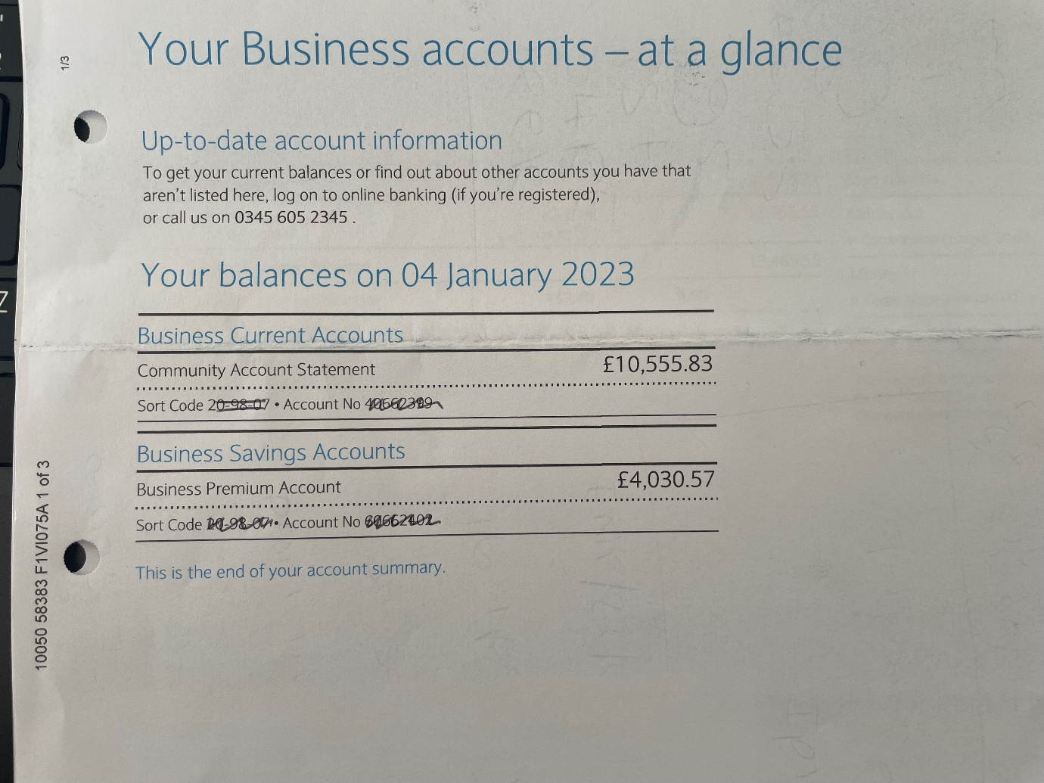
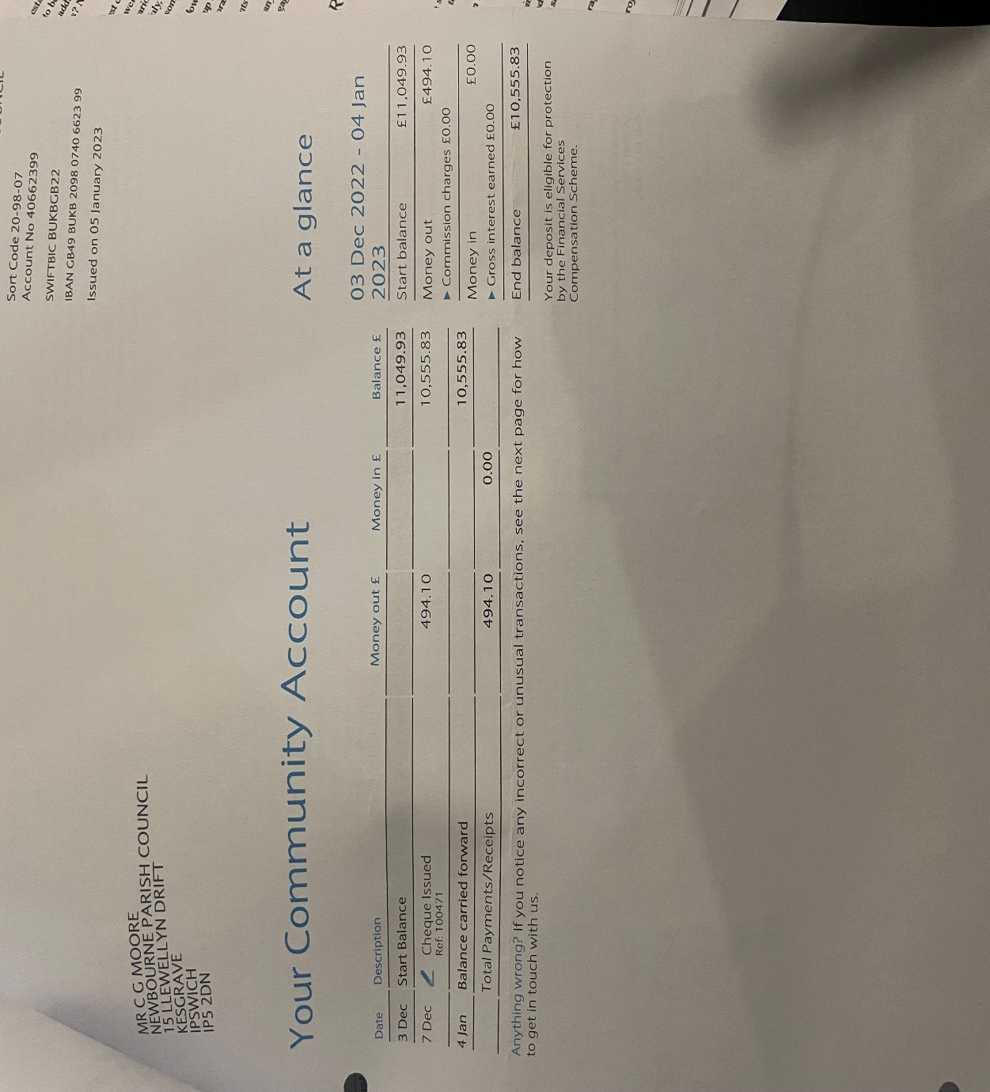

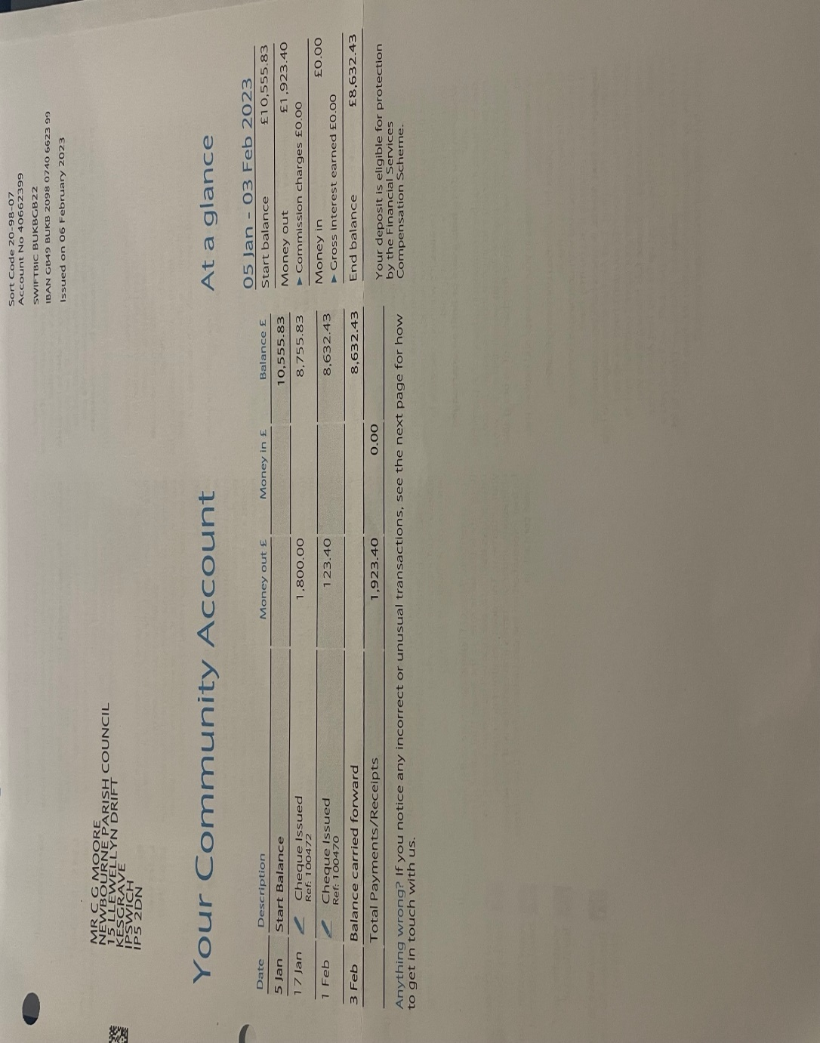
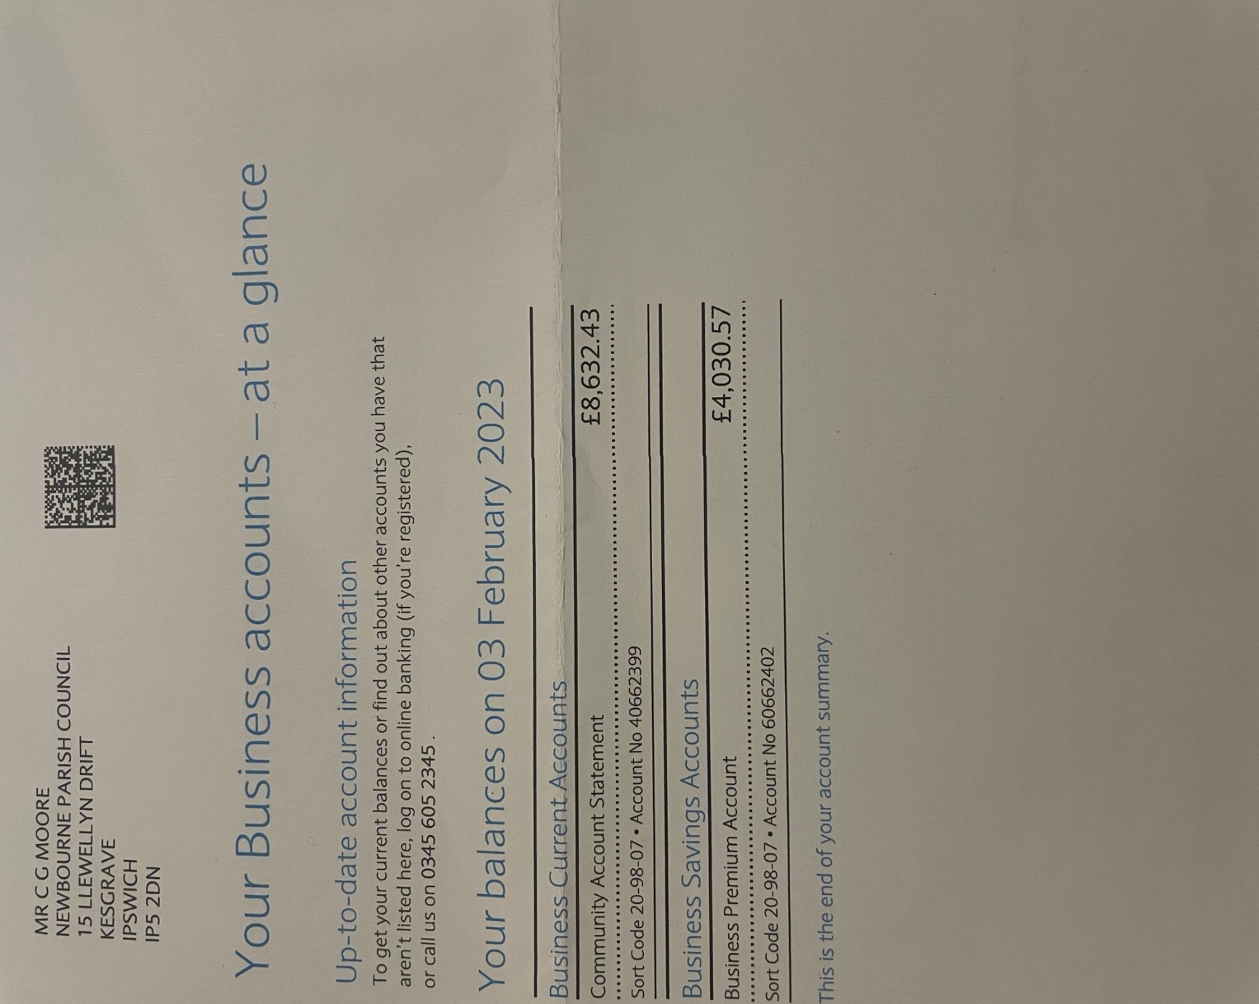
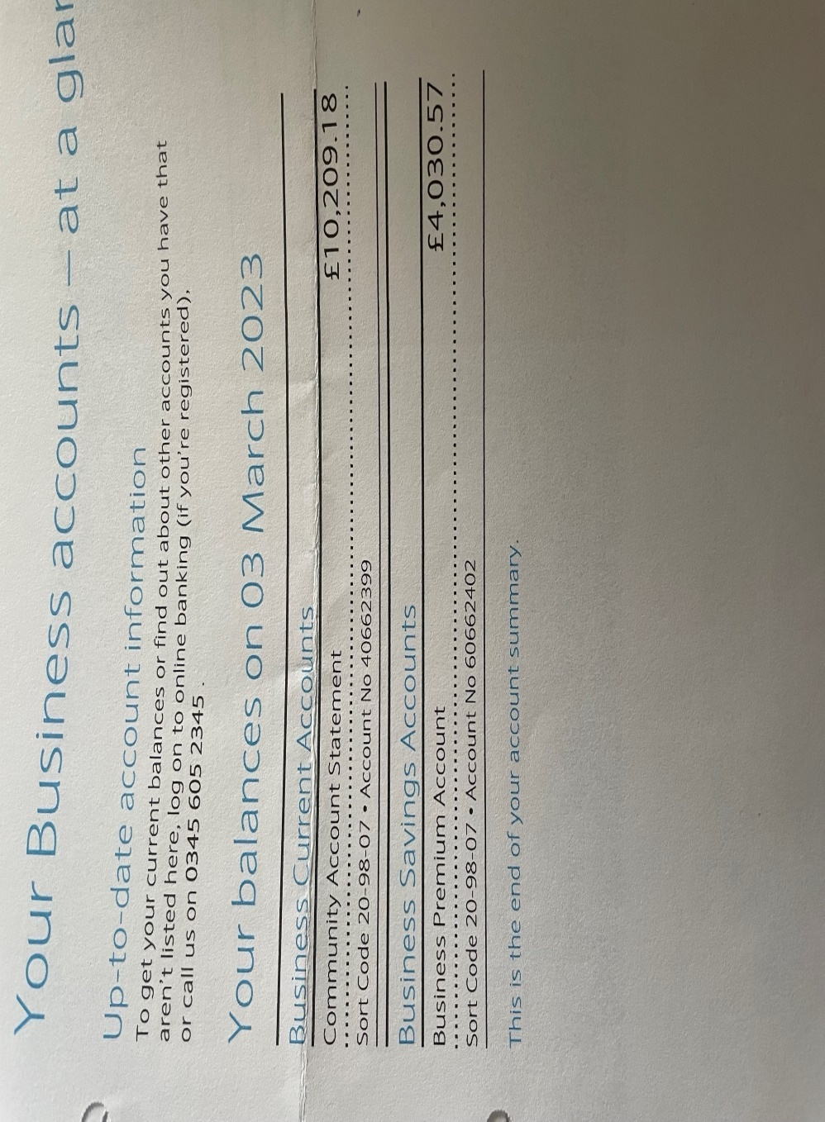

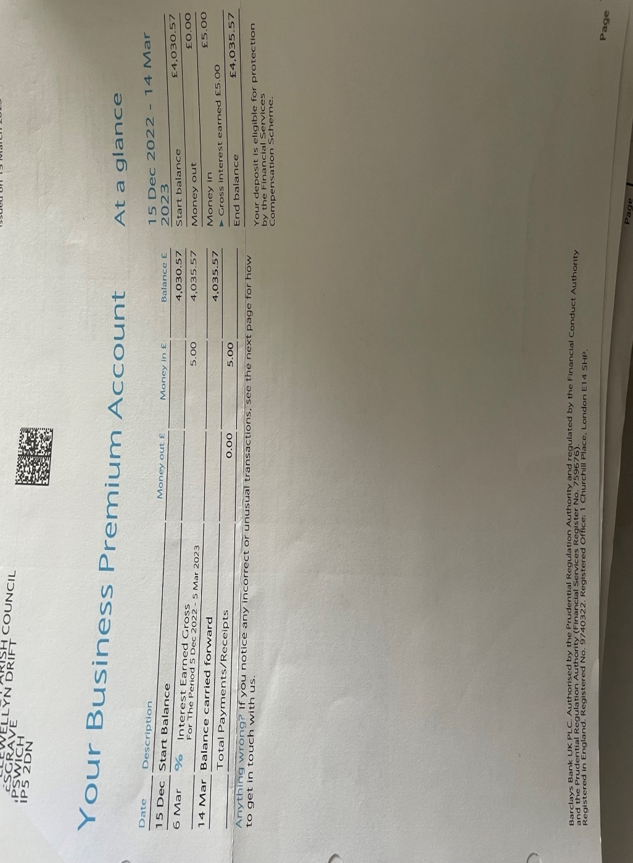
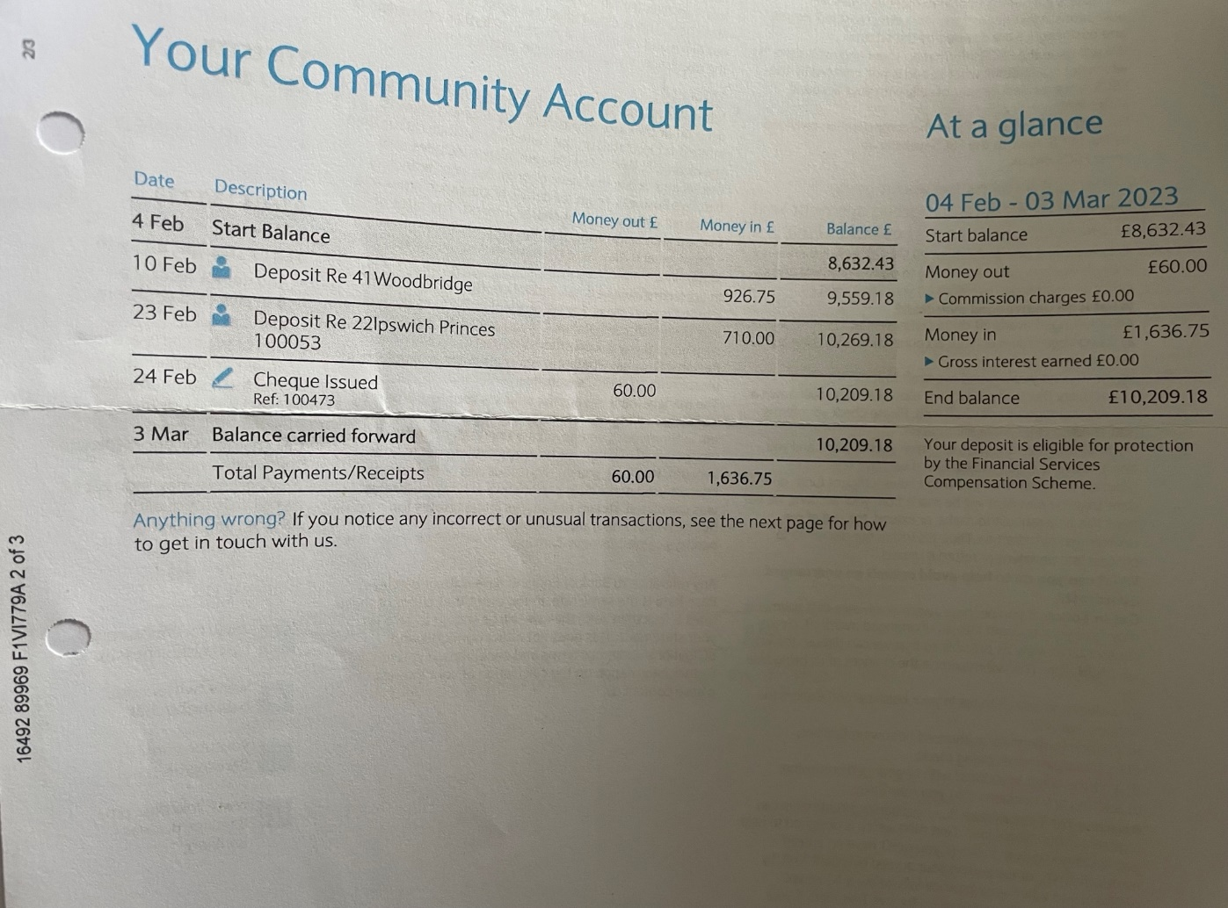
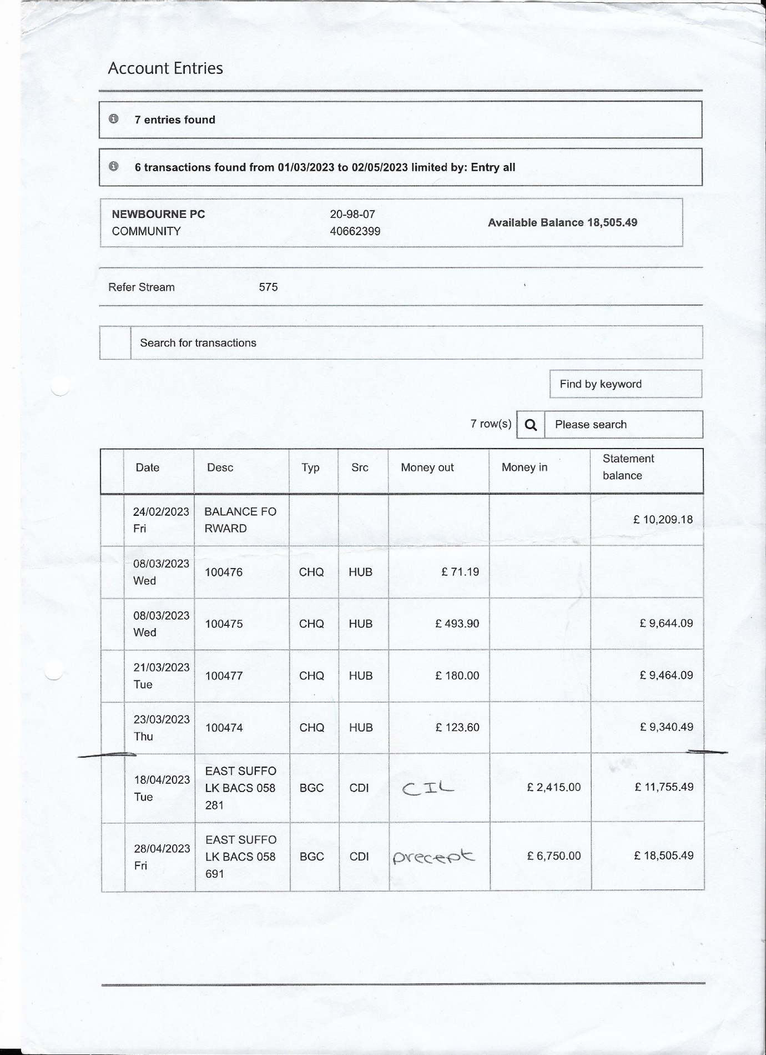

March 2022
Cash in hand 01/03/2022 £18,101.22
Community £14,074.54
Saving £4026.68
ADD
Receipts
0.10p Interest on saving account
Total £18,101.32
SUBTRACT
Payments
AMOUNT CHEQ No PAYEE CASHED
£453.40 100449 Wages 08/03/2022
Cash in hand 01/04/2022 £17,647.92
B
Cash £0.00
Petty Cash £0.00
Community account £13,621.14
Saving £4026.78
£17,647.92

April 2022
Cash in hand 01/04/2022 £17,647.92
Community £13,621,14
Saving £4026.78
ADD
Receipts
£6000.00 Precept £6000.00
Total £23,647.92
SUBTRACT
Payments
AMOUNT CHEQ No PAYEE CASHED
£60.00 100451 CAS Website 29/04/2022
£567.00 100452 Lewis Culf Builders Defib Box 07/04/2022
£113.40 100448 HMRC 13/04/2022
£22.80 100450 SALC payroll 26/04/2022
= £763.20

Cash in hand 30/04/2022 £22,884.72

B
Cash £0.00
Petty Cash £0.00
Community account £18,857.94
Saving £4026.78
£22,884.72

May 2022
Cash in hand 01/05/2022 £22,884.72
Community £18,857.94
Saving £4026.78
ADD
Receipts
£0.00
Total £22,884.72

SUBTRACT
Payments
AMOUNT CHEQ No PAYEE CASHED
£52.50 100454 Playground oil 11/05/2022
£40.00 100455 defib batteries 12/5/2022
£486.41 100456 jubilee decorations 17/05/2022
= £578.91
Cash in hand 01/05/2022 £22,305.81

B
Cash £0.00
Petty Cash £0.00
Community account £18,279.03
Saving £4026.78
£22,305.81

June 2022
Cash in hand 01/06/2022 £22,305.81
Community £18,279.03
Saving £4026.78
ADD
Receipts
£0.30 interest on saving account
Total £22,306.11

SUBTRACT
Payments
AMOUNT CHEQ No PAYEE CASHED
£494.10 100460 Wages 07/06/2022
£52.50 100458 playground oil 08/06/2022
£1884.00 100462 Dishwasher 14/06/2022
£245.00 100457 Jubilee event 15/06/2022
£120.00 100461 Playarea 15/06/2022
£144.94 100453 SALC membership 21/06/2022
= £2940.54
Cash in hand 01/06/2022 £19,365.57
B
Cash £0.00
Petty Cash £0.00
Community account £15,338.49
Saving £4027.08
£19,365.57

July 2022

Cash in hand 01/07/2022 £19,365.57
Community £15,338.49
Saving £4027.08
ADD

Total £19,365.57
SUBTRACT
Payments
AMOUNT CHEQ No PAYEE CASHED
£1302.00 100463 zipwire 15/07/2022
£123.40 100459 HMRC 19/07/2022
= £1425.40
Cash in hand 01/07/2022 £17,940.17
B
Cash £0.00
Petty Cash £0.00
Community account £13,913.09
Saving £4027.08
£17,940.17

August 2022

Cash in hand 01/08/2022 £17,940.17
Community £13,913.09
Saving £4027.08
ADD
Total £17,490.17
SUBTRACT
Payments
AMOUNT CHEQ No PAYEE CASHED
Cash in hand 01/08/2022 £17,940.17
B
Cash £0.00
Petty Cash £0.00
Community account £13,913.09
Saving £4027.08
£17,940.17
September 2022
Cash in hand 01/09/2022 £17,940.17
Community £13,913.09
Saving £4027.08
ADD
£1.24 interest on savings account
Total £17,941.41
SUBTRACT
Payments
AMOUNT CHEQ No PAYEE CASHED

Cash in hand 01/09/2022 £17,941.41
B
Cash £0.00
Petty Cash £0.00
Community account £13,913.09
Saving £4028.32
£17,941.41
October 2022

Cash in hand 01/10/2022 £17,941.41
Community £13,913.09
Saving £4028.32
ADD
£698.05 CIL payment in from ESC
Total £18,639.46
SUBTRACT
Payments
AMOUNT CHEQ No PAYEE CASHED
£493.90 100467 WAGES 10/10/2022
£92.40 100464 PLAYGROUND 11/10/2022
£123.60 100466 HMRC 11/10/2022
£1853.51 100465 INSURANCE 13/10/2022
£22.80 100468 SALC 19/10/2022
= £2586.21
Cash in hand 01/10/2022 £16,053.25
B
Cash £0.00
Petty Cash £0.00
Community account £12,024.93
Saving £4028.32
£16,053.25

November 2022
Cash in hand 01/11/2022 £16,053.25
Community £12,024.93
Saving £4028.32
ADD
Total £16,053.25
SUBTRACT
Payments
AMOUNT Cheq nO PAYEE CASHED
£975.00 100469 defib 22/11/2022
Cash in hand 01/11/2022 £15,078.25
B
Cash £0.00
Petty Cash £0.00
Community account £11,049.93
Saving £4028.32
£15,078.25
December 2022
Cash in hand 01/12/2022 £15,078.25
Community £11,049.93
Saving £4028.32
ADD
Total £15,078.25
SUBTRACT
Payments
Amount Cheq no Payee Cashed
£494.10 100471 Wages 07/12/2022

Cash in hand 01/12/2022 £14,584.15
B
Cash £0.00
Petty Cash £0.00
Community account £10,555.83
Saving £4028.32
£14,584.15

January 2023

Cash in hand 01/01/2023 £14,584.15
Community £10,555.83
Saving £4028.32
ADD
£2.25 interest on saving account.
Total £14,586.40
SUBTRACT
Payments
AMOUNT CHEQ No PAYEE CASHED
£1800.00 100472 speed camera 17/01/2023

Cash in hand 30/02/2023 £12,786.40
B
Cash £0.00
Petty Cash £0.00
Community account £8755.83
Saving £4030.57
£12,786.40

February 2023

Cash in hand 01/02/2023 £12,786.40
Community £8755.83
Saving £4030.57
ADD
£926.75 Money in from Village Hall
£710.00 Money in from Quiz

Total £14,423.15

SUBTRACT
Payments
AMOUNT CHEQ No PAYEE CASHED
£123.40 100470 HMRC 01/02/2023
£60.00 100473 CAS Website 24/02/2023

Cash in hand 28/02/2023 £14,239.75
B
Cash £0.00
Petty Cash £0.00
Community account £10,209.18
Saving £4030.57
£14,239.75

March 2023
Cash in hand 01/03/2023 £14,239.75
Community £10,209.18
Saving £4030.57
ADD
£5.00 INTEREST ON SAVING ACCOUNT 06/03/2023
Total £14,244.75

SUBTRACT
Payments
AMOUNT CHEQ No PAYEE CASHED
£71.19 100476 Tracker + ink 08/03/2023
£493.90 100475 wages 08/03/2023
£180.00 100477 Grass cutting 21/03/2023
£60.00 Website
£123.60 100474 HMRC 23/03/2023
= £868.69

Cash in hand 01/04/2023 £13,376.06
B
Cash £0.00
Petty Cash £0.00
Community account £9340.49
Saving £4035.57
£13,376.06

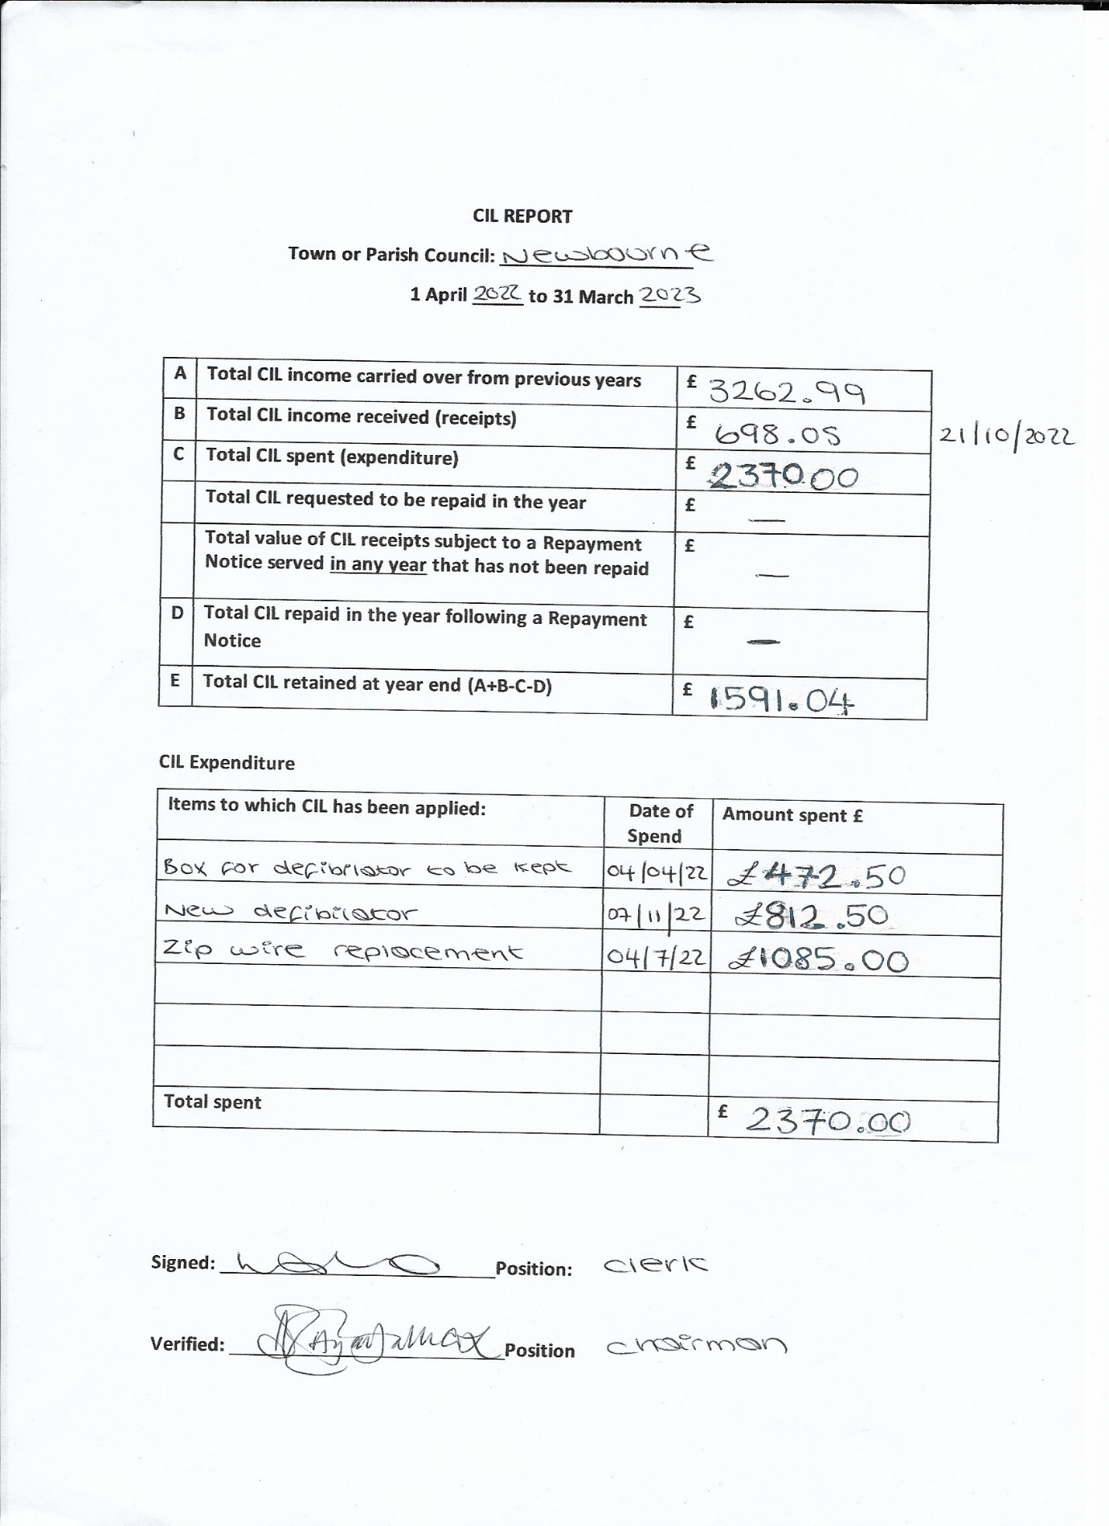

 | Predicted | What was Spent
Clerk Wages | £1980.00 | £1976.00  £494.10  £493.90  £494.10  £493.90
HMRC | £494.00 | £483.80  £113.40  £123.40  £123.40  £123.60
SALC Payroll | £91.20 | £45.60  £22.80 26/04/2022  £22.80 19/10/2022
SALC Membership | £145.00 | £144.94
Printer ink | £50.00 | £71.19
Insurance | £1500.00 | £1853.51
Training | £0.00 | £0.00
Internet | £0.00 | £0.00
Defibrillator | £50.00 | £40.00 Batteries  £567.00 Defib box  £975.00 New Defib
Grass cutting / Maintenance | £800.00 | £180.00
Playground Repairs | £1000.00 | £52.50 Playground oil  £52.50 Playground Oil  £120.00 Removal of damaged parts /inspection of zip wire  £1302.00 Zipwire replacement
Village Items | £0.00 | £1884.00 Dishwasher for village Hall
Village Day | £1000.00 | £486.41 Decorations for Jubilee Celebration  £245.00 East Coast Adventures
Playground Inspection | £92.40 | £92.40
Speed Camera | £3000.00 | £1800.00
Donations | £0.00 | £0.00
Membership | £0.00 | £0.00
CAS Website | £60.00 | £60.00 29/04/2022  £60.00 24/02/2023

Money In
Precept | £6000.00
Interest in from saving account | £8.79
CIL | £698.05
Grants from local authorities | 0.00
Fundraising | £710.00 quiz money
Village Hall money in | £926.75

Money Out
Date | Description | AMOUNT
07/04/2022 | DEFIB BOX | £567.00
13/04/2022 | HMRC | £113.40
26/04/2022 | SALC FINANCE | £22.80
29/04/2022 | PRECEPT | £6,000.00
29/04/2022 | WEB SITE | £60.00
11/05/2022 | oil for playarea | £52.50
12/05/2022 | defib batteries | £40.00
17/05/2022 | Decorations jubilee | £486.41
07/06/2022 | wages | £494.10
08/06/2022 | oil for playarea | £52.50
14/06/2022 | dishwasher village hall | £1,884.00
14/06/2022 | east coast adventures | £245.00
15/06/2022 | damaged play area | £120.00
21/06/2022 | salc membership | £144.94
15/07/2022 | replace zipwire | £1,302.00
19/07/2022 | hmrc | £123.40
10/10/2022 | wages | £493.90
11/10/2022 | play area inspection | £92.40
13/10/2022 | insurance | £1,853.51
19/10/2022 | salc membership | £22.80
19/10/2022 | hmrc | £123.40
22/11/2022 | new defib | £975.00
07/12/2022 | wages | £494.10
17/01/2023 | Speed camera | £1,800.00
02/02/2023 | hmrc | £123.40
10/02/2023 | village hall money | £926.75
23/02/2023 | quiz fundraising | £710.00
24/02/2023 | Website | £60.00
08/03/2023 | tracker and printer ink | £71.19
08/03/2023 | wages | £493.90
21/03/2023 | grass cutting | £180.00
23/03/2023 | hmrc | £123.60
 |  | =£10,032.05

Asset Register
Description | Location | Date brought | Cost | value | Insurance Value
Village Hall | Mill road , Newbourne | 1985 | £2000.00 | £2000.00 nominal | £350.000
Play area | Village hall grounds | 2010 | £44,000 | £44,000 | £40,000
Bus Shelter | Opposite fox pub | Pre 1980 | Not known | £1 nominal | Outside furniture policy
Park bench | Village hall | 2012 | £800.00 | £800.00 | Outside furniture policy
Newbourne village sign | Centre of village | 2006 | £3094.00 | £3094.00 | Outside furniture policy
3 grit bins | Mill road, jackson road, Ipswich road | 2013 | £406.00 | £406.00 | Outside furniture policy
Litter bin | Village hall gounds | 2014 | £240.00 | £240.00 | Outside furniture policy
Sign | Village hall grounds | 2014 | £183.00 | £183.00 | Outside furniture policy
Notice Board | Outside village hall | 2020 | £1000.00 | £1000.00 | Outside furniture policy
Defibrillator | Outside pub | 2023 | £1500 | £1500 | £1500.00
Speed Camera | Outside village hall | 2023 | £1800.00 | £1800.00 | £1800.00
 | YEAR ENDING 2021- 2022 | YEAR ENDING 2022 -2023
Balance brought Forward | £16,987 | £17,648
Precept | £5,450 | £6,000.00
Receipts | £1,516.00 | £2,344.00
Staff costs | £2,721.00 | £2,459.80
Loan | £0.00 | £0.00
payments made | £3,584.00 | £10,032.00
Balance carried forward | £17,648 | £13,376.06

