Finance 1ST April 2022 – 31st March 2023
Predicted Spend 2022 -2023
 | Predicted
Clerk Wages | £1980
HMRC | £494
SALC Payroll | £91.20
SALC Membership | £145.00
Postage, Printer ink | £50.00
Insurance | £1500.00
Training | £0.00
Internet | £0.00
Defibrillator | £50.00
Grass Cutting | £800.00
Playground Maintenance | £1000
Celebration Day’s | £1000
Community items | £0.00
Playground inspection | £92.40
Speed camera | £3000.00
CAS | £60.00
Election | £0.00
Donations | £0.00
Membership | £0.00

Predicted Money In
Precept | £6000.00
CIL | £1000.00
Grants from local authorities | £0.00
Fundraising | £500
Village Hall money in | 900

Opening balance from March 2022
Current Account £13,621.14
Saving Account £4026.78

APRIL CHEQUES
Cheque Number 100451 Community Action Suffolk £60.00 Website
Cheque Number 100452 Lewis Culf £567.00 Defibrillator box for phone box. New Defibrillator box to keep the defibrillator at constant temperature.
Cheque Number 100453 SALC Membership £144.94 Membership for Suffolk association of local council membership
Cheque Number 100454 Playground oil £52.50 Playground maintenance
Cheque Number 100455 L Naunton Defibrillator batteries £40.00 Defibrillator Maintenance
MONEY IN
29/04/2022 East Suffolk Precept £6000.00

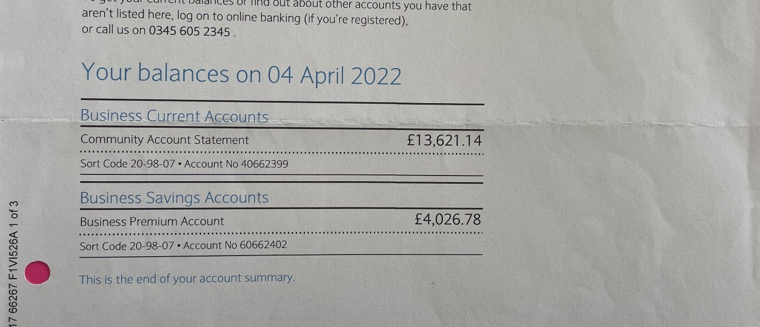

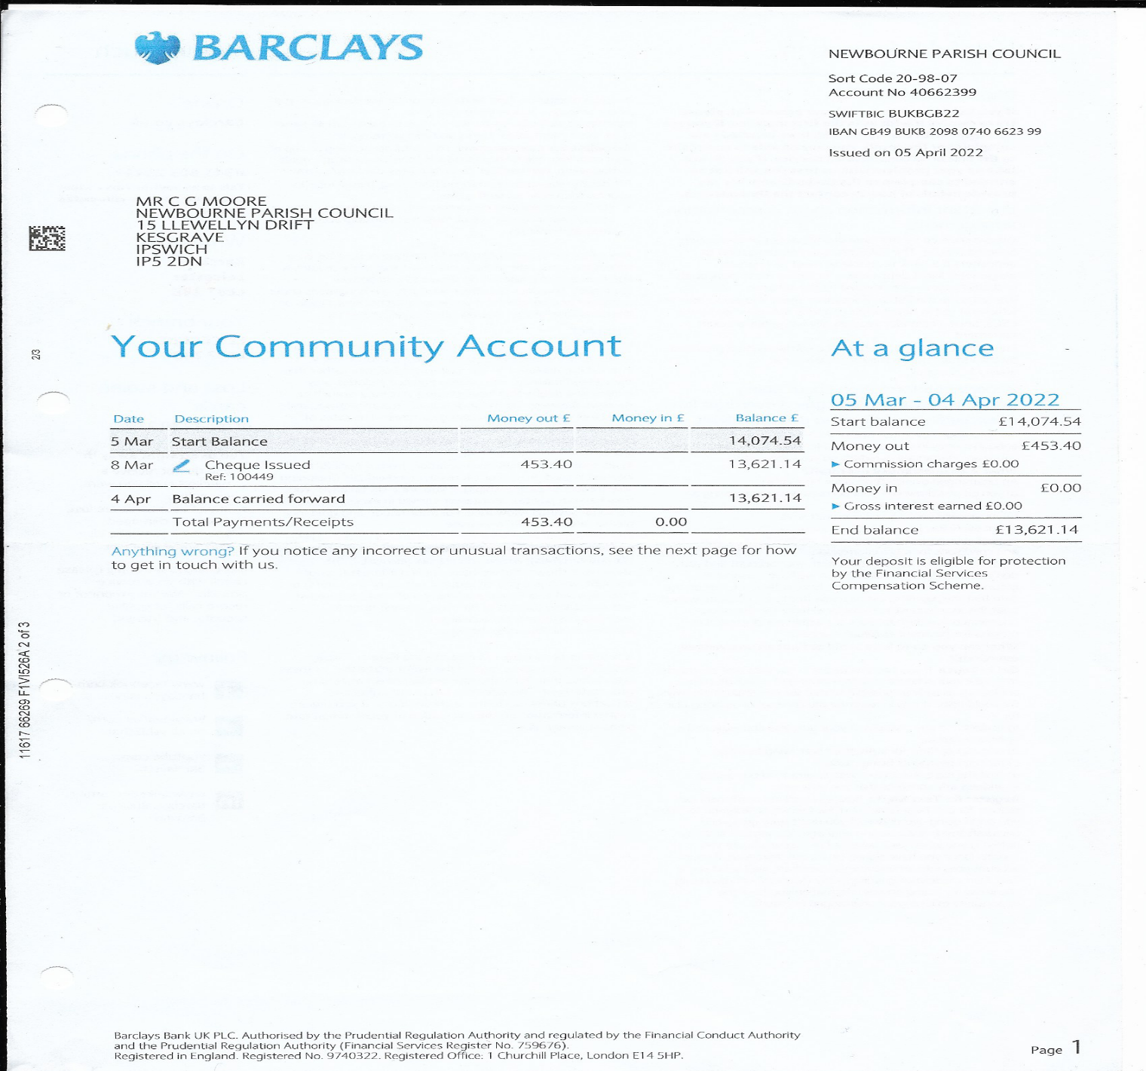
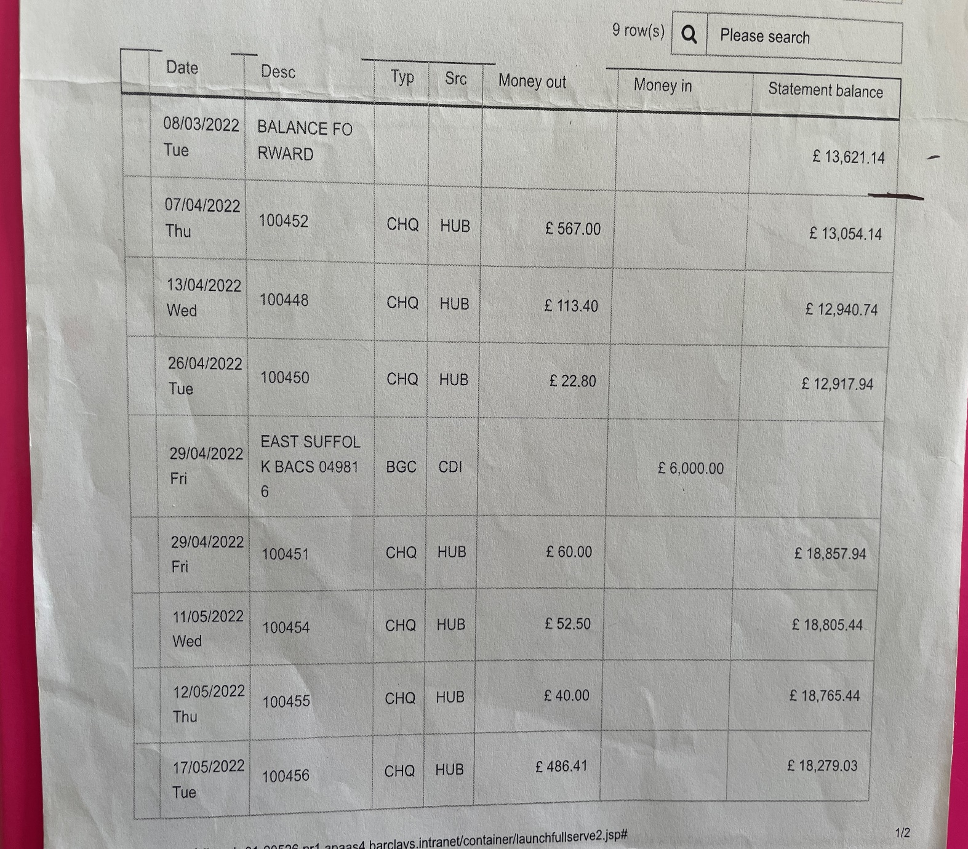

May Cheques
Cheque 100456 Tracey Holt Jubilee decorations £486.41 Decorations for our Jubilee celebrations
Money In
£0.00
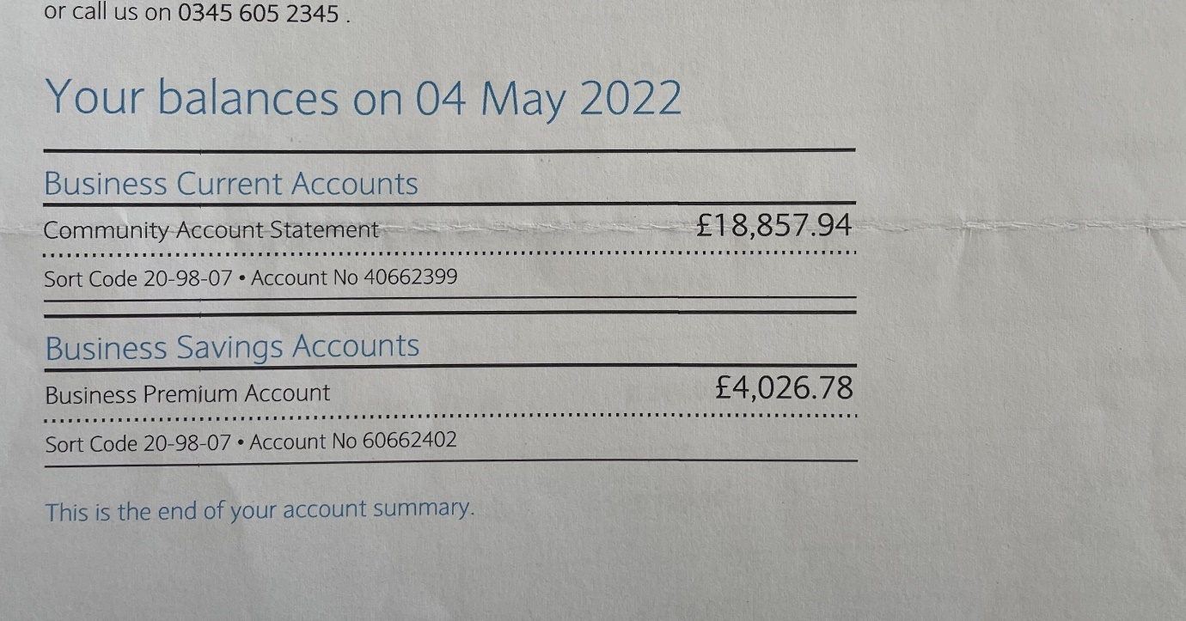
May Balance 2022
Current £18,857.94
Saving £4026.78

JUNE CHEQUES
Cheque 100457 East coast Adventures £245.00 Jubilee Celebration activity
Cheque 100458 Tim Leeder oil for play area £52.50 Play area maintenance
Cheque 100459 HMRC £123.40 HMRC payment for wages February – May 2022
Cheque 100460 Clerk wages £494.10 L Naunton Wages February – May 2022
Cheque 100461 Eastern Play area £120.00 Remove damaged play parts and inspect zipwire.
Cheque 100462 Dishwasher for village hall £1884.00 Replacement for dishwasher in village hall

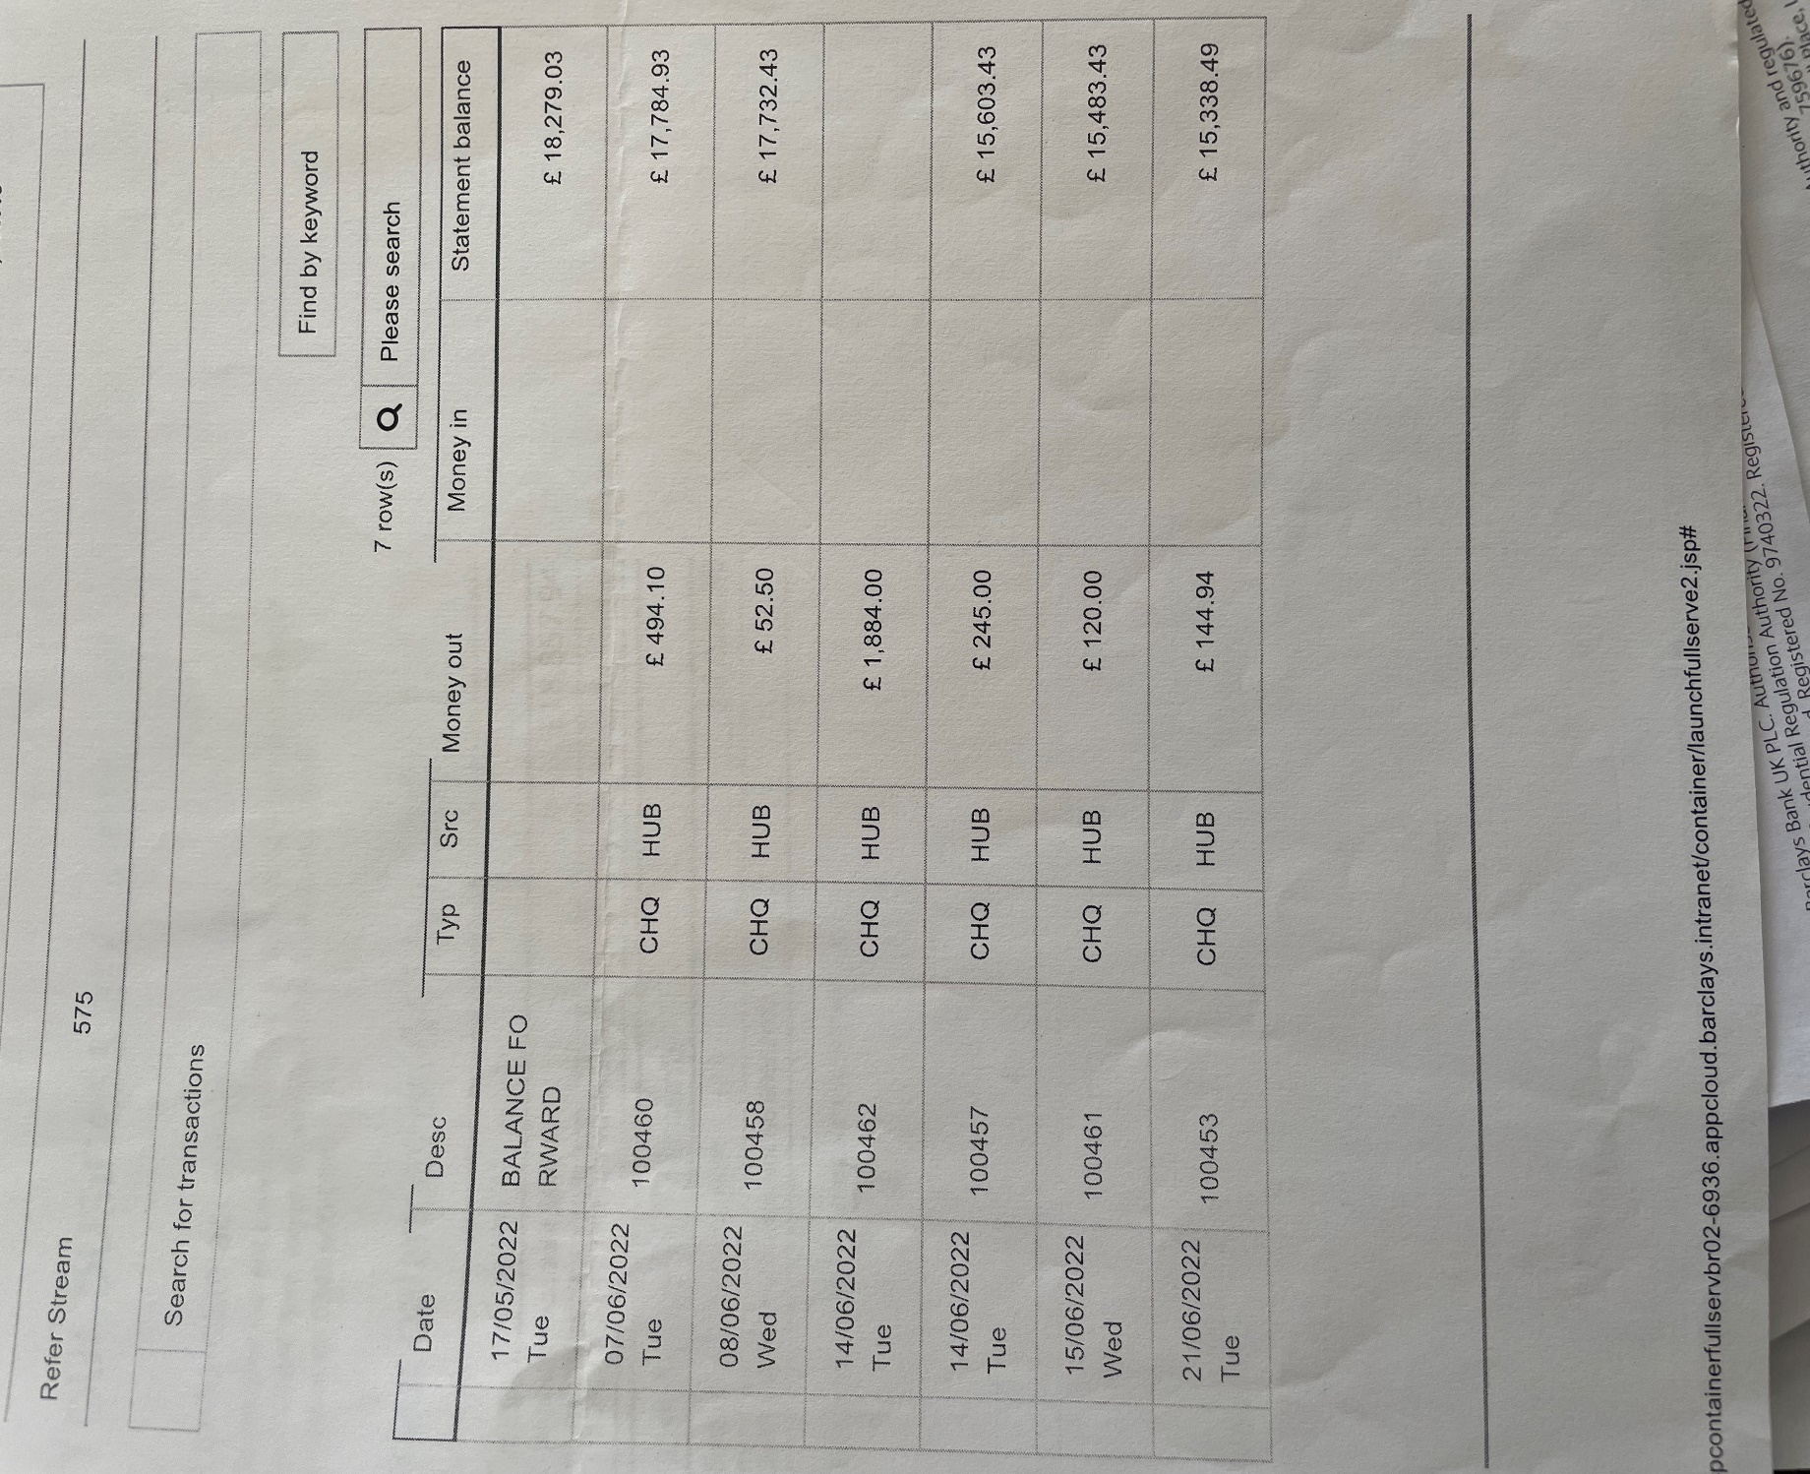

JULY CHEQUES
Cheque 100463 Eastern Play area £1302.00 Replacement Zip wire INV 1928

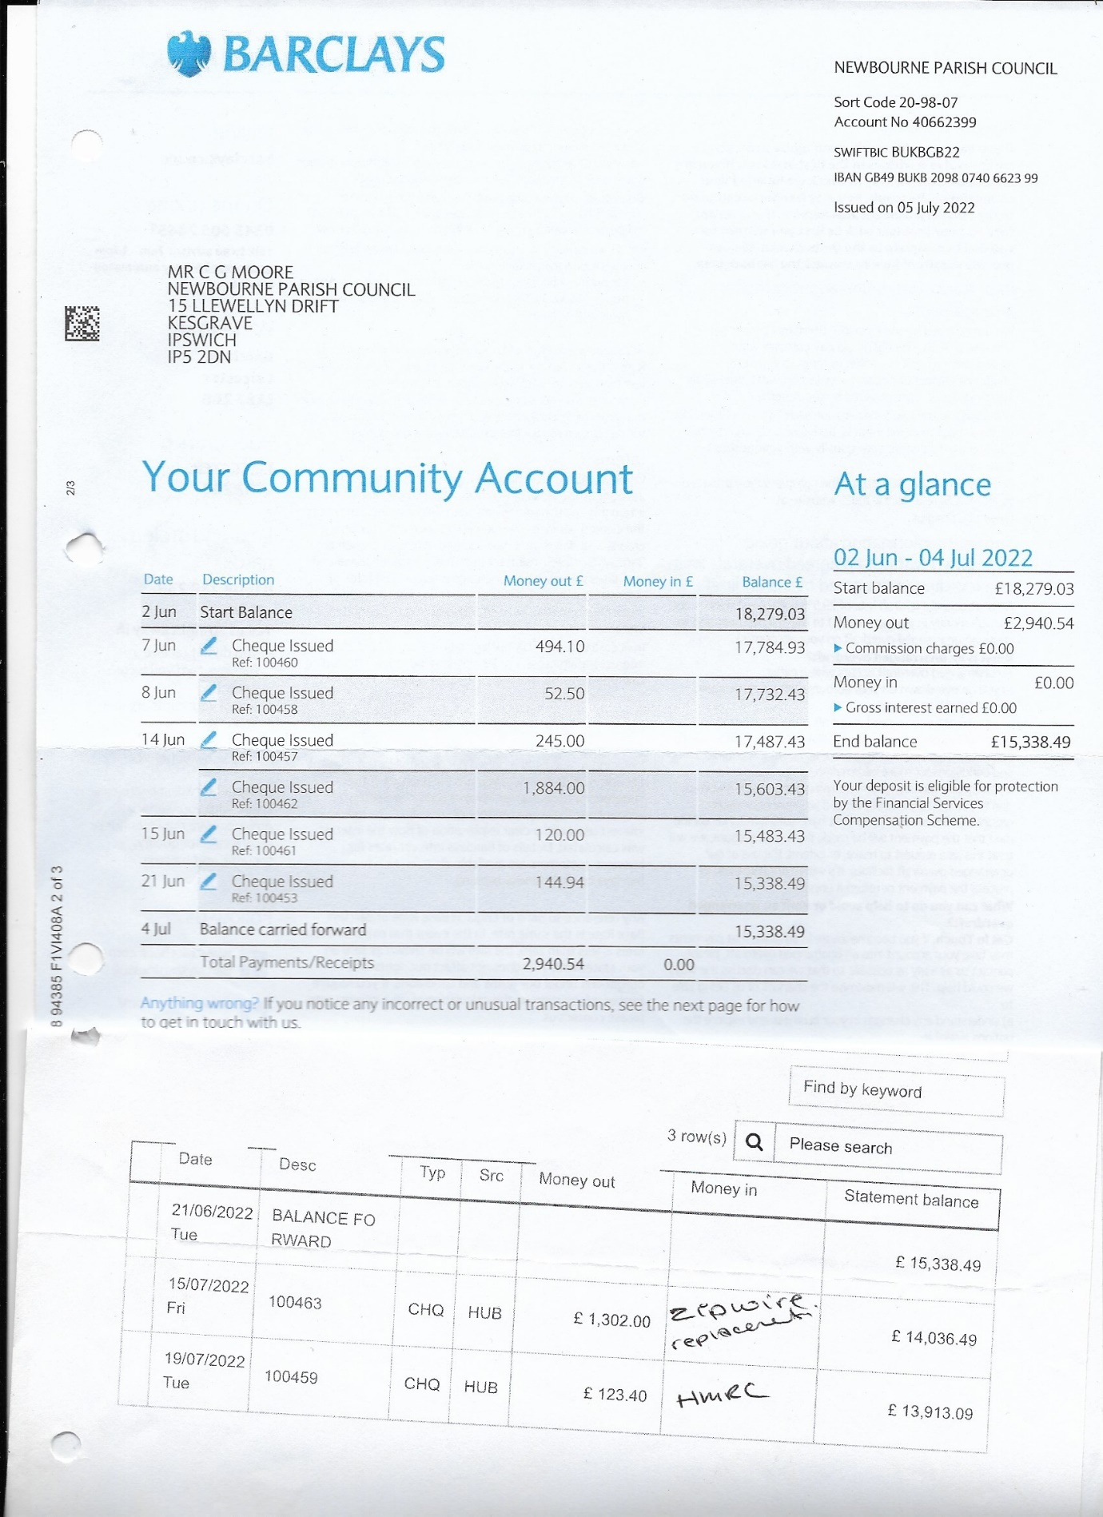

Balance 4TH August 2022
Current £13,913.09
Saving £4027.08

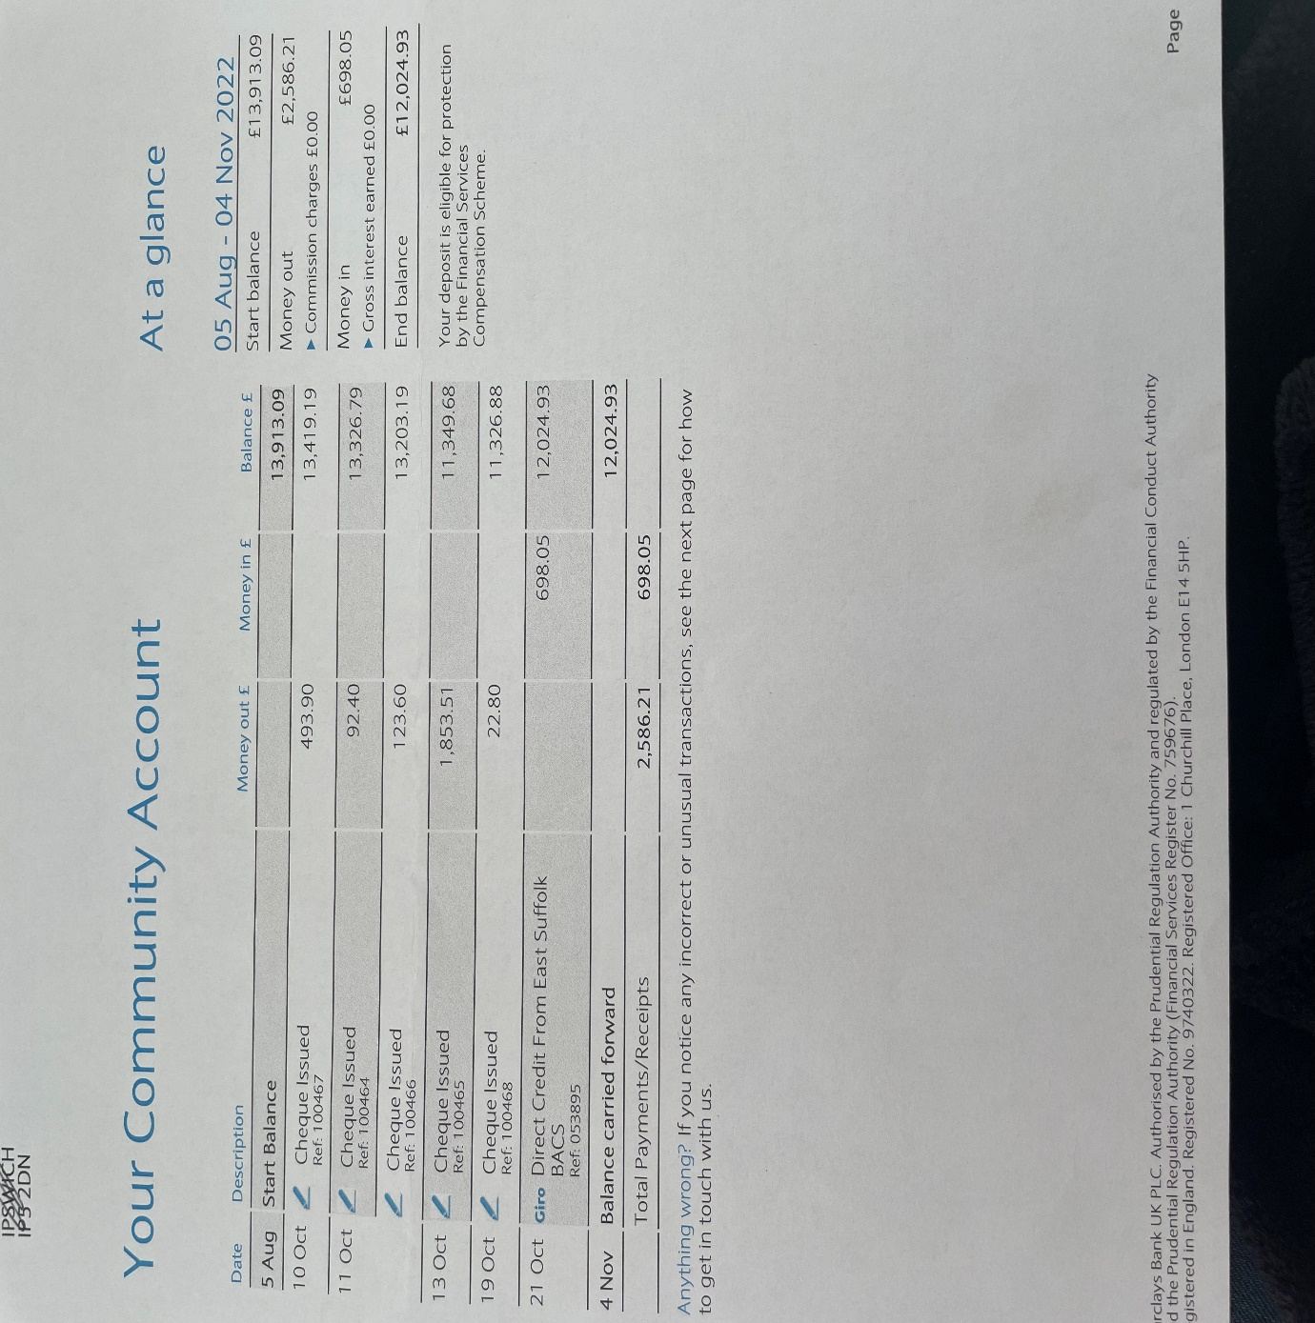

OCTOBER MONEY IN
£698.05 CIL PAYMENT IN From East Suffolk council
OCTOBER CHEQUES
Cheque 100464 Play safety £92.40 Play area inspection Annual inspection
Cheque 100465 Hiscox £1853.51 Insurance 1st October 2022 – 1ST October 2023
Cheque 100466 HMRC £123.60 HMRC Payment May 2022 – August 2022
Cheque 100467 Clerk wages £493.90 L Naunton wages May 2022 – August 2022
Cheque 100468 SALC Payroll £22.80 SALC Payroll payment
BALANCE 4TH November 2022
Current £12,024.93
Saving £4028.32

NOVEMBER CHEQUES
Cheque 100469 DEFIB AED DONATE £975.00 New defibrillator
BALANCE 4TH December 2022
Current account £11,049.93
Saving Account £4028.32

DECEMBER 2022 CHEQUES
Cheque 100470 HMRC £123.40 L Naunton HMRC September – November 2022
Cheque 100471 Clerk wages £494.10 L Naunton wages September – November 2022
Cheque 100472 Protect and Detect £1800.00 Speed Camera

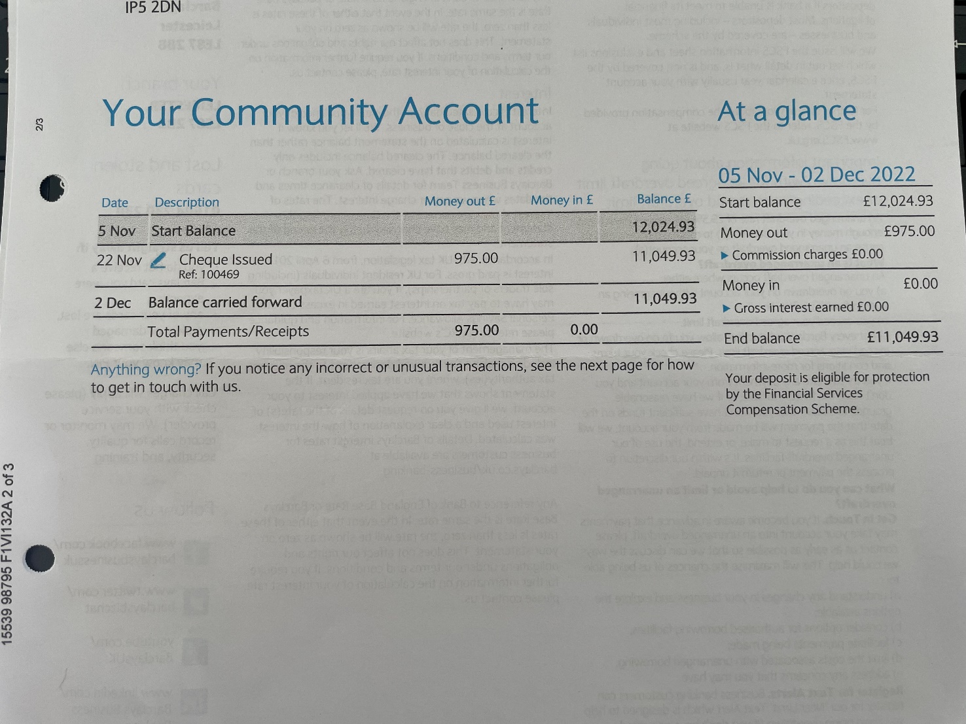

Balance JANUARY 2023
Current account £10,555.83
Saving £4030.57

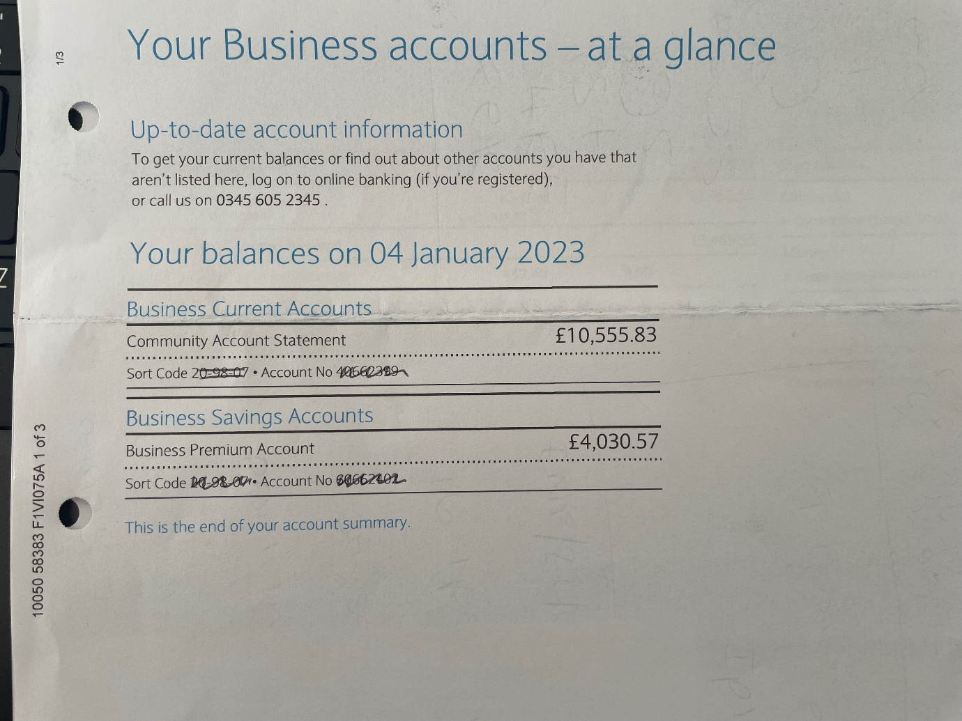
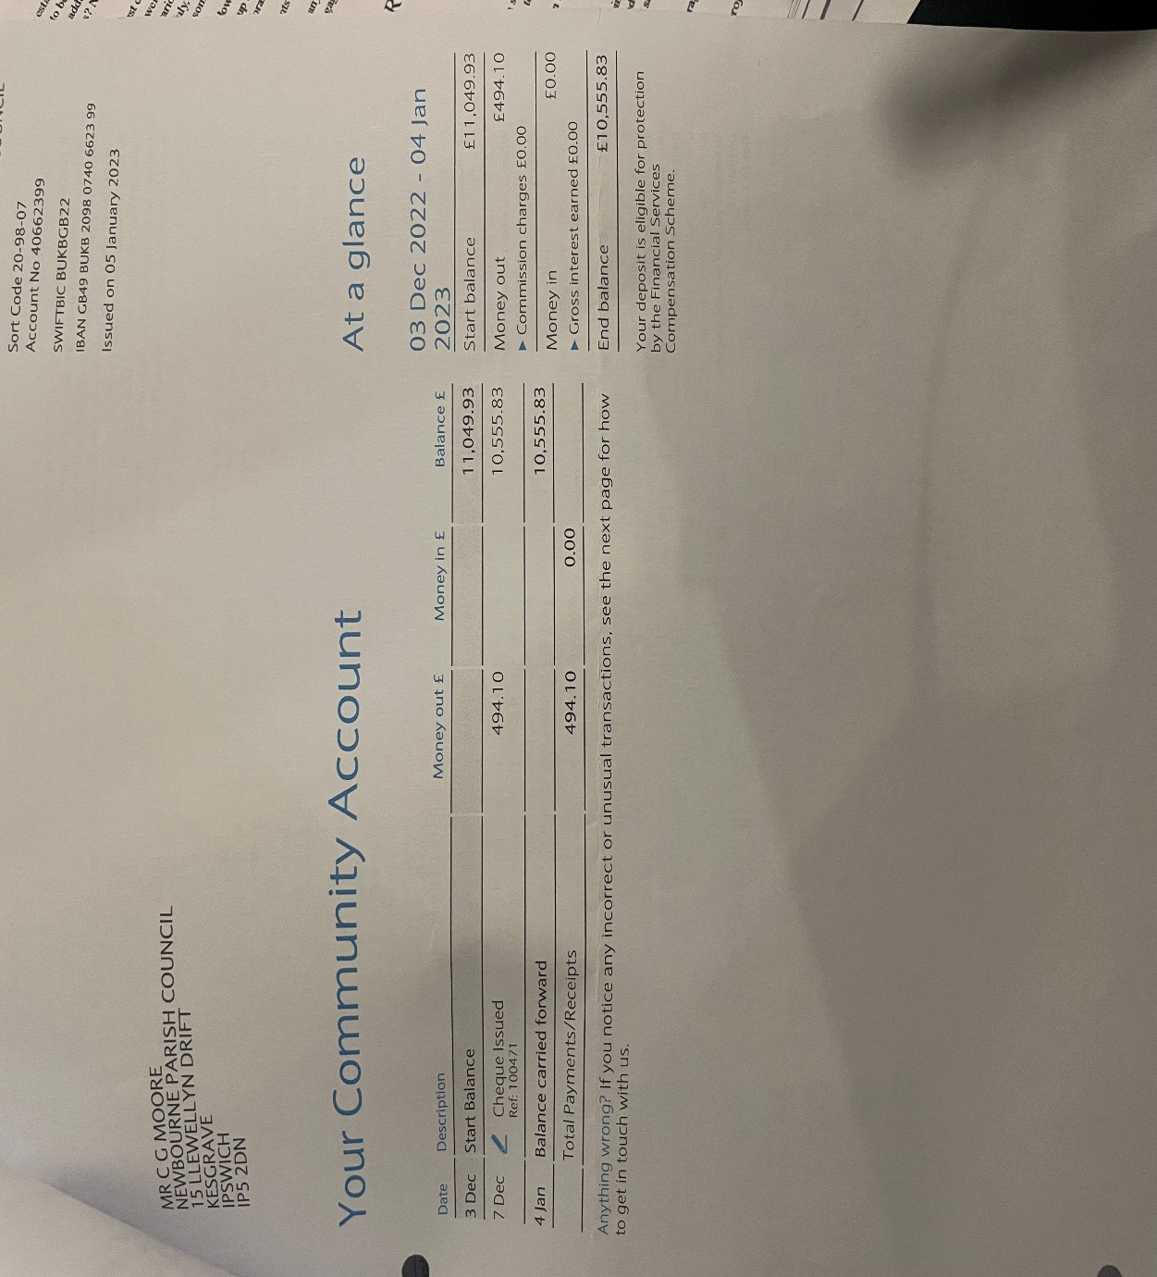

February 2023 Cheques Issued
Cheque 100473 £60.00 Community Action Suffolk Website maintenance
February 2023 Cheques Paid in
Cheque £926.75 Money from Village Hall ½ of insurance
February 2023 Money in
£710.00 paid in Money raised from Quiz night.

Balance on March 2023
Community £10,209.18
Saving £4030.57

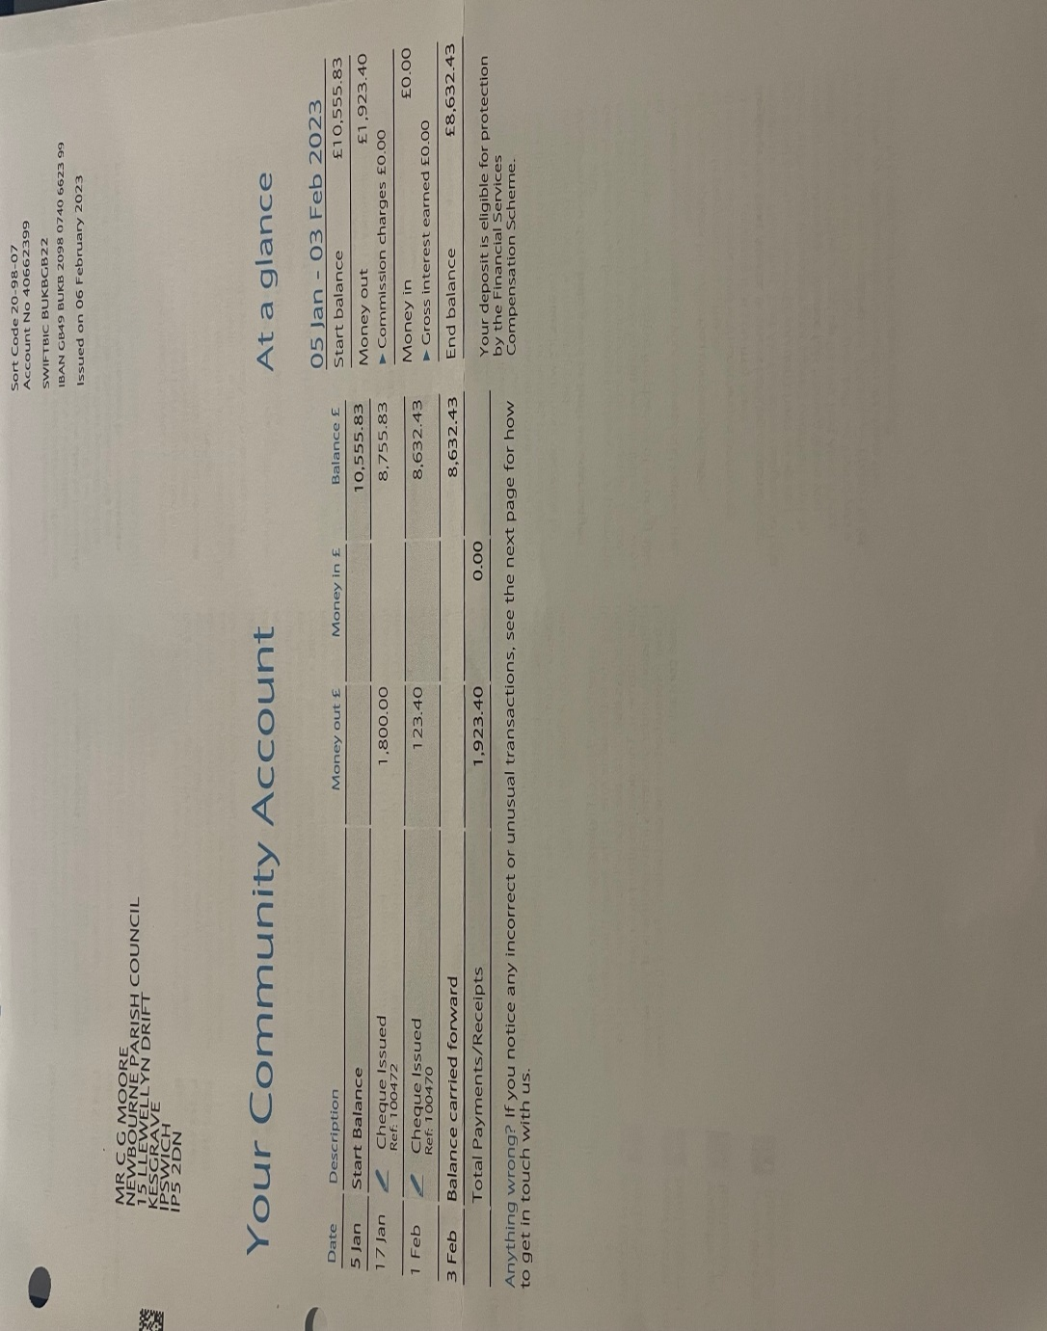
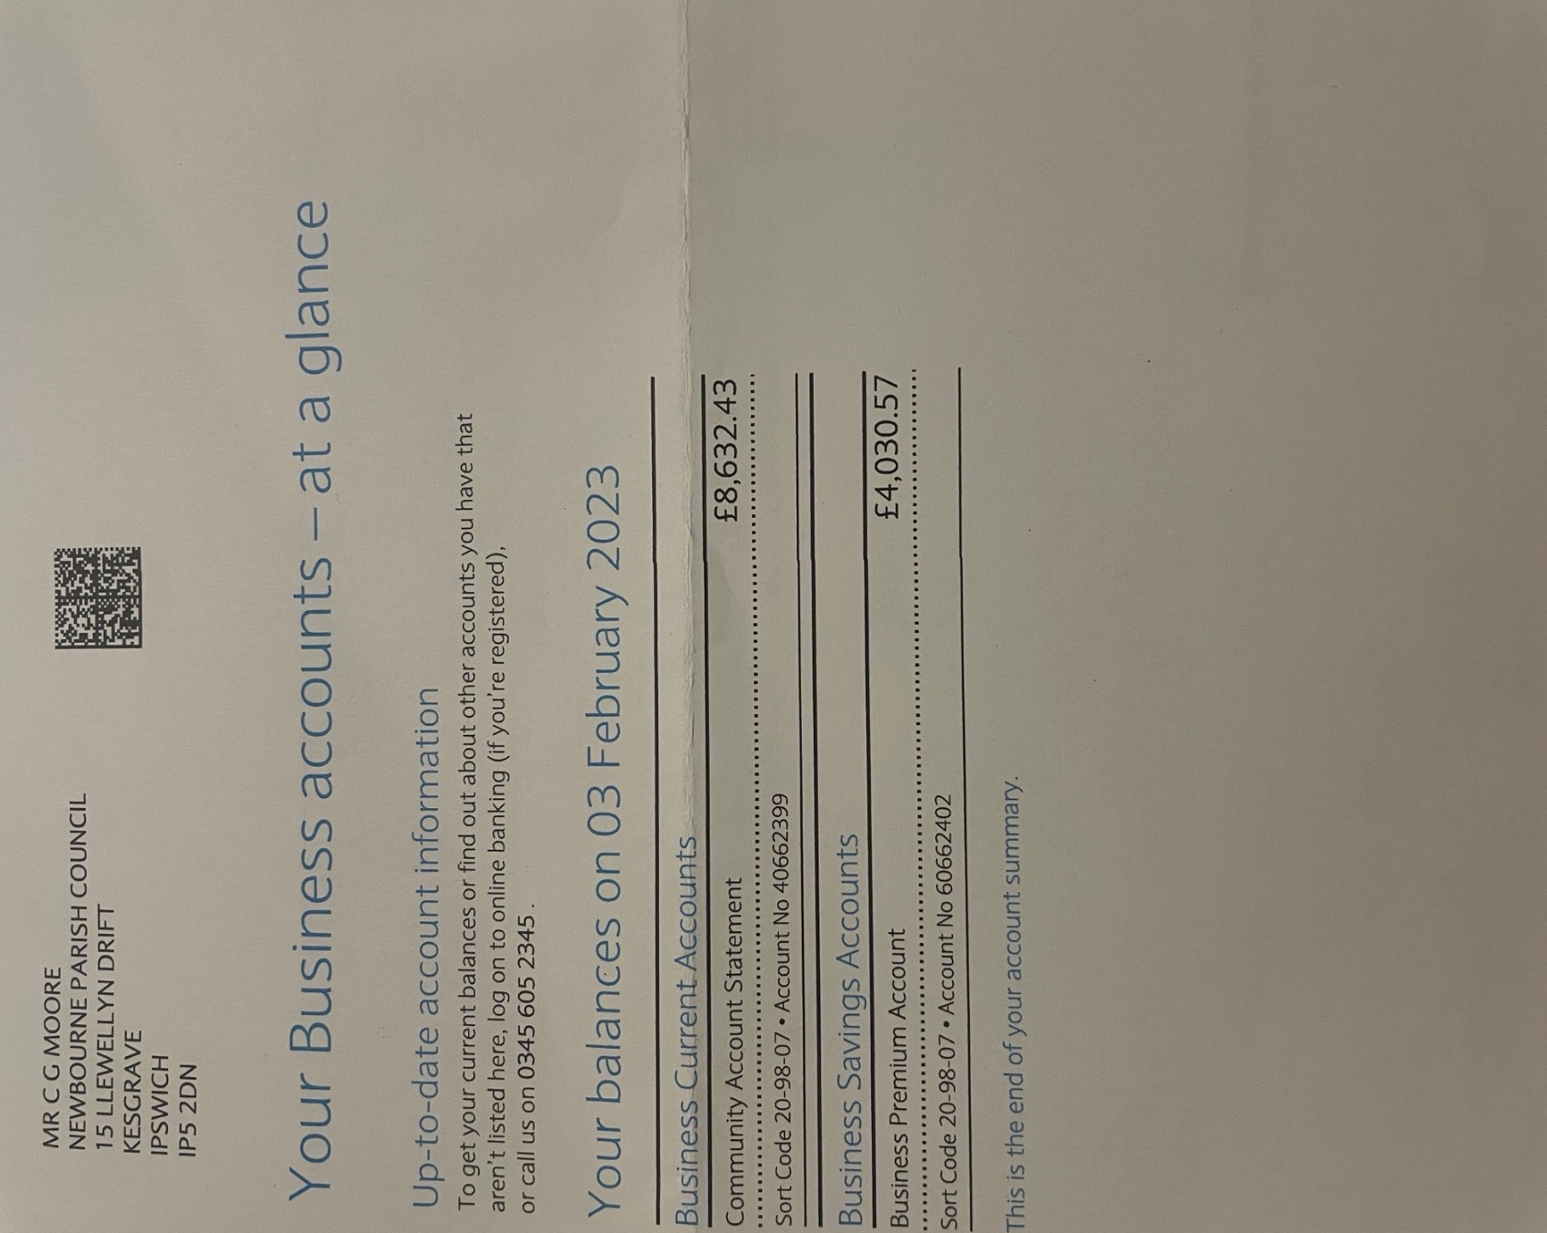
March 2023 Cheques
Cheque 100474 HMRC December 2022 – February 2023 £123.60 HMRC
Cheque 100475 Wages Clerk December 2022 – February 2023 £493.90 Clerk Wages
Cheque 100476 L Naunton Tracker for Defibrillator £29.00 and printer ink £42.19 = £71.19 Printer ink Ink & Defib tracker
Cheque 100477 Adam Sterry – Grass Cutting £180.00
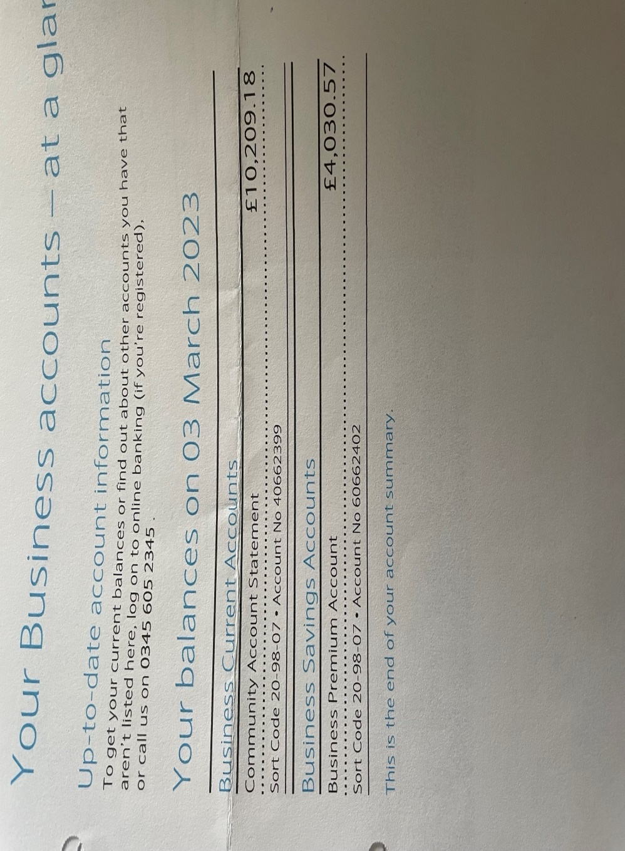

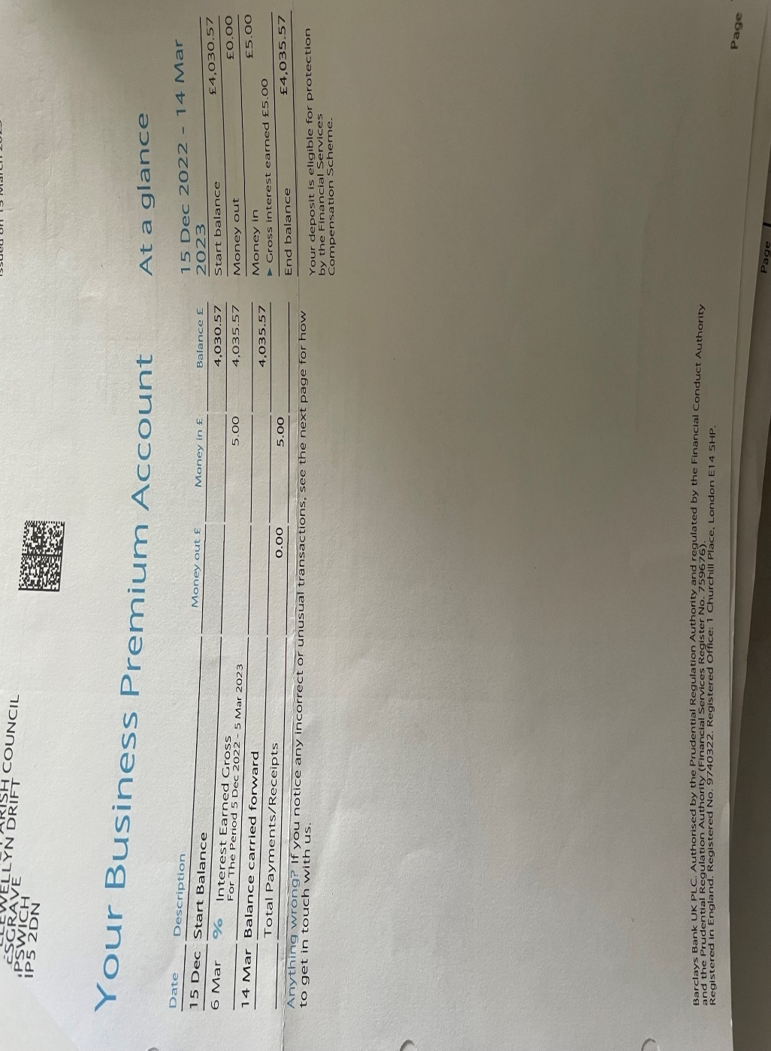
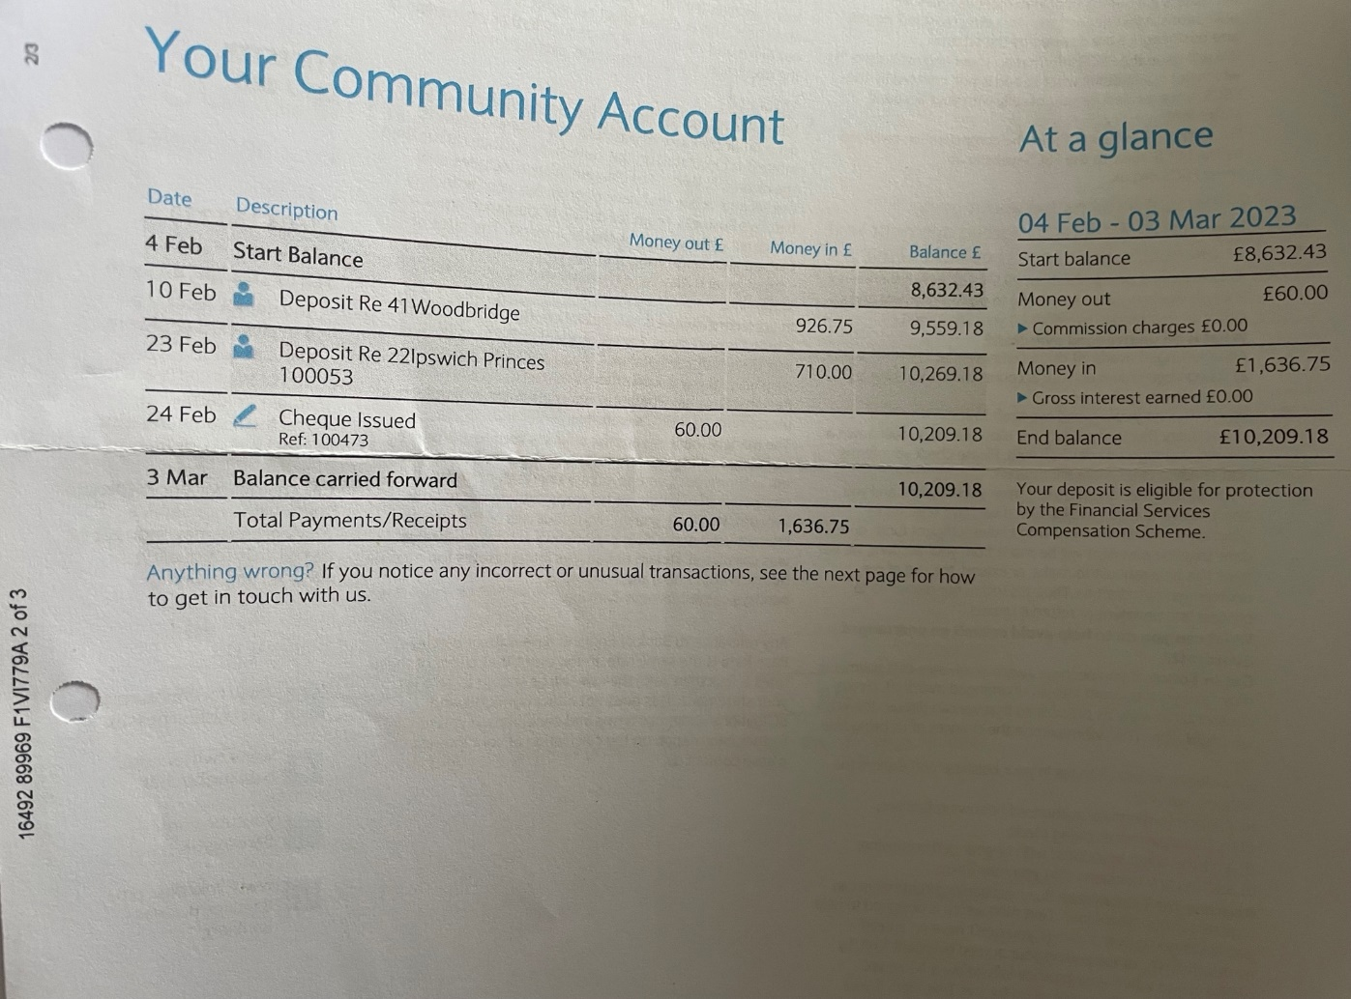
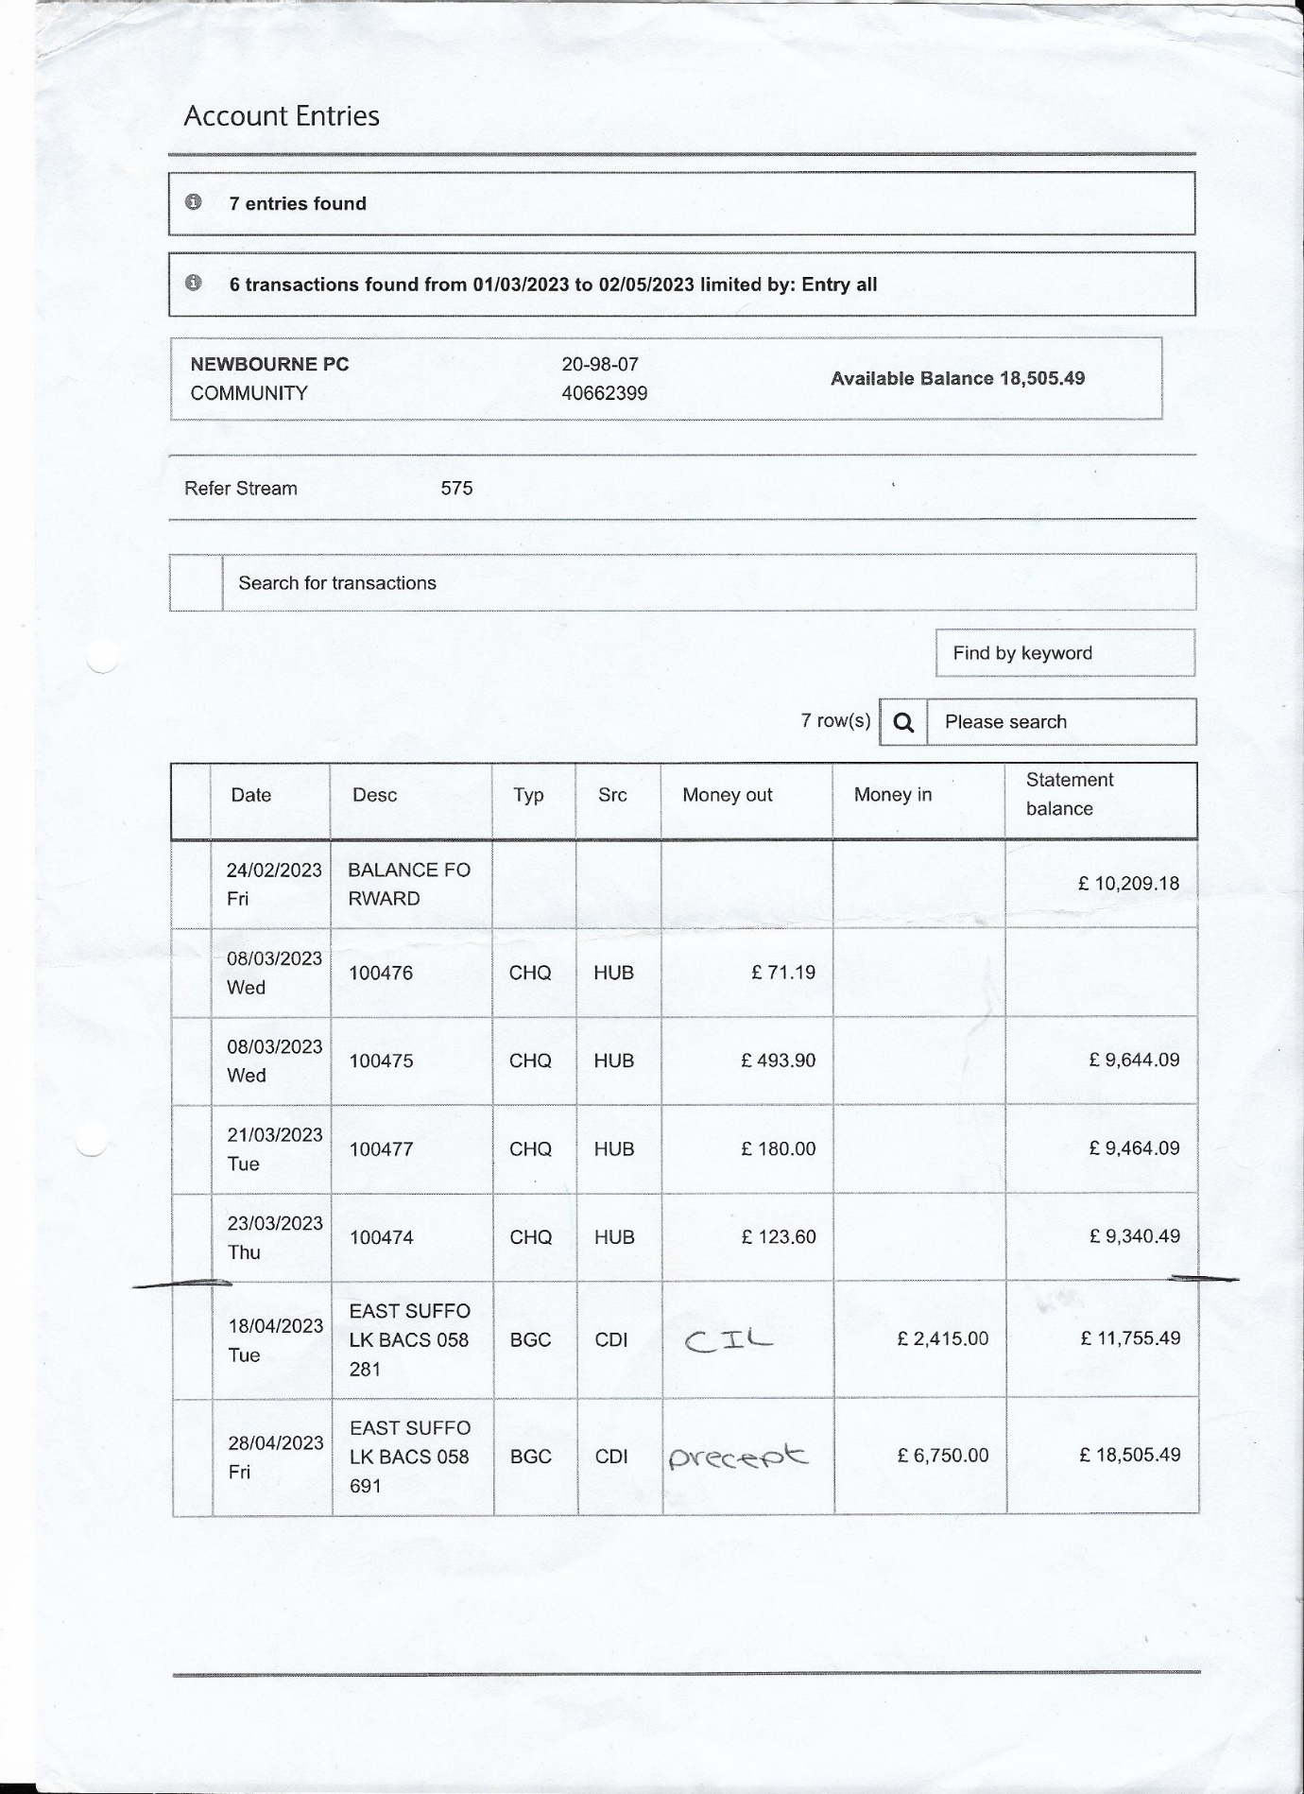

Bank Reconciliation March 2022

Cash in hand 01/03/2022 £18,101.22
Community £14,074.54
Saving £4026.68
ADD
Receipts
0.10p Interest on saving account
Total £18,101.32

SUBTRACT
Payments
£453.40 100449 Wages 08/03/2022

Cash in hand 01/04/2022 £17,647.92

B
Cash £0.00
Petty Cash £0.00
Community account £13,621.14
Saving £4026.78
£17,647.92

Bank Reconciliation April 2022

Cash in hand 01/04/2022 £17,647.92
Community £13,621,14
Saving £4026.78
ADD
Receipts
£6000.00 Precept £6000.00

Total £23,647.92

SUBTRACT
Payments
Amount Cheq no Payee Cashed
£60.00 100451 CAS Website 29/04/2022
£567.00 100452 Lewis Culf Builders Defib Box 07/04/2022
£113.40 100448 HMRC 13/04/2022
£22.80 100450 SALC payroll 26/04/2022
= £763.20

Cash in hand 01/05/2022 £22,884.72

B
Cash £0.00
Petty Cash £0.00
Community account £18,857.94
Saving £4026.78
£22,884.72

Bank Reconciliation May 2022

Cash in hand 01/04/2022 £22,884.72
Community £18,857.94
Saving £4026.78
ADD
Receipts
£0.00
Total £22,884.72

SUBTRACT
Payments
Amount Cheq no Payee Cashed
£52.50 100454 Playground oil 11/05/2022
£40.00 100455 defib batteries 12/5/2022
£486.41 100456 jubilee decorations 17/05/2022
= £578.91
Cash in hand 01/05/2022 £22,305.81

B
Cash £0.00
Petty Cash £0.00
Community account £18,279.03
Saving £4026.78
£22,305.81

Bank Reconciliation June 2022

Cash in hand 01/06/2022 £22,305.81
Community £18,279.03
Saving £4026.78
ADD
Receipts
£0.30 interest on saving account
Total £22,306.11

SUBTRACT
Payments
Amount Cheq no Payee Cashed
£494.10 100460 Wages 07/06/2022
£52.50 100458 playground oil 08/06/2022
£1884.00 100462 Dishwasher 14/06/2022
£245.00 100457 Jubilee event 15/06/2022
£120.00 100461 Playarea 15/06/2022
£144.94 100453 SALC membership 21/06/2022
= £2940.54
Cash in hand 01/06/2022 £19,365.57

B
Cash £0.00
Petty Cash £0.00
Community account £15,338.49
Saving £4027.08
£19,365.57

Bank Reconciliation July 2022

Cash in hand 01/07/2022 £19,365.57
Community £15,338.49
Saving £4027.08
ADD

Total £19,365.57

SUBTRACT
Payments
Amount Cheq no Payee Cashed
£1302.00 100463 zipwire 15/07/2022
£123.40 100459 HMRC 19/07/2022
= £1425.40
Cash in hand 01/07/2022 £17,940.17

B
Cash £0.00
Petty Cash £0.00
Community account £13,913.09
Saving £4027.08
£17,940.17

Bank Reconciliation August 2022

Cash in hand 01/08/2022 £17,940.17
Community £13,913.09
Saving £4027.08
ADD

Total £17,490.17

SUBTRACT
Payments
Amount Cheq no Payee Cashed

Cash in hand 01/08/2022 £17,940.17

B
Cash £0.00
Petty Cash £0.00
Community account £13,913.09
Saving £4027.08
£17,940.17

Bank Reconciliation September 2022

Cash in hand 01/09/2022 £17,940.17
Community £13,913.09
Saving £4027.08
ADD
£1.24 interest on savings account

Total £17,941.41

SUBTRACT
Payments
Amount Cheq no Payee Cashed

Cash in hand 01/09/2022 £17,941.41

B
Cash £0.00
Petty Cash £0.00
Community account £13,913.09
Saving £4028.32
£17,941.41

Bank Reconciliation October 2022

Cash in hand 01/10/2022 £17,941.41
Community £13,913.09
Saving £4028.32
ADD
£698.05 CIL payment in from ESC
Total £18,639.46

SUBTRACT
Payments
Amount Cheq no Payee Cashed
£493.90 100467 WAGES 10/10/2022
£92.40 100464 PLAYGROUND 11/10/2022
£123.60 100466 HMRC 11/10/2022
£1853.51 100465 INSURANCE 13/10/2022
£22.80 100468 SALC 19/10/2022
= £2586.21

Cash in hand 01/10/2022 £16,053.25

B
Cash £0.00
Petty Cash £0.00
Community account £12,024.93
Saving £4028.32
£16,053.25

Bank Reconciliation November 2022

Cash in hand 01/11/2022 £16,053.25
Community £12,024.93
Saving £4028.32
ADD
Total £16,053.25

SUBTRACT
Payments
Amount Cheq no Payee Cashed
£975.00 100469 defib 22/11/2022

Cash in hand 01/11/2022 £15,078.25

B
Cash £0.00
Petty Cash £0.00
Community account £11,049.93
Saving £4028.32
£15,078.25

Bank Reconciliation December 2022

Cash in hand 01/12/2022 £15,078.25
Community £11,049.93
Saving £4028.32
ADD
Total £15,078.25

SUBTRACT
Payments
Amount Cheq no Payee Cashed
£494.10 100471 Wages 07/12/2022

Cash in hand 01/12/2022 £14,584.15

B
Cash £0.00
Petty Cash £0.00
Community account £10,555.83
Saving £4028.32
£14,584.15

Bank Reconciliation January 2023

Cash in hand 01/01/2023 £14,584.15
Community £10,555.83
Saving £4028.32
ADD
£2.25 interest on saving account.
Total £14,586.40

SUBTRACT
Payments
Amount Cheq no Payee Cashed
£1800.00 100472 speed camera 17/01/2023

Cash in hand 01/02/2023 £12,786.40

B
Cash £0.00
Petty Cash £0.00
Community account £8755.83
Saving £4030.57
£12,786.40

Bank Reconciliation February 2023

Cash in hand 01/02/2023 £12,786.40
Community £8755.83
Saving £4030.57
ADD
£926.75 Money in from Village Hall
£710.00 Money in from Quiz

Total £14,423.15

SUBTRACT
Payments
Amount Cheq no Payee Cashed
£123.40 1000470 HMRC 01/02/2023
£60.00 100473 CAS Website 24/02/2023

Cash in hand 01/03/2023 £14,239.75

B
Cash £0.00
Petty Cash £0.00
Community account £10,209.18
Saving £4030.57
£14,239.75

Bank Reconciliation March 2023

Cash in hand 01/03/2023 £14,239.75
Community £10,209.18
Saving £4030.57
ADD
£5.00 INTEREST ON SAVING ACCOUNT 06/03/2023
Total £14,244.75

SUBTRACT
Payments
Amount Cheq no Payee Cashed
£71.19 100476 Tracker+ink 08/03/2023
£493.90 100475 wages 08/03/2023
£180.00 100477 Grass cutting 21/03/2023
£123.60 100474 HMRC 23/03/2023
= £868.69

Cash in hand 01/04/2023 £13,376.06

B
Cash £0.00
Petty Cash £0.00
Community account £9340.49
Saving £4035.57
£13,376.06

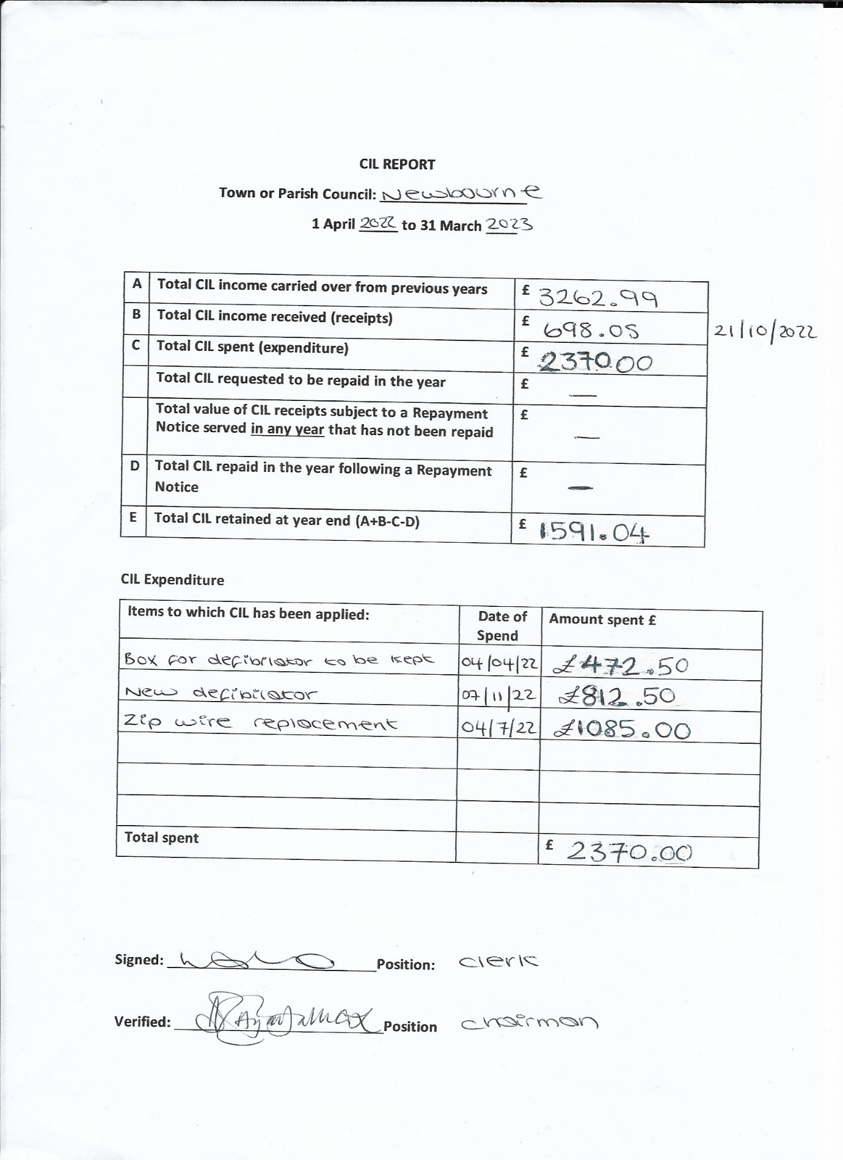

 | Predicted | What was Spent
Clerk Wages | £1980.00 | £1976.70  £494.10  £493.90  £494.10  £493.90
HMRC | £494.00 | £494.00  £113.40  £123.40  £123.40  £123.60
SALC Payroll | £91.20 | £91.20  £22.80 26/04/2022  £22.80 19/10/2022
SALC Membership | £145.00 | £144.94
Printer ink | £50.00 | £42.19
Insurance | £1500.00 | £1853.51
Training | £0.00 | £0.00
Internet | £0.00 | £0.00
Defibrillator | £50.00 | £40.00 Batteries  £567.00 Defib box  £975.00 New Defib  £29.00 tracker
Grass cutting / Maintenance | £800.00 | £180.00
Playground Repairs | £1000.00 | £52.50 Playground oil  £52.50 Playground Oil  £120.00 Removal of damaged parts /inspection of zip wire  £1302.00 Zipwire replacement
Village Items | £0.00 | £1884.00 Dishwasher for village Hall
Village Day | £1000.00 | £486.41 Decorations for Jubilee Celebration  £245.00 East Coast Adventures
Playground Inspection | £92.40 | £92.40
Speed Camera | £3000.00 | £1800.00
Donations | £0.00 | £0.00
Membership | £0.00 | £0.00
CAS Website | £60.00 | £60.00 29/04/2022  £60.00 24/02/2023

Money In
Precept | £6000.00
Interest in from saving account | £8.79
CIL | £698.05
Grants from local authorities | 0.00
Fundraising | £710.00 quiz money
Village Hall money in | £926.75

