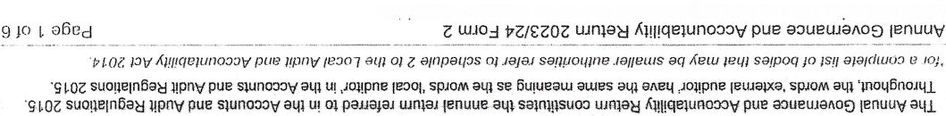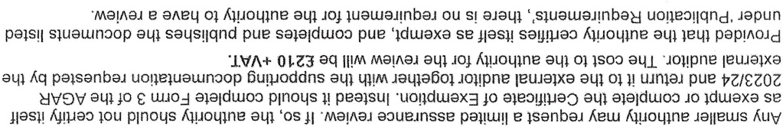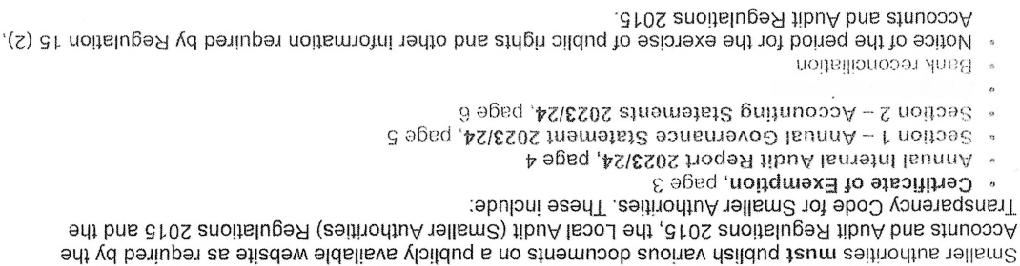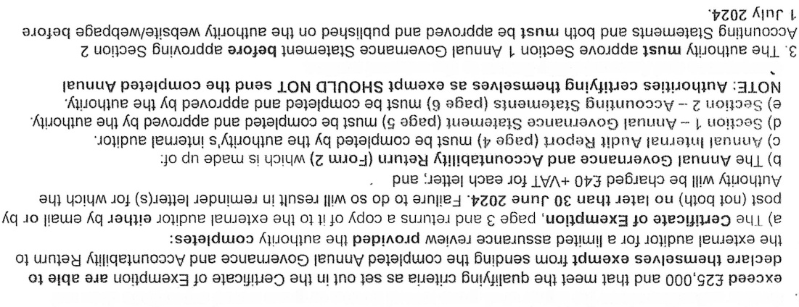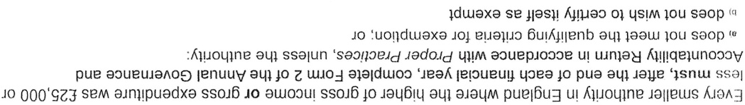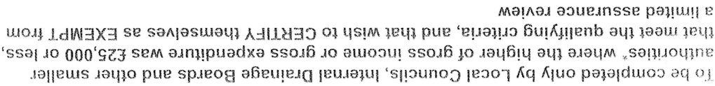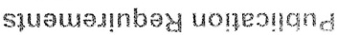
sal}uoq+nVJalietuS lay io puc spieo8 a6euleia teuia}ul 'sj13unoO le30l
sooueueA JO s}sAleuV
-Jo}!pne letHalxa 014) 0) Lun)ON A}111qe}un030V pUC a3UeUJaAOr)
lou soap aJn+}puadxa lenuue SSOJ6 ro aLUOOu! lenuue SSOJ6 lie JO ial46 lq aq) aiaqM saRiroLIIng ial[eLUS

