1.Balance carried over from April 2025 £11,782
Community Account £7637.37
Saving account £4144.76
Total = £11,782.13
2. Precept £8500.00
3. Money in
06/08/2025- £950.00 – Village Hall
4. Staff costs
03/09/2025 – 100552 - £317.41 – Wages
04/09/2025 – 100551 - £317.41 – Cheque unpaid.
5.Loan repayments £0.00
6. Payments made
09/04/2025 - £1236.00 – Hand dryer in village hall - 100538
15/04/2025 - £756.41 – Water heater for village hall - 100537
12/05/2025 - £19.80- Printer ink
12/05/2025 – Noble Nature - £97.50 Greenspace Maintenance -100541
12/05/2025 – Matt Moore - £1548.00 Hedge, Work on village hall and swing preparation.
12/06/2025 - £22.80 – SALC - 100535
12/06/2025 - £167.67 SALC Membership 100539
07/07/2025 - £158.60 – HMRC - 100543
11/07/2025 - £70.00 - 100546
05/08/2025 - £84.99 - 100547
06/08/2025 - £196.95 – New laptop and post box for outside village hall -100550
06/10/2025 - £110.40 Playground inspection 100557
06/10/2025 - £64.69 BT internet – 100558
03/11/2025 - £510.00 Hedge Cutting at Village Hall -Treescape Group -100559
03/11/2025 - £1260.00 Removal of condemned play equipment and landscaping at village hall 100560
03/11/2025 – Clerk – Stamps and 1st class postage to Barclays £20.80 100561

Saving Account
01/04/2025 Opening balance £4144.76
01/06/2025 Interest + £13.77 £4158.53
08/09/2025 Interest (2nd June – 7th September) +£13.80 £4172.33

Precept
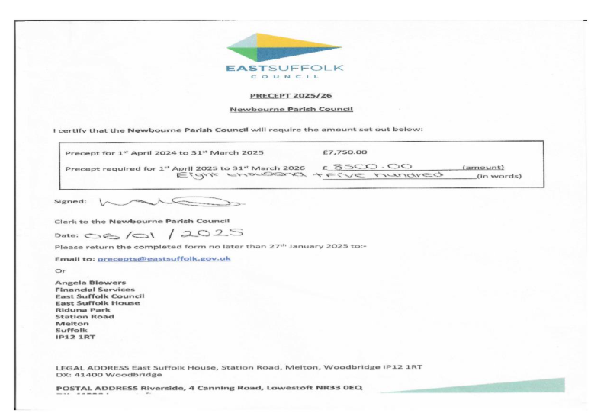
Bank Statements
