Purchases
Play area update new swing purchased £5583.00 and £2111.26 for repairs to zipwire and other areas. The council have decided to put £3165.00 CIL money towards swing. The village hall boiler needed to be replaced as broken this was £7980.33 and £1000.00 CIL money was put towards this.
Audit Figures
1 Balance carried forward 2023-2024+ £20,372.00
2 Precept + £7750.00
3 Total Receipts received £8462.00
£20,372+ £7750.00 + £8462.00 = £36,584
-
4 Staff costs + £2594
5 Loan repayments + £0.00
6 All other payments = £22,208
= £24,802
Balance to be carried forward to 2025- 2026 £11,782
Community Account £7637.37
Saving account £4144.76
Total = £11,782.13
= £11,782

Receipts in 2024 -2025 = £16,212.15
Payments made 2024 -2025 = £24,534.21

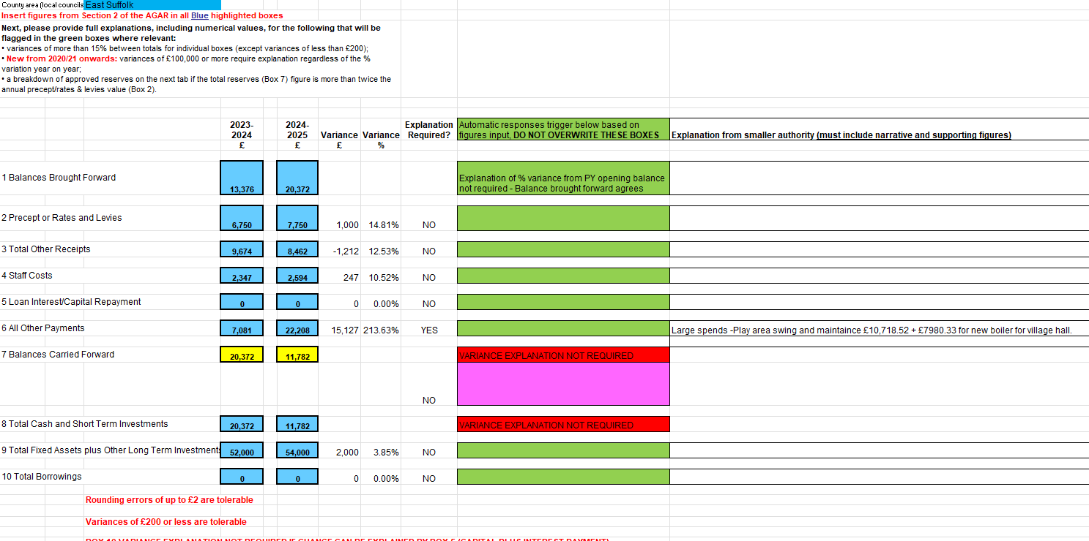
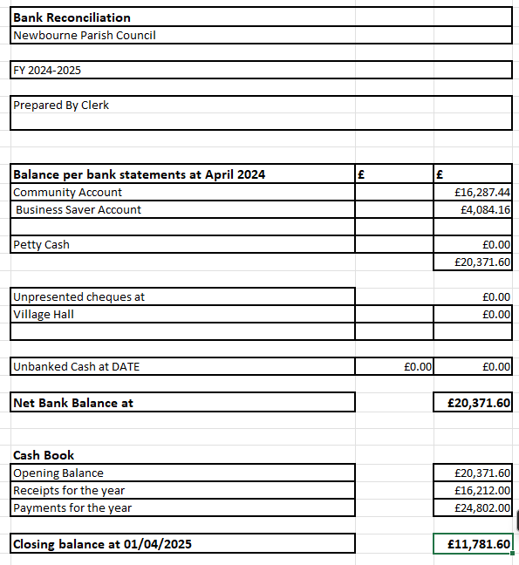
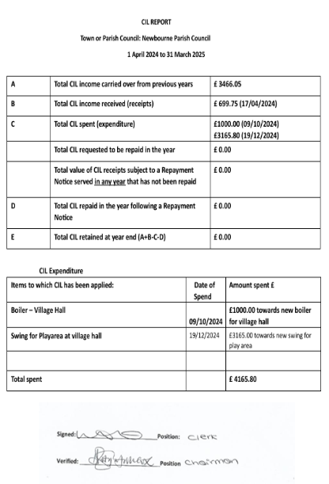
Asset register
Description | Location | Date Purchased | Cost | Current Value | Insurance Value
Village Hall | Mill Road | 1985 | £2,000.00 | £2000.00 nominal | £350,000
Play Area | at village hall | 2010 | £44,000 | £44,000 | £40,000
Bus Shelter | o/s fox public house | Pre 1980 | not known | £1 nominal | Outside furniture policy
Park Bench | village hall grounds | 2012 | £800.00 | £800.00 | Outside furniture policy
Village sign | centre village | 2006 | £3,094 | £3,094 | Outside furniture policy
3 grit bins | mill road, jackson road, woodbridge road | 2013 | £406.00 | £40,600 | Outside furniture policy
Litter bins | village hall grounds | 2014 | £240.00 | £240.00 | Outside furniture policy
Sign | village hall grounds | 2014 | £183.00 | £183.00 | Outside furniture policy
Notice board | Mill Road | 2020 | £242.00 | £242.00 | Outside furniture policy
Speed indicator device | mill road | 2022 | £2,500 | £2,500.00 | Outside furniture policy
Defibilator | Phone box | 2023 | £1,000.00 | £1,000.00 | Outside furniture policy

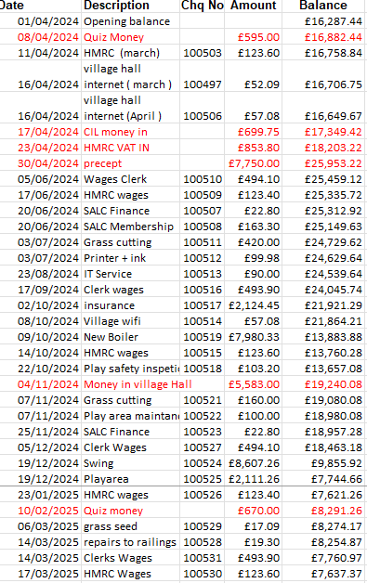

Business Saver
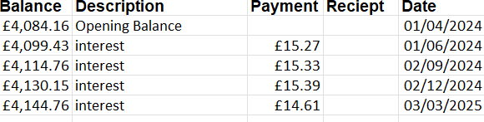

Precept = £7750.00
Total receipts –
08/04/2024 – Quiz Money in £595.00
17/04/2024 – CIL money in £699.75
23/04/2024 – HMRC VAT £853.80
04/11/2024 – Village hall money in =
10/02/2025 – quiz money - £670.00
Interest money in £60.60
Total money in = £8462.15
Staff costs –
11/04/2024 – HMRC £123.60
05/06/2024 – wages £494.10
17/06/2024 – HMRC £123.40
17/09/2024 – WAGES £493.90
14/10/2024 – HMRC £123.60
05/12/2024 – WAGES £494.10
23/01/2025 – HMRC £123.40
14/03/2025 – WAGES £493.90
17/03/2025 – HMRC £123.60 = £2594.60
Payments
16/04/2024 – Village Hall internet £52.09
16/04/2024 – Village Hall internet £57.08
20/06/2024 – SALC Finance £22.80
20/06/2024 – SALC Membership £163.80
03/07/2024 – Grass cutting £420.00
03/07/2024 – Printer ink £99.98
23/08/2024 – IT Services £90.00
02/10/2024 – insurance £2124.45
08/10/2024 – village hall internet £57.08
09/10/2024 – New boiler £7980.33
22/10/2024 – Play area inspection £103.20
07/11/2024 – Grass cutting £160.00
07/11/2024 – Play area Maintenance £100.00
25/11/2024 – SALC Finance £22.80
19/12/2024 – Swing £8607.26
19/12/2024 – Play area repairs £2111.26
06/03/2025 – Grass seed £17.09
14/03/2025 – Repairs to railings £19.30
= £22,208.52
Audit Figures
1 Balance carried forward 2023-2024+ £20,372.00
2 Precept + £7750.00
3 Total Receipts received £8462.00
£20,372+ £7750.00 + £8462.00 = £36,584
-
4 Staff costs + £2594
5 Loan repayments + £0.00
6 All other payments = £22,208
= £24,802

Balance to be carried forward to 2025- 2026 £11,782
Community Account £7637.37
Saving account £4144.76
Total = £11,782.13

= £11,782

Receipts in 2024 -2025 = £16,212.15
Payments made 2024 -2025 = £24,534.21

